CS486C – Senior Capstone Design in Computer Science
Project Description

Project Title: LeGIT/AI (Logical expression Generator Intended for TLA+ with Artificial Intelligence)

 | Chris Ortiz, Senior Technologist  Tools & Infrastructure  SanDisk Corp., Engineering & Product Management  chris.ortiz@sandisk.com  Rex Jackson, Vice President  Tools & Infrastructure  SanDisk Corp., Engineering & Product Management  rex.jackson@sandisk.com

Project Overview:
At SanDisk, we take the quality of our popular storage products seriously, and we always strive to be best-in-class in upholding our global SanDisk brand. To further improve our design assurance, SanDisk has launched an initiative to formally specify our designs using PlusCal and TLA+ (Temporal Logic of Actions), enabling formal verification through a model checker.
TLA+ is a mathematical specification language based on set theory and logic, used to write rigorous and unambiguous formal specifications. PlusCal is a developer-friendly, pseudocode-like language that automatically transpiles into TLA+.
Before a higher-level product design can be formally verified against its requirements, the requirements themselves must first be formally verified using the common verifier. Requirements must be converted from informal natural language into their shared mathematical formal language, TLA+.
Manually reading through a large block of requirement text to extract the relevant context for a specific feature—and then translating it into logical expressions—is a daunting task. Without immediate feedback from the common verifier, it becomes difficult to detect inconsistencies that arise when all logical expressions are combined into a single TLA+ formal specification.
An automation tool integrated into the VS Code IDE is needed to help streamline this challenging process.
- The requirements will be provided in the form of NVMe and PCIe Standard Specification PDF files.
- The tool will use GitHub Copilot in Agent Mode to extract the context of a selected feature from the requirements and generate the necessary definitions and formulas intended for TLA+ specification draft with corresponding TLA+ and CFG files.
- Users will be able to manually edit this TLA+ specification draft within the VS Code IDE.
- The draft and any edits can be iteratively verified with the TLC model checker, either automatically through the tool or via Agent Mode AI (Artificial Intelligence).
- The final output is a successfully model-checked TLA+ formal specification of the targeted feature from the requirements.
- Create a dictionary of the VARIABLES and CONSTANTS found in the TLA+ specification. This dictionary will be used as a common global collection of terms or identifiers found in NVMe and PCIe PDF files, which future TLA+ specifications will reference.

The proposal is to automate this process in VSCode IDE through Rust codes and provide effective prompt for the Agent mode AI. The proposal mitigates the tedious verification of AI-generated results. This is possible because the AI output is in TLA+ form, which can be verified by TLC—an external tool for model-checking TLA+. AI results are probabilistic, but they can be exhaustively checked across all possible scenarios by the model checker, unlike traditional testing.
The figure below is our proposed solution where the grayed boxes and arrow’s label are the ones we need NAU to help. In light blue, if any, it is the stretch goal. This project will expose the NAU students to be familiar with PlusCal and TLA+ which Leslie Lamport invented. He is an ACM Turing Awardee where his contribution to Computer Science is used in universities, and by big companies like AWS, Microsoft, Oracle, Google, LinkedIn, MongoDB, Datadog, Intel, ARM, Nvidia, etc. Also, there is also potential that projects such as this can get granted from TLA+ Foundation if submitted to and get selected by TLA+ committee.
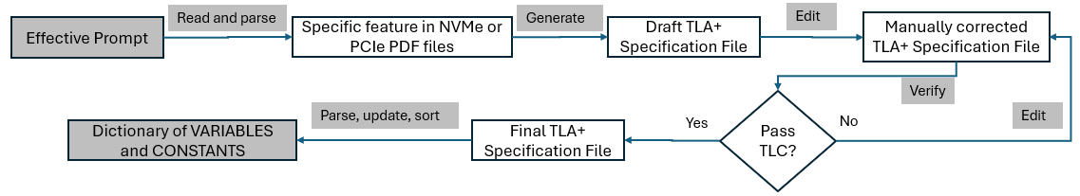

Knowledge, skills, and expertise required for this project:
- Knowledge of TLA+ and PlusCal using TLA+ VSCode extension.
  - Home Page: https://lamport.azurewebsites.net/tla/tla.html
  - Github: https://github.com/tlaplus
  - Conferences: https://conf.tlapl.us/home/
  - Foundation: https://foundation.tlapl.us/
- Coding skill in Rust (preferred) or Python: https://www.rust-lang.org/

Equipment Requirements:
Computer system with VSCode installed with the following extensions and internet connectivity.
- Rust-analyzer (The Rust Programming Language)
- TLA+ (Temporal Logic of Actions by TLA+ Foundation)
- Graphviz Interactive Preview (tintinweb)
- Live Share (Microsoft)
- Github Copilot with agent mode, Claude Sonnet 4.5 (preferred) or Opus 4.5

Other software:
- OpenJDK >= 11.0.6 (Please do not use Oracle’s)
- Rust Installation and crates that might be needed

Software and other Deliverables:
Detailed, clear, and professionally composed documentation and literature which SanDisk product teams will use as reference manual.
Complete documentation and well-commented codebase in Private Github account, for which SanDisk can solely decide freely if it is beneficial for SanDisk to open-source this repository (or fork of it) or not in the future.

