CS486C – Senior Capstone Design in Computer Science
Project Description

Project Title: CryPTO (Cryptic PlusCal and TLA+ Obfuscator)

 | Chris Ortiz, Senior Technologist  Tools & Infrastructure  SanDisk Corp., Engineering & Product Management  chris.ortiz@sandisk.com  Rex Jackson, Vice President  Tools & Infrastructure  SanDisk Corp., Engineering & Product Management  rex.jackson@sandisk.com

Project Overview:
At SanDisk, we take the quality of our popular storage products seriously, and we always strive to be best-in-class in upholding our global SanDisk brand. To further improve our design assurance, SanDisk has launched an initiative to formally specify our designs using PlusCal and TLA+ (Temporal Logic of Actions), enabling formal verification through a model checker. TLA+ is a mathematical specification language based on set theory and logic, used to write rigorous formal specifications. SanDisk will collaborate with and seek assistance from our partners and the broader TLA+ community regarding these PlusCal (a developer-friendly, pseudocode-like language that transpiles automatically to TLA+) and raw TLA+ specifications.
SanDisk partners—such as third-party vendors, contractors, consultants, and NAU CS Capstone teams—must secure an NDA with us before we can share sensitive or confidential designs. Even with NDAs in place, SanDisk may further redact or obfuscate such designs to mitigate the risk of public information leakage. However, this common practice can introduce ambiguities that lead to inconvenient back-and-forth clarification with external partners. Additionally, when we seek help on formal specifications written in PlusCal or TLA+, we cannot request assistance from global experts in the public TLA+ community without sharing our specification as-is. It is not possible to secure NDA with public TLA+ community.
A key property of logic is that its validity does not depend on the contextual meaning of text, if the logical structure remains sound. This property of logic is what we will leverage for the CryPTO project. If all textual substitutions in the specification are applied consistently, the logical meaning remains unchanged. To guarantee this, we rely on TLC, the model checker for PlusCal and TLA+ specifications.
We know that by consistently substituting textual labels for identifiers across all declarations and definitions in all relevant specifications (including user-defined INSTANCE and EXTENDS modules), without altering logical operators, connectives, or relationships, the results, statistics, and coverage produced by TLC before and after substitution should remain identical. To non-logicians and LLMs—who and which often rely on contextual meaning—the CryPTO-processed specification will appear cryptic. However, to well-disciplined logicians and TLC itself, even though the text looks obfuscated, the underlying logic remains intact and verifiable. The output specification is cryptic, but it is simply an obfuscated version of the original.
We plan to preserve and maintain the textual-mapping plaintext as a password-protected ciphertext to further enhance the security of the obfuscation process. The choice of which text to substitute for another is completely arbitrary; however, we will allow the NAU students to research this and provide guidelines, including recommendations on whether to implement a dictionary-based method, RAG (Retrieval-Augmented Generation), or a key-value database.
We recognize that even if the CryPTO-processed specification is obfuscated, its underlying logic remains intact. As a stretch goal, we propose using a litmus test in which the obfuscated specification is analyzed by AI to determine whether the AI can infer its meaning. If the AI cannot decode it, make sense of it, or if it hallucinates, then the obfuscation is considered successful. This breakthrough will benefit us in two important ways:

- It allows us to leverage our visibility to receive free and crucial assistance from public TLA+ community experts, many of whom have decades of experience with PlusCal and TLA+ in both academic settings and real-world industrial and IT applications.
- It will encourage designers, architects, and engineers to adopt PlusCal and TLA+ without needing to manually create different versions of a specification due to the risk of sharing confidential information with non-NDA third parties.

The figure below is our proposed solution where the grayed boxes and arrow’s label are the ones we need NAU to help. In light blue, it is the stretch goal. This project will expose the NAU students to be familiar with PlusCal and TLA+ which Leslie Lamport invented. He is an ACM Turing Awardee where his contribution to Computer Science is used in universities, and by big companies like AWS, Microsoft, Oracle, Google, LinkedIn, MongoDB, Datadog, Intel, ARM, Nvidia, etc. Also, there is also potential that projects such as this can get granted from TLA+ Foundation if submitted to and get selected by TLA+ committee.
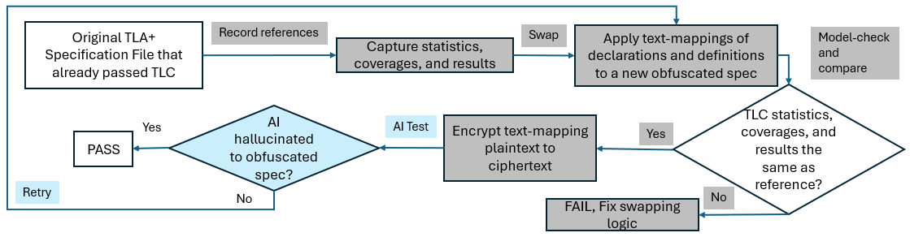

Knowledge, skills, and expertise required for this project:
- Knowledge of TLA+ using TLA+ VSCode extension.
  - Home Page: https://lamport.azurewebsites.net/tla/tla.html
  - Github: https://github.com/tlaplus
  - Conferences: https://conf.tlapl.us/home/
  - Foundation: https://foundation.tlapl.us/
- Coding skill in Rust (preferred) or Python: https://www.rust-lang.org/

Equipment Requirements:
Computer system with VSCode installed with the following extensions and internet connectivity.
- Rust-analyzer (The Rust Programming Language)
- TLA+ (Temporal Logic of Actions by TLA+ Foundation)
- Live Share (Microsoft)
Other software:
- OpenJDK >= 11.0.6 (Please do not use Oracle’s)
- Any Rust cargo extensions needed especially for parsing and encryption

Software and other Deliverables:
Detailed, clear, and professionally composed documentation and literature which SanDisk product teams will use as reference manual.
Complete documentation and well-commented codebase in Private Github account, for which SanDisk can solely decide freely if it is beneficial for SanDisk to open-source this repository (or fork of it) or not in the future.

