Project Proposal



# Particle Imaging Velocimetry

[Insert Team Number]:

Santiago Gamez

Kian Pack

Christopher Rapoport

Jett Scruggs

# Table of Contents

Particle Imaging Velocimetry 1

Table of Contents 2

Executive Summary / Abstract 3

Background 4

Project Description 4

Deliverables 4

Success Metrics 4

Constraints 4

Requirements 5

Customer Requirements 5

Engineering Requirements 5

Quality Function Deployment Diagram 5

Design Space Research 6

Benchmarking 6

State-of-the-Art (SOTA) Literature Review 7

Engineering Analyses 8

Design Concepts 9

Functional Decomposition 9

Concept Generation 9

Selection Criteria 10

Concept Selection 11

Conclusion 12

References 13

Appendix A 14

Appendix B 14

Appendix C 14

Appendix D 14

# Executive Summary / Abstract

[insert here]

# 

# Background

### Project Description

### Deliverables

### Success Metrics

Table 1.Objectives summarized.

|  |  |  |
| --- | --- | --- |
| **Objective** | **Basis for Measurement** | **Measurement** |
|  |  |  |
|  |  |  |
|  |  |  |
|  |  |  |
|  |  |  |
|  |  |  |

### Constraints

Constraints that apply to this project include:

* Constraint- Description
* Constraint- Description
* Constraint- Description

# 

# Requirements

### Customer Requirements

[insert here]

1. Requirement: Description
2. Requirement: Description
3. Requirement: Description
4. Requirement: Description
5. Requirement: Description
6. Requirement: Description

### Engineering Requirements

After determining the customer requirements, the team then had to translate these requirements into engineering characteristics that can be quantified and measured. Some of these engineering requirements include:

Engineering Requirement: Description

Engineering Requirement:Description

Engineering Requirement:Description

Engineering Requirement:Description

Engineering Requirement:Description

Engineering Requirement:Description

### Quality Function Deployment Diagram

# To simplify and organize the design process of the PIV system, a quality-function diagram (QFD) was made to separate the project into multiple parts that takes into account the customer requirements, engineering characteristics, and benchmarking.

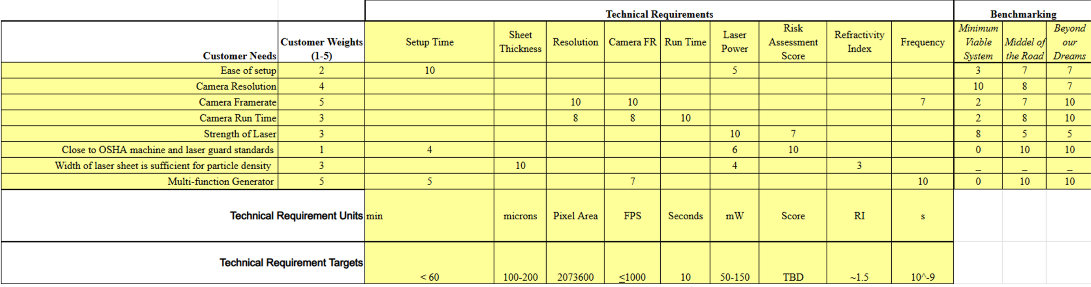

Figure (x) - Quality Function Deployment Diagram

# Design Space Research

### Benchmarking

Benchmarking existing systems in the PIV space can be somewhat challenging due to both the highly custom nature of many PIV systems and the relatively secrecy they are developed in. Due to these challenges, the team developed benchmarks based on known specifications from other labs and development teams across the world.

Minimum Viable PIV System - Least capable system possible that can still technically be called a Particle Imaging Velocimeter. This system takes significant

|  |  |  |  |
| --- | --- | --- | --- |
| **Subsystem:** | **Component:** | **Price:** | **Specifications:** |
| Camera |  |  |  |
| Laser |  |  |  |
| Function Generator |  |  |  |

Middle-of-the-Road PIV System – This system uses purpose-built components that are common in many research laboratories that are not entirely focused on the development of Particle Imaging systems. This system will likely produce results that are of a similar accuracy to the system we will create.

|  |  |  |  |
| --- | --- | --- | --- |
| **Subsystem:** | **Component:** | **Price:** | **Specifications:** |
| Camera |  |  |  |
| Laser |  |  |  |
| Function Generator |  |  |  |

Top-of-the-Line PIV System - This system requires a much higher budget than ours, but provides a cutting-edge example to aim for with our system.

|  |  |  |  |
| --- | --- | --- | --- |
| **Subsystem:** | **Component:** | **Price:** | **Specifications:** |
| Camera |  |  |  |
| Laser |  |  |  |
| Function Generator |  |  |  |

### State-of-the-Art (SOTA) Literature Review

* W. H. Ho, I. J. Tshimanga, M. N. Ngoepe, M. C. Jermy, and P. H. Geoghegan, “Evaluation of a Desktop 3D Printed Rigid Refractive-Indexed-Matched Flow Phantom for PIV Measurements on Cerebral Aneurysms,” *Cardiovasc Eng Tech*, vol. 11, no. 1, pp. 14–23, Feb. 2020, doi: [10.1007/s13239-019-00444-z](https://doi.org/10.1007/s13239-019-00444-z). (Journal Article)

This source covers the direct manufacturing of transparent flow phantoms using an SLA resin 3D printer, for use with a 2D PIV system. This method is faster and cheaper than the traditional casting method, but there are a few considerations to make before picking a method of manufacture. First is that the refractive index of the resin used in this study is higher than the silicone used in casting methods. This can introduce difficulties surrounding the selection of a blood equivalent fluid, although this can be worked around with the correct mixture. Another potential issue is the slightly higher surface roughness of the resin phantom compared to a cast silicone counterpart. Despite these challenges, this method of manufacturing is still attractive due to its lower cost per unit, faster turnaround time, lower complexity, and less rigorous equipment requirements. This study had 2 separate examples prepared: one was an idealized aneurysm geometry, while the other was a complex patient-specific arterial geometry.

* D. P. G. Nilsson *et al.*, “Patient-specific brain arteries molded as a flexible phantom model using 3D printed water-soluble resin,” *Sci Rep*, vol. 12, no. 1, p. 10172, Jun. 2022, doi: [10.1038/s41598-022-14279-7](https://doi.org/10.1038/s41598-022-14279-7). (Journal Article)

This source reviews a phantom manufacturing process that is roughly halfway between the traditional silicone casting process and the novel SLA process presented in Ho et al. This process uses a water-soluble resin in an SLA type 3D printer to create a negative of the phantom geometry, which is then used in a silicone mold. This method still requires the careful silicone handling and desiccator of the traditional casting method, but with a quicker turnaround time due to the negative requiring almost no post-processing. As for advantages over the full SLA process, this method can produce phantoms with a lower RI, better clarity, and smoother surfaces. This study was focused on the production of large, complicated, patient-specific arterial models. This will be useful for helping the teams working on further research once our design is complete but is unlikely to directly inform our PIV design.

* J. Tu, G. H. Yeoh, C. Liu, and Y. Tao, *Computational fluid dynamics: a practical approach*, Fourth edition. Oxford Cambridge, MA: Butterworth-Heinemann, 2024. doi: [10.1016/C2021-0-01771-5](https://doi.org/10.1016/C2021-0-01771-5). (Textbook)

This textbook covers the practical aspects of implementing Computational Fluid Dynamics (CFD) simulations into design and research. It will be very useful in understanding what governing equations and assumptions to use when modeling flow in the phantom geometry we will use to test out the PIV prototypes and final system. An especially useful method in this case will likely be to simulate the tracer particles in the fluid system as actual particles in a two-phase flow, which will help us pick what particle characteristics are most well suited to our system.

* M. Tomaszewski, K. Sybilski, P. Baranowski, and J. Małachowski, “Experimental and numerical flow analysis through arteries with stent using particle image velocimetry and computational fluid dynamics method,” *Biocybernetics and Biomedical Engineering*, vol. 40, no. 2, pp. 740–751, Apr. 2020, doi: [10.1016/j.bbe.2020.02.010](https://doi.org/10.1016/j.bbe.2020.02.010) (Journal Article)

This paper goes in-depth on an experiment conducted by the authors involving the effectiveness of various stents in arterial applications. While their results won’t directly inform the design of our system or experiments, the process documented will help guide our progress. Special attention will be paid to what design decisions the authors made that impacted the ease of use of their PIV system.

* F. Kojo Chaway Acquah, J. Paul Konadu Takyi, and H. R. Beem, “Design and characterization of a low-cost particle image velocimetry system,” *HardwareX*, vol. 19, p. e00563, Sep. 2024, doi: [10.1016/j.ohx.2024.e00563](https://doi.org/10.1016/j.ohx.2024.e00563). (Journal Article)

This paper discusses the development of a PIV system with a budget even lower than ours. The authors managed to create a working PIV for slightly over 500 USD. This paper serves as a great benchmark for what even the prototypes of our system should be capable of. It also gives examples of places to save cost (like lenses) that will allow us to spend more on actual capability. Finally, this source’s explanation of the simple experiments used to verify the results of the authors’ PIV system will help our team design our own experiments to validate our system prototypes.

* D. J. Biswas and D. J. Biswas, *Insights into laser science*. in A beginner’s guide to lasers and their applications / Dhruba J. Biswas, no. Part 1. Cham: Springer, 2023. (Textbook)

This textbook covers the basic theory and application of lasers in a variety of fields. This resource will be useful in helping us choose the specifics of the laser diode that we will use in our final design. This is important because no members of the team have any background or formal education in the design or use of lasers. Aspects of our design like diode selection, optics selection, and safety guarding will be informed by the content in this source.

* F. Zigunov, “How Bright are my PIV Particles?,” *Zigunov Aero*, Jun. 30, 2023. https://zigunov.com/2023/06/30/how-bright-are-my-piv-particles/ (accessed Mar. 09, 2025). (Website)

This is an article made by an assistant professor at Syracuse University, Dr. Fernando Zigunov. The article is called, “How Bright are my PIV Particles?”, and evaluates Zigunov’s method to theoretically calculate if your PIV system will work. It uses all the laser and optics components of your system including the Camera ISO, wavelength information, pixel sizing, and other light parameters. This will be beneficial in our prototype phase because we will be able to test and evaluate different PIV systems with different components faster. Instead of having to test multiple different systems and hoping for the best, we can have a better understanding before we get into the hands-on testing phase.

* “Considerations When Using Cylinder Lenses,” *Edmundoptics.com*, 2023. [https://www.edmundoptics.com/knowledge-center/applicationnotes/lasers/considerations-when-using-cylinder-lenses/srsltid=AfmBOoqqON2maCTx6XYNjrSre8Ck-e4nh7X_ULfvTMfIijDaxhKc-Ai2](https://www.edmundoptics.com/knowledge-center/application-notes/lasers/considerations-when-using-cylinder-lenses/?srsltid=AfmBOoqqON2maCTx6XYNjrSre8Ck-e4nh7X_ULfvTMfIijDaxhKc-Ai2) (accessed Mar. 09, 2025). (Website)

In this article Edmund Optics goes over how a cylindrical lens can be used to create a sheet of light. It states that cylindrical lenses are different from spherical lenses because they will not affect light in the perpendicular dimension. This means that they have optical power in only one direction. The drawback from the cylindrical lens is that the manufacturing aspect of your lens can not have any mistakes. If there is a misalignment in the polishing process, then the cylindrical lens will be prone to aberration, and it could affect its performance elsewhere. This will be important as the team decides on what kind of method would be best to split the laser into a laser sheet.

* U. Stopper *et al.*, “PIV, 2D-LIF and 1D-Raman measurements of flow field, composition and temperature in premixed gas turbine flames,” vol. 34, no. 3, pp. 396–403, Apr. 2010, doi: <https://doi.org/10.1016/j.expthermflusci.2009.10.012>. (Journal)

This is a journal called, *Experimental Thermal and Fluid Science*, that evaluates different diagnostic measuring techniques and how they were applied to view the air flames of an industrial swirl burner. Although the PIV is not made for the same application, it is still a useful example of a successful PIV. A useful note from this article is that the “resolution of the measured velocity depends on the seeding particle density, the degree of window contamination, and the turbulence of the flow (Aigner, 2010).” It is possible we may need to take these factors into account when determining how well we can picture particles and how many. The PIV setup in the journal also consisted of a laser lens system with two mirrors, two cylindrical lenses, and one spherical lens. This could be helpful when thinking of different possible prototypes.

* S. R. Tenney, M. Moshirfar, and Y. Ronquillo, “Concave And Convex Lenses,” *PubMed*, Oct. 31, 2022. <https://www.ncbi.nlm.nih.gov/books/NBK587441/> (Book)

This book section goes over useful formulae for calculating the focal length of a concave and convex lens, the magnification, and the optical power. As well as notes on aberration which is possible when working with lenses. The PIV laser system will require a precise combination of convex and concave lenses in order to display an accurate laser sheet over the patient. Moving forward in this project we will have to decide on the correct lens distance between each lens in order to create the desired focal point. This book’s contents will help the team quantify the parameters on what is possible with the lenses.

* View, “My milli-micro-PIV setup,” *The Fluid Dynamics Lab*, Feb. 15, 2021. <https://ronshnapp.wordpress.com/2021/02/15/my-milli-micro-piv-setup/> (accessed Mar. 09, 2025). (Website)

This is a website that talks about a milli-micro-PIV setup. The website starts by talking about PIV setup and all the basic components that it requires. After giving some background information, the author then goes in depth about the lenses they used and how they configured their setup. The laser beam first hits a mirror and then turns 90 degrees as it enters the first spherical lens. From there it enters another spherical lens that collimates the beam. From there it enters the third lens, concave cylindrical, to expand the beam in the horizontal direction. To finish the setup the beam goes through a convex cylindrical lens that focuses the beam in the desired sheet thickness. This formation is something to consider when thinking of multiple ways to set up the optics system.

* “Light sheet optics for PIV - HackMD,” *HackMD*, 2023. <https://hackmd.io/@cdcl-rpr/light-sheet-optics> (accessed Mar. 09,2025). (Website)

This online resource is a study on creating a laser system that creates a laser sheet that is 200 mm in height and 1.6 mm thick. Although the author is not verified, he references his use of a book called, Particle Image Velocimetry, made in 2018. This article shows his laser PIV setup and describes what lens types he used and at what distances each of their focal points were. This will be useful as we review different lens types and decide what lenses will be the most efficient. This information can be used to theoretically calculate the focal points and laser sheet thickness using different lenses.

* “Gaussian Beam Propagation,” *Edmundoptics.com*, 2017. [https://www.edmundoptics.com/knowledge-center/applicationnotes/lasers/gaussianbeam-propagation/srsltid=AfmBOorJAMCl13Iu7FQpSGa_Uktg12pTzUPRDqvCvcvbUiEqHlaRmdB](https://www.edmundoptics.com/knowledge-center/application-notes/lasers/gaussian-beam-propagation/?srsltid=AfmBOorJAMC-l13Iu7FQpSGa_Uktg12pTzUPRDqvCvcvbUiEqHlaRmdB) (accessed Mar. 09, 2025). (Website)

In this article Edmund optics explains how gaussian beam propagation is evaluated to understand the formation of the laser beam and its travel. This will be helpful towards creating our laser system for the PIV and understanding the radiance of the laser itself. This article gives useful formulas for different applications of gaussian beams including “focusing a gaussian beam to a spot”. This formula is useful for the laser system by calculating how the laser beam will converge tightly into one point before it diverges into a laser sheet. From there we will have to decide how we would want to make the lasers converge using different lenses.

* G. J. Johnson, “Springer Handbook of Lasers and Optics200884Edited by Frank Träger. Springer Handbook of Lasers and Optics. Heidelberg and New York, NY: Springer 2007. xxvi+1332 pp., ISBN: 978 0 387 95579 7 £192.50 $199 Includes a CD‐ROM containing all eight chapters; also available as an e‐book (ISBN 978 0 387 30420 5),” *Reference Reviews*, vol. 22, no. 2, pp. 42–42, Feb. 2008, doi: <https://doi.org/10.1108/09504120810855093>. (Book)

This is the Springer handbook of lasers and optics that develops fundamental information for a plethora of different applications. In chapter 9 it goes over gaussian beam theory and the fundamental equations for calculating traits of the beam. This will be useful, but is information gained from other sources as well. A new component from this book compared to other research is chapter 21.6 on protective measures. It states some key components to consider when deciding on protective eyewear including wavelength of operation, laser output wavelength, and any other relevant national regulations. It has some other information when dealing with higher powered lasers, but that is not applicable for this project.

* Source (type) [X]

Source Description and Takeaways.

### Engineering Analyses

#### Camera Subsystem -

#### Light Sheet Generator -

To create the desired laser sheet thickness, it is going to require a specific combination of convex and concave lenses with specific distancing. The initial bi-convex lenses will make the diameter of the laser beam smaller as it approaches the concave lens. After this process the laser will go through the first concave lens which will expand the beam in the horizontal direction, and then the final concave lens which will expand the beam in the vertical direction. For the calculations below, the final laser sheet thickness will depend on the focal length of the last concave lens, the beam waist before reaching the lens, and the wavelength of the laser beam. The lens system was created below based on the lens system made by “Shashikant Verma” and utilized the same equations [Santiago 6]. Assumptions for the initial convex lenses and distances were made to get a theoretical laser diameter of 0.4 mm. A length from the last lens to the point of illumination of 180 mm was assumed to calculate the angle of divergence, of 6.667 [millirad].

The calculations performed and a picture representing necessary assumptions is depicted below:

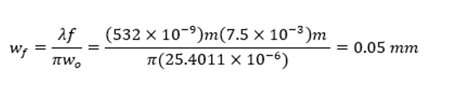(#,[1]) 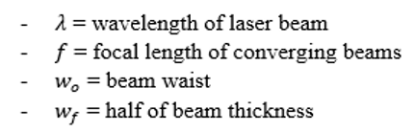

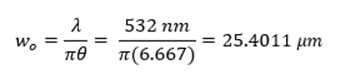(#,[1 ]) 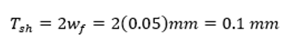 (#,[ 1])

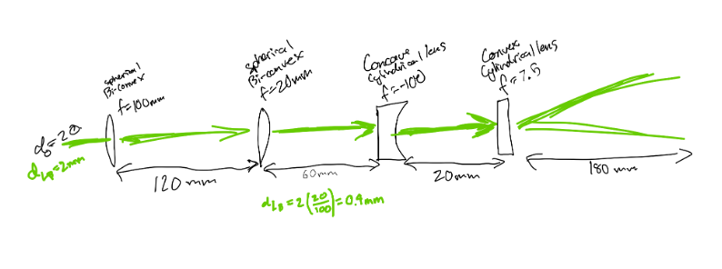(#,[ ])

#### Laser Subsystem -

#### Flow Phantom Manufacturing -

#### Experiment Design -

### 

# Design Concepts

To design an effective [], the [] team would begin a design process that can be explained in-depth in the following sections.

### Functional Decomposition

### 

### 

### Concept Generation

After the construction of the QFD and reviewing all requirements stated, the team generated different tables to review options for the

After the construction of the morphological matrix, the team generated six different designs which were compiled into a Pugh chart as shown in Table 3. Six different design criteria were used to judge each design and determine their score relative to a datum. A plus sign indicates that the design meets the criteria whereas a negative sign refers to a failure of the criteria. Each plus and negative would be summed to show the overall score of each design. An N means that the criteria is neutral and doesn’t affect the overall score. Design 1 was chosen as the datum because it is the highest performance option but also the highest cost option. The six criteria that were chosen can be detailed below:

1. Criterion: Description.
2. Criterion: Description.
3. Criterion: Description.
4. Criterion: Description.
5. Criterion: Description.
6. Criterion: Description.

### Selection Criteria

### Concept Selection

# 

# 

# Conclusion

# 

# References

# 

# Appendix A

# Appendix B

# Appendix C

# Appendix D