**Formula SAE – Chassis Design Report 1**

**Gustavo Ruiz – Chassis Team Lead, CAD Engineer**

**Brandon Guzman – Test Engineer, Engine box design**

**Alexandra Brister – Cockpit Engineer**

**Ryan Meger – Rear Suspension Box, Chassis Analysis**

**Carson Kent – Aerodynamic Engineer**

**Fall 2024-Spring 2025**

**Project Sponsor: Northern Arizona University**

**Faculty Advisor: David Willy**

# DISCLAIMER

This report was prepared by students as part of a university course requirement. While considerable effort has been put into the project, it is not the work of licensed engineers and has not undergone the extensive verification that is common in the profession. The information, data, conclusions, and content of this report should not be relied on or utilized without thorough, independent testing and verification. University faculty members may have been associated with this project as advisors, sponsors, or course instructors, but as such they are not responsible for the accuracy of results or conclusions.

# EXECUTIVE SUMMARY (Ryan Meger)

The Formula SAE chassis sub-team is tasked with the design and construction of the chassis for a Formula SAE style race car, with focuses on structural integrity, safety, integration, and overall performance. The chassis serves as the backbone of the car, supporting suspension, powertrain, driver and everything in between. The team’s primary objective is to create a lightweight, yet stiff frame that is compliant with the Formula SAE Rule Book, all while designing the cockpit to be comfortable, and pickup points and other aspects of the car to be widely adjustable, all while performing at a high level.

The chassis type chosen for NAU’s Formula SAE car was a steel space frame, mainly due to its adjustability when designing, but also cost. Primarily being constructed from 4130 chromoly steel tubing, this material was used for its high yield strength, ease of fabrication and fantastic weldability. The design of the frame was influenced strongly by the rules in the Formula SAE rule book, such as triangulation of the steel tubes, roll cage parameters, side impact structure (SIS) design requirements.

Key design considerations as of now are weight minimization, driver ergonomics, suspension integration, and powertrain mounting. Reducing the weight of the chassis is a priority, while not compromising strength and stiffness. A force analysis study, done in SolidWorks and Ansys, was employed to quickly change designs and optimize the frame for both parameters mentioned above. Driver ergonomics were lacking luster from last year’s design. We aim to create more space in the cockpit by moving the front hoop forward and upwards, make the pedal box adjustable for different drivers, and keep the driver at a reasonable viewing angle. The suspension integration was done through extensive communication with the suspension sub-team. Making sure all mounting points were placed to ensure optimal load transfer during acceleration, braking, and cornering. All while making the body of the car integrate seamlessly with the suspension. The last design consideration was the powertrain mounting points. The chassis will have reinforced mounting points for the engine and transmission. Designing mounting points for high adjustability will allow for proper alignment, and weight distribution during high-performance operation.

Significant progress has been made on the chassis frame development and several deliverables have been met. The final chassis frame design has been reviewed and confirmed to comply with all applicable FSAE rules and regulations, this ensures that the frame meets the required safety, structural, and dimensional standards set forth by the competition. A full-scale PVC prototype of the chassis has been constructed to provide a physical representation of the final design allowing for verification of dimensions and customer requirements. The jig design, which is essential for accurate positioning and alignment during the chassis welding process has been fully completed. The Structural Equivalency Spreadsheet (SES) has been initiated with key data already being entered, this document ensures that the chassis structure adheres to FSAE’s safety and material standards. Lastly, the front and main hoops have been successfully bent according to the specified dimensions, these hoops will serve as the foundation for the rest of the chassis assembly. These accomplishments represent our team’s goals in the development of the chassis and show that we are on track to the completion of the final chassis design and manufacturing stages.

# TABLE OF CONTENTS

Contents

DISCLAIMER 2

EXECUTIVE SUMMARY (Ryan Meger) 3

TABLE OF CONTENTS 4

1 BACKGROUND (Ryan Meger) 5

1.1 Project Description (Ryan Meger) 5

1.2 Deliverables (Brandon Guzman) 5

1.2.1 Course deliverables: 5

1.2.2 Client and competition specific deliverables: 5

1.2.3 Main Constraints for chassis: 2

1.3 Success Metrics (Ryan Meger) 2

2 Requirements (Ryan Meger) 3

2.1 Customer Requirements (CRs) (Ryan Meger) 4

2.2 Engineering Requirements (ERs)(Carson Kent) 5

2.3 House of Quality (HoQ) 8

3 Research Within Your Design Space 10

3.1 Benchmarking (Everyone) 10

3.1.1 Benchmarking – Side Impact Structure (Ryan Meger) 10

3.1.2 Benchmarking – Front, rear and main hoop concepts (Brandon Guzman) 13

3.2 Literature Review (Everyone) 16

3.2.1 Alexandra Brister – Seat Belt System 16

3.2.2 Ryan Meger – Torsional Stiffness 17

3.2.3 Gustavo Ruiz – Chassis Frame Design 17

3.2.4 Brandon Guzman Benchmarking and Bending(b) 18

3.3 Mathematical Modeling (Everyone) 20

3.3.1 Seatbelt Stress and Safety for 6-point – Alexandra Brister 20

3.3.2 Finite Element Analysis (FEA) of the Chassis – Ryan Meger 21

3.3.2.1 Torsional Analysis 21

3.3.2.2 Front and Side Impact Analysis 22

4 Design Concepts 27

4.1 Functional Decomposition (Ryan Meger) 27

4.2 Concept Generation (Everyone) 29

4.2.1 Chassis Generation Ryan Meger & Gustavo Ruiz 29

4.2.2 Seat Belt Systems – Alexandra Brister 30

4.3 Selection Criteria 31

4.3.1 Chassis Selection Criteria – Gustavo Ruiz 31

4.4 Concept Selection 33

4.4.1 Concept Selection for Chassis Design (Ryan Meger) 33

5 CONCLUSIONS 33

6 REFERENCES 35

6.1 Alexandra Brister 35

6.2 Ryan Meger 35

6.3 Brandon Guzman 36

6.4 Gustavo Ruiz 36

6.5 Carson Kent 36

7 APPENDICES 38

7.1 Appendix A: FSAE Rules 38

7.2 Appendix B: Descriptive Title 38

# BACKGROUND (Ryan Meger)

The first chapter will be used to introduce the goals and requirements of the Formula SAE capstone project. This includes the requirements given by the Formula SAE rulebook, and team goals. The NAU Mechanical Engineering school is setting ambitious yet tangible goals and objectives as a second-year team to create a standard for future Formula SAE teams.

## Project Description (Ryan Meger)

The Formula SAE project described by SAE International is “*The Formula SAE competitions challenge teams of university undergraduate and graduate students to conceive, design, fabricate, develop and compete with small, formula style vehicles. The competition is an engineering education competition that requires performance demonstration of vehicles in a series of events, both off track and on track against the clock. Each competition gives teams the chance to demonstrate their creativity and engineering skills in comparison to teams from other universities around the world*.” As a second-year team, we are striving to exceed last year’s performance and fix any issues that arose during design, manufacturing and testing. Building a base for future teams to be successful.

As described above by SAE International, the project gives students the opportunity to put all their engineering knowledge gained into practice. Allowing students to expand their connections with other students, faculty, and potential employers. It also connects the teachings from past engineering courses to develop an engineering design process that will end with a successful capstone project. With the nature of the Formula SAE project, hands on skills in the machine shop will also be developed. Creating and refining real-world knowledge on manufacturing.

The chassis team’s total budget for the Formula 2025 car project is $6,058.24. To date, $1,747.99 has been spent on all the tubing, jig materials, and the PVC prototype, leaving $4,310.25 for future expenses. We plan to secure a sponsorship from Nova Kinetics, which will cover the cost of our first aerodynamic component, the front nose cone, which will help reduce the overall project expenses. Our primary fundraising efforts are focused on obtaining donations from individuals to support the team, while also exploring potential sponsorships to further offset expenses.

## Deliverables (Brandon Guzman)

### Course deliverables:

The project scope for this course is to design and manufacture a new FSAE chassis for the 2025 racing season. The sub-team has been given the task of iterating on the 2024 FSAE chassis design which was also the first year NAU competed in this competition. Main goals include:

* Conform to all FSAE chassis rules
* Improve on the previous year senior designs
* Manufacture components for final design
* Document manufacturing process for future senior designs.

In addition to these major goals, the chassis design plays a large role in impacting the other systems and sub-team designs. To achieve the most efficient design, the team aims to be as flexible as possible to consider the needs of each subsystem for the car.

### Client and competition specific deliverables:

The client and competition specific deliverables for this project were determined after a thorough review of the rules and research in each iteration of the chassis design. These deliverables can be summed into a brief list of constraints that will reinforce decisions with chassis designs and iterations.

### Main Constraints for chassis:

* Tubing specifications: Tubing requirements are based on application are defined in section F.3.2 of the 2025 FSAE Rules. This involves thickness and tube diameter.
* Roll Hoop dimensions: The main and front hoop design are to comply with rules in sections F.5.6—F.5.9. Which defines clearance for safety based on the 95th percentile male as well as protection in case of rollover.
* Cockpit: Cockpit dimensions must comply with section T.1. this is a requirement for the competition. The driver must be able to safely and quickly exit the vehicle through the Egress test which is defined in section IN.5 which is also a requirement for the competition. Both sections can be found in the 2025 FSAE Rule Book.
* Driver Template Position: Bottom 200 mm circle on seat bottom where the distance between the center of this circle and the rearmost face of the pedals is no less than 915 mm. The driver template is important to ensure that rules and regulations are met while applying our customer requirements.

All of these sections will be linked in Appendix A at the end of this report, any other constraints or competition specific deliverables will be defined in section 2.1 and 2.2 regarding Customer and Engineering requirements.

## Success Metrics (Ryan Meger)

The success metrics for the Formula SAE project will be measured by categories as laid out by the SAE Design Judging Score Card. The four categories are based of the car’s design, build, refinement/validation, and understanding. Having an innovate design that push the limits of the rule book and performance of the vehicle is an interest point the judges will be investigating. As a second team year, we are focusing on completing all dynamic events and static tests while having a safe car and performing at a high level.

Success of the project means completing all dynamic events and static tests, while passing inspection done by the judges at the SAE International this coming May. The dynamic tests are performance tests on the car, which include acceleration, skid pad, autocross, efficiency, and endurance events. The Static tests include a leak test, and a knowledge test of the car and the design choices. The primary goal of the project is to have a car that goes to competition, passes technical inspection, and competes in all dynamic events at a higher level than last year. As last year’s car didn’t complete all the events, we want to make a name for NAU’s mechanical engineering school as a high-level competitor.

# Requirements (Ryan Meger)

When building an FSAE car the most important requirements would be to build a high performance, durable racecar that can compete against the rest of the field. Along with this there are numerous underlying requirements which help us succeed in building a successful design. There are several sections which these requirements are divided into including general regulations, administrative regulations, chassis and structural, technical aspects, and driver equipment. All of the regulations and requirements will be discussed in the section following.

## Customer Requirements (CRs) (Ryan Meger)

The customer requirements for the chassis were taken from the rules specified in the Formula SAE rulebook for 2024 and improvements from last year’s car. These requirements are specifications and functions that the chassis must perform to pass the technical inspection. The customer requirements are as follows.

The cockpit of last year’s car was cramped, not allowing the driver to use the car to its full extent. Changing the design of the cockpit to make it larger is a priority in our chassis design this year.

The primary structure must meet the specified requirements for each section of the chassis. The rules split the tubing sizes into size A, B, and C, with the specified dimensions for each size. Tube sizes must meet the standards for each section of the chassis, laid out in the FSAE rulebook.

Another improvement the team would like to achieve on this year’s design is a removeable firewall. The fire wall is in proximity to the powertrain system so having it be removeable will allow for maintenance and adjustability of the engine to be efficient and effective.

Aerodynamics attached to the car have also been considered for this year’s car. Having aero will give the car more of a fighting chance against the other school we are competing with. The body of the car and other aero attachments must seamlessly integrate on the chassis. Making it easy to remove and assemble.

The pedal box is required to fit three pedals. Making sure the area for the pedal box is large enough to house the new pedal box design.

Reduce Rear Suspension Z-axis size?

The car must use a 5-, 6-, or 7-point harness and meet one of the following: SFI Specification 16.1, SFI Specification 16.5, or FIA Specification 8853/2016. Also, the lap belt must pass around the pelvic area below the anterior superior Iliac Spines.

The front bulkhead must be securely integrated into the frame. This creates a protection bubble around the driver’s legs in between the front hoop and front bulkhead area.

The fuel tank is a potential safety hazard for the driver. Having it shielded from side and rear impacts is paramount to the safety of the driver.

To meet rule book requirements regarding aero, the front aero must be no more than 700mm forward of the front tire. The aero in the back must be no more than 250mm rearward of the rear tire.

The SIS is required to connect the front and main hoops, creating a stiff design and give the driver a bubble of protection.

The cockpit must accommodate the driver template, designed by FSAE. This gives the cockpit is the correct dimensions to accommodate a driver up to the size of a 95th percentile male.

Meeting deliverables is important for the success of the car, so prioritizing the ease of manufacturing the chassis is important to the team.

## Engineering Requirements (ERs)(Carson Kent)

**Vehicle Configuration**

The engineering requirements along with the customer requirements are derived directly from the FSAE rulebook. The requirements listed below are the technical requirements that we must accomplish to not only build a high performing car but more importantly to be able to compete. The engineering requirements are listed below in categories.

Since the vehicle must be open wheeled, the top 180 degrees of the wheels/tires must be unobstructed when viewed from above and from the side of the wheels. (see figure 1)

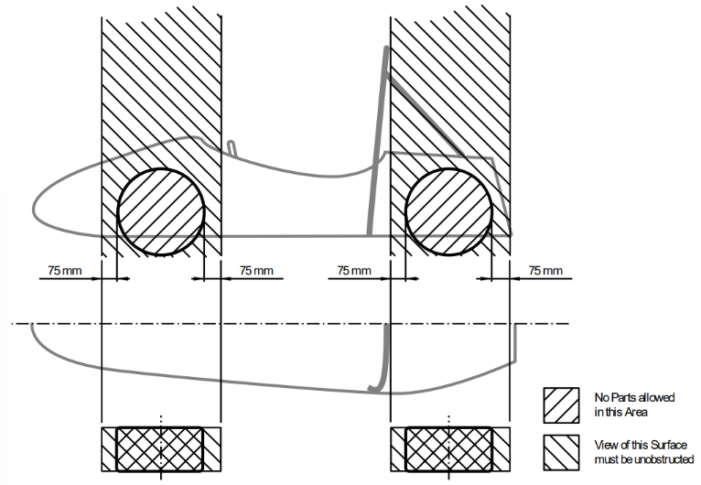

Figure 1: Open Wheel Requirements

The vehicle must have a minimum wheelbase of 1525 mm, and the track and center of gravity must combine to provide sufficient rollover stability.

The smaller track of the vehicle must be no less than 75% of the larger track.

**Ground Clearance**

Ground clearance must be sufficient to prevent any portion of the vehicle except the tires from touching the ground during dynamic events.

The distance to the ground below the Lower Side Impact Structure at its lowest point must be 90 mm or less. The distance to the ground should be 75 mm or less. There must also be an opening for measuring the ride height at that point without removing aerodynamic devices.

Intentional or excessive ground contact of any portion of the vehicle other than the tires will forfeit a run or event.

**Driver**

The vehicle must be able to accommodate drivers of sizes ranging from 5th percentile female to 95th percentile male.

The driver's head and hands must not contact the ground in any rollover attitude.

The driver must have sufficient visibility to the front and sides of the vehicle.

In a normal seating position, the driver must have a minimum field of vision of 100 degrees to the left and right sides.

**Chassis**

The fabricated structural assembly that supports all functional vehicle systems. This assembly may be a single fabricated structure, multiple fabricated structures or a combination of composite and welded structures.

The minimum radius of any bend, measured at the tube centerline, must be three or more times the tube outside diameter.

**Frame members**

A minimum representative single piece of uncut, continuous tubing.

**Monocoque**

A type of chassis where loads are supported by external panels.

**Main hoop**

A roll bar located alongside or immediately aft of the driver’s torso.

**Front hoop**

A roll bar located above the driver’s legs, in proximity to the steering wheel.

**Roll hoop**

Referring to the front hoop and the main hoop.

**Roll hoop bracing supports**

The structure from the lower end of the roll hoop bracing back to the roll hoop(s).

**Front bulkhead**

A planar structure that provides protection for the driver’s feet.

**Impact Attenuator**

A deformable, energy absorbing device located forward of the front bulkhead.

**Primary Structure**

The combination of these components:

1. Front bulkhead and front bulkhead support
2. Front hoop, main hoop, roll hoop braces and supports
3. Side impact structure
4. Any frame members, guides, or supports that transfer load from the driver restraint system

**Primary structure envelope**

A volume enclosed by multiple tangent planes, each of which follows the exact outline of the primary structure frame members.

**Major Structure**

The portion of the chassis that lies inside the primary structure envelope, excluding the main hoop bracing and the portion of the main hoop above a horizontal plane located at the top of the upper side impact member or top of the side impact zone.

**Rollover protection envelope**

The primary structure plus a plane from the top of the main hoop to the top of the front hoop, plus a plane from the top of the main hoop to the rearmost triangulated structural tube, or monocoque equivalent.

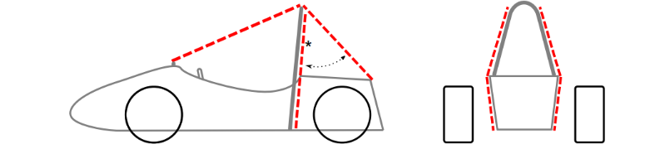

Figure 2: Rollover Protection Envelope

**Tire surface envelope**

The volume enclosed by tangent lines between the main hoop and the outside edge of each of the four tires.

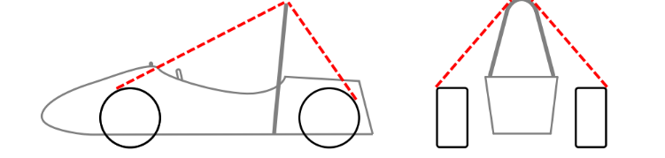

Figure 3: Tire Surface Envelope

**Component envelope**

The area that is inside a plane from the top of the main hoop to the top of the front bulkhead, plus a plane from the top of the main hoop to the rearmost triangulated structural tube, or monocoque equivalent.

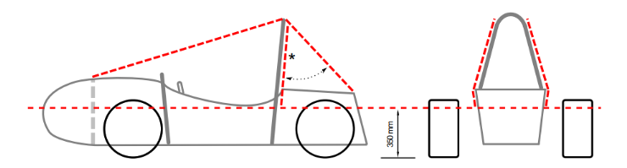

Figure 4: Component Envelope

**Buckling modulus**

Equal to E*I, where E = modulus of elasticity and I = area moment of inertia about the weakest axis.

**Triangulation**

An arrangement of frame members where all members and segments of members between bends or nodes with structural tubes form a structure composed entirely of triangles.

1. This is generally required between an upper member and a lower member; each may have multiple segments requiring a diagonal to form multiple triangles.
2. This is also what is meant by “properly triangulated”



Figure 5: Triangulation Requirement

## House of Quality (HoQ)

The house of quality QFD can be found in Appendix (Letter). Since our customer requirements are pulled from the rule book, the engineering requirements correlate with the customer requirements, meaning the customer requirements must be met to pass technical inspection. The engineering requirements describes how to customer requirements will be fulfilled. Due to the nature of passing technical inspection the customer requirements were all weighted with 5, the highest possible. When looking at the engineering requirements a majority of them are in regard to the main hoop. This result makes sense since the main hoop provides the highest level of protection for the driver if a roll over occurs. The chassis must meet tangible and important requirements in order to pass technical inspection, meaning all the customer and engineering requirements must be met to pass. Having a ranking system of importance regarding the chassis is unnecessary. To be repetitive and assertive in this statement, all requirements must be met.

# Research Within Your Design Space

## Benchmarking (Everyone)

### Benchmarking – Side Impact Structure (Ryan Meger)

Conducting research on universities Formula teams, University of Arkansas had an extensive review of seven different iterations. The first iteration had SIS tubes running backwards up towards the main hoop, providing support for the main hoop. It did leave a large amount of area towards the front hoop that could be dangerous in a collision. Iteration 2 added more SIS structure to deal with that concern and increased torsional rigidity by 58%. Farther down the iterations, iteration 6, they reduced the size of the top SIS tube, to reduce weight. Their final iteration surpassed their goal of 1750 ft-lb/deg(2372.7 Nm/deg) by 13ft-lb/deg.

Figure 6: University of Arkansas V.1

Figure 7: University of Arkansas V.2

Figure 8: University of Arkansas V.3

The next source is from the University of Bhopal, India. Their frame design took an unorthodox approach by adding structural side pods. This increased torsional rigidity and protection from side impacts. The structural side pods were highly effective at protecting the driver in their analysis but added a large amount of weight to the chassis.

Figure 9: University of Bhopal Chassis Design

Figure 10 7: University of Bhopal SIS Analysis

The last source is from the University of Charotar. Choosing a highly triangulated and complex SIS design. Resulting in a max displacement of 11.7mm. This design results in protecting the driver, but at the cost of more weight and complexity. Other designs have shown that complexity isn’t always the right decision.

Figure 118: University of Charotar Chassis Design

Figure 129: University of Charotar SIS Analysis

### Benchmarking – Front, rear and main hoop concepts (Brandon Guzman)

While conducting research and benchmarking with other Universities formula teams State of the art (SOTA) designs, the team was able to narrow down our own design concepts to the one that best meets the present and other sub team deliverables. A few goals from the chassis specific sub team are regarding larger front hoops, more room in cockpit/pedal box, and proper triangulation. In addition, NAU’s previous FSAE team from the 2024 competition did not get the opportunity to include an aerodynamics aspect to their vehicle design, this year it is one of our sub teams goals to also create a design that could incorporate this feature to allow for more downforce and less drag on the vehicle. In this section of the report, a brief description of 3 SOTA chassis designs from other universities followed by the team’s final selected design that will later be used in section 4.4 as the datum for the Pugh chart regarding concept selection.

Figure 13: San Diego state Chassis

In Figure 13 above, this is the chassis design from San Diego state during the 2010 FSAE competition. Although an older design it still performed admirably enough to be show cased at SolidWorks world. This is due to its robust design from being properly triangulated, the large front hoop with extra pedal box room, and cockpit space Which is why this design was selected for one of SOTA designs to benchmark the teams designs with.

Figure 14: University of Delaware chassis design

This figure above showcases the university of Delawares chassis design from the 2017 FSAE competition. Their design includes a very large cockpit and front hoop, giving the driver lots of space. It is more of a stalky design but because they were a top performing school it is interesting to compare a variety of designs to see what does well and what doesn’t which is why this design was selected as a SOTA design.

Figure 15: Purdue University chassis design

In figure 15 above, this was Purdue university’s chassis design from the 2020 FSAE competition. This chassis design scored 2nd place in the knowledge event competition of the entire event, and was the best design score a team has scored in the University’s history of competing in this competition. It is important to note this design also has a large front hoop and lots of space in the cockpit. For those reasons, this design was selected as the last SOTA design to be benchmarked with the team’s designs.

Figure 16: Final design for FSAE 2025 Car

Lastly, Figure 16 is a picture of the final selected CAD design for the 2025 car. In this final design, the team increased the height of the front hoop, made the rear suspension box smaller, and increased the width of the cockpit. The front hoop size was one of the most notable changes for the design, this was done for safely in case of the event of a roll over and to implement more aerodynamic designs to the car. It is also important to note that the other designs chosen as the teams SOTA designs also incorporate a large front hoop. More description as to why this design was selected will be further described in section 4.3, section 4.3 and section 4.4 further down in this design report.

## Literature Review (Everyone)

### Alexandra Brister – Seat Belt System

[1a] Bruno Muss. "Crash test numerical analysis of a Formula SAE vehicle," YouTube, 1/17/2018. <https://www.youtube.com/watch?v=c8k9Idy5kwk>

This video shows an impact simulation of a Formula SAE vehicle using LS-Dyna software. It shows a visual and computational insight into the safety systems and how they behave during a crash. It relates to the project because it allows for the team to observe how the seat belt systems behave under a simulated crash; this offers data for comparison with theoretical models which helps validates the design choices for the seat belt stress analysis.

[2a] C. D. Carter, C. B. Sherman, and R. D. Matthews, “Design of a Formula SAE race car: Vehicle Dynamics and Performance,” SAE Technical Paper Series, Feb. 1982. doi:10.4271/821092 Aerodynamics

This discusses the dynamics of the vehicle and the aspects of performance for a Formula SAE standard. This discusses how the forces are transmitted through the vehicle; it is important to understand how the seat belt system reacts during impacts or maneuvers of the vehicle. This paper shows how to apply Newton’s laws in real world examples, it provides case studies show how to optimize the performance of seat belt systems with different conditions.

[3a] C. Itu, A. Toderita, L.-V. Melnic, and S. Vlase, “Effects of seat belts and shock absorbers on the safety of racing car drivers,” Mathematics, vol. 10, no. 19, p. 3593, Oct. 2022. doi:10.3390/math10193593

This paper explains how the driver's safety is impacted by the seat belt systems in various scenarios. This is useful for the mathematical modeling for calculating the stress of the seat belt system under impact conditions and use this information to assess the safety and design for the application.

[4a] The, Dynamics: Force and Newton’s Laws of Motion. 2019 (Chapter 4).

This chapter covers Newton’s Second Law of Motion, it focuses on the relationship between acceleration, force, and mass. Using the Newton laws to analyze the forces acting on the seat belt systems during impact. This creates a foundation for calculating the crash forces to understand the dynamics that act on the driver during an impact.

[5a] K. Baszczyński and M. Jachowicz, “The Effect of the Use of Full Body Harnesses on Their Protective Properties,” International Journal of Occupational Safety and Ergonomics, vol. 15, no. 4, pp. 435–446, Jan. 2009, doi: <https://doi.org/10.1080/10803548.2009.11076823>.

This provides insight into understanding the long-term effectiveness of racing harness systems, it expresses the importance of periodic maintenance for the protective features. It aids in considering the durability and the shelf life of the seat belt product, this ensures that it remains effective over time, specifically in racing environments.

[6a] R. G. Budynas, J. K. Nisbett, and J. E. Shigley, Shigley’s mechanical engineering design. New York, NY: McGraw-Hill Education, 2020. Chapter 3

This provides information for a foundation on the behaviors of materials under stress and how the forces are distributed across the system. It discusses the force distribution in a 6-point harness system, this explains how the lap, submarine, and shoulder belts share the forces from impact. This forms a basis for understanding stress analysis on the seat belt systems. This ensures uniform force distribution across the system to increase safety.

[7a] “SAE standards for Mobility Knowledge and Solutions,” SAE International, https://www.sae.org/standards?utm_source=google&utm_medium=ppc&utm_campaign=LVL_SAE_SCH_GSE_NTN_GPM_B2C_Standards&utm_content=Standards&utm_term=B2C&utm_device=c&utm_keymatch=p&utm_adposition=&gad_source=1&gclid=CjwKCAjw0aS3BhA3EiwAKaD2ZSgsuuN9rfyeBQE_uWePei2JlxfRiqc2r97IeRPudAJ_66PtXDuT6xoC7T4QAvD_BwE (accessed Sep. 17, 2024).

This website outlines the standards for vehicle safety and efficiency. This provides essential information on the safety requirements specific to the seat belt harness. This further benchmarks for safety for the system.

### Ryan Meger – Torsional Stiffness

For my portion of the literature review, I researched how the chassis will react to torsional forces when cornering. I first looked at a well-known vehicle dynamics textbook*, Race Car Vehicle Dynamics Milliken Milliken* [1r]. This familiarized me with chassis stiffness, impact on handling and the dynamics associated, optimization, and driver feedback. Next, I needed to know the required equations and calculations to find the torsional rigidity, which was found using a combination of *Analysis of Torsional Stiffness of the Frame of a Formula Student Vehicle* [2r] and *Formula SAE Chassis System* [3r]. Both sources helped me develop method to analyze a chassis for its torsional rigidity. To test torsional rigidity, SolidWorks’ simulation tool was chosen for its available resources and ability to test different designs efficiently. I learned how to use the simulation tool by watching *SolidWorks Simulation By Mahtabalam* [4r] and *SolidWorks FSAE & Formula Student Tutorials* [5r]. The simulation tool is only as good as how you know how to use it. Studying on how to use the simulation tool was paramount to having correct results. Sources: *ANALYSIS OF FSAE CHASSIS* [6r], *MEEG 402-010 Chassis Design Report* [7r], and *Modeling of a chassis for an SAE formula car* [8r] for a larger selection of frame types to compare to each other for our team’s chassis design.

### Gustavo Ruiz – Chassis Frame Design

[1g] "Design and Analysis of FSAE Chassis for Safe Conditions" (Paper)​

Helpful design parameters and calculations to run our design through, as well as finding vertical center of gravity methods.​

[2g] "FEA Analysis of FSAE Chassis" (Paper)​

Main goal highlighted were to decrease weight and increase torsional rigidity, helpful ANSYS simulation of stresses and torsion.​

[3g] "The Science of Vehicle Dynamics", Chapter 3 "Vehicle Model for Handling" (Book)​

Great explanation on aerodynamics in a Formula car, and goes more in depth on front and rear vertical forces​

[4g] "Fundamentals of Aerodynamics", Chapter 19 "Turbulent Boundary Layers" (Book)​

Helpful way to create turbulent modeling and find characteristics of a turbulent flow.​

[5g] "Renewable Energy Vehicle Project: Pedal Box Design for Formula SAE" (Paper)​

Future Work ideas from pedal box are to decrease weight and use an angle-mounted cylinder to decrease pedal box length, like our goal. ​

[6g] "Formula SAE Rules 2025", F- Chassis and Structural (Standard)​

[7g] M. L. Mohamad *et al.*, “Design and static structural analysis of a race car chassis for Formula Society of Automotive Engineers (FSAE) event,” *Journal of Physics: Conference Series*, vol. 908, p. 012042, Oct. 2017. doi:10.1088/1742-6596/908/1/012042

Main design constraints and regulations that are frame needs to abide by. Helpful templates to ensure ergonomics of vehicle and as well as its functionality.

### Brandon Guzman Benchmarking and Bending(b)

[1b] M. Planchard, “San Diego state university formula SAE team showcased at Solidworks World,” SOLIDWORKS Education Blog, <https://blogs.solidworks.com/teacher/2014/01/san-diego-state-university-formula-sae-team-showcased-at-solidworks-world.html>

Source 1b is a blog from SolidWorks showcasing the sand Diego state chassis that was very helpful for benchmarking designs for the chassis. This aided in the selection process of our own designs.

[2b] C. Dodd, N. Geneva, P. Geneva, and C. Morris, Dr. Steven Timmins , rep., 2017 ​

Source 2b is the final report from the university of Delaware on their chassis design for the 2017 competition. This source was full of a lot of insight on designing and modeling the chassis as well as bending and welding it together.

[3b] “Purdue Formula SAE scores 2nd place; Best Design Score in their history,” Mechanical Engineering - Purdue University, <https://engineering.purdue.edu/ME/News/2021/purdue-formula-sae-scores-2nd-place-best-presentation-score-in-their-history->

This source is from Purdue university showcasing their best design score in their history at the competition, this document was full of helpful insight and was also a main source for benchmarking.

[4b] William F Milliken and Douglas L Milliken. Race car vehicle dynamics. Vol. 400. Society of Automotive Engineers Warrendale, 1995​

Source 4b is a book the whole team is utilizing for the design process of the chassis, this book is full of useful equations regarding analysis of acceleration weight transfer, stiffness, and force impact.

[5b] Martin Meywerk. Vehicle Dynamics. John Wiley & Sons, 2015​

This is another useful book full equations for weight transfer and forces on the vehicle.

[6b] “The construction Process: Pipe and Tube bending,” https://www.herl.pitt.edu/indiachair/indiachairsh/cl_bend.html#:~:text=Rule%20for%2090%20degree%20and%20180%20degree%20Bends&text=180%20degree%20bends%3A%20Multiply%20the,length%20of%20the%20curved%20section.

Source 6b is a website that is dedicated to tube bending, this will be utilized during the beginning manufacturing processes of the car to ensure tube will not need to be remade.

[7b] “Mastering small tube bends,” YouTube, https://youtu.be/MymUqxuCKv4?si=pWnrkCMSN0BtZO4K

Source 7b is a YouTube video that goes over pipe bending basics, this is another source that will be useful for the manufacturing process of the final chassis design.

[8b] “TFS: Tube Bending Basics 1 - What You Need to Know,” YouTube, https://youtu.be/3n_lf2RHIPs?si=NaGZuH7i3eOT0MqW

This last source is another YouTube video that goes over roll cage designs, as well as how to effectively bend using centerline radius of tubes. This will also be useful during the manufacturing process of the cars design.

# 3.2.5 Carson Kent Aerodynamic Design

[1c] "Aerodynamics Analysis of a Formula SAE car" (Paper)

Helped in giving an overview of all components studied when designing aerodynamics

[2c] "Aerodynamics of Road Vehicles, 5th edition" (Book)

Gives tons of information about production passenger cars and other various road vehicles

[3c] "Aerodynamic Study of Formula SAE car" (Paper)

Gives great insight into design of previous SAE cars and good practices

[4c] "NACA 4-digit airfoil generator" (standard)

Helped me pick out which airfoil geometry will be best for this application.

[5c] "Introduction to Aircraft Airfoil Aerodynamics" (paper)

It gave me a broader understanding of airfoils outside of car aerodynamics.

[6c] "How an Airfoil Works – MIT" (website)

Showed some great methods for characterizing an airfoil for different applications.

[7c] "Theory of Airfoil Lift Aerodynamics" (book chapter)

Helped give an overall grasp of how airfoils are generally used

## Mathematical Modeling (Everyone)

### Seatbelt Stress and Safety for 6-point – Alexandra Brister

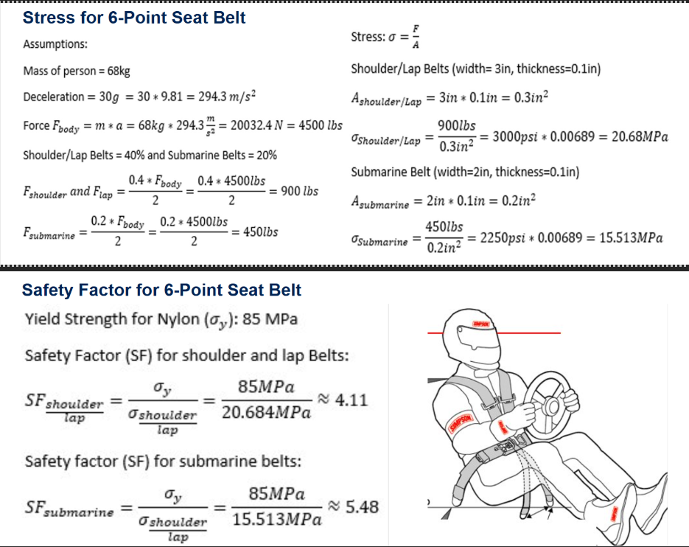

Figure 17: Stress and FOS for 6-Point Seat Belt

The mathematical modeling analyzes the stress and safety factor of a 6-point seat belt system. The analysis starts with basic assumptions, this includes a person's mass, deceleration of 30g, which shows 30 times that gravitational acceleration. The total force acting on the body is calculated based on the parameters which is about 20034N or about 4500lbs. This force is then distributed between the different straps of the seat belt system. The shoulder and the lap belts bear 40% of the total force and the submarine belts bear about 20% of the total force. Using these forces calculated for each belt, the stress can be determined by the force divided by the cross-sectional area of the belt. The cross-sectional areas of the shoulder and lap belts is 0.3in2the calculated stress is about 20.68MPa. For the submarine belts the cross-sectional area is 0.2 in2the stress is about 15.51 MPa. The factor of safety (SF) for the 6-point seat belt is determined using the yield strength of Nylon (85 MPa). The safety factor is calculated by dividing the yield strength of the belt by the stress of the belt. The safety factor (SF) for the shoulder/lap is about 4.11 which means that the material is over four times stronger than the stress applied to the belts. For the submarine belts the safety factor is about 5.48 which shows a great margin of safety. These calculations show that the 6-point belt system is within the safe limits, indicating that it will not fail under high impact forces.

### Finite Element Analysis (FEA) of the Chassis – Ryan Meger

#### Torsional Analysis

Torsional stiffness of a race car is important for a race car because it improves handling, weight transfer, suspension optimization, and consistent aerodynamics performance. Making this analysis have meaningful impact on the performance of the car. An ideal stiffness the team has chosen is high, at 2400 Nm/deg. The equations below explain how I tested and calculated the theoretical torsional stiffness.

$C_{T}=\frac{T}{α}$ [1]

The variable T is the applied Torque in Nm. This value is calculated using equations [3] and [4]. Alpha is the angular deflection in degrees using equation [2], and $C_{T}$ is the torsional stiffness in Nm/deg.

Figure 18: Deformation Triangle

[2]

[3]

[4]

The part of the frame that will be analyzed for displacement is the front hoop, where a most of the torsional forces will be acting upon when driving. The figure below gives a representation of how a real-life experiment would gather displacement data, instead it will be conducted in solid works using the displacement plot in SolidWorks simulation tool. The mass of the car was estimated to be 250kg and a lateral acceleration of 2 Gs. Displaced along 4 points on the front suspension box, giving an applied force of 1103N.

Using the max displacement on the front hoop, at 3.586x10-3 meters, a theoretical Torsional rigidity of 1932.7 Nm/deg. This does not meet our goal of 2400 Nm/deg but is high enough to be competitive.

Figure 19: Displacement Plot

#### Front and Side Impact Analysis

The forces in the next two analyses were calculated using the following equations:

$p=mass ×velocity$ [5]

$F= \frac{p}{time} [N]$ [6]

The mass is 250kg and velocity was estimated to be 70 mph. The impact time was set at 0.25 seconds. Resulting in a force of 31,300 N.

Figure 20: Top View of SIS Impact Stress Plot

Figure 21: Side View of Front Impact Stress Plot

#### Bending mathematical modeling – Brandon Guzman

This section of this report will cover the bending calculations and analysis for the beginning manufacturing process of the front and main hoops for the final designs. The calculations used are simple but will aid in ensuring the lengths of bending won’t be to short and too long. Accuracy here is important because of material cost and time, mistakes could cost money and take away time meant to be spent on other parts of this project. The figure below is the drawing of the front hoop, and the angles used for the calculations described further below.

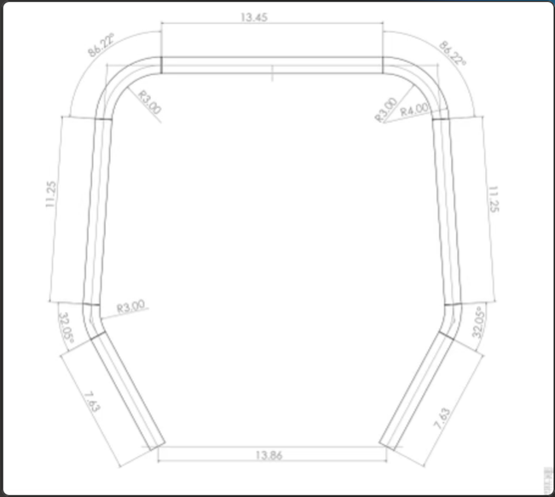

Figure 22: Drawing of front hoop

The calculations used were found from a website about tube bending [6b], which utilizes a bending constant that allows for users to find the total length of the tube using simple calculations. The constant is equal to 0.01745.

$Length=r ×angle × const$ [7]

Equation 7 will be utilized for both angled parts of the front hoop drawing. The first angle is 32.05 degrees which is a smaller section and using equation 7 the length was found to be around 1.7 inches but was rounded up to 2 inches to be safe during manufacturing. The length of the bigger angle which was around 85.76 degrees was found to be around 4.5 inches but was rounded up to 5 to be safe. The reason these angles were increased so much was to make sure even if the team uses too much tube, we can still cut off excess to be safe. After these calculations were done the total length of tube was calculated to be around 68 inches in total for the front hoop. The figures below show the manufacturing process for the front hoop and main hoop, which follows the same process described above.

Figure 23: Front hoop over drawing

Figure 24: Offset of bending chuck

It is important to also note that every bending chuck has an offset from when the true bend starts, figure 24 demonstrates the offset by showing where the bend starts from the marks made. The offset is around a half an inch, so wherever there was a bend, the team measured half an inch from the marking and placed an arrow in front of it, the arrow represents how far the tube will be placed in the chuck. This was not added to the calculations but was used during the manufacturing process. The same process was followed for the main hoop, which is shown in figure 25 below.

Figure 25: Main hoop over drawing

#### Preliminary Aerodynamics Mathematical Modeling – Carson Kent

Aerodynamic calculations were performed on the chosen airfoil geometry using the Vortex Panel Method, to find coefficient of lift and drag. Results prove there are high pressure zones at the front of the airfoil which produce the lift and drag when in fluid flow. Negative lift values show the amount of downforce and after tests at –30 degrees for angle of attach, there is a lift coefficient of around –3 which proves these airfoils will be capable of producing significant downforce.

*Figure 26: Pressure plot for –30 degrees angle of attack*



*Figure 27: Lift and drag for –30 degrees angle of attack*

# Design Concepts

## Functional Decomposition (Ryan Meger)

The main concept that the chassis must accomplish while driving, is to be stiff under any loads it receives. Inputs on the chassis are from the suspension, driver, and road. All of which test the chassis’ ability to resist torsional forces.

Figure 28: Chassis Black Box Model

Next is the functional model for the chassis. It’s end goal is the same as the black box, which is that chassis remains rigid. This model dives deeper into the interactions with the chassis and the associated outputs and system behavior.

Figure 29: Functional Decomposition for Chassis

The physical decomposition consists of all the components that are connected to the chassis. All need to be considered in order for the sub-teams to successfully integrate their designs onto the chassis. Keeping track of all the components helps with organization and not forgetting what is needed.

Figure 30: Physical Decomposition of Chassis

## Concept Generation (Everyone)

### Chassis Generation Ryan Meger & Gustavo Ruiz

Table 1: Frame Design Concept Generation

|  |  |  |  |  |
| --- | --- | --- | --- | --- |
| **Criterion** | Design 1 (Final) | Design 2 | Design 3 | Design 4 |
| Torsional Rigidity | 4 | 5 | 4 | 4 |
| Cost | 4 | 2 | 4 | 4 |
| Weight (lbs.) | 4 | 1 | 3 | 4 |
| Manufacturability | 4 | 2 | 3 | 3 |
| Safety | 4 | 5 | 4 | 4 |
| Total | 20 | 15 | 18 | 19 |

The concept generation for the chassis was kept simplistic to encourage specialized designs for the specific sections of the chassis design. The first design is our final design, having the third best torsional rigidity, which can be referenced in Table 4. It also is the second lightest, meaning it is cheaper and will perform better than the heavier frames. Design 2 wanted to incorporate more triangulation to increase torsional rigidity. It did by 15%, but at the cost of increases the weight by almost 12%. The weight increase did not justify the increased stiffness of the chassis, since our designs is stiff enough to be competitive. Design 3 aimed to change the design of the front hoop, allowing for more cockpit gauges and leg room to be possible. It did however make the front hoop more complex to manufacture and increased it weight. The last design aimed to making the main hoop less dramatic in its top bend. This would allow for better integration with attachments for aerodynamics. The bend would consist of two smaller bends, to make a flatter top surface to attach the aerodynamics to. Its design is great but would make manufacturing difficult and might not even be used if we don’t implement large rear wing.

### Seat Belt Systems – Alexandra Brister

Table 2. Seat-Belt Systems Concept Generation

|  |  |  |  |
| --- | --- | --- | --- |
| Criterion  Scale 1 to 5 | Design 1: 5-point | Design 2: 6-point | Design 3: 7-point |
| Cost:  1 being the most expensive  5 being affordable | 5 | 4 | 1 |
| Force Distribution:  1 very poor force distribution, with significant pressure on small areas  5 Force distribution across the body, minimizing the pressure points | 3 | 4 | 5 |
| Comfort:  1 Uncomfortable, causes pain and discomfort  5 Very Comfortable, can wear belt for long periods | 2 | 4 | 3 |
| Durability:  1 very low durability, wears out quickly  5 the system is built to withstand wear and tear | 4 | 5 | 5 |
| Safety:  1 Poor protection, high risk during impacts  5 Excellent protection, low risk during impacts | 3 | 5 | 5 |
| Total: | 17 | 22 | 19 |

Based on the concept generation table, the 6-point seat belt system is the best choice, it offers balance of comfort, cost, and safety. While the 7-point seat belt systems would provide better protection, the cost is extremely high and due to the complexity, it ranks lower than the 6-point system.

Table 3: Nose Cone Designs

|  |  |  |  |
| --- | --- | --- | --- |
| Criterion  Scale 1-5 | Design 1: | Design 2: | Design 3:  U,{62004a69-241f-4e8f-972d-28cba34b15f7}{176},2.9375,1.7653245192307692 |
| Driver Visibility | 4 | 5 | 3 |
| Performance | 4 | 4 | 3 |
| Removability | 5 | 3 | 5 |
| Applicability | 4 | 3 | 4 |
| Total: | 17 | 15 | 15 |

Design 1 is the best design thus far however there have not been any full simulations done on these designs. Ansys Fluent will be used in the near future to better rank these designs and choose the best one to move forward with.

## Selection Criteria

### Chassis Selection Criteria – Gustavo Ruiz

The selection of the final chassis frame design was based on five primary engineering criteria: torsional rigidity, cost, weight, manufacturability, and safety. Each criterion is rooted in the engineering requirements of the chassis and can be quantified through calculations and well-established specifications.

Torsional rigidity is a critical parameter for the chassis frame as it directly affects the vehicle’s handling and overall structural stability under dynamic loading conditions. The torsional rigidity of each frame design was found by using SolidWorks Simulation for stress and torsional rigidity. A summary of the torsional stiffness values for the evaluated designs is presented in Table 4.

Table 4: Design Torsional Rigidity

|  |  |
| --- | --- |
| **Design Option** | **Torsional Stiffness (Nm/°)** |
| Design 1 | 2009.25 |
| Design 2 | 2321.7 |
| Design 3 | 2091.05 |
| Design 4 | 1948.27 |

The cost analysis focused solely on the material cost. For the materials, we obtained quotes from Industrial Metal Supply and Online Metals for the steel tubing used in the designs. The manufacturing cost was estimated based on the complexity of the frame constructing, including the number of welds, joints, structural members with respective cuts, and specialized process required such as tube bending. Based on the frame design concept generation showed earlier in table 1 our final design which is design 1, design 3, and design 4 have a really similar amount if each sized tube; 17 feet of Size A tube at $8.85 per foot totaling to $150.45, 37 feet of Size B tube at $9.80 per foot totaling to $363.00, and 46 feet of Size C tube at $10.11 per foot totaling to $465.06. Our design 2 received the lowest score for cost due to more structural members, where it has 8 feet more of size B tubing and 5 feet more of size C tubing, totaling to a total of around $125.00 more, and we also need to consider purchasing for safety stock in case of any mistakes or variability in usage.

The weight of the chassis is a key factor in the overall performance of the vehicle, particularly in terms of acceleration, braking, and fuel efficiency. The total mass of each chassis design was found from SolidWorks “Mass Properties” tool, after setting the frame material to AISI 4130 steel annealed at 865°C. The lighter the frame, the better the vehicle performance would be, as long as the design still met safety requirements. Table 5 below shows the weight for each design.

Table 5: Design Total Weight

|  |  |
| --- | --- |
| **Design Option** | **Weight (lbs.)** |
| Design 1 | 62.72 |
| Design 2 | 69.97 |
| Design 3 | 63.01 |
| Design 4 | 62.67 |

Manufacturability was evaluated based on the complexity of the design and the ease with which it could be fabricated using available tools and processes. This including assessing the number of welds, the complexity and amount of tube notching and tube bends. Designs that required more complex jig setups and specialized tube bending were deemed less favorable. Design 2 had more structural support members so that meant more difficult to reach welds, and more tube notching so it received the lowest score. Designs 3 and 4 had one to two more bends so the bending of the those would require more time in the machine shop compared to design 1, which only had seven total bends.

Safety is a paramount and was evaluated based on the ability of each design to protect the driver in the event of the crash, our reengineering requirements are all from the FSAE rulebook. This includes compliance with FSAE safety rules and regulations, as well as the frame’s overall structural integrity. Stress analysis simulations were performed to assess the energy absorption capabilities and determine the likelihood of failure under front and side impact conditions.

## Concept Selection

### Concept Selection for Chassis Design (Ryan Meger)

|  |  |  |  |  |  |
| --- | --- | --- | --- | --- | --- |
|  | Weight (1-5) | Design 1(datum) | Design 2 | Design 3 | Design 4 |
| Torsional Rigidity | 4 | + | ++ | 0 | 0 |
| Cost | 3 | + | - | + | 0 |
| Weight | 4 | + | - | 0 | 0 |
| Manufacturability | 4 | 0 | - | - | 0 |
| Safety | 5 | 0 | + | - | + |
| Total |  | +3 | 0 | -1 | +1 |

# CONCLUSIONS

This report covers the comprehensive design and building process for our Formula SAE chassis as part of the 2025 Formula SAE competition. The project, as outlined by SAE International, challenges university teams to design, build, and compete with formula-style vehicles. For our second year in the competition, the goal is to improve upon the previous year’s performance and address any issues encountered during design, manufacturing, and testing phases. Critical project requirements include ensuring safety, optimizing torsional rigidity, minimizing weight, and maintaining cost-effectiveness while complying with Formula SAE rules. Additionally, the project offers students hands-on experience in engineering design, manufacturing, and teamwork, contributing to their professional development.

This report includes the key stages of the engineering design process: customer and engineering requirements, house of quality, benchmarking, literature review, mathematical modeling, functional decomposition, concept generation, selection criteria, and final concept selection. The final solution for the chassis was selected based on its ability to meet the critical requirements of torsional rigidity, safety, manufacturability, and ergonomics, while staying within our budget of $6,058.24. Detailed analysis was done to ensure that the final chassis design would optimize performance with these constraints. To help reduce overall costs, the chassis team plans to secure a sponsorship from Nova Kinetics for aerodynamic components, starting with the front nose cone.

The final chassis design meets the key engineering requirements, and the team is moving forward with manufacturing and fundraising to support the completion of the vehicle. These steps guarantee the project remains on track, creating a solid foundation for this year’s competition and future team success.

# REFERENCES

## Alexandra Brister

[1a] Bruno Muss. "Crash test numerical analysis of a Formula SAE vehicle," YouTube, 1/17/2018. <https://www.youtube.com/watch?v=c8k9Idy5kwk>

[2a] C. D. Carter, C. B. Sherman, and R. D. Matthews, “Design of a Formula SAE race car: Vehicle Dynamics and Performance,” SAE Technical Paper Series, Feb. 1982. doi:10.4271/821092 Aerodynamics

[3a] C. Itu, A. Toderita, L.-V. Melnic, and S. Vlase, “Effects of seat belts and shock absorbers on the safety of racing car drivers,” Mathematics, vol. 10, no. 19, p. 3593, Oct. 2022. doi:10.3390/math10193593

[4a] The, Dynamics: Force and Newton’s Laws of Motion. 2019 (Chapter 4).

[5a] K. Baszczyński and M. Jachowicz, “The Effect of the Use of Full Body Harnesses on Their Protective Properties,” International Journal of Occupational Safety and Ergonomics, vol. 15, no. 4, pp. 435–446, Jan. 2009, doi: <https://doi.org/10.1080/10803548.2009.11076823>.

[6a] R. G. Budynas, J. K. Nisbett, and J. E. Shigley, Shigley’s mechanical engineering design. New York, NY: McGraw-Hill Education, 2020. Chapter 3

[7a] “SAE standards for Mobility Knowledge and Solutions,” SAE International, https://www.sae.org/standards?utm_source=google&utm_medium=ppc&utm_campaign=LVL_SAE_SCH_GSE_NTN_GPM_B2C_Standards&utm_content=Standards&utm_term=B2C&utm_device=c&utm_keymatch=p&utm_adposition=&gad_source=1&gclid=CjwKCAjw0aS3BhA3EiwAKaD2ZSgsuuN9rfyeBQE_uWePei2JlxfRiqc2r97IeRPudAJ_66PtXDuT6xoC7T4QAvD_BwE (accessed Sep. 17, 2024).

## Ryan Meger

[1r] A. Castrillion, G. Contreras, and A. Martinez, Modeling of a chassis for an SAE formula car, http://www.irphouse.com/ijert21/ijertv14n10_10.pdf (accessed Oct. 21, 2024).

[2r] SolidWorks, “SolidWorks FSAE & Formula Student Tutorials,” YouTube, https://www.youtube.com/playlist?list=PL38088C14E31FAF31 (accessed Oct. 20, 2024).

[3r] C. Dodd, C. Morris, P. Geneva, and N. Geneva, Meeg 402-010 chassis design report 2017 FSAE SENIOR ..., https://udel.edu/~pgeneva/downloads/fsae/2017_FSAE_chassis.pdf (accessed Oct. 21, 2024).

[4r] N. Vishal and S. Aditya, Analysis of FSAE chassis - IJSER, https://www.ijser.org/researchpaper/ANALYSIS-OF-FSAE-CHASSIS.pdf (accessed Oct. 21, 2024).

[5r] CAD CAM tutorial by Mahtabalam, “Solidworks simulation,” YouTube, https://www.youtube.com/playlist?list=PLRhna5_X7uWt2LF-ZiuXFt5jrubF32C94 (accessed Oct. 20, 2024).

[6r] V. Chikkali and R. Patil, FEA analysis of FSAE chassis, https://www.ijert.org/research/fea-analysis-of-fsae-chassis-IJERTV9IS070148.pdf (accessed Oct. 21, 2024).

[7r] D. Krzikalla, J. Mesicek, J. Petru, A. Sliva, and J. Smiraus, “Analysis of torsional stiffness of the frame of a formula student vehicle,” *Journal of Applied Mechanical Engineering*, vol. 08, no. 01, 2019. doi:10.35248/2168-9873.19.8.315

[8r] W. F. Milliken and D. L. Milliken, *Race Car Vehicle Dynamics William F. Milliken; Douglas L. Milliken*. Warrendale, Pa: Society of Automotive Engineers, 1995.

## Brandon Guzman

[1b] M. Planchard, “San Diego state university formula SAE team showcased at Solidworks World,” SOLIDWORKS Education Blog, <https://blogs.solidworks.com/teacher/2014/01/san-diego-state-university-formula-sae-team-showcased-at-solidworks-world.html>

[2b] C. Dodd, N. Geneva, P. Geneva, and C. Morris, Dr. Steven Timmins , rep., 2017 ​

[3b] “Purdue Formula SAE scores 2nd place; Best Design Score in their history,” Mechanical Engineering - Purdue University, <https://engineering.purdue.edu/ME/News/2021/purdue-formula-sae-scores-2nd-place-best-presentation-score-in-their-history->

[4b] William F Milliken and Douglas L Milliken. Race car vehicle dynamics. Vol. 400. Society of Automotive Engineers Warrendale, 1995​

[5b] Martin Meywerk. Vehicle Dynamics. John Wiley & Sons, 2015​

[6b] “The construction Process: Pipe and Tube bending,” https://www.herl.pitt.edu/indiachair/indiachairsh/cl_bend.html#:~:text=Rule%20for%2090%20degree%20and%20180%20degree%20Bends&text=180%20degree%20bends%3A%20Multiply%20the,length%20of%20the%20curved%20section.

[7b] “Mastering small tube bends,” YouTube, https://youtu.be/MymUqxuCKv4?si=pWnrkCMSN0BtZO4K

[8b] “TFS: Tube Bending Basics 1 - What You Need to Know,” YouTube, https://youtu.be/3n_lf2RHIPs?si=NaGZuH7i3eOT0MqW

## Gustavo Ruiz

## Carson Kent

[1] S. Gupta and K. Saxena, “AERODYNAMICS ANALYSIS OF A FORMULA SAE CAR.” Available: <https://repository.up.ac.za/bitstream/handle/2263/62356/Gupta_Aerodynamics_2017.pdf?sequence=1>

‌ [2] “Aerodynamics of Road Vehicles, Fifth Edition,” *www.sae.org*. <https://www.sae.org/publications/books/content/r-430/>

‌

[3] R. Jing, Kok Wee Chong, C. Chin, and M. R. M. Julaihi, “Aerodynamic optimisation of prototype FSAE vehicle through biomimetic approach,” vol. 72, pp. 2869–2874, Jan. 2023, doi: <https://doi.org/10.1016/j.matpr.2022.07.307>.

[4] Airfoil Tools, “NACA 4 digit airfoil generator (NACA 2412 AIRFOIL),” *Airfoiltools.com*, 2019. <http://airfoiltools.com/airfoil/naca4digit>

[5] A. Wood, “Introduction to Airfoil Aerodynamics | AeroToolbox,” *AeroToolbox*, Jul. 20, 2017. <https://aerotoolbox.com/intro-airfoil-aerodynamics/>

[6] M. Nakamura, “How An Airfoil Works,” *Mit.edu*, 2019. <https://web.mit.edu/2.972/www/reports/airfoil/airfoil.html>

[7] mi508668, “Chapter 5: Theory of Airfoil Lift Aerodynamics,” *pressbooks.online.ucf.edu*, Available: <https://pressbooks.online.ucf.edu/aerodynamicstext/chapter/chapter-5-theory-of-airfoil-aerodynamics/>

‌

# APPENDICES

## Appendix A: FSAE Rules

<https://www.fsaeonline.com/cdsweb/app/NewsItem.aspx?NewsItemID=3c9ca3eb-471e-472f-8453-99b943840ac7>

## Appendix B: House of Quality

