**Hamster Mouse**

**ME486C: Testing Plan**

**Jared Hemauer**

**Rylee Horney**

**Joseph Lopez**

**Keenan Keams**

**Spring 2024 – Fall 2024**

**Project Sponsor: Reza Sharif-Razavian**

**Sponsors Mentor: Terae Jones**

**Instructor: David Willy**

# ***1.0 Introduction***

In this document, the testing plan that the Hamster team will use to determine whether the design requirements of the project have been met is outlined. The thirteen customer requirements and six engineering requirements that both the client and team have identified as beneficial to the project are listed, each accompanied by a brief description of the expectations in detail. From the customer requirements (CRs) and engineering requirements (ERs), an outline of all five tests that the team will perform to assess whether the requirements were met and if the results meet the client’s expectations is provided. The Quality Function Deployment (QFD) is included to visually demonstrate the correlation between the customer’s requirements and the team’s engineering requirements.

# ***2.0 Customer Requirements (CRs)***

Provided is a list of the customer requirements from the initial proposal and feedback from meetings.

**CR 1.** Size – the client wants the device to be small enough that it is portable and can move over the surface of a desk.

**CR 2.** Speed – the device will need to be able to reach a speed of up to 1 m/s in any direction. This is to allow for the device to keep up with a patient’s hand speed.

**CR 3.** Force – must be able to produce a force of up to 10 N to the patient’s hand in any direction or 5 Nm of torque about the vertical axis.

**CR 4.** Internal Friction – when motors are not being used the device must be able to be moved with less than 5N of force.

**CR 5.** Backlash- when motors are off the device must not move more than 0.1mm.

**CR 6.** Run Time – device must run for at least 30 minutes on a single charge.

**CR 7.** Interface: device must be able to receive commands from a computer and send its position back to the computer in (x, y) coordinates.

**CR 8.** Screen – there must be a touch screen that is at least four inches on the device.

**CR 9.** Cost – total production of the device must be <$500.

**CR 10.** Microcontroller – client prefers Raspberry Pi to be used due to faster processing speeds.

**CR 11.** Ease of Use – should not require more than a number for the force being applied and a direction.

**CR 12.** Comfortable – the device should be comfortable in a patient’s hand.

# ***2.1 Engineering Requirements (ERs)***

Below is the list of engineering requirements chosen based on the customer requirements.

**ER 1.** Motor Torque (Nm) – the motor must be able to produce enough torque to output a force of 10N on the patient’s hand.

**ER 2.** Battery Life (kW hr ) – needs to last with three motors and the other electrical components for at least 30 minutes.

**ER 3.** Battery Amperage (A) - need to be able to produce enough current for all components in the robot at least 6 Ah (i.e. three motors, raspberry pi, sensors, motor controller, and screen)

**ER 4.** Size (ft) – less than 1ftx1ftx1ft

**ER 5.** CPU Speed (s) – the microcontroller needs to be able to send commands quickly so there is minimal delay in the movement of the robot. (16 MHz)

**ER 6.** Weight (lb.)- The device should not weigh more than 10 lbs. to allow for the patient to be able to move it easily.

***3.0 Top Level Testing Summary***   
Below are the tests that the team will be performing to meet applicable design requirements for the Hamster project in Table 1.

*Table 1. Test Summary Table*

|  |  |
| --- | --- |
| **Experiment/ Test** | **Relevant Design Requirements** |
| EX 1: Prony Brake | CR 2, CR 3, ER 1 |
| EX 2: Force Output Test | CR 3, CR 4 |
| EX 3: Duration Test | CR 6, ER 2, ER 3 |
| EX 4: Position Test | CR 5, CR 7 |

***4.0 Detailed Testing Plans***

# ***4.1 Prony Brake Test***

# ***4.1.1 Test Summary***

With the Prony Brake test the team will be able to answer the question if the motors that were selected based on calculations can produce the right amount of torque at certain speeds. These force measurements will verify that the robot will be able to output 10N of force against the patient’s hand based on customer requirement three. From our customer’s third requirement this leads back to the team’s first engineering requirement.

To perform this test the team will have to design a Prony brake test rig. An example of this test rig can be seen in Figure 1. For this testing structure the equipment needed is a drum that will fit onto the shaft of the motor, a tachometer, a nylon rope, two hooks that are threaded, two threaded washers, and two scales.

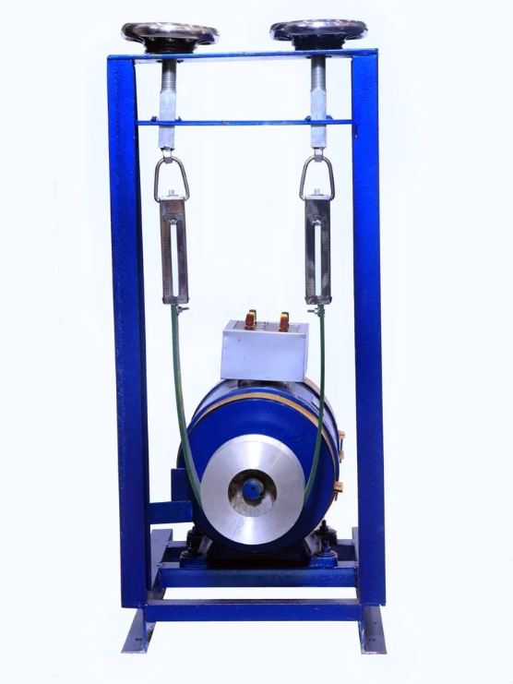

*Figure 1. Prony Brake Example [1]*

While testing the variables that will be isolated are the force measurement from the scales and the RPM of the motors while under load. From the recorded variables then the Torque can be calculated based on the force readings and the radius of the drum. With the RPM of the motor measurement and the torque calculation then the power output of the motor underload can be calculated.

# ***4.1.2 Procedure***

**Step 1.** Setup the testing rig. Place scales on hooks, secure nylon rope to scales, attach the drum to the shaft of the motor, and place motor on stand. As parts of the test rig are being put together verify that none of the parts are damaged.

**Step 2.** Once the motor is placed in the rig, wrap the rope around the motor's drum. Check that the rope is evenly spaced on the drum to prevent twisting on the shaft.

**Step 3.** Turn on the power supply to the motor

**Step 4.** Using the code for the robot, type in the desired RPM and start the motor.

**Step 5.** Once the motor is running using the tachometer record the speed that the shaft is moving without a force applied.

**Step 6.** Begin applying a force to the motor shaft in increments of 2N up to 10N.

**Step 7.** Record each measurement for the force as well as the RPM using the tachometer.

# ***4.1.3 Results***

The expected results from this test will provide the team with a torque vs. speed curve. Due to the motors chosen being patent pending it is critical that the output torque and max power output can be seen in such a curve. Based on prior calculations with the wheels spaced 8 inches apart the result was 0.36 m of torque per motor. Below are the calculations regarding the expected results for this test.

|  |  |  |
| --- | --- | --- |
|  | $$N=\frac{5Nm}{(8in)/39.97\frac{m}{in}}$$ | (1) |

|  |  |  |
| --- | --- | --- |
|  |  | (2) |

|  |  |  |
| --- | --- | --- |
|  |  | (3) |

# ***4.1.4 Conclusion***

Based on the results of the test, if torque reaches the required amount per customer requirement, the team can conclude that the motors were a valid choice in design. By creating the torque speed curve, the team will have more information regarding the efficiency of these motors while being used at various speeds. If the results from the test fall below the engineering requirements, the team will have to notify the client and prepare for possible changes in motor choice.

# ***4.2 Force Output Test***

# ***4.2.1 Test Summary***

Performing the force output test on the robot will verify that the robot can produce an output force of 10 N based on the customer requirements. There will also be confirmation on if by a patient pushing the robot without the motors in use that they will only have to use 5 N of force to move the robot. To perform this test, the equipment needed includes a testing rig and a spring scale. The testing rig will be a box that will have the appropriately sized spring scale attached to it by an eye hook. The variable that will be isolated for measurement in this test is the force that is measured on the scales when the robot is producing various force amounts. No variables will need to be calculated from the results of this test. The results will be numerical values that will show what output force the robot is producing when in use and when being manually pushed.

# ***4.2.2 Procedure***

**Step 1.** Place testing rig on a flat and level surface (Floor or Table)

**Step 2.** In the testing rig verify that the spring is attached to the eye hook. Check scales to see that they are properly functioning, and eye hook is secure to box.

**Step 3.** Place robot inside testing rig and attach the spring to the robot by hooking it to a central location.

**Step 4.** Turn on robot, using the code input 0 N for the force to verify scale is reading properly.

**Step 5.** Increase force by 2 N increments up to 10 N of force. Record the value that the scale is reading at each interval.

**Step 6.** Once complete with the motors portion of this test, move robot back to the location where the scale reads 0 N of force.

**Step 7.** Then use someone's hand, push the robot until it moves slightly, and a second person needs to record the force applied once the robot moves.

**Step 8.** Repeat Step 7 five times and ensure that robot is moved back to the neutral location where the scale reads 0 N.

# ***4.2.3 Results***

For this test the results the team is looking for is for the robot to produce a force of 10 N when moving through the control algorithms. With this result the team would like to see the robot output such force while structurally staying sound. It’s important to the team that the design is durable enough to handle multiple tests such as the force output test. Meeting the client’s requirement (CR 3) and not falling out of tolerances.

# ***4.2.4 Conclusion***

With positive results it would validate the chosen motors and robot design. The team would not have to further evaluate changes to the robot which would keep us on track for the project as a whole. If the robot cannot produce enough force to reach CR 3’s requirement, the team will have to determine why it failed and provide recommended actions to the client in the final user document to prevent this in the future.

# ***4.3 Duration Test***

# ***4.3.1 Test Summary***

With this duration test, we will check the time span of the battery with the electrical load of the robot. The battery will have to have enough amperage to supply the motors, screen, and internal components of the robot while meeting the desired time. The test will help us verify engineering requirements 2 and 3 and customer requirement 6 of the battery running for a minimum of 30 minutes on a single charge. For the test, we need a working robot and a stopwatch to verify the time. We put the robot through different forces and speed simulations and measured the time it takes the battery to run out. The variable that is being isolated for this test is the run time of the battery. If the battery does not meet the run time of 30 minutes, we have to recalculate the amperage of the whole system and verify it is within our battery period.

# ***4.3.2 Procedure***

**Step 1.**  Wire the system up with a charged battery.

Step 2. Run the training simulation

Step 3. Measure the time it takes for the battery to die out

Step 4. Record simulations that are used and run the system through a different simulation.

# ***4.3.3 Results***

After the test has been completed, we will know if the battery is sufficient enough to withstand the load of the training simulation for a minimum of 30 minutes. We anticipated the amperage of the system and multiplied it by the minimum time needed to find the battery needed. The equation we used was amps times the time of discharge. With that, we were able to find a battery that is over the amp hour usage. We are using all our power components in series, so the voltage stays the same.

$$3.5Ah = 7amp x 0.5\left(\min{}\right)$$ (4)

# ***4.3.4 Conclusion***

If the test checks all the engineering and customer requirements, we are able to use the battery for our hamster system. If the battery does not meet the time or amperage needs, then we will have to get a bigger battery or find a smaller battery to wire in series to increase the amount of amperage throughout the system. With the addition of another battery, we will have to change our CAD design to make room for another battery.

# ***4.4 Position Test***

# ***4.4.1 Test Summary***

The position test helps our hamster system locate itself within a given area. In this test, we are going to run the system for a certain time and measure the distance traveled within that time and speed. We will need a measuring tape, the hamster robot, and a good amount of space to do the test. The variables that we isolated are distance in meters, time in seconds, and speed of the motors in M/s. The only variable we need to calculate is the distance traveled over a certain time. We enter the speed of the motors for a certain time into our code and measure the distance the robot travels. After the distance is measured, we add that to the code to give us a boundary for the robot to stay in.

# ***4.4.2 Procedure***

**Step 1.** Clear a good amount of space for the robot.

**Step 2.** Set up the robot with a fully charged battery.

**Step 3.** Run the robot in one direction with speed and time.

**Step 4.** Measure distance traveled with measure tape.

**Step 5.** Repeat steps 3 and 4 with different speed and time.

**Step 6.** Add results to our raspberry pi code.

# ***4.4.3 Results***

We are looking to define a boundary condition for the robot to operate in and to define the location of the robot. With the position located, we can establish simulations to go a certain distance with speed and change direction once that position has been reached. The boundary conditions have to be made for the robot to run within the boundary limit, otherwise, it can cause harm to the patient or the device. The only variable to calculate is the distance with speed x time for our results.

# ***4.4.4 Conclusion***

The results do not change our design, but it does change the coding section of the design. The design might change a little if we must change the position of the motors but that is highly unlikely. This position test only affects the coding aspect of our design.

# ***5.0 Specification Sheet Preparation*** Based on the results of testing Tables 2 and 3 will be filled out to summarize if the team’s design met the customer’s requirements and the engineering requirements. A short description correlated to the design requirements is listed next to each numbered requirement. Comparison between the teams calculated values and the results is summarized in Table 3.

*Table 2. Summary of Customer Requirements Met*

|  |  |  |
| --- | --- | --- |
| **Customer Requirement** | **CR met? (Y or N)** | **Client Acceptable (Y or N)** |
| CR 1- Size |  |  |
| CR 2- Speed |  |  |
| CR 3- Force |  |  |
| CR 4- Internal Friction |  |  |
| CR 5- Backlash |  |  |
| CR 6- Run Time |  |  |
| CR 7- Interface |  |  |
| CR 8- Screen |  |  |
| CR 9- Cost |  |  |
| CR 10- Microcontroller |  |  |
| CR 11- Ease of Use |  |  |
| CR 12- Comfortable |  |  |

*Table 3. Summary of Engineering Requirements Met*

|  |  |  |  |  |  |
| --- | --- | --- | --- | --- | --- |
| **Engineering Requirement** | **Target** | **Tolerance** | **Measured/ Calculated Value** | **ER met? (Y or N)** | **Client Acceptable (Y or N)** |
| ER 1- Motor Torque | 0.36 Nm | +/- 0.05 Nm |  |  |  |
| ER 2- Battery Life | 30 mins | +/- 5% of target |  |  |  |
| ER 3- Battery Amperage | 6 Ah | +/- 5% |  |  |  |
| ER 4- Size | < 12in3 | +/- 2” for all |  |  |  |
| ER 5- CPU Speed | 16MHz | +/- 5% of target |  |  |  |
| ER 6- Weight | <10lbs | +/- 1 lb. |  |  |  |

***6.0 QFD***

The engineering requirements that the team is testing are the motor output, battery life, and battery amperage. When determining which customer requirements and engineering requirements were correlated to each other the team used a QFD. When the team created the QFD a scale system was used to showcase how much each of the ERs impacted meeting CRs. As can be seen in our teams QFD (Figure 2), motor output can poorly impact the customer requirements related to producing a force of 10 N, the robot having a speed of 1 m/s, and the robot producing 5Nm of torque. Battery life of the robot is an important factor to the team’s design, it corresponds to making the design applicable in all spaces, affects costs, and allows for the potential patients that use this device to have an easier way to use it. Battery amperage in the robot affects how the robot functions once it’s under load. With this robot needing to produce a force of 10N against a patient’s arm or hand a drop in current could cause a failure mid use. Not only would a failure occur but it impacts the speed the robot can go at while under load.

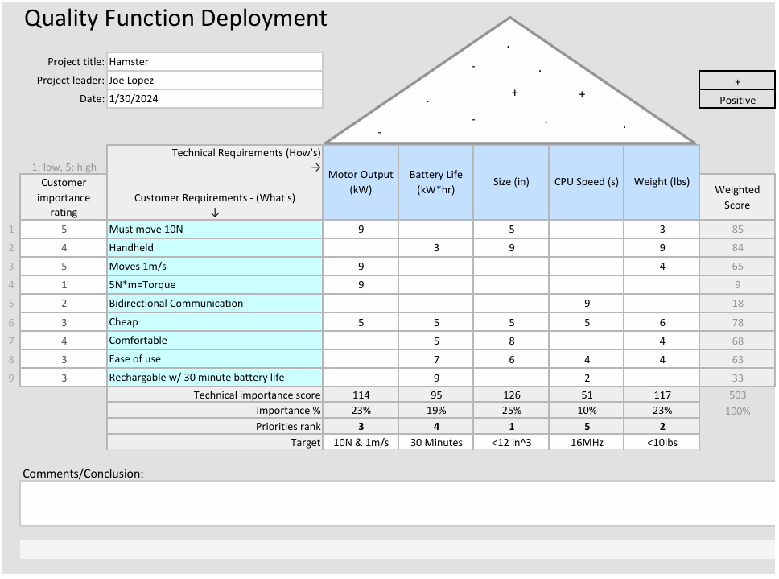*Figure 2. Hamster QFD*

# ***References***

[1] “Rope Brake Dynamometer,” indiamart.com, <https://www.indiamart.com/proddetail/rope-brake-dynamometer-2853084232455.html> (accessed Oct 31, 2024).