**SAE Aero Competition**

**Final Proposal**

**Alec Zodrow**

**Iain Pettit**

**Gabriella Liquidano**

**Jacob Cabanyong**

**Devin DuBois**

**Alexander Vierhout**

**2022-2023**



**Project Sponsor: W.L. Gore and Associates**

**Faculty Advisor: David Willy**

**Instructor: Armin Eilaghi**

# DISCLAIMER

This report was prepared by students as part of a university course requirement. While considerable effort has been put into the project, it is not the work of licensed engineers and has not undergone the extensive verification that is common in the profession. The information, data, conclusions, and content of this report should not be relied on or utilized without thorough, independent testing and verification. University faculty members may have been associated with this project as advisors, sponsors, or course instructors, but as such they are not responsible for the accuracy of results or conclusions.

# EXECUTIVE SUMMARY

SAE Aero is an internationally recognized competition between colleges intended to provide engineering students with a real-life engineering challenge. The goal of the project is to design and manufacture a functional micro class airplane while simultaneously following the SAE competition rules. The client for this project is David Willy, an engineering professor at Northern Arizona University.

The design process was completed over a multitude of stages. The initial tasks to begin this process were to establish the customer requirements. The customer requirements were obtained from the competition rules and the client. Then, the engineering requirements were created based on ways to satisfy the customer needs. The design process incorporated many tools to help fabricate ideas. The entire plane system was broken down and mapped out via a functional decomposition model and a black box model. This helped the team design important subsystems to carry out specific tasks. These subsystems include to propellor, wings, tail, fuselage, landing gear, and the electrical components. The subsystems were also analytically analyzed using back-of-the-envelope calculations. The prototyping stages included an assembly of electronic components and manufacturing gliders out of foam. During the manufacturing process of the final design, iterations of repair and testing are expected to optimize the design.

The final design will have a flat body with a straight wing design. It will include a two-blade propeller and a two-tail design connected to two vertical stabilizers. Connecting the two will be a horizontal stabilizer. Inside the fuselage will be a box that is 12in x 12in x 2in. This box will then carry a load for the competition. Two carbon fiber rods will also be used to connect the fuselage and empennage. As a result, the team hopes for a light yet strong and stable design.

# TABLE OF CONTENTS

Contents

DISCLAIMER 1

EXECUTIVE SUMMARY 2

TABLE OF CONTENTS 3

1 BACKGROUND 1

1.1 Introduction 1

1.2 Project Description 1

2 REQUIREMENTS 2

2.1 Customer Requirements (CRs) 2

2.2 Engineering Requirements (ERs) 2

2.3 Functional Decomposition 3

2.3.1 Black Box Model 4

2.3.2 Functional Model/Work-Process Diagram/Hierarchical Task Analysis 4

2.4 House of Quality (HoQ) 5

2.5 Standards, Codes, and Regulations 5

3 Testing Procedures (TPs) 2

3.1 Testing Procedure 1: Static and Dynamic Propeller Testing 2

3.1.1 Testing Procedure 1: Objective 2

3.1.2 Testing Procedure 1: Resources Required 2

3.1.3 Testing Procedure 1: Schedule 2

3.2 Testing Procedure 2: Payload Capacity 2

3.2.1 Testing Procedure 2: Objective 2

3.2.2 Testing Procedure 2: Resources Required 3

3.2.3 Testing Procedure 2: Schedule 3

3.3 Testing Procedure 3: Structural 3

3.3.1 Testing Procedure 3: Objective 3

3.3.2 Testing Procedure 3: Resources Required 3

3.3.3 Testing Procedure 3: Schedule 3

3.4 Testing Procedure 4: Maneuverability 3

3.4.1 Testing Procedure 4: Objective 4

3.4.2 Testing Procedure 4: Resources Required 4

3.4.3 Testing Procedure 4: Schedule 4

4 Risk Analysis and Mitigation 4

4.1 Critical Failures 4

4.1.1 Potential Critical Failure 1: Wing Frame 4

4.1.2 Potential Critical Failure 2: Battery 5

4.1.3 Potential Critical Failure 3: Landing Gear 5

4.1.4 Potential Critical Failure 4: Server Motor 5

4.1.5 Potential Critical Failure 5: Wing Wrap 6

4.1.6 Potential Critical Failure 6: Power Limiter 6

4.1.7 Potential Critical Failure 7: Speed Controller 6

4.1.8 Potential Critical Failure 8: Flaps 6

4.1.9 Potential Critical Failure 9: Controller 6

4.1.10 Potential Critical Failure 10: Red Arming Plug 6

4.2 Risks and Trade-offs Analysis 6

5 DESIGN SELECTED – First Semester 7

5.1 Design Description 7

5.2 Implementation Plan 7

6 CONCLUSIONS 8

7 REFERENCES 9

8 APPENDICES 12

8.1 Appendix A: Descriptive Title 12

8.2 Appendix B: Descriptive Title 12

# BACKGROUND

## Introduction

The task at hand is to design a remote-controlled aircraft that can compete in the 2023 SAE Aero Micro Design Competition. The 2023 NAU Micro team will develop a final design oriented around both competition requirements, as well appealing to our stakeholder goals. A deeper understanding of the engineering design process will be obtained by the team of six, allowing us to apply our aeronautical engineering knowledge to a physical final deliverable. Tasked with designing a plane from the ground up, the team will learn about professional documentation of a project as well as developing presentation skills. The latter half of the project will further the team’s ability to manufacture a final design and bring it to competition in April of 2023.

## Project Description

The original project description provided by the sponsor is, “The SAE Aero Design competition is a real‐world design challenge designed to compress a typical aircraft development program into one calendar year, taking participants through the system engineering process of breaking down requirements. It exposes participants to the nuances of conceptual design, manufacturing, system integration/test, and sell‐off through demonstration”.

# REQUIREMENTS

This chapter contains the customer and engineering requirements the team used as a guide for designing the prototype. Before the process of designing and manufacturing began, the team compiled customer requirements to satisfy before attending the SAE competition. These customer requirements were determined based on the competition rules and what is expected of the team from our client David Willy. The team then used these customer requirements to come up with a set of quantifiable engineering requirements that will address each of the customer’s needs. An analysis of the two sets of requirements was done using a house of quality. This chapter also contains a functional decomposition, a black box model, a functional model, and a list of standards, codes and regulations that the team followed. The functional decomposition, black box model, and functional model are tools the team utilized to map out systems within the plane responsible for carrying out specific tasks derived from the engineering and customer requirements.

## Customer Requirements (CRs)

The overall project objective is to create an aircraft that can safely compete in the SAE Aero competition and finish the course successfully. Shown below are the customer requirements in no specific order. A competition ready design holds the highest weight at 19%. The reason for this weight is because not only does the client desire a plane that will be able to compete in the competition, but also being competition ready implies that the team successfully designed a plane that is ready to compete. Lightweight is the second highest customer weight at 17%. This is because the team wants the plane to have an easy weight ratio allowing the plane to lift off the 4x8 ft takeoff platform. Stable flight is third at 13%. Stable flight ensures that everything in the plane’s dimensions is designed properly and there are possibilities for safe landings. Short takeoffs are at 12% because the platform that the plane must be able to take off from is relatively small. In the competition, if the plane fails to take off before the takeoff platform ends, the plane will fall off and go straight towards the ground. The durability of the plane has a weight of 10%. This is because having a durable plane would mean less repairs and less potential damage from system failures. A cost-effective design holds a weight of 10%. A cheaper design allows for the creation of more prototypes and saves money for solving potential problems during flight testing or other testing. The ability to land has a weight percentage of 7%. The reason for this is because the ability to land is the last task that must be performed for a complete trial run in the competition. Repairability has a weight of 5%, this is because we know that there will be damage to the plane and want to have it repaired easily. High maneuverability is at 4% due to lack of concern for maneuverability because the team is focused on getting a plane to fly safely. The payload capacity is at 3%. Although the competition encourages teams to carry more weight for more points, the sponsors main objective is to get the plane to take off and land to place in the competition. Lastly the high speed has a customer weight of 2%. High speed is encouraged by the competition judges; however, it is not as important as ensuring a functional design.

## Engineering Requirements (ERs)

The first engineering requirement is to reduce the total cost of the design. To do this, the team chose materials that have high strength and durability and are low cost. This engineering requirement will go along with the customer requirements of being durable and having a low cost. Examples of this would be Balsa wood, and some types of foams to have a durable design, with cheap material. The target cost of one rendition of the plane is $600-$900. With a budget of $3000 dollars provided by our sponsor, the team needs to limit the percentage of the budget used on materials to allow for adequate prototyping as well as travel costs.

The second engineering requirement is to reduce the total weight. To reduce the total weight of the aircraft, the team chose lightweight materials to prototype the frame. The main material used is foam, but considerations of utilizing carbon fiber may be executed in later stages of the project. This is an important requirement due to the knowledge of knowing the weight is a big factor to lift ratios. Another example of reducing weight would be using skid plates for the tail wheel landing gear, instead of a wheel configuration. The target weight for the final design is 3-4 pounds. This number was decided upon by the team because the plane in limited to 450 W of power per competition rules. Most commercial motors that intake that power is fitted to planes no larger than 4 pounds.

The next engineering requirement is to increase the max stress that the plane can endure during flight. Increasing the max stress will allow the wings and body of the plane to withstand the stress applied from the aerodynamic forces when flying. This can be done by improving the strength-to-weight ratio through material selection or building more supporting members of the plane. This increases the reliability and durability of the plane itself. The initial goal for stress resistance capabilities is to have all parts being able to withstand 200 ± 30 psi for the entirety of the flight, including the landing. This target strength was determined from a preliminary analysis of the total stress the plane might be under at any given time. The plane also needs to be able to endure rough transportation to competition because the team might need to ship the plane to Fort Worth, Texas.

High thrust to weight ratio is the next engineering requirement. This helps the team address the issue that most SAE Aero teams run into. With only 8 feet of runway to take off from, the plane needs exceptional acceleration capabilities to generate enough lift. The target thrust-to-weight ratio is 1:1.6, but the team is satisfied with a ratio as high as 1:3. This guarantees a consistent take-off at competition. This also allows the team to score more competition points in the cargo run. Having the ability to increase throttle allows the team to carry more weight and not worry about takeoff capabilities.

The fifth engineering requirement is to have a high lift-to-drag ratio. With a target lift-to-drag ratio of 4:5, the team will be able to increase speed and maneuverability when in flight. Higher ratios of 1:1 gives the team more room to breathe when it comes to stresses on the plane. Reductions in drag come from designing a slim body that not only reduces skin drag but pressure drag as well. Further analysis of this can be done by putting protypes of this into a wind tunnel and measuring pressure differences during the testing procedures. Effective airfoil design will produce more lift without increasing the planform area of the wings.

The sixth engineering requirement is to increase the total part count. The reason the team chose this as an important engineering requirement is to increase repairability of the plane. With a target of 5 major parts of the plane, the team plans to possess the ability of interchange portions of the plane at any given time in case of emergency. This is to address the issue of a broken part or even a part that is not performing to the team’s standards. This will also allow us to potentially have different wing designs for when we are carrying different amounts of cargo.

The final engineering requirement is to maximize power consumption. With a competition required power limiter of 450 W, the team wants to aim to consume between 400 and 450 watts of power. This will allow us to produce the most amount of thrust, which will in turn produce more lift. This will also reduce the takeoff distance and increase maneuverability, as a higher speed will allow more manipulation of the working fluid.

## Functional Decomposition

For this section the team created a black box model and a functional decomposition model to depict the input and outputs of each sub-system of an aircraft. These sub-systems include landing gear, fuselage, propeller, tail, and wing design. Each sub-system guides the aircraft in flight and correlates to the four forces related to flight. Such forces include drag, lift, weight, and thrust. The size of the aircraft and gravity affect the weight and drag. The wings affect lift, and the propeller determines thrust. Each input and output of the model aircraft that the team will be designing is crucial for the team's success. In order to fully understand how an airplane works and flies, the team first designed a black box model to determine the different inputs and outputs running through the aircrafts system. Afterwards, the team designed a functional model to break down each sub-system to depict how each part affects flight and the different forces associated with it.

### Black Box Model

A black box is a system which can be viewed in terms of its inputs and outputs. For the teams design the inputs will be the same as the outputs. First, energy will be inputted through the battery's electricity which will be turned on through human energy with the push of a button. The output then results in kinetic, potential, heat, and sound energy through the planes' movement through the air. The second input will then be material as hand air cargo. This will result in the same output as the material does not change throughout the flight of the plane. Lastly, the third input will be the signal which includes the on/off switch and its radio servos and motor. The output will then be the visual signal. Therefore, through each input and output the team understands the general inputs and outputs that can be further analyzed through a functional model. **Figure 1** shows a visual of how the black box model looks with the above inputs and outputs involved.

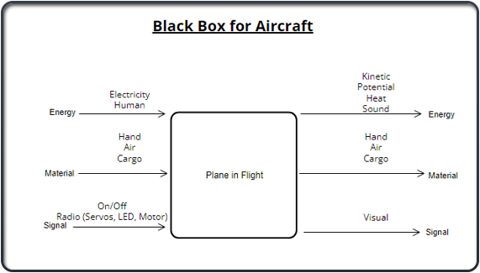

**Figure 1: Black box model**

### Functional Model/Work-Process Diagram/Hierarchical Task Analysis

A functional model is a structured representation of the functions within the modeled system or subject area. The model shown below in **Figure 2** depicts each sub-system of the team’s final design. Beginning with electricity, it then is imported and stored into an on/off switch. This energy is then released once the plane is turned on or off and results in a visual signal. Human energy is also prevalent as one is needed to turn the plane on or off. This is also stored into the cargo and turned into kinetic energy. Thirdly comes hand with is used to actuate electricity and then converted to electrical energy to rotational energy. This is then converted to thrust, and the plane is then exported into the air. Hand is also stored and exported and released as cargo. Once the plane is in the air the plane converts to mechanical energy to drag and lift to as well aid the plane through the air. The last system described in the functional model is the cargo. First the cargo is imported and then stored which is then exported and turned into potential energy.

The functional model aids the team in its project by allowing them to fully understand all sub-systems' inputs and outputs. It also helps the team understand the designs’ functions and processes through take-off and landing. Such a model assists the team with discovery of information needs, helps identify opportunities, and establish a basis for determining product and service costs.

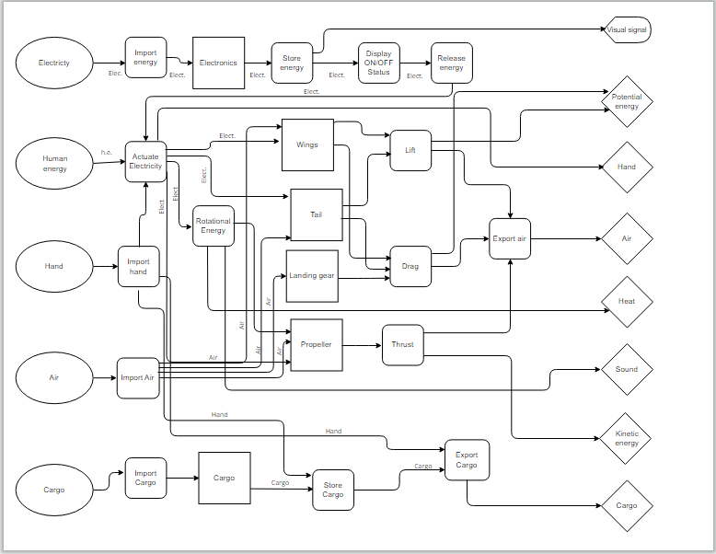

**Figure 2: Functional Decomposition Model**

## House of Quality (HoQ)

A house of quality was constructed to compare our eleven customer needs to our seven engineering requirements. In the house of quality, the customer needs were weighted from most important to least important, with being competition ready as the highest priority. The engineering requirements were then assigned a score of one, three, or nine, which represents how well they address the customer needs. A summation of the ratings for each requirement was made to give the team insight into which engineering goal will satisfy our customers' needs the best. In addition to the internal analysis of our own goals, three benchmarking projects from past SAE teams were explored to see how well those designs would have addressed our personal goals. These teams were given a score of 1-5 on their tackling of each customer's need. This process is displayed in **Figure 3**.

**Figure 3: House of Quality**

The use of the House of Quality was a key initial step into the design phase of the project. The HoQ indicated that the most important engineering requirement to address is the reduction of the total plane weight. With a target weight of four pounds, the team will focus efforts on all portions of the plane to achieving this weight. The team will look at the build process of Georgia Tech’s 2021 RC plane to know how to efficiently reduce weight without losing performance.

## Standards, Codes, and Regulations

Two sources are used that designate standards and regulations for the aircraft design: the Institute of Electronics and Electrical Engineers (IEE) and the Society of Automotive Engineers (SAE). IEEE was used a guideline for the electrical components within the plane. It also serves a source for physical explanations behind electrical concepts. SAE sets the regulations that the plane must comply with for the competition. This includes several very specific part requirements and design limitations. All standards are tabulated below in (**Table X**).

Table X: Standards of Practice as Applied to this Project

|  |  |  |
| --- | --- | --- |
| **Standard Number or Code** | **Title of Standard** | **How it applies to Project** |
| SAE Aero 2.1 | Aircraft Identification | School name, address, email address must be on the plane and be at least 2 in of height |
| SAE Aero 2.2 | Prohibited Aircraft Configuration | The design must be a fixed wing aircraft |
| SAE Aero 2.3 | Empty CG Requirements | The plane must fly without any cargo and the center of gravity must be clearly marked on both sides of the plane |
| SAE Aero 2.7 | Spinner and Safety Nut Requirement | To secure the propeller a spinner or rounded nut must be used. Nylon-insert lock nuts are prohibited |
| SAE Aero 2.11 | Static Payload Plate Attachment | Static payload plates must be secured with metal hardware that penetrates all plates |
| SAE Aero 2.16 | Stored Energy Restrictions | Must be powered by motor onboard the aircraft. No other forms of energy are allowed such as rubber bands or C02 cartridges. |
| SAE Aero 2.19 | Power Limiter | Specified Power limiter must be used to limit the propulsion power |
| SAE Aero 2.20 | Red Arming Plug | Aircraft must have a red arming plug that can disarm the propulsion system. It must be placed in the back half of the aircraft. |
| SAE Aero 9.1 | Aircraft Dimension Requirements | Micro Class aircraft are limited to a maximum planform wingspan of 36inches |
| SAE Aero 9.2A | Propulsion Requirements | Aircraft must be powered by electric propulsion only |
| SAE Aero 9.2C | Aircraft Propulsion System Battery | A LiPo battery with no more than 4 cells must be used. |
| SAE Aero 9.2E | Power Limiter | Power limiter must be 450W |
| IEEE 128-1976 | Guide For Aircraft Electric Systems | Provides recommendations and technical reasoning for how the team can design the electrical systems. |

# Testing Procedures (TPs)

This section details all planned testing procedures to satisfy the customer needs and engineering requirements. The resources, schedule and objective will be included for each test.

## Testing Procedure 1: Static and Dynamic Propeller Testing

This test utilizes a thrust meter to test the thrust generated by different propellers. It examines thrust when the plane is stationary (static) and when moving (dynamic). Through this the optimal propeller can be found and what rpm it should operate at. This test will satisfy the high thrust to weight ratio engineering requirement. This test is scheduled to be completed by December 2nd, 2022.

### Testing Procedure 1: Objective

This test will run by setting up the propeller-motor configuration onto a thrust meter. The thrust will be measured in a 0 windspeed environment as well as over range of windspeed. The 0 windspeed will give the team information on the thrust generated by the plane at the point of takeoff. The range of windspeeds will give information on the change in thrust as the plane moves faster relative to the air. The static thrust value will be the most important value, as the plane has only 8 ft to leave the ground. Knowing this value will help allow the team to design for a certain weight, aiming for the goal of a thrust to weight ratio of 2:1. These tests will also allow the team to choose what propeller configuration best suits the plane.

### Testing Procedure 1: Resources Required

Three measurement instruments are needed for this test: tachometer, thrust meter, and anemometer. The group will test 3 different propeller sizes. The motor, ESC, and battery that will be used on the plane are also required. Static propeller testing will take place at the home of two of our group members, and the dynamic will take place in a remote location, as the testing will be done by driving a car to generate windspeed.

### Testing Procedure 1: Schedule

The materials have already been acquired for the lab to begin. All the testing will be completed by December 2nd, 2022. The length of testing will span from 1-3 days depending on how fast the group can finish it.

## Testing Procedure 2: Payload Capacity

The payload capacity test will determine how much weight the plane can hold and still successfully complete a flight circuit. The more weight (lbs) that the plane can carry, the higher the flight score the team will receive. The payload will be custom metal plates where the team can choose the size, weight, and material of each. This test will help satisfy the customer needs of high speed, short takeoff, ability to land and payload capacity. This test will be performed next semester.

### Testing Procedure 2: Objective

The objective for this test is to maximize the flight score the team will receive in competition. This will be done by determining the maximum amount of weight (W) the plane can carry, as well as the time of flight from takeoff to 300 ft (T). The equation is shown in (**Equation 1**) below.

$FS=80*\frac{\sqrt{W*Bonus}}{T}$ [1]

By creating several data points of weight to time, a fit curve can be applied to the data and a maximum can be determined. This testing procedure will also double dip and look at landing and takeoff since the plane must do both of those things to perform this test. For each different weight, the distance required to land will also be measured to make sure it can be done in the 200ft of space given in competition. Takeoff will require no measurements but just a verification that it can take off with only 8 ft of space.

### Testing Procedure 2: Resources Required

The testing will require a large open field to fly at. This can be done at the Flagstaff Flyers Club. Markers will be needed to set distances, so the team know how far the plane moves. A measuring is needed to set up these markers. A phone will record the flights and a timer will measure the flight time. From this plane velocity can be found. The team will need the machine shop to make the metal plates. Raw material for this also needs to be ordered. A fully operational plane is also needed to be able to perform this test. An 8 ft by 4 ft wooden platform will need to be constructed to act as the takeoff pad. This is dimensions of the one used for competition, so the conditions need to be simulated to ensure it can take off in such a short distance.

### Testing Procedure 2: Schedule

This testing will be one of the last to be conducted. It will be performed in the second semester. If the team can create a fully functional plane by the end of winter break, then the test can be one at the very beginning of second semester when the team gets access to the machine shop.

## Testing Procedure 3: Structural

To determine the structural integrity of the plane, a drop test will be performed. It is almost a guarantee that the plane will crash at some point, so the team needs to ensure that the structure can handle this and determine where the plane might break. This will satisfy the customer need of durability and reparability and determine the engineer requirement of max stress and increasing total part count. This test will be performed next semester.

### Testing Procedure 3: Objective

The objective of this test is to determine the maximum impact that the plane can take and see what structural points fail first. This will be done by dropping the plane from increasing heights until it fails structurally. This height can be used to find the impact felt by the plane. Depending on the severity of the break, a flight will be attempted to see if breaking at this point disables the plane or not. Once the plane is unable to fly, then the group will know what points will need to be strengthened. This test will also include repairability, so the total part count will be taken before testing. The ease of repairability will also be analyzed when the team fixes the plane. This will give some qualitative insight on how the design could be changed to make the process easier so it can be done when at competition.

### Testing Procedure 3: Resources Required

This test will require a ladder and a fully functioning plane. A tape measurer is also needed to find the height dropped from. It will need to be performed at the Flagstaff Flyers Club since flight testing will be done after. There will be tools and materials needed to repair the plane after, but these will be unknown until the damage on the plane can be assessed.

### Testing Procedure 3: Schedule

This test will be performed second semester. Similar to the payload testing a fully functional plane is needed before. This will be the last test to be completed as it will require breaking the plane, and it would be more sensible to get the other tests done first. This test can be completed in a day, possibly the same day as the others requiring the Flagstaff Flyers Club Field.

## Testing Procedure 4: Maneuverability

Maneuverability testing is needed to determine if the plane can turn and be controlled within reasonable distances. This test will involve determining the turn radius that the plane is able to achieve with the designed control surfaces. This test will fulfill the high maneuverability customer requirement. It will take place in the second semester.

### Testing Procedure 4: Objective

The objective of this test procedure is to determine the minimum turn the plane can achieve without failure. This will be done by doing simulated flight tests through the circuit outlined by the competition. There are no restrictions on the turn radius, but it should be within reason and minimizing total flight time will allow for one battery to last longer. It will also allow the pilot to not roll the plane to far and risk crashing the plane. By starting at a large turn radius, the team can slowly reduce it until the plane starts to lose too much lift and begin free fall. Much caution must be taken to avoid a crash, as this can set the team behind schedule having to do repairs.

### Testing Procedure 4: Resources Required

The test will need to be performed at the Flagstaff Flyers Club field. Markers will be needed to act as visual aids for the team to reference when in flight. A measuring tape will also be needed for the place of the markers. An 8 ft by 4 ft wooden take off platform will need to be constructed to properly simulate competition conditions.

### Testing Procedure 4: Schedule

This test will be completed near the beginning of the second semester. If the team creates a fully functioning model over winter break, then this testing can be completed after payload capacity testing is done. Due to the risk of crashing as much data should be collected on it before performing this test. The test will not take more than a day.

# Risk Analysis and Mitigation

Using a complete FMEA for the aircraft on the critical subsystems, the team discusses there are varieties of failures and ways to mitigate the potential critical failures. The team has taken the top 10 failures from the completed FMEA based off the highest RPN values and discusses the ways to reduce the failures. These potential critical failures are, the wing frame, the battery, the landing gear, the servo motor, the wing wrap, the power limiter, the speed controller, the ailerons, the remote controller, and the DC motor. There are plans to mitigate each failure that are explained and listed below. All these plans are to try and reduce the number of times a failure happens, as well as to try and prevent the failure from happening as much. These failures must be mitigated, but the method of prevention for these failures may interfere with one another, so a risks and trade-offs analysis are necessary to compare different mitigation methods.

## Critical Failures

### Potential Critical Failure 1: Wing Frame

Wing Frame failure is a potential failure point that has been illustrated numerous times to the team. The crossbar of the wing frame has been known to deform, fracture, and snap on many occasions. The most common cause of this failure is due to a rough, or crash, landing. In this scenario, the crossbar would succumb to most of the impact force from the landing. An alternate cause of this failure would be due to the wings generating too much lift for the crossbar to handle, and snap.

If the wing frame were to fail, the team would have to rebuild the body of the plane. Additionally, any electronic components that were inside of the wing, or near any major fracture points, would need to be inspected and tested for any potential damages. This would set the team majorly behind on schedule as the team would not be able to test fly the plane and would have to dedicate their time to the reconstruction before being able to progress. Also, this could potentially cost a great deal of money depending on how many additional components were damaged. To mitigate this failure from occurring, the team would need to be thorough in their analysis and could set a greater factor of safety than expected. Additionally, the team can conduct wind resistance tests to simulate the amount of lift force the wings would generate and determine if the crossbar’s rigidity is up to par.

### Potential Critical Failure 2: Battery

Battery failure is a failure point that could potentially be catastrophic. Battery failure could be any of the following: reduction of power, reduction of capacity, increased charge transfer resistance, drastic voltage reduction, high heat generation, bloating of cell casing, ignition, and explosion. Most of the more severe outcomes have been known to be much less likely to occur; however, these outcomes occur due to impact forces. Aside from this, multiple other failures can occur due to overcharging, high temperatures, short circuiting, and excessive load on the cells.

If the battery were to fail, the team could potentially be set greatly behind on schedule. Failure of the battery could require a recovery of the battery as well as the recovery of various additionally electronic components. The team would potentially have three options for recovery of the battery. The options are as follows: repair the battery, purchase a new battery, or find a replacement battery from legacy parts. If there is no replacement legacy battery, either of the other options could potentially take up to a month to fulfill. In this time period, the team would only be able to work on anything non-electrical. However, depending on how late into the project the battery was to fail, this could potentially leave the team stranded for a month or even unable to compete in competition.

Due to the large quantity of battery failure modes, numerous tests have been formed to ensure these failures can be identified before they occur. Most of these tests are as simple as just a visual inspection or a multimeter test. These tests should be conducted regularly to ensure that the battery is well maintained.

### Potential Critical Failure 3: Landing Gear

Landing Gear failure could be any of the following modes: buckling, creep buckling, impact fatigue, or impact fracture. These failures can be caused by the static load or impact load. Depending on the strength of the landing gear, they will either buckle under the weight of the plane or buckle over time. Additionally, from landing the plane, the landing gear could fracture from the impact force or become warped over time.

If the landing gear were to fail, the team would potentially need to replace numerous additional components. In the event the landing gear was to fail during a landing, components such as the fuselage wrap, wing wrap, flaps, motors, or horizontal stabilizers would also need to be repaired. However, in the event the landing gear did not fracture during the landing, the likely hood of other components needing to be repaired is greatly reduced.

To mitigate this failure from occurring, numerous stress tests can be conducted. The first test would be to load the landing gear with weight greater than the plane to ensure that the gear won’t buckle. Finally, to ensure the gear won’t fracture or warp from landing, drop tests can be conducted. In a worst-case scenario, the plane would fall straight down onto the landing gear deforming them. By loading the landing gear with weight similar to, or slightly greater than, the plane and dropping it from a great height, the team can confirm that the landing gear would not deform.

### Potential Critical Failure 4: Servo Motor

The servo motor essentially incorporates potential feedback in order to control the rotational or linear speed and position of the aircraft. The motor is controlled with an electric signal, in this case being the battery. The servo motor’s potential failure can be caused by the battery dying during the aircrafts flight. Since the motor is attached to the propeller and generates most of the thrust for the aircraft, the potential failure for the motor can be detrimental for the team. If the battery were to die, then the motor would essentially stop working, thus causing the propeller to stop spinning leading the plane to lose its thrust resulting in a crashing plane. This chain of events could greatly set back the team in their progress.

Such failure can be mitigated through proper insulation and extended battery life/replacement batteries. Through proper insulation the team can prevent damage and corrosion from humidity and overheating from ambient temperature. Through an extended battery life, the team can assure the battery will work for the entire competition without having to worry that it will die. If that is not feasible, then the team could always call for replacement batteries to have as backup just in case the original battery dies.

### Potential Critical Failure 5: Wing Wrap

The wing wrap is a composite material that encompasses the structural ribs of the plane. The wing wrap experiences lift and drag during flight. A potential failure for the wing wrap is loss of structural integrity causing the material to deform or tear. The most critical mode of failure is impact damage. Impact damage occurs when the plane experiences high energy impacts, typically from crashes. This type of damage may also occur if the plane is at rest but experiences a projectile-like impact. This type of failure could be caused by various factors including malfunction of the subsystems or compromised structural integrity due to stress concentrations and aerodynamic forces. If this failure were to occur, the team would need to completely replace the wing(s). Repeated replacements and repairs generate more expenses which could potentially be detrimental to the project.

As a means of mitigation, the geometry of the wings can be structurally analyzed via computational methods to locate stress concentrations in the design. These stress concentration areas may be reinforced with structural members or stronger materials. This helps ensure that high energy impacts are not focused on a singular weak point in the plane. The wing wrap should also be thoroughly inspected following each flight to ensure that there are no tears in the material.

### Potential Critical Failure 6: Power Limiter

The power limiter is designed to prevent overstressing due to excessive compressor outlet pressure during high-speed low altitude running. In other words, the limiter is used to restrict power level to the RC plane. The power limiter may fail if the power exceeds the limit allowed. This will then result in the power limiter to shut off the electricity to the plane. As a result, the plane’s motor will stop the propellers and completely turn off the plane and prevent it from flying. As long as the team stays within the limit, the power will stay on. The only way the team can mitigate such potential critical failure to stay within the power limit provided by the SAE regulations and guidelines.

### Potential Critical Failure 7: Speed Controller

The DC motor speed controller function is one of the most common manipulations used in DC controllers. Through this the speed can be controlled in four different ways such as the flux variation, armature voltage variation, a change in the supply voltage, and pulse width modulation (PMW). One possible failure for the speed controller can be that it disconnects mathematically or electrically. If this happens, the drive from the speed controller will “think” that the motor is not turning. As a result, the drive will send full power to the DC motor in an attempt to get it up to speed. This will cause the motor to operate at full speed, which will affect the plane's flight.

In order to mitigate this potential failure, the team will have to limit the motor current through the power limiter. By doing so, the motor and controller will be protected from damage in case of stalling and overloading. The team will also have to keep the motor as cool as possible to prevent breakdowns. Before flight the team will also have to check all wires to make sure the connections are firm.

### Potential Critical Failure 8: Ailerons

The aileron’s role during flight is critical as they control one of the three major axes about which a plane moves. They control the roll axis, which is how the plane turns during flight. The failure of one these will result in the plane moving off path and potentially crashing and at worst causing harm to others. This can fail by having structural damage to the frame or surface damage to the wrap. In either case if the aileron is unable to manipulate the air the pilot will not have full control of the plane. It can also fail by disconnection to the servo motor, which will result in a total loss of control.

To mitigate this failure, point the ailerons must be visually inspected before and after each flight. They should also be actuated by the pilot before flight to ensure proper connection. To account for this in design. The connection point between the servo and the aileron must be over engineered to be very secure. This should be balanced with making sure the aileron can be easily taken off and replaced, so if structural damage occurs during competition, it can easily be replaced and return to operating safely.

### Potential Critical Failure 9: Controller

The controller itself will be used to fly the actual aircraft through signals from the transmitter. The antenna transmits signals and uses them to control the motor and other features based on the information the antenna receives from the transmitter. The controller will be controlling the power, the ailerons, the motor which controls the propeller. A possible failure for the controller would be losing signal or losing connection between the controller and aircraft. If the radio system disconnects, the team will completely lose control of the aircraft. This is detrimental because if the team loses control, the plane will crash and cause potential damage and it will be difficult to rebuild.

To mitigate this failure, the team will have to check the servos to make sure they are all working properly. By checking the power supply and network connections, the team can ensure that the controller will not lose connection with the plane during flight. Another potential failure cause could be electromagnetic interference from other teams' controllers during competition. Although this is unlikely to happen, the team should prepare to control the effect of EMI of the device.

### Potential Critical Failure 10: DC Motor

The failure of the DC Motor, similarly to the battery, has the potential to be detrimental to the project. Failure modes of the DC Motor could be any of the following: thermal fatigue, high-cycle fatigue, impact fatigue, or impact fracture. These failure modes can be caused by a rough/crash landing or prolonged use of the motor. It has been illustrated to the team that due to a plane’s aerodynamics and momentum, in the event the motor were to cut out or lose connection, the plane is expected to nosedive. In this event, the DC Motor would endure a great deal of the impact force.

If the motor were to fail, this could set the team back for approximately a month due to the time to get a new motor or receiving a Legacy motor. A Legacy motor is a motor that has been left by previous teams that will allow tests until the purchase of the needed motor is completed. The mitigation for the failure is going to involve dynamometer testing, multimeter testing, and visual inspections.

## Risks and Trade-offs Analysis

The potential critical failures must be mitigated, but the method of prevention for these failures may interfere with one another. Therefore, a risks and trade-offs analysis is necessary for allowing the team to compare different mitigation methods. There are two main types of components that could potentially fail. There are electrical components that could potentially fail, and there are structural components that could fail. The electrical components include the battery, speed controller, DC motor, servo motor, power limiter, and controller, while the structural components include the wing frame, landing gear, wing wrap, and the ailerons.

Because the electrical components are all connected to each other, The potential critical failure of each part poses a functional threat to all other electrical components in the system. As a result, the mitigation techniques are similar to one another. For example, the battery and DC motor simply need visual and functional inspection before each flight. By adopting a full body inspection routine, all the electrical components can avoid failure. However, this would require an efficient design for accessing internal components. This may interfere with structural optimization of the geometrical components such as the wing frame and wing wrap. Similar to the electrical components, the structural components are linked in functionality. An example of this can be seen in the wings. The entire wingspan encompasses the frame, wrapping, and the ailerons. Mitigating failure of these components ensures collective safety for the entire system. In this case, failure mitigation of these components involves structural reinforcement and functional testing before each flight. Testing the ailerons for functionality can be included in the inspection routine as well.

Most of the airplane safety measures are visual and functional inspections between flights. As a result, the prevention of critical failures for each component generally does not interfere with one another allowing the team to efficiently mitigate failures of all components. The structural failure prevention techniques are emphasized in the manufacturing process.

# DESIGN SELECTED – First Semester

For this chapter, the team will be focusing on the design description and implementation plan. The design description details the changes the team has made since the preliminary report and why those changes were made. As well as providing engineering calculations to such analysis. The implementation plan will focus on fabricating a prototype through a breakdown of resources needed. This will be followed by a detailed schedule for all implementation activities for the second semester.

## Design Description

The current design utilizes a wide flat body with a straight wing design. A two-blade propeller is placed on the nose to generate thrust. The empennage is a two-tail design which connects to two vertical stabilizers. A raised horizontal stabilizer connects the two. The design is able to carry 1 12 in x 12in x 2 in box, as well as several metal plates. The box is placed in the fuselage below the wings, while the metal plate can be placed inside the point where the wings meet the fuselage. The design has had several large changes since the preliminary report. Instead of attempting to carry the 6 in x 6 in x 4 in box, the team found the larger box could result in a more desirable fuselage geometry by keeping the body flatter and wider. This design will also generate more lift, as lift was one of the main problems with the previous design. The tail design also changed by having two connection points to the fuselage and raising the horizontal stabilizer to avoid prop wash. Two carbon fiber rods will be used to attach the empennage to the fuselage. This allows for a light, strong, and stable design.

The new design can best be assessed by determining the four forces of flight: lift, weight, drag, and thrust. The thrust estimation is determined by (**Equation 2**).

$F=4.39*{10}^{-8}*RPM*\frac{d^{3.5}}{\sqrt{pitch}}(4.23*{10}^{-4}*RPM*Pitch-V_{o})$ [2]

By assuming a propeller diameter of 13 in and pitch of 8 in and a motor RPM of 10400, the static thrust calculated was 9.31 lbf. This calculation is an ideal one and realistically won’t be this high. But this first analysis of it is promising. This will be experimentally determined by static and dynamic thrust testing. The lift is determined using (**Equation 3**).

$C_{L}=\frac{L}{0.5*ρ*V_{∞}^{2}*A}$ [3]

The coefficient of lift for the NACA 63-412 airfoil is 0.8 at an angle of attack of 5 degrees. Assuming flagstaff air density and a speed of 32 ft/s, the total lift force was found to be 2.5 lbf. This calculation only accounts for lift generated by the wings. The body and tail will also be generating lift during flight. This initial calculation lines up with the weight goal of 2.5 lbs while carrying no cargo. A computational fluid dynamics (CFD) analysis will give us a true value for lift over the whole plane. The drag estimation is found using (**Equation 4**) below.

$D=C_{D}*\frac{{ρV}_{∞}^{2}}{2}*A$ [4]

The coefficient of drag for the NACA 63-412 airfoil is .015. Using the same values for lift, the drag comes out to only 0.77 lbf. This is smaller than what the actual drag will be as it does not account for every type of drag. The full drag will be determined by a CFD analysis. The weight is determined through the Solid works model. This totals two 2 lbs. This will allow for the team to carry lots of weight and get a high score in the competition.

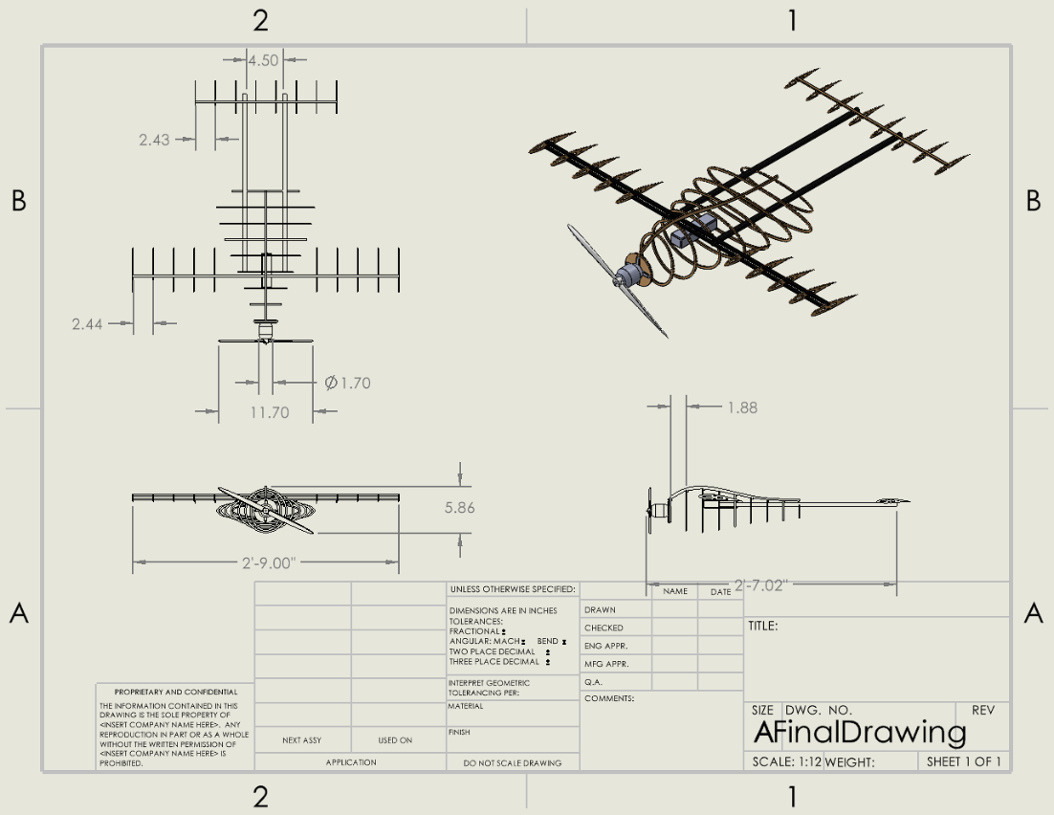

**Figure 4: Final Cad Drawing**

**Figure 5: Configuration of Servo Motor and Aileron**

## Implementation Plan

To completely implement the design, there will be multiple prototypes, a bill of materials, a detailed schedule including when implementation activities are taking place. The team has access to the tools and equipment that is in the Makers lab, which is one of the locations where the project will be built and tested on. The materials needed to complete this project are going to include materials for the prototypes, and the final design. This consists of different types of foams, balsa wood, possibly carbon fiber, and electronics to control the plane with a remote controller. The places needed while creating and prototyping will include the Makers Lab located in the Engineering building on NAU Campus, as well as outside in an open area away from human contact when test-flying so no damage can be done to any person. Further small scale testing will be done on the subsections of the plane, to pinpoint any failures. One of these failures is shown in the figure below.

U,{69e474ea-9069-4379-bd96-781ddc04c042}{143},3.125,3.125

**Figure 6: Thrust Generation Subsystem Prototype**

The bill of materials is located in **Appendix E** and shows the total costs of all parts required to build and operate the plane as well as expected expenditures required to get the team to competition. Most of the electrical parts will be purchased online from various sources, such as the following: Servo City, Horizon Hobby, NEU Racing, Innov8tiveDesigns, Amazon, and Home Depot. Additionally, components purchased for constructing prototypes of the design are indicated in the building expenditures section of the BOM. The only part of the building expenditures section that was estimated is the manufacturing cost of the body of the plane. This was assumed to be $50 as an overshot to ensure the team doesn’t go over budget. Additionally, the body is expected to be manufactured by Nova Kinetics and built from carbon fiber in their factory. In total, to build the plane, the team is expecting to spend approximately $715.00. If the team were to drive to competition in Texas, the team is expected to spend around $2770.82. This mostly is comprised of the competition registration cost. This itself cost the team $1400.

The detailed schedule that is to be followed is shown in **Appendix F.** To start, the team will test the wings, tail, and body to examine any failures in them at the end of January to give a month of testing to finalize the sizes and shapes of the sub-systems. The team is to have finished the prototyping by March 6th and have the final design completed by the 13th of March. This will give the team a month to analyze the final design, if the design has failures somewhere, this timeframe is where the team will fix the problems and ensure a safe and stable final design. In the beginning of April, the team is to have finished the CAD model right before competition to include in the report for the competition grade. On April 24th, the team finishes the website, and turns in the project to the Client on May 1st.

# CONCLUSIONS

SAE Aero is an internationally recognized competition between colleges intended to provide engineering students with a real-life engineering challenge. The goal of the project is to design and manufacture a functional micro class airplane while simultaneously following the SAE competition rules. The critical requirements to satisfy this project are minimize cost, minimize weight, increase maximum stress, ensure high thrust to weight ratio and high lift to drag ratio, and maximize power consumption. The team’s final design utilizes specific geometrical features to satisfy the engineering requirements. These features include wide flat body with a straight wing design, a two-blade propeller, a two-tail design that connect to two vertical stabilizers. As the team embarks on the testing procedures, the final design will continue to further improve.

# REFERENCES

[1] “3D printing best practices - Cincinnati incorporated.” [Online]. Available: <https://wwwassets.e-ci.com/PDF/Products/3D-Printing-Best-Practices-Guide.pdf>. [Accessed: 24-Oct-2022].

[2] J. J. D., “Chapter 8.6.5 Horizontal and Vertical Tail Size,” in Aircraft Performance and Design, Boston, MA: McGraw-Hill Higher education, 2012.

[3] E. Staff, “Control Surface Design: Keeping them balanced,” AVweb, 25-Jan-2018. [Online]. Available: <https://www.avweb.com/flight-safety/control-surface-design-keeping-them-balanced/>. [Accessed: 23-Oct-2022].

[4] “Handbooks & Manuals,” Handbooks & Manuals | Federal Aviation Administration. [Online]. Available: <https://www.faa.gov/regulations_policies/handbooks_manuals>. [Accessed: 23-Oct-2022].

[5] “How to manufacture carbon fiber parts,” Formlabs. [Online]. Available: <https://formlabs.com/blog/composite-materials-carbon-fiber-layup/>. [Accessed: 22-Oct-2022].

[6] “General thrust equation,” NASA. [Online]. Available: <https://www.grc.nasa.gov/WWW/k-12/airplane/thrsteq.html>. [Accessed: 23-Oct-2022].

[7] P. Good, “RC Plane weight: The ultimate guide,” Goodies RC, 10-Jan-2022. [Online]. Available: <https://www.goodiesrc.com/rc-plane-weight/>. [Accessed: 23-Oct-2022].

[8] “Propeller thrust,” NASA. [Online]. Available: <https://wright.grc.nasa.gov/airplane/propth.html>. [Accessed: 23-Oct-2022].

[9] “Welcome to how things fly,” How Things Fly. [Online]. Available: <https://howthingsfly.si.edu/media/thrust>. [Accessed: 23-Oct-2022].

[10] aerotoolbox, “Horizontal and vertical tail design,” AeroToolbox, 28-Sep-2022. [Online]. Available: <https://aerotoolbox.com/design-aircraft-tail/>. [Accessed: 23-Oct-2022].

[11] J. J. D., Aircraft Performance and Design. Boston, Mass: McGraw-Hill Higher education, 2012.

[12] “Aerodynamic considerations in the design of truss-braced-wing aircraft.” [Online]. Available: <https://www.researchgate.net/publication/283010588_Aerodynamic_Considerations_in_the_Design_of_Truss-Braced-Wing_Aircraft>. [Accessed: 24-Oct-2022].

[13] “Llis,” NASA. [Online]. Available: <https://llis.nasa.gov/lesson/819>. [Accessed: 23-Oct-2022].

[14] R. Jamieson, “The Radio Control Model Hub,” radio control models. [Online]. Available: <https://rcmodelhub.com/what-are-rc-planes-made-of/>. [Accessed: 23-Oct-2022].

[15] Dong Sun, Huaiyu Wu, Rong Zhu and Ling Che Hung, "Development of Micro Air Vehicle Based on Aerodynamic Modeling Analysis in Tunnel Tests," Proceedings of the 2005 IEEE International Conference on Robotics and Automation, 2005, pp. 2235-2240, doi: 10.1109/ROBOT.2005.1570445.

[16] Benaouali and S. Kachel, "Structural wing sizing and planform shape optimization using multidisciplinary CAD-CAE integration process," 2017 8th International Conference on Mechanical and Aerospace Engineering (ICMAE), 2017, pp. 478-483, doi: 10.1109/ICMAE.2017.8038692.

[17] Kellogg, C. Bovais, and R. Foch R, et al. "The NRL micro tactical expendable (MITE) air vehicle," Aeronautical Journal, August 2002, vol. 106, pp. 431-441

[18] Huaiyu Wu, Dong Sun and Zhaoying Zhou, "Micro air vehicle: configuration, analysis, fabrication, and test," in IEEE/ASME Transactions on Mechatronics, vol. 9, no. 1, pp. 108-117, March 2004, doi: 10.1109/TMECH.2004.823885.

[19] T. A. Shams, S. I. A. Shah, H. Abbas, S. Khushbash, M. A. Ahmad and K. Mehmood, "Identification of Geometrical Parameters Dependency on Aerodynamic and Stability Characteristics of Flying Wing Micro Air Vehicle," 2021 International Bhurban Conference on Applied Sciences and Technologies (IBCAST), 2021, pp. 152-158, doi: 10.1109/IBCAST51254.2021.9393015.

[20] S. V. Chavan and S. S. Pawar, “The modified design of aeroplane fuselage to overcome drag resistance acting due to flow of air,” Materials Today: Proceedings, 12-Jun-2018. [Online]. Available: <https://doi.org/10.1016/j.matpr.2018.02.331>. [Accessed: 23-Oct-2022].

[21] S. Gudmundsson, “The anatomy of the fuselage,” General Aviation Aircraft Design (Second Edition), 14-Jan-2022. [Online]. Available: <https://doi.org/10.1016/B978-0-12-818465-3.00012-4>. [Accessed: 23-Oct-2022].

[22] F. Nicolosi, P. D. Vecchia, D. Ciliberti, and V. Cusati, “Fuselage aerodynamic prediction methods,” Aerospace Science and Technology, 16-Jun-2016. [Online]. Available: <https://doi.org/10.1016/j.ast.2016.06.012>. [Accessed: 23-Oct-2022].

[23] Y. Ma and A. Elham, “Twin-fuselage configuration for improving fuel efficiency of passenger aircraft,” Aerospace Science and Technology, 08-Aug-2021. [Online]. Available: <https://doi.org/10.1016/j.ast.2021.107000>. [Accessed: 23-Oct-2022].

[24] kgulledge3, “Design build fly team dominates at the SAE Aero Design East Competition,” Aerospace Engineering | Georgia Institute of Technology | Atlanta, GA, 23-Jul-2021. [Online]. Available: <https://ae.gatech.edu/news/2021/06/design-build-fly-team-dominates-sae-aero-design-east-competition>. [Accessed: 20-Sep-2022].

[25] SAE International, 2022 Collegiate Design Series SAE Aero Design Rules, 2022.0 ed. 2022.

[26] A. D. J. John, Aircraft Performance and Design, Boston, Mass: McGraw-Hill Higher education, 2012

[27] United States Department of Transportation, "Federal Aviation Administration," United States Government, 23 August 1958. [Online]. Available: <https://www.faa.gov/>. [Accessed 17 September 2022].

[28] “Visual Paradigm,” Online cross-functional Flowchart Tool. [Online]. Available: <https://online.visual-paradigm.com/diagrams/features/flowchart-tool/cross-functional-flowchart-maker/>. [Accessed: 12-Oct-2022].

[29] “Delta Wing,” Delta Wing - an overview | ScienceDirect Topics. [Online]. Available: <https://www.sciencedirect.com/topics/engineering/delta-wing>. [Accessed: 12-Oct-2022].

[30] I. I Fly America, “The wing's The thing,” Wing Design. [Online]. Available: <https://iflyamerica.org/safety_wing_design.asp>. [Accessed: 12-Oct-2022].

[31] J. Bennett, “Why airplane wings angle backwards,” Popular Mechanics, 14-Nov-2017. [Online]. Available: <https://www.popularmechanics.com/flight/a19875/why-airplane-wings-angle-backwards-explainer/>. [Accessed: 12-Oct-2022].

[32] “Tail designs,” whatwhenhow RSS. [Online]. Available: <http://what-when-how.com/flight/tail-designs/#:~:text=The%20many%20types%20of%20airplane,and%20multiple%2Dplane%20tail%20designs>. [Accessed: 12-Oct-2022].

[33] P. J. Pritchard, J. C. Leylegian, R. Bhaskaran, J. W. Mitchell, and R. W. Fox, Fox and McDonald's introduction to Fluid Mechanics, 9th edition. Wiley, 2015.

[34] B. Dunbar, “The four forces of Flight,” NASA. [Online]. Available: <https://www.nasa.gov/audience/foreducators/k-4/features/F_Four_Forces_of_Flight.html>. [Accessed: 12-Oct-2022]. Amazon.com: Flysky FS-I6 6CH 2.4GHz AFHDS RC transmitter w/FS-IA6B ...” [Online]. Available: <https://www.amazon.com/Flysky-Transmitter-Multirotor-Helicopter-Quadcopter/dp/B07CXL9LCT>. [Accessed: 12-Oct-2022].

[35] “Amazon.com: Gowoops SX1278 Lora Radio Wireless 433mhz UART serial ...” [Online]. Available: <https://www.amazon.com/Gowoops-Wireless-Transmitter-Compatible-Microcomputer/dp/B07G7ZRLQB>. [Accessed: 12-Oct-2022].

[36] “Arduino Uno Rev3 [a000066] + free shipping - amazon.com.” [Online]. Available: <https://www.amazon.com/Arduino-A000066-ARDUINO-UNO-R3/dp/B008GRTSV6>. [Accessed: 12-Oct-2022].

[37] “Arming plug cable with T-Plug Connectors,” Arming Plug Cable with T-Plug Deans Connectors. [Online]. Available: <https://innov8tivedesigns.com/arming-plug-cable-with-t-plug-connectors.html>. [Accessed: 12-Oct-2022].

[38] “Avian 4260-480kv outrunner brushless motor,” Spektrum Avian 4260-480Kv Outrunner Brushless Motor | Horizon Hobby. [Online]. Available: <https://www.horizonhobby.com/product/avian-4260-480kv-outrunner-brushless-motor/SPMXAM4715.html>. [Accessed: 12-Oct-2022].

[39] “Ceias ︳Northern Arizona University,” The College of Engineering, Informatics, and Applied Sciences. [Online]. Available: <https://nau.edu/ceias/>. [Accessed: 12-Oct-2022].

[40] “HS-5245MG Servo,” ServoCity. [Online]. Available: <https://www.servocity.com/hs-5245mg-servo/?sku=35245S00%E2%80%8B>. [Accessed: 12-Oct-2022].

[41] “SAE 2021 limiters,” NeuMotors store. [Online]. Available: <https://neumotors.cartloom.com/storefront/product/sae-2021-limiters>. [Accessed: 12-Oct-2022].

[42] “Treaded wheels, 3’ (2),” Dubro Products Treaded Wheels, 3" (2) | Horizon Hobby. [Online]. Available: <https://www.horizonhobby.com/product/treaded-wheels-3-2/DUB300T.html>. [Accessed: 12-Oct-2022].

[43] H. Wang, J. T. Xing, W. G. Price, and W. Li, “An investigation of an active landing gear system to reduce aircraft vibrations caused by landing impacts and runway excitations,” *Login - CAS – central authentication service*, 21-Oct-2008. [Online]. Available: <https://www-sciencedirect-com.libproxy.nau.edu/science/article/pii/S0022460X08002563>. [Accessed: 24-Oct-2022].

[44] R. K. Schmidt, *The design of Aircraft Landing Gear*. SAE International, 2021.

[45] S. Gudmundsson, “13,” in *General Aviation Aircraft Design: Applied Methods and procedures*, Kidlington, Oxford: Butterworth-Heinemann, 2022.

[46] U. J. Blanchard, “Landing-Impact Characteristics of Load-Alleviating Struts on A Model of A Winged Space Vehicle,” 20-Oct-2022.

# APPENDICES

## Appendix A: Black Box Model



## Appendix B: Functional Model



## Appendix C: House of Quality

## Appendix D: Table X

|  |  |  |
| --- | --- | --- |
| **Standard Number or Code** | **Title of Standard** | **How it applies to Project** |
| SAE Aero 2.1 | Aircraft Identification | School name, address, email address must be on the plane and be at least 2 in of height |
| SAE Aero 2.2 | Prohibited Aircraft Configuration | The design must be a fixed wing aircraft |
| SAE Aero 2.3 | Empty CG Requirements | The plane must fly without any cargo and the center of gravity must be clearly marked on both sides of the plane |
| SAE Aero 2.7 | Spinner and Safety Nut Requirement | To secure the propeller a spinner or rounded nut must be used. Nylon-insert lock nuts are prohibited |
| SAE Aero 2.11 | Static Payload Plate Attachment | Static payload plates must be secured with metal hardware that penetrates all plates |
| SAE Aero 2.16 | Stored Energy Restrictions | Must be powered by motor onboard the aircraft. No other forms of energy are allowed such as rubber bands or C02 cartridges. |
| SAE Aero 2.19 | Power Limiter | Specified Power limiter must be used to limit the propulsion power |
| SAE Aero 2.20 | Red Arming Plug | Aircraft must have a red arming plug that can disarm the propulsion system. It must be placed in the back half of the aircraft. |
| SAE Aero 9.1 | Aircraft Dimension Requirements | Micro Class aircraft are limited to a maximum planform wingspan of 36inches |
| SAE Aero 9.2A | Propulsion Requirements | Aircraft must be powered by electric propulsion only |
| SAE Aero 9.2C | Aircraft Propulsion System Battery | A LiPo battery with no more than 4 cells must be used. |
| SAE Aero 9.2E | Power Limiter | Power limiter must be 450W |
| IEEE 128-1976 | Guide For Aircraft Electric Systems | Provides recommendations and technical reasoning for how the team can design the electrical systems. |

## Appendix E: Bill of Materials

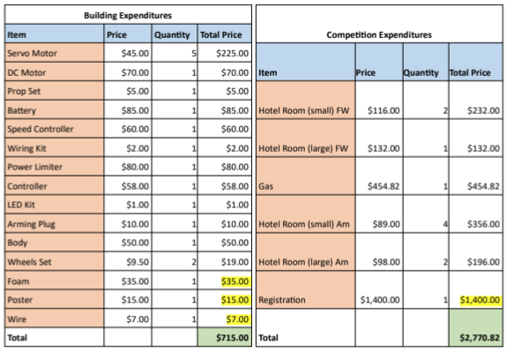

## Appendix F: Schedule

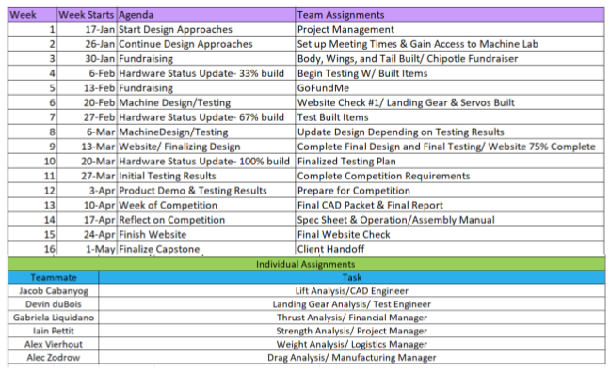

## Appendix G: FMEA

U,{107000ba-c784-4019-b854-cbcd8b4fe200}{41},3.125,3.125

## Appendix H: Final CAD Drawing



## Appendix J: Thrust Generation Subsystem Prototype

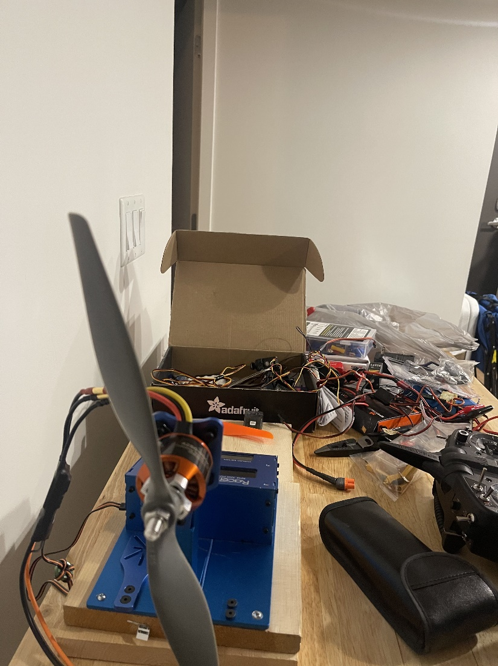

## Appendix K: Equations

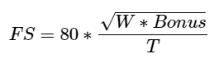[1]

