Team 8 SAE Aero
ME 486C Section 002

Control Surfaces Analysis

Iain Pettit
Gabriela Liquidano

Date: 02/05/2023

Table of Contents
Group Assignment 2
Introduction 2
Research 2
Assumptions 3
Details of Physical Modeling 3
Equations 4
Results 5
References 7
Appendix 8

Group Assignment
Before beginning set assignment, the team spoke with Professor David Willy and decided to divide the assignment in teams of two within the SAE Aero Team. The first team will focus on the landing gear analysis while the second team focuses on the stability analysis. Lastly, the third team will analyze and discuss the primary control surfaces of the aircraft, which is this analysis. This was decided by Professor and Willy and the team due to their fast-track schedule and fast approaching deadlines for competition. This will further allow the team to stay ahead of schedule without falling behind.

Introduction
The goal of this project is to design and build an RC aircraft to compete in all aspects of the SAE Aero competition in April of 2023. There are many different aspects to designing and building an electric aircraft. One of them being a stable and well-balanced control surface system. The team will focus this analysis on the three primary flight control surfaces: ailerons, elevators, and a rudder. Through this analysis, the team will analyze the forces applied to the system while in flight using hydrostatics and varying equations found through research. With the main design focus of this aircraft being a weight reduction, the team must analyze the torque required to operate control surfaces under max stress conditions to select the correctly sized servo motors. The team will also conclude the best placement for said system to maintain balance. This is essential to avoid flutter and catastrophic failure.

Research
Control for a fixed-wing aircraft takes place around the lateral, longitudinal, and vertical axes. The ailerons, which are attached to the trailing edge of both wings move the aircraft about the longitudinal axis causing it to roll. The elevators, on the other hand, are attached to the trailing edge of the horizontal stabilizer and when moved, it alters the aircrafts pitch. This causes the plane to move about the lateral axis. Lastly, the rudder is hinged to the trailing edge of the vertical stabilizer and when its position is changed, the plane rotates about the vertical axis. It is critical for the primary flight control surfaces to be balanced so they do not vibrate or flutter in the wind. [4]
The team found that an aircraft’s successful performance heavily relies on its maneuverability. This implies thrust, aircraft mass moment of inertia and control power. Since the ailerons cause the aircraft to steer along its three-dimensional flight path to a specified destination, the team found that an aileron’s main goal is roll control. In order to properly design an aileron, the team must determine four particular parameters. These parameters include the aileron area, chord/span, maximum and minimum deflection, and the location of the inner edge of the aileron along the wingspan. Based on extensive research, the group found that 5 to 10 percent of the wingspan is devoted to the aileron. 15 to 25 percent is the aileron to wing chord ratio and 20-30 percent is the aileron to wingspan ratio. Lastly, 60 to 80 percent is the inboard aileron span. Given these statistics, the team’s CAD model seems to correlate respectively with each percentage. [1]
Another critical note the team must take into consideration is the aircraft’s balance and flutter. Flutter is essentially instability due to the aircraft’s interaction with aeroelasticity. Balancing the control surfaces will help reduce the effects of flutter. By balancing the aircraft correctly, this will also reduce the load on the servo gear. By calculating the forces applied on the control surfaces, the team may be able to navigate any potential flutter before competition. This will allow the team to ensure their servos are properly sized or if they need to purchase a different size. [3]

Assumptions
To be able to estimate the forces applied on each control surface, some assumptions about the conditions of the aircraft were made. The first assumption is that at the leading edge of each control surface, the air is flowing parallel to the surface. This implies that when the control surfaces are not angled away from their cruising position, there is no pressure applied from the working fluid. This is also implying that the largest resulting force from the fluid will occur when the control surfaces are deflected at their maximum angle from their resting position. The team also assumed standard sea level air conditions to accurately represent flying conditions in Fort Worth, Texas which has an elevation of on 500 ft.

Details of Physical Modeling
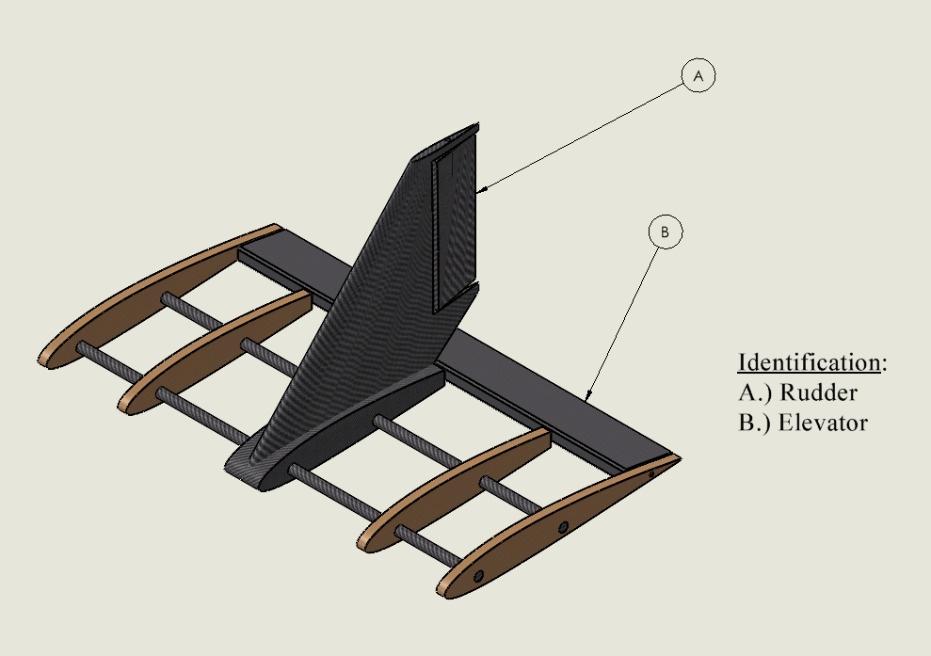
Figure 1: Rudder & Elevator Locations
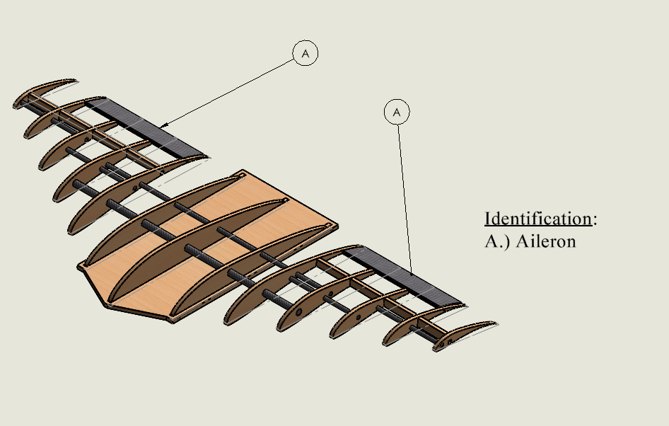
Figure 2: Aileron Locations
As shown in Figure 1, the rudder and elevator are located on the tail portion of the plane. The elevator is a long strip than spans the backend of the horizontal stabilizer. The elevator has a chord length of 1.4 inches, with a span of 11.4 inches. While the team found that the elevator should only span 60 percent of the horizontal stabilizer’s wingspan, the team felt that they would need a larger surface area to ensure a quick takeoff at competition, by enabling a larger manipulation of the working fluid. The rudder is located along the trailing edge of the vertical stabilizer. The rudder has a chord length of 1.4 inches, with a span of 3.77 inches. The span of the rudder was reduced to work with the existing geometry of the vertical stabilizer, but still falls within the recommended span.

Equations
The first step in analyzing the effectiveness of our control surfaces was calculating the force that would be applied by the air. To do this, this team first identified our load case by defining our maximum speed as 12.192 m/s. The max stress on the control surfaces would occur at this load case speed and would also occur at our maximum angle of deflection from each surface’s resting point. The maximum angle that our surfaces would be deflected to is 30 degrees. With our load case defined, Equation 1 was used to calculate the applied pressure of the working fluid.
$F_{∞}= \frac{1}{2}*ρ{*V}^{2}*A_{wetted}*sin⁡(θ)$ (1)

The wetted area of each control surface was found using the surface area measuring tool within Solidworks. The next step to validate our control surface design is to calculate the amount of torque on the servo motors. These torque values for the aileron, rudder, and elevator servos are found using Equation 2 below:
$T=F_{∞}*L_{arm}$ (2)
The servo arm lengths were found using the length measurement tool within Solidworks. This length is defined as the length from the servo motor to the resultant force of the fluid on the control surface. Once these values are found, they can be compared to the industry rated maximum torque values that our servo motors can handle. If our current servo motors are incapable of performing, an adequate servo must be found that can deflect our control surfaces to the desired 30 degrees.
When analyzing the effectiveness of the aircraft’s ailerons, the team had to assess its rolling moment. The rolling moment is essentially an aerodynamic force and the distance between where it is applied and the aircraft’s center of mass. This is the force that causes the plane to roll about its longitudinal axis. This is critical information as the rolling motion increases the angle of attack from the lowering wing whilst decreasing the angle of attack for the rising wing. The rolling moment can be characterized using Equation 3 below:
$L_{A}=\overline{q}SC_{l}b$ (3)
$\overline{q}$ is the dynamic pressure which is the pressure exerted perpendicular to the direction of the flow. The team found that the dynamic pressure came out to 91.04 pascals which was found using Equation 4 below:
$\overline{q}=\frac{1}{2}ρV_{T}^{2}$ (4)
Where rho is the air density and V is the aircraft’s airspeed which was calculated at 12.192 m/s. S in Equation 3 signifies the wing area and b signifies the wingspan while $C_{l}$ is the rolling moment coefficient. As a result, the team found that the rolling moment around the longitudinal axis is about 0.39 N*m. This would then mean that the rolling moment coefficient would then be approximately 0.417.

Results
Using a MATLAB code shown in Figure 1, the force applied on each control surface was calculated. The resulting force from the working fluid on each aileron was calculated to be 0.4643 N. With an arm length of 0.2567 m, the torque applied to the servo motor is 0.1192 Nm per aileron. This servo will be experiencing double that amount of torque due to our current configuration, which has one centrally located servo motor control both ailerons in series. The applied force on our elevator was found to be 0.4913 N, giving us a torque of 0.0699 Nm. The applied force of the fluid on the rudder was calculated to be 0.1639 N. With a servo arm of only 0.0711 m, the torque acting on this servo motor is 0.0117 Nm. While it was found that our control surfaces would not be enacting a great deal of torque on their respected motors, the motor that we currently possess will not suffice. Our servo motors are only rated for a maximum applied torque of 0.1412 Nm, which will not be strong enough for our ailerons. These motors will provide enough torque to deflect both our rudder and elevator, but a more powerful servo motor will be needed for the ailerons.
While analyzing the team’s aileron design, they found that the rolling moment around the longitudinal axis is about 0.39 N*m at a velocity of 12.192 m/s. This would then result their rolling moment coefficient to be approximately 0.417.

References
[1] “Aileron design Chapter 12 design of Control Surfaces - aero.us.es.” [Online]. Available: http://aero.us.es/adesign/Slides/Extra/Stability/Design_Control_Surface/Chapter%2012.%20Desig%20of%20Control%20Surfaces%20(Aileron).pdf. [Accessed: 05-Feb-2023].
[2] “Balancing RC airplanes - how to,” RC Airplane World - Complete Beginners RC Flying Guide. [Online]. Available: https://www.rc-airplane-world.com/balancing-rc-airplanes.html#:~:text=Methods%20of%20Balancing%20RC%20Airplanes%201%20Ballasting%20Up,plane.%20...%203%20Roll%20Balancing%20RC%20Airplanes%20. [Accessed: 05-Feb-2023].
[3] M. Bedding, “Control surface flutter, balance, and Vne,” Motion RC, 13-Oct-2020. [Online]. Available: https://www.motionrc.com/blogs/motion-rc-blog/control-surface-flutter-balance-and-vne. [Accessed: 05-Feb-2023].
[4] “Primary flight control surfaces and dual purpose flight control surfaces of a fixed-wing aircraft,” Aircraft Systems. [Online]. Available: https://www.aircraftsystemstech.com/p/flight-control-surfaces-directional.html. [Accessed: 05-Feb-2023].

Appendix

Equation 1: Applied Force
$$F_{∞}= \frac{1}{2}*ρ{*V}^{2}*A_{wetted}*sin⁡(θ)$$
Equation 2: Servo Torque
$$T=F_{∞}*L_{arm}$$
Equation 3: Rolling Moment
$$L_{A}=\overline{q}SC_{l}b$$
Equation 4: Dynamic Pressure
$$\overline{q}=\frac{1}{2}ρV_{T}^{2}$$
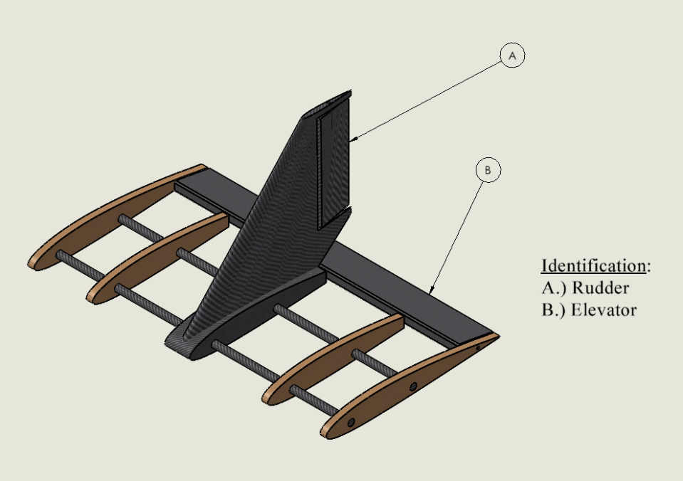
Figure 1: Rudder and Elevator Locations

Figure 2: Aileron Locations
Figure 3: Servo Torque MATLAB code
%Gabriela Liquidano
%Iain Pettit
%SAE Aero

clc
clear all
close all

%air density
rho = 1.225;
%aileron surface area
A_aileron = 0.0102;
%Rudder Surface Area
A_rudder = 0.0036;
%Elevator Surface Area
A_elevator = 0.0108;
%Load Case Velocity (Max Speed)
V_Max = 12.192 ;
%Load Case Aileron Angle (Max Angle)
theta = pi/6;

%Forces
%Force on Aileron
F_Aileron = (0.5*rho*V_Max^2*A_aileron*sin(theta));
%Force on Rudder
F_Rudder = (0.5*rho*V_Max^2*A_rudder*sin(theta));
%Force on Elevator
F_Elevator = (0.5*rho*V_Max^2*A_elevator*sin(theta));
%Arm Lengths
%Aileron Arm Length
L_Aileron = 0.2567;
%Rudder Arm Length
L_Rudder = 0.0711;
%Elevator Arm Length
L_Elevator = 0.1422;

%Torque
%Torque on Aileron
T_Aileron = L_Aileron*F_Aileron
%Torque on Rudder
T_Rudder = L_Rudder*F_Rudder
%Torque on Elevator
T_Elevator = L_Elevator*F_Elevator

