**Fall 2022 Project 16 Microscale**

**Bubble Generator**

**Final Proposal**

**Aaron Walcott**

**Simei Portillo Ramos**

**Musaab Nasralla**

**2022-2023**



**Project Sponsor: Dr. Zhongwang Dou**

**Faculty Advisor: Dr. Zhongwang Dou**

**Instructor: Armin Eilaghi**

# DISCLAIMER

This report was prepared by students as part of a university course requirement. While considerable effort has been put into the project, it is not the work of licensed engineers and has not undergone the extensive verification that is common in the profession. The information, data, conclusions, and content of this report should not be relied on or utilized without thorough, independent testing and verification. University faculty members may have been associated with this project as advisors, sponsors, or course instructors, but as such they are not responsible for the accuracy of results or conclusions.

# EXECUTIVE SUMMARY

The team has been tasked with making a microscale bubble generator for their client Dr. Zhongwang Dou. They have made significant progress despite some setbacks. They are currently tasked with the nozzle design as that is the most important part of this project for the client. They first started with a three-layer coaxial nozzle which ended up getting resin printed but with some design flaws and production limitations the smallest layer was not able to print very well since it is around 0.3 millimeters in diameter which is very small for most machines to make especially a 3D printer.

The team finally got their new nozzle to work with and since then the design has changed a lot. The nozzle they received is a brass two-layer nozzle. Consequently, to this point the team has been working to create a new layer that will be able to screw on and be machines out of aluminum since this will increase the durability and lifespan of their nozzle. The new nozzle layer design can be seen in appendix B.4-B.6. The team has yet to start machining this new design since none of them are certified at the NAU machine shop, but Aaron is planning on doing his certification by December of 2022.

The team has also been working with the new camera specifications that they have received. This is another big aspect to their project since the client wants to be able to capture the bubbles in motions for his aerodynamic or hemodynamic analysis in his research and lab. The camera is a very expensive high-speed camera that will be capturing short bursts of videos at around six thousand frames per second. With these new specifications the team will then be able to do more analysis of their nozzle to make sure that the customer’s requirements are met.

Additionally, they are trying to get an Arduino board so that they can start programming their device. The programming involved would be for the inputs of the machine so that they can read what pressure and flow rate the fluids are being fed through the nozzle. These measurements of flow rate and pressure will allow the team to be able to fix their designs or the nozzle if they do not work or are not up to the client’s requirements.

# TABLE OF CONTENTS

Contents

DISCLAIMER 1

EXECUTIVE SUMMARY 2

TABLE OF CONTENTS 3

1 BACKGROUND 1

1.1 Introduction 1

1.2 Project Description 1

2 REQUIREMENTS 1

2.1 Customer Requirements (CRs) 1

2.2 Engineering Requirements (ERs) 1

2.3 Functional Decomposition 2

2.3.1 Black Box Model 2

2.3.2 Functional Model/Work-Process Diagram/Hierarchical Task Analysis 2

2.4 House of Quality (HoQ) 2

2.5 Standards, Codes, and Regulations 3

3 Testing Procedures (TPs) 3

3.1 Testing Procedure 1: Bubble Output 3

3.1.1 Testing Procedure 1: Objective 3

3.1.2 Testing Procedure 1: Resources Required 3

3.1.3 Testing Procedure 1: Schedule 3

3.2 Testing Procedure 2: Bubble Concentration 3

3.2.1 Testing Procedure 2: Objective 3

3.2.2 Testing Procedure 2: Resources Required 3

3.2.3 Testing Procedure 2: Schedule 1

3.3 Testing Procedure 3: Bubble Size 1

3.3.1 Testing Procedure 3: Objective 1

3.3.2 Testing Procedure 3: Resources Required 1

3.3.3 Testing Procedure 3: Schedule 1

3.4 Testing Procedure 4: Device Residence 1

3.4.1 Testing Procedure 4: Objective 1

3.4.2 Testing Procedure 4: Resources Required 1

3.4.3 Testing Procedure 4: Schedule 1

3.5 Testing Procedure 5: Device Material 1

3.5.1 Testing Procedure 5: Objective 1

3.5.2 Testing Procedure 5: Resources Required 1

3.5.3 Testing Procedure 5: Schedule 1

3.6 Testing Procedure 6: User & Environmentally Friendly 1

3.6.1 Testing Procedure 6: Objective 1

3.6.2 Testing Procedure 6: Resources Required 1

3.6.3 Testing Procedure 6: Schedule 1

4 Risk Analysis and Mitigation 2

4.1 Critical Failures 2

4.1.1 Potential Critical Failure 1: Thermal Fatigue 2

4.1.2 Potential Critical Failure 2: Stress Rupture 2

4.1.3 Potential Critical Failure 3: Corrosion Wear 2

4.1.4 Potential Critical Failure 4: Combined Creep and Fatigue 2

4.1.5 Potential Critical Failure 5: Combined Creep and Fatigue 2

4.1.6 Potential Critical Failure 6: Combined Creep and Fatigue 2

4.1.7 Potential Critical Failure 7: Corrosion Wear & Combined Creep and Fatigue 3

4.1.8 Potential Critical Failure 8: Corrosion Wear 3

4.1.9 Potential Critical Failure 9: Combined Creep and Fatigue 3

4.1.10 Potential Critical Failure 10: Corrosion Wear & Combined Creep and Fatigue 3

4.2 Risks and Trade-offs Analysis 3

5 DESIGN SELECTED – First Semester 4

5.1 Design Description 4

5.2 Implementation Plan 5

6 CONCLUSIONS 6

7 REFERENCES 7

8 APPENDICES 8

8.1 Appendix A: Shortened FMEA 8

8.2 Appendix B: CAD models and Drawings for the Nozzle 8

8.3 Appendix C: Functional Decomposition Model 11

# BACKGROUND

## Introduction

The Project the team is tasked on working is to make a microscale bubble generator. The client, Dr. Zhongwang Dou, is an Assistant Professor in the Engineering Department at Northern Arizona University and would like to have this device in his lab. The microscale bubble generator is a device that could be used in a wind tunnel to be used to analyze the aerodynamics of objects. The bubbles are a form of particle for visualization to see how the object is affected by wind.

Our team is working to make a micro-scale bubble generator. Dr. Zhongwang Dou is our client for this generator, and he is the one who wants to see this device in his lab. He is the Assistant Professor in the Engineering department at Northern Arizona University. The size of the bubble that the generator will make will depend on the parameters like orifice diameter as well as the gas flow rate. The volume of the gas reservoir is another parameter which our team has considered. The device can be used in the wind tunnel, and it can be used for analyzing the aerodynamics of objects.

## Project Description

The goal of this project as said above is to make a microscale bubble generator. The client has requested that the machine can generate bubbles ranging from 15-150 microns in diameter. The client would also like this machine to have an output of one hundred million bubbles a second with a general density of twenty thousand per cubic centimeter with “easy to adjust settings.” This is so that one can analyze objects with precision. Finally, the client has requested that the machine has a residence time of thirty or more minutes.

# REQUIREMENTS

## Customer Requirements (CRs)

The team has been given a set of multiple requirements by the client Dr. Zhongwang Dou that the bubble generator should have. The most important requirements are the bubble output rate, the concentration of the bubble, and the size of the bubble. These are the major requirements which will make our machine different and better than the currently available machines. The requirements with ratings are given below

(1) Bubble output rate, this was rated at 12/12

(2) Bubble Concentration, this was rated at 12/12

(3) Device residence, this was rated at 10/12

(4) Device material, this was rated at 10/12

(5) Bubble size, this was rated at 12/12

(6) User friendly, this was rated at 4/12

(7) Durability, this was rated at 12/12

(8) Reliability, this was rated at 12/12

## Engineering Requirements (ERs)

The engineering requirements were based off the customer requirements that the team received. So, the team took the customer requirements and had to come up with a feasible way to conceptualize them. They were then able to make the list below.

(1) Bubble output rate: (bubbles / second)

(2) Bubble concentration: (bubbles / cm^3)

(3) Device residence: (time)

(4) Device material: (material chosen properties)

(5) Bubble size: (millimeters)  
(6) Durability: (time)  
(7) Reliability: (time)

## Functional Decomposition

Since the last report, there have been no changes made to the black box or functional decomposition model.

### Black Box Model

This section will be used to talk about the black box model of the team’s project. Pictured below in figure 14 is the black box model which is a simplified version of the functional model but is still a good representation of how the team visualizes their project. They chose three different modes of imports that allow them to make the bubbles with three different outputs. This is important for the team since they can easily come back to this and see exactly what needs to be done in order to complete their project.

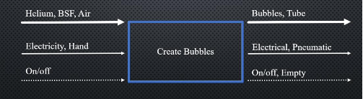

Figure 1: Black box Model

### Functional Model/Work-Process Diagram/Hierarchical Task Analysis

Using the black box model in chapter 2.3.2, a Functional Decomposition model was developed. The functional decomposition model uses the same notation as a black box model but creates a breakdown of each step throughout the device’s process. Each step was conceived from the customer requirements and the preliminary soup bubble design.

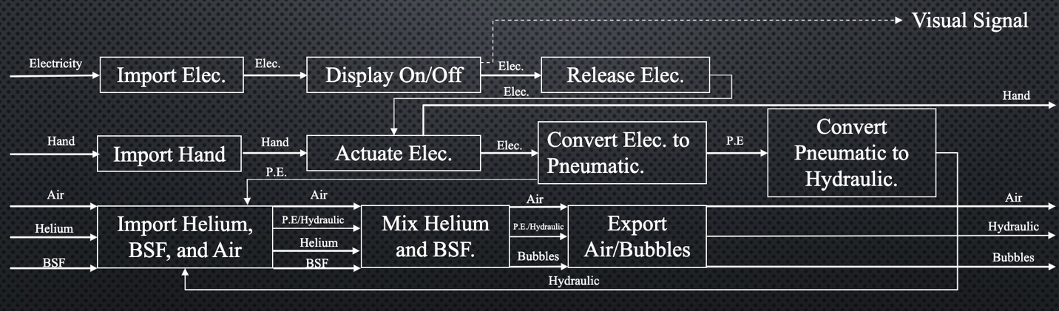

Figure 2: Detailed Decomposition Model

## House of Quality (HoQ)

For connecting the engineering requirements and customer requirement this house of quality is made. The importance score is given to every requirement, and we will use scores to understand how much the requirement is fulfilled. The importance of each requirement will be correlated. After completing the House of Quality, it was determined that the nozzle structure has the most importance in this project as it affects the bubble structure, output, size, and volumetric concentration. We also found that we need to design a 3-layer coaxial atomizer.

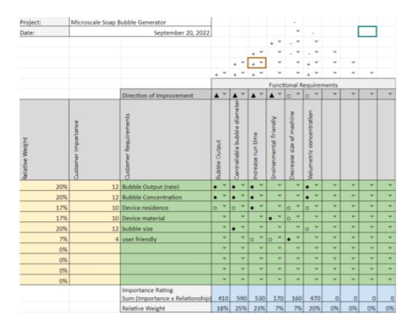

Figure 3: House of Quality

[Summarize project requirements in a House of Quality using the template provided on the course website. If the HoQ is small enough, you may include it here as landscape or portrait. If it is too large, add the HoQ as an Appendix. Include a detailed introduction to the section and a discussion of how the HoQ has helped the team in the design process. Be specific and detailed (i.e., do not write any statements that could be applied to multiple projects besides your own). Ensure that every Engineering Requirement has a legitimate target value and tolerance to the target.]

[Include Testing Procedures in the House of Quality for this report.]

## Standards, Codes, and Regulations

In this section of the report the team will be writing about the standards and codes they believe they will need for their project. The first code being from the ASME standards, and it details how the team needs to tolerate their CAD drawings as well as their dimensioning. The second code is also from the ASME standards which details metric bolts. The team thinks this is relevant since they will need to know about how to put their final device next semester. The third code is relevant to their project since it details pump energy, and they are pumping multiple fluids to produce their bubble. The fourth code is detailing valves which the team is going to be using so they can regulate the amount of fluid being pumped through their nozzle. Finally, the last code is detailing temperature measurement, this is relevant since the team will need to monitor the device temperature to make sure it stays at a normal operating temperature otherwise their fluids could change and make the device nonfunctional. Below in the table are the codes.

Table 1: Standards of Practice as Applied to this Project

|  |  |  |
| --- | --- | --- |
| **Standard Number or Code** | **Title of Standard** | **How it applies to Project** |
| ASME  Y14.5 | Dimensioning and Tolerancing | Applying GD&T to the CAD models that are made |
| ASME B18.3.6M | Metric Series Socket Screws | Information about socket head screws for the main device |
| ISO/ASME  14414 - 2019 | Pump system energy assessment | Assess the energy needed for the team’s pumps |
| ASME N278.1 - 1975(R1992) | Self-Operated and Power-Operated Safety-Related Valves Functional Specification Standard | Information about valves that the team will need to look at pressure running through their device |
| ASME  PTC 19.3 - 1974-(R2004) | Temperature measurement | Going to need to examine the overall device temperature |

# Testing Procedures (TPs)

This section will discuss the testing procedures that the team has come up with to accomplish all the Customer and Engineering Requirements. Each procedure will discuss the objective of the test, the resources needed for the procedure, and finally, the schedule the team plans to follow to complete the procedure.

## Testing Procedure 1: Bubble Output

The first customer requirement is the bubble output of the device. Our goal is to be able to produce 107 bubbles/s and to do so, the team plans on using multiple nozzles with a controllable pressure for the helium, BSF, and air using valves. The team will hand-calculate the theoretical output rate by hand and then use the Phantom camera to find out what the actual output of the device is.

### Testing Procedure 1: Objective

To obtain the desired bubble output, the team will be modifying the output rate of Air, BSF, and helium as well as adding more nozzles to the device if necessary. The bubble output is a customer requirement for which the team plans to obtain 107 bubbles/s. While running the device, the team will capture data using the Phantom camera and perform a series of calculations until they are able to obtain the desired output.

### Testing Procedure 1: Resources Required

* Nozzles
* Air Compressor
* Helium
* BSF
* Water Pump
* Wind Tunnel
* Phantom v7.3

### Testing Procedure 1: Schedule

For this test, the team plans to begin working next semester once they assemble the Helium-Filled Bubble Generator. This testing procedure might take many trials to complete, but they expect to at least be close enough on the first trial if their calculations are correct.

## Testing Procedure 2: Bubble Concentration

The bubble concentration of the device is a customer requirement where the device must be able to produce 20,000 bubbles/cm3. To test the concentration of the device, the team will have to produce bubbles after assembly on the wind tunnel and using the Phantom v7.3 camera they will calculate the bubble concentration.

### Testing Procedure 2: Objective

The objective of this procedure is to find what the bubble concentration is per cubic centimeter. Once the Helium-Filled Bubble Generator has been assembled, they’ll use the wind turbine and the Phantom camera to obtain data through a series of trials and calculations until they are able to obtain the desired concentration.

### Testing Procedure 2: Resources Required

* Phantom v7.3 Camera
* Helium
* BSF
* Air Compressor
* Water Pump
* Nozzles
* Pressure Valves
* Wind Tunnel

### Testing Procedure 2: Schedule

For this procedure, the team plans on running the trials sometime next semester once the assembly of the device is complete. If their calculations are correct, the actual bubble concentration should be close to the desired concentration, if not, then they will make corrections on the device as needed.

## Testing Procedure 3: Bubble Size

This third testing procedure will help them complete another customer requirement where the size of the bubble must range between 15 and 150 microns. To find what the size of the bubble is, they will use the device in the wind tunnel and capture data using the Phantom camera. After obtaining the data, they’ll perform calculations to figure out what the diameter is.

### Testing Procedure 3: Objective

The objective of this procedure is to obtain data regarding the bubble size, which is a customer requirement given by Dr. Dou. They plan on aiming for a diameter of 15-150 microns for the bubbles. Once the device is fully assembled, they’ll use the wind tunnel and the Phantom camera to obtain data and then measure the diameter of all the bubbles.

### Testing Procedure 3: Resources Required

* Phantom v7.3 Camera
* Wind Tunnel
* Helium
* BSF
* Air Compressor
* Water Pump
* Nozzles
* Valves

### Testing Procedure 3: Schedule

The team plans on running tests for the bubble size once the device has been completely assembled next semester. This test will be run at the same time as Testing Procedure 1 and Testing Procedure 2, taking advantage of the fact that they can obtain data from all of them at the same time.

## Testing Procedure 4: Device Residence

The customer requirement they will be completing by doing this test will be the device residence where the device must run for at least 30 minutes, as stated by the customer. While running the Testing Procedures 1-3, they will use a timer to see for how long they can use the device running while still meeting the requirements stated in Procedures 1-3.

### Testing Procedure 4: Objective

The objective of this procedure is to make the device have a time residence of at least 30 minutes, which is a customer requirement. Dr. Dou had stated before that the usage of an Arduino is optional, but for now the team does not plan on using one. To figure out how long the device can last while running, they will measure the time while they run tests for the previous three Testing Procedures.

### Testing Procedure 4: Resources Required

* BSF
* Air Compressor
* Helium
* Wind Tunnel
* Stopwatch
* Electricity

### 3.4.3 Testing Procedure 4: Schedule

To test the device residence, the team will need to have the device fully assembled; therefore, this procedure will take place next semester. As the team runs tests for the previous Testing Procedures mentioned above, they will also run tests on how long the device can run for.

## Testing Procedure 5: Device Material

For this procedure the team will figure out the total weight of all components to then calculate if the material is resistant enough to withstand all the weight without damage. They plan on using Aluminum sheets as they tend to be somewhat resistant and cheap. The device material was selected as an Engineering Requirements because they want to be able to use a material that can be strong and within their budget.

### Testing Procedure 5: Objective

The objective of this procedure is to determine what material would be beneficial for the device, a material that is both resistant and affordable. To determine what material would be beneficial for the team, they will figure out the interior layout and the total weight of the components inside the device, then they’ll run some calculations and tests that will determine whether the material is good for the device.

### Testing Procedure 5: Resources Required

* Air Compressor
* Water Pump
* Helium
* Valves
* Connectors
* Aluminum Sheets

### Testing Procedure 5: Schedule

This procedure is planned to be started next semester as the team works on connecting the air compressor, helium tank, water pump, and BSF altogether. By doing so, they will have a more detailed idea on how big the device should be and how thick they should buy the aluminum sheets.

## Testing Procedure 6: User & Environmentally Friendly

This procedure’s goal is to make a device that can easily be used with easy to adjust settings for anybody in the lab. The team also plans on using materials for the bubbles and the device that are not harmful for the environment, which they have planned on using aluminum sheets for the device and the client will provide them with the Bubble Soap Formula.

### Testing Procedure 6: Objective

The objective of this procedure is to make the device easy to use while still taking into consideration the avoidance of any chemicals that can be harmful to the user and the surrounding environment. These are two customer requirements given by the client at the beginning of the semester.

### Testing Procedure 6: Resources Required

* Helium-Filled Bubble Generator
* Wind Tunnel
* (Possibly) Arduino
* Lab Partners Opinions

### Testing Procedure 6: Schedule

For this procedure the team plan on starting in adjusting the device next semester as we run tests and figure out ways to make the device easier to be used. The device material can be changed sometime next semester as well, only if they find out that Aluminum sheets can cause any problems to the device itself or the wind tunnel.

# Risk Analysis and Mitigation

This section will discuss the potential failures and ways the team came up with to mitigate those potential failures. Before drafting this report, the team was tasked to complete the FMAE excel template. For the FMAE the team had to come up with a minimum of four critical subsystems to then figure out ten potential failures later for each subsystem. The excel sheet also provides a summary of the FMEA (Appendix A) in which it has been shortened to ten of the highest RPN values for the team’s project.

## Critical Failures

### Potential Critical Failure 1: Thermal Fatigue

The first potential failure is thermal fatigue from the connection of all electrical components, this can be caused by overloading the supply power into the air compressor and water pump. Thermal fatigue may cause a fire or power outage on the power supply or devices. This problem can be fixed by making sure that the total amount of electricity coming out of the power supply is not consumed completely from the air compressor and the water pump.

### Potential Critical Failure 2: Stress Rupture

The second potential failure is stress rupture from the nozzle, this can be caused by having a high output pressure coming out of the air compressor, water pump, and helium tank. Stress rupture can cause a destruction of the nozzle which affects the bubble output rate and the size of the bubbles. To avoid stress rupture on the nozzle the team plan on using valves that control the pressure going into the nozzles.

### Potential Critical Failure 3: Corrosion Wear

The third potential failure is corrosion wear on the aluminum sheets that we plan on using for the device. Corrosion wear can happen with any leaks from the BSF, if this were to happen then the aluminum sheet will start to wear down until eventually it will need to be replaced. To avoid this potential failure, the team will need to secure all connections where the BSF will be passing through.

### Potential Critical Failure 4: Combined Creep and Fatigue

The fourth potential failure is combined creep and fatigue on the helium tank. This potential failure can happen by overstressing the helium tank and not providing proper care to the tank (this will be noticeable over time). Combined creep and fatigue can cause the helium tank to explode or leak through cracks that have appeared over time. To avoid this potential failure, the team and the lab team will need to take proper precautions when handling the helium tank and providing proper maintenance overtime.

### Potential Critical Failure 5: Combined Creep and Fatigue

The fifth potential failure is combined creep and fatigue on the air compressor. This potential failure can only happen if the pressure regulator on the compressor is broken or the storage for the compressed air is dropped. Combined creep and fatigue can cause the air compressor to explode or leak through cracks that have appeared over time. To avoid this potential failure, the team and the lab team will need to take proper precautions when handling the air compressor and providing proper maintenance overtime.

### Potential Critical Failure 6: Combined Creep and Fatigue

The sixth potential failure is combined creep and fatigue on the regulators or valves, like potential failures four and five. This potential failure can occur when the valves are overstressed by the pressure of air, helium, and BSF. If a failure were to happen in the valves, the air, helium, and BSF would leak out making a disaster inside the device which could potentially lead to more failures. To avoid this potential failure, the team and the lab team will have to obtain valves that can withstand the maximum pressure obtained from the compressor, helium tank, and water pump that will pressurize the BSF.

### Potential Critical Failure 7: Corrosion Wear & Combined Creep and Fatigue

The seventh potential failure is corrosion wear & combined creep and fatigue for the water pump. It was determined that for the water pump it could have combined creep and fatigue since it will be pressurizing the BSF and in case there is a problem and the water pump breaks and spills all over the device, then it could cause corrosion wear if it’s not properly cleaned. To avoid this potential problem, the team are expecting for the water pump to be made out of a durable material, and in case it was to break, then the team plans on building a little removable tray that can be cleaned in case of spills and leaks.

### Potential Critical Failure 8: Corrosion Wear

The eighth potential failure is corrosion wear for the exit hose. This potential failure can occur if the exit hose is not properly clean after using the device, this could cause the exit hose to deteriorate over time. To avoid this potential failure, the team has decided to find a hose that will have little to no corrosion over time (like a garden hose) and will be asking the lab team to properly clean the hose occasionally.

### Potential Critical Failure 9: Combined Creep and Fatigue

The ninth potential failure is combined creep and fatigue for the hoses that will connect from the air compressor, helium tank, and BSF to the nozzles. This potential failure can occur if the hoses are not made of a material that can withstand such high pressures, if this failure were to occur then the device will not be able to create the helium-filled bubbles and could cause a spill all around and inside the device. To avoid this failure, the team will find a hose that withstands high pressures as well as properly securing the hoses to wherever they connect.

### Potential Critical Failure 10: Corrosion Wear & Combined Creep and Fatigue

The tenth and last potential failure is corrosion wear & combined creep and fatigue for the connectors of the hoses. This potential failure can occur if the connectors are not strong enough to withstand the pressure forces to keep the hoses attached in place, if this failure were to occur, we would not be able to create bubbles as well as having a mess of spilled and leaked material. To avoid this failure the team has decided to find strong connectors such as those found in cars or add a series of “steps” into all 3D printed components.

## Risks and Trade-offs Analysis

After discussing all the potential critical failures above, the team has determined that mitigating one failure will not negatively affect mitigating another critical failure, on the contrary, it will benefit other components as they will not be affected at all. In other words, we have determined that there is no trade-off between mitigating one failure with all other components.

# DESIGN SELECTED – First Semester

In this section of the memo Aaron will be talking about the team’s current prototype and how it is meeting expectations as well as how he and the team plan to change the design for future proofing.

## Design Description

The team’s current prototype is a resin 3d printed nozzle that is coaxial with three different layers. The outermost layer being for the air, the second layer for the bubble fluid solution and the smallest inner layer being or the helium. These three layers all converge in an end cap that mixes the fluids together and the helium pushes through and creates the bubble from the mixture. The team is currently working on a newer prototype as they just received a brass version of the nozzle. So, Aaron has been tasked with making the third layer to it since it is just a two-layer nozzle. This new nozzle is made of brass and the third layer will be made of aluminum so that the nozzle overall should be able to last a long time. The team’s current design and future design can be shown in figures ## and ## below. Another major idea that has changed from the team’s initial prototype and the final design they are working to now is the overall size. They learned that to get the nozzle diameter they wanted it would be complicated to print since it was so small. The client saw this and ordered a coaxial nozzle online. This was going to change quite a few things for the team since now they have a whole new nozzle to work with towards the end of the semester.

Aaron has started looking at which formulas he will need to use for future analysis since to this point the team has not had to do many calculations for the prototype. Aaron has found some equations of interest through the sources that the client gave to the team. Below is equation 1 which is the equation of motion for a particle. This equation will help the team determine what needs to be done to figure out how to get a good particle spacing so that it can be analyzed. Additionally, equation 2 will be used to help determine the velocity of the output of the particles. Both equations can be found in (insert reference 2).

$m\frac{du_{p}}{dt}=\frac{πd^{3}}{6}ρ_{p}g-\frac{πd^{3}}{6}ρ_{f}g-3πμd\left(u_{p}-u_{f}\right)$---------- [1]

$u_{t}=u_{p}-u_{f}=\frac{\left(∆tρ_{p}-ρ_{f}\right)d^{2}g}{18μ}$-------- [2]

Continuing, Aaron has been tasked with most of the CAD work. He has made a nozzle design using onshape and is now working on the updated version of the nozzle since he just received the new nozzle the client would like to be using. Refer to Appendix 8.2 to see the nozzle drawings and current CAD models. Pictured below is the current nozzle the team has prototyped.

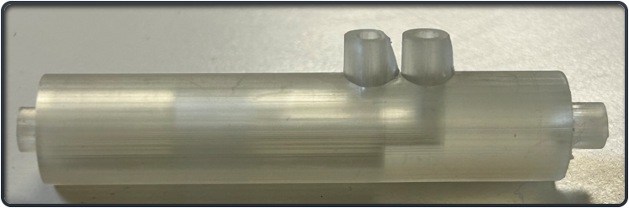

Figure ##: 3D resin printed nozzle

## Implementation Plan

In this section Aaron will talk about the team’s plan for this design to be implemented into the final design. The future nozzle detailed in section 5.1 of this report will be the final design so the team can start working on the rest of the device. The team plans on getting the third layer manufactured in house at the NAU machine shop. Aaron is planning on getting certified so that he can hopefully use the machines to make the design so that the team can save some money. Aaron has background knowledge in CNC machining as well as a general knowledge of how to use the other machines such as a mill and lathe however he is going to try and make his parts easy to CNC since he has a lot of experience in that. The team currently has a relatively small bill of materials as seen in figure ##, and there are a few things they are going to buy or already bought as well as the client has provided some of the bill of materials such as the high-speed camera and air compressor which saves the team twenty thousand dollars or more.

Aaron will additionally be refreshing himself on how to CAM a part which is taking a CAD assembly or part and importing it to another program to convert it to gcode which is what CNC machines read to produce a part. Finally, Aaron will be making sure that he can create readable part drawings that may need to be manufactured by his peers in the machine shop for time efficiency however he plans to try and do most of it himself.

For the upcoming semester, the team can move on to the rest of the device. The nozzle is the most important part so with that design finalized the team will be able to continue. For the first month of the next semester, the team will be designing the outer casing of the device. They will then move on to the electronics after they have finished that since they will have a representation of the amount of space, they will be able to work in.

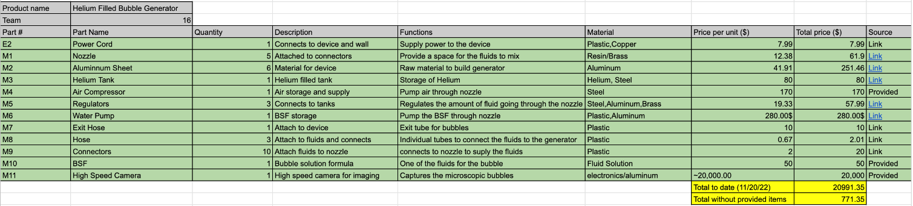Figure ##: Bill of Materials

# CONCLUSIONS

The purpose of the project was to make a micro scale bubble generator. It was requested by the client to make a device which generates bubbles from 15 to 150 microns in diameter. It was also requested that the machine should have the ability to make a hundred million bubbles per second at a general volume of twenty thousand bubbles per cubic centimeter. It was decided that the team will hand-calculate the theoretical output rate then they’ll use the high-speed camera to find out what the actual output of the device is. Also, to obtain the desired bubble output, the team will be modifying the input rate of Air, BSF, and helium as well as adding more nozzles to the device if necessary. It was concluded that bubble size testing procedure will help the team complete another customer requirement where the size of the bubble must range between 15 and 150 microns. To find what the size of the bubble is, the team will use the device in the wind tunnel and capture data using the phantom camera. The team’s current prototype is a resin 3D printed nozzle that is coaxial with three different layers. These three layers all converge in an end cap that mixes the fluids together and the helium pushes through and creates the bubble from the mixture. This is how we will fulfill the requirements of the customer and face the challenges.

# REFERENCES

[1] Caridi, G. C. A. (2018). Development and Application of Helium-Filled Soap Bubbles: For Large-Scale PIV Experiments in Aerodynamics. <https://doi.org/10.4233/uuid:effc65f6-34df-4eac-8ad9-3fdb22a294dc>

[2] Barros, D.C., Duan, Y., Troolin, D.R. et al. Air-Filled Soap Bubbles for Volumetric Velocity Measurements. Exp Fluids 62, 36 (2021). <https://doi.org/10.1007/s00348-021-03134-6>

[3] S. Shibata, T. Yamazaki, and H. Matsuda, “Development of Micro Soap Bubble Generator for piv tracer using home stereolithography 3D printer,” *14th International Symposium on Particle Image Velocimetry*, vol. 1, no. 1, 2021.

[4] F. Scarano, S. Ghaemi, G. C. Caridi, J. Bosbach, U. Dierksheide, and A. Sciacchitano, “On the use of helium-filled soap bubbles for large-scale tomographic PIV in wind tunnel experiments,” *Experiments in Fluids*, vol. 56, no. 2, 2015.

[5] J. I. Arrizubieta, I. Tabernero, J. E. Ruiz, A. Lamikiz, S. Martinez, and E. Ukar, “Continuous coaxial nozzle design for LMD based on numerical simulation,” *Physics Procedia*, vol. 56, pp. 429–438, 2014.

[6] G. M. Neunzert, "FLUID CHARACTERISTICS AND PRESSURE DROP IN A HIGH PRESSURE FOAM SYSTEM," ProQuest , vol. 1, no. 2, p. 71, 2018.

[7] Y. Kubo, "Bubble Clouds: 3D Display Composed of Soap Bubble Cluster," ACM, vol. 01, no. 2, p. 10, 2015.

[8] M. Raffel, "Applications: Volumetric Flow Measurements," Springer, vol. 2, no. 1, p. 632, 2018.

[9] M. Nakamura, G. Inaba, J. Tamaoki, K. Shiratori, and J. Hoshino, “Mounting and application of bubble display system: bubble cosmos,” Jun. 2006.

[10] Huhn, F., Schanz, D., Gesemann, S. *et al.* Large-scale volumetric flow measurement in a pure thermal plume by dense tracking of helium-filled soap bubbles. *Exp Fluids* **58**, 116 (2017). <https://doi.org/10.1007/s00348-017-2390-2>

# APPENDICES

## Appendix A: Shortened FMEA

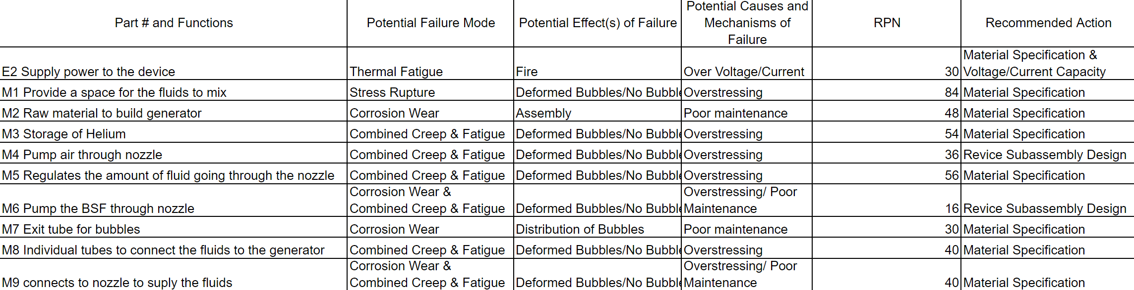

## Appendix B: CAD models and Drawings for the Nozzle

**Appendix B.1: Current revision of the nozzle**

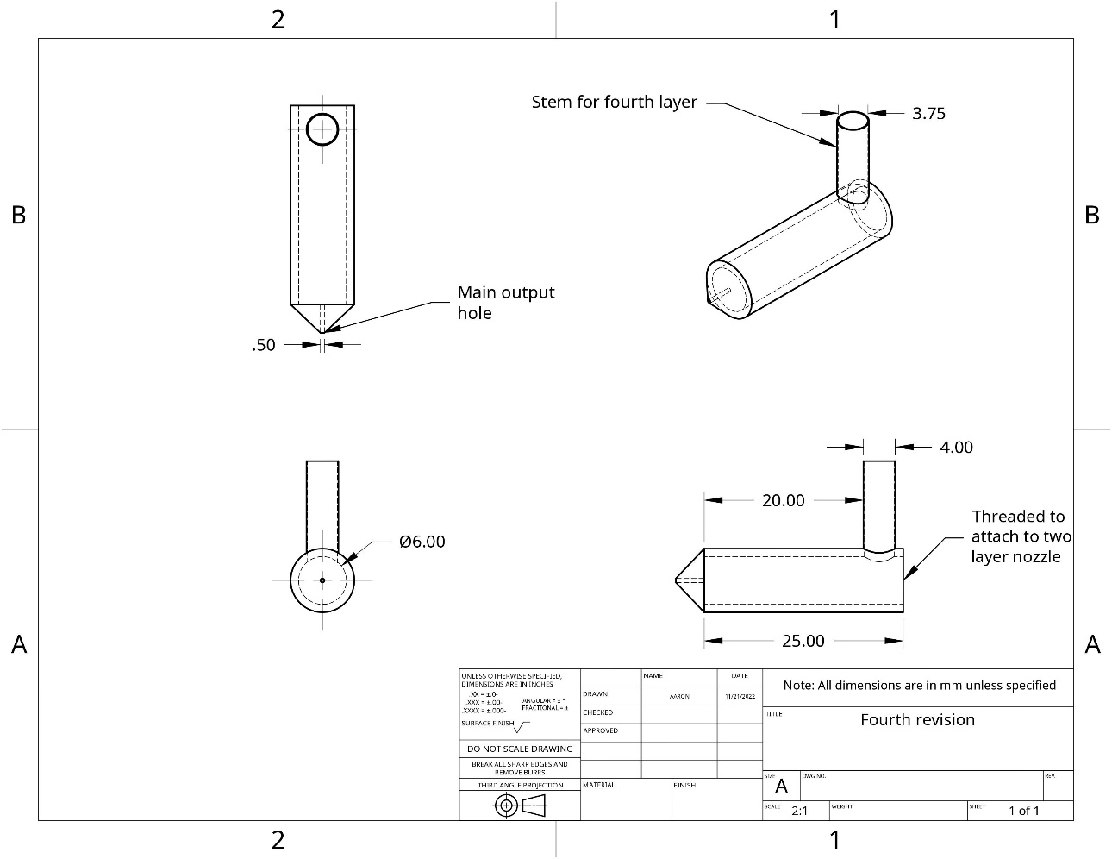

**Appendix B.2: Older nozzle design**

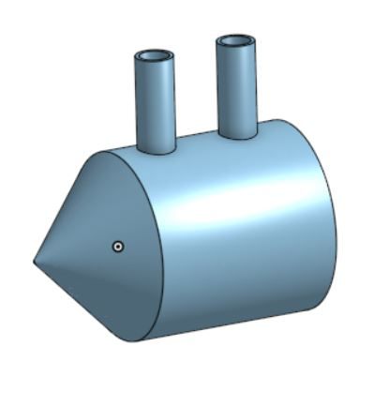

*\*Older prototype design as seen in section 5.1*

**Appendix B.3: Cross section of the older model**

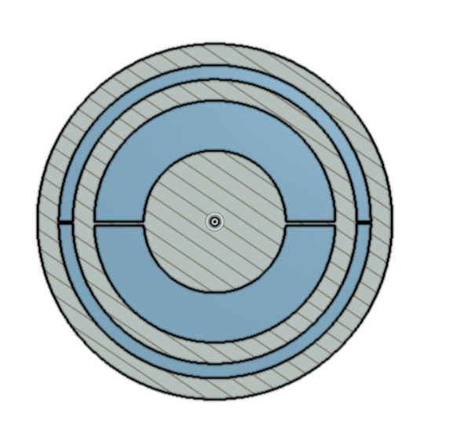

*\*Older prototype design as seen in section 5.1*

**Appendix B.4: Newest revision of the nozzle**

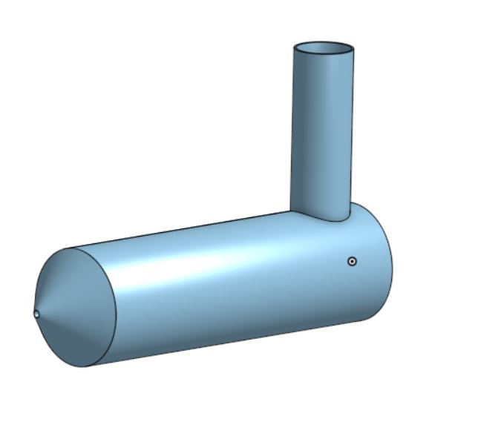

*\*Newer design as seen in the part drawing*

**Appendix B.5: Brass nozzle**

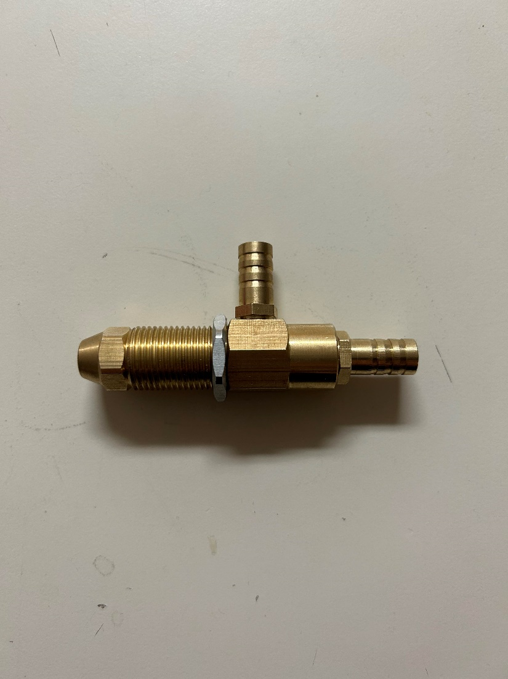

**Appendix B.6: Exploded view of the brass nozzle**

## Appendix C: Functional Decomposition Model

