**SAE Baja**

**Final Proposal**

**Omer Alamoudi**

**Chujian Wang**

**Salem Al Marri**

**Musaed Fraidoun**

**Rashid Algelmod**

**2020-2021**



**Instructor: Dr.David Willy**

# DISCLAIMER

This report was prepared by students as part of a university course requirement. While considerable effort has been put into the project, it is not the work of licensed engineers and has not undergone the extensive verification that is common in the profession. The information, data, conclusions, and content of this report should not be relied on or utilized without thorough, independent testing and verification. University faculty members may have been associated with this project as advisors, sponsors, or course instructors, but as such they are not responsible for the accuracy of results or conclusions.

# EXECUTIVE SUMMARY

SAE Baja has many systems to focus on, our project has three subsystems that we were assigned at the beginning of the semester, which are: the brake, front suspension, and dashboard systems. The brake system is one of the most important systems and it has the responsibility to stop the vehicle, the front suspension will provide the stability once the vehicle moves in different terrains in the competition, and the dashboard system should be able to appear the data regarding the vehicle, it includes the speed, rpm, and other specifications about the vehicle. The front suspension system should be in excellent condition and strong to keep the competitors in a relaxed mode where they will face lots of jerks in the competition. Also, the front suspension should be able to resist the different terrains while the car should not stop. Similar to these, the dashboard has to be designed in such a way that it will not take a lot of power from the battery and it will provide the vehicle details with precise results.

Our team focused on the critical requirements that are needed to achieve by the end of fall 2021 and these requirements include efficient brake, front suspension, and dashboard systems. Each system should be designed in a good manner to have safety, durability, etc. Also, each system should be designed with consideration durability and long-lasting. No less important, brake and front suspension systems should be able to resist all terrains without stopping the vehicle. The suspension should be flexible and strong to rescue from all terrains. Also, the dashboard system should provide the driver with the vehicle’s specifications.

The selected designs accomplish the engineering requirements produced from the customer requirements. For example, the brake system can stop the vehicle within 10 meters, and the time duration does not exceed 5 seconds. Also, the heat that is found during the braking should not reach 80 degrees and the overall weight of the systems should not cross 80 lb. All of these specifications followed by the design, the CAD model has developed in which the brake system has shown with the disc, caliper, spindle, and the suspension includes wishbones and moveable links with the spring. The project is not going to be implemented in physical form, rather it will be done as an analytical project and it will present a 3D CAD model at the end. It will perform different analyses about the design which includes FEA analysis for the materials, heat transfer analysis using the Laplace transformation, and FEA for observing the heat generation during the braking process. It will use different software to analyze them like MATLAB, LTSpice, and SolidWorks.

In the next semester, the team will work on the analysis and it will perform different analysis and will implement the SolidWorks for CAD model with the motions of each part to analyze the forces and different aspects of the design and will select the material that will be used to build the project through the analysis.

# TABLE OF CONTENTS

Contents

**DISCLAIMER** **1**

**EXECUTIVE SUMMARY** **1**

**TABLE OF CONTENTS** **2**

**BACKGROUND** **1**

Introduction 1

Project Description 1

**REQUIREMENTS** **1**

Customer Requirements (CRs) 2

Engineering Requirements (ERs) 2

Functional Decomposition 3

Black Box Model 4

Functional Model/Work-Process Diagram/Hierarchical Task Analysis 4

Front End Suspension 5

Brake System 5

Dashboard System 6

House of Quality (HoQ) 6

Standards, Codes, and Regulations 8

**Testing Procedures (TPs)** **3**

Testing Procedure 1: Heat 3

Testing Procedure 1: Objective 3

Testing Procedure 1: Resources Required 3

Testing Procedure 1: Schedule 3

Testing Procedure 2: Spring 3

Testing Procedure 2: Objective 3

Testing Procedure 2: Resources Required 3

Testing Procedure 2: Schedule 4

Testing Procedure 3: Track Width 4

Testing Procedure 3: Objective 4

Testing Procedure 3: Resources Required 4

Testing Procedure 3: Schedule 4

Testing Procedure 4: Dashboard 4

Testing Procedure 4: Objective 4

Testing Procedure 4: Resources Required 4

Testing Procedure 4: Schedule 4

Testing Procedure 5: Braking Distance 4

Testing Procedure 5: Objective 5

Testing Procedure 5: Resources Required 5

Testing Procedure 5: Schedule 5

Testing Procedure 6: Braking Time 5

Testing Procedure 6: Objective 5

Testing Procedure 6: Resources Required 5

Testing Procedure 6: Schedule 5

Testing Procedure 7: Circuit Power Limits 5

Testing Procedure 7: Objective 5

Testing Procedure 7: Resources Required 6

Testing Procedure 7: Schedule 6

Testing Procedure 8: Decrease Weight 6

Testing Procedure 8: Objective 6

Testing Procedure 8: Resources Required 6

Testing Procedure 8: Schedule 6

Testing Procedure 3: Battery 6

Testing Procedure 3: Objective 6

Testing Procedure 3: Resources Required 7

Testing Procedure 3: Schedule 7

**Risk Analysis and Mitigation** **8**

Critical Failures 8

Potential Critical Failure 1: Leather Pads 8

Potential Critical Failure 2: Wishbone Hinges 8

Potential Critical Failure 3: Wishbone 8

Potential Critical Failure 4: Rotor 9

Potential Critical Failure 5: Connections 9

Potential Critical Failure 6: Controller Board 9

Potential Critical Failure 7: Wishbone Central Rod 9

Potential Critical Failure 8: Caliper 9

Potential Critical Failure 9: Spindle 10

Potential Critical Failure 10: Brake Rod 10

Risks and Trade-offs Analysis 10

**DESIGN SELECTED – First Semester** **12**

Design Description 12

Brake System 12

Front Suspension Brake System 15

Implementation Plan 20

**CONCLUSIONS** **24**

**REFERENCES** **25**

**APPENDICES** **26**

Appendix A: FMEA 26

# BACKGROUND

## Introduction

The rationale of this design is to be able to comparatively assess the design of a small off-road car that is capable of treading complex terrains. In order to effectively design and create a prototype, the three vital subsystems must be properly evaluated namely the brake, front suspension and the dashboard systems. The main goal of the design is for the prototype to have a shorter stopping time and distance relative to the commercially known SAE 2021 vehicle designs. The rules state that the braking mechanism must be capable of simultaneously locking all four wheels [1]. The main takeaway of this endeavor is for the stakeholders to believe that such design is safer and sturdier. This can only be attained if the braking mechanism is able to do the locking process in a simultaneous manner for the four wheels available.

## Project Description

There are three main points for improving and designing new systems in this design: brake, front suspension, and dashboard system. The SAE-BAJA off-roading vehicle designs and regulations will be incorporated for possible market benchmark propulsion and commercialization in this design. The tests involved the acceleration tests, hill climbing, and endurance tests. The achievement of these targets necessitates the accurate design of the vehicle's suspension and braking system to be comparable to the commercially existing ones. For this project, the design is generated from the SAE Baja and from the customer requirements that are in the competition rules to compete. The design should overcome all difficult and complex conditions such as the acceleration tests, braking tests, hill climbing, and endurance. To succeed and realize the design's target, it should be an accurate front suspension and braking system in the perfect, accurate manner of design. Finally, the implementation of this design will be analyzed, and the testing will follow by meeting all the client's requirements.

# REQUIREMENTS

For any design project, requirements are the main focus, and on the premise of given requirements, the project designs. There are different requirements, and one is customer requirements which obtain from the project description, engineering requirements obtains from the customer requirements. This chapter introduces the customer requirements, engineering requirements, and HOQ of our project. The wants gave us the direction and standards of project design. When comparing different designs, these requirements can help us to attain and choose the finest design plan.

## Customer Requirements (CRs)

The aim of the project is to style and build a reliable single-seat sporting vehicle that's suitable for all-terrain. The project is split into three subsystems, for example Front-End Suspension, Brakes, and Dashboard. These subsystems were assigned to the members of the team. Following are the requirements that were pulled out from the SAE Baja Project instructions.

Table 1: Customer Requirement

|  |  |
| --- | --- |
| **Customer Requirements** | **Details** |
| Efficient Brake System | The system need to efficiently stop the vehicle in short duration of time |
| Efficient Front Suspension System | The suspension need to work smoothly and efficiently to provide complete comfort |
| Sleek Dashboard | Display the dashboard with all the data in simplified manner |
| Safe to Use | Brake system should be safe to use |
| Durable/Long Lasting | Suspension and brake should work for long duration |
| Reliable | Systems should be reliable and must not fail during the operation |
| Flexible Suspension | Suspension should be flexible enough to bear the rough terrains and off-road hectic. |
| Light in Weight | Suspension, brakes, and dashboard everything should be light weight |
| Long power backup | Battery size should be sufficient for power |

## Engineering Requirements (ERs)

Depending on the customer requirements (CR), the engineering requirement is generated by the CR. the most ideas here within the ERs that specialize in the sturdiness and stability of the car, and absolutely weight. Supported Baja competition rules, the measurement of weight should be 250 Ib, and therefore the track width of the vehicle should be <64 In. The brakes must follow the competition rules for SAE Baja that states to lock all four wheels at the same time. The warmth that's released from the rotors in Baja vehicles is approximated in an exceedingly range that's not above 700 K, that the best brakes are that the disk because it's the power to soak up the warmth better than other brake systems. For the dashboard, the error of the test instrument wont to measure the vehicle speed shall not be greater than ±1.0%. The minimum speed division value shouldn't be greater than 10km/h. The minimum graduation value of the tachometer shouldn't be greater than 500r/min. The nominal voltage of the meter is 12V, and also the working voltage range is 10.8V-16V. The current working range of the meter is 0.05A to 0.4A. If using over 12V, the transformer on Arduino may overheat and damage the board.

Table 2: Engineering Requirements

|  |  |  |
| --- | --- | --- |
| **Engineering Requirements** | **Targets** | **Rationale** |
| Heat | < 80 Degrees | The brake system in SAE Baja should be designed and equipped as a disk brake because it is less receptive to heat during the stopping vehicle time. |
| Spring | < 2 N/m | The Spring means that it contributes to reduce the effect of shock force when the vehicle shocks a stone or rigid body |
| Track width | <64 in | referees to the distance between the two wheels in the front suspension. when the track width is smaller |
|  |  |  |
| Dashboard shows data | Error <±1.0%. | Accuracy of the value displayed on the dashboard |
| Braking Distance | < 10 meters | Stop the vehicle after applying the brake, the distance it will cover during the applied brake |
| Braking Time | < 5 sec | Time it takes to apply the brake and then the vehicle required the time to get stop |
| Circuit Power Limit | 10.8V-16V;0.05A-0.4A | Voltage range:10.8V-16V. Current range:0.05A to 0.4A. |
| Decrease the Weight | <250 Ibs | Depends on the Baja rules, is able to carry the driver weight that should not exceed 250 Ibs |
| Battery | 12 V | Depends on power limit and component operating voltage |

## Functional Decomposition

Functional decomposition is the division of the particular projects into subsystems, and thus the functional decomposition defines how the system works from start till the tip and what steps will perform within the system to require the input to the output. The hierarchical task analysis or functional model defines the system with its subsystems while the recorder model defines the inputs and outputs of the system, and it doesn't define what's happening inside the system, whereas the functional model defines the entire internal working of the system. In this section, the black box model and functional model will be introduced.

### Black Box Model

The Black Box model tells the inputs and outputs of the system, and these inputs and outputs are consisting of a mass, energy, and signal. The project contains three aspects, front suspension, brake system, and dashboard system, so the black-box model of each system is shown below.

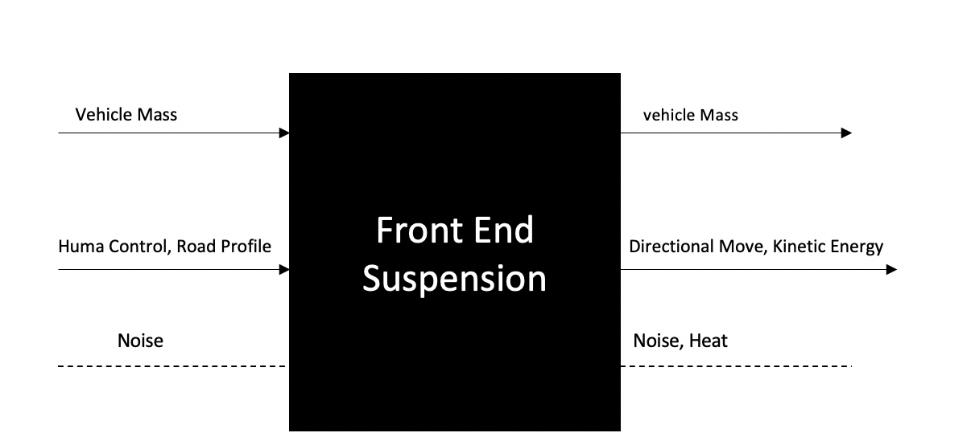

Figure 1: Black Box Model for Front End Suspension

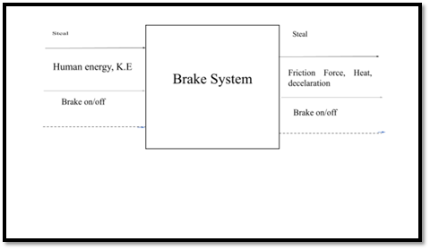

Figure 2: Black Box Model for Brake System

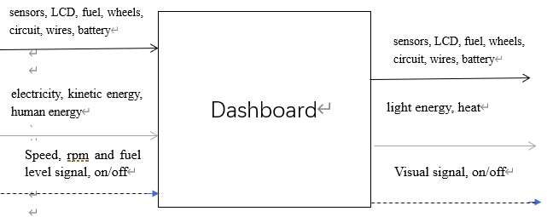

Figure 3: Black Box Model for Dashboard

### Functional Model/Work-Process Diagram/Hierarchical Task Analysis

Functional model describes the inputs, outputs and the complete process to reach the input to the output through different steps that perform within the system defined in the functional model.

#### Front End Suspension

The analysis of the front-end suspension process is required for system design. The team divided the black box model into a step-by-step workflow process. The expected functional output and the normal input for each step are defined. The model is then used to create exciting front-end suspension component configurations. As a result, the team was able to determine the most efficient design that meets the requirements of the Baja SAE vehicle. The impact (shock) force of the terrain profile is the starting point for the process. The Baja vehicle will receive a new dynamic signal as a result of the shock it has received. The vehicle weight and direction change are also stored in the front-end system. Consequently, the vehicle mass admits the initial shock force, which then reflects a sudden dynamic behavior to the vehicle systems. The energy of the off-road shock impact is represented in the system as a kind of potential energy at this point. The front-end system's shock absorber is now responding to the sudden dynamic signal by converting vehicle potential energy into kinetic energy in the absorber mechanism. The kinetic energy is then dissipated and released by the front-end suspension system. The dynamic movement is then stabilized once more, and the Baja vehicle is damped and returned to its original position. To change the vehicle's direction, a human control may be added, which necessitates the application of torque to the steering wheel. The human control's potential energy is transformed into kinetic energy. The steering converts this energy into a mechanical component that causes the vehicle to change direction. The process of energy transformation is expected to include heat. However, because it is so minor, it is often overlooked. The front-end suspension system is decomposed functionally in the following figure.

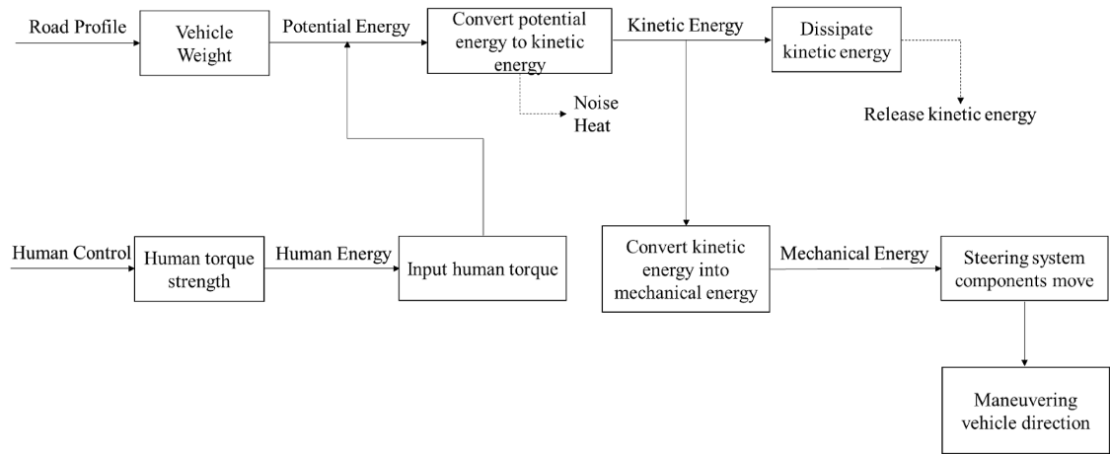

Figure 4: Functional Decomposition of Front End Suspension

#### Brake System

There are three inputs that are converted by energy into a series of processes that lead the vehicle to stop as the friction force.

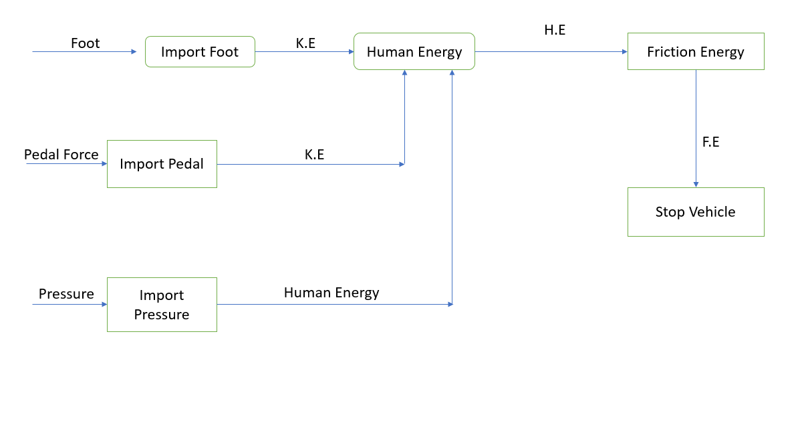

Figure 5: Functional Decomposition of Brake System

#### Dashboard System

The figure is indicating the whole instrument panel system. The main cycle is to convert the transmission of the analog signal system of the vehicle into a digital signal through sensors and circuits, and display it on the screen as a light signal.

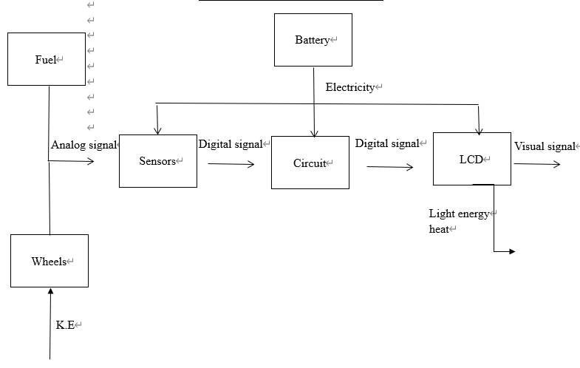

Figure 6: Functional Decomposition of Dashboard

## House of Quality (HoQ)

House of Quality provides the link between the customer requirements and engineering requirements. As engineering requirements have devised from customer requirements, so it is important to define the relationship with the customer requirements and through this relationship determine the priority list of engineering requirements as which engineering requirement is most important and which engineering requirement is least important. It will benefit in finalizing the product and in testing phases where engineering requirements are measured through different tests, as the engineering requirement fulfilled by the design is fine or needs an improvement or the deficiency of that engineering requirement is fine for the project. The HoQ has shown below in the following figure.

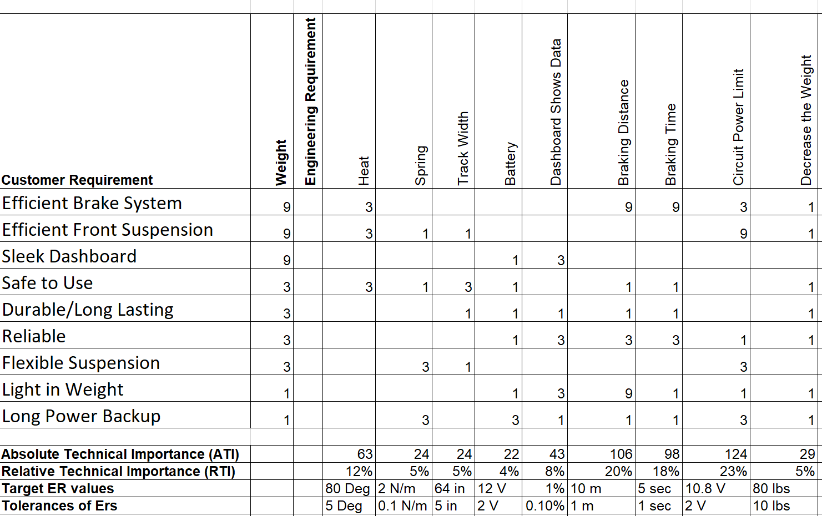

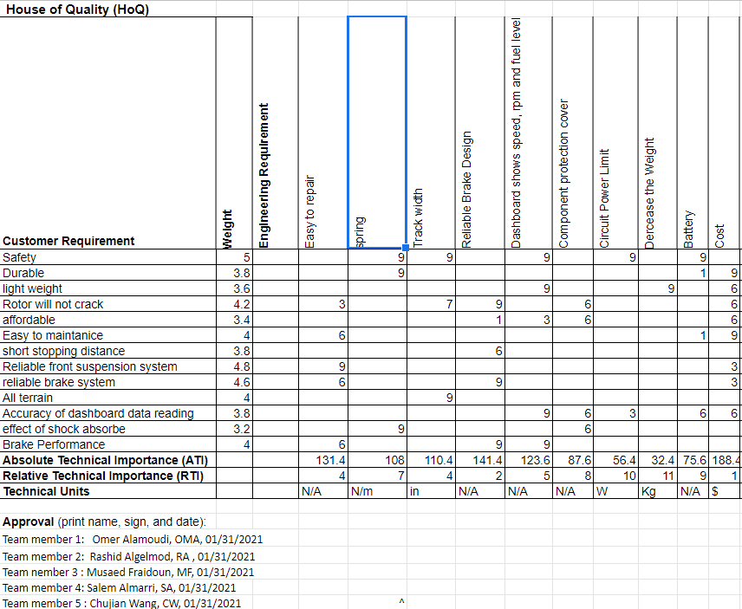

Figure 7: House of Quality

The House of Quality has shown that the most important engineering requirement is braking distance, and then braking time and logically it is also true because braking distance should be small to make the brakes efficient and braking time should be small as well to keep the brakes efficient and the least important here is the battery because it relates to the dashboard and with some ups and down vehicle can work with low battery but cannot work with the inefficient braking system.

Testing procedures have shown below:

* Heat
  + This can be done using a heat analysis through Finite Element inside the brake and test the brake system to record the temperature of brakes rising
* Spring
  + Spring suspension can test by using the hook’s law and then applying the computational equations in MATLAB to determine the spring constant value
* Track Width
  + Width track can measure by the feet scale in software like SolidWorks
* Dashboard
  + It can test through digital meters to record, voltage, current values using the Spice Software
* Braking Distance
  + The distance of breaking can analyze using the MATLAB simulation by implementing the computational equations, and then measure the distance using the meter scale after how long the car has stopped
* Braking Time
  + The time can calculate using the time equations using the MATLAB simulation to see after how long it stops.
* Circuit Power Limit
  + It can test through the Spice simulation software to record voltage, and current values
* Decrease Weight
  + Weight of the overall system can measure by using material analysis in the system like MATLAB
* Battery
  + The battery output voltage level can measure in Spice software through the volt-meter or digital multi-meter

## Standards, Codes, and Regulations

Standards and codes come from many organizations and societies. Examples of those that most directly apply to Mechanical Engineering projects include (but are not limited to):

* Aluminum Association (AA)
* American Gear Manufacturers Association (AGMA)
* American Iron and Steel Institute (AISI)
* American National Standards Institute (ANSI)
* American Society of Mechanical Engineering (ASME)
* American Society of Testing and Materials (ASTM)
* American Welding Society (AWS)
* American Bearing Manufacturers Association (ABMA)
* Industrial Fasteners Institute (IFI)
* Institute of Electrical and Electronics Engineers (IEEE)
* International Standards Organization (ISO)
* National Institute for Standards and Technology (NIST)
* Society of Automotive Engineers (SAE)

For NAU’s engineering library resource on standards and codes, visit: <https://libraryguides.nau.edu/engineering386/patents-etc>

The Standards, Codes, and Regulation that applied to the current project have listed below:

* American Society of Testing and Materials (ASTM)
* Institute of Electrical and Electronics Engineers (IEEE)
* American Society of Mechanical Engineers (ASME)
* Aluminum Association (AA)
* American Gear Manufacturers Associations (AGMA)
* American Welding Society (AWS)

Table 3: Standards of Practice as Applied to this Project

|  |  |  |
| --- | --- | --- |
| **Standard Number or Code** | **Title of Standard** | **How it applies to Project** |
| ASTM | American Society of Testing and Materials | Apply this code for testing the materials and verifying the material is up to the ASTM standards. |
| IEEE | Institute of Electrical and Electronics Engineers | Research done for the design project must follow the IEEE standards and all the citations must be done according to the IEEE standards. |
| ASME | American Society of Mechanical Engineers | This code applies for mechanical designing of the project and it helps in standardizing the design material. |
| AGMA | American Gear Manufacturing Associations | This code applies for the manufacturing of the product in case the project will manufacture |

# Testing Procedures (TPs)

In engineering, testing procedures are conducted to ascertain the functioning principles of a given design project. A test procedure can be conducted on platforms such as units, integration tests, system tests, and acceptance tests. So, testing procedures consider the important part for the design since it assists recognizing if the design has met requirements for this project such as the customer requirements CRs and engineering requirements ERs. When conducting a test procedure, a formal specification of test cases has to be applied to one, or more target program models. A process is used to produce a report of the test procedure. The final report has to indicate the number of specific tests conducted, the ones that succeeded, and those that failed if any. Testing procedures can be conducted either on a physical design or on a tangible one. Whether the test is carried out on a physical, or tangible design, the main goal is to prepare a report showing the functionality of the design. The tests can also be carried out using a simulation program that is either specific to one test, or numerous tests. The report of a test procedure is used to improve the functionality of the design project by making it better considering the issues encountered during the tests performed. In this research, simulation, and software are used to perform test procedures on the braking system of a car. The main idea is to determine the efficiency of the process of braking. Challenges that may arise, and corrections to improve the system. The testing procedure dwells on several units of the front suspension and braking system to perform a conclusive report.

## Testing Procedure 1: Heat

The process of brake starts at the point of applying mechanical energy which is converted through the brake fluid to the brake pads. The primary goal of performing a heat test is to know the amount of heat dissipated during braking. The knowledge can be transferred into creating a more efficient brake system that has less effect on the entire system. In moving parts of machines, the amount of heat energy produced can either have less, or more effect on the system. Conducting a heat test using simulation requires the actual knowledge of the system being tested. The heating of the brake disc and pads is a result of the head produced every braking time. Another important information is to find out the time it takes before the system requires another new set of the brake pad. The simulation report on the heat test will give approximate heat dissipated every braking time. The average amount of heat can be used to understand the kind of heating, and its implication to the brake system.

### Testing Procedure 1: Objective

In this test, the main objective is to analyze the amount of heat produced when a car brakes. The test is performed using MATLAB software, and python language. Some of the visual characteristics of the analysis include the production of systematic graphical patterns and numerical heat values for the compilation of the final report. Python language is applied in this case for its readability, and ease of functionality. MATLAB software can manipulate graphics, numerals, and tangible configurations of the system being analyzed.

### Testing Procedure 1: Resources Required

Before commencing the test, it is important to acquire the latest versions of MATLAB software, and programming templates for python. This can be done on a laptop, desktop, or any lab equipped with these requirements. Heat transfer equation can be coded in python, and the syntax connected to MATLAB through coding. A typical braking system can also be tested using the software to check how it behaves. It is important to have a consistent source of power for the simulation to avoid incomplete reports.

### Testing Procedure 1: Schedule

The program for this test requires more time. First, the MATLAB, and python codes have to be tested and verified for compatibility. Once the confirmation check is complete, the second step is to launch the equation (heat) and check the patterns. During this, it is important to take note of some difficulties which may hinder a proper output. The whole process requires 12 to 24 hours to get the best results for the test.

## Testing Procedure 2: Spring

A spring can either be stiff, or soft depending on the material used to make it. This test is performed to determine the spring constant, which can be used to understand the amount of stretching force required for the spring. A large spring constant means the spring is stiff and requires more force to stretch while a small spring constant implies a soft spring. For moving machines, a very stiff spring is not comfortable..

### Testing Procedure 2: Objective

In this test, the main objective is to determine the spring constants of different materials and compare the results to acceptable values in the database. The test can be run on a simulation of any Math lab that is equipped with spring experiments.

### Testing Procedure 2: Resources Required

The test procedure requires a lab equipped with computers. The computer used must have analytical software such as Math Lab, which can integrate Hooke's law into the equation of a line, and perform the necessary arithmetic required.

### Testing Procedure 2: Schedule

The spring constant test is not a complex one. The constant of most materials made are already in the database. It is easy to compare the result obtained from the software with those that exist. The maximum time this can take is 3 hours, and it can be performed anywhere as long as the platform used can execute numerical, and graphical data.

## Testing Procedure 3: Track Width

Track width is reflected in the distance between the center of two wheels on the same axle. The test on track width is performed to determine the effect of widening or narrowing this distance. The test is done under the specifications of the engineer's specified track width.

### Testing Procedure 3: Objective

Track width is an important factor in finding the suspension of the system being tested. The test aims to ascertain the requirement of appropriate track width. The test can be performed using analytical software.

### Testing Procedure 3: Resources Required

The SolidWorks can be used to measure track width. The value obtained is used to check whether it can suspend the system under test. Three-dimensional graphics are also applied as a counter check to the design of different track widths. It makes sure if the track width is suitable or it requires some changes for the suspension. This kind of test can be done by using SolidWorks and it can be implemented by the 3D operation model to make sure if the design can be suitable or not.

### Testing Procedure 3: Schedule

The test can be performed anywhere as long as there is the right software to carry out the analysis. It is also not so complex that it requires much time. A maximum of 3 hours can be sufficient to obtain the measurements for the overall report.

## Testing Procedure 4: Dashboard

In this project, the dashboard is the main output for the entire test procedure. The dashboard is the mainframe for information management. It also shows all performance of other parts such as the brake system, voltage meter, fuel gauge, and pressure of brakes and tires.

### Testing Procedure 4: Objective

In this project, the main objective of the dashboard test is to verify the functions of the other peripheral parts of the system. The dashboard displays all the functions of parts such as the current, and voltage operating in the system.

### Testing Procedure 4: Resources Required

To perform this test, a computer with software such as segment, or LT spice can be used. Dashboards are built using specific software, and the segment is one of such software which is also easy to manage. It has measuring tools which can compute data required in this project.

### Testing Procedure 4: Schedule

The test requires a lot of time since it gives the output of all the other parts of the system. To run the software to completion, a maximum of 10 hours is required.

## Testing Procedure 5: Braking Distance

Every car has a designed distance it can travel before coming to a stop once the brake is hit. This is a vital part of engineering since safety is a major concern in designing an efficient braking system. The test has to verify the risks, and benefits of braking distance, and provide the best distance required.

### Testing Procedure 5: Objective

The objective of this test is to determine the distance a vehicle will cover before stopping when the brake is applied. The experiment is performed using analytical software.

### Testing Procedure 5: Resources Required

Performing this test requires MATLAB and segment software. The equations relating to kinematics can be coded in MATLAB, and the output can be displayed in the segment since it has meters that can measure distance.

### Testing Procedure 5: Schedule

The test requires a maximum of 10 hours for the operation of segment, and MATLAB software

## Testing Procedure 6: Braking Time

When the brake is applied, the car takes a given time to stop. In this project, the amount of time taken before the car stops is very important. If the time is more, it means the braking system is not efficient enough for use.

### Testing Procedure 6: Objective

The objective of this test is to determine the most efficient time to take before the car stops after braking. This can be done using software that can analyze time and distance.

### Testing Procedure 6: Resources Required

The braking time test requires the application of MATLAB software to analyze the equation relating to deceleration, and time. Excel can be used to obtain the statistical information required for the interpretation of the data from MATLAB.

### Testing Procedure 6: Schedule

The test involves the use of MATLAB in performing equation analysis. It will require a maximum of 10 hours and can be performed in a computer lab, or at a personal study place with a computer.

## Testing Procedure 7: Circuit Power Limits

The system requires operating on the lowest power possible. The dashboard always indicates the amount of power that the systems draw from the battery

### Testing Procedure 7: Objective

The main objective of carrying out this test is to determine the amount of power the system can take from the battery. The power consumption can be used to know the weight, and energy the vehicle can run on.

### Testing Procedure 7: Resources Required

The test requires a simulation capable of calculating voltage, and current output. MATLAB and segment software can be used to do this.

### Testing Procedure 7: Schedule

A maximum of 5 hours is needed to perform the calculations, and give the circuit report of the system.

## Testing Procedure 8: Decrease Weight

The weight of the vehicle determines power consumption, the use of the braking system, and the lifespan of the battery. An efficient system must have a reasonable weight. Engineers have the task of ensuring the weight of the vehicle corresponds with other operating parts.

### Testing Procedure 8: Objective

In this test, the aim is to determine the overall weight of the system under analysis. This can be done through the analytical process by using the software.

### Testing Procedure 8: Resources Required

The best software to use in this test is MATLAB. It analyzes all the required parameters required. It also integrates the analysis through comparisons of weights already designed in engineering.

### Testing Procedure 8: Schedule

The test requires a maximum of 13 hours to perform and can be operated anywhere once the resources are acquired.

## Testing Procedure 3: Battery

The battery is an essential requirement for operating a car. It provides power that runs the dashboard. A good battery should provide minimal power, and be light enough for the car.

### Testing Procedure 3: Objective

The objective of this test is to determine the efficiency of the battery used, and if it is enough to run the dashboard with minimal operation.

### Testing Procedure 3: Resources Required

Current and voltage related to Ohm’s law. MATLAB software can be used to verify the amount of current supplied by the battery. A computer equipped with MATLAB, or Math lab software can be used to perform the test.

### Testing Procedure 3: Schedule

The test can take a maximum of 5 hours to ultimately report the battery functionality.

# Risk Analysis and Mitigation

Potential failures have many different kinds of failures for any design while it works and operates, and engineers have to expect those failures and expect the risk in the design. This portion includes many different potential failures discussed and shown in the appendix how to calculate the failure mode and effect analysis (FMEA) and describe each subsystem. We will discuss the top 10 of the potential failures in this portion with its analysis from the table. For instance, this portion will talk about how the failures happen and the mitigation strategies to avoid any failures in the subsystems. To summarize this, this part will discuss any failures in the subsystems and what the risk is possible, and how to change the risk or failures to become better in the design.

## Critical Failures

### Potential Critical Failure 1: Leather Pads

Leather pads are vital brake system components necessary in the effective distribution of the brake fluid to and fraught the master cylinder and piston lines. This failure may be a result of substandard material usage, sharp edges contacting, and most probable unnoticed manufacturing defects from its conception. Such failure will cause the depressurization of the braking system, thereby causing intense deceleration of the SAE Baja model, thereby losing its thorough effectiveness. In the competition, the success of the goal to directly stop the vehicle within the allowable prescribed time is readily dependent also on the pressure input of the driver on the brake pedals.

### Potential Critical Failure 2: Wishbone Hinges

Possible failure may also exist in wishbone hinges. This failure occurs when a specific object that is out of phase with the motion of the arms strikes it at a hostile angle, causing its collapse. The action could cause a shearing effect which tends to lock up the suspension preventing additional movements. The inability of the vehicles to move will put pressure on the frame causing the imbalance of the vehicle connected with the driver causing an accident. This failure can be mitigated if by using sufficiently thick tubing material for the control arms of the hinges, thereby decreasing the chances of failure.

### Potential Critical Failure 3: Wishbone

The wishbone is used in the fronts suspension, and this kind of suspension can be broken, which is called the potential failure. This failure can happen and be caused by accident during the competition caused by death. This failure can occur when the pressure keeps increasing and applying to the wishbone, which causes off-roading and high speeding, and the vehicle makes a high effort on the suspension. Because of that, the suspension can cause failure and can be broken. To treat this issue and avoid this failure , it is so important to use materials for the wishbone that have a high quality of standard, and the materials have to tolerate the high level of pressure with considering the thickness of the wishbone to prevent the failure. The mitigation of the wishbone is to keep tracking the maintenance of the standard basis to prevent any failure.

### Potential Critical Failure 4: Rotor

The rotor allows the machine to drive the power from the differentials going to the wheels for movement. This continuous connection and functioning is necessary for the continuous and efficient movement of the vehicle. A terrible effect could happen when the spline connection fails at the sight of rotor breakdown. The splines fasten the axle to the wheels so that a proper torque distribution can be observed. Such failure will cause the waggling of the vehicle caused by torque disruption, and motion is horribly impeded. The splines being critical to such function should have higher than average Young’s modulus to resist abrupt changes in the pressure interruption of the moving vehicle. As such, the primary preventive maintenance step is to ensure that the torsion experienced by the rotor is well within the limits of the CV axle attached to it.

### Potential Critical Failure 5: Connections

Several connections exist in the vehicle design of BAJA SAE 2021, and its functions are dependent on the effectiveness of each connector to transmit details of movement and command. The steering wheel is an important part to transmit the physical input of the driver in the movement. The improper installation and connection of the wheel into the column when not checked could be fatal. The connection for this assembly, including the connection of the gears within the system, must be calibrated with the prescribed speed expected by the driver during the operation. This can be carried out by using effectively fitted when connections and stronger material for connection sealing. Welded portions, as well as weak points of the connection system, must be regularly assessed to prevent failure.

### Potential Critical Failure 6: Controller Board

The main controlling section of the SAE Baja 2021 design is in the controller board, where tiny microelectronic chips are placed for multifunctional circuit systems. This is the most sensitive part of the assembly, and as such, proper use of current and voltage flow must be ensured to avoid power tripping and bogging down of the circuitry that commands the entire vehicle movement processing. This can be done by ensuring installations of the electrical attachments such as light bulbs, sirens, warning devices to be of recommended specifications such as wattage and power requirement and is well within the capacity of the board to supply.

### Potential Critical Failure 7: Wishbone Central Rod

The road's function is to support the vehicle, and its location is located between the wishbone for the softness benefits and the vehicle. The consequence of this rod, in case it is failure that means the suspension will stop working then it leads to vehicle bumps and no more supporting for the vehicle. So, the effect of failure is incredible and will prevent the vehicle from moving on. Another reason for this failure is the road will be broken due to the overweight. To avoid this, it should utilize the high quality materials while keeping track of the regular maintenance. This can be done by ensuring installations of the electrical attachments such as light bulbs, sirens, warning devices to be of recommended specifications such as wattage and power requirement and is well within the capacity of the board to supply.

### Potential Critical Failure 8: Caliper

Prominent caliper problems in the vehicular assembly are the caliper mounting bracket. The primary reason for such failure is due to high impact and, more so, is the relatively substandard material type choices for the support. The failure of the caliper bracket will cause its misalignment and detachment from the intended mounting point of the braking system. This weakens, therefore, the braking capability of the vehicle due to its inability to produce a clamping force into the brake rotor.

### Potential Critical Failure 9: Spindle

The function of the spindle is to work with caliper and leather pads that are connected to the wheel, and it happens and acts in the brakes, and the functionality is that if the spindle does not work, then the wheels will stop working what is caused the vehicle will stop entirely and make an accident. However, the spindle can be no longer for use, or it can break, and for preventing this failure is to buy or replace it with a new one, and thus the mitigation is. That will provide safety for the critical operator in this design.

### Potential Critical Failure 10: Brake Rod

The brake rod consists of attaching the brake with the suspension and the vehicle. The functionality of this road is when the vehicle gets the order to stop from the brake system, and this brake road causes the vehicle to stop. Therefore, if this brake's brake is broken, then the brake will not happen and work this will cause the accident, so this is the failure and the risk of the brake rod by designed more pressure over it. To avoid this failure, it can utilize the solid materials and keep track of their maintenance.

## Risks and Trade-offs Analysis

From the FMEA analysis different failures have determined which can affect the brake, suspension and dashboard system. The determined sources of failures are equivalently important and must be effectively addressed. The strength and success of the SAE Baja 2021 design is only as good as its weakest part and therefore, effective design of these parts must be made. The critical failures mentioned in the aforementioned parts can be remedied by the use of properly tested and material sufficient to withstand the demand of the part operation. In regulating impending failures on the failure during operation, the use of thickened and high-quality material may do the purpose of the design. On the other hand, frame placements and installation failures can be remedied by expert installation and effective connector systems. Such series of connections must have continuity of operations well within the ambit of possible operation. Engineering requirements of this design necessitate that it must be lightweight and durable. The increase in the thickness, density and rigidity of materials and parts for front, brakes and connectors may well add enough deadweight to the design. An effectively balance of this requirement without sacrificing strength and lightweightness must be attained. The material specifications for each purpose can be directed in the table of specifications for this design.

# DESIGN SELECTED – First Semester

In this section, the selected design will be introduced, and all the details about that design will be provided in the following sections. In addition, the next part will introduce the design layout in the form of a CAD model. A detailed design description is provided, and an implementation plan is also proposed. In the implementation plan, the plan will describe the resources that will be used to implement the project, including a complete bill of materials. The implementation will be implemented in the next semester, so the implementation plan will be used in the next semester.

## Design Description

There are three separate components to design in this project: the front suspension system, the dashboard system, and the brake system. The chosen design includes a wishbone-based suspension and a disc brake system with caliper and disc, as well as an Adriano-based dashboard design. The design chosen in the preliminary report is the same as the design chosen at the time of choice. There were two choices for braking systems: drum brake and disc brake. The disc brake system was chosen because drum brakes are intended for heavy cars, while disc brakes are designed for normal vehicles. Disk brakes often generate less heat than drum brakes, and because of their low-temperature sensitivity, they can run with reduced fade at high temperatures. Not only that, but the disc is simpler to patch than the drum, making it ideal for the SAE Baja competition. Similarly, the suspension system, a double-wishbone suspension system that involves upper and lower arms, damper, and spring, has remained the same and will remain the same in the coming semester.

### Brake System

This system has different components which includes

* Caliper
* Spindle
* Rotor
* Hinges
* Leather Pads

Caliper:

The caliper in this configuration is a holder to hold leather pads and it is fixed over the rotor, the caliper can press to tighten from inside and can loosen to release the rotor. Basic purpose of the caliper is to hold the disc, and provide friction against the rotor to stop it. The design of the caliper is in figure 7.

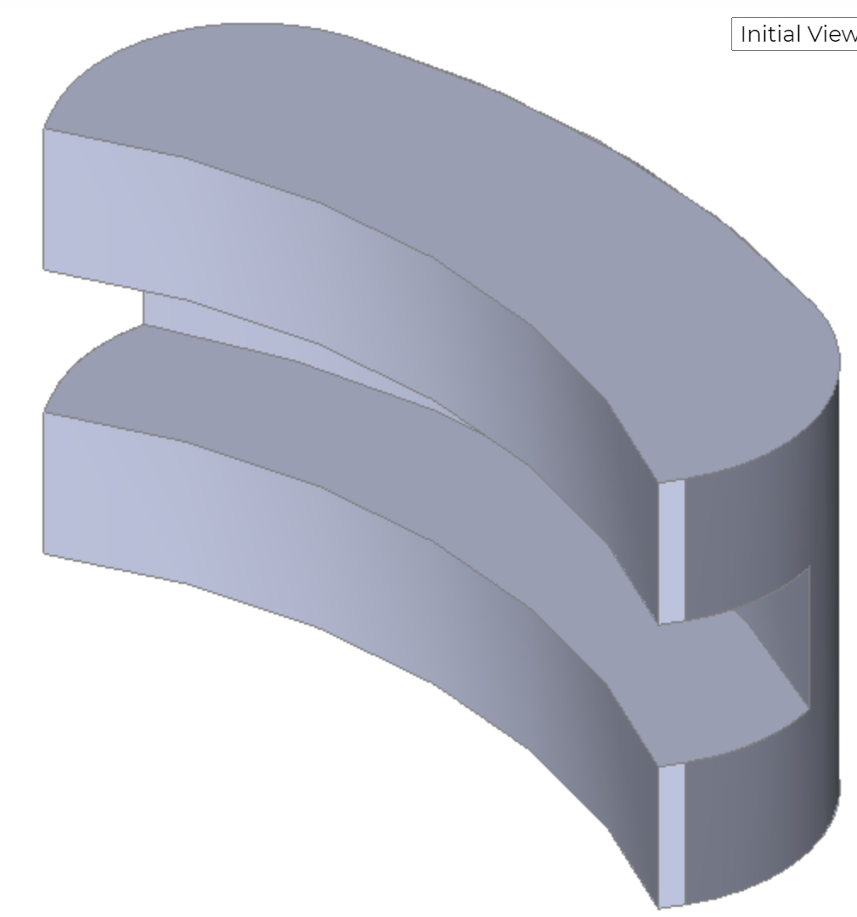

Figure 7: Caliper

The caliper design is clear in the above figure as it looks like a clip and the working caliper is just like a clip which can open its mouth or can close its mouth. Inside the mouth of the brake caliper, a leather pad will be installed to provide the required friction to stop the vehicle. When the brake pedal is pressed by the driver, the pedal will pass the force to the caliper and that force will compress the caliper and tighten its mouth and it will stop the vehicle. This is one of the most important parts in the braking system and without the desire working of the caliper, the brake system will not be able to perform effectively. Now coming to the next part in the brake system that is the spindle.

Spindle:

Spindle is a joint holder that is present after the disc, and it holds the disc and it holds the wheels as well. The design of the spindle has shown below in figure 8.

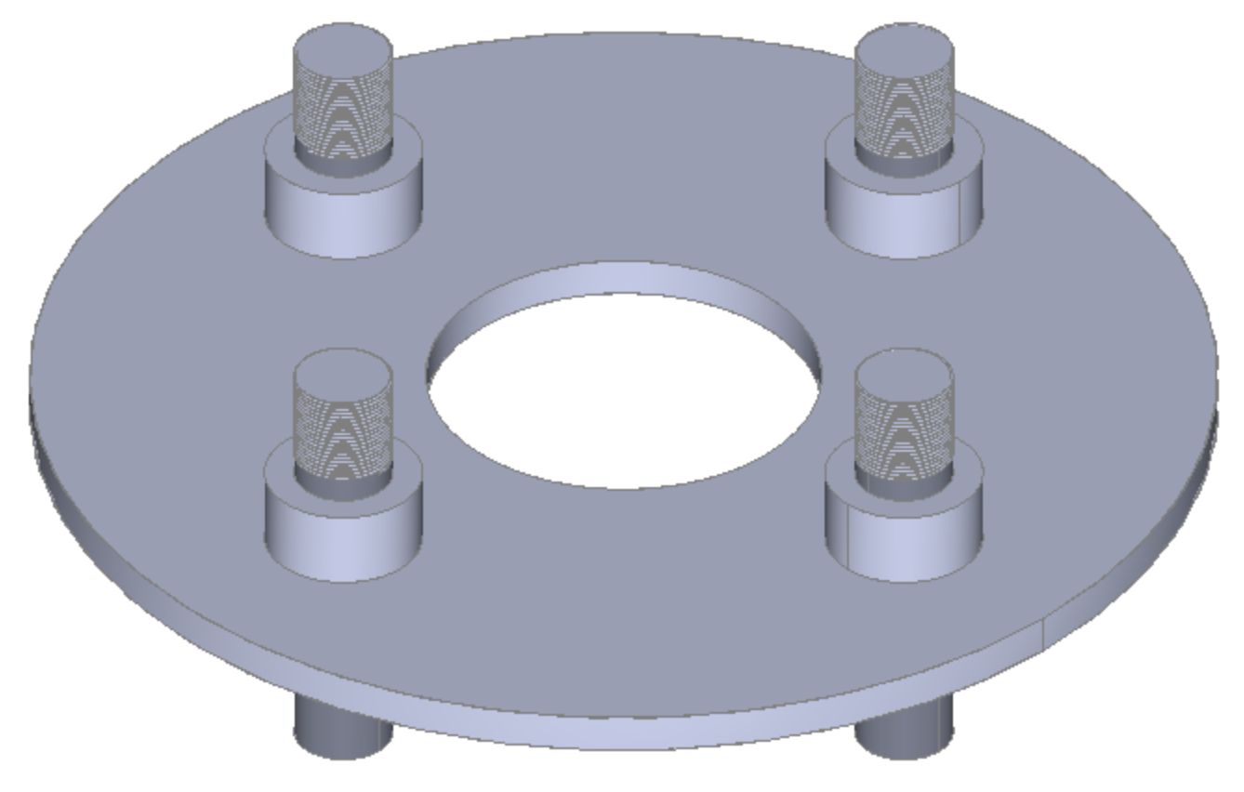

Figure 8: Spindle

This spindle will put on the same rod, on which the disc will put, and the wheel as well will put over the same excel rod, and this spindle will keep the wheels tight, there are four bolts coming out from the spindle and the wheels will put over these bolts and then nuts will use to tight the wheels. This is also important for the brake system as it holds the wheel and if it doesn’t install, the wheels are not possible to install over the excel with the brake system.

Rotor:

Rotor is a disc that rotates with the wheels, this rotor connects to the wheels through the same axle on which the wheels have installed and as the wheels move, the disc rotates as well. The disc has shown below

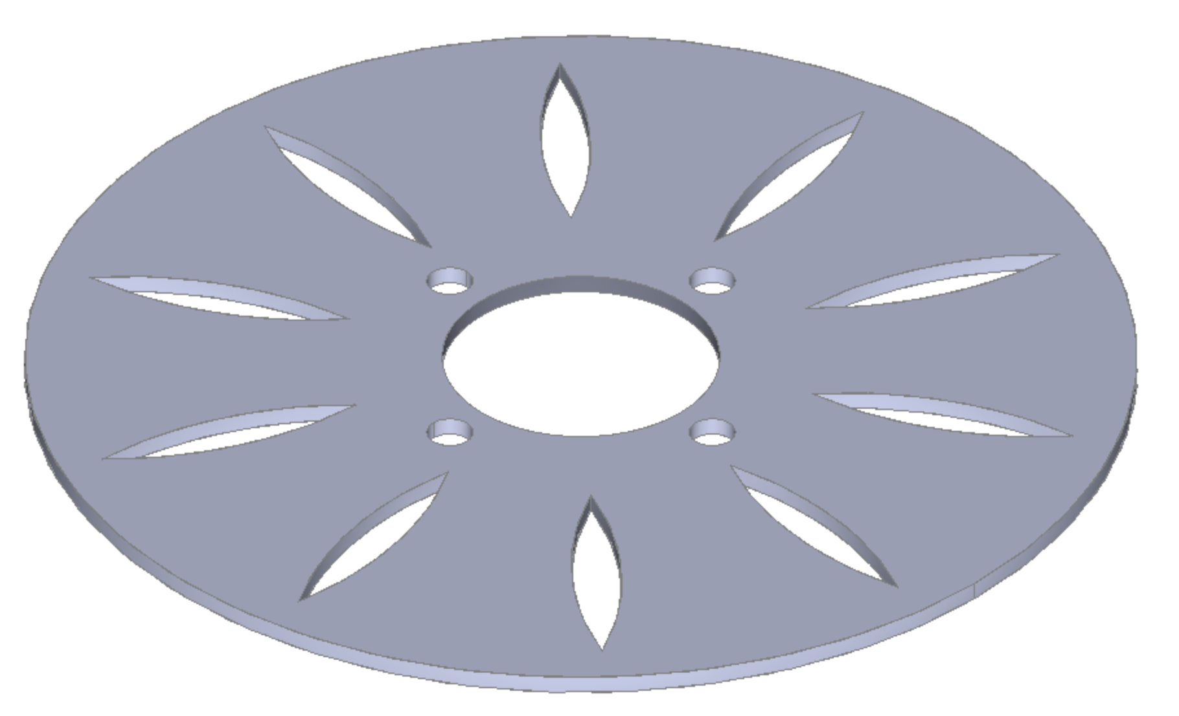

Figure 8: Disc or Rotor

The disc above contains the open spaces like a leaf, and these open spaces have been created in the disc to pass on the air in order to avoid any air pressure disturbance that will cause any fatal accident. This disc fits over the rod, and the wheels connect through the nuts as four nuts’ places are showing on the disc and the caliper will fit over this disc and when the caliper will press through the leather pads, this disc will face a lot of friction and that friction will cause the disc to stop from rotating and in the same time wheel also get a stop from moving and hence the brake applies. The disc is one most important part of the brake system, and without the disc, the brake system cannot develop and use.

Hinges/Link:

This is another important part of the brake system, and it connects the brake with the suspension and also holds the disc and spindle together over its rod. And the hinge link is shown below.

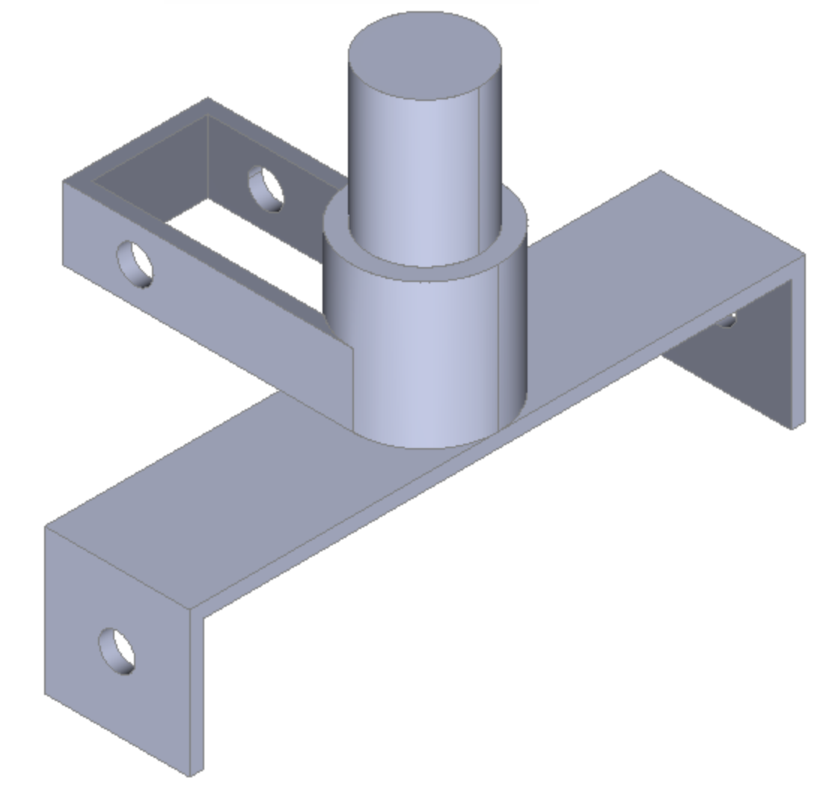

Figure 9: Hinge/Link

This link uses between the disc, spindle, and suspension for holding all the components, and it is an important part of the brake; without this link, the brake system cannot hold and operate.

Leather Pads:

This is a fabric used to provide friction from the caliper to the disc, as it installs on the caliper and operates between disc and caliper. The reason to use a leather pad inside the caliper is to avoid rubbing two metals together because rubbing the two metals can cause any damage, so leather pads are used as a medium between the caliper and disc. As this is a fabric and it will install within the caliper and it will cover the caliper from inside so there is no design to make in CAD model for it. .

.

### Front Suspension Brake System

Following are the parts of front suspension:

* Bottom Wishbone
* Top Wishbone
* Link
* Spring

Bottom Wishbone:

This is a part of double-wishbone geometry, and it is a lower part with two legs, and both are interconnected from one end and the other end is open. The bottom wishbone has shown below in figure 10.

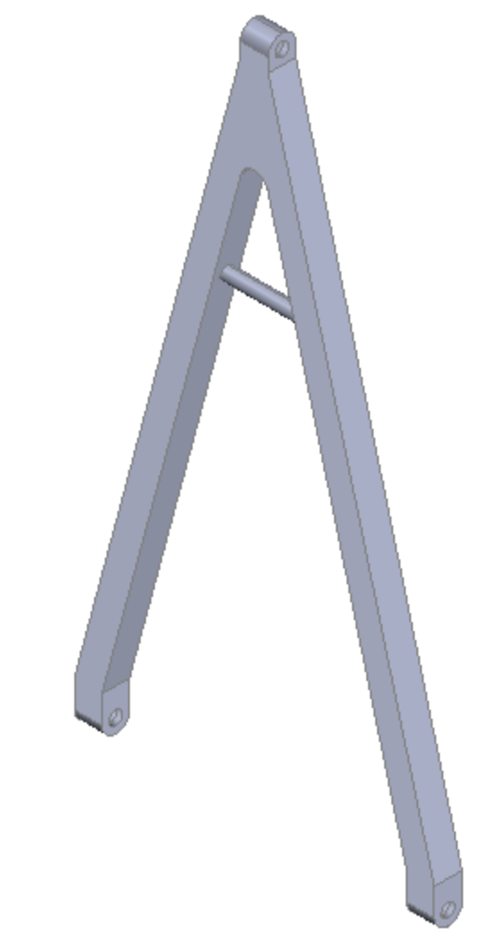

Figure 10: Bottom Wishbone

This bottom wishbone will provide the support for suspension from the downside of the suspension, and it will install with the top wishbone. A middle rod is present on it, which is used for the spring purpose to adjust the compression and expansion of the wishbone. This wishbone is playing a major role in the design, and it is not possible to build the suspension system without this wishbone.

Top Wishbone:

Top wishbone has a design similar to the bottom wishbone, with the difference that there is no middle rod present for the spring in the top wishbone, and the working operation of the top wishbone is the same as the bottom wishbone. Both of them collectively move in the upward and downward direction to give the bumpy effect of inhaling in their movement, the top wishbone as shown below in figure 11.

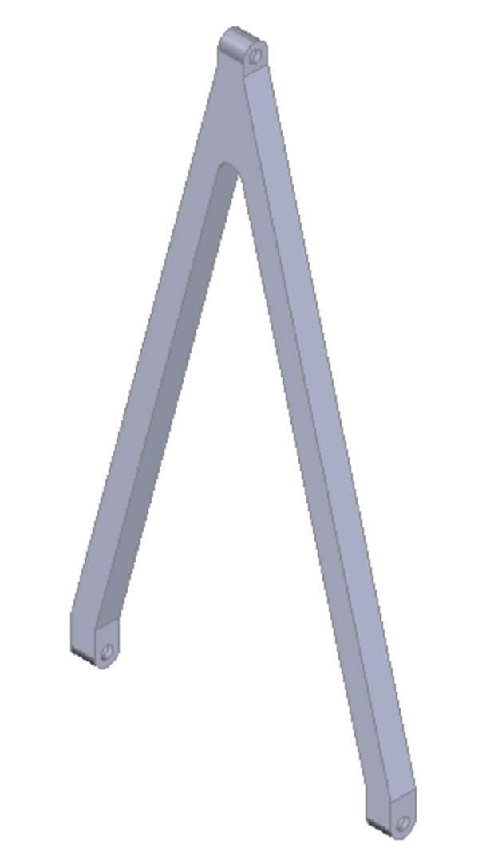

Figure 11: Bottom Wishbone

This wishbone will move up and down from the top-notch where both ends are joining together while the other end is open face. Wishbone is an important part of the suspension, and without the wishbone, it is not possible to make the suspension system as for this project design.

Link:

The link used between the suspension system and the brake system to join them together is showing below in figure 12

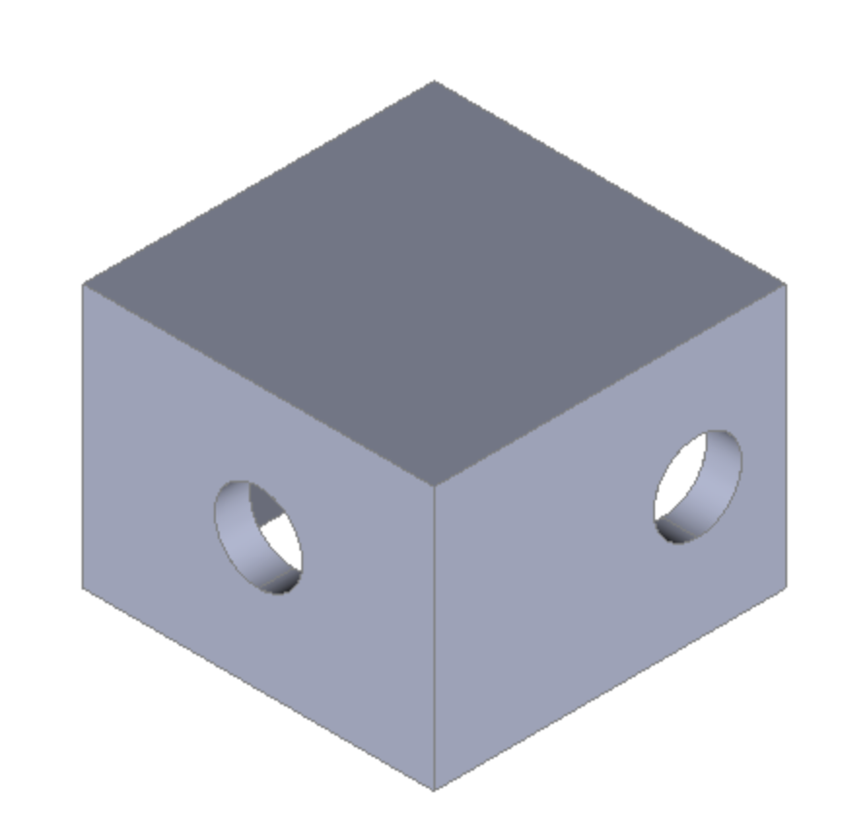

Figure 12: Link

This link is supporting both the wishbones, and both wishbones connect through each other and also through the brake system through this link, and this link is supporting the directional movement for the wishbone as well.

.

Spring:

The spring is used for the suspension system to absorb the jerks and provide the compression for the wishbones movement as well in order to keep the suspension safe and soft.

The spring is holding the energy in it and releasing it in a soft manner to provide the smooth ride and spring will install with the wishbone and plays a major role in reducing the jerks.

Some of the engineering calculations which have performed have shown below:

Using the newton equation of motion find the distance

$2aS=v_{f}^{2}-v_{i}^{2}$

As the final velocity is zero when the brake will apply, the vehicle will stop after some time so the distance it will cover is calculating so the final velocity in this is zero

$v_{f}=0$

And considering the acceleration which is basically deceleration and a negative sign has given as well to show it as deceleration

$a=-0.5\frac{m}{s^{2}}$

And consider the initial velocity of the vehicle at which it is coming before the brake has applied

$v_{i}=3\frac{m}{s}$

So, putting everything in the above equation gives

$2\left(-0.5\right)S=0 -{\left(3\right)}^{2}$

So, the distance has calculated as

$S=\frac{-9}{-1}$

$S=9 m$

Hence, the distance after the braking has applied and the vehicle will cover is around 9 m.

Other calculation for the braking time has done and calculated as

$s=v_{i}t+\frac{1}{2}at^{2}$

Considering that the distance it will cover is 9 m, as calculated

$S=9 m$

And the acceleration has considered before as well so use that acceleration

$a=0.5\frac{m}{s^{2}}$

And the initial velocity has taken already as

$v_{i}=3\frac{m}{s}$

And need to determine the time it will take can calculate as

$9=\left(3\right)t+\frac{1}{2}\left(0.5\right)t^{2}$

$9=3t+0.25t^{2}$

$0.25t^{2}+3t-9=0$

Now, solve the above equation to get the time

$t= 2.485 sec, t= -14.48 sec$

As the negative time is not possible, hence the time it will take to stop the vehicle is

$t=2.485 seconds$

The prototype has not been built in this semester, because the project is analytical and it will only implement in the software-based models and it will then verify through different simulations software and these simulations will perform in the next semester after the implementation of models.

* + 1. **Dashboard system**

This system has different components which includes

* AT89C51 microcomputer
* LCD
* Motor
* Circuit element: capacitor, resistor

The dashboard is a device used to display the condition of the vehicle. In this project, the instrument panel includes detection of vehicle speed, rotation speed and liquid level.

Schematic:

The schematic circuit diagram shows how the single-chip microcomputer and each component are connected. The most important components in the figure are the LCD, the motor and the switch that controls the oil level. The interface information of the MCU comes from the AT89C51 datasheet. The AT89C51 is an age old 8-bit microcontroller from the Atmel family. It works with the popular 8051 architecture and hence is used by most beginners till date. It is a 40 pin IC package with 4Kb flash memory. It has four ports and all together provide 32 Programmable GPIO pins. The LCD screen displays the speed and rotation speed of the motor. The speed is calculated from the rotational speed. The speed of the motor can be changed by changing the frequency of the pulse. It also displays the level of liquid level according to the status of the switch

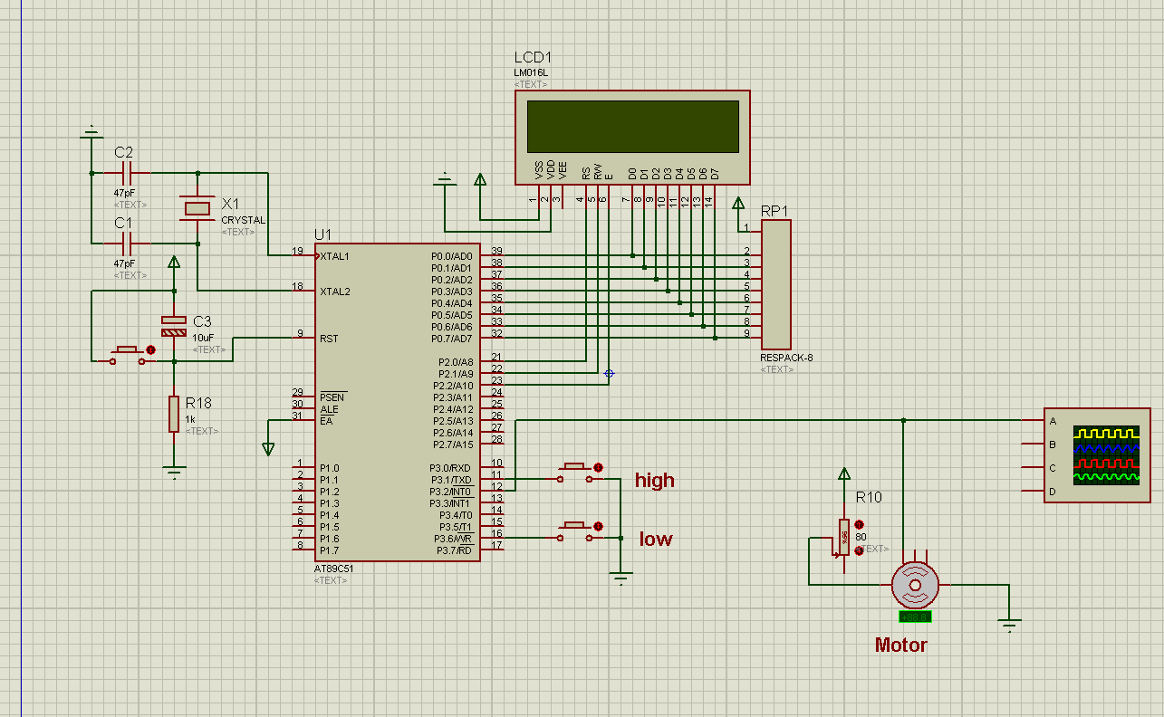

Figure 14: schematic of dashboard circuit design

Simulation:

This picture is the result of the simulation. Through observation, it can be found that the rotation speed of the motor and the calculated vehicle speed are displayed on the LCD. And shows the liquid level condition. By changing the motor speed, the pulse frequency changes, and the speed and rotation speed change accordingly. In practice, the pulse frequency can be changed by the analog signal received by the sensor. By changing the switch that controls the liquid level, the level of the liquid level can be displayed. In actual situations, the liquid level can be detected, and the LCD prompts that the liquid level is low when it is below a certain level. The interface part includes the power supply of the single chip microcomputer, the conversion of analog signals to visual signals on the LCD, the reception, reading, writing and enable of the analog signals of the motor and the liquid level control switch.

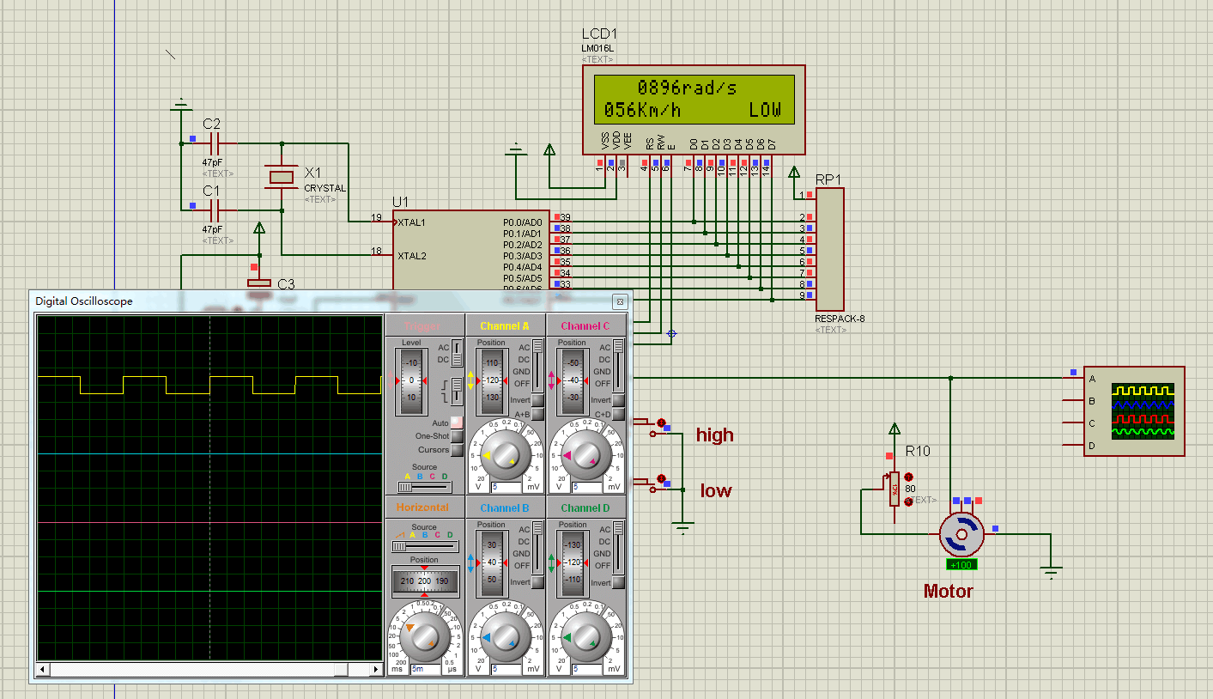

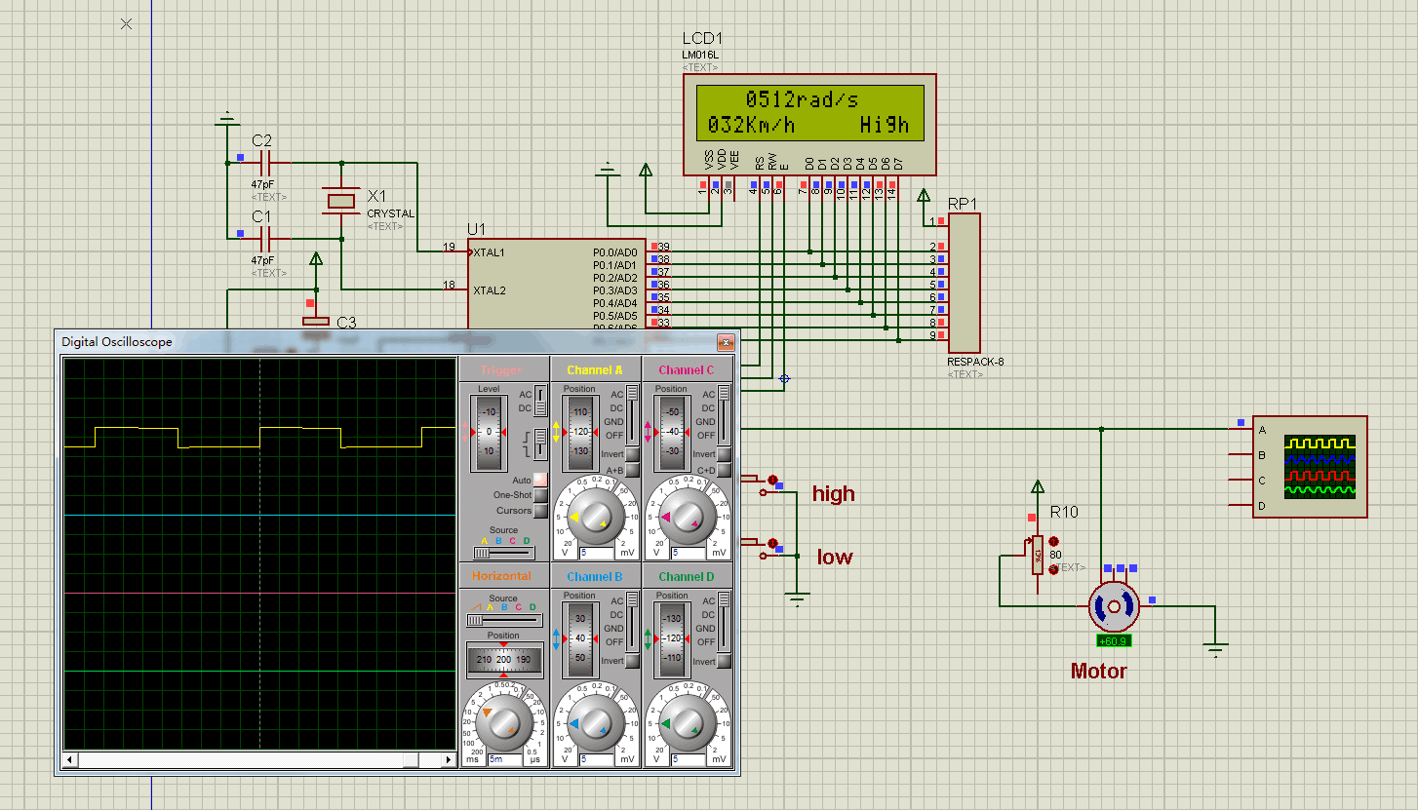

Figure 15: Simulation of the dashboard

## Implementation Plan

The project is focusing on three separate subsystems for the SAE BAJA, which are the braking system, suspension system, and dashboard, as stated earlier. This is a design project, and the team has agreed to design the project; but, instead of building the project in concrete shape, the team will focus on the design and apply simulations for the plans, study the design using software, and evaluate the design using simulations. Apart from the fact that the commodity will not be constructed physically, infos required to complete this mission have been collected. A full bill of material has been created for this reason, and the cost of the project has been calculated using the materials that would be used to construct it. For the implementation, we will develop the 3D CAD model in SolidWorks and then we will develop the simulations, these simulations will include the FEA analysis about the materials, time and distance calculations for the brake system, heat transmission analysis through FEA and heat transfer equations using the Laplace transformation. These analyses will run in MATLAB software and the simulations for the electrical components will run in proteus software which runs the circuits simulations. The dashboard will have a hardware design based on schematics in next semester.

In next semester, the team will work on the design to build in SolidWorks where the movements of each component can show, as for now the team has the CAD model already built in SolidWorks but in next semester the team will perform the CAD model with the operational views and also the team will perform the SolidWorks analysis for the design and will visualize the forces that acts over the brakes and suspension after applying the loads and then see the stress strain graphs for the materials. The CAD model developed has shown below

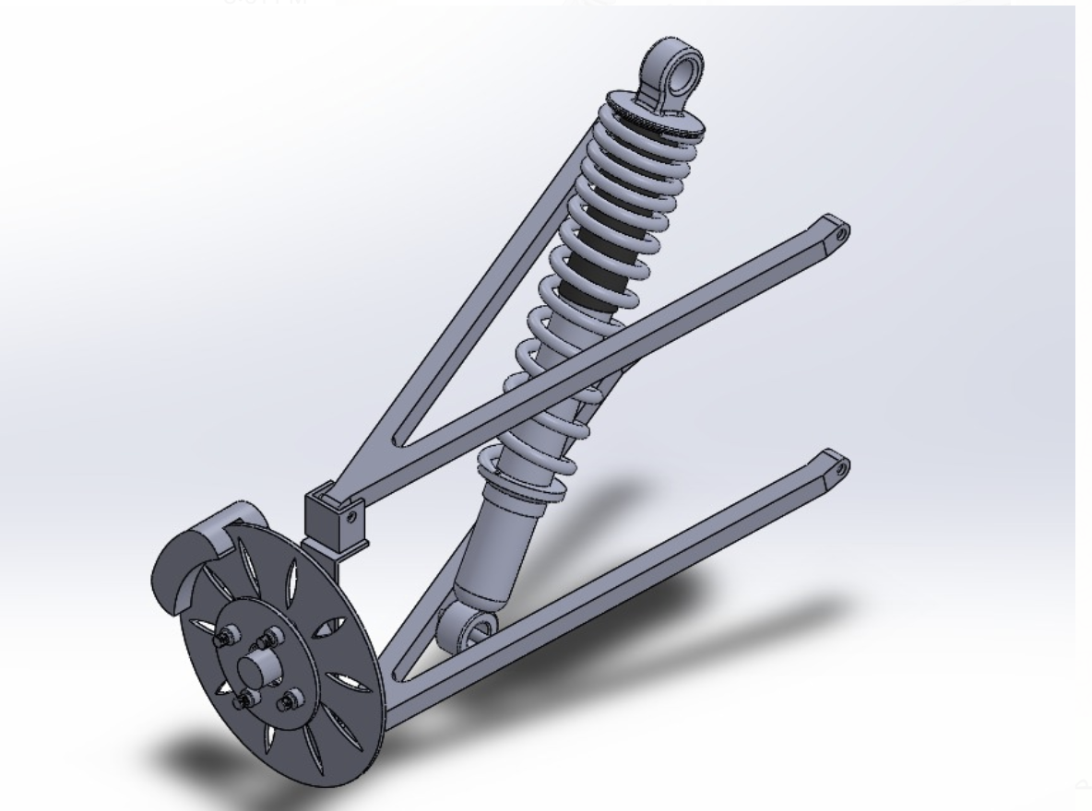

Figure 14: Isometric view

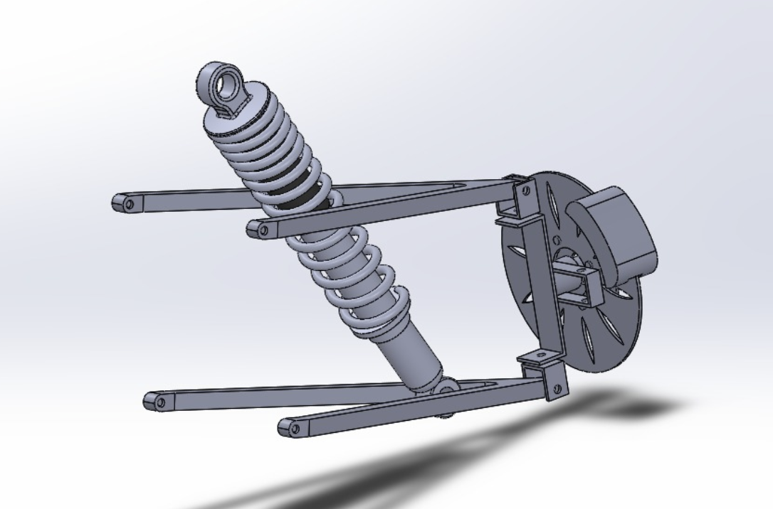

Figure 15: Side View

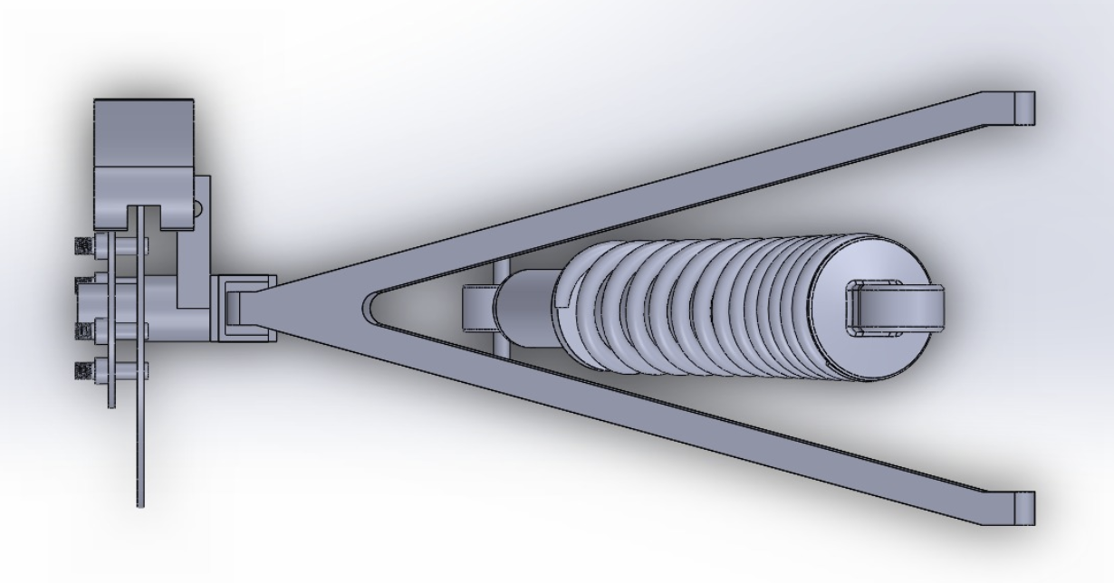

Figure 16: Top View

The implementation plan for the next semester has scheduled already and the Gantt chart for the schedule has given below

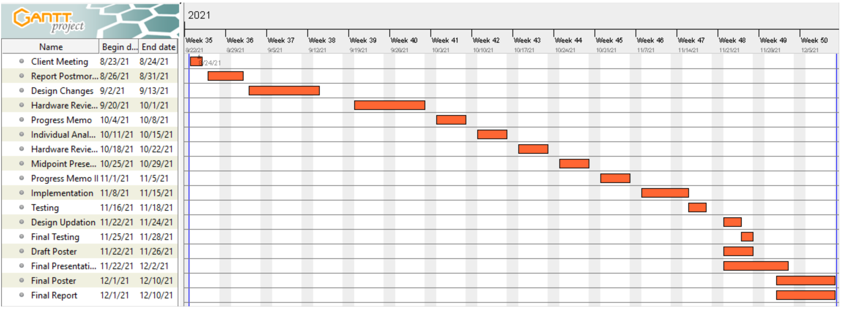

Figure 14: Gantt Chart

Using the above schedule, the team will work on the implementation next semester.

# CONCLUSIONS

Our project is focused on the three subsystems for the SEA BAJA off roading car project and these subsystems assigned to the team as the brake system, front suspension system and dashboard. The brake system consists of a braking system that is responsible to stop the vehicle, the front suspension will vehicle moves on the smooth over the different terrains like usually seen in the off roads that the car moves competition, and the dashboard system should appear information to show the data that are related to provide the vehicle with the speed, rpm, and other details about the vehicle. We were assigned to work and make suggestions to these systems and we are responsible to give essential ideas in this project. The SAE BAJA cars were built some years ago, but our project needs to have an effective system to re-design the SAE vehicle where the braking system has to be active enough to stop the vehicle in a less period of time, no less important, the braking system should be able to stop the vehicle in the shorter distance by comparing our system to the previous systems. Same as same, the front suspension system must be in excellent condition, strong to keep the drivers comfortable and not struggling with jerks that they will face on the off-road. Also, the front suspension should be able to resist the different terrains while the car should not stop, so the suspension system must be in a good manner. On the other hand, SAE Baja has the dashboard system and it has to be designed in a way that will not take high power from the vehicle’s battery and it will provide the vehicle details with accurate results.

We focused on the critical requirements that are needed to be achieved by our team members and these include efficient brake system, efficient suspension system, dashboard system, and each system have to be designed in such a way that they are safe to use and all the failures must tackle in the design so that it will not cause any serious problem in the vehicle while driving. Our systems should be durable, not complicated to build, and long-lasting. Each system should be reliable if vehicles face bumpy terrains without tension. Also, the battery power should be long lasting and will not discharge quickly. we focused and made sure to have light weights for Brake, front, dashboard systems while we make sure each system provides excellent work. With the requirements, different design ideas have been proposed and after all those design ideas the selected solution is a brake system with discs, suspension using the double-wishbone geometry.

The selected designs must achieve the engineering requirements generated from the customer requirements, as they are looking to have a brake system that can stop the vehicle within 10 meters while it takes less than 5 seconds as well. The heat produced by the braking process will not exceed 80 degrees and the overall weight of the systems should not cross 80 lb, all these specifications followed by the design, the CAD model has developed in which the brake system has shown with the disc, caliper, spindle, and the suspension includes wishbones and moveable links with the spring. The project is not going to implement in physical form, rather it will done as an analytical project and it will present a 3D CAD model at the end and it will perform different analysis about the design which includes FEA analysis for the materials, heat transfer analysis using the Laplace transformation and FEA for observing the heat generation during the braking process will analyze, and also the voltages, currents in the dashboard system will analyze. It will use different software to analyze them like MATLAB, LTSpice and SolidWorks.

In next semester the team will work on the analysis and it will perform different analysis and will implement the SolidWorks for CAD model with the motions of each part to analyze the forces, and different aspects of the design and will select the material that will be used to build the project through the analysis.

# REFERENCES

[1] Sourav Pattnaik (2020). Design and Analysis of Braking System for Baja All-Terrain vehicle. International Research Journal of Engineering and Technology (IRJET) .Volume: 07 Issue: 02.

[3] Limpert, R. (2011). Brake design and safety (3rd ed.). Warrendale, Pa.: Society of Automotive Engineers.

[4] R. Limpert, Brake design and safety, 3rd ed., Warrendale, Penn.: SAE International, 2011.

[5] S. John, "Hydraulic Disc Brakes | Order Custom Hydraulic Disk Brakes from Knott Brake - Knott Brake Company", *Knottbrake.com*, 2021. [Online]. Available: https://knottbrake.com/categories/disc-brakes/hydraulic-disc-brakes/. [Accessed: 05- Mar- 2021].

[6] F. Flin, "Drum brakes", *Your Mechanic*, 2019. [Online]. Available: https://www.yourmechanic.com/article/how-drum-brakes-work. [Accessed: 05- Mar- 2021].

[7] B. Parama, "Disc vs. Drum Brakes: Pros and Cons", *NAPA Know How Blog*, 2020. [Online]. Available: https://knowhow.napaonline.com/disc-vs-drum-brakes-pros-and-cons/. [Accessed: 05- Mar- 2021].

[8] J. D. Stimson, "2015-2016 SAE Baja Major Qualifying Project Final Report," *wpi.edu,* vol. 1, no. 1, pp. 1-70, 2016.

[9] F. Liver, "BODEN AUTOHAUS", BODEN AUTOHAUS, 2021. [Online]. Available: http://www.bodenautohaus.com. [Accessed: 04- Mar- 2021].

[10] G. Michel, "Shock absorbers explained", *Outback Travel Australia*, 2021. [Online]. Available: https://outbacktravelaustralia.com.au/4wd-mods-tech-torque/shock-absorbers-explained/. [Accessed: 05- Mar- 2021].

[11] P. Falase, "What is a monotube shock?", *Help.summitracing.com*, 2021. [Online]. Available: https://help.summitracing.com/app/answers/detail/a_id/5251/~/what-is-a-monotube-shock%3F. [Accessed: 05- Mar- 2021].

# APPENDICES

## Appendix A: FMEA

Table 5: FMEA

|  |  |  |  |  |  |  |  |  |  |
| --- | --- | --- | --- | --- | --- | --- | --- | --- | --- |
| Product Name | | Development Team | | | | Page No of | | | |
| System Name | | FMEA Number | | | |
| Subsystem Name | | Date | | | |
| Component Name |  |  | | | |
| Part # and Functions | Potential Failure Mode | Potential Effect(s) of Failure | Severity (S) | Potential Causes and Mechanisms of Failure | Occurrence (O) | Current Design Controls Test | Detection (D) | RPN | Recommended Action |
| **Suspension** |  |  |  |  |  |  |  |  |  |
| 1.1 Wishbone | Breaking of Wishbone | Disconnection with Car | 7 | 1. Bad quality of rod | 5 | 1. Over weight condition | 5 | 175 | check the quality of wishbone |
| 1.2 Wishbone Joint | Breaking of Wishbone Joint | Disconnection with car | 6 | 1. Bad qualit of joint | 4 | 1. Over weight condition | 4 | 96 | Check the quality of joint |
| 1.3 Hinges | Breaking of hinges | Disconnection with car | 7 | 1. Bad quality of hinges | 5 | 1. Over weight condition | 5 | 175 | Check the quality of hinges |
| 1.4 Wishbone Spring | Breaking of Spring | Cracks and bends | 4 | 1. Bad quality of spring | 3 | 1. Over Pressure Test | 3 | 36 | Check the quality of spring |
| 1.5 Wishbone Rotor Rod | Breaking of rod | Disconnection with car | 3 | 1. Bad quality of rod | 3 | 1. Over weight condition | 3 | 27 | Check the quality of rod |
| 1.6 Wishbone central rod | Breaking of centeral rod | Disconnection with car | 5 | 1. Bad quallity of rod | 6 | 1. Over weight condition | 5 | 150 | Check the quality of rod |
| **2 Brake System** |  |  |  |  |  |  |  |  |  |
| 2.1 Rotor | Bending of Shaft rotor | Brake fail can cause accident | 7 | 1.Bad quality of rotor | 4 | 1.Bad seeding, Poor Quality | 6 | 168 | Check the quality of rotor |
| 2.2 Spindle | Breaking of spindle | Brake fail can cause accident | 6 | 1. Bad quality of spindle | 5 | 1. Over weight test | 5 | 150 | Check the quality of spindle |
| 2.3 Caliper | Bending of caliper | Brake fail or malfuctioning | 7 | 1. Bad quality of caliper | 4 | 1. Over weight test | 6 | 168 | Check the qulaity of caliper |
| 2.4 Leather | Leather wipe out | Brake fail | 6 | 1. Bad quality of leather or leather life completes | 7 | 1. Speed test and over pressure test | 5 | 210 | Check leather quality |
| 2.5 Nuts | Breaking of nuts | Brake fail | 2 | 1. Bad quality of nuts | 1 | 1. Over Pressure Test | 3 | 6 | Check the qulaity of nut |
| 2.7 Brake Rod | Breaking of rod | Brake fail | 6 | 1. Bad quality of rod | 6 | 1. Over Pressure Test | 4 | 144 | Check the qulaity of rod or steel |
| **3 Dashboard** |  |  |  |  |  |  |  | 0 |  |
| 3.1 Board | Burning of board | shorting of circuit | 5 | 1. unsecure circuit lining | 7 | 1. Over Voltage Test | 5 | 175 | Check the circuit lining |
| 3.2 Pins | Breaking of Pins | Over Pressure | 5 | 1. Pins not inserted Correctly | 7 | 1. Over Pressure Test | 4 | 140 | Check the pins |
| 3.3 Components | Breaking of Components | Over Pressure | 5 | 1. components break | 6 | 1. Over Pressure Test | 5 | 150 | Check the components properly |
| 3.4 Connections | Failed to connect | Code Issue | 6 | 1. code fixing | 7 | 1. Connection fixing | 4 | 168 | Check the code reseting |
| 3.5 Reset | Failed to reset the board | Code Issue | 5 | 1. code fixing | 6 | 1. Reset failure | 5 | 150 | Check the reseting in the code |
| 3.6 Reciever | Reciever failed to responsd | Code issue or physical issue | 5 | Reciever not working properly | 2 | Antenna check | 7 | 70 | Reciever Check |
| 3.7 Transmitter | Failed to send the data | Code issue or physical issue | 5 | Transmittor not workin properly | 2 | Antenna check | 7 | 70 | Transmittor check |
| 3.8 Power Source | Power source burning | Power source burning | 4 | Burning of source may break | 4 | 1. Over Voltage Test | 6 | 96 | Power source check |
| 3.9 adoptor | burning of adoptor | Power source burning | 4 | Power adoptor burns | 4 | 1. ove voltage test | 5 | 80 | check the adoptor |
| 3.10 heat sink | Burning of heat sink | Heat sin cause trouble | 5 | Bad qualiyf of heat sink | 3 | 1. Over Voltage Test | 5 | 75 | check the heat sink quality |
| **4 Battery** |  |  |  |  |  |  |  | 0 |  |
| 4.1 Over voltage | Producing over voltage caussing other devices to burns | Over Current | 5 | Bad quality of wiring | 5 | 1. Over Voltage Test | 6 | 150 | Check quality of wire copper |
| 4.2 Over Current | Producing over current | Over Voltage | 5 | Bad qaulty of copper | 5 | 1. Over Current Test | 6 | 150 | Check quality of copper |
| 4.3 Wire | Burning of wire | Over Voltage | 5 | Bad quality of copper | 5 | 1. Over Voltage Test | 5 | 125 | Check copper quality |
| 4.4 Wire Cover | Breaking of cover | Over Pressure | 2 | Bad quality of plastic | 4 | 1. Over Pressure Test | 4 | 32 | Check qualty of cover |
| 4.5 Voltage Supply | Disconnection | Low Voltage | 4 | Interrupted Voltage | 3 | 1 Over Voltage test | 4 | 48 | Input terminal Connection |
| 4.6 Reverse Terminals | Negative Voltage Break Supply | Reverse Voltages | 3 | Connection Problem | 4 | Voltage Sign Test | 4 | 48 | Terminals Check |