

Team: 21Spr 05-SAE Baja  
Instructor: David Willy  
Course: ME 486C  
Hardware review 1  
Date: 09/17/2021

**Introduction:**

The SAE Baja is an analytical project, and the team altered the design of the SAE Baja vehicle to increase its toughness and enable it to withstand rough terrain. The amalgamation of the various structures in the vehicle was performance in compliance with the financial plan and the necessary plan to come up with a less costly but powerful plan. The team autonomously planned to work on the dashboard, the front wheels brakes, and the front suspension. The plan regarding the dissipation, the head position and the braking system were simulated, and the team identified the design that was conversant with the requirements. Likewise, the strength of the brake plate was tested by recording all output breaking powers, and the results of its reconstruction were confirmed using manual results. An SAE Baja vehicle front arm test was carried out to confirm the plan by combining the effect convincing of the protection from the applied vehicle weight and the driver weight. Also, analyzing the loads of design by combining the impact force because of the shock absorber and spring, take into consideration the friction force that comes between the wheel and the ground. Then, analyzing each force separately from the spring and shock absorber, for which the dynamic and the static condition response rating of the spring was disrupted after braking to ensure the driver’s safety and comfort. The dashboard part focuses on infrared sensors and will analyze the types and working logic of the sensors. The dashboard system will be built using Arduino as a platform. The purpose of the sensor is to detect the motor speed and display it on the LCD screen in real time.

**Analysis of Brake System:**

Force analysis of car brakes were carried out by making generic simplifications. The rate of deceleration was calculated using the Third Law of Motion and incorporating the formula of braking force to make use of the car weight, speed and braking distance using AASHTO guidelines to compute the braking force on design speed. The clamping force on the disk single pad was then calculated to calculate the design force of the brake clippers. The force on the single brake clipper was computed and it was designed to be carried out on two brake pads simultaneously. The total force on the brake pedal was further calculated which was found in agreement with SAE Baja recommended clamping forces. Solid works software suite was then used to simulate the disk by using appropriate boundary conditions. The boundary conditions and area of the break under force is given below.

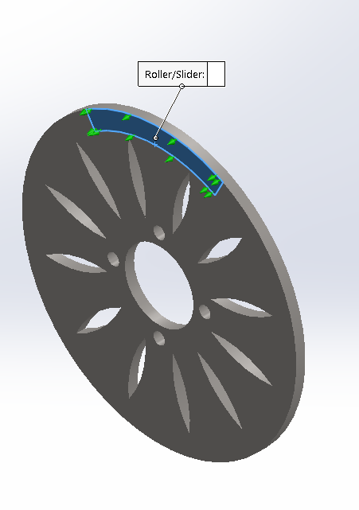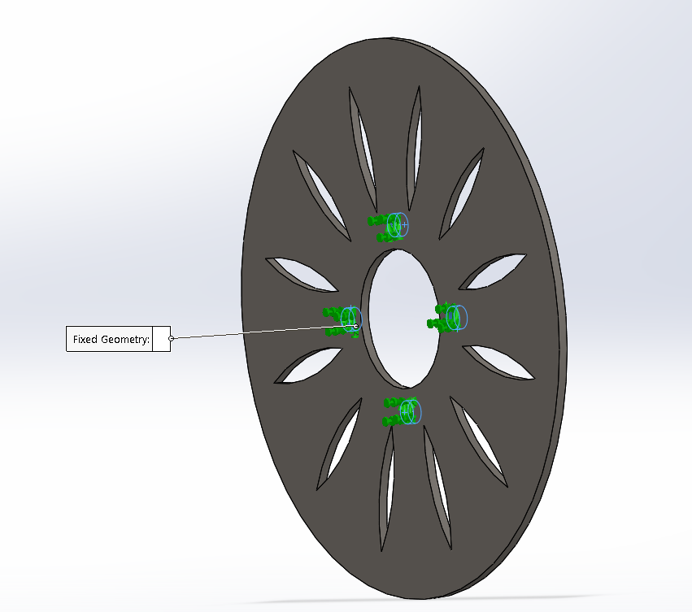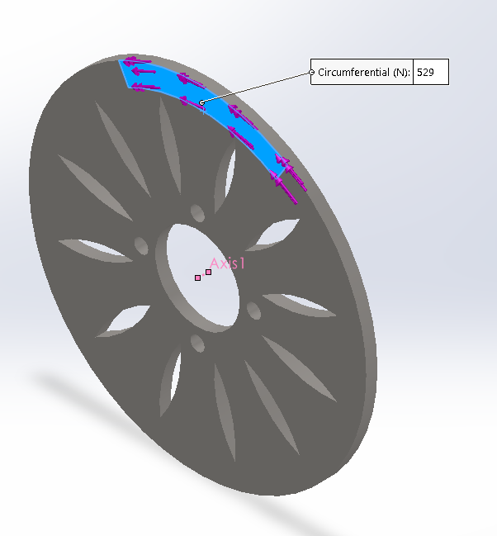

Figure 1: Breaking Force Area, Boundary Condition and Friction Force on Brake

The meshing and material properties of cast iron for the brake were used to calculate the Von Mises Stresses using Yield Strength criteria. The results of the FEM simulations are given below.

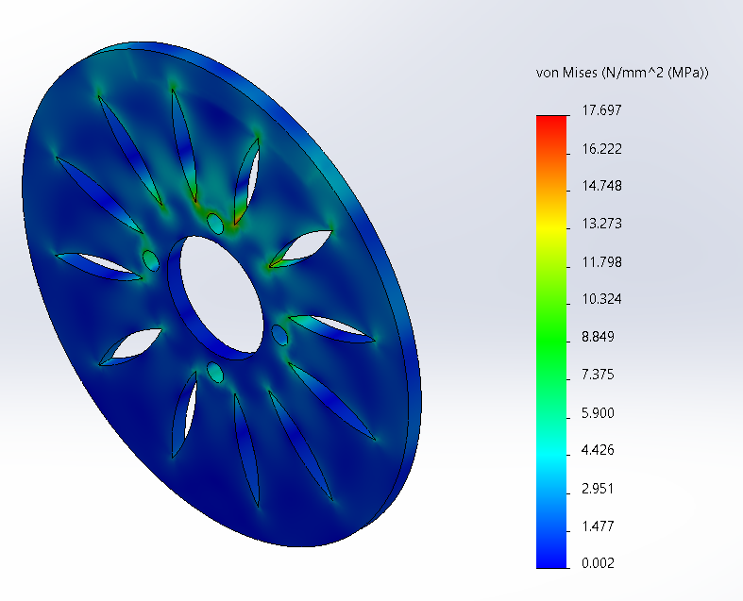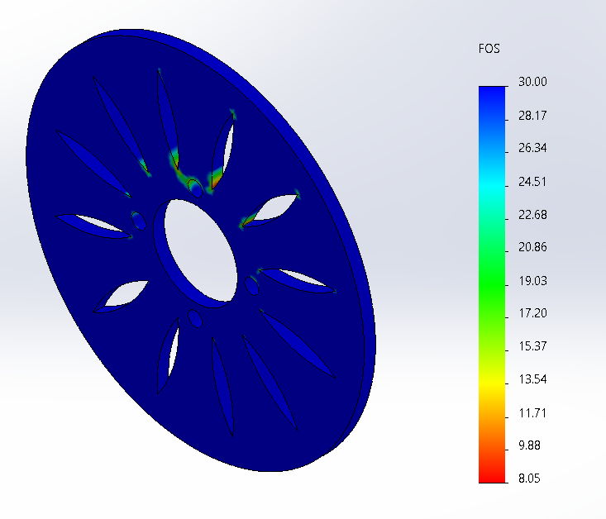

Figure 2: Von Mises Stresses and Factor of Safety Simulated Results

The same methodology was adopted in calculating the heat generation for which the acceleration rate and braking distance using the design speed of the vehicle were used to compute the braking time. The kinetic energy and heat generated were calculated, and convective heat transfer calculated by carrying out the transient thermal analysis on Solidworks. The convective and heat power boundary conditions used in the modeling is shown in the following Figure 3.

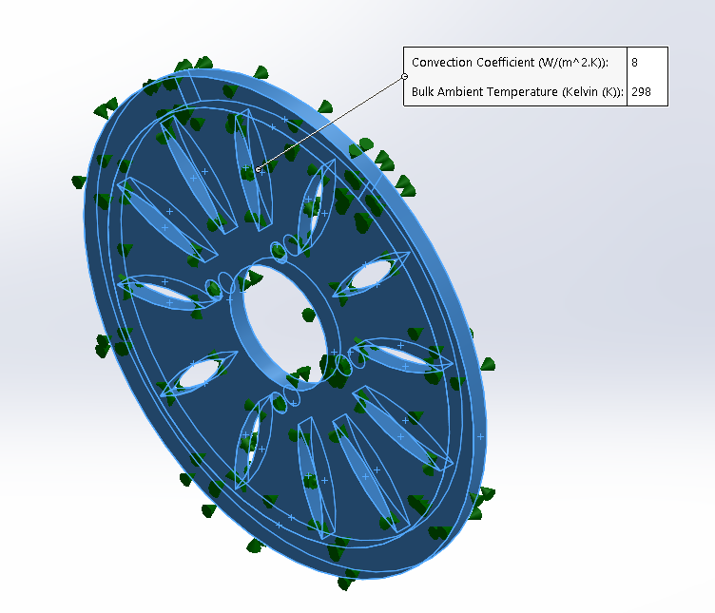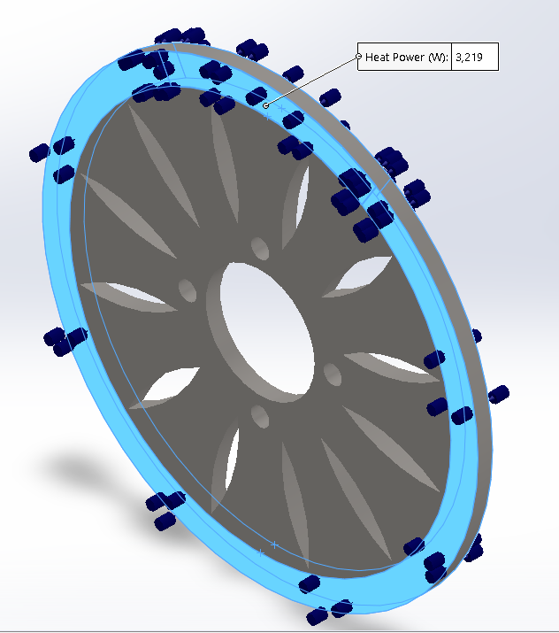

Figure 3: Convective and Heat Power Boundary Conditions.

The thermal profile due to breaking using transient thermal analysis based on the heat generated load is shown in the following temperature distribution plot.

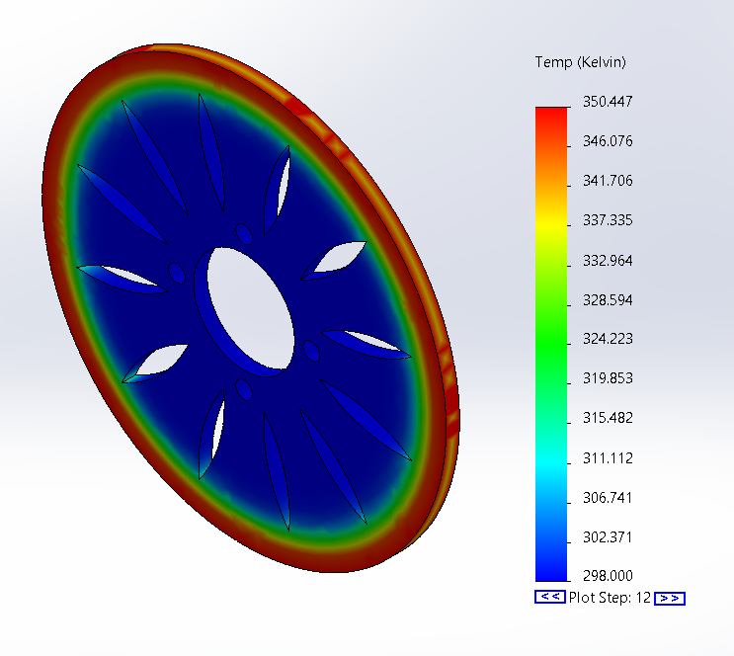

Figure 4: Temperature Distribution After Braking

**Analysis of Front Suspension:**

For the analysis of the front suspension of the Baja vehicle, a free body diagram was drawn. Afterwards, the weight of the vehicle and driver were determined by centre of gravity, and indicated at the point where it acted. In addition, the weight of the engine and passengers was also determined and found to be 600 Ib. Having determined the total acting weight, the weight of each arm was determined as well as the load acting on each arm with the help of the free body diagram. Furthermore, the loads acting on the springs and shock absorber due to impact were determined which is equal to 141.34 Ib. Due to the contact of the wheels with the ground, the friction force was determined which is equal 15.9 Ib. Other forces that were determined include the force on each shock absorber and later the static and dynamic loads were established.

Using the dimensions provided, the distance at which the weight of the car acted was determined to be 83 in from the location of the front wheel. To fully compute the forces that are acting on the free body diagram, it was necessary to determine the weight of the driver equal 150 Ib and the location that the weight of the driver was acting. It was established that the weight of the driver acted at a distance of 30 in from the front wheel. Considerably, when the vehicle is resting on the ground, there are support reactions which must also be considered. The reaction forces acted on both the front and the rear of the vehicle, and due to the geometry of the vehicle, the equal forces acted at the front wheels. As a rule; upward forces must balance with downward forces, and clockwise moments must balance with anticlockwise forces. Calculations from the system were done and it was found out that reaction force at the front wheel was 106.25 Ib and 193.25 Ib at the rear wheel.

From the setup, the lower control arm which was subjected to the reaction force from the ground as well as the spring force. From the side of the wheel, the shock absorber and springs were attached at a 1/5th length the distance with an inclination angle of 70 degrees. A pin joint connected the lower control arm with the chassis of the vehicle. The sum of moments at the pin joint were established to be 0 and it was possible to determine the impact force that was applied by the force absorber. The force was computed and established to be 141.34 Ib. The coefficient of friction between the car and the surface was provided as 0.15 and was used to determine the friction of one of the front wheels was established to be 7.95 Ib.

There is a need to analyze and simulate the von-mises stresses that are induced at the arm of the front suspension system. When evaluating the lower arm, there are two integral factors that must be considered: the impact force and the reaction force, and the loads coming from weight of vehicle and driver. The impact force emerges as a result of the shock absorber and spring while the reaction force is considered the ground. Both arms are chromoly materials; however, this is fixed at the chassis of the vehicle. The chassis joints are built to withstand the maximum stress. In figure 4, it points to the value measured for the lower arm is 2.487 psi for the stress while the yield strength is 6.6720 psi. Thus, the induced stress in the arms is considered to be within the stress limit of the material.

Figure 5: Von Mises Stresses

By following the figure 5, criticality of the factor of safety (FOS) cannot be overlooked when analyzing the stress level of materials. Normally, the standard factor of safety should be greater than one for all safe designs. The lower arm has an estimated factor of safety ranging between 2.68 and 4.005 based on the available conditions and load. Given that the lowest value is 2.68, the design is certified and will be durable and will not fail

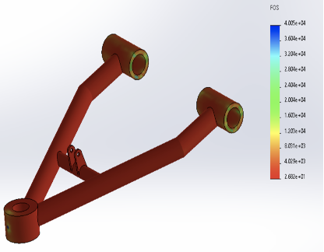

Figure 6: FOS Plot of Lower Arm

For the impact force, needs to figure out the shock absorber force and the spring force by the sum of these forces. Since impact force is inevitable in a vehicle, springs and shock absorbers are designed to eliminate that force. Typically, the kinetic energy of any given car is absorbed by shock absorbers. In physics, the kinetic energy transmitted by the car equals the work that will be done on the shock absorber which eliminates that energy. The value of the work done at the shock absorbers is a multiple of stroke length and force. For example, for a vehicle moving at a speed of 40mph and has a stroke length of 2.5 in, the work done will be 41.7lb. This makes the force on the spring to be 99.64lb.

It should be noted that greater stroke lengths are not designed to improve the comfort of drivers in vehicles. When designing, the stroke length is made in a way that it equals the expansion and contraction of the springs. Therefore, the product of stroke length and stiffness makes the spring force experienced. When we substitute the stroke length and spring force of the given equation, the stiffness is calculated to be 39.84lb/in. The implication of this is that the stiffness of the spring is expected to be greater than or equal to 39.84 Ib/in. When the value meets this criterion, then it can be considered as a safe design. This is because when the stiffness of the spring goes lower than 39.84 Ib/in, the expansion and contraction limits of the spring will be exceeded, which can have a detrimental impact. The normal limit should be 2.5 in and exceeding that value can have some impact.

**Analysis of Dashboard:**

The sensor I want to use first is the IR sensor, which is included in the Arduino module. The infrared sensor includes an infrared LED and an infrared photodiode. Together they are called optocouplers. The infrared sensor has a built-in infrared transmitter and infrared receiver. An infrared transmitter is a light emitting diode (LED) that emits infrared radiation. Therefore, they are called IR LEDs. Even though an IR LED looks like an ordinary LED, the radiation it emits is invisible to the human eye. Infrared receivers are also called infrared sensors because they detect radiation from IR transmitters. Infrared receivers take the form of photodiodes and phototransistors. When the infrared transmitter emits radiation, it will reach the object, and some of the radiation will be reflected back to the infrared receiver. According to the receiving intensity of the infrared receiver, the output of the sensor is defined. [1]

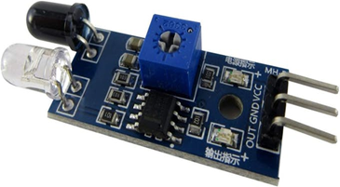

Figure 7: IR sensor.[1]

When I place the IR sensor on an Arduino and try to measure the number of gaps on a wheel, I realize that the sensing accuracy of this type of infrared sensor is not so accurate. When it is applied in this experiment, the wheel gap is too thin for it. Therefore, it is not applicable.

After consulting the information, I found another more suitable sensor for detecting speed. LM393 speed sensor can be divided into two parts: the sensor part and the control part. The sensor part of LM393 speed sensor module includes infrared LED and NPN phototransistor. The two components are placed opposite each other in a special shell made of black thermoplastic. This special casing ensures that the phototransistor only receives light from the infrared LED and all external light eliminates the light source. Coming to the control unit, it is composed of LM393 voltage comparator and some passive components to form electronic components. The signal from the phototransistor is provided to the LM393 and depending on whether there is an object between the infrared LED and the phototransistor, the output of the LM393 IC will be high or low. The module can be used in association with a microcontroller for motor speed detection, pulse count, position limit, etc. [2]

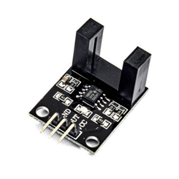

Figure 8: LM393 speed sensor [2]

After I confirm the type of sensor, I start to build the prototype of the design. Here is the list of the required components: Arduino UNO, LM393 speed sensor module, 16×2 LCD display, 5V gear DC motor, Encoder wheel, Motor speed controller, Connection line, Breadboard. Since the wheel and the plate are connected to the same shaft, both rotate at the same speed, so by measuring the speed of the plate, we can measure the speed of the wheel. Make sure that the gap on the grid plate passes through the IR sensor. Only in this way can the sensor calculate the number of gaps that have passed through.

The final formula: V_display = rpm * R * 0.3768 (Km/h)

**Conclusion:**

The force analysis of brake pads on the brake was manually calculated by using equations of motions, and other equations that we have explained in the hardware review and FEA analysis was carried out, which showed that the results of braking force and the stresses generated as a result are within the materials yield limits and FOS of the current design is acceptable. The temperature analysis on the brake heat generation and heat transfer showed that the maximum temperature of the disk at the end of the braking was 350.5 K which is 77.3 ◦C. The disk will cool down under the normal convection after brakes are released as the heat generation would end. The maximum temperature was found to be far below the melting point of the cast iron. The force analysis of the front suspension on the lower-case arm was analyzed by manual calculation and Simulation by Finite Element Analysis (FEA). As per the FEA result, the maximum stress is equal to 2.48 psi which is less than the yield strength. In the lower arm, the safety factor for a particular load is from 2.68 to 4.005. The primary reason for this is that the min safety factor is 2.68. In this case, there are minimal chances of failure and the design is free from the risks of rust. The rate of the spring has two primary conditions including the dynamic and the static condition. In the dynamic condition, there is compression force which is 39 Ib/in. In the static condition, there is expansion of the spring and the force will be 99.64 Ib/in. For the dashboard part, The infrared sensor can successfully detect the gap between the wheel and send out an interrupt signal. The flashing of the LED indicates the occurrence of the interruption. The wheel has 20 gaps. This means that the sensor will find 20 gaps and 40 interrupts for a full revolution of the wheel. By calculating the number of gaps detected by the sensor, the distance traveled by the wheel can be calculated. Similarly, by measuring the speed at which the sensor finds the gap, it can detect the speed of the wheel.

Reference

[1] Arduino with IR Sensor, Alfa, Arduino project hub, September 23, 2019.

[2] Interfacing LM393 Infrared Speed Sensor with Arduino, Mohammad Damirchi, eletropeak, August 20, 2018.