To: Dr. David Willy
CC: Matilda Koa, Diego Ruiz
From: NG Umbilical
Re: Final Prototype
Final Prototype:
The final prototype was constructed to help our team evaluate different design decisions including the shape of the spool and the overall construction of the housing. Below in Figure 1 is the completed design for this semester.
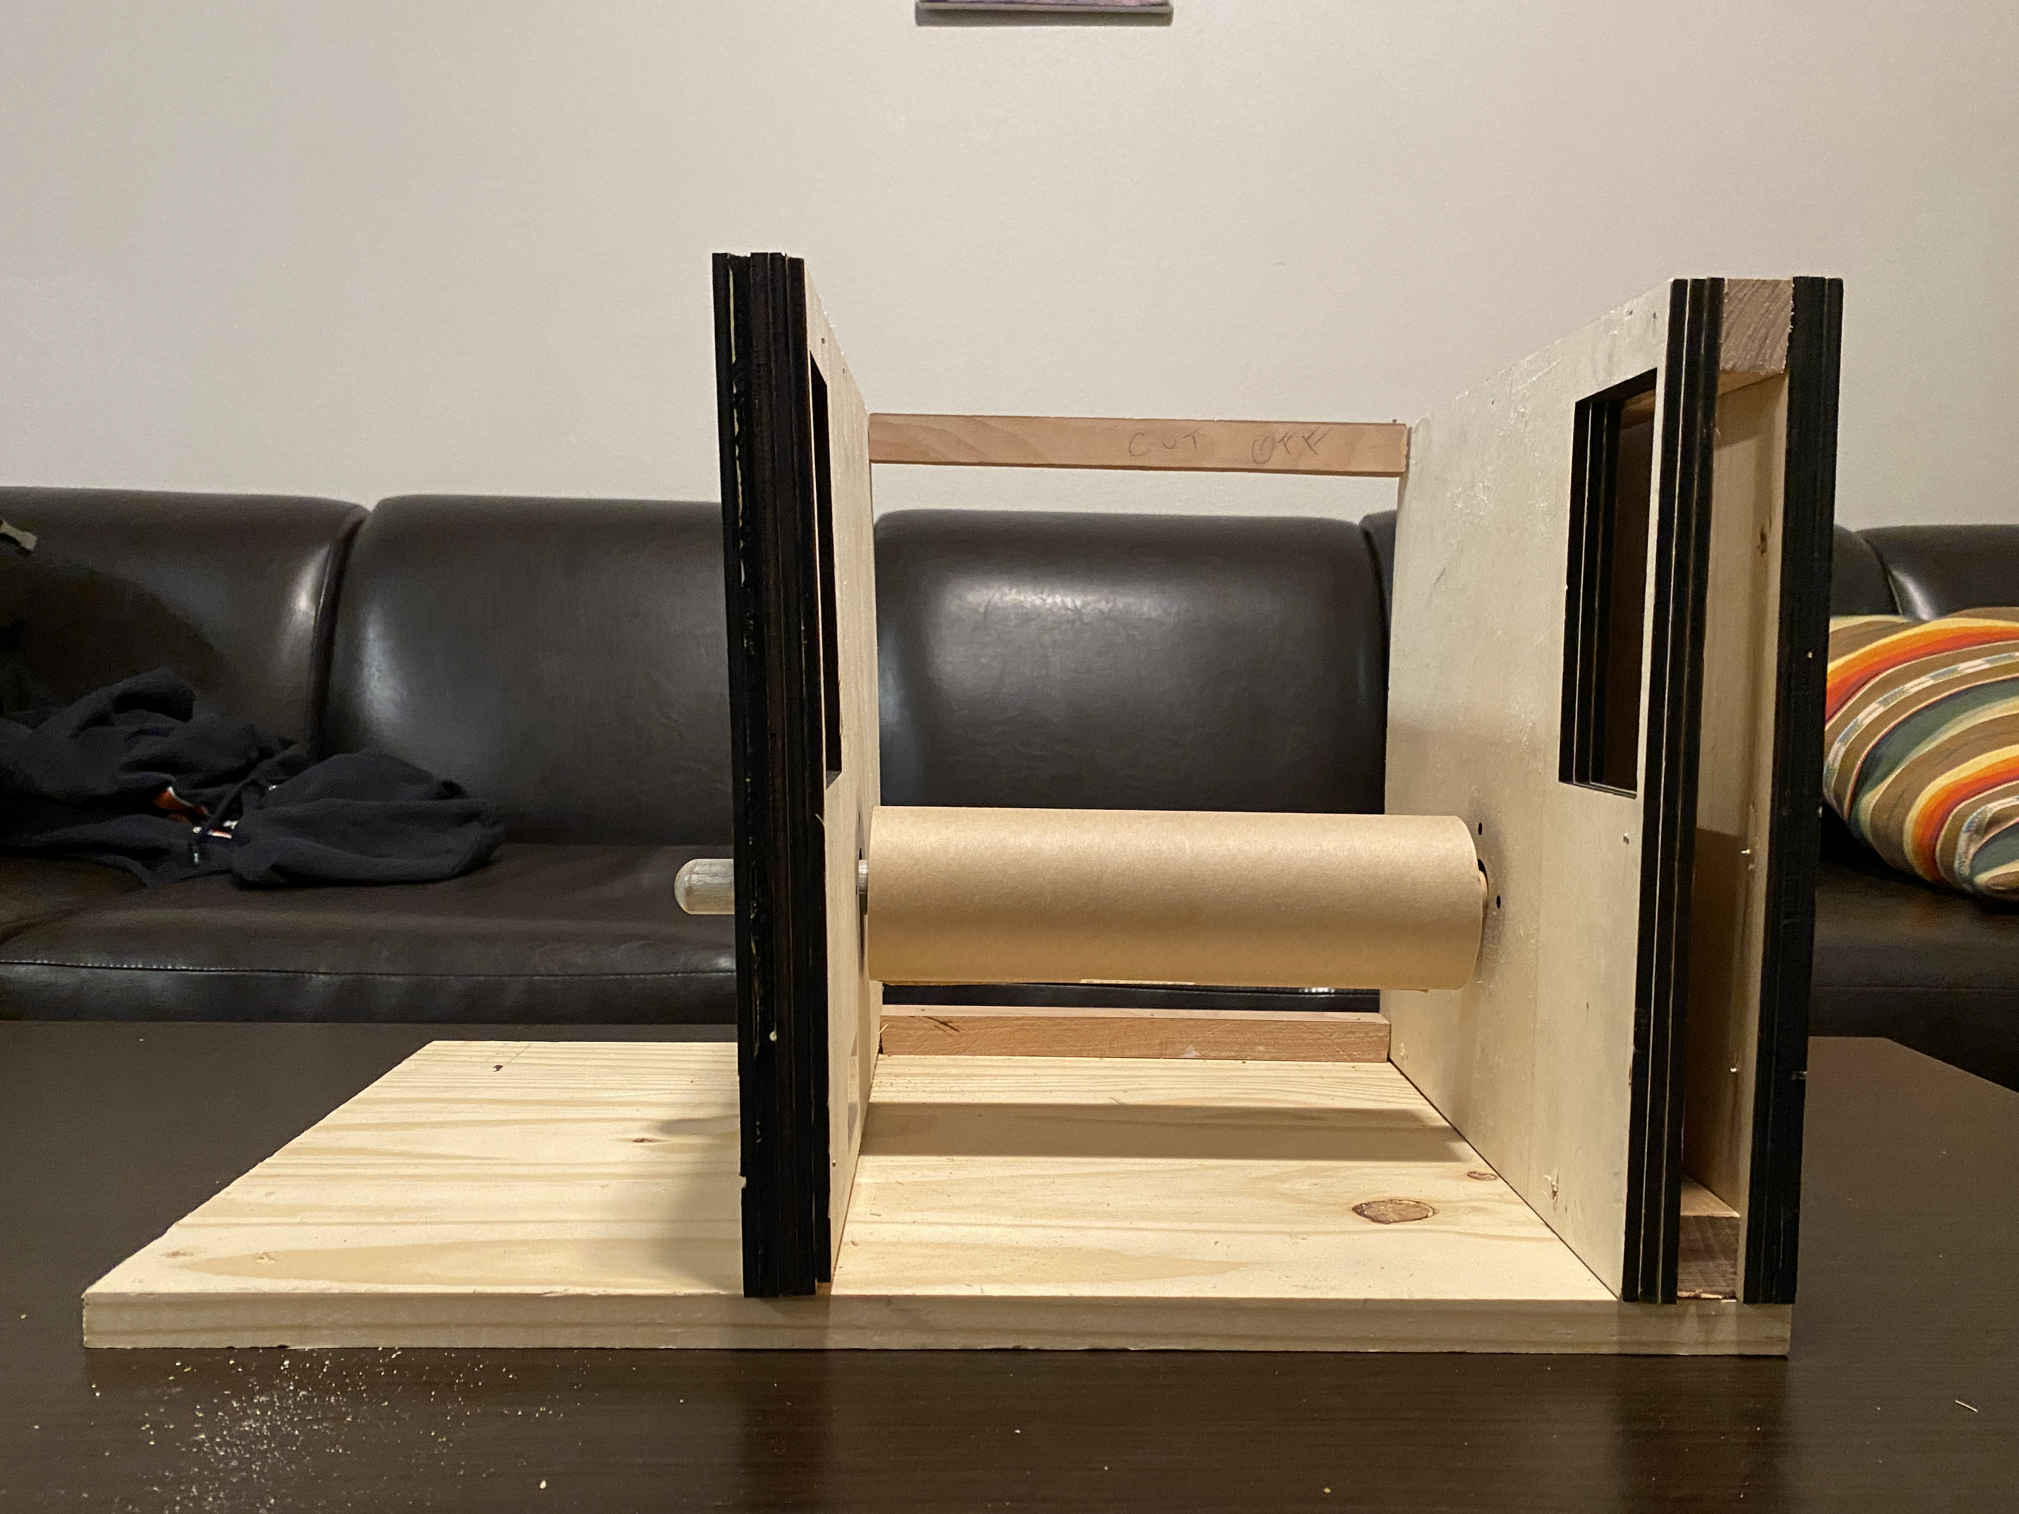
Figure 1: Front View of Prototype
The design was built out of wood to allow for cheap and easy manufacturing, but future prototypes and models will be built out of more realistic materials such as metal and composites. The side boards shown mainly in Figures 2 and 3 were constructed using the NAU laser cutter and the rest of the parts were pieced together using various woodworking techniques.
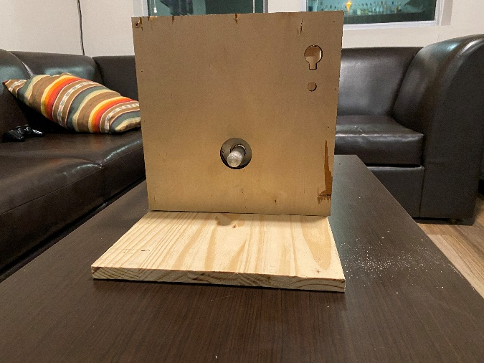
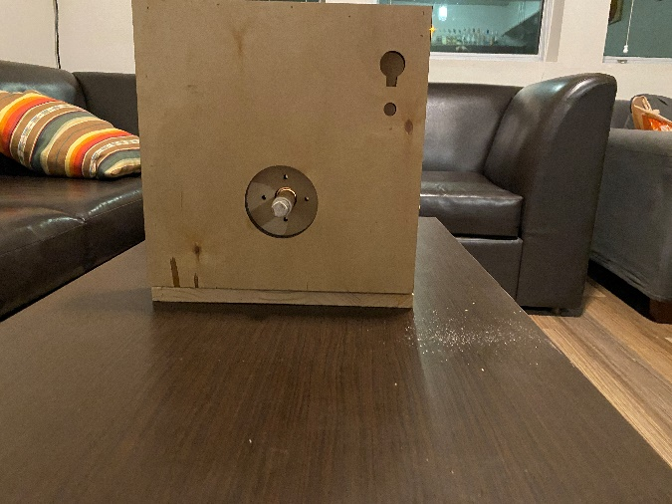
The
Figure 3: Side View 2
Figure 2: Side View 1

The shaped holes within both Figures 2 and 3 on the top right of the sides are where a sliding reel will be installed that will be used to guide the chord to prevent bunching up. It can also be seen through the holes in the middle of each board where ball bearings will be placed for future models. The motor for this assembly (a power drill) will connect to the rod that is sticking out of the side. It will be connected by drilling holes inside of the rod and forming the drill to take hold and stay placed inside of it. In Figure 2, you can see multiple holes drilled into the board, these holes will act as guide and screw holes for when the actual motor the team purchases will be inserted. The figures below showing the spools show different concepts that the team has thought of.
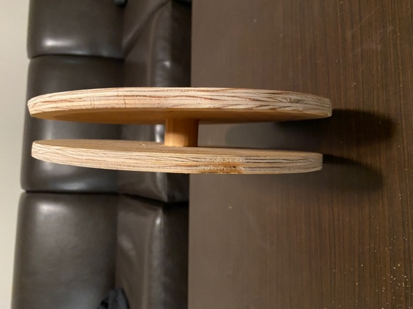
Figure 4: Large Spool
Figure 4 is a larger, but skinnier spindle that would have the rope build on top of itself neglecting the need to have a reel assist guideline as discussed above. This spindle could save the team work on creating that part, but it comes with its own challenges of having to redesign for a larger rotational inertia, along with checking to see if the dimensions of it fit the client’s needs.
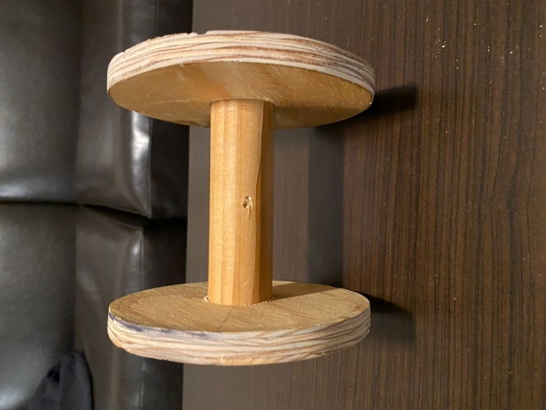
Figure 5: Small Spool
The smaller spindle shown in Figure 5 features a smaller overall size with a longer connecting rod. This option may need to use the guide assisted retraction system where the retracting chord will move along the spindle like the line guides found on fishing rods. This could save on the overall size of the design, but it would make it more expensive and there would be more challenges to overcome when designing the guideline. Overall, the design shows to prove that the team can design a well working model that is sturdy and can hold up to a couple of the design aspects presented by the client.
Final Testing:
To test this design, a drill was attached to the rod holding the spindle to see if it was able to retract the rope, which it was. The purpose of this was to see if it could work under some strength and torsion conditions as well as to observe if the chord would bunch up along the spool in one spot. The spindles were tested by drilling a hole in the middle of them and placing a drill attachment on the inside to spin the wheel via a motor. Testing of these designs will continue over the break where further design improvements will be made in preparation for next semester and further prototyping.

