Finalized Testing Plan – Northrop Grumman Umbilical
March 25th, 2022

Section 1: Design Requirements Summary
The design requirements for this project were supplied by our client Northrop Grumman. They are broken into two categories: qualitative customer requirements and quantitative engineering requirements. The five customer requirements are high manufacturability, high reliability, easily installed/removed, high durability, and safe from electrostatic discharge. The seven engineering requirements are: a five-thousand-dollar budget, a side force of less than ten pounds prior to umbilical separation from the vehicle, support an umbilical weighing up to one pound per foot of cable, support adjustable cable lengths between two and six feet, retract an umbilical at maximum weight and cable length in under one second, withstand launch pad temperatures between negative thirty and one-hundred and sixty degrees Fahrenheit, and have a one-hundred percent success rate. For easy identification, each design requirement is assigned a label seen in Table 1 below.
Table 1: Design Requirements
Customer Requirements | Engineering Requirements
CR1 - High Manufacturability | ER1 - Cost
CR2 - High Reliability | ER2 - Side Force
CR3 - Easily Removable/Installed | ER3 - Retraction Speed
CR4 - High Durability | ER4 - Temperature
CR5 - ESD Safe | ER5 - Weight
 | ER6 - Length
 | ER7 - Success Rate
DeR
Section 2: Testing Summary
The team has developed five tests to determine if the design requirements are met. They are organized below in Table 2. Three customer requirements and one engineering requirement do not have a specific test assigned to them because they can be proved by other means. The engineering requirement of cost is met by our team not exceeding our budget. The customer requirement high manufacturability can be proven by analyzing the total time needed to manufacture the entire design. The customer requirement easily installed/removed can be evaluated on size and weight of the final design. The customer requirement of being safe from electrostatic discharge is met based on the materials used in the design.
Table 2: Testing Summary
Tests | Relevant DR
T1 - Motor Startup | CR2
T2 - Cable Type | CR2, CR4, ER4, ER6
T3 - Temperature | CR2, CR4, ER2, ER3, ER4, ER5, ER6, ER7
T4 - Side Force | ER2, ER6, ER7
T5 - Retraction Speed | CR2, ER3, ER5, ER6, ER7

Section 3: Detailed Testing Plan
3.1: T1 – Motor Startup
3.1.1 Test Summary:
This test has already been completed and was proven successful. This test was to ensure our motor functions properly correlating to the customer requirement of high reliability. This required proper setup and wiring connection of the motor controller to the power supply and motor controller to the motor. To avoid damage to the power supply we plan to use in our final design, a supplementary power supply was used. This supplemental power supply supplied a constant 24 volts to simulate how the final power supply would function. The motor was run for ten seconds before turning off the power supply. The list of materials used in this test is shown below.
Required Materials:
- Basic Micro Motion Controller – MCP266 Brushed DC Motor Controller
- DC Power Supply PS-3010DF
- Amp Flow A128-150-G8 Motor
- Commercial Electric Non-Contact Voltage Tester
- Screwdriver
- Electrical Tape
- USB connector
- Personal Computer - with Basic Micro Motion Studio program
- Spade and Ring Terminals
- Wall outlet – 25 amp
- Timer
3.1.2 Procedure:
- Gather required materials and set up testing area
- Connect motor control to supplemental 30 volt and 10-amp power supply, which is plugged into a 25-amp wall outlet, using spade terminals
- Connect motor control to computer with Basic Micro Motion Studio program using a USB
- Connect motor control to motor wires using screwdriver and ring terminals
- Check wiring connections before starting program
- Run program watching power supply values and motor actuation
- Let motor run for 10 seconds
- Turn off program
- Before disconnecting use a non-contact voltage tester to see if the wire connections are still hot
- Disassemble circuit
3.1.3 Results:
The result our team expected from this test was the motor would begin to spin once the power was supplied.
3.1.4 Conclusion:
This test was successful. The motor did spin once the power was supplied. This meant our team could move forward with the wiring and electrical aspects of our final design by connecting the motor controller to the final power supply.
3.2: T2 – Cable Type
3.2.1 Test Summary:
The purpose of this test is to determine which cable the team will use in the final design. The prevalent customer requirements in this test are high reliability and high durability. The prevalent engineering requirements in this test are temperature range and length of cable. All cables meet the tensile strength requirement and are constructed of materials that meet the temperature range requirement of the client. Therefore, we will conduct a flame resistance test to select the final design cable. We are conducting a flame resistance test because the cable will be exposed to a flame as the vehicle is launching, so we want to find which of the five cables will have the least damage when exposed. Each cable will be exposed three times each for five seconds. The cables will be positioned approximately five inches from the flames. The materials needed for this test are listed below.
Required Materials:
- 5 cable types
- 5 roasting skewers
- Rubber bands
- Fire pit
- Fuel for fire
- Lighter
- Measuring tape
- Timer
- Gloves
- Phone camera
- Personal computer with Microsoft Office
- Form of fire extinguisher
3.2.2 Procedure:
- Gather required materials and set up testing area
- Brief teammates on fire safety and location of fire extinguisher
- Prepare timer and phone camera to record test
- Fasten cable 1 to a roasting skewer using rubber bands on either side and take a before flame exposure photo
- Position cable 1 setup roughly five inches above the fuel in the fire pit and use a measuring tape to record distance
- Use lighter to light the fuel placed into the fire pit
- Start video and expose the cable for five seconds
- Use gloves to remove cable from flames and take a photo of the cable, record time duration and note any changes to the cable.
- Apply expose cable 1 to the flames for two more trials in the same location as original exposure taking a photo between each trial
- Use gloves to remove cable 1 from testing area and repeat procedure for remaining cables
3.2.3 Results:
Our team expects there to be a difference between the five cables after exposure to the flame due to variation in material composition of the outer layer of the cables. The team will be looking for discoloration or even melting of the material. The photos taken before the start of the test and after each trial will pose as great reference for comparison between the integrity of the cable itself between trials and the final contrast between the other cables.
3.2.4 Conclusion:
This test will determine if the current five cables are suitable for use in the final design or if a new cable type will need to be considered. Further, this test will determine the best cable of the current five options.
3.3: T3 – Temperature
3.3.1 Test Summary:
The main purpose of this test is to verify that our design will meet the temperature range engineering requirement set by our client. The remaining engineering requirements must be met as well to prove functionality of the design. This will further support our design meets the customer requirements of high reliability and high durability. This test will prove or disprove that our design can function at any temperature within the range of negative thirty degrees Fahrenheit to one-hundred- and sixty-degrees Fahrenheit. Five initial measurements must be taken before the experiment can begin. They are temperature, length of cable, weight of mock umbilical, force applied by the cable, and pull angle. During the test time taken to retract the mock umbilical will be measured. Leading to the calculation of the side force applied and the retraction speed to ensure the device functions properly. The materials needed for this test are listed below.
Required Materials:
- Full design
- Thermometer
- Heating Source – Hair Dryer/Heat Gun
- Cooling Source – Dry Ice
- Force Gauge
- Protractor
- Scale
- Timer
- Gloves (grab design from cold/warm)
- Measuring Tape
- Phone camera (video of test)
- Personal computer with Microsoft Office
3.3.2 Procedure:
- Gather required materials and set up testing area
- Brief teammates on safety hazards within test
- Set up cooling source and allow temperature to reach at least -30F
- Measure pull angle with protractor and force applied by cable with force gauge
- Measure cable length when fully extended and weigh mock umbilical
- Set up phone camera
- Place design in cooling source and cool until thermometer reads -30F
- Start video recording and remove design from cooling source using gloves
- Quickly set up design, actuate, and record time of retraction
- Reset design
- Record temperature of design, if temperature is too cold allowed time to warm apply heating source if need be, if temperature is too warm allow time to cool apply cooling source if need be
- Collect data for the following temperatures: -30F, 0F, 25F, 50F, 75F, 100F, 125F, 160F
- For each trial, preform calculations and report if the design was functional
3.3.3 Results:
The team expects our device to successfully function at any temperature. We believe this because we used materials that do not experience variation of physical properties within the temperature range supplied to our client.
3.3.4 Conclusion:
This test will require the effort of the whole team because there are many initial measurements that need to be taken for each temperature to accurately evaluate if the design operated successfully. Further, this test features some safety hazards, with the heating and cooling sources and being near the device when actuated, so the team will need to be very aware of our surroundings in the testing area.
3.4: T4 – Side Force
3.4.1 Test Summary:
This test is to make sure our design does not exert a side force greater than 10lbs. This test is important because if more then 10lbs of force is applied complications could be caused when our device is attached to a vehicle. Therefore, this test focuses on the side force, cable length, and success rate engineering requirements. The initial measurement taken in this test will be the pull angle and force applied by the cable, as well as the length of the cable. These measurements will lead to the calculation of the side force. The required materials for this test are listed below.
Required Materials:
- Full design
- Force gauge
- Protractor
- Measuring Tape
- Personal computer with Microsoft Office

    - Procedure:
- Gather required materials
- Measure the cable length using a measuring tape
- Attach force gauge to the end of the umbilical cable when it is fully extended
- Record the force applied by the cable
- Measure the pull angle using a protractor
- Reset force gauge
- Repeat procedure 4 more times with varying cable lengths and pull angles
- Calculate the side force from each trial and identify if the engineering requirement was met
3.4.3 Results:
Our team expects our design to meet the side force engineering requirement by exerting less than ten pounds of force regardless of the cable length. We believe this because our device is designed to acuate once the umbilical is released from the vehicle, so in theory the side force exerted by our device should be very minimal since it is not initially loaded.
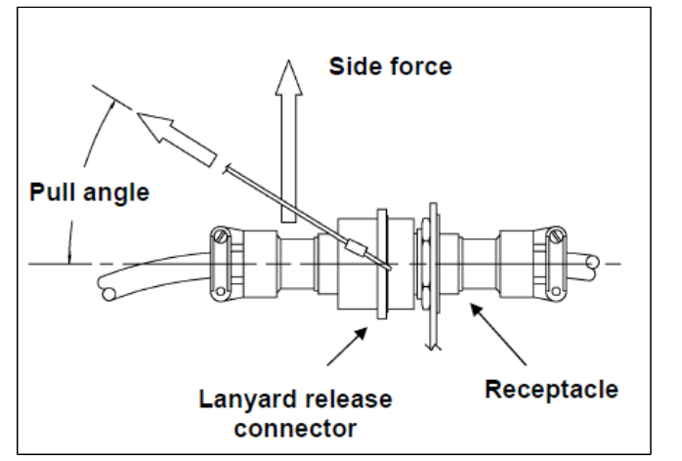
Figure 1: Side Force and Pull Angle Diagram
Based on the Figure 1, the side force (SF) can be evaluated by multiplying the force applied by the cable (F) by the sin of the pull angle ($θ).$
$SF=Fsin⁡(θ)$ Equation (1)
We expect our design to exert less than one Newton, 0.225-pound force. If we set our pull angle to 45 degrees, our expected side force range is 0 to 0.159 pounds.
3.4.4 Conclusion:
Our device was designed to have a minimal side force based on the principle that the force applied by the cable will be low because tension is not applied until after the release of the umbilical from the vehicle. The team will experiment with varying cable lengths and pull angles to see if the side force is affected.
3.5: T5 – Retraction Speed
3.5.1 Test Summary:
This test is arguably the most important to our project. This test will determine if our final design meets the retraction speed engineering requirement given to us by the client. Further, the mock umbilical weight, the cable length, and the success rate engineering requirements will be considered. This test will determine if our customer requirement of high reliability is met as well. The initial measurements taken in this test will be the weight of the mock umbilical and the cable length. During the test the time required for the umbilical to retract will be recorded and the speed of the motor. From this the retraction speed can be calculated, thus determining if the design was successful. The materials needed for this test are listed below.
Required Materials:
- Full design
- Tape measure
- Timer
- Tachometer
- Scale
- Phone camera
- Personal computer with Microsoft Office
3.5.2 Procedure:
- Gather required materials and set up testing area
- Brief teammates on safety hazards within test
- Set up camera making sure the full design is in view
- Use scale to weigh mock umbilical used and record weight in pounds
- Use tape measure to record length of cable in inches when fully extended
- Prepare timer and start video recording
- Point tachometer on the axis of rotation of the motor shaft to record speed
- Actuate design timing the retraction using a timer and stop video recording (can also get time stamp from video)
- Repeat test a minimum of five times varying the mock umbilical weight corresponding to the cable length (Note: the design must successfully operate with a 6-pound umbilical attached to a 6-foot cable)
- Identify if the test was successful
3.5.3 Results:
Based on our motor selection, we believe our design will meet the maximum weight with corresponding retraction speed requirement of retracting six-pound umbilical six feet in one second.
Retraction speed (RS) is calculated by dividing the length of the cable (x) by the time it takes for the umbilical to fully retract (t).
$RS= \frac{x}{t}$ Equation (2)
$RPM=\frac{\frac{RS}{\frac{Pully Diameter}{2}}}{0.1047}$ Equation (3)
$τ=τ_{Friction}+τ_{Damping}+τ_{Acceleration}$ Equation (4)
$τ_{Acceleration}=a_{rotational} *I=\frac{l*F}{I }*0.5*m*l^{2}$ Equation (5)
$HP=\frac{RPM*τ}{745.7}$ Equation (6)
In the above equations, ‘I’ is the inertia of the pully, ‘m’ is the mass of the pully, and ‘l’ is its diameter. ‘F’ is the force that the pully is going to be under which is given as the weight of the rope squared.
This will relate to an RPM of 175 to retract the entire 6 ft cord. As another suggestion by the client, it would be good to see the device be able to pull a second umbilical if space and application allows for it. In relation, this would entail the motor to be running at 350 RPM which considering the added weight will equate to a force of 11 Nm of torque to pull. The torque is calculated as shown in Equation 4 where the torque caused by friction and damping is 0.1 Nm and 0.25 Nm respectfully which are researched values. The torque for the acceleration term though is shown as Equation 5. The motor purchased by the team meets all these specs at its highest efficiency point as shown below in Figure 2 below. The plot shows that at the peak efficiency point, the motor will be turning right around 670 RPM which is really four times the minimum speed required by the client, all while being able to pull 11 Nm of force. The power supply purchased is well equipped to run this motor at its highest efficiency point for long or short periods of time. The one consideration to consider is the surge power from the motor at stall. To avoid backflow and damaging our power supply, fuses will be added to the circuit to break any surge in power.
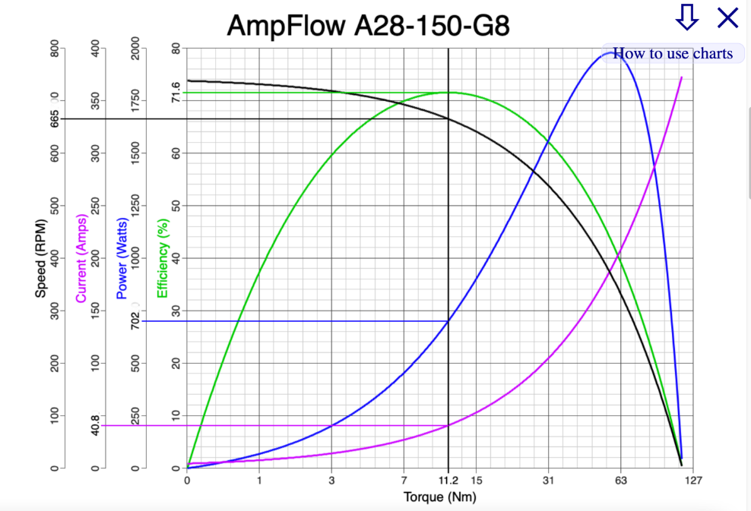
Figure 2: Motor Curve
3.5.4 Conclusion
This test would prove if we successfully completed our project since the main objective stressed by our client is the retraction of the umbilical from the launch zone. Our design must have a one-hundred percent success rate, so the team will test multiple cable lengths paired with corresponding mock umbilical.
Section 4: Specification Sheet Preparation
For organization and easy identification, two tables, one for each category of design requirements, were created. Both are formatted to answer if the requirement was met and if the outcome is approved by the client. These columns are formatted to prompt the user to select, either yes or no. If yes is selected the cell will be highlighted green, but if no is selected the cell will be highlighted red. The engineering requirement table includes a target and tolerance column to provide more information. Further, an actual measured/calculated value column is included to compare the values found through testing with our target values.

Table 3: Specification Customer Requirements
Customer Requirements | CR Met? | Client Approved?
CR1 - High Manufacturability
CR2 - High Reliability
CR3 - Easily Removable/Installed
CR4 - High Durability
CR5 - ESD Safe

Table 4: Specification Engineering Requirements
Engineering Requirements | Target | Tolerance | Measured/Calculated Value | ER Met? | Client Approved?
ER1 - Cost | 5000 ($)
ER2 - Side Force | <10 (lbs.)
ER3 - Retraction Speed | 6ft/1s
ER4 - Temperature | -30 to 160 (F)
ER5 - Weight | 1lb/1ft
ER6 - Length | 2 to 6 (ft)
ER7 - Success Rate | 100 (%)

Section 5: Quality Function Deployment
The Quality Function Deployment (QFD) links the customer requirements and engineering requirements together. This helps to determine if the customer requirements are met because if the engineering requirements are met, they correspond to the customer requirements. For example, within our team’s QFD, the engineering requirement retraction speed is highly related to the customer requirement of high reliability because if there is variation in the retraction speed or the target is not met, the device is not reliable. Another example from our QFD is the relationship between the engineering requirement temperature and the customer requirement high durability because if the design cannot withstand the potential temperature conditions of the launch zone the device cannot be considered durable. Included below in Figure 3 is our full QFD.
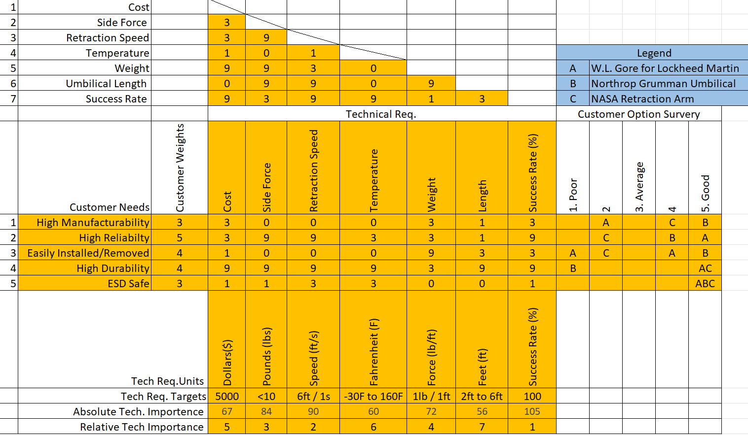
Figure 3: Full Quality Function Deployment

