**Environmental Control Systems (ECS) Door Redesign**

**Preliminary Proposal**

**Jake West**

**Alexander Soto**

**Michael Wilson**

**Andrea Hernandez**

**Sam Mangialardi**

**Timothy Anderson**

**Fall 2020**

**Project Sponsor: Northrop Grumman, Daniel Johnson**

**Faculty Advisor: David Trevas**

# DISCLAIMER

This report was prepared by students as part of a university course requirement. While considerable effort has been put into the project, it is not the work of licensed engineers and has not undergone the extensive verification that is common in the profession. The information, data, conclusions, and content of this report should not be relied on or utilized without thorough, independent testing and verification. University faculty members may have been associated with this project as advisors, sponsors, or course instructors, but as such they are not responsible for the accuracy of results or conclusions.

# TABLE OF CONTENTS

Contents

DISCLAIMER 2

TABLE OF CONTENTS 2

1 BACKGROUND 1

1.1 Introduction 1

1.2 Project Description 1

1.3 Original System 1

1.3.1 Original System Structure 1

1.3.2 Original System Operation 2

1.3.3 Original System Performance 2

1.3.4 Original System Deficiencies 2

2 REQUIREMENTS 3

2.1 Customer Requirements (CRs) 3

2.2 Engineering Requirements (ERs) 4

2.3 House of Quality (HoQ) 6

2.4 Functional Decomposition 6

2.4.1 Black Box Model 6

2.4.2 Functional Model/Work-Process Framework 7

3 DESIGN SPACE RESEARCH 8

3.1 Literature Review 8

3.1.1 Jake West: Electrostatic Discharge 8

3.1.2 Alex Soto: Computation Fluid Dynamics 8

3.1.3 Timothy Anderson: Geometric Dimensioning and Tolerancing 8

3.1.4 Michael Wilson: Aerodynamic Protuberance 8

3.2 State of the Art - Benchmarking 9

3.2.1 System Level State of the Art – Benchmarking 9

3.2.1.1 Existing Design #1: Pegasus Design 9

3.2.2 Subsystem Level State of the Art Benchmarking 10

3.2.2.1 Subsystem #1: Latch 10

3.2.2.1.1 Existing Design #1: Velcro 10

3.2.2.1.2 Existing Design #2: Door latch 10

3.2.2.1.3 Existing Design #3: Cabinet Latch 10

3.2.2.2 Subsystem #2: Hinge 11

3.2.2.2.1 Existing Design #1: External Door Hinge 11

3.2.2.2.2 Existing Design #2: Sliding Door 11

3.2.2.2.3 Existing Design #3: Internal Door Hinge 11

4 CONCEPT GENERATION 12

4.1 Full System Concepts 12

4.1.1 Full System Design #1: Sliding Door 12

4.1.2 Full System Design #2: External Hinge Door 13

4.1.3 Full System Design #3: Internal Hinge Door 14

4.2 Subsystem Concepts 15

4.2.1 Subsystem #1: Opening/closing 16

4.2.1.1 Design #1: Door Latch 16

4.2.1.2 Design #2: Cabinet Latch 16

4.2.1.3 Design #3: Spring Latch 16

4.2.1.4 Design #4: Velcro Latch 16

4.2.1.5 Design #5: Hydraulic latch 16

4.2.2 Subsystem #2: Door Movement 16

4.2.2.1 Design #1: Exterior Swing 16

4.2.2.2 Design #2: Sliding Inside/Outside 16

4.2.2.3 Design #3: Pivoting Point 17

4.2.2.4 Design #3: Rolling Door 17

4.2.2.5 Design #3: Double Sliding 17

4.2.3 Subsystem #3: Failsafe 17

4.2.3.1 Design #1: Torsion Spring 17

4.2.3.2 Design #2: Tension Spring 17

4.2.3.3 Design #3: Compression Spring 17

4.2.3.4 Design #4: Hydraulics 17

5. DESIGNS SELECTED – First Semester 19

4.3 Technical Selection Criteria 19

4.4 Rationale for Design Selection 19

5 REFERENCES 22

6 APPENDICES 23

6.1 Appendix A: House of Quality 23

# 1 BACKGROUND

## Introduction

In this project, the Northrop Grumman capstone team from NAU will be designing a latching door to be implemented on Northrop Grumman’s rockets. The rockets require an inlet on the fairing of the rocket, to allow airconditioned air to be pumped into the cabin of the vehicle. As the rocket launches, the inlet must be sealed shut in order to maintain the internal pressure of the cabin. The heritage design has had problems with maintaining a seal during flight, causing air the suddenly force open the door and lose some of the internal pressure. This sudden leak of air has potential to cause serious damage to the vehicle in flight and could even result in a mission failure. Solving this potential issue helps to eliminate risks of failure, which can cost millions of dollars put towards the project. Our teams' goal is to create a closing and latching system that effectively seals of the inlet and will remain closed throughout the entire flight.

While the team is currently designing the system based off Northrop Grumman’s Antares rocket, one of the main goals is to allow the design to be scalable in order to be implemented onto other systems. One of the major problems that lead to the previous design to fail occurred when the rocket took new trajectories. It is important that the design will work in many different circumstances to allow for the design to be successful from different launchpads. Creating a design that is versatile, scalable and reliable will save Northrop Grumman valuable resources that can be used to develop and improve on other systems.

## Project Description

Following is the original project description provided by the sponsor:

*Most vehicles that Northrop Grumman Space Systems flies have a requirement to keep their payload air conditioned. This air is blown into the fairing through a specific door in the fairings of the vehicle prior to launch. In the past, the use of heritage designs to meet the needs of new or developing vehicles was relied upon for these doors. However, recently, there has been an undesirable side effect discovered largely due to this method. The main issue has been traced back to the way these doors are kept closed during flight. The latching method used has been discovered to be sensitive to different flight trajectories. The way we currently latch our ECS doors is to use hook and loop (Velcro) in combination with a hinge that is precisely shimmed to allow the mating halves to properly align. This ensures the strongest possible bond and has worked well in the past due to its simple nature. However, we have found that with steeper trajectories and higher pressure differentials between the interior and exterior surfaces of the fairing, there can be a tendency for the door to “burp” or open during flight.*

*NGC is requesting that NAU select one team to design, analyze, and build a prototype door system that is insensitive to pressure differences that may be seen during flight.*

## Original System

The original or heritage system is limited in the information that can be shared due to Northrop Grumman’s request. However, we can share the basic overview of how the system operated, where it did not succeed and the basic structure.

### Original System Structure

The original system consisted of an Aluminum door latched onto the Antares with Velcro. The Velcro was glued using JB weld onto the inside face of the door. The mating surface had the same exact same thing. As much of the surface area of the door was covered in Velcro in order to provide the necessary latching for the door. Any additional information cannot be disclosed by the client due to that information being used for internal uses for Northrop Grumman.

### Original System Operation

Though more accurate results cannot be shared describing the heritage system it operated by closing due to gravity during launch. The door was attached with a simple hinge as shown in Figure 1. This design used a hinge shown in orange and Velcro to keep the door closed during flight. The door is aluminum and is an area of 17 x 20 square inches for the dimensions. The outside edge in pink is a lip to allow for the air flow pass around the door.

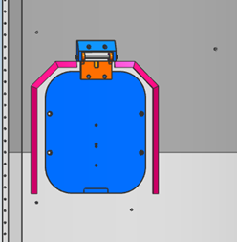

Figure 1: Heritage Design Closed

### Original System Performance

The performance of the heritage design worked in terms of closing and keeping the payload secure while in flight. The design was also scalable as this design was applied to most of Northrop Grumman’s vehicles, whether they went to space or not. This design was easy to install as it relies on a simple hinge and Velcro as the latching mechanism. Also, while this happens when installing and on rare cases when the door closes before launch, it was easily openable as you would apply pressure to overcome the Velcro. The door did not introduce any materials that can affect the satellite but relied on gravity to close it and partial keep it closed.

### Original System Deficiencies

While the heritage design did prove effective it did not prove helpful in all cases. When new trajectories were made with the door the door “burped” in flight. This meant the door opened then closed in flight which can be disrupt the security of the payload as well as the calculated trajectory. While tests did not occur due to a new design being manufactured immediately, it can be noted the previous design could cause unforeseen events. While this design fulfilled most of the customer requirements it did fail under the most important one, withstand the pressure differential.

# REQUIREMENTS

## Customer Requirements (CRs)

Various customer requirements have been discussed with the project sponsor, Northrop Grumman, and the team. These are all qualitative requirements that the ECS door design must fulfill as agreed upon by Northrop Grumman and the team. Majority of the customer requirements were presented in the project proposal provided by Northrop Grumman. Additional customer requirements were added by the Capstone team as they were determined to be essential for a successful design.

* Ease/Safety of Installation: The door design must be able to be easily installed into the vehicle fairing at the launch site. The installation shall not require any specialized, uncommon tooling and can be installed by no more than two people due to the limited access on site.
* Scalable: The design shall be able to be scaled for use across various launch vehicles. While the door is being initially designed for the Antares rocket, the goal is to create a design that can be implemented across the entire selection of Northrop Grumman’s launch vehicles.
* Reopenable: The ECS door shall be able to be opened from the outside. There is potential for accidental closure of the door during installation and during insertion of the ECS nozzle. The installation team must be able to easily open the door on site.
* Withstand Pressure Differential: The design will potentially be implemented into various launch vehicles with different launch trajectories. These trajectories cause various pressure differentials and the door must be able to remain closed when exposed to these various pressures.
* No Contaminates: The design materials shall not generate any foreign object debris (FOD) such as sparks, shavings, dust, or material off-gassing. The location of the door is close to sensitive satellites in which FOD can affect.
* Not Based on Gravity: The closure of the door design shall not rely solely on the force of gravity. Additional systems must be implemented for closure to ensure an accurate design.
* Door Closes on Launch: The design must automatically close upon removal of the ECS nozzle. It is acceptable for the ECS nozzle to hold the door open with direct contact.
* No Interference with Surrounding Systems: The components of the door shall not interfere with nearby systems or operation of the rocket fairing. Any system interference can create potential for mission failure.
* Professionalism: The team shall conduct themselves in a professional manner throughout their work with Northrop Grumman. The team recognizes that they not only represent themselves, but also the reputation of NAU’s mechanical engineering program.
* Minimal Effect on Aerodynamics: The design must be externally flat and free of any major protuberant components to minimize potential effects on overall aerodynamics of the launch vehicle.
* Electrostatic Discharge Safe: The design shall not have any major potential electrostatic discharge (ESD) as any discharge can affect the performance of the sensitive satellite systems nearby.
* Door Status Indicator: This indicator is an optional stretch goal. An indicator that remotely communicates that status of the door as open or closed is an optional customer requirement that has been requested by Northrop Grumman.

These various customer requirements were rated by the team on a scale of 1-10 to allow the team to prioritize the most important requirements. It has been determined that the highest priority customer requirements are withstanding pressure differentials, automatic closure upon vehicle launch, and no interference of surrounding systems. The customer requirement that is the lowest priority is the optional door status indicator. The rating of all customer requirements is shown below in Table #1.

Table 1: Rating of Customer Requirements

|  |  |  |
| --- | --- | --- |
| **#**​ | **Customer Requirement**​ | **Rating**​ |
| *1*​ | Ease/safety of installation​ | 7​ |
| *2*​ | Scalable​ | 8​ |
| *3*​ | Reopenable​ | 4​ |
| *4*​ | Withstand Pressure Differential​ | 10​ |
| *5*​ | No contaminates ​ | 8​ |
| *6*​ | Does not use gravity or acceleration​ | 6​ |
| *7*​ | Activates on launch​ | 10​ |
| *8*​ | Does not interfere with nearby systems​ | 9​ |
| *9*​ | Professionalism​ | 5​ |
| *10*​ | Does not influence aerodynamics​ | 9​ |
| *11*​ | ESD safe​ | 7​ |
| *12*​ | Indicates open/closed status​ | 1​ |

## Engineering Requirements (ERs)

The various engineering requirements are quantitative characteristics that were provided by Northrop Grumman. These requirements are necessary to successfully fulfill the intended use of the design. These engineering requirements help to ensure a high standard of design performance, reliability, durability, and safety. Many of these engineering requirements are directly related to customer requirements and give a quantitative measurement to fulfill the customer requirement.

* Safety Factor: All metal components shall meet the minimum safety factors of 1.6 to yield and 2.0 to ultimate. All plastic or composite components shall meet the minimum safety factors of 2.0 to ultimate and 2.3 to buckling. These safety factors help to prevent any potential failure of components that can potentially lead to door failure.
* Vibrations: The design shall withstand a vibration test with a load of 73 Gs while in the closed position. The vibration test helps to ensure the reliability of the latching mechanism during launch of the vehicle.
* Pressure Differential: The door shall withstand a pressure differential of up to 7.5 psi during flight. Failure to withstand this pressure differential was the main issue of the original design. The new design must be able to withstand the pressure differential that the previous design was not able to withstand.
* Budget: The team shall not exceed the allocated budget of $8,000. This budget includes all costs of materials, prototypes, and out-sourced manufacturing.
* Dimensions: The maximum inlet area shall not exceed 203 ${in}^{2}$. The design will be scaled for implementation on various launch vehicle. This is the maximum potential area required.
* Weight: The overall mass of the design shall not exceed 5 lbs. This weight limit is important as overall weight of the launch vehicle must not have major effects due to the door.
* Pressure Limit: The compressive stress applied to the surrounding fairing area of the door shall not exceed 810 psi. This compressive pressure limit ensures that the design will not cause any damage that can potentially compromise the integrity of the fairing structure.

## House of Quality (HoQ)

The use of a house of quality ensures the customer requirements and engineering requirements are examined through a quality function deployment, QFD, which is an engineering technique used to make sure customer needs are correctly translated into specific design inputs of a device being designed. The proceed evaluates customer needs to quantifiable and measurable criteria. The team create the weighted values of each customer requirement from the project proposal and client input to prioritize design functions and qualities for the final concept. Then, relationships between requirements were compared on a scale of 9 (strong), 3 (moderate), 1(weak), or no value. Since the engineering requirements are based on customer needs for the design, there is at least one engineering requirement to one customer requirement.

In summary the results showed that the most important engineering requirement to keep in mind thought the design process will be the weight limitation. As we consider safety factors for yield, ultimate and bucking of a material we effect the weight of the system. Also, wanting to keep the design easy and safe to install, the team must review the weight value. Other factors such as cost, gravity, additional component for an ESD safe design can further add to the total design’s weight. Detailed team results of the House of Quality can be seen in Appendix A.

## Functional Decomposition

The functional decomposition of the door redesign is a visual representation that assists the team in understanding the use and results needed of the product. In this case the team needed to consider all the components necessary to have an effective prototype latching system on the ECS door of the Antares vehicle that will significantly reduce air escaping. Specifically, a Black Box Model approach was used to see a broad view of these inputs and outputs a system required to accomplish the tasks listed for the project. Then, a detailed breakdown of the main functions in a Functional Model Basis Functions chart was created to help the team clarify the project. The analysis from this section is strongly related to the customer needs thus extends through the engineering design process in the following sections as well.

### Black Box Model

The black box model creates a visual description of the operations needed for product to perform the desired outcomes. The generalized goal of the project is to close a door. Therefore, the inputs and outputs break down into three flow categories: energy, material, and signal. Figure 2 shows the functions required for the overall redesign goal. For example, a potential customer need is to have the door close electronically and have accurate readings during flight of its status, therefore, the signal in category involved electricity as an input function. However, the team must also consider designs without that component thus a signal in is also visual. The inspection is of the closed or open status of the door.

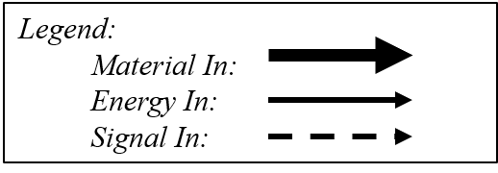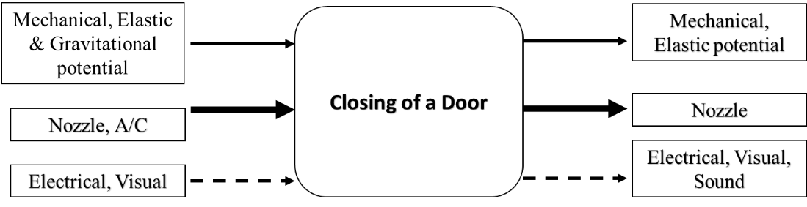

Figure 2: Black Box Model

Since the functions considered are simplified by only taking into account the beginning and end, the team can formulate concepts that complete the objectives of the project without restricting creativity from specificity.

### Functional Model/Work-Process Framework

Further analysis on the black box model leads to functional decomposition. The outcome, Table 2, is a detailed look into the sub functions of each flow input and output of the black box model of Figure 2. The division gives emphasis on how functions will be achieved throughout the use of the design and the results of the material, energy, or signal flow path.

Table 2: Functional Model Basis Functions



From Table 2 above, it is clear how the mechanical energy is related to a possible application the team can use to create a closing system, or electrical energy by use of a control system such as radio. Additionally, a material present in the system is the nozzle since it will interfere with any closing system the team designs. The team used the breakdown of the functions to clarify the categories needed for the morph matrix in concept generation since the derived sub functions of the design ensure the customer needs are satisfied.

# DESIGN SPACE RESEARCH

## Literature Review

### Jake West: Electrostatic Discharge

One of the requirements for the design of the door being implemented on Northrop Grumman's vehicle is that the entire design is electrostatic discharge, or ESD safe. ESD is a natural phenomenon that occurs when electrons are transferred from one material to another, then rapidly released to a new material, causing an electric shock. This interaction often offers when insulative materials rub against one another, causing a transfer of electrons from one to the other, creating one positive and one negatively charged material. When the negatively charged material meets any material that does not have an excess of electrons, the electrons quickly jump to the new material to reach equilibrium [1]. This sudden jump of electrons can cause serious damage to sensitive electrons, like those that are used in potential satellites that would be carried on the rocket.

If the team does not design around ESD, the door could potentially build up a charge that jumps to the sensitive components stored within the rocket, permanently damaging them. To avoid this, the team can select conductive materials that easily transfer any new electrons directly to the ground, avoiding risk of a charge buildup. All the components of the team's design must be grounded to the fairing of the rocket. Using insulative materials such as rubbers and plastics may be harder to ground, however it is possible to use materials like this that have conductive properties, allowing for easy conduction to the ground [2].

### Alex Soto: Computation Fluid Dynamics

By following along with an ANSYS tutorial on simple approximation flows using computational fluid dynamics (CFD) we can learn more about what we cannot see with our eyes [3]. This course will allow our group to model for potential leaks that our design may have while in flight. While extra sealing measures could be added to create small variations in leakage, we have to consider if debris or ESD can form from the material added for example rubber. From this course CFD was used in ANYSYS fluent and various objects and flows were model using it. To see considerable change the shape matters since the fluid flow over a square object is different than a rounded square. Noticing this difference has allowed our design to resemble the heritage design as our design has adapted around rounded parts.

### Timothy Anderson: Geometric Dimensioning and Tolerancing

A Udemy course was taken to gain a better understanding of geometric dimensioning and tolerancing for the final design’s future drawings [4]. The class explained all the symbols used in GD&T as well as discussing how to check if a machined part successfully fits the tolerances given. These new learned skills will be applied to the dimensioning and tolerancing of the team’s final design when it is ready to be fully designed. Next, the client was consulted to determine the tolerance range the design’s parts should have. It was then established that the parts should have a tolerance of 0.03 inches overall. This is a very loose tolerance, but if Northrop Grumman choses to implement our design, they will apply their own tolerances based on their standards.

### Michael Wilson: Aerodynamic Protuberance

One of the customer requirements for the door is to minimize any aerodynamic effects that the door might have on the launch vehicle. An important analysis topic for this customer requirement is studying aerodynamic protuberance. Any protruding components of the design must be analyzed to make sure there are no major effects on the overall aerodynamics of the rocket. Extensive research of aerodynamic analysis was conducted, and information was gathered from sources [5], [6], and [7]. Based on the learned skills, a MATLAB file was developed to assist in analysis of essential equations for calculating the drag force generated from any protuberance. This code will be useful for the team to validate that the chosen design has no major effect on the vehicle’s aerodynamic flow.

## State of the Art - Benchmarking

### System Level State of the Art – Benchmarking

Figure 3: Pegasus Rocket [8]

Pegasus, shown in Figure 3, was the original target for the door. Once that door and latch design was proven to work, it was the applied to be used universally in Northrop Grumman’s vehicles.

#### Existing Design #1: Pegasus Design

The Pegasus rocket was used to aid in deploying small satellites up to 1000 lbs. [8]. This aircraft flew in low-Earth orbit to deliver satellites in space. Due to the unique shape of the wing the Pegasus can put satellites into orbit in about 10 minutes. What Pegasus does is it assist satellites as shown just below the aircraft in the above figure to reach orbit with minimal ground support. The satellite then is dropped and falls then ignites its first stage rocket motor. Pegasus was the first privately developed space launch vehicle, the first winged vehicle to accelerate to eight times the speed of sound and first air-launched rocket to place satellites into orbit [8]. The concept for this door was then used in the Antares rocket shown below in Figure 4.

Figure 4: Antares Rocket [9]

### Subsystem Level State of the Art Benchmarking

#### Subsystem #1: Latch

The latch subsystem is important in the overall design due to the customer requirement of the door being able to secure tightly and allow for little to no air leakage. This latching system is restricted to having no ESD which can restrict ideas and designs our team can develop. The latching system also has a stretch goal of being able to indicate electrically if the door is in the closed/open position.

##### Existing Design #1: Velcro

The Velcro design is what was previously used by the Northrop Grumman engineers on the Antares rocket. This design did not secure correctly and allowed for “burping” while in flight. This design relates to the requirements by securing to the side of the rocket, while being compact and lightweight. The design closes properly at launch and does not create an electrostatic discharge.

##### Existing Design #2: Door latch

The door latching system is similar to any generic door latching, it has a swinging arm that grabs onto the other latch that will hold the door tight to the door frame. This design relates to the requirements because it is simple and can be scaled up or down to match the customer requirements. This design also can be manufactured to be activated by the energy systems involved in the overall design.

##### Existing Design #3: Cabinet Latch

The cabinet latch consists of tight springs that are forced into a tight space like locks seen on cabinets. The idea of this design is when the door is closed, the springs will impact on an opposing lock and the springs will compress and enter the locking mechanism. The springs will be designed to stay secured and lock inside the mechanism. This design relates to the requirements by being simple and can be replicated throughout the perimeter to the door. The design also has the simplicity to be scaled up and down as desired.

#### Subsystem #2: Hinge

The hinge subsystem allows for the door to swing open or closed. This hinge system needs to be strong and consistent with the various vibrations and loads on our system. This subsystem is important to the overall project because it is what connects the rocket to the door system.

##### Existing Design #1: External Door Hinge

The external door hinge is a hinge on the exterior of the rocket that will allow for the door to be forced closed with a torsion spring. This design relates to our requirements because it allows for the door to close consistently and stay closed throughout launch. This design was used before in the past and has worked.

##### Existing Design #2: Sliding Door

The sliding door design has no hinge but is a door design used in closing the door. This sliding door is held open by the nozzle of the environmental control system. The door is forced shut by gravity and locked in place by the latching subsystem. This design relates to the requirements because it allows for the door to be closed and not affect any of the surrounding systems.

##### Existing Design #3: Internal Door Hinge

The internal door hinge is a torsion spring installed on the inside of the rocket that will pull down the door to close flush with the exterior of the rocket. This design relates to our requirements because it is unique and compact being on the inside of the rocket. The interior design allows for minimal aerodynamic interruption, meaning it can be more efficient for the rocket overall.

# CONCEPT GENERATION

## Full System Concepts

After the Morphological matrix was developed, three unique designs were generated from it. These three designs are the sliding door, the exterior hinge, and the interior hinge. Each design pulled different concepts for each subsystem. This produced functional designs with different pros and cons.

### Full System Design #1: Sliding Door

The first full system design that the team analyzed was a sliding door design. The system was positioned on the inside of the fairing, in order to not have protrusion on the exterior of the vehicle that could affect the aerodynamics. The door rests on top of the nozzle that goes in the inlet, holding the door up while the nozzle is in place. As the rocket launches, the nozzle is removed, and the sliding door falls into place, with the help of several springs at the top to ensure it does not get stuck. As the door falls into place, a latching system, much like those seen on common doors, is activated as the door passes its threshold. These latches can be released from the outside fairing by a pull tab, in case the door prematurely closes and needs to be reopened. The system used the internal pressure to push the door against the fairing to keep a better seal. The bottom of the system uses a rubber pate to seal the bottom edge, and the top uses brushes that line the area between the top of the door and the fairing.

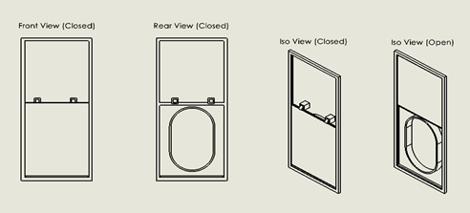

Figure 5: CAD Sketches of Sliding Door Design.

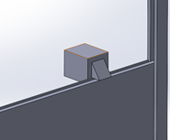

Figure 6: Close Look at Latching Mechanism

The sliding door design had several key criteria that made it a competitive design. One of the first things the design handled was maintaining a tight seal. This is achieved by the pressure pushing the door against the fairing. This design is also easily scalable to be implemented on other systems. The overall design has simple parts that can be easily manufactured and reproduced.

This design was not perfect and had several flaws that caused it to not be the team's first choice. The flaws of this design were that it did not cover the inlet hole from the outside, allowing a one-inch deep hole to be exposed to the exterior, possibly affecting the aerodynamics of the vehicle. The design was also difficult to reopen if prematurely closed and did not have a way to remain open if the nozzle was not placed in the inlet. The movement of the door relied almost entirely on gravity, with only some short springs to help with the initial movement. With the design being on the inside, there are tight restrictions on how large the design can be, since a diffuser plate is right behind the inlet area. With the inclusion of a rubber plate to form a stronger seal, the design may also have challenges grounding all the components to ensure it remains ESD safe. Finally, this design used more material than the others, causing the cost and weight to potential increase.

### Full System Design #2: External Hinge Door

The next full system design that was developed from the Morphological matrix was the External hinge Door. This door can be seen open and closed in the figures below, as well as a back view of the design. This design consists of a simple hinge that is loaded with a torsion spring. This creates a force that pulls the door down into its closed state. Next, the door will be made of aluminum and be rectangular in shape with rounded edges. The door will fully cover the inlet seen in figure 7 and will lie flush with the rocket fairing. Moving on to the design’s last component, it has a spring-loaded system. The latch piece is loaded with a compression spring to keep it popped out and is angled in shape so as it pushes against the inlet ring, the piece retracts. Once the piece clears the inlet thickness on the inside of the fairing, the latch will pop open again and hold the door shut.

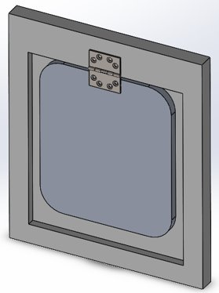  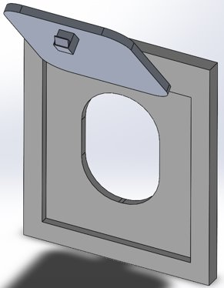

Figure 7: Closed Door View Exterior Hinge Figure 8: Open Door View Exterior Hinge

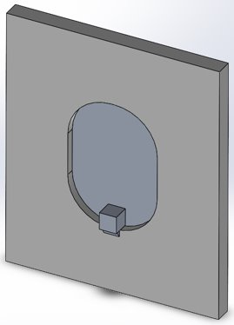

Figure 9: Back View Exterior

The main advantage of this design is that it is very simple and could be built to be very reliable. It is very similar to Northrop Grumman’s heritage design so they could keep their door and hinge system and simply implement the latching system which would be very cheap. Another advantage to this design is the ease of scalability. NG wants a design that can be used on most of their rockets. This means the whole system must be able to change in dimension to properly fit each separate rocket. Because this design is so simple, it would be very easy for NG to scale it to fit any of their rockets.

The main disadvantages of this design are its ability to withstand the amount of vibrations it will experience, and its need to have a very strong latch so that it does not break. In the rockets process from launch to flight, it will experience a great deal of vibrations. With a simple compression spring latch, these vibrations could push the latch piece inside of its housing and therefore release the door, causing the system to fail.

### Full System Design #3: Internal Hinge Door

The last full system design that was considered by the team is an interior hinge design with a pop-in roller latching system. The overall motion of this design is similar to the external hinge design. The main advantage of the interior hinge design is that it allows for a completely flat external door face. This provides minimal effects on the aerodynamics of the vehicle as there are no protruding components. However, this interior hinge is not as robust as an external hinge due to the increased moment force on the hinge. The latching system consists of a rounded knob on the lower interior section of the door. The latch relies on the closing force of the door to push through rounded rollers that are installed in the lower inlet area of the fairing. The exterior face of the rollers is rounded with a flat interior face. This prevents potential door opening during flight. The open position of the door can be viewed in Figure 10 and the closed position of the door is shown in Figure 11.

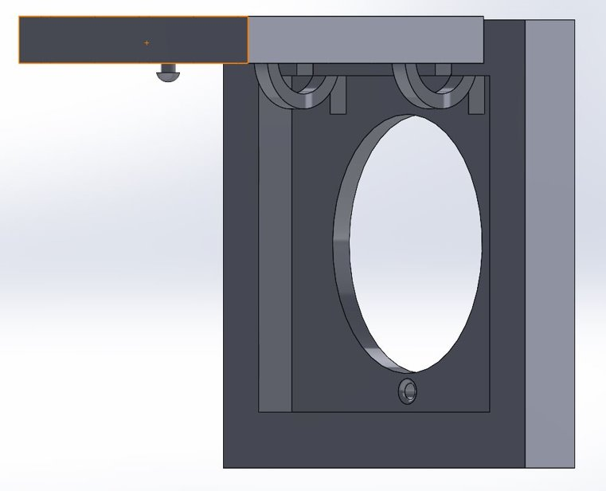

Figure 10: Open Position of Interior Hinge Design

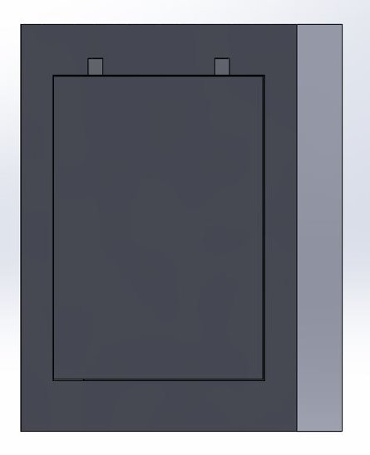

Figure 11: Closed Position of Interior Hinge Design

The main disadvantage of this design is the latching system. Since the system relies on the closing force of the door, this creates potential for failure to securely latch if the closing motion of the door is slowed due to removal of the ECS nozzle. Another potential issue is that when the design is scaled smaller, the weight and momentum of the door might not apply enough closing force to push through the rollers. While the design would likely be secure enough to withstand the pressure differential and vibrations during flight, the potential failure to properly close makes this design unreliable in small-scale applications.

## Subsystem Concepts

The system concepts are distinct different full-system concepts. These subsystems have been used in our designs and have been selected using a morph matrix. The subsystems were generated using our engineering requirements and our customer requirements.

### Subsystem #1: Opening/closing

The opening and closing subsystem are what keep the door from opening on launch. This subsystem consists of different ways the door can maintain its closure while also ensuring there is no leakage from the inside of the rocket.

#### Design #1: Door Latch

The door latch consists of a mechanical swinging arm that will grab onto and latch the door into position. These latches are familiarly seen in U-Haul vehicles. The pros of this design are the simple swinging motion makes it easy to manufacture, the design can also be scaled up and down with minimal effort. The cons of this design are it can be bulky and heavy causing issues with our weight limit. The latch also will not be consistent and will not be as reliable as the other designs.

#### Design #2: Cabinet Latch

The cabinet latch is a spring that is compressed on impact with a latching system to hold the door into place. This design is commonly seen in ordinary kitchen cabinets. The pro of this design is it can be easily placed along the perimeter of the door to allow for complete coverage. The cons of this design consist of the latch coming undone on launch due to the high amounts of vibrations on the system.

#### Design #3: Spring Latch

The spring latch is a spring-loaded design that will compress on closure and expand once in place to create a tight seal on the door. The pros of this design are it is cheap and easy to make, with movable parts and a small area. The cons of this design are the consistency of closing and stay closed over a period of time, the spring has a potential to compress unwillingly and open the door.

#### Design #4: Velcro Latch

The Velcro latch is what was seen before in previous designs. This design is a Velcro perimeter on the door that will seal and close after launch. The pros of this design are the light weight and tight frame on the inside of the door. The cons of this design are the strength of the Velcro could allow for the door to reopen while in flight as well as give the not align properly after the launch

#### Design #5: Hydraulic latch

The hydraulic latch is similar to the spring latch, but instead of a spring being used to shut the door the hydraulics take its place. The pro of this design is the consistency of the hydraulics over a period of time, the latch can be closed at wherever we design it. The cons are the heavy and large amount of area a hydraulic component will take, as well as an overall more complex design.

### Subsystem #2: Door Movement

The door movement is important in the overall design due to it being the overall base to how we expand and design our other subsystems. If the door movement is not consistent or does not meet the desired requirements, it can lead to an overall failure of the system.

#### Design #1: Exterior Swing

The exterior swinging door movement uses one hinge to open and close the door. With the door moving away from the rocket, this design can get in the way of different subsystem. The pros to this design is the simplicity and the overall smaller volume required for the door. The cons are designing a way to keep the door open for long periods of time.

#### Design #2: Sliding Inside/Outside

The sliding door design is a door that falls down and locks on launch of the rocket. The door will be controlled by gravity and will have no used of outside energies to close. The pros of this design are it allows for a tight seal if approached correctly and does not require any precise tolerances to be made. The con of this design is creating a frame to guide the door into place and seal it properly.

#### Design #3: Pivoting Point

The pivoting point design is a swinging door that will pivot on one point of the rocket and will create a seal on the required area of the system. The pros of this door are it can be compact and flush with the exterior of the rocket and the swinging action will require it to not have too much extra energy put into the system. The cons of this door are it will not be reliable, closing the area completely might be hard to design and the swinging action could create a lot of extra momentum

#### Design #3: Rolling Door

The rolling door is similar to the garage doors seen in most houses, the door will be flexible and able to roll onto itself to keep the area requirement low. The pros of this design is it will be compact and held tightly to the rocket, meaning it will have little room to move. The con of this device is it will be hard to scale the device up and down without creating too much bulking.

#### Design #3: Double Sliding

The double sliding door is the same concept of the sliding door design but has two doors meeting in the meeting of the covering area. This design is unique and has advantages of being compressed into different rockets and designs. The pros of this design are it is unique and has not been used before. The con of this design is it has to be locked in the center of the area to stay secured.

### Subsystem #3: Failsafe

The failsafe subsystem is what keeps the door from failing and not being able to reopen. The. failsafe is put into place to ensure that the door can close fluidly and stay closed throughout launch. This subsystem is important because if anything were to go wrong, we will be able to reopen the door without causing any problems.

#### Design #1: Torsion Spring

The torsion spring would be used to create a tight seal on the door to the rocket. The torsion spring also can be loaded to be easily opened by hand as well as stay tight when needed. The pros of this design are it can be compressed easily and reused for any focuses. The cons of this device are the overall thickness of the spring can cause issues with aerodynamics on the exterior of the rocket and if designed incorrectly, the door can close and not be able to open properly

#### Design #2: Tension Spring

The tension spring can be used on the latching subsystem to keep the door locked and sealed during launch. The tensions can be designed to easily get undone and allow for the door to reopen if there are any failures. The pro of this design is it can be put into place on latches that need to be opened frequently. The con of this design is it can lose tension during flight if the vibrations cause any kind of unlatching.

#### Design #3: Compression Spring

The compression spring can also be used in the latching system to keep the door locked and sealed during launch. The pro of this design is it will be kept tight in position on launch and can be compressed in a closed area to theoretically not lose compression during flight. The con of this design is if we need the spring to be compressed too much, it can cause safety issues for the manufacturers.

#### Design #4: Hydraulics

The hydraulics of this design can be used like the previous springs but will require more maintenance than the springs. The pro of this design is it has unlimited force potential, allow for us to use it wherever we need it. The con of this design is it will need to maintain a certain weight and it will be hard to design a hydraulic system to maintain the weight requirement.

# 5. DESIGNS SELECTED – First Semester

This section will contain the basis of the technical selection criteria and then will move to a rational for design choice. The selection criteria will be explained as the customer needs and engineering requirements and why they were chosen. A Pugh chart and decision matrix will then be used with that selection criteria to evaluate the designs.

## Technical Selection Criteria

The main technical criteria that will be used to compare the designs will be the set of customer needs and engineering requirements. The customer needs are qualitative and come directly from our client at Northrop Grumman. These needs include an easy and safe installation process, able to withstand pressure differential, activates on launch, electrostatic discharge safe as well as a few others. Each customer need will be given a weight in a Pugh chart and then compared to a datum which will be NG’s heritage design which can be seen below in Figures 12 and 13. Because customer needs are more qualitative, these will be used in the Pugh chart to get an overall understanding of which of the designs appear to be a better fit for what the client wants.

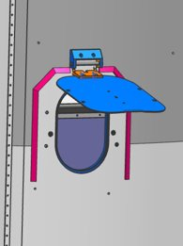  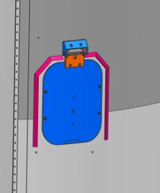

Figure 12: Heritage Design Open Figure 13: Heritage Design Closed

The next set of criteria that will be used to compare designs will be the engineering requirements and they will be placed in a decision matrix. The engineering requirements again come from the client as well as the customer needs but are in a quantitative form that numbers can be attached to. Some of these engineering requirements the team have chosen are safety factor, vibrations, pressure differential, budget, weight, dimension, and crush rating. Because these requirements are quantitative, the results from the decision matrix will select the final design that the team will proceed with.

## Rationale for Design Selection

With the design selection criteria laid out in the form of customer needs and engineering requirements, a Pugh chart and Decision matrix were used to evaluate the designs and select a final design. These two tables can be seen below.

Table 4: Pugh Chart

|  |  |  |  |  |  |
| --- | --- | --- | --- | --- | --- |
| **Selection Criteria​** | **Weight​** | **DATUM​** | **Concepts​** | | |
| ​ | ​ | ​ | 1​ | 2​ | 3​ |
| Ease/Safety of Installation​ | 7​ | -​ | S​ | -​ |
| Scalable​ | 8​ | S​ | S​ | S​ |
| Reopenable​ | 4​ | -​ | S​ | S​ |
| Withstand Pressure Differential​ | 10​ | +​ | +​ | +​ |
| No contaminates​ | 8​ | -​ | S​ | S​ |
| Does not use gravity ​ | 6​ | -​ | S​ | S​ |
| Activates on launch​ | 10​ | S​ | S​ | S​ |
| Does not interfere with nearby systems​ | 9​ | -​ | S​ | +​ |
| Professionalism​ | 5​ | S​ | S​ | S​ |
| Does not influence aerodynamics​ | 9​ | -​ | S​ | +​ |
| ESD Safe​ | 7​ | -​ | S​ | S​ |
| Indicates open/closed status​ | 1​ | S​ | S​ | S​ |
| Total (+)​ | ​ | 1​ | 1​ | 3​ |
| Total (-)​ | ​ | 7​ | 0​ | 1​ |
| Overall Score​ | ​ | -6​ | 1​ | 2​ |
| Weighted Total (+)​ | ​ | 10​ | 10​ | 28​ |

In the Pugh chart, 12 customer needs were used to evaluate three designs based on the datum. Each customer need was given a weight. The highest weighted were the ability to withstand pressure differential, and the activation of the system on launch. The lowest weighted were an indication that the door is closed as it was a stretch goal, and professionalism because it is not necessary. The datum is Northrop Grumman’s heritage design that includes an exterior hinge with a Velcro latching system. Each design was evaluated on how it fulfills each customer need on a plus, minus, or same scale. The interior hinge design scored the highest because it does not influence aerodynamics and it does not interfere with nearby systems. The exterior hinge and the sliding door scored the lowest because the exterior hinge design is very similar to the datum, and the sliding door design is hard to install, relies on gravity, and could influence aerodynamics. While the interior hinge design outscored the others, the Pugh chart is a comparison based on qualitative reasoning. With this, the designs need to be further compared in a decision matrix which can be seen below.

Table 5: Decision Matrix

|  |  |  |  |  |  |  |  |
| --- | --- | --- | --- | --- | --- | --- | --- |
| **​** | **​** | **Sliding Door​** | | **Exterior Hinge​** | | **Interior Hinge​** | |
| Criteria​ | Weight (%)​ | Score (1-10)​ | Weighted Score ​ | Score (1-10)​ | Weighted Score ​ | Score (1-10)​ | Weighted Score ​ |
| Safety Factor​ | 12​ | 7​ | 84​ | 7​ | 84​ | 6​ | 72​ |
| Vibrations​ | 16​ | 8​ | 128​ | 7​ | 112​ | 4​ | 64​ |
| Pressure Differential​ | 20​ | 7​ | 140​ | 8​ | 160​ | 7​ | 140​ |
| Budget​ | 8​ | 3​ | 24​ | 9​ | 72​ | 7​ | 56​ |
| Dimensions​ | 14​ | 4​ | 56​ | 8​ | 112​ | 9​ | 126​ |
| Weight​ | 10​ | 2​ | 20​ | 9​ | 90​ | 7​ | 70​ |
| Crush Rating of Design​ | 20​ | 6​ | 120​ | 7​ | 140​ | 7​ | 140​ |
| Totals​ | 100​ | ​ | 572​ | ​ | 770​ | ​ | 668​ |

This decision matrix used 7 engineering requirements to evaluate each design. The criteria were weighted in order of importance. The highest weighted were crush rating of design and pressure differential while budget weighted the lowest. Each design was then given a score from one to ten and then multiplied by the criteria’s weight. In this evaluation the exterior hinge design scores the highest at 770 points. This is because it scored well in dimensions, pressure differential and weight. The sliding door and interior hinge designs had lower scored in pressure differential, budget, and weight. The other systems have more components so they will clearly be heavier. The basis of the exterior hinge withholding the pressure differential the best is through the simple latching system that can be relied on. The other two designs are more complicated and therefore have more potential for a part to fail.

From the Pugh chart and decision matrix, the top design is the exterior hinge. It did not score the highest in the Pugh chart, but it did in the decision matrix which is more important. The team will be moving forward with this exterior hinge design and will be focusing on the latching system. Northrop Grumman already have a door and hinge system that works so if our latch design could be implemented into their rockets, it would be a very cheap transition for the company to make.

# REFERENCES

[1]“The science of static electricity - Anuradha Bhagwat - YouTube.”[Online]. Available: https://www.youtube.com/watch?v=yc2-363MIQs.[Accessed: 29-Sep-2020]

[2]“The Prevention and Control of Electrostatic Discharge ,” MiniCircuits, 2015. [Online]. Available:https://www.minicircuits.com/app/AN40-005.pdf. [Accessed: 28-Sep-2020].

[3] “Introduction to Simple Approximations of Fluid Flows - Lesson 1 - ANSYS Innovation Courses.” [Online]. Available: <https://courses.ansys.com/index.php/courses/simple-approximations-of-fluid-flows/lessons/introduction-to-simple-approximations-of-fluid-flows-lesson-1/>. [Accessed: 26-Sep-2020].

[4] Udemy. 2020. *Online Courses - Learn Anything, On Your Schedule | Udemy*. [online] Available at: <https://www.udemy.com/> [Accessed 27 September 2020].

[5] N. Hall, "NASA Beginner's Guide To Aerodynamics," NASA, 5 May 2015. [Online].

Available: https://www.grc.nasa.gov/WWW/k-12/airplane/ffall.html. [Accessed 24

September 2020].

[6] "Drag Coefficient," Engineering Toolbox, 2004. [Online]. Available:

https://www.engineeringtoolbox.com/drag-coefficient-d_627.html. [Accessed 24 September

2020].

[7] R. Mehta, "Computation of Aerodynamic load on Protuberance over Satellite Launch

Vehicle at Supersonic Speed," Scholars Journal of Engineering and Technology, vol. 4, no.

7, pp. 301-307, 2016.

[8] “Pegasus Rocket – Northrop Grumman.” [Online]. Available: https://www.northropgrumman.com/space/pegasus-rocket/. [Accessed: 17-Oct-2020].

[9] “Antares Rocket,” *Northrop Grumman*. [Online]. Available:     https://www.northropgrumman.com/space/antares-rocket/. [Accessed: 19-Sep- 2020].

# APPENDICES

## Appendix A: House of Quality

