To

From:

Date:

Subject: DFMA - Design for Manufacturing and Design for Assembly

# Design of Manufacturing

For the manufacturing following step need to follow:

* Take the ABS round pipe lengths and cut them down using the blade. The ABS pipes can easily cut through the blade so cut 4 pieces of 30 inches length. Cut two pieces of pipes having 35 inches length.
* And then take the square pipe and cut that pipe into two pieces, one piece of 40 inches length and second piece of 30 inches length.
* Use the sharp edge blade and mark the points where propellers will install on the square pipe, cut that points through the blade from the upper side only so that rotor can easily come out of the pipe.
* Now mark the round pipes where the propellers will install and remove the upper side through the blade for the rotor and propeller position.
* Take a round pipe length and mark the points where nozzles will install, 6 points will be marked, cut those round points according to the size of nozzles. The pipe structure is ready to make after assembling the pipes. That will describe in the design of assembly section.
* For the hose, take the pipe and measure the length of 65 feet, and cut the hose using the blade.

Following parts will need to purchase:

|  |  |
| --- | --- |
| **Components** | **Details/Quantity** |
| 6 mm Propeller Motors | 10 |
| Water Tank | 1 |
| Water Pump | 1 |
| Water Pump Nozzle | 1 |
| Arduino UNO R3 | 1 |
| RC Controller | 1 |
| Fabric Brushes | 2 |
| Brush Rollers | 2 |
| Roller Motors | 2 |
| Reel with Motor | 1 |
| Hose | 1 |
| Pipe | 150 feet |
| Electric Power Wire | 100 feet |
| Jumper Wires | 1 Set |
| Wheels | 2 |
| Propeller | 10 |
| Shower nozzle | 6 |
| Glow | 2 Packs |
| Screws | 1 Set |
| Clamps for holding hose connections | 10 |
| Elbows | 6 |
| T-Shaped connector | 1 |
| PVC Tape | 3 |
| Plastic Box | 1 |

After getting the above components, it will then assemble and the process of assembly has described in the design of assembly which is presenting underneath.

# Design for Assembly

Assembly as done using the following steps:

* Take the pipe pieces and then connect the elbow with two pipes at their both ends through the glow. After joining the elbows, connect the other two pipes in the elbow and make it firm using the glow. So square structure of pipes has assembled. Like the one shown below

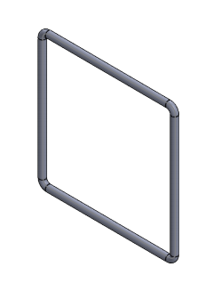

Figure 1: Pipe Outer Structure

* Now in the middle of pipe structure draw a plus sign using the square pipes and join them with round pipes through the glow. The horizontal square pipe makes it large so it goes out of the pipe structure. And in the center of plus sign, place the control box in which Arduino will fix. The box will connect with the square pipes through the glow.
* Now place the motors inside the square pipes, and tight them using the screws. 10 motors need to install at the propeller’s location. After fixing the motors with the screws, connect the propellers with the rotor of motors, one propeller will connect with one motor, hence 10 propellers will connect for the 10 motors. The propellers will fix on the rotor using the screws.
* Now connect the front brush roller with the pipes using the glow, but before installing the front pipe, put the rollers inside the pipe and then fix it.
* The wheels need to connect at the front pipe, and it connects through the long nut and bolts. Place the wheels and then pass the bolts from the middle of the wheels and then cover the nuts with the bolts to tight the wheels.
* Install the nozzles on separate pipe and tight them with the screws and then connect the nozzle pipe with the pipe structure using the glow.

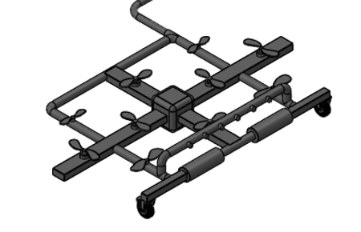

Figure 2: Drone Structure

* Now the structure is ready, connect the motors with the Arduino for motor controller through the jumper wires, also connect the nozzle showers with the Arduino through the jumper wires, and then connect the roller motors with the Arduino through the jumper wires.
* The drone structure has developed, now connect the drone structure with the hose. To connect the hose with the drone a T-shaped connected has used at the back end of drone where it inserted the T- pipe joint into the hose and then clipped the hose tightly.
* Now pass the electric power wire along with the hose and connect it to the Arduino at the center of console.
* Now connect the hose with the reel and power wire with the socket. Wrap the wire around the hose and then tight the hose with the reel. The reel connects with the hose through the joint socket and clipped tightly.
* Pass the hose to the water tank and connect the hose with the water pump present inside the water tank. The hose connects with the water pump through the nozzle. The power wire connects with the water pump to provide electricity to the pump.
* Connect the reel with the motor engine and pass the electric wires to the motor engine for electric supply. The reel is already an assembled component and just need to connect the motor with the reel through the belt.
* The product is ready to use.

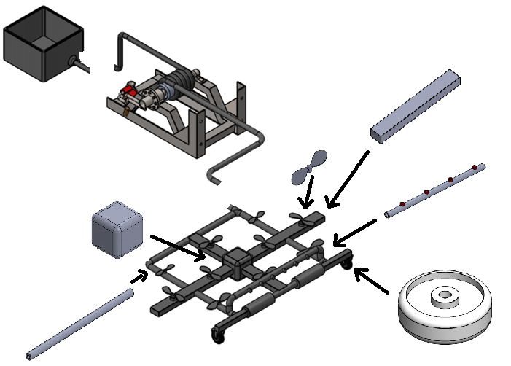

Figure 3: Complete Design

# FMEA

Here is the table presenting the FMEA of the project.

|  |  |  |  |  |  |  |  |  |  |
| --- | --- | --- | --- | --- | --- | --- | --- | --- | --- |
| **Part # and Functions** | **Potential Failure Mode** | **Potential Effect(s) of Failure** | **Severity (S)** | **Potential Causes and Mechanisms of Failure** | **Occurrence (O)** | **Current Design Controls Test** | **Detection (D)** | **RPN** | **Recommended Action** |
| **1 Controller** |  |  |  |  |  |  |  |  |  |
| 1.1 Controller Brun | Burning of Controller | Disconnection with Drone | 7 | 1. Bad quality of controller | 4 | 1. Over Voltage Test | 4 | 112 | Check the quality of controller |
| 1.2 Controller Transmitter | Burning of transmitter | Disconnection with Drone | 6 | 1. Bad quality of transmitter | 4 | 1. Over Voltage Test | 4 | 96 | Check the quality of controller |
| 1.3 Controller Receiver | Burning of Receiver | Disconnection with Drone | 6 | 1. Bad quality of receiver | 4 | 1. Over Voltage Test | 4 | 96 | Check the quality of controller |
| 1.4 Controller Body | Breaking of Body | Cracks and bends | 4 | 1. Bad quality of controller | 3 | 1. Over Pressure Test | 3 | 36 | Check the quality of controller |
| 1.5 Controller Board | Burning of board because of short circuit | Disconnection with Drone | 3 | 1. Bad quality of controller | 3 | 1. Over Voltage Test | 3 | 27 | Check the quality of controller |
| 1.6 Controller battery | battery Dead | Disconnection with Drone | 4 | 1. Bad quality of battery cells | 4 | 1. Over Voltage Test | 4 | 64 | Check the battery quality |
| 1.7 Controller Button | Button failure | Not working of specific function | 3 | 1. Bad quality of push button | 3 | 1. Over Pressure Test | 4 | 36 | Check the quality of button |
| 1.8 Controller Handle | Handle stick motion failure | Not working the directions | 3 | 1. Bad quality of handle | 3 | 1. Over Pressure Test | 3 | 27 | Check the quality of handle |
| 1.9 Controller Screen | Breaking of screen | No display | 3 | 1. Extra pressure and bad quality | 3 | 1. Over Pressure Test | 2 | 18 | Protect the screen |
| 1.10 Controller Range | Failure of range abruptly | Low battery level | 3 | 1. Voltage excess and low level | 2 | 1. Over Voltage Test | 3 | 18 | Check the quality of battery |
| **2 Motor** |  |  |  |  |  |  |  |  |  |
| 2.1 Shaft | Bending of Shaft, Breakage of Shaft | wait for new shaft, cost increased | 7 | 1.Bad quality due to molding,  2. poor quality shaft is used | 4 | 1.Bad seeding, Poor Quality aluminum | 6 | 168 | Test various qualities if pipes available at same cost |
| 2.2 Motor Winding | Winding burn out | Cost increase | 8 | 1. bad quality of copper 2. poor windings 3. over voltage, over speed | 4 | 1. Speed test 2. Over voltage test | 5 | 160 | Check multiple motors and test them roguishly |
| 2.3 Motor Housing | Bending of Housing | Body trouble will cause extra cost | 2 | 1. Bad quality of steel | 3 | 1. Over Pressure Test | 2 | 12 | Check the quality of housing |
| 2.4 Motor Wire | Wire Burn out | Cost increase | 6 | 1. bad quality of copper 2. poor windings 3. over voltage, over speed | 4 | 1. Speed test 2. Over voltage test | 4 | 96 | Check multiple wires |
| 2.5 Motor Stator | Bending of stator | Cost increase | 2 | 1. Bad quality of steel | 1 | 1. Over Pressure Test | 3 | 6 | Check the quality of steel |
| 2.7 Motor Rotor | Bending of rotor | Cost increase | 3 | 1. Bad quality of steel | 1 | 1. Over Pressure Test | 3 | 9 | Check the quality of steel |
| 2.8 Motor Bearing | Slip of balls | Cost increase | 4 | 1. bad quality of bearing | 3 | 1. Over Pressure Test | 3 | 36 | Check the quality of bearings |
| 2.9 Motor Insulation | Burning of Insulation | Trouble in running the motor | 4 | 1. Bad quality of plastic insulator | 5 | 1. Over Voltage Test | 4 | 80 | Check the quality of Insulator |
| 2.10 Motor Screws | Detach of screws | Vibrations cause removal of screws | 2 | 1. Bad quality of covering | 4 | 1. Over Pressure Test | 3 | 24 | Check the quality of screws |
| **3 Arduino** |  |  |  |  |  |  |  | 0 |  |
| 3.1 Arduino Board | Burning of board | shorting of circuit | 5 | 1. unsecure circuit lining | 7 | 1. Over Voltage Test | 5 | 175 | Check the circuit lining |
| 3.2 Arduino Pins | Breaking of Pins | Over Pressure | 5 | 1. Pins not inserted Correctly | 7 | 1. Over Pressure Test | 4 | 140 | Check the pins |
| 3.3 Arduino Components | Breaking of Components | Over Pressure | 5 | 1. components break | 6 | 1. Over Pressure Test | 5 | 150 | Check the components properly |
| 3.4 Arduino Connections | Failed to connect | Code Issue | 6 | 1. code fixing | 7 | 1. Code fixing problem | 4 | 168 | Check the code resetting |
| 3.5 Arduino Reset | Failed to reset the board | Code Issue | 5 | 1. code fixing | 6 | 1. Code fixing problem | 5 | 150 | Check the resetting in the code |
| 3.6 Arduino Receiver | Receiver failed to responds | Code issue or physical issue | 5 | Receiver not working properly | 5 | Antenna check | 7 | 175 | Receiver Check |
| 3.7 Arduino Transmitter | Failed to send the data | Code issue or physical issue | 5 | Transmitter not working properly | 5 | Antenna check | 7 | 175 | Transmitter check |
| 3.8 Arduino Power Source | Power source burning | Power source burning | 4 | Burning of source may break | 4 | 1. Over Voltage Test | 6 | 96 | Power source check |
| 3.9 Arduino adaptor | burning of adaptor | Power source burning | 4 | Power adaptor burns | 4 | 1. Over voltage test | 5 | 80 | check the adaptor |
| 3.10 Arduino heat sink | Burning of heat sink | Heat sin cause trouble | 5 | Bad quality of heat sink | 3 | 1. Over Voltage Test | 5 | 75 | check the heat sink quality |
| **4 Power Adopter** |  |  |  |  |  |  |  | 0 |  |
| 4.1 Over voltage | Producing over voltage causing other devices to burns | Over Current | 5 | Bad quality of wiring | 5 | 1. Over Voltage Test | 6 | 150 | Check quality of wire copper |
| 4.2 Over Current | Producing over current | Over Voltage | 5 | Bad quality of copper | 5 | 1. Over Current Test | 6 | 150 | Check quality of copper |
| 4.3 Wire | Burning of wire | Over Voltage | 5 | Bad quality of copper | 5 | 1. Over Voltage Test | 5 | 125 | Check copper quality |
| 4.4 Wire Cover | Breaking of cover | Over Pressure | 2 | Bad quality of plastic | 4 | 1. Over Pressure Test | 4 | 32 | Check quality of cover |
| 4.5 Voltage Supply | Disconnection | Low Voltage | 4 | Interrupted Voltage | 3 | 1 Over Voltage test | 4 | 48 | Input terminal Connection |
| 4.6 Reverse Terminals | Negative Voltage Break Supply | Reverse Voltages | 3 | Connection Problem | 4 | Voltage Sign Test | 4 | 48 | Terminals Check |

# CAD PACKAGE ITEMS

