To: Sarah Oman

From: Ashley Blood, Nick Green, Jennifer Lawson, Cameron Lissarrague

Date: September 18th, 2020

Subject: Implementation Memo



This memo discusses the requirements of the design and previous design from the previous semester as well as any adjustments that were made to those requirements and the design over the course of the current semester. The client requested the device to include an iris design, a diameter range, length range, radial force and diameter output, safety standards, and remained within budget. With these customer requirements, engineering requirements were then established. The initial engineering requirements are shown in table 1.

|  |  |
| --- | --- |
| **CUSTOMER NEED** | **ENGINEERING REQUIREMENT** |
| Iris design | Device must perform like an iris |
| Meets safety standards | Must meet ANSI and OSHA standards |
| Accommodates a range of stent diameters | Diameter range of 0 - 30mm |
| Accommodates a range of stent lengths | Length range 0 - 40mm |
| Appropriate radial force | Radial Force 0 - 105N |
| Outputs data | GUI that can receive input and outputs both diameter and radial force |

Table 1. Original Engineering Requirements

Building on previous research and beginning construction of the device has given the team insight on certain characteristics of the design which has led to modifications in the requirements originally defined. The updated requirements are shown in table 2.

|  |  |
| --- | --- |
| **CUSTOMER NEED** | **ENGINEERING REQUIREMENT** |
| Iris design | Device must perform like an iris |
| Meets safety standards | Must meet ANSI and OSHA standards |
| Accommodates a range of stent diameters | Diameter range of 0.5 - 30mm [1,2] |
| Accommodates a range of stent lengths | Length range 8- 100mm [3,4] |
| Appropriate radial force | Radial Force 108 - 823 N [5] |
| Cost | Must be below $3,000 |
| Accuracy | Specified tolerances for diameter, length, and radial force |
| Outputs data | GUI that can receive input and outputs both diameter and radial force |

Table 2. Updated Engineering Requirements

Along with changes to the engineering requirements, changes to the device itself were made. These changes include implementing a different motor, adjusting the size of the slots in the iris plate, and addition of inserts into the leaflets. The original design is shown in figure 1 which can be compared to the updated design shown in figure 2.

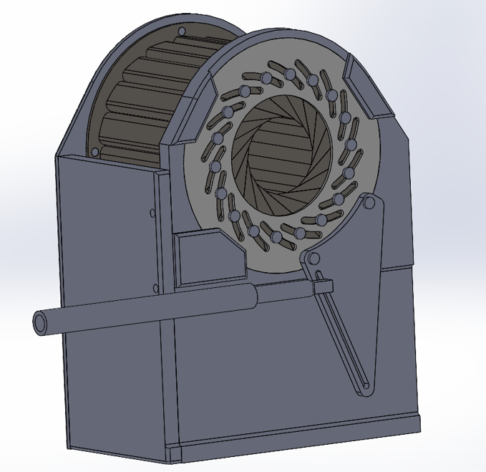

Figure 1. Original CAD design of stent crimper

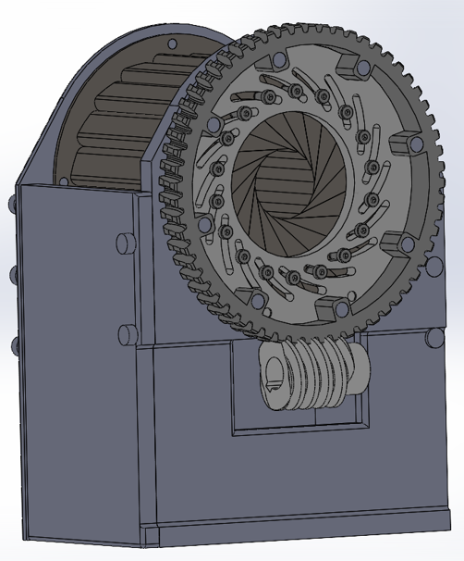

Figure 2. Updated CAD design of stent crimper

# Customer Requirements (CRs)

Customer requirements are characteristics or specifications of a design that a customer identifies for a desirable product. For the stent crimping project, the identified customer requirements include accommodating a range of diameters and lengths, appropriate radial force, cost, accuracy, safety, iris design, and visual data outputs. The top customer requirements were identified as having an iris design and adhering to safety standards due to stated requirements and medical concerns for the project. The lowest customer requirement was identified as visual data outputs as this requirement was considered optional by the client. The customer requirements are listed and weighted in table 3.

|  |  |
| --- | --- |
| **CUSTOMER NEED** | **RANK** |
| Iris design | **5** |
| Meets safety standards | **5** |
| Accommodates a range of stent diameters | **4** |
| Accommodates a range of stent lengths | **2** |
| Appropriate radial force | **4** |
| Cost | **3** |
| Accuracy | **4** |
| Outputs data | **1** |

Table 3. Weighted customer requirements

# Engineering Requirements (ERs)

Engineering requirements are quantifiable parameters or conditions used to measure the design’s ability to meet customer requirements. The engineering requirements for this project include an iris design, a diameter range, a length range, a radial force, a cost for the designing process, and a visual display through the use of a GUI.

## ER #1: Iris Design Leaflets

### ER #1: Iris Design Target = 10 Leaflets

An iris design of at least 10 leaflets was chosen for optimal accuracy of the desired diameter for a stent. A 10-sided polygon will encompass approximately 96% of the surface of an inscribed circle meaning only 4% of the leaflet surface will not be in contact with the stent [6].

[6] https://www.calculatorsoup.com/calculators/geometry-plane/polygon.php

### ER #1: Iris Design Tolerance = +8 Leaflets

The tolerance for the iris design leaflets was created to ensure functionality as well as feasibility for the design.

## ER #2 (updated): Diameter Range

### ER #2: Diameter Range - Target = 0.5 to 30 mm

The diameter range of the design should be capable of crimping a wide range of stents including intracranial, vascular, coronary, aortic, and esophageal stents. The smallest stents are intracranial stents with average diameters of 2 to 4 mm and a crimped diameter of approximately 0.5 mm [1,3]. The largest stents include esophageal and aortic stents. For esophageal stents, the average diameter is 12 to 28 mm with a crimped diameter of 10 mm for balloon expandable stents [4,7]. For aortic stents, the average diameter is 16 to 30 mm with a crimped diameter of 4.6 mm [8]. Initially the smallest diameter of the device was chosen to be approximately 5mm due to inability to accommodate intracranial stents. After researching more design options, it was determined that the device may be capable of reaching a diameter as low as 0.2 mm and thus the diameter requirements were adjusted. Based on the smallest and largest stents, the minimum range was determined to be 0.5 mm to 30 mm. The final design may be capable of a larger range than the prescribed target to ensure accuracy.

[1] S. Hähnel et al., “Small-vessel stents for intracranial angioplasty: In vitro comparison of different stent designs and sizes by using CT angiography,” Am. J. Neuroradiol., vol. 24, no. 8, pp. 1512–1516, 2003.

[3] <https://www.sciencedirect.com/science/article/pii/S2590093520300059>

[4] P. Hindy, J. Hong, Y. Lam-Tsai, and F. Gress, “A comprehensive review of esophageal stents,” Clin. Adv. Hematol. Oncol., vol. 10, no. 8, pp. 526–534, 2012.

[7] <https://www.ncbi.nlm.nih.gov/pmc/articles/PMC3533211/>

[2] https://www.jvascsurg.org/article/S0741-5214(95)70186-9/pdf

### ER #2: Diameter Range - Tolerance = +/- 0.013 mm

The diameter tolerance was chosen based on provided stent tolerances for various diameters. For a stent of a diameter less than 1.5 mm, a tolerance of +/-0.013 mm is permissible [8]. For a diameter of 1.5 to 6.3 mm, a tolerance of +/- 0.025 mm is permissible [8].

[8] see Stent_Standard_A in research documents

## ER #3 (Updated): Length Range

### ER #3: Length Range - Target = 8 to 100 mm

The length range of the design should be compatible with a wide range of stents including intracranial, vascular, coronary, aortic, and esophageal stents. Intracranial and coronary stents tend to have the smallest length with a range of 8 to 28 mm and 8 to 38 mm, respectively [3,9]. Aortic and esophageal stents have the longest length with a range of 10 to 20 cm and 10 to 15 cm [4,10]. A list of commercially available stents in the U.S shows a range of balloon expandable stent lengths ranging from 10 - 75mm [11]. To accommodate the smallest length and make room for the lengthening of the stent when crushed, the length range was determined to be 8-100mm.

[9] K. Anders, “Coronary artery stents,” Card. CT, Second Ed., vol. 284, no. 14, pp. 199–224, 2014.

[10] <https://www.sciencedirect.com/science/article/pii/S0741521404014855>

[11] <https://www.ctsnet.org/sites/default/files/documents/pdf/BalloonExpanding.pdf>

### ER #3: Length Range - Tolerance = +/- 3 mm

The length tolerance was specified as +/- 3 mm based on provided stent tolerances [8].

**2.4 ER #4: *Radial Force (updated)***

***2.4.1* ER #3: Radial Force - Target = minimum: 108N, maximum: 823.1 N**

Both minimum and maximum radial force values were determined for the reason that the device must use enough force to be able to crimp a stent but must not exert so much as to damage the device itself. The initial minimum estimate was determined based on research performed by the team and was found to be 105N. Revisiting the engineering requirements as well as the article used to find the initial value, allowed for more thorough calculations. The radial force, or hoop strength, was found by multiplying the circumference by the pressure used to crimp the stent [5]. The pressure was assumed to be ~17psi after back calculating from the information provided in the article. The circumference of the lowest desired diameter (3mm) was used in the calculation. This calculation was performed using equation (1) which was then multiplied by 0.689 to convert the units to N/cm. The minimum radial force was then determined by multiplying the hoop strength by the minimum expected stent length of aortic stents (10mm) and the maximum radial force was determined using the maximum expected stent length (75mm).

$Hoop Strength = C*Pressure (psi)$ (1)

[5] S. H. Duda *et al.*, “Physical properties of endovascular stents: An experimental comparison,” *J. Vasc. Interv. Radiol.*, vol. 11, no. 5, pp. 645–654, 2000.

**2.4.2 ER #3: Radial Force - accuracy = Less than 1%**

The accuracy of the stent crimper was determined to be approximately +/- 1%. This was decided after researching other stent crimpers currently on the market such as blockwise and machine solutions stent crimpers [12, 13].

[12] <http://www.e-tronics.hu/v4/e69bc5c4-143b-4e1a-8b00-6e75fc4558c9/uploads/TTR2-DataSheet.pdf>

[13] <https://machinesolutions.com/msi/wp-content/uploads/sites/3/2016/03/SC1775S.pdf>

**2.5 ER #5: *Cost under $3,000***

***2.5.1* ER #3: Cost under $3,000 - Target = $2,700**

The cost will be under $3,000 as specified by the grant allowance provided by the client. A target value of $2,700 was chosen.

**2.5.2 ER #3: Cost under $3,000 - Tolerance = +/- $300**

The tolerance for cost should be +/-$300 to ensure the team does not exceed the grant allowance for the project.

**2.6 ER #6: Visual Display**

The visual display will be implemented through a Graphic User Interface (GUI) system based on an arduino system. The visual display must output radial force and diameter to a user. This will take information from a compressive load cell and correlate that into radial force. The arduino will also count motor steps and plug that information into a formula to calculate the diameter of the iris.

# Design Changes

The original design shown in Figure 1 was modified by changing the actuation, inserts, and leaflet slots shown in Figure 2.

## Design Iteration 1: Change in Design

The original design was an iris design with basic connectors and actuated by a linear actuator. Modifications to the original design include changing the actuation system, modifying the extruded slots of the leaflets, and replacing the connectors. The actuator was replaced with a worm gear system for precision. The dimensions of the extruded slots on the leaflets were modified for better precision. The basic connectors were updated to standardized threaded inserts and screws.

**3.1.1 Subsystem One: Actuation System**

The original actuation system consisted of a linear actuator and a bracket that converts the linear motion to rotational motion rotating the iris. This was a simple design as it required less parts for the actuation of the device but lacks originality and had limitations when measuring forces. The team decided that a worm gear design. The worm gear design allows for more control over closing speed, greater force, a self locking feature which will limit spring back from the stent when the motor stops turning, and more measurements to be taken from within the device. The change in actuator style can be seen in figure 1 and figure 2 from the beginning of the report.

**3.1.2 Subsystem Two: Leaflet Extruded Slot and Corresponding Slot**

The extruded slots on the leaflet were modified from a length of 10 mm and a width of 1mm to a length of 2 mm and a width of 1.5 mm [Figure 3]. The corresponding slots located on the non-rotating plate were updated in response to the modifications to the leaflet. The non-rotating plate linear slot dimensions were updated from a length of 44 mm and a width of 1 mm to a length of 37 mm and a width of 1.5 mm. The modification of the extruded slot decreased the closing diameter of the iris which allows for the consideration of intracranial stents. Originally, the team excluded intracranial stents due to diametral concerns of the design.

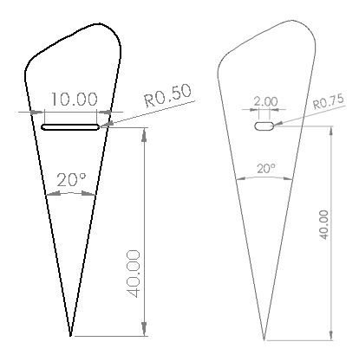

Figure 3: Extruded Leaflet Slots Comparison (left: original leaflet, right: modified leaflet)

**3.1.3: Subsystem Three: Connectors**

The basic connectors of the design were replaced with standardized threaded inserts and screws for better securement of the design. A comparison of the original components and updated components is shown in Figure 4 and Figure 5 [14]. The use of standardized components will also decrease tolerance requirements for the overall design and prevent poor connection between components.

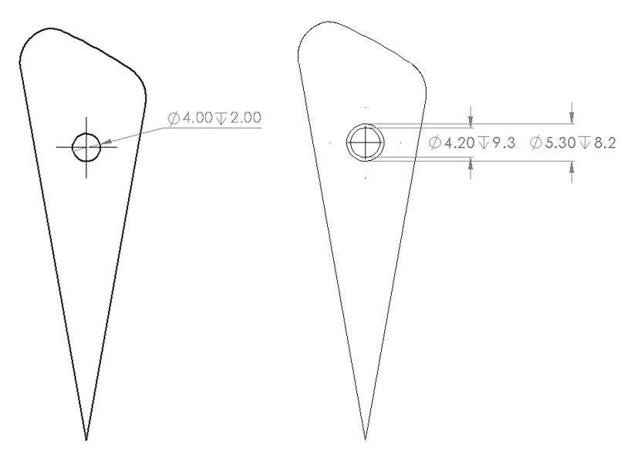

Figure 4: Comparison of Leaflet Holes (left: original leaflet, right: modified leaflet)

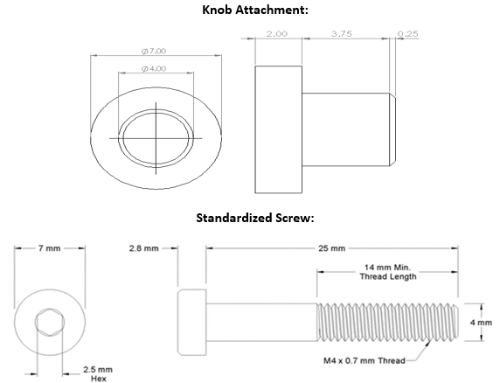

Figure 5: Connector Comparison

[14] “Alloy Steel Low-Profile Socket Head Screw,” McMaster-Carr, 2013. [Online]. Available: https://www.mcmaster.com/93070A109/. [Accessed: 22-Sep-2020].

**3.1.4 Subsystem Four: Threaded Inserts**

Threaded inserts were added to the design to prevent poor connection between components and decrease tolerance requirements. To avoid a binding fit or no fit for the standard screw, threaded inserts are being used in replacement of 3D printed threads. The threaded insert is shown in Figure 6 [15].

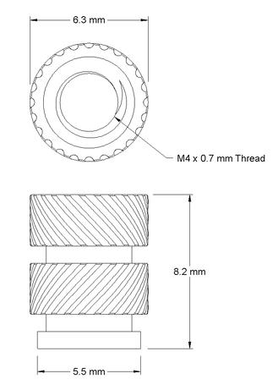

Figure 6: Threaded Insert

[15] “Brass Heat-Set Inserts for Plastic,” McMaster-Carr, 2018. [Online]. Available: https://www.mcmaster.com/94459A170/. [Accessed: 22-Sep-2020].

# Future Work

The team is looking to get as many parts as possible from retailers, to minimize the amount of novel parts. This will allow the ability to switch out broken parts with new ones easily. The team is also 3D printing much of the design. This will allow custom parts to be created cheaply and can quickly be analyzed and adjusted as necessary.

## Further Design

In the coming weeks, the team will begin to order the final parts for the design. This includes the worm and gear, as well as any more filament needed for the final prototype. The team will modify the gantt chart to match the semester and plans as needed. Concurrent with the above items, the team will continue to 3D print the parts and assemble. The team wants to limit additions to the design and focus on iterating the current design as needed. Iterations occur when a portion of the prototype needs to be adjusted due to failures or unexpected flaws. Any modifications will be documented for future reference and will be posted on the team website as a way to monitor our progression throughout the project.

## Schedule Breakdown

The team has decided to have a design to move forward with by Sunday September 27, 2020 in which most, if not all, parts will be ordered to ensure enough time to construct the device and allow for modifications. This way the team can change gears from initial design to iterative design. Changing to iterative design will allow the team to focus on improving existing ideas instead of creating novel ideas. From September 27, 2020 the team expects a shipping period of two to three weeks, after which the device will be immediately constructed and tested to allow the team to analyze any improvements that must be implemented before the end of the semester. The team should have a final design assembled by October 16th to ensure functionality of each component. Meanwhile, the team will debug the arduino setup that is in progress. Our goal is to have most of the code debugged by October 10th, 2020 in which we can continue to add any necessary code to ensure the actuation of the device.

# 

# Reference

[1] Y. Cai, Z. Meng, Y. Jiang, X. Zhang, X. Yang, and S. Wang, “Finite element modeling and simulation of the implantation of braided stent to treat cerebral aneurysm,” Medicine in Novel Technology and Devices, 13-Apr-2020. [Online]. Available: https://www.sciencedirect.com/science/article/pii/S2590093520300059. [Accessed: 12-Sep-2020].

[2] J. Parodi, “Endovascular repair of abdominal aortic aneurysms and ...,” 1995. [Online]. Available: https://www.jvascsurg.org/article/S0741-5214(95)70186-9/abstract. [Accessed: 12-Sep-2020].

[3] S. Hähnel et al., “Small-vessel stents for intracranial angioplasty: In vitro comparison of different stent designs and sizes by using CT angiography,” Am. J. Neuroradiol., vol. 24, no. 8, pp. 1512–1516, 2003.

[4] P. Hindy, J. Hong, Y. Lam-Tsai, and F. Gress, “A comprehensive review of esophageal stents,” Clin. Adv. Hematol. Oncol., vol. 10, no. 8, pp. 526–534, 2012.

[5] S. H. Duda et al., “Physical properties of endovascular stents: An experimental comparison,” J. Vasc. Interv. Radiol., vol. 11, no. 5, pp. 645–654, 2000.

[6] L. L. C. CalculatorSoup, “Regular Polygon Calculator,” CalculatorSoup. [Online]. Available: https://www.calculatorsoup.com/calculators/geometry-plane/polygon.php. [Accessed: 12-Sep-2020].

[7] P. Hindy, J. Hong, Y. Lam-Tsai, and F. Gress, “A comprehensive review of esophageal stents,” Gastroenterology & hepatology, Aug-2012. [Online]. Available: https://www.ncbi.nlm.nih.gov/pmc/articles/PMC3533211/. [Accessed: 12-Sep-2020].

[8] Wrought Seamless and Welded and Drawn Cobalt Alloy Small Diameter Tubing for Surgical Implants, F2527, 2016. [Online]. Available: https://www.astm.org/Standards/F2527.htm. [Accessed: 12-Sep-2020].

[9] K. Anders, “Coronary artery stents,” Card. CT, Second Ed., vol. 284, no. 14, pp. 199–224, 2014.

[10] M. S. Makaroun, E. D. Dillavou, S. T. Kee, G. Sicard, E. Chaikof, J. Bavaria, D. Williams, R. P. Cambria, and R. S. Mitchell, “Endovascular treatment of thoracic aortic aneurysms: Results of the phase II multicenter trial of the GORE TAG thoracic endoprosthesis,” Journal of Vascular Surgery, 02-Feb-2005. [Online]. Available: https://www.sciencedirect.com/science/article/pii/S0741521404014855. [Accessed: 12-Sep-2020].

[11] “Balloon-expandable Stents Available for Sale in the US,” Stents, 2008. [Online]. Available: https://www.ctsnet.org/sites/default/files/documents/pdf/BalloonExpanding.pdf. [Accessed: 23-Sep-2020].

[12] “Tensile Testing Machine for Radial Force Model TTR2 - E-Tronics.” [Online]. Available: http://www.e-tronics.hu/v4/e69bc5c4-143b-4e1a-8b00-6e75fc4558c9/uploads/TTR2-DataSheet.pdf. [Accessed: 23-Sep-2020].

[13] “SC1775S- Automated Stent Crimping Equipment,” MSI Stent Crimping. [Online]. Available: https://machinesolutions.com/msi/wp-content/uploads/sites/3/2016/03/SC1775S.pdf. [Accessed: 23-Sep-2020].

[14] “Alloy Steel Low-Profile Socket Head Screw,” McMaster-Carr, 2013. [Online]. Available: https://www.mcmaster.com/93070A109/. [Accessed: 22-Sep-2020].

[15] “Brass Heat-Set Inserts for Plastic,” McMaster-Carr, 2018. [Online]. Available: https://www.mcmaster.com/94459A170/. [Accessed: 22-Sep-2020].