# Components:

## Screws

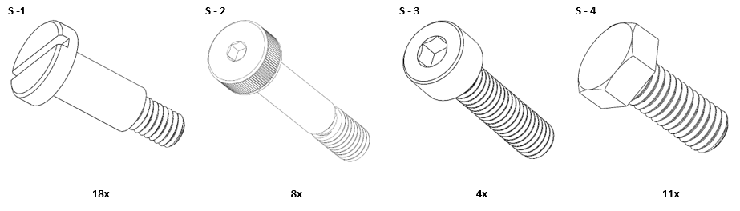

## Housing

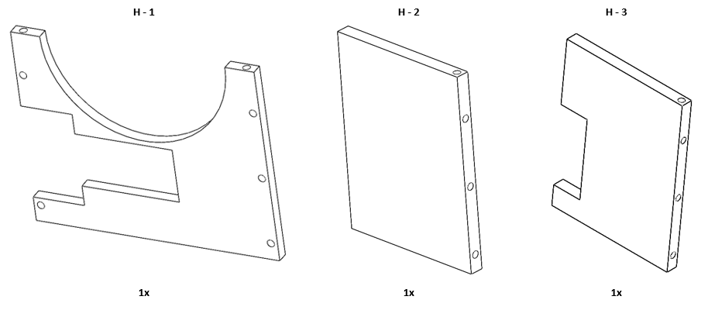

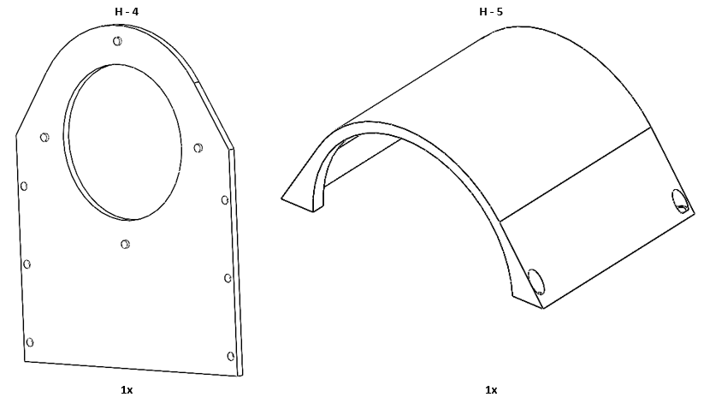

## Gear

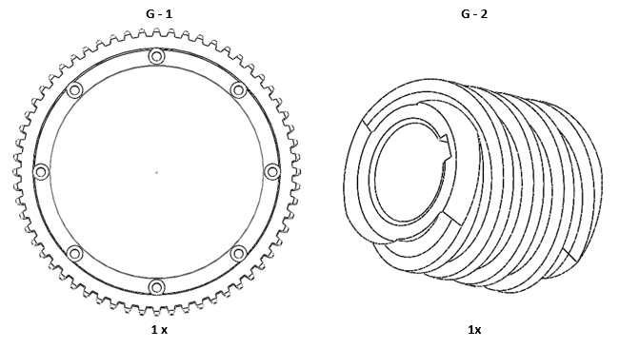

## Motor Cage

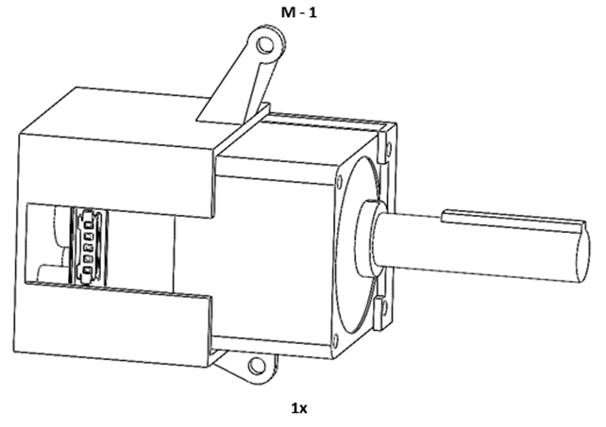

## Spacer

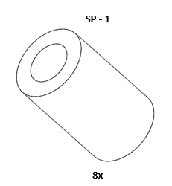

## Main Body

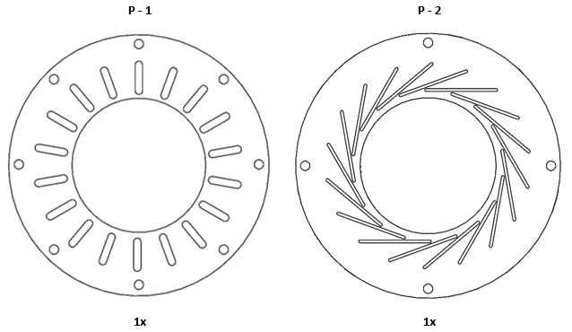

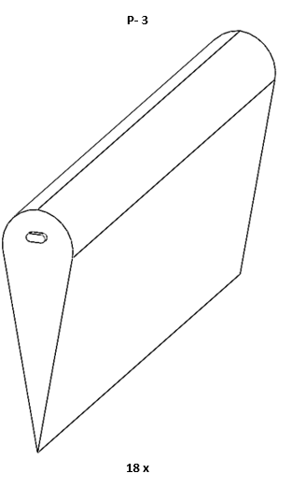

# Assembly

1. Assembly Main Body
   1. Place Part SP-1 through Part S-2

Insert thread of Part S-2 through holes on G-1

Thread S-2 onto holes the Part P-1

* 1. Individually place Part S-1 through slots on P-1 and fasten to Part P-3

1. Motor
   1. Place Part G-2 onto shaft of Part M-1
2. Assembly Housing
   1. Use Part S-4 to secure the Part H-1 to Part H-2
   2. Place Part M-1 on Part H-1 and attach to Part H-2
   3. Place P-2 on knobs on the Part H-4
   4. Place extruded knobs of Part P-3 into slots of non-P-2
   5. Attach Part H-4 to the side plates (Part H-2 and H-3)
   6. Place Part H-5 onto rest of housing and use Part S-3 for attachment
   7. Verify that G-1 and G-2 are properly aligned
      1. If the parts are not aligned detach then reattach M-1 to part H-1

*See Diagrams for more details*

## Main Body

### Step A

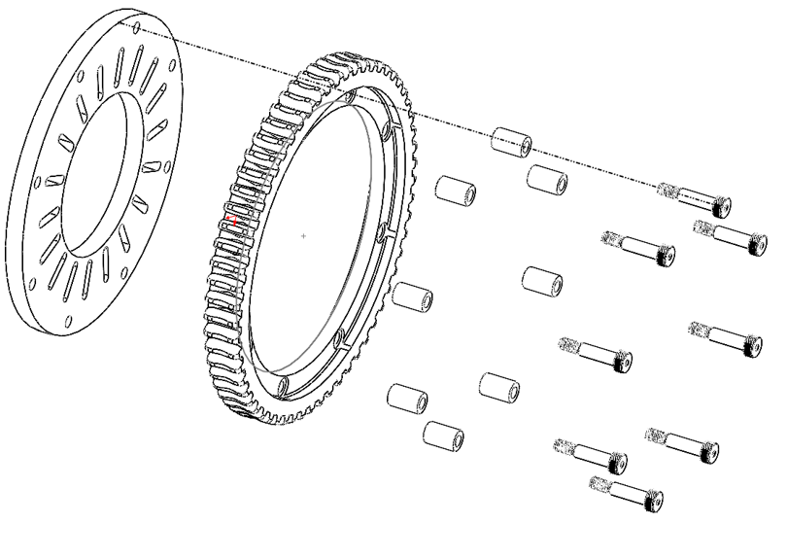

### Step B

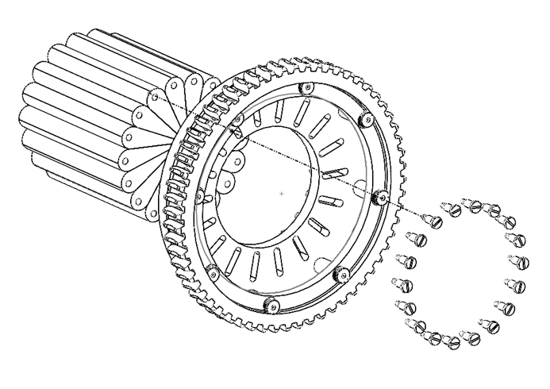

## Motor Cage

### Step A

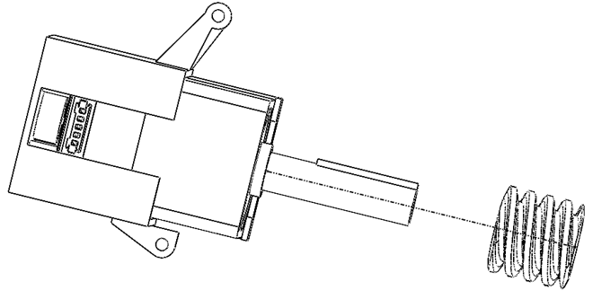

## Housing

### Step A

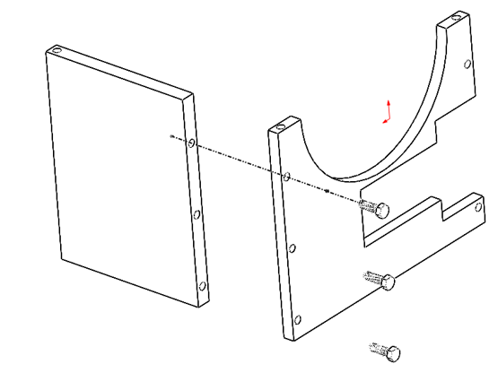

### Step B

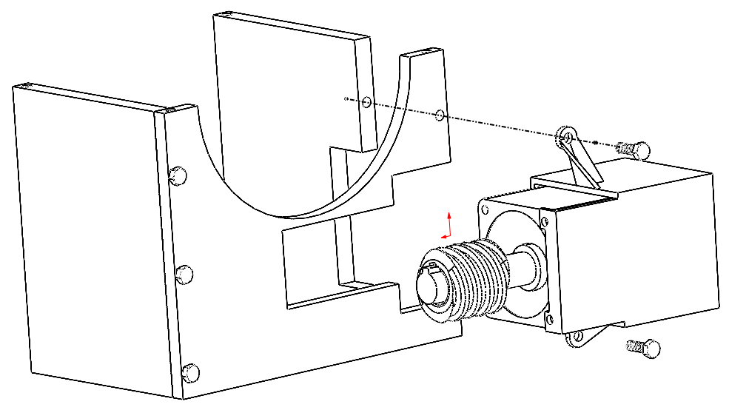

### Step C

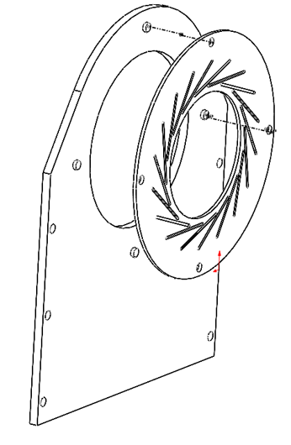

### Step D

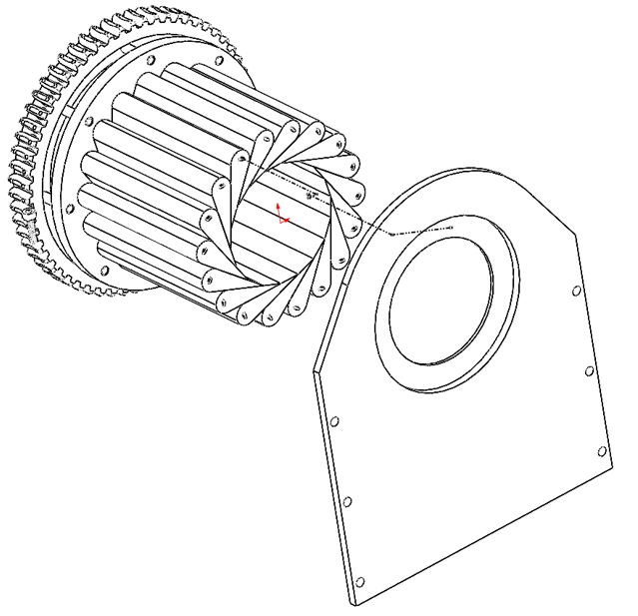

### Step E

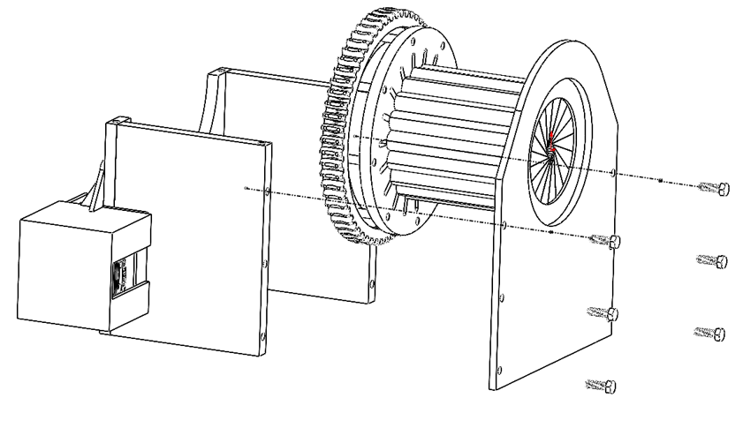

### Step F

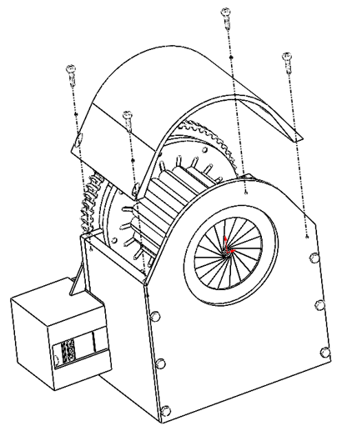

Arduino Schematic

