Balancing Robot

Final Report

Team:

Fahad Alostath

Naif Alfihan

Mohammed Alshammari

2019-2020

[Insert NAU or Team Logo as watermark or include a photo of the team or project]

Project Sponsor: NAU Program Fees

Faculty Advisor: Sarah Oman

Instructor: Sarah Oman

DISCLAIMER
This report was prepared by students as part of a university course requirement. While considerable effort has been put into the project, it is not the work of licensed engineers and has not undergone the extensive verification that is common in the profession. The information, data, conclusions, and content of this report should not be relied on or utilized without thorough, independent testing and verification. University faculty members may have been associated with this project as advisors, sponsors, or course instructors, but as such they are not responsible for the accuracy of results or conclusions.
Table of Contents
DISCLAIMER 2
1 BACKGROUND 5
1.1 Introduction 5
1.2 Project Description 6
1.3 Original System 6
2 REQUIREMENTS 7
2.1 Customer Requirements (CRs) 7
2.2 Engineering Requirements 7
2.3 House of Quality (HoQ) 8
3 DESIGN SPACE RESEARCH 11
3.1 Literature Review 11
3.1.1 Naïf 11
3.1.2 Fahad 12
3.1.3 Mohammed 13
3.2 Benchmarking 14
3.2.1 System Level Benchmarking 14
3.2.2 Subsystem Level Benchmarking 16
3.3 Functional Decomposition 20
3.3.1 Black Box Model 20
3.3.2 Functional Model/Work-Process Diagram 21
4 CONCEPT GENERATION 22
4.1 Full System Concepts 22
4.1.1 Full System Design # 1: Two Wheeler Wide Robot 22
4.1.2 Full System Design # 2: Two Wheeler Double Story Robot 22
4.1.3 Full System Design # 3: Back holder Robot 23
4.1.4 Full System Design # 4: Single Wheel Robot 24
4.1.5 Full System Design # 5: Two Wheels High Centered Robot 24
4.2 Subsystem Concepts 25
4.2.1 Subsystem # 1: Controller 25
4.2.2 Subsystem # 2: Motor 26
4.2.3 Subsystem # 3: Wheels 28
5 DESIGN SELECTED 30
5.1 Technical Selection Criteria 30
5.2 Rational for Design Selection 30
5.2.1 Final Design 33
5.2.2Design Analysis 40
5.2.3 Prototype Building 41
6 REFERENCES 43
APPENDICIES 45
APPENDIX A – Bill of Materials 45
APPENDIX B – FMEA 47
APPENDIX C – Gantt Chart 49

1 BACKGROUND

1.1 Introduction
Robotics is a field which incorporate many engineering disciplines including mechanical engineering, electronics engineering, Nano-technology, software engineering, bioengineering and information engineering. These advancements are utilized to create machines that can substitute for people and duplicate human activities. As the robotics covers the design, operation, construction, controls, and uses for multipurpose as well. It has been using the field of manufacturing processes, space, under water, hazardous areas where human cannot survive, in the labs, at homes, hotels etc. Because of vast use and multipurpose functions robotics is getting famous. Since the beginning, it has been much of the time accepted by different researchers, designers, engineers, and professionals that robots will one day have the option to mirror human conduct and oversee assignments in a human-like style. Today, robotics is a quickly developing field, as innovative advances keep; investigating, structuring, and constructing new robots fill different handy needs, regardless of whether locally, monetarily, or militarily. Robotics is additionally utilized in STEM (science, innovation, engineering, and arithmetic) as an educating aid. Robotics is a part of engineering that includes the origination, plan, assembling, and activity of robots. Now the robots are building on the basis of autonomous feature and Artificial Intelligence which cause the robot to self-learn and self-operate. Robot Games are getting famous around the world because people can watch their attractive moves and intelligent designs. As the robots are getting common, lot of companies are working around to develop the robots with the new technology that can be useful as a personal robot.
In fact, now robotics is using in the games as well, developing the robots for the game, and worldwide competitions are arranging for the robotic games. One of the common and well-known international competition is RoboGames. It is an annual competition about the robotic games held in San Mateo, California, which involves lot of countries who compete in over fifty categories likewise autonomously navigating robots in combat robots, weight lifting, sumo bots, climbing, soccer bots etc. RoboGames has known to be in the top ten for the North American Geek Fests.
This project is also related to the RoboGames and it has been asked to develop a robot that can compete in the RoboGames Competition. Purpose of this project is to develop the designing skills and become familiar with the complete of process of designing as the designing need lot of research and documentation work as well so this project is basically focusing on that. This project is of interest to the sponsor as it will develop a unique robot which will utilize in the RoboGames. And the robot will benefit the sponsor and other stakeholders as they can use it directly into the competition, upon the completion of robot.
This project is important in the fact that it is a design project and designing is quite important for the engineers whereas the project main emphasis is to design a robot, so designing and robotics to things are together in this project. As it has mentioned earlier robotics is using extensively and in future, all the technology will depend on the robotics so designing the robot in this course will help the team understand the designing processes and will able to learn about the robots and will help in the future as well, so this project will have vast scope in the near future. Talking about the issues, this project will address a unique way of developing the robot and solve the balancing problem for the robot which is quite difficult.

1.2 Project Description
In this project, it has required to select a competition from the RoboGames and design a Robot that can part in the competition. The robot will design on the basis of choice from these three challenges.
- Robotic BiPed Racing
- Robotic BiPed Freestyle Dancing
- Balancing Robot
It has been assigned to select One of Project from the above three options, and look for the challenge rules in the RoboGames, and design a robot which will take part into the specific challenge. It has not required to attend the RoboGames, in fact the RoboGames is currently active, so it becomes the opportunity to work on Robotic design. Robotics is going to start in the ME Capstone and this will be on going project in the future as well.

1.3 Original System
This is the original system and we are developing the design from the start. There is no such system developed before by the time this project has been started. “By the time this project has started, there is no Robotics system developed, this is the original system developing in the project”.

2 REQUIREMENTS
This project requires to develop a robot that can compete in one of the robotic challenge organized by the RoboGames, and it must fulfill the challenge rules described the by RoboGames. This section will develop the customer requirements, engineering requirements and house of quality chart. It is important for any design project to organize the problem description in a tabular form with the most important points that will develop in the project. As it helps the team as well to understand what the project is and which things need to consider more in the design.

2.1 Customer Requirements (CRs)
Customer requirements are actually the project description provided by the client but in tabular form. As the project description has provided in a paragraph form so in customer requirements, a table has developed which point out the main instructions one by one. As in the description it has asked to select one of the challenge and develop the Robot that fulfills the challenge rules as well. So for this project the team has selected “Balancing Robot” and according to the project following are customer requirements shown below in the table [1].
Table 1: Customer Requirements
Customer Requirements
Wheeler Robot
Reciprocal Linear Mechanism
Forward and Backward Motion
Safe to Use
Autonomous control
Long battery backup
Capable of Balancing in all directions
Balance over rough terrains
Cross the Obstacles
Light Weight
Reliable
Durable
Customer requirements have developed from the challenge rules given by the RoboGames regarding the balancing robot.

2.2 Engineering Requirements
Engineering requirements relates to the technical side of the customer requirements, as most of the customer requirements can only visualize if it is present or not but in order to measure to which extent the requirement is fulfilling in the project engineering requirements have developed because ER’s are the technical requirements which can measure, testify and observe as well. Engineering Requirements are those requirements which have some physical value and we can determine that physical value. These requirements have developed from the challenge rules of RoboGames and presented in the following table.
Table 2: Engineering Requirements
Engineering Requirements | Operational Values
Dimension | Less than 120 cm
Battery Time | 180 seconds
Moving Capacity in the Arena | 3 meters
Height | 20 cm
Wheel Radius | 4 cm
Degree of Freedom | 4 Degrees
Width | 6 cm
Weight | 5 lb.

These requirements have generated from the RoboGames challenges, and in the rules it has stated that the dimension must be within the 140 cm so it has selected 120cm or less for our design to have some margin. In the same way battery time is the thing which depends on its on time, and it must be able to move for more than 150 seconds therefore 180 seconds on time has selected. In the same way it must able to move within the 3 meters of arena and the height has required to be not more than 24 cm so 20 cm has selected for the design. And comparing to the height, it has stated to make the center of gravity above the wheel’s axis that’s the reason 4 cm of radius has selected. Degree of freedom is movement in the direction so the wheeler robot can move in 4 directions to make itself stable. Width of robot is to make 6 cm for stability purpose, and the weight of robot should be 5 lb. or less.

2.3 House of Quality (HoQ)
House of Quality is basically a chart which determines the relationship between the customer requirements and engineering requirement through which it can determine the most effective engineering requirements. In the chart, left side column contains the customer requirements and top of chart contain engineering requirements, below the ER’s there is a matrix which shows the number relating the CR’s with the ER’s. A weightage has assigned to each CR and then observe each ER against each CR and assign a number according to the relation it founds. Below the matrix, unit of ER’s, targeted values of ER’s, absolute technical importance, and relative technical importance are present and on the right side three are benchmarks showing the similar projects. The HoQ table has shown below
Table 3: House of Quality

Customer Requirement | Weight | Engineering Requirement | Dimensions | Battery Time | Moving Capacity in the Arena | Height | Wheel Radius | Degree of Freedom | Width | Weight
Wheeler Robot | 9 |  | 3 |  | 1 | 1 | 3 | 3 | 1 | 3
Reciprocal Linear Mechanism | 9 |  | 1 |  | 1 | 1 | 1 | 3 | 1 | 1
Forward and Backward Motion | 9 |  | 3 |  | 3 |  | 1 | 3 |  | 1
Safe to Use | 3 |  | 1 |  | 1 | 3 | 3 |  | 3
Autonomous control | 3 |  |  |  | 1 |  |  |  |  | 1
Long battery backup | 3 |  | 1 | 9 | 3 |  |  |  |  | 1
Capable of Balancing in all directions | 3 |  | 1 |  | 1 |  | 1 | 1 |  | 3
Balance over rough terrains | 1 |  | 3 | 1 | 1 | 1 | 1 |  | 1 | 1
Cross the Obstacles | 1 |  | 9 |  |  | 1 | 3 | 1 |  | 3
Light Weight | 3 |  |  |  | 3 |  | 1 | 3 | 3 | 9
Reliable | 1 |  | 1 | 1 | 1 | 1 | 3 | 3 | 1 | 1
Durable | 3 |  |  |  | 1 |  | 1 | 1 | 1 | 1
Absolute Technical Importance (ATI) |  |  | 85 | 29 | 77 | 30 | 70 | 100 | 41 | 95
Relative Technical Importance (RTI) |  |  | 16% | 6% | 15% | 6% | 13% | 19% | 8% | 18%
Target ER values |  |  | 120 cm | 180s | 3 m | 20 cm | 4 cm | 6 Deg | 6 cm | 6 cm
Tolerances of Ers |  |  | 150 cm | 200s | 4 m | 25 cm | 6 cm | 5 Deg | 8 cm | 8 cm
Testing Procedure (TP#) |  |  | 1 | 2 | 3 | 4 | 5 | 6 | 7 | 7

From the HoQ table, the most important engineering requirement is Degree of Freedom and the second important requirement is weight of the device.
- Dimensions
  - The Area can test using the foot scale
  - Multiply the width and height to get the area
- Battery Time
  - Battery time can test by running the battery with the motors with full load and use the time clock to record the total battery time
- Walking Length Capacity
  - The Capacity of moving for the robot can test by measuring the distance using the meter scale
- Height
  - Height will test using the foot scale.
- Wheel Radius
  - The radius of the wheel can also test using the foot scale.
- Degree of Freedom
  - It will test by counting the motors and then check with the naked eyes how many motors are using DOF
- Width
  - It will also test using the foot scale

3 DESIGN SPACE RESEARCH
According to the Chapter 3, designing any product need lot of documentation to do before implementation, as just directly design the product and implement it is not a good practice though it takes more time and it will have lot of error issues so the best practice for the design is to do some research before and determine what type of projects have done similar to the current project and what similarities can be seen in those existing projects and the current project. It also need to focus the main functionality and then focus on sub-functions. In this way, a new design can generate by taking some help from old design and it also make sure that nothing is going to develop again as it has developed before. This practice makes the current design as the most advanced one and most reliable one because it may solve the issues faced by other people in the existing designs.

3.1 Literature Review
The literature review has proposed on different aspects of this project. Different kind of robots with their self-balancing techniques have studied in the literature review and it has presented below.

3.1.1 Naïf
Self-Balancing using Arduino with PID
This paper reports the plan, development and control of a two-wheel self-balancing robot. The framework design contains a couple of DC engine and an Arduino microcontroller board; a solitary hub gyrator and a 2-hub accelerometer are utilized for disposition assurance. What's more, a correlative channel is actualized to make up for gyro floats. Electrical and kinematic parameters are resolved tentatively; PID and LQR-based PI-PD control structures, individually, are performed on the linearized conditions of movement. Test results demonstrate that self-balancing can be accomplished with PI-PD control in the region of the upstanding position [2].
This will help the team in developing the robot using the Arduino and the feedback controllers can use for this purpose.
Self-Balancing using Arduino with complex algorithm
The field of robotics is the play area of the innovative personalities of current age. Dreams transformed into reality with the advancement in this field. Two-wheel self-balancing robot is additionally a case of cutting edge advancement in the field of robotics. The idea of two-wheel self-balancing robot depends on Inverted pendulum hypothesis. This sort of robot has earned premium and acclaim among analysts and designers of worldwide as it dependent on such a control framework, that is utilized to balance out an insecure framework utilizing productive miniaturized scale controllers and sensors [3].
This paper can help the team in developing the design as it has given in this paper and it can further modify so this paper is useful for the manufacturing purpose.
Self-Balancing Robot for control education
This paper reports the structure, development and control of a two-wheel self-balancing robot. The framework design involves a couple of DC engine and an Arduino microcontroller board; a solitary hub whirligig and a 2-hub accelerometer are utilized for disposition assurance. Also, a corresponding channel is executed to make up for gyro floats. Electrical and kinematic parameters are resolved tentatively; PID and LQR-based PI-PD control plans, individually, are performed on the linearized conditions of movement. Exploratory outcomes demonstrate that self-balancing can be accomplished with PI-PD control in the region of the upstanding position [4].
This paper is also helpful for the team in understanding the new idea of two-wheeler robot which can balance with the help of Arduino.

3.1.2 Fahad
Development in self-balancing using single wheel control
One wheeled balancing robots are a zone of research that may well give the future motion to regular robots. The novel solidness control that is required to keep the robot upstanding separates it from customary types of robotics. The modified pendulum guideline gives the numerical demonstrating of the normally unsteady framework. This is then used to create and execute an appropriate security control framework that is responsive, convenient and fruitful in accomplishing this goal. Finishing the plan and advancement period of the robot requires cautious thought of all viewpoints including working conditions, materials, equipment, sensors and programming [5].
Looking at the paper, it defines multiple options to support the single wheel structure design and this can help in selecting the final design.
Balancing using single wheel and gyroscope
This examination presents a single-wheeled self-balancing versatile robot dependent on a control minute gyrator module. Single-wheeled versatile robots can accomplish better portability and revolution in little spaces and to move quicker than legged robots, for example, humanoid type robots. Thus, the single-wheeled portable robot is commonly utilized as a versatile robot stage. Be that as it may, to keep up its parity, the single-wheeled robot needs to utilize developments of its one wheel. At the point when a surprising aggravation influences the robot, the robot keeps up its offset with developments of the wheels and tilting of the body. In the event that the unsettling influence surpasses the reaction ability of the robot, the robot will lose its dependability [6].
As the paper has defined balancing of robot using the single robot is a unique idea because it uses gyroscope so this paper can help the team in selecting the final design by taking help from this literature review.
Single-Wheel Balancing Design
Numerous electrical vehicles have been grown as of late, and one of them is simply the vehicle type with the adjusting ability. Transportability likewise one of issue identified with the improvement of electric vehicles. This paper presents one wheeled self-adjusting electric vehicle to be specific PENS-Wheel. Since it just comprises of one engine as its actuator, it turns out to be more versatile than some other self-adjusting vehicle types. This paper talks about on the usage of Kalman channel for sifting the tilt sensor utilized by oneself adjusting controller, mechanical structure, and creation of the vehicle. The vehicle is planned dependent on the guideline of the upset pendulum by using engine's torque on the wheel to keep up its upstanding position. The sensor framework utilizes IMU which consolidate accelerometer and whirligig information to get the exact pitch point of the vehicle. The paper exhibits the impacts of Kalman channel parameters including commotion fluctuation of the accelerometer, clamor difference of the spinner, and the estimation commotion to the reaction of the sensor yield. At last, we present the consequence of the proposed channel and contrast it and restrictive channel calculation from InvenSense, Inc. running on Digital Motion Processor (DMP) inside the MPU6050 chip. The consequence of the channel calculation executed in the vehicle demonstrates that it is competent in conveying equivalent execution with the exclusive one [7].
This paper can help the team in designing the robot using the gyroscope so functionality of the robot can finalize using this paper.

3.1.3 Mohammed
LQR Controller Robot
In this paper, authors propose another powerful model of the balancing robot, and present the execution technique and results of the controller dependent on this model. The model condition of the framework is inferred through the Lagrange-ian approach. The model for following control of balancing robot is proposed, of which following reference is included as state, and executed through LQR controller. The dynamic model proposed in this paper has the speeding up of robot body as the control input, in contrast to the ordinary model which utilizes the torque or voltage as the control input. The increasing speed from the LQR controller is changed to the speed reference of an engine and this worth is applied to the genuine framework through engine speed controller. The engine speed controller could be isolated from the LQR controller making control reference [8].
From the above paper, the team can get the idea of LQR and can utilize in the final design depending on the response and efficiency of system.
Multi-Dimension robot using stepper motor
A two-wheeled, self-balancing robot is proposed utilizing 6-pivot MEMS sensors MPU6050 to quantify its stance. The sensors incorporated with a 3-pivot gyrator and a 3-hub accelerometer, can yield the tendency of the robot dependent on sensor combination calculation. A handheld remote controller conveys directions to the robot, for example, forward, back, and pivoting. As indicated by the tendency and direction directions, a 16-piece MCU utilizing the PID control calculation ascertains the necessary control voltage for the engines, to modify the robot's stance and keep the body adjusted. In this paper, the standard of the sensor combination calculation is completely portrayed, and its belongings are checked through related examinations. The exploratory outcomes demonstrate that the proposed robot is viable and ready to adjust utilizing cheap MEMS sensors [9].
In this paper stepper motor design has presented and it can implement in this project as well therefore the team can take help after analyzing if the design is suitable for the project.
Controlled Motor with the Stepper Motor
In this paper authors portray an inexact scientific model for stepper engine based two-wheeled self-balancing (TWSB) robot. We additionally demonstrate the use of this model in PC supported structure of a computerized controller to adjust and to direct the robot. TWSB robot can be executed utilizing equipped DC engines and stepper engines. The last form is famous as of late after the presence of open-equipment plan for stepper engine driver module, which was initially made for work area 3D printers and CNC machines, and the straightforwardness with which stepper engines can be controlled with beat electrical sign [10].
This paper is focusing on the stepper motor which is highly efficient in the robotics therefore taking help from this paper will help the team in finalizing the design.

3.2 Benchmarking
In this section different existing designs will present that have developed and relates to the project. As these robots will help in developing different designs and help in selecting the sub-functions as well therefore it is a good option to research on existing designs and sub-function designs.

3.2.1 System Level Benchmarking
In system level benchmarking, some existing designs of complete robots have presented and their functionality has described.

3.2.1.1 Existing Design # 1: Elegoo Self-Balancing Robot
This is a robot with two wheels and it can balance itself. It used the Arduino controller with the sonar system to detect the front hurdles, it is an autonomous robot with the bouncing mode, and provide the access to control through the cell phone. This design has shown in the following image [11].
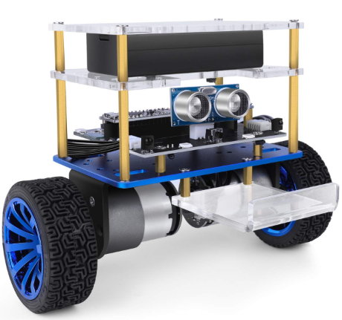
Figure 1: Elegoo Robot [11]

3.2.1.2 Existing Design # 2: MakeBlock Robot
This is another two wheeler design and it is smaller in size and having eyes shaped sonar in front side to detect the obstacles, and it uses 3-axis accelerometer and gyro sensor as well. It has the capability to calculate the driving force that it need to move the robot because on smooth surfaces it will consume less power and on rough terrains it will consume more power so in either case it is power efficient as well and the device has presented below [12].
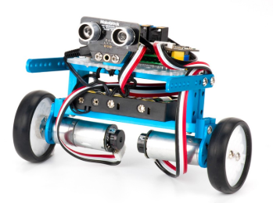
Figure 2: MakeBlock Robot [12]

3.2.3 Existing Design # 3: Uni-wheel Balancing Robot
This is a robot with single wheel and it can balance the complete structure easily. It is a high-order, under-actuated system and multi-coupling robot. It used lot of sensors including gyro sensor, accelerometer, ultrasonic, and sonar. It controls through the MATLAB for sending the instructions. All the instructions load to the controller and then it works autonomously. The speed of the controller can control as well and it can run with good speed, even though it has multiple sensors it is quite small and compact sized device and it has shown below [13].

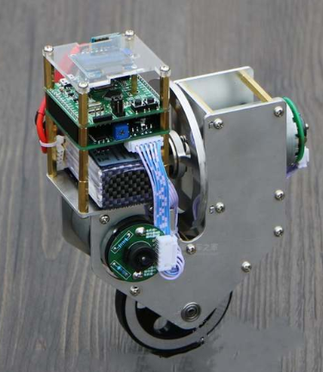
Figure 3: Uni-Wheel Balancing Robot [13]

3.2.2 Subsystem Level Benchmarking
In the same way as the system level benchmarking has done, subsystem level benchmarking stands for the sub-functional parts that will use in the project and searched these parts, and determined the design of these parts. For example, sub-functions like, motor, controller, wheels etc.

3.2.2.1 Subsystem #1: Controllers
Controller is a device that control the complete device, it sends the instructions to each part and then operate the device accordingly. Controller is the main part of robot and so it is most important part, without the controller a robot cannot operate autonomously or through the remote controller.

3.2.2.1.1 Existing Design # 1: Arduino
Arduino is the most favorite and most common controller available now in the market. This controller provides a complete set of components on a single chip and it also provides Wi-Fi and Bluetooth over its chip board in different modules. Arduino provides an easy to do the programming and also provide a complete complier for its Arduino with the support of coding through the MATLAB or through the C++ language. Arduino has shown below [14].
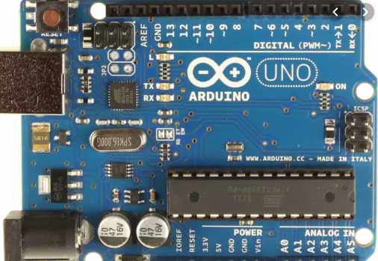
Figure 4: Arduino Controller [14]

3.2.2.1.2 Existing Design # 2: Raspberry Pi Controller
This is another exiting design of controller, Raspberry which is also similar to the Arduino. It has high speed controller chip and it provide direct LAN connection on the same chip with the Wi-Fi functionality and Bluetooth as well. The LAN connection of Raspberry is quite famous because of its high speed and efficiency. And it takes the power from the Ethernet cable as well if no other power has connected with the controller. The Raspberry has shown in the following figure.
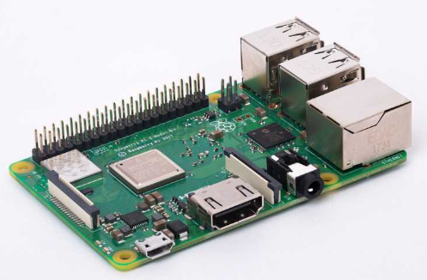
Figure 5: Raspberry Controller [15]

3.2.2.1.3. Existing Design # 3: BeagleBone Controller
This is another existing design available in the market and named as Beaglebone. In this controller, a high speed ARM processor has used along with the high memory and it provides a complete USB connection with the high speed 2.0 connectivity or 3.0 connectivity with the latest modules. It provides the support of microSD as well and it takes the power from the USB to operate all the functions. It has built-in Wi-Fi module to control it wirelessly. It has shown in the following figure.
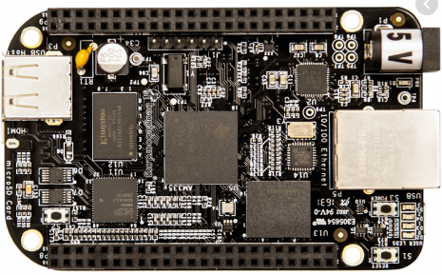
Figure 6: BeagleBone Contorller [16]

3.2.2.2 Subsystem # 2: Motors
Motors uses widely in the robot and without the motors it is not possible to even develop a robot because motors provide the motion to its parts and it also provide the motion to the complete robot. Wheels drive the robot and wheels rotates using the motor, movement of any part of device is not possible with the motor. Degree of freedom also depends on motor because number of motors describes the degree of motor.

3.2.2.2.1 Existing Design # 1: Stepper Motor
Stepper motor is a DC controller motor with the very smooth rotation of rod around the axis with the defined steps. This motor is powerful and provides high torque, and it can rotate at specific angles and these angles defined the number of steps it takes in one rotation. Stepper motor is useful in the context that if we need to drive the robot with some in-filtered motion like moving the hand with specified breaks. The stepper motor has shown below
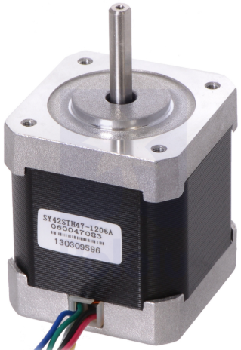
Figure 7: Stepper Motor [17]

3.2.2.2.2 Existing Design # 2: Servo Motor
This is a DC motor with high initial torque and high speed as well and it rotates without any breaks, so a continuous rotation can see in the servo motor. Servo motors uses extensively in the robots for the motion of hands and legs, it is one of most common motor to use in BiPed robots where it shows different degree of freedoms which depends on the number of servo motors connects in the robot. The servo motor has show below
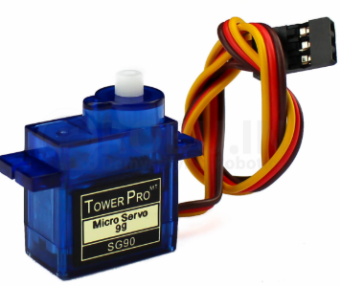
Figure 8: Servo Motor [18]

3.2.2.2.3 Existing Design # 3: Brushless DC Motor
This is a common DC motor without the brushes which can directly install to the robot. These motors usually install in the wheels in the robot, because of high speed and high power. It is capable holding high loads because of high initial torque and controlling the speed is god in brushless motor. The Brushless motor has shown below
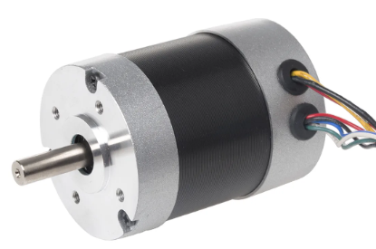
Figure 9: Brushless DC motor [19]

3.2.2.3 Subsystem # 3: Wheels
Wheels is another important part of this project because the robot moves on the wheels and without the wheels these robots are of no use. Therefore, wheels play an important role in the project.

3.2.2.3.1 Existing Design # 1: Rubber Wheel
This is an existing design available in the market, the wheel made up of rubber from the outer and inner part made up of plastic or steel or aluminum. Rubber wheels are soft and provide smooth movement over the surface. It can use in the project as well and it has shown below:
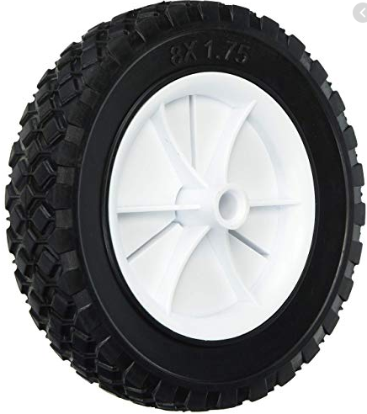
Figure 10: Rubber Wheel [20]

3.2.2.3.2 Existing Design # 2: Silicone Wheel
Silicone wheel is another existing design available in the market. In the silicone wheels it covers with the silicon and inside the wheel it contains the steel part. Silicone wheels are smooth and soft as well and it provide smooth ride for the robot. This can use in the project as well and as it has shown below
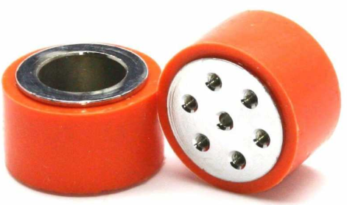
Figure 11: Silicone Wheel [21]

3.2.2.3.3 Existing Design # 3: Plastic Wheel
Plastic wheel is another existing design for the wheels in the market and it can use for this project as well. Plastic wheels are little hard as compare to silicone and rubber wheels but these wheels can also use in the robot because of their smooth movement on the surface and face less ground friction.
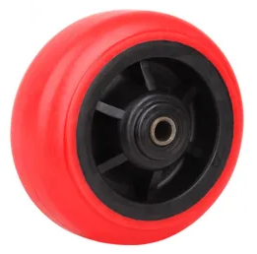
Figure 12: Plastic Wheel [23]

3.3 Functional Decomposition
Functional decomposition is basically showing all the inner functions of robot. These functions will possible be operate in the robot and will provide the output. There are two types of models which define the complete functionality of system. The Black Box model and the functional decomposition hierarchy model.

3.3.1 Black Box Model
The Black Box model describe the inputs and outputs of a system, and it does not depend on what is happening inside the system. That is the reason this model has given the name black box because inside is the black box and outside shows the inputs and outputs of regardless of inner functionality. The Black Box model has shown below
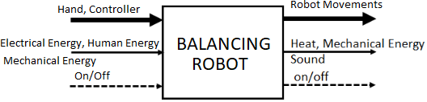
Figure 13: Black Box Model
In the above figure, there are three inputs and three outputs, Hand or Controller is the input which defines the controller will send the instruction as input to the system and hand will use to transfer the robot and send the instruction. So first input is material, second input is energy, as electrical energy will provide current, human energy will provide the input and mechanical energy will use by the motors. And third system is signal which is either on or off for the robot. In the same way, three different types of outputs, robot movement which is material, heat, sound and mechanical energy is the energy and third output is signal which is either on or off.

3.3.2 Functional Model/Work-Process Diagram
The functional decomposition has shown the complete process of how the input will go into the system and will operate different parts and move the robot with balancing condition. The complete organization has described along with inputs and outputs.
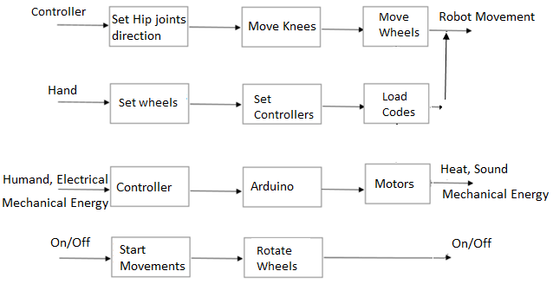
Figure 14: Functional Model

4 CONCEPT GENERATION
Any design project need the designing of different concepts at the start and then select the best option which fulfills the client requirements. In concept generation section different concepts will develop according to the requirements and these sketches will then evaluate to select the final design.

4.1 Full System Concepts

4.1.1 Full System Design # 1: Two Wheeler Wide Robot
This is a design which consist of two wheels which lay down in wide form and reduce the height of robot as well to make the well balanced in all directions. This design has a plate over it which can use to place any item and below the plate, the controller is present over the axel and the length of axel is greater than the height of robot.
Advantages:
- Wide range make it more stable
- Easy to move
Disadvantages:
- Wide range may cause disruption in moving
- Need extra space from surrounding to move
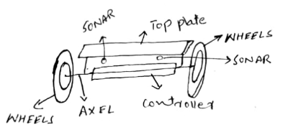
Figure 15: Two Wheeler Wide Robot

4.1.2 Full System Design # 2: Two Wheeler Double Story Robot
This design consists of two wheels and the controller is set in the plate of axel whereas there is an upper plate which is on height and with the handle on the top. In this way it becomes a double story robot with the handle on the top. So it can use to carry a load as well and it can easily balance the robot using the gyroscope. And sonars are present at the top to detect the hurdles.
Advantages:
- Double plate provide extra load to carry
- Easy to move
Disadvantages:
- Need efficient working of gyroscope to self-balance
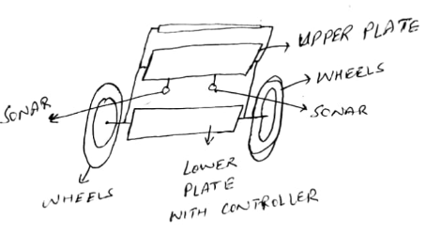
Figure 16: Two Wheeler Double Story Robot

4.1.3 Full System Design # 3: Back holder Robot
This is a robot with a high back so it can easily carry the items whereas the height and width of the robot is not much which can make it more stable and it can easily carry the item as well by using the back plate. It uses the sonar as well to detect the hurdles the round axel to make the base strong.
Advantages:
- High stability
- Extra load can carry
- Hold the load properly
Disadvantages
- Less speed can achieve through this robot
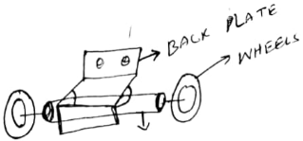
Figure 17: Back Holder Robot

4.1.4 Full System Design # 4: Single Wheel Robot
This is a single wheel robot with the controller lying over the single wheel in the top direction and it can stable in all four directions with the gyroscope working in all four directions. Sonars are present on the top to check the obstacles.
Advantages:
- Single wheel controller
Disadvantages:
- Difficult to balance
- Stability is low
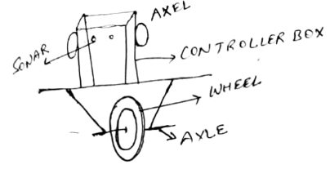
Figure 18: Single Wheel Robot

4.1.5 Full System Design # 5: Two Wheels High Centered Robot
This design consists of two large size wheels and the controller has formed in the standing position and all the items connect in the vertical direction. The axel has connected to the controller as well that is the reason center is high.
Advantages:
- Light Weight
Disadvantages
- Difficult to balance
- Less stability
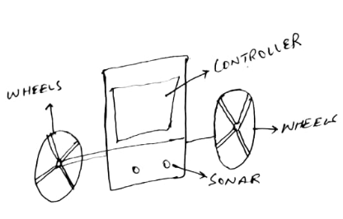
Figure 19: Two Wheels High Centered Robot

4.2 Subsystem Concepts
In this section three different sub-systems are presenting along with their different designs.

4.2.1 Subsystem # 1: Controller

4.2.1.1 Design # 1: Wide Range Microcontroller
This controller consists of all the units installed over the device and it also has a Wi-Fi and Bluetooth module install over it.
Advantages:
- All things are accessible in single unit
Disadvantages:
- Low strength Wi-Fi
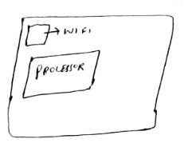
Figure 20: Wide Range Microcontroller

4.2.1.2 Design # 2: PIC Controller
Design the control circuit with the PIC microprocessor including the Bluetooth Built-in module.
Advantages:
- PIC controller is faster in speed
Disadvantages:
- Less memory available on the controller
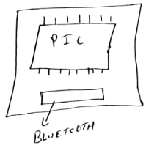
Figure 21: PIC Controller

4.2.1.3 Design # 3: Control Driver with 8051 processor
Develop the controller using the 8051 microcontroller and install the USB pin along with the motor driver to control the motors and access through the USB for loading the program.
Advantages:
- Economical design
- High speed
Disadvantages:
- Low memory
- Less efficient
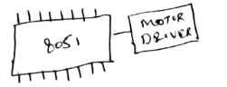
Figure 22: Control Driver with 8051 Processor

4.2.2 Subsystem # 2: Motor

4.2.2.1 Design # 1: Open grade Motor
This design of motor includes the stepper motor with the open grade axis driver.
Advantages:
- Fast
- Efficient
Disadvantages
- Low initial torque
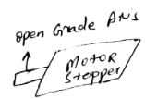
Figure 23: Open Grade Motor

4.2.2.2 Design # 2: Short Servo motor
This design consists of servo motor in small size to install inside the robot and consume less space and light in weight.
Advantages:
- Light weight
- Small in size
Disadvantages:
- Low initial torque
- Low speed
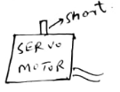
Figure 24: Short Servo Motor

4.2.2.3 Design # 3: Wide Brushless DC motor
This design consists of a motor with the wide size instead of long shape to get over the wheels and can provide high speed as well.
Advantages:
- High Speed
- High initial torque
Disadvantages:
- Large in size
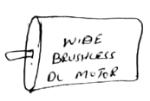
Figure 25: Wide Brushless Motor

4.2.3 Subsystem # 3: Wheels

4.2.3.1 Design # 1: Round Shape Open Wheels
This design consists of a wheel with open from the inside and round shaped as shown below
Advantages:
- Soft
- Low weight
Disadvantages:
- Not able to carry high load
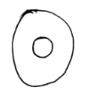
Figure 26: Round Shape Open Wheels

4.2.3.2 Design # 2: Star shape wheel
This design consists of a star shape wheel from inside and round from outside as shown below
Advantages:
- High speed
- Carry load
Disadvantages:
- Heavy in weight
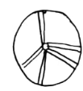
Figure 27: Star Shaped Wheel

4.2.3.3 Design # 3: Full Covered Design
This design consists of a wheel with inside fully covered with a small hole in it as shown below
Advantages:
- Strong
- Able to carry load
Disadvantages:
- Heavy in weight
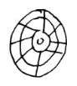
Figure 28: Full Covered Design

5 DESIGN SELECTED
In chapter 5, it has stated that the concept generation must be done using different methods instead of choosing the design directly as comparing the designs directly will not give the best option so there are different methods which can use to finalize the design. These methods include Pugh chart, Decision matrix etc. These methods can help in finalizing the design on the basis of engineering requirements and customer requirements.

5.1 Technical Selection Criteria
In order to select the final design, it will firstly pass through the Pugh Chart method to narrow down the results to top and then from decision matrix the final design will select. As the Pugh Chart is quantitative analysis method so it will analyze each design against customer requirement and see if the requirement is present in the design or not. So either it gives positive value if the requirement is present else it gives the negative value while if the requirement is not relating to the design then it gives no value. At the end calculate total positive values and negative values and see which design got the maximum positive values. In this way top two design will select and then it will pass to the decision matrix.
As the decision matrix is a quantitative method so it uses the engineering requirement and check if the design fulfill requirement or not and see how much it is fulfilling the requirement by assigning some marks to it. In this way add up the marks for each design and determine the final design with the highest marks. In this way both methods have used to finalize the design.

5.2 Rational for Design Selection
Top two designs have selected using the Pugh chart as shown below
Table 4: Pugh Chart
BALANCING ROBOT | Weight | Two Wheeler Wide Robot | Two Wheeler Double Story Robot | Back Holder Robot | Back Holder Robot | Single Wheel Robot | Two Wheels high Centered Robot
Wheeler Robot | 12 | + | + | D | + | + | +
Reciprocal Linear Mechanism | 11 | + | + | D | - | + | +
Forward and Backward Motion | 10 | + | + | D | + | + | +
Safe to Use | 9 | + | + | D | + | + | +
Autonomous control | 8 | + | + | D | + | + | +
Long battery backup | 7 | + | - | D | - | + | -
Capable of Balancing in all directions | 6 | + | + | D | + | - | -
Balance over rough terrains | 5 | + | - | D | - | - | -
Cross the Obstacles | 4 | + | + | D | - | - | -
Light Weight | 3 | + | - | D | - | + | -
Reliable | 2 | + | + | D | - | - | -
Durable | 1 | + | + | D | - | - | -
Pluses |  | 12 | 10 | - | 5 | 7 | 5
Minus |  | 0 | 2 | - | 6 | 5 | 7
Total |  | 12 | 8 | - | -1 | 2 | -2

From the above table top two designs are
- Two Wheeler Wide Robot
- Two Wheeler Double Story Robot
Looking at the advantages and disadvantage of both these methods as
Wide Robot Advantages:
- Wide range make it more stable
- Easy to move
Wide Robot Disadvantages:
- Wide range may cause disruption in moving
- Need extra space from surrounding to move
Double Story Robot Advantages:
- Double plate provide extra load to carry
- Easy to move
Double Story Robot Disadvantages:
- Need efficient working of gyroscope to self-balance
With these pros and cons the best design seem to be wide range robot because it has higher stability and as the wide range is not an issue according to the challenge rules as well therefore it is possible to make the wide range robot until its stability is high. From the back of envelop equation it is clear that
$$Height=10 in$$
$$Width=14 in$$
It is a common rule that stability can determine by comparing the height and width, if height is large and width is small then balancing is difficult for the device and if the height is small and width is large then balancing is easy for the device.
$$Height<Width$$
As this condition is true for the wide robot so it will be good to use this design. Now check the back of envelop equation for the double story robot
$$Height=16 in$$
$$Width=11 in$$
Using the above dimensions,
$$Height>Width$$
Hence this condition shows that balancing will be a problem for the robot and it will be difficult to tackle the balancing. Therefore, the result states that Wide Robot is best design for the project. Now check it through the Decision matrix
Table 5: Decision Matrix
Decision Matrix | Dimensions | Battery Time | Moving Capacity in the Arena | Height | Wheel Radius | Degree of Freedom | Width | Weight | Total
Weight | 8 | 7 | 6 | 5 | 4 | 3 | 2 | 1
Two Wheeler Wide Robot | 8x6=48 | 6x7=42 | 6x6=36 | 4x5=20 | 6x4=24 | 6x3=18 | 4x2=8 | 5x1=5 | 201
Two Wheeler Double Story Robot | 8x4=32 | 4x7=28 | 3x6=18 | 2x5=10 | 4x4=16 | 3x3=9 | 2x2=4 | 2x1=2 | 119

Hence the result of Decision matrix also states that Wide Robot is best design according to the requirements so the selected design is Two Wheeler Wide Robot.

5.2.1 Final Design
Design selected for the project is Wide Robot as a best design so the design has implemented in the SolidWorks to make the 3D CAD model and the 3D CAD model is showing below:
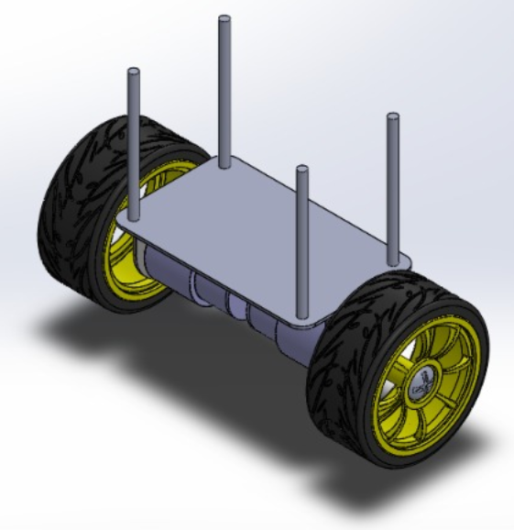
Figure 29: Step Deign CAD Model
In the above figure CAD model has presented in which two wheels have laid down with the rim inside the wheels and the wheels have connected using the shaft and then placed a plate over it. The plate is using for placing all the processors and other components and the radars will install above that. The rods showing in the design will use to carry all the components and the components will then able to fix on the robot. The cad model presented above is a basic version of the design and all the components will add in it. This design is just showing the chassis of actual design and looking at the chassis cad model it is clear that the design is stable and it can balance easily over the rough terrains. It just need to balance from front and back, there is no need of balancing from the other two sides because of wide length present between the wheels which make it stable and the balancing will effect from the wheel’s sides even though when the robot will high which shows the robot has high balancing phenomena. To understand how the wheels have connected with each other the shaft has presented below:
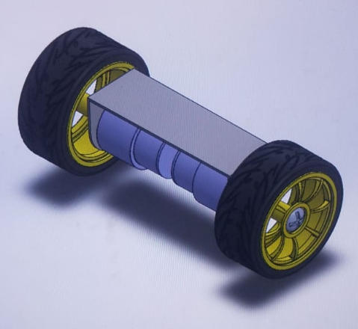
Figure 30: CAD Model for the Wheels and Shaft
So the final CAD model for the project is showing below:
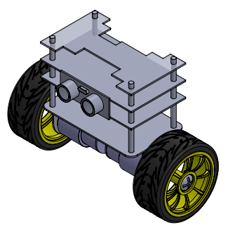
Figure 31: Final CAD Model
Front view is showing below
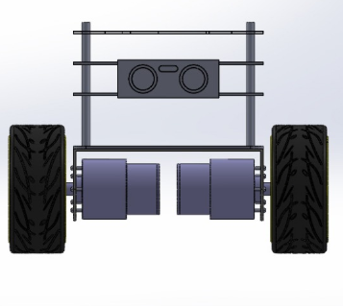
Figure 32: Front View

And the side view is showing below
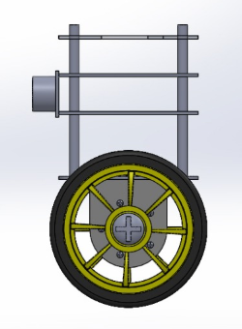
Figure 33: Side View
The top view is showing below
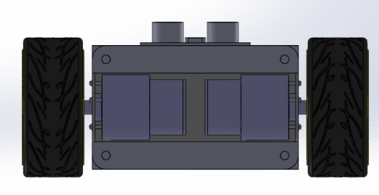
Figure 34: Top View
Exploded View
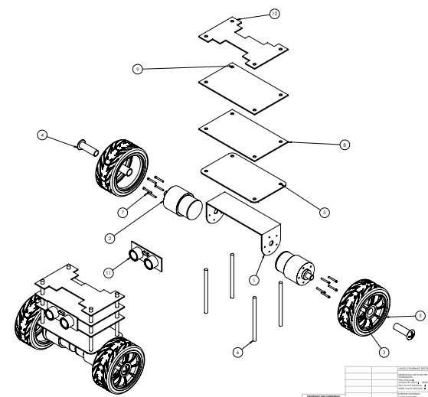
Figure 35: Exploded View
Table 6: Exploded View Names
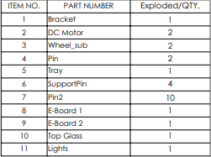

5.2.1.1 Dimensions
Dimensions of the design can write and describe as
Table 7: Dimensions
Dimensions | Values
Width | 1.5 ft.
Length | 0.5 ft.
Height | 1 ft.
Wheels Radius | 4 in.
Shaft Radius | 2 in.
Shaft Length | 1 ft.
Plate Length | 1 ft.
Plate Width | 6 in.

With the above dimensions the device will able to move forward and backward easily and it will balance the robot easily. Hence it can state that device has the capability to move on the rough terrains and can easily manage to balance with high stability.

5.2.1.2 Components
Components that will going to use in the robot project have shown in the table
Table 8: Components
Components Names
Motors
UNO R3 Microprocessor Kit
Wheels
Ultrasonic Module
Gyroscope
Batteries
Power Supply for Charging
USB Connector
Motor Driver Circuit
Bluetooth module

Motors
Motors in the design have connected inside the shaft, as two motors are going to use and one motor for one wheel, as two wheels so two motors.
UNO R3 Microprocessor
UNO R3 Microprocessor kit is using for controlling the device as it will take the actions from the user and will pass them to the driver kit that will move the motors and motors will move the wheels so the UNO processor kit will control the complete device, it will transfer the data to the system, it will load the program that will autonomously move the robot and it will connect with all the other components on the device to keep them working.
Wheels
Wheels are present to move the robots as two wheels are present so both will rotate in the same direction to provide a balancing and smooth drive.
Ultrasonic Module
Ultrasonic module contains the sonars, and the reason for the sonars is to detects the hurdles in front of the device. Sonar send the signals continuously in the forward direction and when any object comes into the way, the signals reflect back to the sonars, in this way sonars get to know something is present in the way, secondly sonar find the distance from the object, as the objects comes close sonar knows this thing and the distance from the object can easily detect as shown below in the figure.
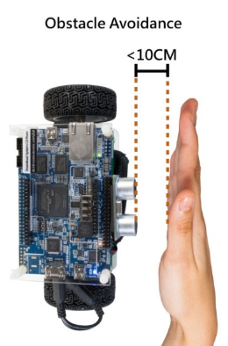
Figure 36: Sonar Object Avoidance
And the sonar can easily follow the objects as well, and it defines in the sonar capability that if the distance is specific between the object and the sonar then it can follow that object as shown below in the figure
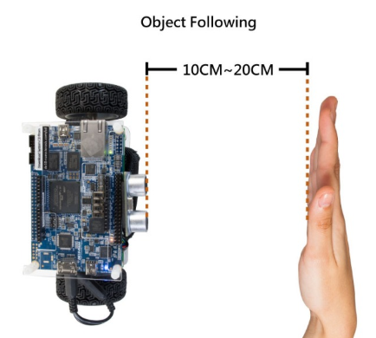
Figure 37: Object following by Sonar
In this way the sonar will work for the device.
Gyroscope
It is a device which uses the gravity effect to determine the angle of falling. This component is going to use for balancing the project from both front and back sides, as the object will tilt from one side then the gyroscope will read more gravity effect on that side and it will send the signal to the processor and processor will send the signal to the driver kit and driver kit will push the motors to the other side and device will come back to the straight position and if it will go to the opposite side then same process will happen to stable the device.
Batteries
Batteries pack is going to use for providing the long backup of power so the robot can move autonomously for long time. Batteries will provide the power to the processor kit, motors, driver circuit, sonars, gyroscopes and all other components works on the power.
Power Supply for Charging
The batteries present in the robot need to charge after sometime and therefor a port is present that will allow the charger to connect with the batteries and will charge them and as soon the charging will complete, power supply will disconnect from the charging and robot will again move.
USB Connector
USB connector is present on the processor kit to load the instructions from the computer on the board and these instructions will continually move the robot and make it autonomous. A program will develop in the computer which will have the instructions for the robot, so when the kit connects with the computer using the USB connector, the program will transfer to the board and make it ready.
Motor Driver Circuit
The motors present in the robot can move through the driver circuit because the driver circuit contains the potentiometer and other resistances to provide complete voltage and current to the motors and also provide the control to rotate the motors in both the directions. It provides the option to control the speed of motors so driver circuit provide the speed and the directional control for the robot. Driver circuit connects with the processor kit to get the instructions.
Bluetooth Module
This module is present in case of any connection problem between the processor and the computer then Bluetooth module will use to connect between the processor and computer.

5.2.2Design Analysis
For the Material Analysis two materials have considered
- Aluminum Alloy 6061 Body
- Steel Body
$$Ultimate Strength of Aluminum 6061 = 290 Mpa$$
$$Ultimate Strength of Steel = 400 Mpa$$
$$Strength to Weight Ratio of Aluminum = 42 ksi$$
$$Strength to Weight Ratio of Steel = 126 ksi$$
Strength to Weight Ratio of Aluminum = 1/3 Strength to Weight ratio of Steel$.$Aluminum is preferable to use because of light weight and high strength.
For the shaft analysis two types of shaft have considered
- Hollow shaft
- Solid shaft
For shaft connecting two wheels can be a hollow shaft or solid shaft. And it can determine using the following equation
$$s_{2}=0.5*\frac{T_{mx}r_{o}}{L*ρ*g}$$
Putting the values into the above equation
$$s_{2}=44\%$$
Results have shown that the strength to weight ratio of hollow shaft is higher than the strength to weight ratio. By 44% which means hollow shaft is better to use and it will light in weight which is better for the design and strong enough to cover the whole body weight.

5.2.3 Prototype Building
For building the prototype, the team has worked on it as the CAD model has developed so the team main problem was the use of UNO processor kit, so in the prototype till now the team has worked on the processor kit to connect with the computer and control the LEDS and other items to understand the working of UNO processor. For this purpose, potentiometer and LED’s have used which connected with the processor to control the intensity of light and also control the different LED’s timer. The prototype working has shown below
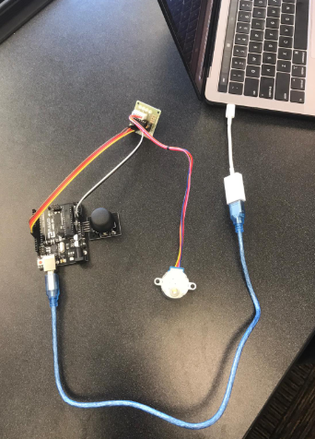
Figure 38: Prototype Building
In the above figure controller board which is UNO R3 has connected with the laptop using the USB connector and the controller has connected with the LED light and potentiometer to test the intensity and timer as shown
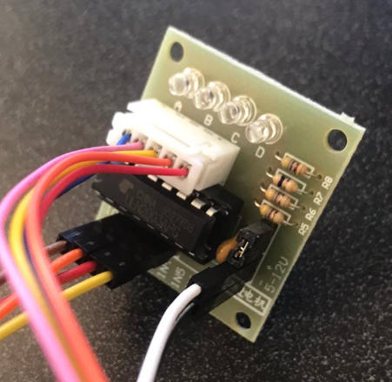
Figure 39: LED’s connection
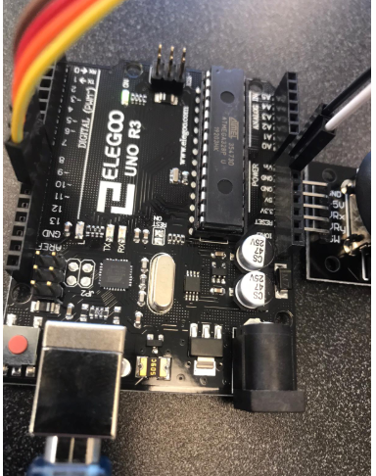
Figure 39: UNO Board
Figure 38 and Figure 39 has shown the closer look of LED’s connection and the UNO board. This prototype is still under process and after the completion of this prototype, the team will move ahead and make the prototype of model and then see how the components will connect and operate. After the completion of prototype, the team will then decide what changes are required in the design and what are working perfect. Then the team will make the correction in the design and the device will implement after that.

6 REFERENCES
[1] R. Games, “RoboGames Challenge for Balancing Robot”, available [online], http://robogames.net/rules/balancer.php
[2] N. Shine, “Design and Control of a two Wheeler Self-Balancing Robot using the Arduino Microcontroller board”, June 2013, published by ICCA in 10th IEEE International Conference
[3] B. Kumar, “Design and Implement of a Self-Balancing Robot”, December 2017, published by International Conference on Mechanical Engineering and Renewable Energy 2017.
[4] C. Gonzalez, “Low Cost Two Wheels Self-Balancing robot for control education”, July 2017, Vol. 50, Issue 1. By IFAC Papers Online.
[5] B. Shanmugavel, “Development of Self-balancing Robot”, July 2018, available [online], https://www.researchgate.net/publication/326294136_Development_of_Self_Balancing_Robot
[6] J. Park, “Development of Self-Balancing Robot with a control moment Gyroscope”, April 2018, by International Journal of Advanced, available [online], https://journals.sagepub.com/doi/pdf/10.1177/1729881418770865
[7] B. Ramadhan, “PENS Wheel One Self-Balancing Mechanical Design and sensor System”, available [online], https://www.researchgate.net/publication/313952986_PENS-wheel_self_balancing_one-wheel_vehicle_mechanical_design_and_sensor_system
[8] J. Choi, “Controller Implementation of a Balancing Robot Through a Dynamic Model with Acceleration Control Input”, June 2017, available [online], https://pdfs.semanticscholar.org/2f85/fe73329428739ee0218eee4f91ffa9cf693c.pdf
[9] J. Han, X. Li, ‘Design of two Wheeled Self-Balancing Robot based on sensor fusion algorithm”, march 2014, by International Journal of Automation Technology available [online], https://www.researchgate.net/publication/289608822_Design_of_two-wheeled_self-balancing_robot_based_on_sensor_fusion_algorithm
[10] F. Kung, “Modelling and Control of Two-Wheeled Self Balancing Robot with Stepper Motor”, April 2019, available [online], https://www.researchgate.net/publication/332572919_Modelling_and_Control_of_Two-Wheeled_Self-Balancing_Robot_with_Stepper_Motor
[11] Amazon, “ELEGOO Tumbller Self-Balancing Robot”, available [online], https://www.amazon.com/ELEGOO-Tumbller-Self-Balancing-Compatible-Arduino/dp/B07QWJH77V
[12] R. Shop, “MakeBlock Project Self-Balancing Robot”, available [online], https://www.robotshop.com/jp/en/makeblock-project-self-balancing-robot.html
[13] A. Express, “Uni-Wheels Balanced Car Single Wheel Robot”, available [online], https://www.aliexpress.com/item/32957299339.html
[14] F. Kart, “Arduino UNO R3 Micro Controller Board”, available [online], https://www.flipkart.com/arduino-uno-r3-micro-controller-board-electronic-hobby-kit/p/itmez4y95sqfqn4t
[15] R. Berry, “Raspbeerry Pi-3 Model B+”, available [online], https://www.raspberrypi.org/products/raspberry-pi-3-model-b-plus/
[16] E. Com, “Beagle Bone Black Development board with 1 Ghz processor”, available [online], https://www.element14.com/community/docs/DOC-84108/l/beaglebone-black-development-board-with-1ghz-am335x-arm-cortex-a8-processor
[17] P. Lou, “Stepper Motor Unipolar and Bipolar”, available [online], https://www.pololu.com/product/1200
[18] Google, “TowerPro Servo Motor 180-degree Rotation”, available [online]. https://www.google.com/imgres?imgurl=https%3A%2F%2Frobu.in%2Fwp-content%2Fuploads%2F2017%2F09%2FIMG
[19] U. Rs, “RS PRO Brushless DC MOTOR”, available [online], https://uk.rs-online.com/web/p/dc-motors/5366046/
[20] Amazon, “Rubber Wheels”, available [online], https://www.amazon.com/slp/rubber-wheels/r5qnf6rmsn8x5j3
[21] J. Sum, “Silicone Wheels”, available [online], https://www.jsumo.com/slt20p-steel-silicone-wheel-set-33mm-x-20mm-pair
[22] M. Chine, ‘Polyurethane Mold Plastic Wheel”, available [online], https://www.made-in-china.com/showroom/mzcaster/product-detailpXhJZoqlEDWI/China-Wholesale-Polyurethane-Mold-on-Plastic-Wheels.html

APPENDICIES

APPENDIX A – Bill of Materials
Table 8: Bill of Materials
Bill of Materials
Team
# | Part Name | Qty | Description | Functions | Material | Dimensions | Cost | Link to Cost estimate
1 | Servo Motor | 6 | To do the movement in each direction | Do the walking, dancing, balancing | Steel | 1.2 x 1 in | $82.74 | Ebay
2 | Steel Sheet | 4 | Cut the sheet to make the robot sides | Form the structure of robot | Steel | 100 x 100 mm | $38.32 | Ebay
3 | Arduino | 1 | Control the Robot motors | Pass the signals to each part | Silicon | 4 in x 4 in | $3.49 | Ebay
4 | Controller | 1 | Control the robot wirelessly | Connect with Arduino to pass signals | Plastic | 6 x 4 in | $27.99 | Ebay
5 | Blue Smurft Bluetooth | 1 | Connect control with Arduino | Make the connection with Controller | Silicon | 4 in x 4 in | $27.99 | Spark Fun
6 | Strap Hinges | 12 | Make conneciton with motor and Plates | Put on the joints | Steel | 2 in x 4 in | $26.28 | Ebay
7 | High gloss Tape | 1 | To hold the items on the board | Grip all the parts over the robot | Vinyl PVC | 4 x 2 in | $139.49 | Ebay
8 | Screws | 50 | Make the connections | Hold the joints with hinges | Steel | 0.5 x 0.1 in | $1.14 | Ebay
9 | Battery | 2 | Provide power to arduino and motors | Generate the electricity from storage | Li-Ion | 4 x 2 in | $97.50 | Ebay
10 | Battery Cells | 4 | Controller power | Provide power to the controller | Li-Ion | 3 x 1 in | $11.96 | Ebay
11 | Jumper Wires | 4 | Connect between the parts | Make all the connection for supply | Copper | 6 x 0.1 in | $4.00 | Ebay
12 | Power Adopter | 1 | To charge the battery | Provide the charging to the robot battery | Plastic | 4 x 2 in | $14.59 | Ebay
Total |  |  |  |  |  |  | $475.49
Total incl. tax |  |  |  |  |  |  | $556.32

APPENDIX B – FMEA
Table 9: FMEA
Product Name |  | Development Team |  |  |  | Page No of
System Name |  |  |  |  |  | FMEA Number
Subsystem Name |  |  |  |  |  | Date
Component Name
Part # and Functions | Potential Failure Mode | Potential Effect(s) of Failure | Severity (S) | Potential Causes and Mechanisms of Failure | Occurrence (O) | Current Design Controls Test | Detection (D) | RPN | Recommended Action
1.1 Aluminum Sheet | steering and net tension | Joint Leakage | 5 | 1. opposite force to the joint | 3 | Putting load on the joint | 2 | 30 | Strong Connect
1.2 Aluminum sheets | Tensions and breakage | cracks on the sheet, destruction of sheet | 6 | Extra load on sheet,  No support for the sheet | 4 | Checking the stress on the sheet | 3 | 72 | None
2.1 screw | Breakage of screw, Destruction of the screw cap | Unable to un screw it, unable to screw properly  Half | 8 | 1. Low quality manufacturing  2. Nonuse of proper tools | 1 | 1. Stress testing for screw  2. Use of various quality tools | 2 | 16 | None
3.1 screw gun | Extra speed of gun, burning of motor | Unable to screw the boards, Extra costs, wastage of time and resources | 3 | 1. Overheating  2. Improper voltage  3. over use | 2 | 1. Testing with various types of screws  2. voltage change test | 3 | 18 | None
3.2 Motor | Burning of motor, dislocation of wings angle | purpose of device failed, extra cost addition | 6 | 1. bad quality of copper  2. poor windings  3. over voltage, over speed | 4 | 1. Speed test  2. Over voltage test | 8 | 192 | Check multiple fans and test them roguishly
4.1 Shaft | Bending of Shaft, Breakage of Shaft | wait for new shaft, cost increased | 7 | 1.Bad quality due to molding,  2. poor quality shaft is used | 4 | 1.Bad seeding, Poor Quality aluminum | 6 | 168 | Test various qualities if pipes available at same cost
3.11 chargeable batteries | Overcharging, no charging, discharge too quick | usefulness will be lost, power will be wasted, less back of power | 4 | 1. No power backup will be available  2. wind energy will be wasted | 6 | 1. Testing with various types charging screws up will be available  2. will change test | 2 | 48 | try to place charging circuit
5.1 rubber Wheels | breaking of rubber start, bending, changing shape due to temperature | start will not work, changing the rubber will be extra costly | 6 | 1. start will not work | 4 | 1. rubber stress test | 7 | 168 | None
5.2 Silicon board | silicon breaking, strand weakness | moisture will increase and short-circuit may occur | 3 | 1. Robot will lose control | 3 | 1. Structure extreme weather conditions tests | 5 | 45 | None
6.1 Wheel Rims | angle changes, breakage, changing load on turbine | Robot will not able to move and cause extra cot | 9 | Wheels will not move in a line | 8 | 1. Efficiency lost | 8 | 576 | Test in extreme conditions and loads

APPENDIX C – Gantt Chart
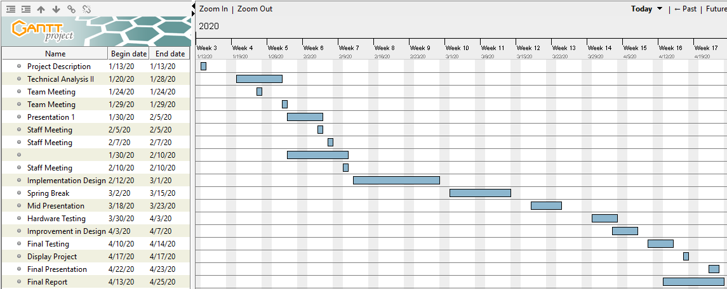
Figure 40: Gantt Chart

