**Honeywell Oil Chip Detector Housing**



**Preliminary Proposal**

**Jered Deal**

**Ilenn Johnson**

**Cullen Matillano**

**John Selee**

**Jacob Vedder**

**2019-2020**

**Project Sponsor: Honeywell**

**Sponsor Mentor: Christopher Temme**

**Instructor: Dr. Sarah Oman**

# DISCLAIMER

This report was prepared by students as part of a university course requirement. While considerable effort has been put into the project, it is not the work of licensed engineers and has not undergone the extensive verification that is common in the profession. The information, data, conclusions, and content of this report should not be relied on or utilized without thorough, independent testing and verification. University faculty members may have been associated with this project as advisors, sponsors, or course instructors, but as such they are not responsible for the accuracy of results or conclusions.

# TABLE OF CONTENTS

DISCLAIMER 1

TABLE OF CONTENTS 2

1 BACKGROUND 1

1.1 Introduction 1

1.2 Project Description 1

2 REQUIREMENTS 2

2.1 Customer Requirements (CRs) 2

2.2 Engineering Requirements (ERs) 3

2.3 House of Quality (HoQ) 3

3 DESIGN SPACE RESEARCH 5

3.1 Literature Review 5

3.1.1 Student 1 (Jered Deal) 5

3.1.2 Student 2 (Ilenn Johnson) 6

3.1.3 Student 3 (Cullen Matillano) 8

3.1.4 Student 4 (John Selee) 8

3.1.5 Student 5 (Jacob Vedder) 9

3.2 Benchmarking 10

3.2.1 System Level Benchmarking 10

3.2.1.1 Existing Design #1: Allen Aircraft Products 11

3.2.1.2 Existing Design #2: Meggitt Sensing Systems 11

3.2.1.3 Existing Design #3: Eaton 12

3.3 Functional Decomposition 13

3.3.1 Black Box Model 13

3.3.2 Functional Model/Work-Process Diagram/Hierarchical Task Analysis 13

4 CONCEPT GENERATION 15

4.1 Full System Concepts 15

4.1.1 Full System Design #1: Square L Bend Design 15

4.1.2 Full System Design #2: Double Cylinder Design 15

4.1.3 Full System Design #3: Single Cylinder Design 16

4.2 Subsystem Concepts 17

4.2.1 Subsystem #1: Material 17

4.2.1.1 Design #1: Stainless Round Bar 416 17

4.2.1.2 Design #2: Stainless Rectangular Bar 303 18

4.2.1.3 Design #3: Titanium Round Bar Grade 2 18

4.2.2 Subsystem #2: Sealant 18

4.2.2.1 Design #1: 3M Scotch-Weld Hi-Temp Sealer EC-1137 Quart 18

4.2.2.2 Design #2: Nitrile Butadiene Rubber (NBR) 18

4.2.3 Subsystem #3: Body 19

4.2.3.1 Design #1: Square Body Designs 19

4.2.3.2 Design #2: Cylindrical Body Designs 19

4.2.3.3 Design #3: U-Bend Designs 19

5 DESIGNS SELECTED 20

5.1 Technical Selection Criteria 20

5.2 Rationale for Design Selection 20

6 References 22

7 APPENDICES 25

7.1 Appendix A.1: Stage I House of Quality 25

7.2 Appendix A.2: Stage II House of Quality 26

7.3 Appendix B: Pugh Chart 27

7.4 Appendix C: Decision Matrix 28

# BACKGROUND

## Introduction

The oil chip detector housing project came about as Honeywell began building a new, small size turboprop engine and elected to allow students from Northern Arizona University design the housing to suit rigorous engine requirements. Honeywell has produced many engines in the past but has normally subcontracted small-scale engines to other suppliers. Many parts of this new, smaller engine are scaled parts from other engines, and some are lifted directly from other designs, including the oil chip detector and oil pump. In order to accommodate these same parts from the bigger engine with smaller oil lines and a smaller capacity, the housing for the detector would have to be redesigned to decrease the flow velocity and pressures across the detector to acceptable nominal values. Other requirements include fire, rot, and weather resistance. This report is intended to update the progress being completed on the oil chip detector housing for the eventual goal of production.

## Project Description

The following excerpt is Honeywell’s project description, verbatim.

Design, analyze, and prototype an oil chip detector housing. The team will need to come up with a design based on the requirements given, and use FEA, CFD, Thermodynamics and Material Science to verify the design meets requirements by analysis. After the analysis and design have been approved a prototype/research component will be manufactured for testing.

An oil chip detector is a sensor we use on engines, which detects the amount of metal chips/debris in the oil. That way an operator can detect if bearings are wearing out or any other issue arise before it becomes a failure. Unlike a car it’s a little bit more difficult and dangerous to pull over in a helicopter or plane when engine failure occurs.

That’s where the oil chip detector housing comes in, because we need to development a unit to mount the oil chip detector sensor and have an in and out port for the oil. It might seem like a simple box, but there will be weight, design, vibration, temperature, fluid flow, flammability/fire and shock (structural) requirements among other potential situations.

# REQUIREMENTS

This section of the report summarizes the customer requirements and how those customer requirements lead the engineering requirements used within the house of quality. Using these requirements design variations were created to best meet these requirements.

## Customer Requirements (CRs)

The customer requirements and weights provided by Honeywell for the project are as follows:

Table . Customer Requirements

|  |  |
| --- | --- |
| Customer Requirements | Relative Weights (%) |
| Weight |  |
| Leak Free |  |
| Fuel and Oil Resistant |  |
| Temperature Resistant |  |
| Vibration Resistant |  |
| Size |  |
| Fitting Quality |  |
| Nonreactive/nontoxic material |  |

Staying within budget is important for any project and coming in under budget for the entire project. Durability is the second highest customer requirement based off the QFD results. The target for this design is that the housing will last the lifetime of the engine it is mounted on. Reliability is similar in that the housing must not fail in any way while in operation. Having a safe to operate housing is necessary if the housing is going to be utilized regularly on many different engines in the future. Weight is tied for the lowest weight relatively but is still important to the overall project. The weight of the housing must be one pound or less. Temperature resistance is weighted at a five and will incorporate a fire test, making sure the housing can remain functional when exposed to 2000-degree Fahrenheit temperatures for five minutes. Temperature resistance falls into the category as well as operating temperature. The envelope size is a 3x3x2 inch area; this is subject to change if Honeywell deems it necessary. The oil chip detector interface is where the detector will be mounted to the housing, at this time the manner of the mounting is still unknown. The burst pressure for the housing is expected to be below 16 PSI. Force loads and vibration resistance analysis are planned to be completed as the team gets closer to finalizing the requirements from Honeywell. Quality assurance will assure the teams design is functional and completes the necessary performance required by Honeywell.

## Engineering Requirements (ERs)

The engineering requirements developed from the customer requirements and customer weights for the housing can be found in the following table:

Table . Engineering Requirements

|  |  |
| --- | --- |
| Engineering Requirement | Target |
| Within Budget | <$1000 |
| Durability | Engine Lifetime |
| Reliability | 1 |
| Weight | <1 lb |
| Safe in Operation | Yes |
| Envelope Size | 3x3x2 in |
| Operation Altitude | -2,000 to 55,000 ft |
| Operating Pressure | 5 – 15 psig |
| Burst Pressure | TBD psig |
| Force Loads | 2 g |
| Shock Resistance | 20 g |
| Tolerancing | TBD in |
| Internal Interface | 0.75 in |
| Temperature Resistance | -65 to 2000°F for 5min dynamic, 310°F for 2min static |

These engineering requirements were developed from the customer requirements as well as provided by Honeywell directly to Team Honeywell. From the table all the requirements are important in order to have a successful housing developed. Many of these requirements are directly related to reliability and durability of the housing. At this point in time there is a rough idea of most of these parameters for the housing, though some like shock resistance and loads are still TBD from Honeywell.

## House of Quality (HoQ)

The full house of quality can be found in the Appendix A. The customer requirements and engineering requirements to construct the house of quality. Using this tool, the most important aspects of the design of the housing, that being quality assurance durability followed by reliability. These aspects are necessary in order to have a successful and function housing to test on and engine this upcoming spring. The temperature resistance must be able to withstand five minutes at 2000 degrees Fahrenheit and two minutes at 310 degrees Fahrenheit, this lower temperature is to simulate a engine cooling down while the higher temperature is to simulate a fire around the housing. For fluid flow a range of 1-4 ft/s currently but is subject to change if Honeywell changes the inlet and outlet fittings. Capture frequency must be >90%. The housing must fit within a 3x3x2 inch envelope size, this is subject to change by Honeywell. The housing must operate at altitudes from -2000 to 55000 feet. Force loads that the housing must endure are outlined in figure 1 below.

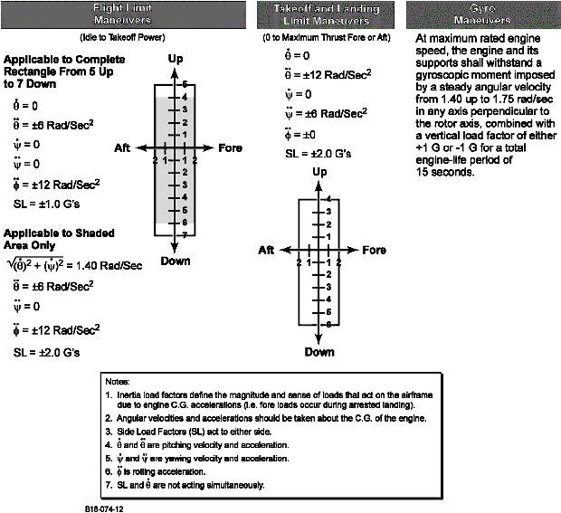

Figure . Altitude and Attitude Requirements [1]

At the present time the operating pressure is known to be < 20 PSI. The housing must also be leak free through all tests, this will be a pass-fail type of test. The housing must also be resistant to certain fuel and oil that will run through the housing. These are found in the table below:

Table . Approved oils and fuels [1]

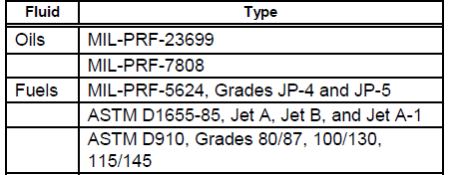

# DESIGN SPACE RESEARCH

Finite Element Analysis (FEA), Computational Fluid Dynamics (CFD), and ANSYS analyses were included in the many journal articles that were reviewed relating to the wearing of on-line systems, appropriate sealants, and oil chip detector designs specific to the aerospace industry. In the beginning of the Capstone class and leading up to the introduction of Honeywell’s procurement specification document, the following research articles were the primary source for information as well as the inspiration behind early concepts and ideas.

## Literature Review

Each member of the group did a preliminary literature review in which different aspects of the project compared to existing works. The individual members each chose an individual set of analysis and found articles that relate to each individual topic.

### Student 1 (Jered Deal)

Jered investigated methods in which the team could design the part to meet any corrosion resistance customer needs that Honeywell required, along with methods of sealing in the oil flow as to mitigate any leaks, another customer requirement given to the team by Honeywell. The following journal articles are sources used to succeed in those customer needs.

Study of glasses/glass-ceramics in the SrO–ZnO–SiO2 system as high temperature sealant for SOFC applications

In this 2009 study, researchers search for a high-temperature resistance sealant to be used in a solid oxide fuel cell which has operating temperatures of 800-850C [2]. Many of the materials that were tested included strontium oxide, zinc oxide, and silica oxide, along with another additive that changed between the test [2].Most of the materials used ended up with having working conditions of 1500-1600C.

None of the materials used in this test were heavily restricted by Honeywell for use, although materials with higher concentrations of silicon would have been a problem. Their operating temperatures were within the max temperature requirement of the project. It is impossible to find a retail sight to purchase any of these specific sealants, but when looking for sealants that can be purchased, the team now has information on some chemical compositions that can be searched for.

Impact of engine oil degradation on wear and corrosion caused by acetic acid evaluated by chassis dynamometer bench tests

This journal describes that acetic acids in used fuels are one of the leading causes of engine wear. Acetic acids are created during engine combustion with fuels containing specifically ethanol-based fuels [3]. These ascetic acids were analyzed in the engine and it was found that they do increase engine wear.

While the design situation Honeywell has provided does not include many ethanol-based fuels, the data that can be still be used since it is about engine corrosion. Corrosion is something that leads to failure and leakage, which is one of the largest customer requirements from Honeywell.

A new formulation of barium–strontium silicate glasses and glass-ceramics for high-temperature sealant

Another study on sealant variant additives, this one looking into the effect of adding barium-strontium silicates. This article also studied the effects of additives to the temperature resistance of sealants but went into more detail on how they were made. These sealants were also being made for solid oxide fuel cells and were expected to last in temperatures of 600C or greater [4].

The utility of having literature reviews like these is to know what to look for in sealants and what to look up when looking for sealant choices. High temperature sealants are difficult to find for the exact situation that they are needed for the Honeywell design.

Corrosion sensors for engine oils—laboratory evaluation and field tests

This article researches methods of measuring engine degradation through methods other than the oil chip detector. The articles goal was to find a way to measure where all the degradation was occurring in the engine while it was happening. The final design idea was to measure the resistance of copper plates in the fluid flow to see how many layers of copper had been worn off [5].

Leak free is one of the largest concerns for the Honeywell design, as leaks could lead to catastrophic engine failure. Researching a method in which to test where a design may be failing or introducing the method to Honeywell as a possible way to increase safety are both reasons this journal article is relevant to the Honeywell design.

Corrosion Resistant Structural Materials for Modernization and Development of New Equipment in the Petrochemicals Industry. Part 5. Corrosion–Electrochemical Studies of Structural Materials in Contact with Graphite Sealant Materials

This journal article was about another different type of sealants that could be considered. This article shows that graphite-based sealants are more resistant to corrosion that most other variants, and that some additives such as nickel may improve the quality of these seals [6].

A type of sealant that did not incorporate silicon was something that deserved to be researched, as minimizing the use of it would appease the client that is Honeywell. These graphite sealants may prove to be a good material to use, although the article did not include information on temperature limits.

### Student 2 (Ilenn Johnson)

Ilenn took a focus on researching the abrasive wearing and life expectancies of oil chip detecting systems as well as the effects of metal chips on all components wetted by oil. The following are conference and journal articles sourced through the IEEE explore library and Compendex databases relating to said topics.

Research of the on-line system for detecting metal particles in oil

From the 2017 IEEE 13th International Conference on Electronic Measurement & Instruments, this article goes into some depth of the effects of mechanical wear on on-line and off-line systems. Authors Yunbo and Yuhai raise extremely valid points on how age and wear eventually begin to affect every aspect of the detecting system including electrical signals, optics, ultrasonic interferences and so on [7].

For the purposes of this team’s design project, this article by itself provides more information on the wear, design of hardware and software, and testing procedures than is likely needed. More than that, basic information on the housing design, sensor electronics, and several potentially relevant formulae related to idealizing signal capture are included in the report.

Oil Debris Monitoring in Aerospace Engines and Helicopter Transmissions

This research article done by engineers at Eaton touches on the abrasive wearing effect of oil chips in aerospace drivetrains. It then goes into detail about three different detection methods used by Eaton to track the wear of the systems in aircraft [8]. The most relevant to Honeywell’s jet engine is the included commentary on magnetic and electric chip detectors.

Despite being a professional advertisement for Eaton, this article can provide a lot of insight to the location and systems that a sensor might to plugged in to. Other relevant inclusions are the oil flow requirements for each form of sensor which can be applied towards the design of a sensor housing.

Real-Time Monitoring of Bearing Condition [9]

This article delves into some more detail on the function and layout of oil chip detector systems as it pertains to bearing conditions. It includes several helpful diagrams for each sort of oil monitoring system and explains how the sump systems works with contaminated oil. Also, parts of the report discuss the effect of abrasive wear on parts, both static and moving.

Although this article mostly focuses on the systems of chip detectors that are established in the industry, it contains plenty of supplemental information on abrasive wear and pitting which can hopefully be used in life cycle calculations for Honeywell’s housing.

Full-Flow Debris Monitoring in Gas Turbine Engines [10]

Another article generalizing the wear of oil chips on parts and the prevention of those issues, this ASME article contains many figures depicting the layout of such systems. Critically, it includes several figures that explain the performance of the detectors as affected by turbulence, location, and flow velocity. Due to the figures and commentary on turbulence and other factors that affect the performance of the detector, this source may just be the most important of all. It is the perfect place to start when the team gets to the actual design of the housing as it relates to detector positioning and flow characteristics.

A Review of the Abrasive Wear of Metals [11]

This article neatly summarizes the effect of metal on metal wear in various situations. It contains plenty of additional data in the form of graphs that may be used in specific situations. Without any moving parts, the only application of such data and formulae would be adaptations for viscous wear. It would be possible to form models or a formula that would determine the wear on the housing and detector purely from oil with metal chips if needed.

### Student 3 (Cullen Matillano)

Cullen focused his research efforts on the effects of vibrations on sensors and the damage that vibration causes. Additional research was focused on vibrations within engines and proper housing of sensors. The following sources discuss the effects of vibrations on sensors and engines.

Signal Processing to Overcome Random Vibration Interference in an Oil Debris Monitor (ODM) Sensor [12]

This thesis discusses the conditions in which oil monitoring has historically taken place. The thesis discusses the locations in which the damage takes place and how the damage is created from varying vibration locations and damaged sensor housings. It further discusses ways of eliminating vibration damage to sensor readings.

Sensing of Diesel Vehicle Exhaust Gases under Vibration Condition [13]

This article discusses the effects that diesel engine vibrations cause on sensor analysis. The article discusses how in this diesel engine when monitoring exhaust fumes the vibrations from the engine do not affect the results. However, the article acknowledges the damage that vibrations on the engine can cause to engine readings.

Vibrations of two circular cylinders due to wind-excited interference effects [14]

This article analyzed the flow patterns of wind behind two cylinders that were under constant vibration. The cylinders were put at different locations and vibrated to see the effects of the vibrations on the flow pattern. The readings were limited to laminar flow but variable vibrations.

Engineering Research of Vehicles; Chapter 3: Diagnostic of Equipment [15]

This chapter talks about the special types of sensors that are required to do research on engines under vibrations due to the changing vibration conditions on the engine and the housing around it. The chapter details how the working parameters and defects within the engine all contribute to engine vibration monitoring systems.

Diesel engine vibration monitoring based on a statistical model [16]

This article analyzes the effects of different engine states on how the fuel quality and oil quality is measured. The authors eventually were able to map engine vibration using statistical models and control charts to understand how vibrations were directly affecting readings given off by the engines.

### Student 4 (John Selee)

As the team’s test engineer, John’s research captured a general overview of oil chip detector design and application, Additional research was focused on development of simulated use models and test method development. Future research will focus on test methods for vibration analysis,

In-line Oil Debris Monitor for Aircraft Engine Condition Assessment [17]

This article was initially presented at an IEEE conference. The article has several qualities that are valuable to the team’s understanding of oil debris monitoring. The article provides a general overview of oil debris monitoring and the presentation of common failure modes in engine and sensor components. Additionally, the article provides a cartoon of an experimental apparatus to test detection of oil debris resulting from small bearing wear.

Anti-clog and non-metallic debris detector for lubrication system inlet[18]

This patent was published by the Sikorsky Aircraft Corporation. The patent describes an oil debris detector for rotary wing aircraft. Although the product is installed on a different platform than intended for the team, the patent provides valuable information. With abstract, and oftentimes vague, language the patent highlights critical design concepts for an oil debris monitoring system. The patent also provides sketches of the detector housing which the team may find useful for benchmarking. Cited patents may prove useful in the research of benchmarked designs.

Fracture analysis of the tearing NBR aged at different temperature [19]

Nitrile Butadiene Rubber (NBR) is a commonly used polymer in automotive and aerospace applications. NBR is valued for its low cost, oil and solvent resistance, and high temperature capabilities. This publication details experimentation with NBR’s facture resistance at varying temperature. The article grants the team insight about material behavior. The research will help the team define ductile to brittle transition behavior of the material. This research is valuable to the team and presents fracture data for a material of interest at a temperature range that nearly matches the team’s design constraints.

Standard Test Method for Durability of Sealants Exposed to Continuous Immersion in Liquids [20]

This ASTM standard presents test methods for sealants exposed to immersion in liquids. This test method is relevant to the team’s research and design work. Presently, the team is narrowing down sealant material selection. This test method is relevant to some of the sealant materials of interest. Use of the ASTM standard presents a test method that the team may use for design feasibility. Testing to an accepted standard is important for documentation and design validation.

Standard Test Methods for Rubber O-Rings [21]

This ASTM standard presents test methods for rubber O-rings in a variety of application environments. This test method is relevant to the team’s research and design work. Presently, the team is narrowing down sealant material selection. This test method is relevant to some of the sealant materials of interest. Use of the ASTM standard presents a test method that the team may use for design feasibility. Testing to an accepted standard is important for documentation and design validation. Test results will provide useful information when conducting failure modes and effects analysis (FMEA).

### Student 5 (Jacob Vedder)

Jacob focused his research efforts on the construction of the oil chip detector housing itself. This includes research into material properties and machining the housing itself. The following are a list of sources used for researching these topics.

Optimization of Dynamic Surface Plastic Deformation in Machining [22]

This article investigates the plastic deformation on the surface of a machined part. This correlates to the project as the team will be machining the housing out of stainless steel most likely. Having a smoother machined surface will help the stresses in the housing. The finish of the part can also have an impact on the fatigue life, which is important for the project as the housing must last the lifetime of the engine.

Title: Advances in Machining and Manufacturing Technology XII [23]

This is a book on the advances of machining and manufacturing. While the project only has a scope of creating a prototype for testing, if this was a project looking to create a housing that could be mass produced this book would prove helpful in learning about the processes used in mass production. This book also has many sections on wear over time, which would also help with a housing that needs to last for the lifetime of the engine it is installed on.

Plating Chromium on Stainless Steel [24]

This is a short article on plating stainless steel and how it is done. Unfortunately for the team we cannot chrome plate this housing, but in other applications this technique would be quite useful for changing the properties of our stainless steel for the better in cases of wear and fatigue life.

Stainless Steel: Microstructure, Mechanical Properties and Methods of Application [25]

This is a book all about stainless steel. As I believe for the team the most likely metal, we will use for the housing will be stainless steel. This metal is resistant to many forms of corrosion and will pass the fire test. This book delves into the properties of stainless steel and has a wealth of information about how stainless steel can be used.

Deformation behavior of additively manufactured GP1 stainless steel [26]

This journal entry is about additively manufactured stainless steel and its deformation behavior. This is a new technique that is being used to create parts rather than the normal subtractive form of machining that has been used for a very long time. While Team Honeywell would likely not be able to use this form of manufacturing due to the higher price, it is a trending form of manufacturing as the material waste is much lower than traditional machining.

## Benchmarking

The benchmarking for this project consists of researching and reviewing several competitor’s oil chip detector designs. Application specific housings aren’t commercially available, but the design of the detector itself drives the design of the housing. The two main classifications of sensors on the market are on-line and in-line. In-line sensors are mounted such that the oil flows through the sensor. Thus, an in-line sensor could double as a housing if it had pipe fitting on either end. The on-line sensor uses a probe that is exposed to the flow, so the sensor is mounted off a side of the housing, usually perpendicular to the flow. For the proprietary design used on this project, the housing is built around an on-line sensor. Information sourced from company websites for the following detector models will be analyzed, and a summary of benefits/drawbacks will be presented for each.

### System Level Benchmarking

The benchmarking at the system level for the housing will review several detector designs commercially available from other companies. Sub-System level benchmarking will be omitted since possible subsystems are limited to material and sealant selection, each with empirical properties. The subsystems are discussed in the concept selection portion.

#### Existing Design #1: Allen Aircraft Products

One example of the in-line style sensors is the sensor by Allen Aircraft Products, figure 2. The team learned early on that chip detectors are used nearly exclusively in the aircraft industry and seldom elsewhere. As such, many aircraft parts suppliers manufacture and carry several versions of an oil chip detector. This example was selected early in the project timeline, even before the introduction of the procurement specifications which is why it is not entirely comparable to Honeywell’s sensor. However, the overall form is strikingly similar as the inlet is a straight shank sealed by an O-ring and it is secured by a single bolt flanged to one side. Before learning of the sensor's range of orientations and oil flow directions, this sensor would have made a reasonable choice to design a housing around. Likely for property trademarks purposes, exact dimensions and other specifications aren’t given and the pictures on AAP’s website are of a lower resolution.

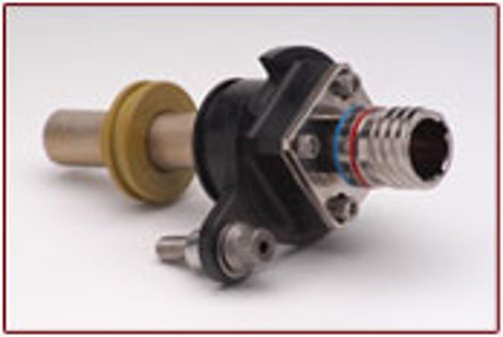

Figure . Complete in-line design by AAP with strainer attached [27]

#### Existing Design #2: Meggitt Sensing Systems

Meggitt Sensing Systems of Switzerland designs both probe sensors and in-line flow sensors. Figure 3 depicts the basic form of another in-line sensor. Figure 3 has a screen and a valve mounted upstream of the sensor. In many ways, this all-inclusive unit is laterally comparable to this project’s probe sensor and dedicated housing. Many of the concepts generated by the team and recorded in this report are designed around a cylindrical form as inspired by this design. Of course, in this design by Meggitt, the oil flows linearly through the sensor instead of across it and it uses a screen whereas Honeywell’s sensor is purely magnetic. However, the form could just as easily allow for the fitment of an on-line sensor and then the oil would flow past the probe in the cylindrical housing instead of through it. The said design could then be altered dimensionally to reduce the flow velocity and still be mounted within the provided envelope on the engine.

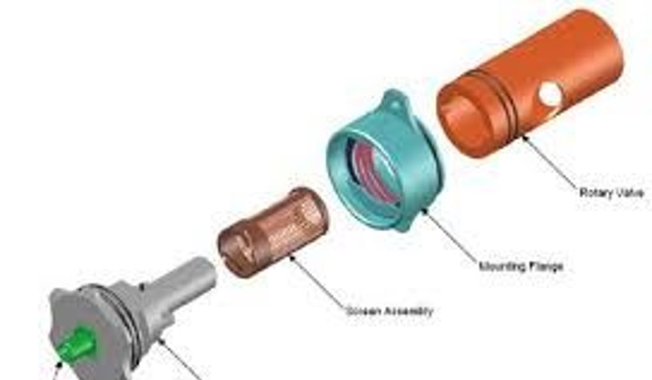

Figure . A self-contained Swiss built Meggitt sensor [28]

#### Existing Design #3: Eaton

As it turned out given more recent information, Eaton’s Zapper system is the most comparable to the detector supplied by Honeywell. It’s an on-line system that could be tapped into any part of an oil sump or splash system. Figure 4 below, each individual sensor is small, cylindrical in form, and secured with a threaded shank. Figure 4 is a sensor installed on Honeywell’s engines with said specifications would require the machining of a housing to hold the sensor in place relative to the flow of oil and the engine itself. The design of such a housing would be open-ended, although the team noted at the time that a box- style housing would be easiest to machine and configure for mounting. This system was chosen for benchmarking before Honeywell’s specifications for released so the form of the sensor was useful for generating rough concepts.

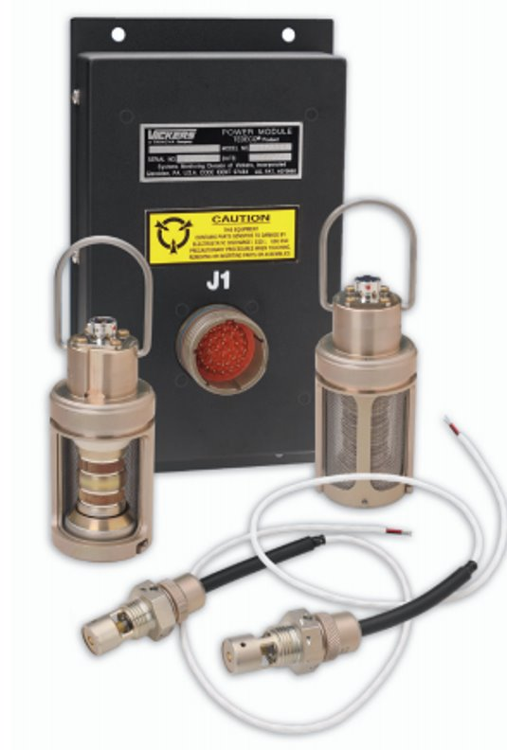

Figure . The Eaton Zapper system [29]

## Functional Decomposition

The functional decomposition includes a black box model, and a hypothesized functional model. The black box model and the hypothesized functional model allow for the most important aspects of the oil chip detector housing to be easily accessible for further concept generation and concept development.

### Black Box Model

The simplest form of modeling related to the function of the housing, the team started the modeling process with a Black Box Model. The model below states the overall objective provided by Honeywell for the housing along with several material, energy and signal flows necessary to achieve the objective.

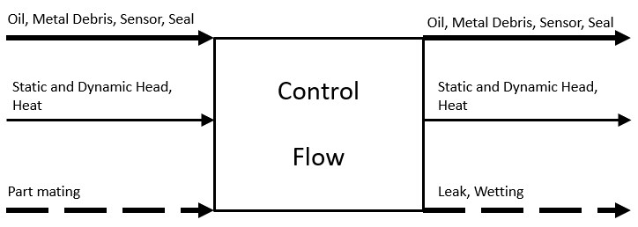

Figure . Black Box Model for Honeywell's oil chip detector housing

The black box model provided an opportunity for the team to thoroughly discuss all essential aspects of the housing in order to satisfy the procurement specifications. Simply put, the above model defines the top three analyses for the design: positioning the detector to effectively capture oil chips; slowing down the flow across the detector; and transferring all energies in line with the detector for a leak-free and pressure-tight design.

### Functional Model/Work-Process Diagram/Hierarchical Task Analysis

An important exercise in the design of the housing is to create a functional model. The functional model expands on the Black Box by focusing on necessary processes and functions that the design needs to fulfill. The functional model uses the same format as the Black Box with a verb object form along with material, energy, and signal flows.

Earlier design tasks such as defining customer needs and engineering requirements helped to shape the functional model. Creation of the functional model assisted the team in defining each function that the housing must perform. Processes in the model answer what functions need to happen rather how those actions occur. That level of ambiguity allows the team to create a diverse array of designs with minimal bias toward a common form.

The functional model of the detector housing accounts for the input materials: the oil, debris, and sensor. The model also shows the energy inputs of head and heat that are associated with the fluid flow. Next the housing conditions the fluid flow for interaction with the sensor. The housing provides a means of coupling the sensor and placing both the debris field and sensor into interaction. Finally, the sensor housing exports the material and energy associated with the fluid flow and allows for decoupling of the sensor.

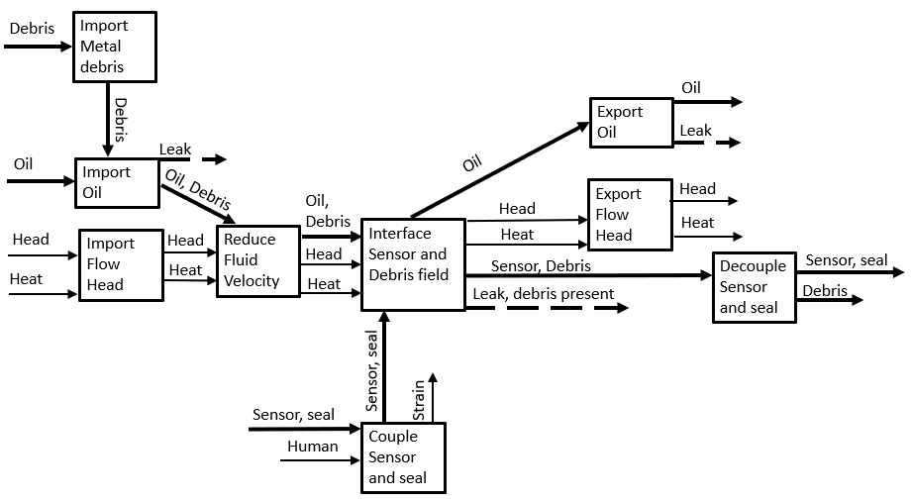

Figure . Oil Chip Detector Housing functional model

# CONCEPT GENERATION

The data gathered from benchmarking provided a basic idea on what the oil chip sensor housing needs to look like. Full designs are provided that meet as many technical requirements as possible. Each full system can be paired with any of the following subsystems to create a full design iteration.

## Full System Concepts

The full systems concepts contain 3-D sketches of three of the main design selections. Each full system concept is designed to be fit with a material selection from section 4.2.1 and sealant section from section 4.2.3. The full concept generations are designed to fulfill as many customer and engineering requirements as possible.

### Full System Design #1: Square L Bend Design

This design is of a square cross-sectional area device that has two simple ports for flow inlet and outlet and hole in the outside of the bend for the oil chip detector to be attached. This design proposed using a rectangular bar of stainless 303 and sealant 2 for manufacturing this design. The pros of this design are that the it accomplishes the flow slowdown that is required, and that the square design would make it easier to mount to the engine. The cons of this design are that it is very difficult to machine, and that the device would be very weak in vibration resistance with all the harder edges.

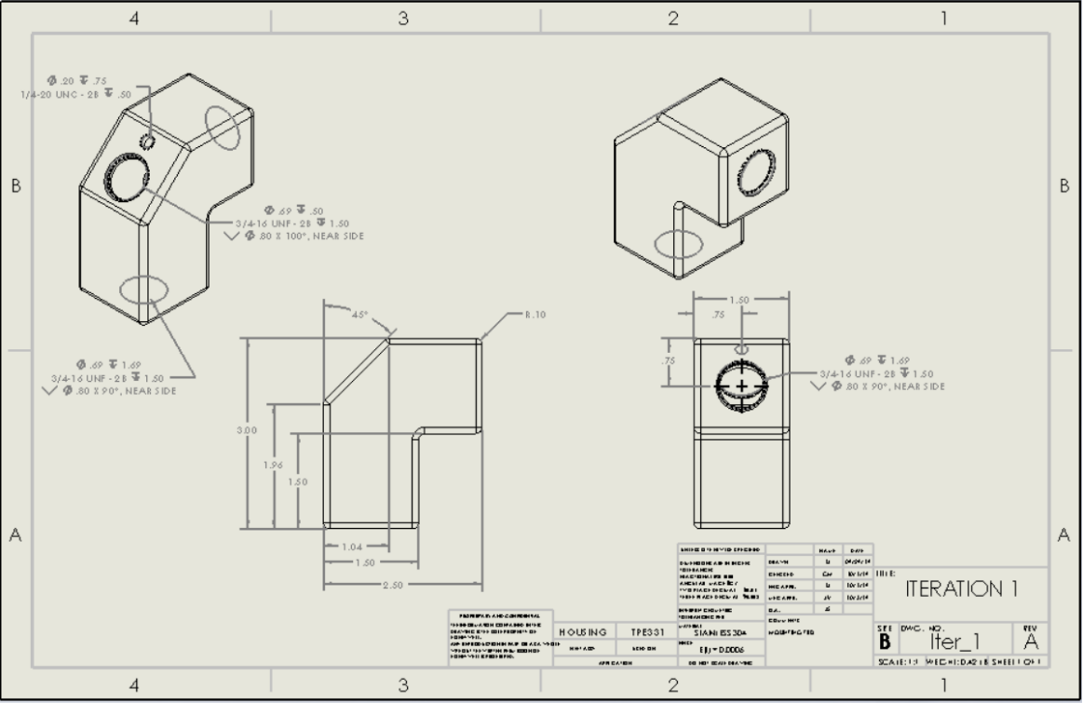

Figure . Square L Bend concept variation

### Full System Design #2: Double Cylinder Design

This design is comprised of two cylinders of different cross-sectional areas that are connected, where the expansion would slow down the flow, with both inflow and outflow ports parallel to each other. The port for the oil chip detector is perpendicular to the direction of the flow. This design defines that the body would be made of stainless round bar 416 and use sealant 1. The pros of this design are that it can be manufactured, although not the easiest, and is one of the cheaper designs. The cons of this design are that it would be difficult to change the inflow and outflow ports as there is not a lot of space on the design, and that it would be difficult to mount to the engine because the sides are cylindrical.

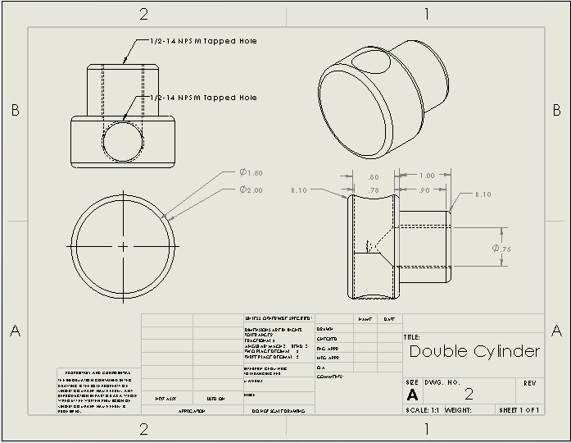

Figure . Double Cylinder concept variation

### Full System Design #3: Single Cylinder Design

The simple cylindrical design is a simplified version of the double cylinder design. There is only a single main hollow tube which has inflow and outflow ports parallel to each other at the ends of the tube with the large expansion for fluid flow slowdown. The oil chip detector is again installed perpendicular to the flow. This design could be made of titanium round bar grade 2 since material and machining costs would be low and should use sealant 2. The pros of this design are that it is both extremely easy to manufacture and easy to change in case more vibration resistance or an easier way of installing the device needs to be added. The cons of the design are that as is, the cylindrical design is difficult to install.

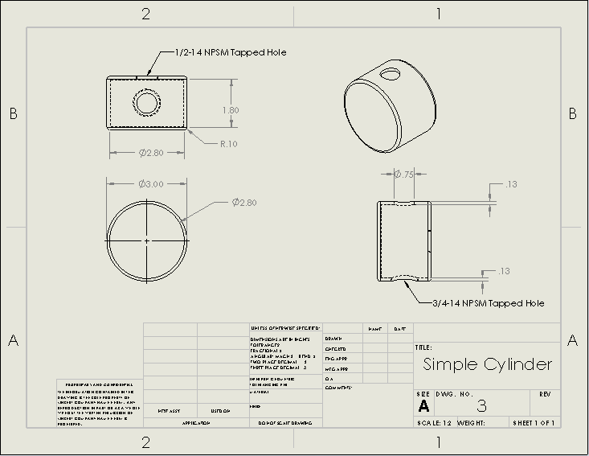

Figure . Single Cylinder concept variation

## Subsystem Concepts

Subsystem concepts together form a full design iteration. Each individual subsystem can stand on its own and comes together to help make the above full design sets. Material selection, Sealant selection and body type are all important subsystems that contribute to the full design iteration.

### Subsystem #1: Material

The material subsystem includes all the material selection criteria for the oil chip sensor housing. Burst protection, temperature resistance, and strength of the material were taken into consideration when comparing materials. Furthermore, only approved materials may be chosen for the final design selection. Table 4 provides a preliminary material analysis for the following design subsystems.

Table . Material Properties



#### Design #1: Stainless Round Bar 416

Most of the design concepts generated would be created using a cylinder, and so finding a material that could be purchased and machined easily and at a reasonable price point is necessary. A retail source could provide this type of stainless-steel which has an acceptable size including tolerances. The pros of this material choice are that it is our cheapest choice, the material has the right shape and size for the application that is needed, and it can be machined with relative ease by the team. The cons are that the material, like most stainless-steel variants, contains chromium, an element that Honeywell would prefer to be kept to a minimum.

#### Design #2: Stainless Rectangular Bar 303

Stainless-steel 316 is another option for the design, as it also has the acceptable heat tolerance and can still be machined internally. The rectangular bar stock would be purchased if the final design was one of rectangular or square shape, like that of Square L Bend design seen above. The pros of this material are that the material is easy to manufacture and has a good size, so plenty of extra material would be available. The cons of this material are that the rectangular bar is the most expensive of our choices, that the size of this bar is at the limits of the design space, and it would be harder to manufacture a square material than it would be to manufacture a cylindrical design.

#### Design #3: Titanium Round Bar Grade 2

A titanium bar was considered as it was stronger than stainless-steel variants. Material quality is an important customer need for the design. Titanium has a better temperature resistance while still being strong enough to be used in the application. The pros of using titanium as the material is that titanium is stronger and therefore higher quality than steel and can be purchased in budget easily. The cons of titanium are that it is very difficult for the team to machine, as the team would need to purchase their own devices to machine titanium.

### Subsystem #2: Sealant

Sealants are combined with the sensor housing and the inlet and outlet couples to create a closed final loop in which oil can flow clearly from one end of the sensor to the other end of the sensor. Sealant selection requires a high temperature sealant that can withstand up to 2000oF for up to 5 minutes.

#### Design #1: 3M Scotch-Weld Hi-Temp Sealer EC-1137 Quart

This sealant is rated to work in systems well above the temperature that is expected in the system that is being designed. The sealer will adhere well to any steel that would be used. The pros of this material are that it is rated to withstand temperatures up to 2000oF, which is double the required temperature. There are many cons with this sealant. Those cons include if the team is unable to acquire a sample, the product can only be purchased for a price point that is too large and only comes in sizes too large. Another con is that the material is a silicate, a material that Honeywell would like to avoid in the sealant choice. This material could be difficult to apply and may not work with a titanium design. It is very difficult to find sealants that work for up to 1000oF, as most traditional sealants melt at much lower temperatures.

#### Design #2: Nitrile Butadiene Rubber (NBR)

NBR is a copolymer of acrylonitrile and butadiene. The rubber is a commonly used material for O-rings seals in the automotive and aerospace industry. Nitrile butadiene rubber is commonly used due to its low relative cost, oil and solvent resistance, and elastomeric qualities. NBR is typically used in applications with operating temperatures between -40°F to 210°F (-40°C - 100°C). NBR can be tuned to withstand higher temperatures. Through hydrogenation or by increasing acrylonitrile concentration, NBR rubber can withstand upper temperatures of 330°F (165°C).

### Subsystem #3: Body

The body section includes preliminary body design ideas. The full system concepts were generated from these preliminary design sections. Each design parameter includes specific shapes that the full concept can be made of. The body subsystems were designed with strict adherence to the technical data provided in the customer and engineering requirements.

#### Design #1: Square Body Designs

The square body design concept was to take the intake flow and push it into an into a square or rectangular cross-sectional area to slow down the flow. Square body designs can have the inflow and outflow lines in parallel or perpendicular. The pros of these types of designs as they would be easier to install since flat portions are easier to mount and are more versatile of a design as they can adjust the place at which the outflow line would be placed at. The downsides of square designs are that they are less resistant to vibrations because of their many edges, they are more expensive as the rectangular bars are more expensive than cylindrical bends, and that they are significantly more difficult to manufacture than cylindrical designs.

#### Design #2: Cylindrical Body Designs

Cylindrical body designs were designs of which both the area that the flow would be passing through and the outside shape of the design would be cylindrical. Cylindrical designs could have the inflow and outflow lines either in parallel or in perpendicular, but the cylindrical design could not include a bend. The pros of cylindrical body designs are that they are strong in vibration resistance, the flow across the oil chip detector is a good size for cylindrical designs, and that they are very easy to manufacture, as they can just be created mostly on a lave. The cons of cylindrical body designs are that they are difficult to mount, since they would have to include a piece that could mount them instead of it just being part of the design.

#### Design #3: U-Bend Designs

Getting the flow to cross the oil chip detector optimally was something that all designs considered. While square body and cylindrical body designs did not focus on what the flow would look like across the oil chip detector. A u-bend designs attempt to maximize the amount of oil flow that would cross the oil chip detector to maximize the detectors usefulness. The pros of these design were that the oil flow would flow into the oil chip detector more. The cons are that u-bend designs cannot fit in the available space while still decreasing the flow rate by 90%, they would be the hardest to manufacture, and that the flow that is being used is not fast enough to make the additional flow across the detector relevant.

# DESIGNS SELECTED

The preliminary design selection will be based upon the provided customer and engineering requirements. The customer requirements are placed in a Pugh Chart and compared directly to the different concept variation. The engineering requirements will be compared to the concept variations in the decision matrix to help determine what the final design selection will be. The final design will then be determined based upon the scores that were calculated from the Pugh Chart and the Decision Matrix. The final design is just a preliminary design based upon the provided information. The design is subject to change if the criterion change.

## Technical Selection Criteria

The technical criteria that will be utilized can be found previously stated in section two. All requirements included within customer and engineering requirements will be utilized within the Pugh Chart or the Decision Matrix respectively. The customer and engineering requirements are essential for the Pugh Chart and Decision Matrix because the concept variations can be directly compared to what the client is seeking. Engineering requirements allow for the concept variations to be directly compared to the most important technical and measurable information available. The Pugh Chart qualitatively helps reduces the number of concept variations to the top choices.

The Pugh chart, Appendix B, compares each customer requirement to a Datum and to each individual concept variation. All the customer needs were chosen to be included in the Pugh Chart because of the specificity of the oil sensor housing. The “S” in the chart means the concept variation scored the same as the datum when compared to the customer requirements. A “+” in the Pugh Chart represents that the concept variation was better than the datum. A “- “represents a lower score compared to the datum and the customer requirements. The Pugh Chart compares the customer requirements to the five main concept variations. The Pugh Chart determined that the small cylinder or the double cylinder met the customer requirements the best. The double cylinder concept had seven positive scores and five similar scores. The small cylinder performed second best with five similar scores and five positive scores. However, due to the two minus scores the small cylinder does not perform as well as the double cylinder. Based on the customer requirements it can be determined that the double cylinder is the best design. The technical requirements will help quantitatively determine the top concept variations.

The Decision Matrix, Appendix C, scores concept variations with the engineering requirements. Relative scores were assigned to the engineering requirements and a scale of 1-10 was used to score each concept against the engineering requirements. The total score determines which design variation has the highest technical score based upon the engineering requirements. The Small cylinder performed the best in the Decision Matrix with a relative technical score of 9.23. This score allows

## Rationale for Design Selection

The double cylinder and the single cylinder performed the best in Pugh Chart and the Decision Matrix respectively. The double cylinder and the single cylinder each have positives and negatives to their design concepts. The final product will preliminarily be a mix of both the double and the single cylinder concept variations. Section 5.1 discusses the qualitative strength of the double cylinder based upon the customer requirements that were provided in section 2.1. The single cylinder performed best quantitively based upon the engineering requirements that are provided in section 2.2 The two concept variations meet the largest amount of customer and engineering requirements which make them work well together. The concept variations meet the technical requirements if the correct material is chosen.

Section 4.2.1 includes a material selection breakdown. The three materials that are given all meet the requirements provided by the customer, however, due to cost considerations the best choice will be Stainless Steel 416. Table 5 contains a preliminary cost breakdown for stock material that can be machined down to the proper design requirements.

Table . Preliminary Bill of Materials for stock metal



Table 5 provides an initial cost estimate for stock material that can be for the final design concept. Stainless steel 416 will provide the best coverage for all the technical requirements and due to its lower price point, it is more economical to use this material.

Based upon all the technical data provided the two best options for the final selection are the single cylinder or the double cylinder. These two concept variations scored the best in the Pugh Chart and the Decision Matrix. Due to the analysis of their body type it can be determined that a cylinder design is best for machining purposes as well as design purposes. A sealant will be paired with stainless steel 416 and one of the cylinder designs to help create the final full concept. Any high temperature sealant will fill the requirements of 2,000oF and cost will be the final evaluation when the final design is decided upon. The final design is subject to change with new technical information but a cylindrical body with a high temperature sealant made form stainless steel 416 is the preliminary design of choice.

# References

|  |  |
| --- | --- |
| [1] | Honeywell Aerospace, "Procurement Specifications for the Oil Chip Detector Housing," Honeywell, Phoenix, AZ, 2019. |
| [2] | B. Tiwari, A. Dixit and G. Kothiyal, "Study of glasses/glass-ceramics in the SrO–ZnO–SiO2 system as high temperature sealant for SOFC applications," *International Journal of Hydrogen Energy,* vol. 36, no. 22, pp. 15002-15008, 2011. |
| [3] | C. Besser, K. Steinschütz, N. Dörr, F. Novotny-Farkas and G. Allmaier, "Impact of engine oil degradation on wear and corrosion caused by acetic acid evaluated by chassis dynamometer bench tests," *Wear,* vol. 317, no. 1-2, pp. 64-76, 2014. |
| [4] | K. Sharma, G. Kothiyal, L. Montagne, F. Méar and B. Revel, "A new formulation of barium–strontium silicate glasses and glass-ceramics for high-temperature sealant," *International Journal of Hydrogen Energy,* vol. 37, no. 15, pp. 11360-11369, 2012. |
| [5] | A. Agoston, N. Dörr and B. Jokoby, "Corrosion sensors for engine oils—laboratory evaluation and field tests," *Sensors and Actuators B: Chemical,* vol. 127, no. 1, pp. 15-21, 2007. |
| [6] | V. Kachanov, E. Gvodzdikova, O. V. Panasenko and N. Kondakova, "Corrosion Resistant Structural Materials for Modernization and Development of New Equipment in the Petrochemicals Industry. Part 5. Corrosion–Electrochemical Studies of Structural Materials in Contact with Graphite Sealant Materials," *Protection of Metals and Physical Chemistry of Surfaces,* vol. 49, no. 7, pp. 835-837, 2013. |
| [7] | G. Yuhai and Z. Yunbo, "Research of the on-line system for detecting metal particles in oil,"," *Internation Conference on Electronic Measurement & Instruments,* pp. 98-102, 2017. |
| [8] | S. Showalter, S. Pingalkar and S. Pahsa, "Oil Debris Monitoring in Aerospace Engines and Helicopter Transmissions," in *1st International Symposium on Physics and Technology of Sensors*, Pune, 2012. |
| [9] | B. Taylor, "Real-Time Monitoring of bearing Condition," *The Americal Society of Mechanical Engineers,* Vols. 99-GT-307, pp. 1-5, 1999. |
| [10] | T. Tauber, "Full-Flow Debris Monitoring in fas Turbine Engines"," *The American society of Mechanical Engieneers,* Vols. 81-GT-60, pp. 1-6, 1981. |
| [11] | A. Misra, "A Review of the Abrasive Wear of Metals," *Journal of Engineering Materials and Technology,* vol. 104, pp. 94-101, 1982. |
| [12] | C. Weihing, "Signal Processing to Overcome Random Vibration INterference in an Oil Debris Monitor (ODM) Sensor," University of Ottawa (Canada), Ann Arbor, 2012. |
| [13] | C. Wei, Z. Zhuang, Q. Xin, A. Al-Shamma'a and A. Shaw, "Sensing of Diesel Vehicle Exhaust Gases under Vibration Condition," *Procedia Environmental Sciences,* vol. 11, pp. 1100-1107, 2011. |
| [14] | H. Sockel and J. Watzinger, "Vibrations of two circular cylinders due to wind-excited intereference effects," *Journal of Wiund Engineering adn Industrial Aerodynamics,* Vols. 74-76, pp. 1029-1036, 1998. |
| [15] | Szymak, Piotr, Pojawa, Bogdan, Grzadziela and Andrzej, "Concept of Engine Vibration Monitoring System," in *Engieneering Research of Vehicles*, Zurich, Trans Tech Publications, 2015, pp. 180-186. |
| [16] | S. Lampreia, J. Requeijo and V. Lobo, "Diesel engine vibration monitoring based on a statistical model," *The 14th International Conference of Vibration Engineering and Technology of Machinery (VETOMAX XIV),* vol. 211, 2018. |
| [17] | J. Miller and D. Kitaljevich, "In-line oil debris monitor for aircraft engine condition assessment," in *IEEE Aerospace Conference*, Big Sky, MT, 2000. |
| [18] | S. A. Corporation, "Anti-clog and non-metallic debris detector for lubrication system inlet". United States of America Patent 9316630, 8 November 2013. |
| [19] | L. Zhao, S. Wang, Y. Chen and Z. W. Fang, "Fracture Analysis of the Tearing NBR Aged at Different Temperature," *Advanced Materials Research,* Vols. 418-420, pp. 893-896, 2012. |
| [20] | C. B. S. Sealants, ASTM, 2009. [Online]. Available: https://arizona-nau-primo.hosted.exlibrisgroup.com/primo-explore/fulldisplay?docid=TN_astm_s66707&context=PC&vid=01NAU&lang=en_US&search_scope=Everything&adaptor=primo_central_multiple_fe&tab=default_tab&query=any,contains,Standard%20Test%20Method%20for%2. [Accessed 17 October 2019]. |
| [21] | D. Rubber, "Standard Test Methods for Rubber O-Rings," ASTM, 2008. [Online]. Available: https://www-astm-org.libproxy.nau.edu/Standards/D1414.htm. [Accessed 17 October 2019]. |
| [22] | M. Tamarkin, E. Tishchenko and S. A, "Optimization of Dynamic Surface Plastic Deformation in Machining," *Russian Engineering Reasearch,* vol. 38, no. 9, pp. 726-727, 2018. |
| [23] | C. H. D. S. M. C. Xipeng Xu, Advances in Machining and Manufacturing Technology XII, Durnten-Zurich: Trans Tech Publications, 2014. |
| [24] | M. P., H. J. N., S. D., N. P. and S. K., "Plating Chromium on Stainless Steel," *Products Finishing,* vol. 79, no. 1, p. 56, 2014. |
| [25] | A. K. P. A. Basak, Stainless Steel: Microstructure, Mechanical Properties and Methods of Application, Hauppauge: Nova, 2015. |
| [26] | B. B. D. C. J. C. K. C. A. V. S. .. .. .. T. J. Clausen, "Deformation behavior of additively manufactured GP1 stainless steel," *Materials Science and Engineering: A,* vol. 696, pp. 331-340, 2017. |
| [27] | Allen Aircraft Products, INC., "Engine Products," Allen Aircraft Products, INC., [Online]. Available: http://allenaircraft.com/products/engine-products/#Chipdetectors. [Accessed 19 September 2019]. |
| [28] | Meggitt smart engineering for extremem environments, "oil debris monitoring chip detector electronic," [Online]. Available: https://meggittsensing.com/wp-content/uploads/2017/02/7-Datasheet-oil-debris-monitoring-Detector-...pdf. [Accessed 17 October 2019]. |
| [29] | Eaton, "Pulsed Electric Chip Detectors," October 2013. [Online]. Available: https://www.eaton.com/ecm/groups/public/@pub/@eaton/@aero/documents/content/ct_194538.pdf. [Accessed 19 September 2019]. |

# APPENDICES

## Appendix A.1: Stage I House of Quality



## Appendix A.2: Stage II House of Quality



## Appendix B: Pugh Chart



## Appendix C: Decision Matrix

