**Team Honeywelli**



**Final Proposal**

**Jered Deal**

**Ilenn Johnson**

**Cullen Matillano**

**John Selee**

**Jacob Vedder**

**2019-2020**

**Project Sponsor: Honeywell**

**Faculty Advisor: Sarah Oman**

**Sponsor Mentor: Christopher Temme**

**Instructor: Sarah Oman**

# DISCLAIMER

This report was prepared by students as part of a university course requirement. While considerable effort has been put into the project, it is not the work of licensed engineers and has not undergone the extensive verification that is common in the profession. The information, data, conclusions, and content of this report should not be relied on or utilized without thorough, independent testing and verification. University faculty members may have been associated with this project as advisors, sponsors, or course instructors, but as such they are not responsible for the accuracy of results or conclusions.

# EXECUTIVE SUMMARY

The oil chip detector housing is a Honeywell sponsored NAU capstone project to design, analyze, and test a housing for the oil chip detector on a small turboprop engine. The housing orients the detector’s probe to suit Honeywell’s requirements while forcing a slowdown and turn in the flow. The design of the housing has been constrained by many requirements from a provided procurement specification document (PSC) that includes objectives for size, weight, and various operating conditions.

Team Honeywell began the project by sketching out several initial concepts based around a cylindrical housing so the housing could be machined easily at NAU’s fabrication shop, 98C. These concepts called for an expansion chamber to effectively slow down the flow of oil across the detector. After review, the team found that it would be impossible to machine a single piece housing to suit the requirements. A focus was then given to mill and secure a 2-piece design that would pass testing. Different metals were considered in the evaluation of each design including titanium, stainless 304 and 316. Any of the three material choices would meet the rigorous testing conditions that challenge strength and fatigue up to 2000°F, but stainless 304 has been selected for its machineability and lower cost. After some review and discussion with engineers at Honeywell, a square tube design has been chosen for ease of mounting compared to cylindrical pieces and a similarity to past designs.

Testing has yet to begin on the current design, but individual team members have taken charge of performing analysis on the housing to ensure it will meet the PSC requirements. Analyses to be conducted include Solidworks simulated vibrations, wall stress calculations, thermal induced deformation, and flow rate/form simulations. The current square tube design has been verified to suit the PSC by said analyses with 1 ½" x 0.12 wall tubing, 0.12-inch caps, and ¾-16 nuts for the inlet and outlet. The design will need to be assembled with various weldments to hold the form of the housing and provide mounting tabs.

Going forward, team Honeywell will begin the fabrication of three prototypes that are variants of the current design for further review by Honeywell before the engine test in February. The team will pursue variations and different fabrication processes to limit the use of weldments as much as possible. Responsibility of the different analyses remaining will be divided between the team members and carried out over the winter, before mid-January. At this stage in the design process, team Honeywell will be collaborating more closely with Honeywell to finalize testing procedures and plan trips to Phoenix for testing.

# TABLE OF CONTENTS

Contents

DISCLAIMER i

EXECUTIVE SUMMARY ii

TABLE OF CONTENTS iii

1 BACKGROUND 4

1.1 Introduction 5

1.2 Project Description 5

2 REQUIREMENTS 6

2.1 Customer Requirements (CRs) 6

2.2 Engineering Requirements (ERs) 7

2.3 Functional Decomposition 7

2.3.1 Black Box Model 7

2.3.2 Functional Model/Work-Process Diagram/Hierarchical Task Analysis 8

2.4 House of Quality (HoQ) 9

2.5 Standards, Codes, and Regulations 11

3 Testing Procedures (TPs) 12

3.1 Testing Procedure 1: Load Test 12

3.1.1 Testing Procedure 1: Objective 12

3.1.2 Testing Procedure 1: Resources Required 12

3.1.3 Testing Procedure 1: Schedule 12

3.2 Testing Procedure 2: Thermal Environment 12

3.2.1 Testing Procedure 2: Objective 12

3.2.2 Testing Procedure 2: Resources Required 12

3.2.3 Testing Procedure 2: Schedule 13

3.3 Testing Procedure 3: Stress and Strength Test 13

3.3.1 Testing Procedure 3: Objective 13

3.3.2 Testing Procedure 3: Resources Required 13

3.3.3 Testing Procedure 3: Schedule 13

3.4 Testing Procedure 4: Vibration and Dynamic Test 13

3.4.1 Testing Procedure 4: Objective 13

3.4.2 Testing Procedure 4: Resources Required 13

3.4.3 Testing Procedure 4: Schedule 13

3.5 Testing Procedure 5: Fluid Flow 14

3.5.1 Testing Procedure 5: Objective 14

3.5.2 Testing Procedure 5: Resources Required 14

3.5.3 Testing Procedure 5: Schedule 14

4 Risk Analysis and Mitigation 14

4.1 Critical Failures 14

4.1.1 Potential Critical Failure 1: Body Failing due to Temperature Induced Deformation 14

4.1.2 Potential Critical Failure 2: Body Failing due to Ductile Rupture 14

4.1.3 Potential Critical Failure 3: Body Failing due to Brittle Fracture 15

4.1.4 Potential Critical Failure 4: Body Failing due to Corrosion by Direct Chemical Contact 15

4.1.5 Potential Critical Failure 5: Body Failing due to High-Cycle Fatigue 15

4.1.6 Potential Critical Failure 6: Seal Failing due to Temperature Induced Deformation 15

4.1.7 Potential Critical Failure 7: Seal Failing due to Corrosion by Direct Chemical Contact 15

4.1.8 Potential Critical Failure 8: Seal Failing due to Adhesive Wear 15

4.1.9 Potential Critical Failure 9: Mounting Bolts Failing due to High-Cycle Fatigue 16

4.1.10 Potential Critical Failure 10: Mounting Bolts Failing due to Thermal Fatigue 16

4.2 Risks and Trade-offs Analysis 16

5 DESIGN SELECTED – First Semester 17

5.1 Design Description 17

5.2 Implementation Plan 20

6 Conclusion 22

7 References 23

8 APPENDICES 24

8.1 Appendix A.1: Phase I House of Quality 24

8.2 Appendix A.2: Phase II House of Quality 25

8.3 Appendix B1: FMEA Section 1 26

8.4 Appendix B2: FMEA Section 2 27

8.5 Appendix C: Bill of Materials 28

*9* Appendix D: Calculations 29

# BACKGROUND

Honeywell required a new housing for an oil chip sensor that requires direct mounting to an aerospace engine that is in development. The housing is required to protect the sensor from all possible failure modes and general usage of a turboprop engine. The housing will be designed and manufactured by Team Honeywell for the use on this engine.

## Introduction

The oil chip detector (OCD) housing, hereinafter referred to as housing, project came about as Honeywell began building a new, turboprop engine and elected to allow students from Northern Arizona University to design the housing to suit rigorous engine requirements. Team Honeywell’s direct is Chris Temme, hereinafter referred to as Honeywell, a control system engineer at Honeywell. The OCD sensor is used to protect the OCD sensor from harmful shock and thermal damage, as well as slow the flow of oil within the housing to allow the sensor to pick up any metal chips that are within the oil. The chips within the oil will inform the mechanics when the bearings within the engine need to be replaced. Honeywell has produced many engines in the past but has normally subcontracted engine components to other suppliers. The new engine consists of scaled parts from other engines, and some parts are directly lifted from previous designs, this includes the OCD. In order to accommodate these same parts from the bigger engine with smaller oil lines and a smaller capacity, the housing for the detector would have to be redesigned to decrease the flow velocity and pressures across the detector to acceptable nominal values. Other requirements include fire, structural, and environmental resistance. This report is intended to update the progress being completed on the oil chip detector housing for the eventual goal of production.

## Project Description

Team Honeywell is to design a housing for a sensor that will be mounted on an engine for Honeywell. The oil chip housing will meet temperature, pressure, force, and vibration requirements that will be set forth by Honeywell. The housing is required to slow the flow of oil within the housing such that the magnetic sensor will be able to pick up metal chips that are present within the oil. The housing shall be analyzed using finite elemental analysis (FEA), computational fluid dynamics (CFD), vibrations, thermodynamics, and material sciences. A final prototype will be constructed and tested based off the requirements set by Honeywell.

# REQUIREMENTS

This section of the report summarizes the customer requirements and how those customer requirements lead the engineering requirements used within the house of quality. Using these requirements design variations were created to best meet these requirements.

## Customer Requirements (CRs)

The customer requirements are found in Table [1] below. The customer requirements are directly pulled from Honeywell’s requirements for this project.

Table . Customer Requirements

|  |  |
| --- | --- |
| Customer Requirements | Relative Weights (%) |
| Weight | 10 |
| Leak Free | 10 |
| Fuel and Oil Resistant | 10 |
| Temperature Resistant | 10 |
| Vibration Resistant | 8 |
| Size | 10 |
| Fitting Quality | 8 |
| Nonreactive/nontoxic material | 10 |

The top customer requirements are weight, temperature resistance, and size. The customer requirements have been updated with the feedback that has been provided by Honeywell. The maximum weight for the housing is one pound. The housing must operate at a temperature between -65 oF to 260 oF, and the housing must withstand 2000 oF for 5 minutes. The housing must fit within an envelope size of 3x3x2 inches. The housing must be leak free in the body and at all fitting locations. The fittings require a high temperature sealant that will not wear out or deform with repeated usage. The chosen material for the housing must be a nontoxic or nonreactive metal. This requirement includes large amounts of chromium, nickel, and other highly toxic metals. The housing is required to be fuel and oil resistance on the inside and the outside of the housing. The housing needs to meet a vibration resistance that allows the housing to operate during aeronautical and flight maneuvers.

## Engineering Requirements (ERs)

The engineering requirements, seen below in Table [2], are developed from the customer requirements and testing requirements. For all forces a “g” is the weight due to gravity times the specific target term.

Table . Derived Engineering Requirements

|  |  |  |
| --- | --- | --- |
| Engineering Requirement | Target | Tolerancing Scale |
| Within Budget | <$1000 | N/A |
| Durability | Engine Lifetime | N/A |
| Reliability | 1 | N/A |
| Weight | <1 lb | ± 0.005 lb |
| Safe in Operation | Yes | N/A |
| Envelope Size | 3x3x2 in | 0.001 in |
| Operation Altitude | -2,000 to 55,000 ft | ± 10 ft. |
| Operating Pressure | 5 – 15 psig | ± 1 psig |
| Burst Pressure | TBD psig | ± TBD psig |
| Force Loads | 2 g | ± 0.1 g |
| Shock Resistance | 20 g | ± 1 g |
| Tolerancing | TBD in | ± TBD in |
| Internal Interface | 0.75 in | ± 0.005 in |
| Temperature Resistance | -65 to 2000°F for 5min dynamic, 310°F for 2min static | ± 5 °F |

The engineering requirements were developed from the customer requirements as well as the testing requirements that were provided by Honeywell. The engineering requirements changed based upon feedback from Honeywell and new requirements that have been provided to the team by Honeywell. The housing must be created and tested within a budget of $1,000. The housing must last the life of the engine unit at a minimum. The device must always be reliable. The sensor housing shall not exceed a weight of one pound maximum. The housing is always required to be safe during operation. The sensor housing needs to fit in an envelope size of 3x3x2 inches to avoid harming any other surrounding cables or fittings. The housing needs to operate at an altitude from -2,000 to 55,000 feet to meet flight operations. The operating pressure of the sensor is 5-15 psi gauge pressure. There will be a burst pressure provided by Honeywell later that the sensor must meet. The sensor needs to withstand all forms of force loads up to two times the pressure of gravity (2g’s). The housing must be shock resistance up to 20g’s of force. For manufacturing purposes tolerancing will be determined later. The internal interfaces need to meet a diameter of 0.75 inches so that the sensor, the inlet and outlet fittings can properly connect to the housing. The housing needs to have a large temperature resistance which includes operating temperature from -65 oF to -260 oF, a static temperature of 310 oF for a minimum of 2 minutes, and a maximum temperature of 2000 oF for 5 minutes.

## Functional Decomposition

The functional decomposition includes a black box model, and a hypothesized functional model. The black box model and the hypothesized functional model allow for the most important aspects of the housing to be easily accessible for further concept generation and concept development.

### Black Box Model

The simplest form of modeling related to the function of the housing; the team started the modeling process with a Black Box Model, figure 1. The model below states the overall objective for the housing with material, energy, and signal flows necessary to achieve the objective.

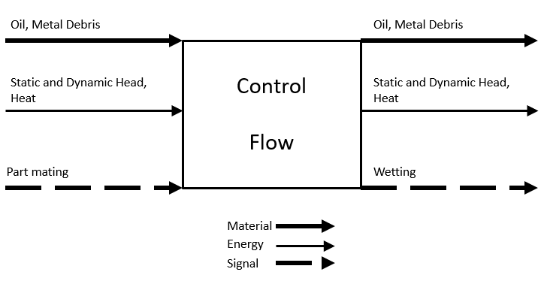

Figure . Hypothesized Black Box Model

The Black Box Model provided an opportunity for the team to thoroughly discuss all essential aspects of the housing in order to satisfy the procurement specifications. The above model defines the top three analyses for the design: positioning the detector to effectively capture oil chips; slowing down the flow across the detector; and transferring all energies in line with the detector for a leak-free and pressure-tight design. Leak has been removed from the signal flow for a more complete version of the black box model.

### Functional Model/Work-Process Diagram/Hierarchical Task Analysis

An important exercise in the design of the housing is to create a functional model. The functional model expands on the Black Box Model by focusing on necessary processes and functions that the design needs to fulfill. The functional model uses the same format as the Black Box Model with verb object form and material, energy, and signal flows.

Earlier design tasks such as defining customer needs and engineering requirements helped to shape the functional model. Creation of the functional model assisted the team in defining each function that the housing must perform. Processes in the model answer what functions need to happen rather than how those actions occur. That level of ambiguity allows the team to create a diverse array of designs with minimal bias toward a common form.

The functional model of the detector housing accounts for the input materials: the oil, debris, and sensor. The model also shows the energy inputs of head and heat that are associated with the fluid flow. Next the housing conditions the fluid flow for interaction with the sensor. The housing provides a means of coupling the sensor and placing both the debris field and sensor into interaction. Finally, the sensor housing exports the material and energy associated with the fluid flow and allows for decoupling of the sensor.

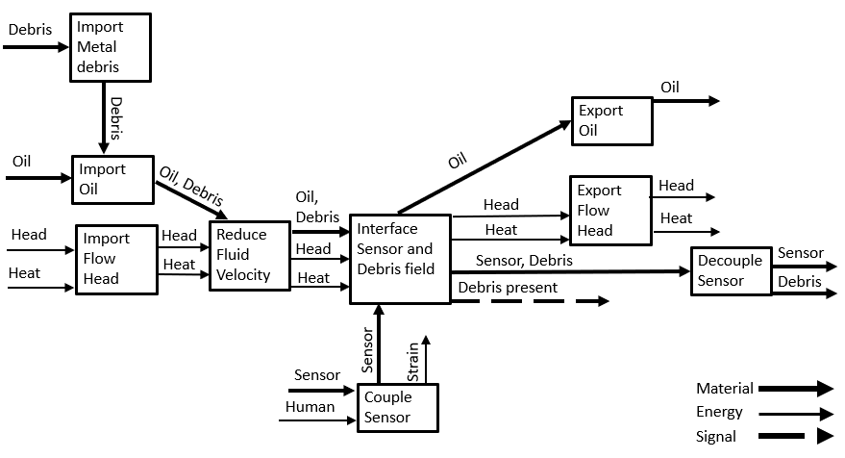

Figure . Functional Model

## House of Quality (HoQ)

The full House of Quality can be found in the Appendix A. The House of Quality is divided into two stages. Stage I takes the customer requirements and engineering requirements to construct the main sections of the House of Quality which provides information on the most important technical engineering requirements. Stage II of the House of Quality is taking the subsystems of the design and comparing them directly to the engineering requirements. This allows the most important subsystem to standout. Using the Stage I HoQ, the most important aspects of the design of the housing, that being quality assurance durability followed by reliability. These aspects are necessary in order to have a successful and functional housing to test. The housing must be able to withstand five minutes of heat at 2000oF and two minutes at 310oF, this lower temperature is to simulate an engine cooling down while the higher temperature is to simulate a fire around the housing. For fluid flow has a range of 1-4 ft/s currently but is subject to change. Capture frequency must be > 90%. The housing must fit within a 3x3x2 inch envelope size, this is subject to change by Honeywell. The housing must operate at altitudes from –2,000 to 55,000 feet. The force loads that the housing must endure are outlined in figure 3 below.

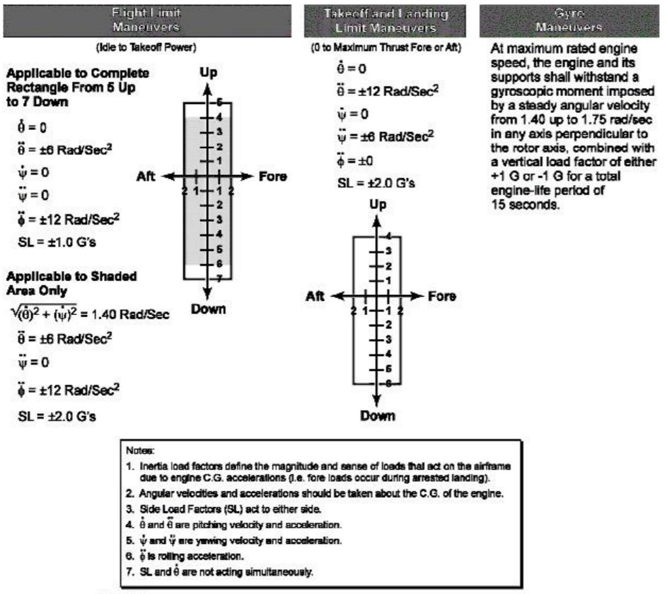

Figure . Provided Altitude and Pressure Requirements [1]

Figure 3 provides a large amount of data about aeronautical forces that the housing will be subject to. The figure also provides large amounts of information about flight the type of flights that the housing will be subjected too. At the present time the operating pressure is known to be < 20 PSI. The housing must also be leak free through all tests, this will be a pass-fail type of test. The housing must also be resistant to certain fuels and oils that will run through the housing. These are found in the table 3.

Table . Approved Fuels and Oils for the OCD [1]

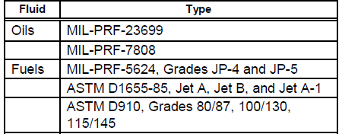

## Standards, Codes, and Regulations

Provided below is a table of standards and codes applicable to the project. All CAD and dimensioning will be conducted to ANSI standards. American Welding Society standards will be referenced if welding is employed in manufacture of the housing. American Welding Society standards will include, but not limited to, AWS: B1.10, B2.1, D10.18, D18.2. The listed AWS standards will be referenced for nondestructive examination of welds, welding procedure and qualification, stainless steel pipe welding, and stainless-steel tube discoloration. The below listed ASTM standards address the testing and analysis of sealants. The ASTM C-1247 covers procedures for the examination of adhesive sealants that are exposed to continuous liquid immersion. The ASTM D-1414 provides a standard method for determining engineering properties of rubber o-rings. Additionally, ASTM D-1414 provides guidance for aging analysis of o-ring sealants.

Table . Standards and Codes

|  |  |  |
| --- | --- | --- |
| **Standard Number or Code** | **Title of Standard** | **How it applies to Project** |
| ANSI | American National Standards Institute | Drawing standard used for schematics |
| AWS | American Welding Society | Welding will be necessary for design fabrication |
| ASTM  C-1247 | Standard Test Method for Durability of Sealants Exposed to Continuous Immersion in Liquids | The standardized test method for sealants under continuous liquid immersion will be referenced for sealant and leak testing. |
| ASTM  D-1414 | Standard Test Methods for Rubber O-Rings | The standardized test method of o-rings will be referenced if the team selects a NBR o-ring as a sealant. |

# Testing Procedures (TPs)

Testing procedures for the housing are set forth by Honeywell. There are 4 required tests that will cover all the engineering requirements. A load test, thermal environment, stress and strength test, and a vibration/dynamic test. All tests will be performed by Honeywell, but the processes will be determined prior to the testing date by Team Honeywell. Operating altitude, safe in operation, and reliability will be determined by Honeywell after the tests are concluded.

## Testing Procedure 1: Load Test

The load test includes static, dynamic, and repeat loads, inertia effects by acceleration, angular velocities and gyroscopic movements. This test will determine altitude, shock resistance, and force loads for the housing.

### Testing Procedure 1: Objective

Static, dynamic, and repeat force testing using force gauges and weights will be used to determine the Load test. The test will be run by adding forces to the housing to help determine the amount of force stresses that the housing can take. This test will be testing for compression and tension, as well as fatigue life usage through multiple cycles. The housing can be rotated to change the locations that the stresses will concentrate on. The housing must withstand up to 20g’s this is to say the housing must survive 20 times the weight of gravity for the test to be considered a pass.

### Testing Procedure 1: Resources Required

Force Gauges, weights and a measurement program to help determine the amount of stress that the sensor housing is under. The force gauges will show how much force is acting upon the sensor housing. The weights will be used to apply the forces on the housing. The measurement program will allow the team to measure the response the housing has based upon the forces that are applied.

### Testing Procedure 1: Schedule

The test should take approximately one hour to complete. The test will be conducted sometime in February of 2020, by either the team directly or by Honeywell during the full engine testing. This test fits directly into the preliminary schedule for completion of February 2020. The housing needs to be complete before testing as well as a full set of programs for data retrieval.

## Testing Procedure 2: Thermal Environment

The thermal environment is putting the sensor directly into a thermal environment that the housing will be subject to on a regular basis. This test meets the thermal and heat resistance engineering requirements and provides a pass/fail for the housing based upon thermal damage done to the sensor.

### Testing Procedure 2: Objective

The thermal environment will consist of a steady-state and transient temperature adjustments. The housing must meet multiple temperature requirements. The housing must operate from -65 oF to 260 oF. The housing must survive a torch test of 2000 oF for a minimum of five minutes. The housing must also survive a startup temperature of 310 oF for two minutes on a consistent basis. The temperature around the OCD will be read by a forward-looking infrared camera (FLIR). This camera will determine the temperature around the OCD and help determine whether the test is a pass or fail.

### Testing Procedure 2: Resources Required

A heat torch is required to fulfill this testing procedure. Due to the high temperature multiple heat torches may be applied to the sensor housing. The housing will need a location to be fixed too and have a consistent temperature placed on it. Variable temperature tests can be performed at the same time. Visual inspection will be required to determine whether the part passes or fails. Deformation or thermal damage to the housing will constitute a fail for this test.

### Testing Procedure 2: Schedule

This test should take approximately two hours. This test will be performed directly by Honeywell during their full engine testing. Due to the dangerous nature of this test Team Honeywell will not be performing this test. The preliminary date is set for February of 2020 which is on track for the team’s current timeline.

## Testing Procedure 3: Stress and Strength Test

The stress and strength test will be testing for the stress that the housing must withstand. Furthermore, deformations and margins of safety will be determined from this test. This test will determine the shock resistance, the force loads, and the quality of the housing. This test will be a pass/fail based upon deformation and damage that is accrued on the housing.

### Testing Procedure 3: Objective

The stress and strength test will run similarly to the load test. The test will consist of variable stresses on the housing. Multiple stresses will be placed upon the housing at any given time. This test will be a pass/fail test based upon the type of deformation that the housing will have present. Any form of deformation is considered a fail. Margins of safety will also be tested during this test. This will help determine the safe in operation engineering requirement.

### Testing Procedure 3: Resources Required

The stress and strength test will require force gauges as well as weights to add forces directly to the housing. A computer program for measurements on the housing will help determine the type of stresses that the housing is under.

### Testing Procedure 3: Schedule

The stress and strength test will take approximately two to three hours. The test will be performed in either late January or early February 2020. This will put the testing either before or after the final date provided by Honeywell. This test is on time with spring semester plan.

## Testing Procedure 4: Vibration and Dynamic Test

The vibration and dynamic test will be used to determine the frequencies that the housing can operate. The test will be a pass/fail to determine if the housing falls under Honeywell’s minimum vibration information. The test meets the vibration and reliability sections of the engineering requirements.

### Testing Procedure 4: Objective

This test will determine the amount of dynamic and vibrational energy that the sensor housing can take before it begins to block the signal on the sensor. The test will allow for both vibration and dynamic forces to be tested at the same time.

### Testing Procedure 4: Resources Required

The vibrational test will require a vibrations table to perform. The test will be performed with the housing as well as computer data recording equipment. The data will be recorded and used to determine the frequency that the housing was under.

### Testing Procedure 4: Schedule

The test will take approximately two hours and will be performed by Honeywell or the team. The test will be scheduled for either late January or early February 2020. This puts the team on track for testing dates that are determined by Honeywell. Early February is when the final model is due.

## Testing Procedure 5: Fluid Flow

Fluid flow testing will ensure that fluid flow characteristics in the housing meet the defined parameters. The fluid flow experiment will replicate the expected operating conditions. Fluid flow testing will allow the team to define the optimal placement of the sensor. The pressure, burst pressure, and durability engineering requirements will be covered within this test.

### Testing Procedure 5: Objective

This test will determine the fluid flow velocity across the sensor. A fluid velocity decrease of 90% across the sensor is desired. The testing will be representative of expected operation conditions. The team seeks to define optimal placement of the sensor. Additionally, the team will verify that test conditions match the operating conditions and fitness for use.

### Testing Procedure 5: Resources Required

The fluid flow test will require a manufactured housing, specified fluid, pump, heater, conduit, pressure transducer, pitot tube, manometer array, graduated container, and fluid reservoir.

### Testing Procedure 5: Schedule

The testing and analysis will take approximately 2-5 days. Preliminary testing of a low fidelity model and experimental setup will take place in early December 2019. Additional iterations of the test will be conducted if critical changes are made to the experimental apparatus or housing design.

# Risk Analysis and Mitigation

There are the 3 subsystems in the housing: the body, sealant, and the mounting bolts. The body is the largest part of the housing, it holds the fluid and directs it across the OCD. It has many methods in which it could fail and has some very sever modes of failure. The body also has the simplest failure modes, the failure methods are easy to design for since all the analysis that would prove that our material choice would work needs to be performed before the design is created. The sealant is the riskiest part of the design, as it is the most likely to fail, even though the failures are not as severe as the failures of the body or bolts. Leakages are still severe for the design as they still lead to the device being unusable, even though they are not dangerous. The mounting bolts have a few failure methods, and they are severe but, like the body, easy to plan for. Unlike the body, the mounting bolts would be the easiest to change if they were to fail, as the amount, size, and position of the bolts could all be changed. The full failure modes and effects analysis sheet can be seen in Appendix B1 and B2.

## Critical Failures

A critical failure is any failure within the housing that will cause either the sensor or the housing to catastrophically fail. There are many potential failures within the OCD, but many failures may not cause catastrophic failure.

### Potential Critical Failure 1: Body Failing due to Temperature Induced Deformation

The engine will undergo high temperatures, and the housing must not fail in high temperature cases. One mode of failure for high temperatures would be the material deforming due to the high temperatures and then rupturing, causing the device to leak and be unusable. To mitigate this failure, a material with an appropriate melting point should be chosen, and an in–depth analysis of the heat transfer through all portions of the design are necessary.

### Potential Critical Failure 2: Body Failing due to Ductile Rupture

The housing needs to be able to hold oil with the housing as it flows past the OCD. In extreme cases, the oil will provide a strong burst of pressure onto the housing. If the housing is not strong enough, the material could fail, causing the system to leak and be unusable. An analysis of the strength of the material will be performed to assure that the chosen material is acceptable, and a test will be done with the housing at the burst pressure to assure that a ductile rupture will not occur.

### Potential Critical Failure 3: Body Failing due to Brittle Fracture

Much like the ductile rupture critical failure, the body could experience such a high amount of pressure that a brittle fracture could occur. Although the brittle fracture is much less likely to occur, as the material is more likely to yield and bend before it fractures, a brittle fracture failure may occur at lower operating temperatures and conditions. This would mean that an analysis of both the material choice and shape would need to be revisited.

### Potential Critical Failure 4: Body Failing due to Corrosion by Direct Chemical Contact

The oils that are being used in the engine are very corrosive, which could wear down the housing body and cause it to weaken and eventually fail. The weakened housing would be more likely to fail in any of the ways described above, causing the device to leak and be unusable. Honeywell has provided a list of prohibited materials, as it is already known that those materials corrode in the oils being used, but an analysis of the materials corrosion resistance can still be performed, as well as testing in the oils. If the chosen material does corrode due to the oil being used, a different material choice would be considered.

### Potential Critical Failure 5: Body Failing due to High-Cycle Fatigue

As the engine vibrates, the oil inside will interact with the vibrating body and could fatigue the inside of the body. This failure is very unlikely to cause any serious failure as it would take a very long time to make a meaningful weakening of the device, as whichever material is chosen needs to be significantly stronger than the point at which this method of failure makes an impact. If this failure does occur, the device needs to be replaced.

### Potential Critical Failure 6: Seal Failing due to Temperature Induced Deformation

Unlike the body of this device, the seal may not have as high a melting point, which means the maximum heat being applied to the seal is much more likely to occur. The seal could be exposed to a temperature too great, causing the seal to deform and fail, allowing leakages to occur. Although the leaks would be smaller than leaks of the body failing, since the seal failing is much more common, they are a bigger problem. To fix these leaks, the seal material can be changed, or the shape and design of the device could be reconsidered to reduce heat on the seals.

### Potential Critical Failure 7: Seal Failing due to Corrosion by Direct Chemical Contact

The seal is required to hold the oil in the system, but the oil could be corrosive to the seal, breaking down the seal and causing leaks. Honeywell has provided a list of known materials to avoid during sealant choice, but additional testing on the final material should be performed to assure that the material would not corrode due to chemical contact. If this failure were to occur, it would be very serious as a redesign would need to be in order.

### Potential Critical Failure 8: Seal Failing due to Adhesive Wear

Vibrations from the engine will move the device, causing contact between the seal and the body. The seal is softer and weaker than the body, so it is likely to fall apart due to the moving of the adhesion between the two materials. This failure is not too likely to occur, and so it is not the largest priority in the design. If the failure were to occur, replacing the seal is the best course of action if the seal lasted for an acceptable amount of time before this failure occurred. If this failure occurs very soon into use, a change in material to something stronger would be in order.

### Potential Critical Failure 9: Mounting Bolts Failing due to High-Cycle Fatigue

The mounting bolts hold the housing onto the engine, and as such are affected by the constant vibrating of the engine. These vibrations produce a high-cycle load onto the mounting bolts, which could cause them to fatigue and fail. If the bolts fail due to this, what is left of the bolt would be very difficult to remove from the engine. This means that this failure is very severe, but it is easy enough to test for and can easily be accounted for. To protect the device from this kind of failure, the correct number of bolts, their sizes, their material and their positions should be changed.

### Potential Critical Failure 10: Mounting Bolts Failing due to Thermal Fatigue

Due to the high temperatures that the housing will be experiencing, failure of the mounting bolts due to thermal fatigue could occur. The thermal fluctuations that the engine will go through will act as a cyclic load on the device, and the mounting bolts need to be safe from deforming or failing due to these thermal loads. To mitigate this failure, repositioning of the bolts on the engine would reduce the heat pushed onto the bolts.

## Risks and Trade-offs Analysis

Many of the critical failures that can occur are very severe, because one of the customer requirements provided was that the device be leak free. Some of the failures lead the device to be dangerous and unusable, such as the ductile failure of the body or bolts failing in high-cycle loads. Both these failures are simple to plan for, as they both require choosing a material that will be plenty strong enough to survive loads applied to them, but this also means that changing those choice would be difficult. Even if those are the most serious failures that can occur, neither had either of the largest risk priority numbers (RPN). The largest RPN’s belonged to the seal failing in either temperature-based deformation or corrosion by direct chemical contact. These both are very high risk as they both could occur more often than any other failure method, while still causing the system to leak. Both these failure methods were a focus when designing, and if the device needs to be changed these two failure methods would be consulted to assure that they do not occur. The other important failure methods that are focused are failure methods that weaken the housing, such as all the corrosion and fatigue failure methods. If either of these failure methods were to occur, they would be harder to detect as they do not make the device directly fail, they weaken the device causing it to fail in other ways.

While the mounting bolt failures were related to only the mounting bolts, the failures of the body and the seal often affect each other. Many solutions to seal failures is to change their position, size, or material choice, which could affect the design of the body. But since the seal is significantly more likely to fail, the design of the seal takes priority.

# DESIGN SELECTED – First Semester

After reviewing the current field of concepts and discussing mounting options with Honeywell, the cylindrical form and billet designs were abandoned in favor of a square tubing-based design. This decision came about as a result of machinability issues with several designs and the similarities to housings that Honeywell design engineers have used in the past. Going forward, a focus will be given to metal fabrication practices and processes to produce the prototypes within budget.

## Design Description

The general design Honeywell is now expecting is based on the Elbow Joint seen in figure 4. Honeywell has expressed a need for several variations for testing which suits this design. The final prototype will be chosen by Honeywell engineers based on engine testing and observations.

The original square tubing-based concept is pictured below.

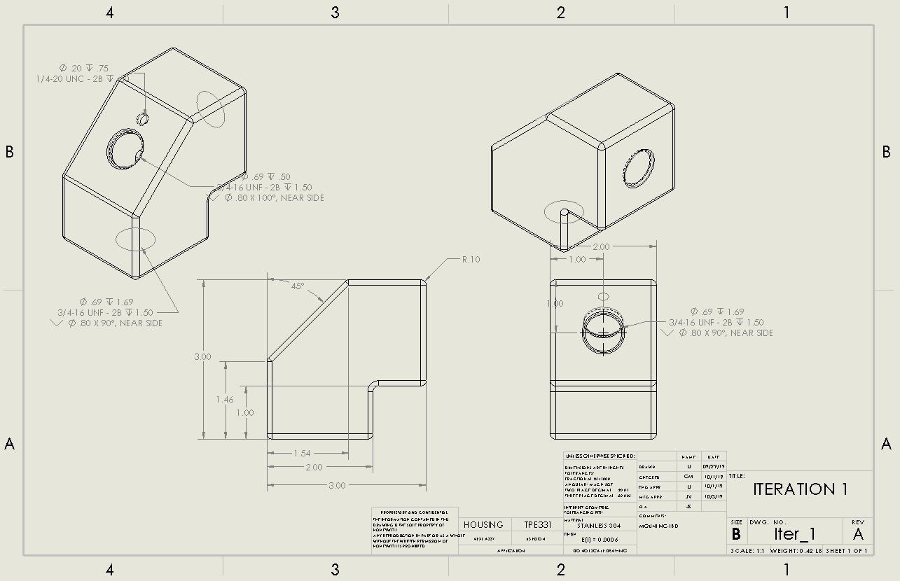

Figure . Elbow Joint Design

The Elbow Joint has since been updated with 3/4-16 flange nuts welded over the inlet and outlet to accommodate the engine’s -08 oil lines as shown below.

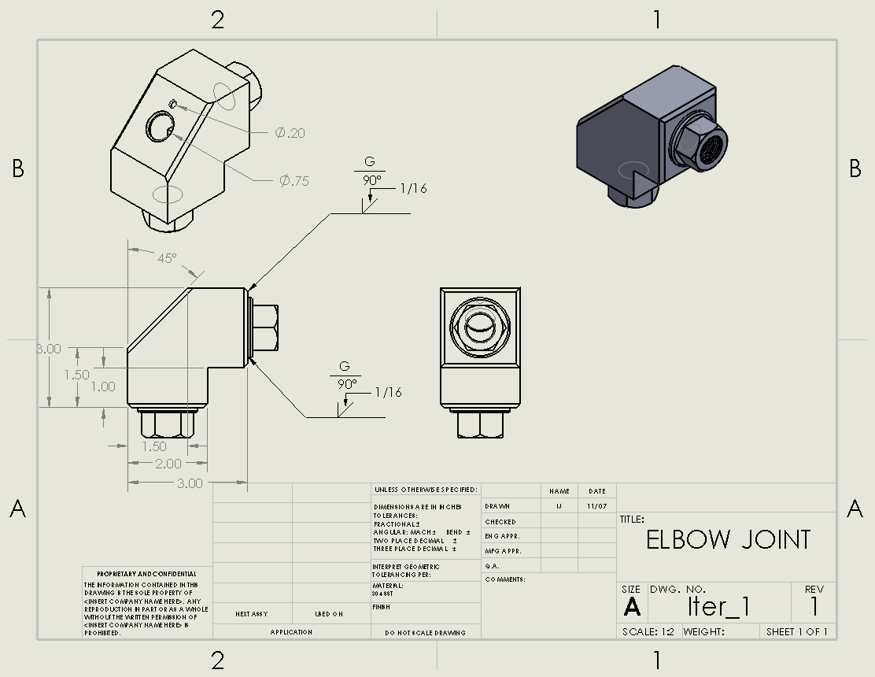

Figure . Improved Elbow design with fasteners

Per the front view in figure 5, the inlet is on the right, the outlet is on the bottom, and the detector fits normal in the ¾ in hole on the left, angled side. The principle design is based around forcing a flow direction change in front of the OCD while positioning the detector appropriately. Each variation fills out the maximum allowed envelope size solely to fulfill the flow rate reduction value of 90% via expansion and the head loss from the 90° bend. Velocity drop by expansion is defined by the continuity equation [2].

$$\begin{aligned}A_{2}=A_{1}*\left(\frac{v_{1}}{0.1v_{1}}\right)\#\left(1\right)\end{aligned}$$

Equation 1 is modified here for calculating the cross-sectional area of the housing based on the flow in the –08 AN line. Per equation (1), inner area of the housing by the OCD must be 1.96 in2. Velocity drop by minor head loss is defined by equation 2 [2].

$$\begin{aligned}h_{l}=\frac{K_{i}v_{1}}{2*g} \#\left(2\right)\end{aligned}$$

In equation 2, K is the loss coefficient associated with a 90° turn. G is the acceleration of gravity. For this project, the velocity drop by minor head loss is 16.3%.

The following series of pictures represent the progress from a low fidelity prototype based on the current design to a marginal proof of concept piece used in an experimental flow apparatus. Figure 6 below is a picture of the low fidelity acrylic prototype.

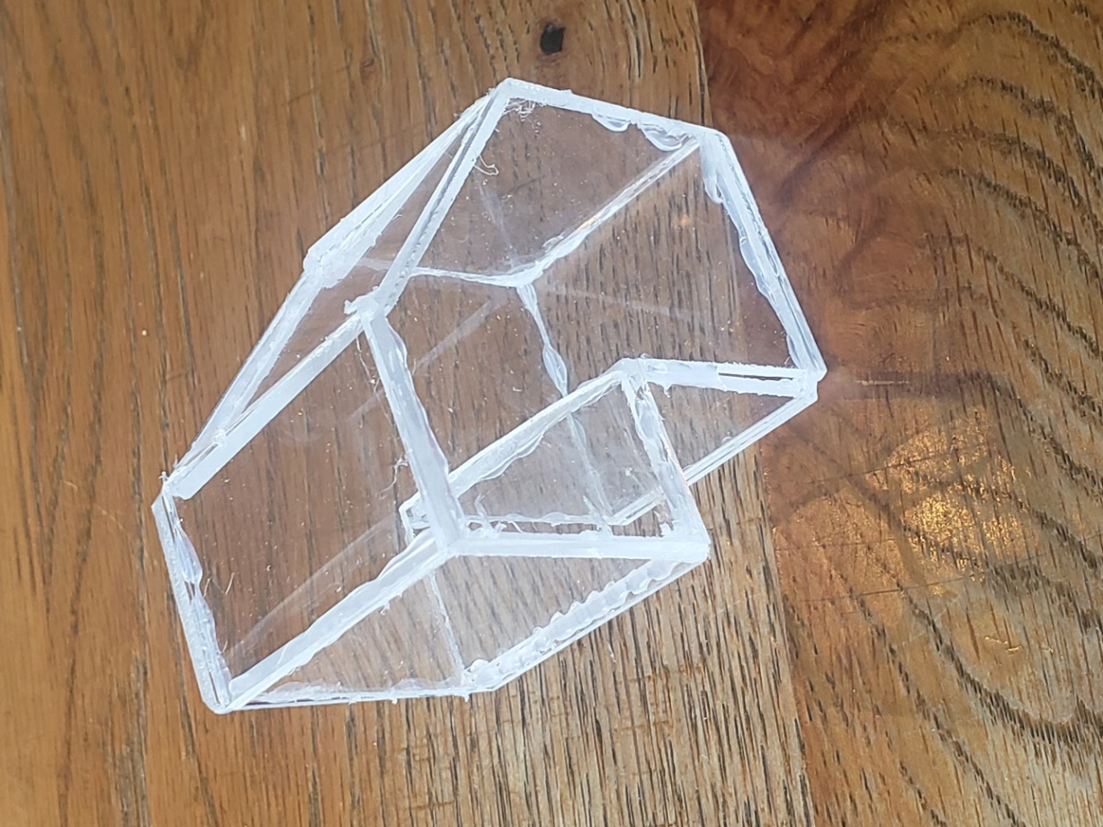

Figure . Acrylic Proof of Concept

Figure 7 is brazed version of the oil chip detector design. The brazed version is used for preliminary testing and experimental calculations.

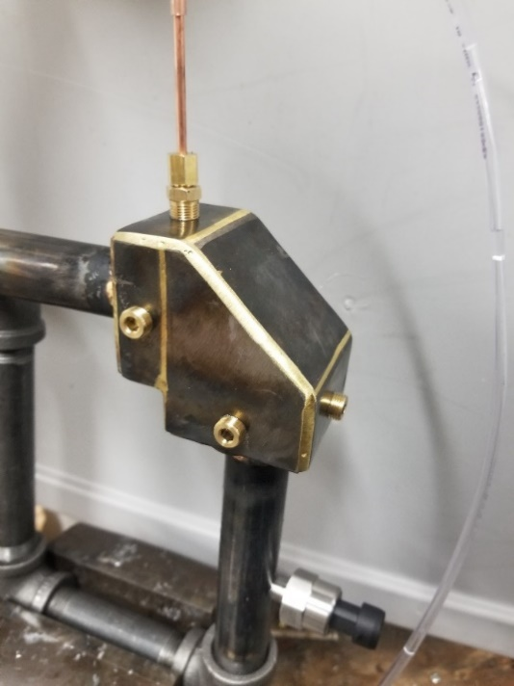

Figure . Brazed OCD for experimental testing

The proof of concept is currently being tested for flow characteristics at different pressures and flow rates in the experimental apparatus shown below in figure 8.

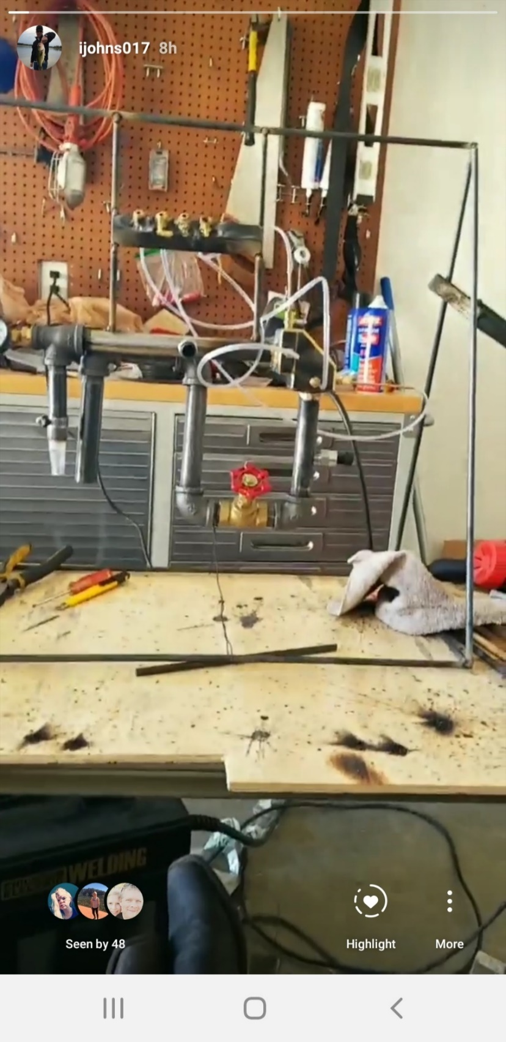

Figure . Full experimental apparatus

The outstanding flaws with the prototypes stem from the number of joints on each one. Both were made from flat stock material. The present fabrication process for the stainless prototypes will be designed around square tube which mitigates the need for welds on all outside corners. Also included now in the process for constructing the housing is the fixture of a ¾-16 nut over the inlet and outlet to suit the –08 fittings on the engine.

## Implementation Plan

The designs will be created in the form of three similar prototypes fabricated for Honeywell’s engine testing in February 2020. All fabrication will be completed in 98c by the team members. The students have been permitted use of the bandsaw and simple equipment for the 304 stainless steel. If needed, milling can be done by the shop personnel with shop tooling. Otherwise, Honeywell’s budget allows for tooling. Table 5 the final bill of materials, from hereinafter known as the BOM, which assumes that the students will be doing all machining within the 98c machine shop.

Table . Bill of Materials

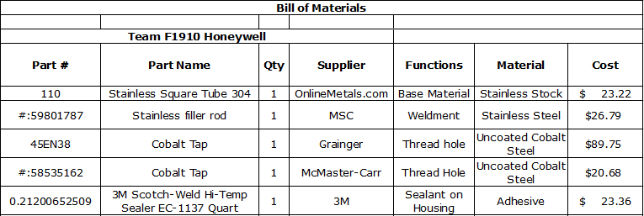

As seen in the full BOM is provided in appendix C, the projected materials cost of one prototype is $183.80. This is significantly lower than the budget of $1000. The cost of each prototype thereafter will be the price of another foot of stock, $23.22. An additional pound of filler rod may be needed after three prototypes. All costs considered, there should be $750 remaining in the budget for additional unforeseen costs.

The materials that are found in the BOM will be used in conjunction with a manual mill to create the part. The part will be threaded and machined within a tolerance of ±0.005 inches. There are 2 sections to the OCD the top section and the bottom section. Each section will be threaded separately to the required specifications. Each section will be milled to the proper dimensions and then welded together. The two sections will be welded together using gas metal arc welding (MIG) machine. The sealant will be applied later during the preliminary testing times. This manufacturing process is still yet to be finalized and is subject to change based upon further information provided by Honeywell.

# Conclusion

Team Honeywell, with the guidance of Honeywell, has been able to select a design to manufacture and test for Honeywell. The housing is used to house the OCD and protect it from the elements while in use on the engine. The housing will meet or exceed all requirements set forth from Honeywell. The housing must adhere to all engineering requirements from section 2.2 of this report. Currently the selection of material, 304 stainless steel and the plans presented for fabrication outlined in this report will meet all requirements necessary. After the prototype is constructed all testing will be done by Honeywell with their facilities on-site. Currently Team Honeywell is on or ahead of schedule for all deadlines set by NAU and Honeywell. The prototype will be ready for testing early February as required by Honeywell.

As outlined in section 5, Team Honeywell has decided to move forward with the elbow joint design. This design incorporates using 3/4-16 flange nuts welded to the inlet and outlet sections of the design. These nuts will help with tightening the oil inlet and outlet ports to the housing. This design also fits within all size requirements and slows the flow of the oil by 90% due to the loss coefficient associated with the 90° bend. Currently this design is within budget and should not exceed the $1,000 budget set by Honeywell. A full failure analysis was completed pertaining to the elbow joint design. These aspects will be tested by Honeywell as outlined in section 3 of this report.

Team Honeywell has been able to successfully conceptualize a design that will fulfil requirements for Honeywell this semester. This was completed through initial meetings with Honeywell and research done by Team Honeywell. Using the engineering and customer requirements to successful create multiple prototypes to present to Honeywell for feedback lead to a final design being chosen to conduct future analysis and testing on. Each member of Team Honeywell will be conducting individual analysis on the housing to further satisfy the requirements set forth by Honeywell. This includes structural analysis, a fluid flow experiment, fundament engineering analysis, computational fluid dynamics analysis and temperature distribution analysis.

# References

|  |  |
| --- | --- |
| [1] | Honeywell, "Procurement Specifications for the Oil Chip Detector Housing," Honeywell Aerospace, Phoenix, 2019. |

# APPENDICES

## Appendix A.1: Phase I House of Quality

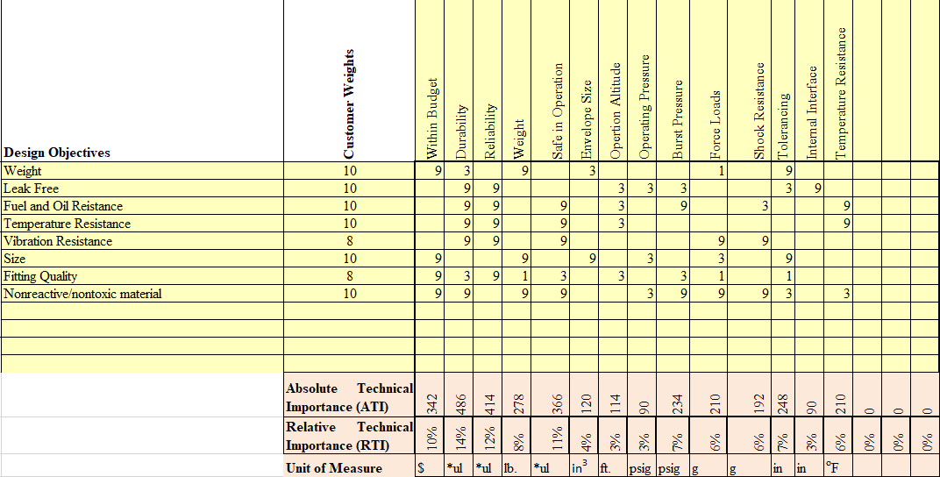

## Appendix A.2: Phase II House of Quality

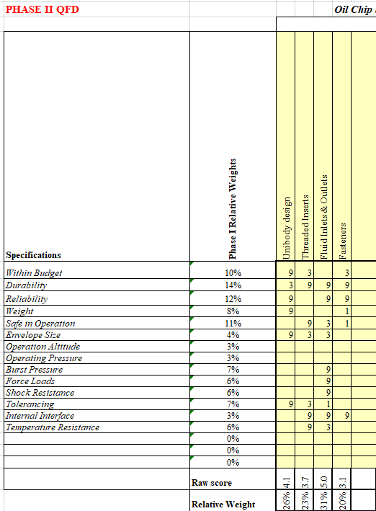

## Appendix B1: FMEA Section 1

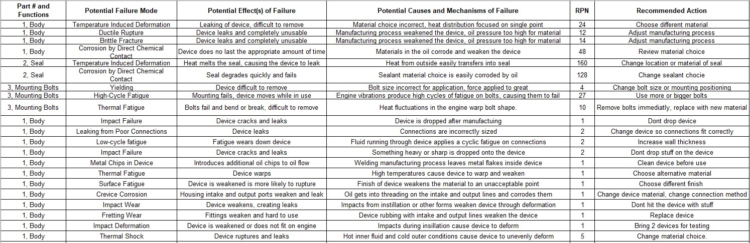

## Appendix B2: FMEA Section 2

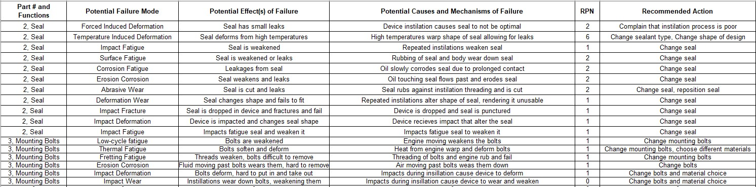

## Appendix C: Bill of Materials

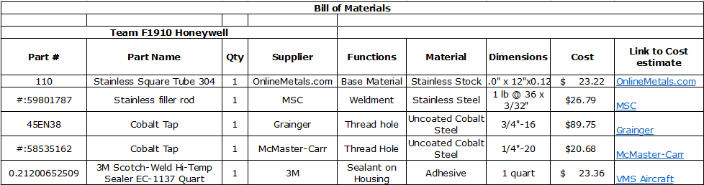

## Appendix D1: Calculations



## Appendix D2: Calculations

