Team 4B Conceptual Report

**By:**

Abdulaziz Alzaid

Shanna Lechelt

Israel Sotelo

Alexandra Spotts

**Instructor:** David Willy

*March 4, 2018*



Department of Mechanical Engineering

Northern Arizona University

Flagstaff, AZ 86011

**1.Background**

1.1 Introduction

The team has been presented with the task to create a universal test fixture for missile flight components such as radomes and leading edges in high temperature and high-pressure flight conditions. The final design must have a quick set up and take down time, with minimal time delay between each step in the process. The team’s client and sponsor, Chuck Vallance, is a former Raytheon employee who has asked us to make changes to the current testing environment either by improving upon the currently existing design or by a redesign using an original concept to increase the efficiency of the testing process.

1.2 Project Description

Outer mold line flight components, such as missile and aircraft radomes and wing leading edges often operate in extremely harsh environments. Small practical radomes can be 6 inches in diameter and 18 inches in length. A large radomes can be 4 feet in diameter and 8 feet long. Wing leading edges can vary as dramatically.

Successful design efforts for these hardware components include testing to validate the design. Common environments to which the hardware is subjected to include internal and external pressure, high heat fluxes, and pressure induced flight loads. Specialized test rigs to perform the testing are standard. The output of this project will be a set of design specifications for a test fixture which can be deployed in standard laboratories (may be outside) and capable of testing a wide variety of radomes and leading-edge shapes and sizes as well as producing a wide variety of testing environments (pressures, loads, fluxes). Some fabrication and testing of scaled models of the test fixture will benefit this project to prove it is viable but is not required.

1.3 Original System

The original system does not currently meet all the requirements of the client, and therefore original or improvement designs will need to be considered for this project. Greater detail of the original system will be covered in section 3.1.

**2. Requirements**

2.1 Customer Requirements

After meeting with the client, customer requirements were established. The goal of the customer requirements is to narrow the scope of the project and translate what the client wants into qualitative design requirements. For the test fixture the following customer needs must be met:

* Simulate supersonic and hypersonic flight conditions
* Ability to test a variety of missile parts
* Applies varying mechanical loads
* Applies varying heat loads
* Applies loads in different orientations
* Minimal labor required for set up and changing out parts
* Measures loads, strain, temperature, and heat flux
* Transmits measurements to the command center
* Portable
* Compact Storage
* Safe

2.2 Engineering Requirements

Engineering requirements were decided based on customer requirements. The team identified how each customer need could be translated into an engineering requirement that can be quantitatively measured. Units for each engineering requirement can be found in Figure 1. The following are the engineering requirements for the test fixture:

* Transports quickly from storage
* Assembles quickly
* Mounts to a standard 6 inch bolt pattern
* Applies and withstands extreme temperatures
* Applies and withstands extreme loads
* Ability to test parts up to 3 feet long
* Sensors read out to a different location
* Load driven from an alternate location
* Small storage space

2.3 House of Quality

Once customer and engineering requirements were determined, the team created a House of Quality to relate them to each other, as well as rank currently existing designs. The House of Quality helps the team prioritize design requirements by calculating the relative and absolute technical importance. The team gave each customer need a value (on a 1-9 scale) based on how important it was to the client. Next the team determined how much each engineering requirement might influence each customer need. These values were then used to determine absolute and relative technical importance. Each engineering requirement was evaluated for how it related to other engineering requirements as well. As a result of the House of Quality (Figure 1), applying both mechanical and thermal loads will be prioritized because they are ranked first in relative technical importance. Quick assembly, transportation, and testing parts up to 3 feet are ranked second, third, and fourth respectively. These requirements will be important, although slightly less so than those ranked above.

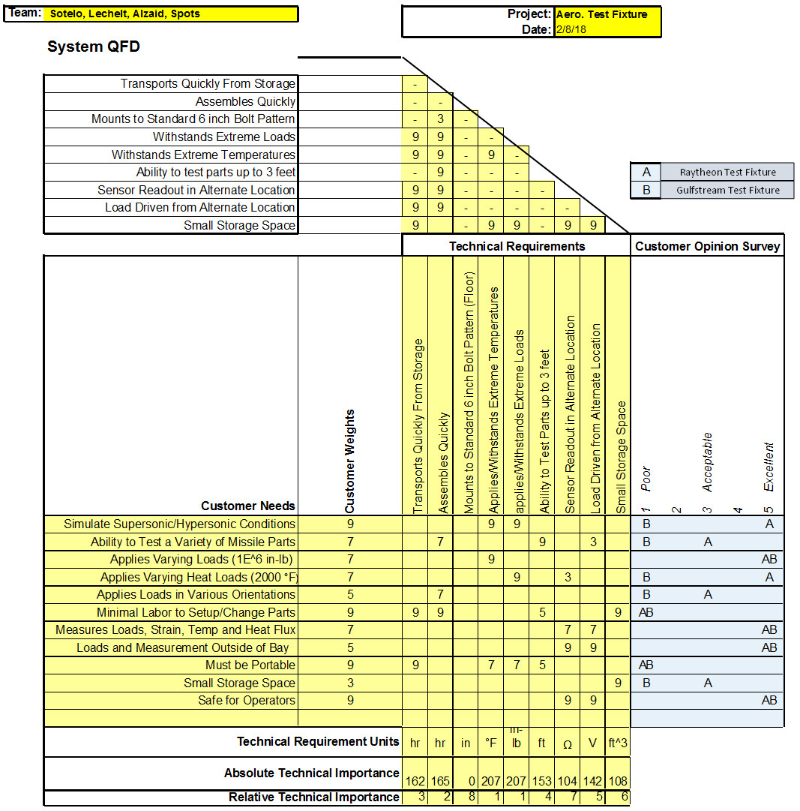

Figure 1: House of Quality

**3. Existing Designs**

3.1 Design Research

Due to the nature of our project as well as company confidentiality, existing test fixture designs are not readily available for public access. The team’s mentor, Chuck Vallance, has instead given us a clear picture of what currently exists for flight testing at Raytheon; this will also be the basis of our benchmarking process. Presently, testing occurs in a large room where all equipment can fit in a 24’x24’ space. The loading area is typically built on a steel platform with holes drilled every four inches as to form a grid where things can be screwed down to the floor. The loading structure is a three-foot-tall mechanism made of steel I-beams with a strap attachment that is designed to cradle the flight component that is subject to testing and replicate a pulling mechanical load. To reproduce a thermal load that a missile component would experience during flight, several quartz heat lamps are placed in multiple, specific locations around the component to achieve a heat flux distribution that is as equal as possible. Sensors such as thermocouples and calorimeters are placed along the surface of the radome as well as inside to measure temperature. Force transducers and load cells are used to measure mechanical loads. Linear variable differential transformers(LVDTs) collect deflection data. Separate from the test fixture is a control room that receives signals from the sensors and displays data from the testing room as well as prescribes loading and temperature profiles to the mechanical and thermal equipment. When benchmarking Raytheon’s test fixture in the QFD (Figure 1), we found that it scored excellent in the following categories:

* Simulates supersonic and hypersonic conditions
* Applies varying mechanical loads
* Applies varying heat loads
* Measures loads, strain, temperature, and heat flux
* Measurements and data collected outside the testing bay
* Safe for operators

The reason being is that Raytheon’s test fixture has already proven to be adequate in these areas, meaning the team’s final design must meet these customer needs at a minimum in addition to the other needs requested by the customer. For the remaining customer requirements, the existing test fixture scored either acceptable or poorly:

* Ability to test a variety of missile parts
* Applies loads in various orientations
* Minimal labor to set up and change parts
* Must be portable
* Small storage space

The logic behind this scoring indicates that these are the customer needs that the team needs to be focusing on in order to assure that our design is more useful and desirable than the currently existing design. Coincidentally, these are also the issues Chuck specified to us that he wanted addressed the most.

The other design that the team benchmarked was the Gulfstream test fixture. The team used videos of the testing environment to gather the information needed to benchmark this design[2]. The Gulfstream Aerospace test fixture is suitable for only testing wings and leading edges. The inner side of the wing, which would be attached to the body of the aircraft, is held in place by a fastening mechanism while the opposing side, the point of the wing farthest away from the body, is subjected to the stress test. The load is applied by a strong pully mechanism, lifting the wing up, causing the wing to bend into an upwards, curved shape until fracture or the conclusion of the test. Many wires and sensors are attached to the wing and the equipment to convey information and data to the control room. Due to the restrictions on the content that Gulfstream Aerospace is allowed to release about their testing environment, we are making an educated assumption that thermal load testing must occur in a separate environment that achieves all requirements needed for a successful and accurate thermal load test. On our QFD, as seen in figure 1, the Gulfstream test fixture scored excellent for the following customer needs:

* Applies varying loads
* Measures load, strain, temperature, and heat flux
* Measurements and data collection outside the bay
* Safe for operators

These ratings are justified because this design meets all the basic requirements needed for the types of loading we will be analyzing and can safely execute the desired test while keeping the operators and analysts in the control room safe. Although it meets these basic requirements needed for any loading test, it is still missing quite a few major elements requested by the client, and scores poorly in all other categories. This benchmark is not precisely the type of design we are looking into, but it provides us with some valuable information that will help us be able to identify the areas our own designs miss the target set by the client.

3.2 System Level

The test fixture has several system level features which need to be explored within this design project. This test fixture will not be a permanent addition to any testing bay, therefore considerations need to be made about the storage, transport, and construction of the test fixture. It is important that the fixture transport has no effect on the testing process, data collected, or the safety of the operators. Time considerations must also be made as the client has indicated that to be one of his primary concerns. Finally, the test fixture must be placed in a location at some distance away from the operators. Due to the dangerous nature of the heat and forces involved, a control panel or separate control room must be utilized.

The transport, storage and time to assemble are all closely related. The existing test fixture is composed of large I-beams which require forklifts to maneuver. There are many threaded fasteners, in addition to the hydraulic ram, heat lamps, and sensors. Designing a fixture which is light, partially assembled, and compact will aid in achieving these system level goals. Utilizing a control center which can quickly connect to the loading devices and sensors will also speed up setup times.

This iteration of the design process will focus on improving sub-functions and system level designing will be left for a later date.

3.3 Functional Decomposition

The team first created a black box model(Figure 2) to identify inputs and outputs for the test fixture. Both material inputs and outputs will include the fixture, as well as the missile part that is being tested. Human energy, hydraulics, heat, and electricity are the energy inputs. The only energy output is human energy. Load signals will be inputted, and visual signals as well as sensor data will be outputted. For the functional model(Figure 3), the major problem is to create a test fixture, but to make it more simple to design we broke it down into four subsystems(Figure 4). The first is the mechanical load; the fixture will apply bending and shear stresses onto the missile part using hydraulic energy. Simultaneously thermal loading will be applied to the part in order to simulate flight conditions. Next, sensors such as thermocouples will collect the thermal load data, and strain gauges will collect data from the mechanical loads. Last is the control center, which will receive data from the sensors. Functional decomposition is important for the project because it breaks a complex problem into smaller, more manageable pieces. It is also particularly important for this project because it helps the team identify the particular case studies to design.

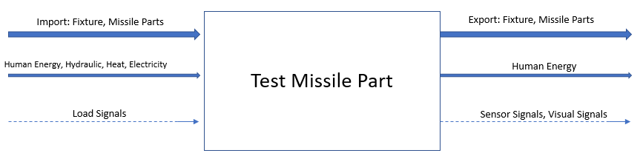

Figure 2: Black Box Model

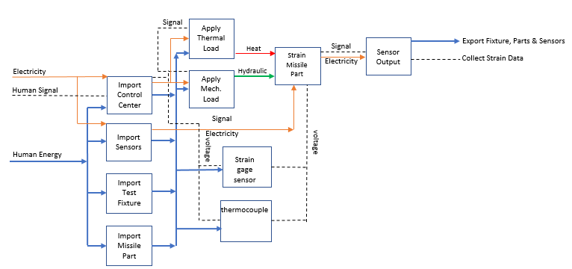

Figure 3: Functional Model

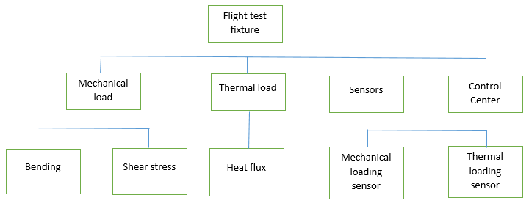

Figure 4: Subsystem Decomposition

3.4 Subsystem Level

One of the subsystems in this project is thermal loading. At Raytheon they use heat lamps all around the missile part, but there are gaps between each heater. This approach is inaccurate because the flux will not be constant along the missile part surface. In this project, the team will improve upon that design and will make it more accurate to make it consistent with flight conditions.

Next, Raytheon applies mechanical loading on the part by using a loading strap. This way is not ideal because the strap cannot cover the entire radome, so it does not meet the flight condition properly. The team’s design will meet the flight condition better because it will apply a constant load over the area of the part’s surface. Also, in Raytheon’s case, they do two tests for mechanical loading. For the second test they rotate the radome 90 degrees. This way requires more labor and is inefficient, and one of our goals is quick assembly.

**4. Designs Considered**

The first subsystem models that the team explored was the application of mechanical and thermal loads to radomes. Each design will be compared to the benchmark currently used by Raytheon. These benchmarks consist of quartz heat lamps to apply thermal loads, and large straps to apply mechanical loads. The analysis of applying test loads to leading edges will occur in a future case study.

1. **Oven** – For the oven design, the test fixture operator places the radome in a large heating chamber that acts like a powerful oven. This oven contains much of the test fixture and the mechanical load is applied within this oven. The advantages of this system compared to the benchmark include its ability to deliver even heat loads, it is universal, and nearly any mechanical loading method can be utilized. Some of the drawbacks include the amount of energy required to heat a larger volume and the fact that the temperature inside the oven is nearly at the melting point of steel. Therefore, anything in the oven will likely be more expensive.
2. **Heat Coils** – The heat coil design utilizes a heating element which is wrapped around the radome. This creates an even heat distribution which is an area of opportunity for the benchmark. The drawback of this design is that it may prove difficult for the mechanical load to operate through the coils.

1. **Fixture-** The fixture is a device that combines the thermal and mechanical loading**.** With this design, there will be an even distribution of both thermal and mechanical loads which is ideal. The heat is delivered via heating or induction coils, and the mechanical load is delivered by the clevis on the outside of the fixture. The drawbacks of this design are that it is not universal, and it may take longer to heat the block which may change the heat flux.
2. **Flame/Plasma-** The flame or plasma design would directly apply heat to the radome. The positives are that it is relatively cheap and universal. The drawback is that the flame may be destructive and that the heat is applied to a very small area. It is challenging to have a flame system that applies an evenly distributed load.
3. **Fluid-** The fluid concept also incorporates a combination on thermal and mechanical loading. The concept is similar to a wind tunnel, however, the fluid has a high density which would allow us to apply larger loads with lower velocities. The fluid could also be heated to an appropriate temperature to simulate flight conditions. The drawbacks of this design include the fact that oils would most certainly combust at these temperatures, so finding an inert fluid may be a challenge. This design most likely would be a permanent fixture which is directly against the customer needs.
4. **Cage-** The cage design has a uniform lattice of heating elements strategically placed to provide uniform heating. The mechanical load can also be applied directly to the cage which would apply a uniform load.

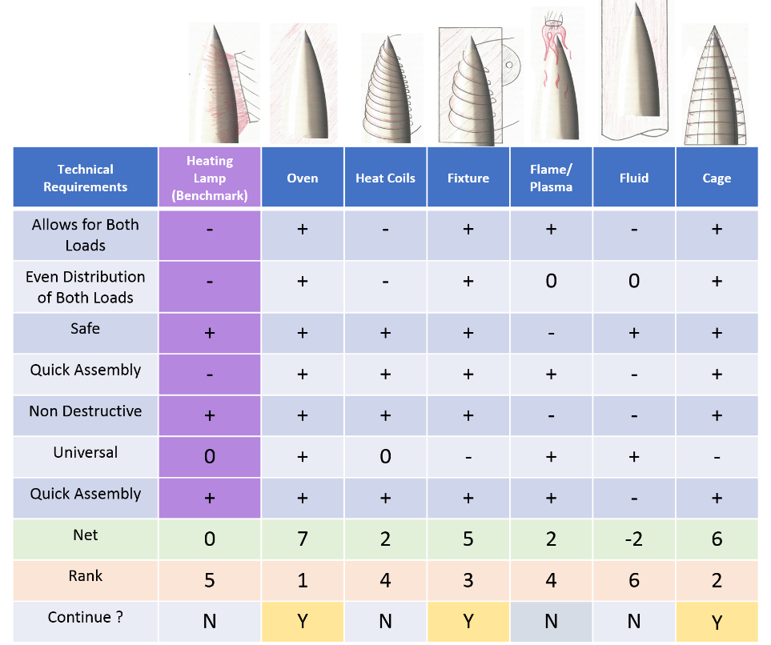

Figure 5: Thermal Loading Pugh Chart

The next set of designs considered are focused around delivering the mechanical load to the radomes. Several of the designs have overlapping features and were previously discussed and they will not be repeated.

1. **Block-** The block is directly connected to the hydraulic ram providing the mechanical interface between the load and the radome. While this design is universal, it will most assuredly create pressure points which could cause the radomes to crack. In addition to this cracking issue, there is an additional issue of the block not allowing the heat to pass through evenly creating a cold spot.
2. **Cradle-** The cradle is similar to the block except that the surface of the cradle is contoured to perfectly match that of the radome. The cracking issue is resolved, however, the cradle still blocks the heat causing uneven heating.
3. **Rings –** The ring or rings are a design which matches the contours of the radome in one or more locations allowing for a more even distribution of heat and mechanical loading. The idea is that this is a compromise between the mechanical and thermal loading.

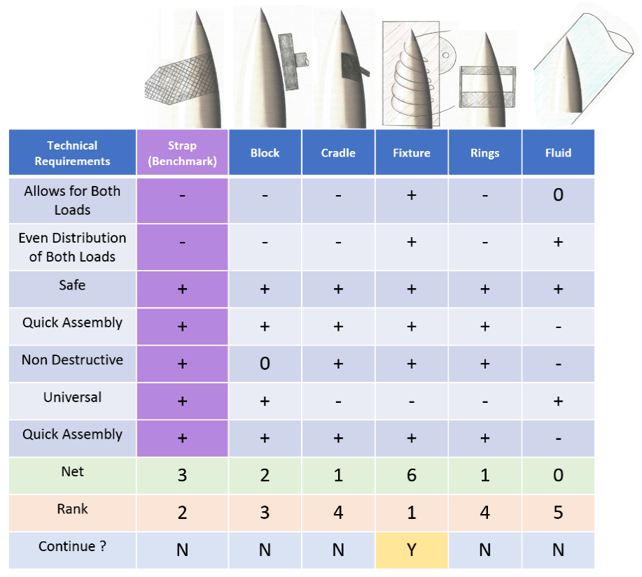

Figure 6: Mechanical Loading Pugh Chart

**5. Design Selected**

5.1 Rationale for Design Selection

As a result of the Pugh charts in Figures 5 and 6, the team decided to continue with the designs that most easily incorporate both kinds of loading. The designs will also need to be able to apply at least a mechanical load of 100,000 in-lb. and a heat flux of about 90 W/cm^2, based on the team’s calculations[1]. One such design is the fixture design, which fulfills all the customer needs except universality. The fixture design is safe, nondestructive, and can be quickly assembled because it is one single piece. The only negative factor of this design is that each radome and leading edge will have to be individually fitted. Other designs that the team will continue to consider are the cage and oven designs. The cage design also fulfills all requirements except universality. Like the fixture design, each part will have to be fitted individually. The oven design fulfills all the customer requirements. It is able to apply both loads simultaneously, as well as apply a constant heat flux across the entire part. This design is also very powerful, and will have no problem applying the necessary heat flux. Although, currently these designs are for only two case studies of the overall design project. As the team designs for more case studies, some other designs may need to be reconsidered depending on how well everything meshes together.

**6. Conclusion**

The redesign of Raytheon’s test fixture at both the system and subsystem level is a complicated task which will require many iterations. The storage, transport and construction of the test fixture will define the performance at the system level. The means in which the thermal and mechanical loads are applied, as well as the measurement data defines the performance of the sub functions. While it is our intention to refine all these design parameters, at this junction we have only begun our case studies. Thorough calculations to determine heat flux and mechanical loading requires further evaluation so appropriate fixture components can be selected. While there is much that still needs evaluating, the design process thus far has illustrated that designs which incorporate the thermal and mechanical loads simultaneously are quicker to assemble and have more consistent load profiles. It is our intention to further explore those paths moving forward.

**7. References**

[1] R. Cunnington, "Recommended Aeroheating Methods", Teleconference, 2018.

[2] Gulfstream Aerospace, ”Ultimate Load Test I,” 2016. [Online]. Available: https://www.youtube.com/watch?v=UGFZ7OWlNpo. [Accessed Feb. 5, 2018].