Team FanFlyer

Semester One CAD package and BOM

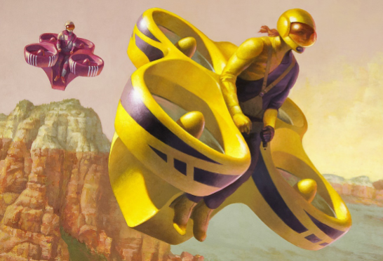

**Parts**

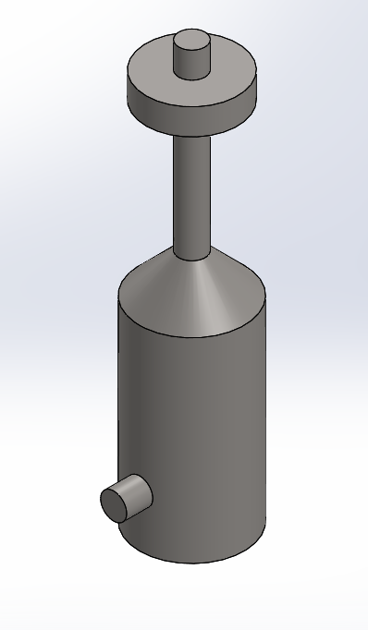

Figure 1: Engine & Crank Shaft (1)

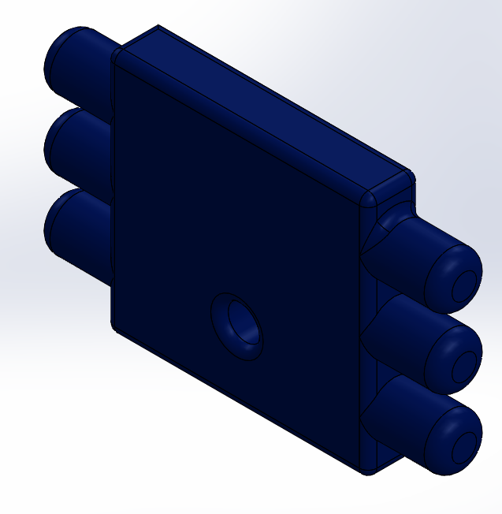

Figure 2: Engine Front (1)

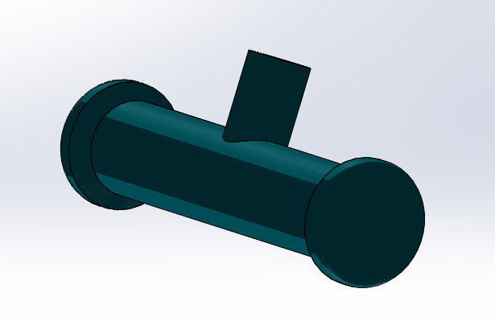

Figure 3: Engine Bottom (1)

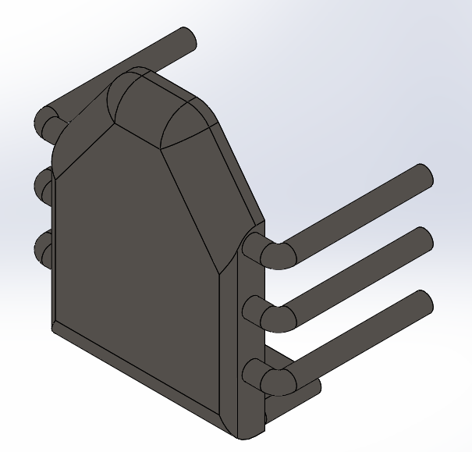

Figure 4: Engine Exhaust System (1)

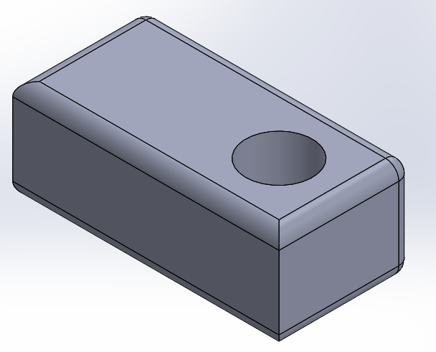

Figure 5: Reversing Gearbox (1)

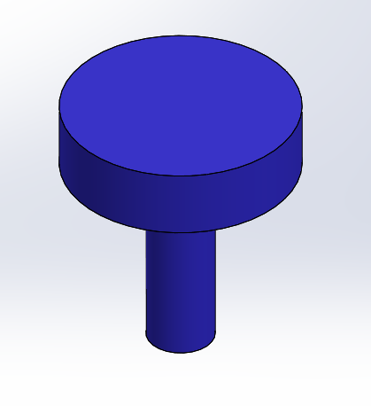

Figure 6: Top Belt Drive (1)

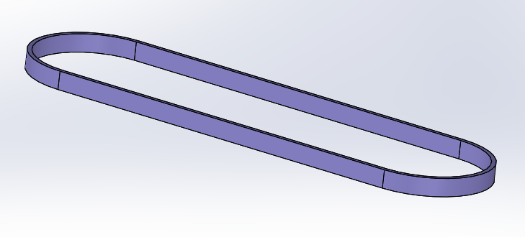

Figure 7: Lower & Upper Belts (2 sets of 2)

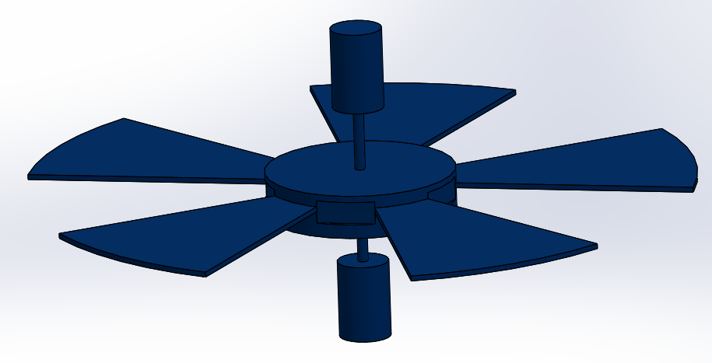

Figure 8: Rotors (4)

**Assemblies**

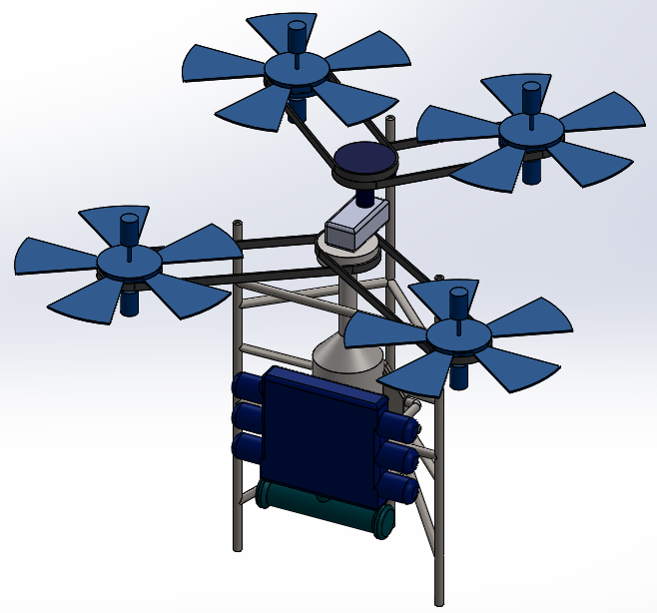

Figure 9: Jim’s Assembly

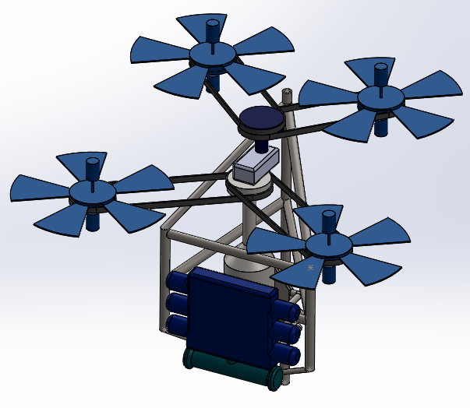

Figure 10: FanFlyer’s Assembly

**Drawings**

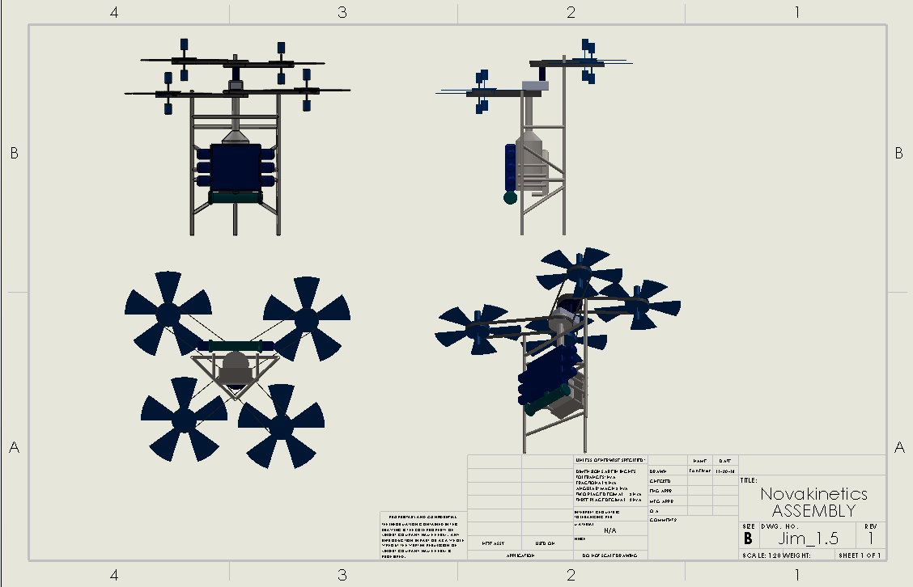

Figure 11: Nova-Kinetics

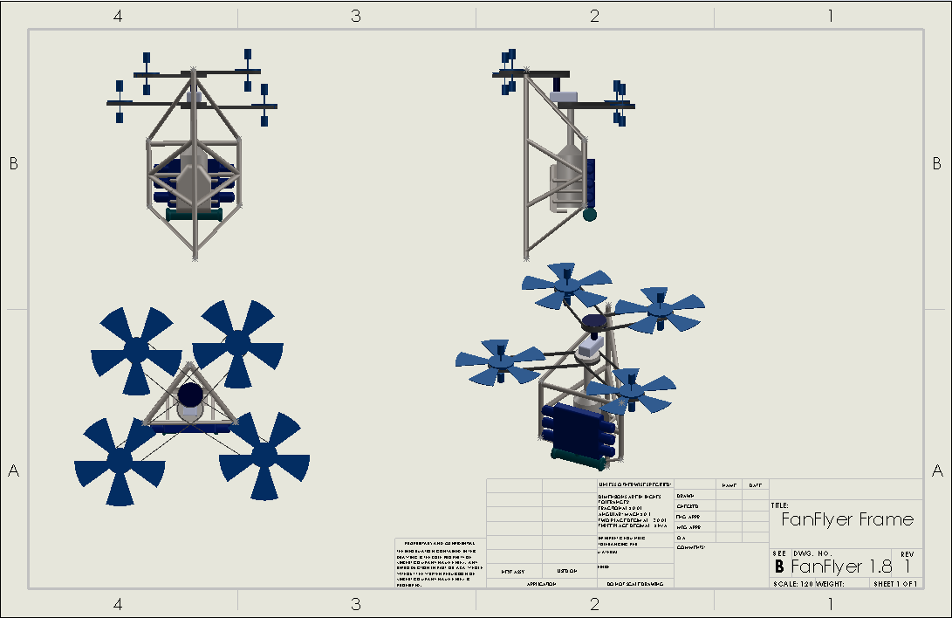

Figure 12: FanFlyer

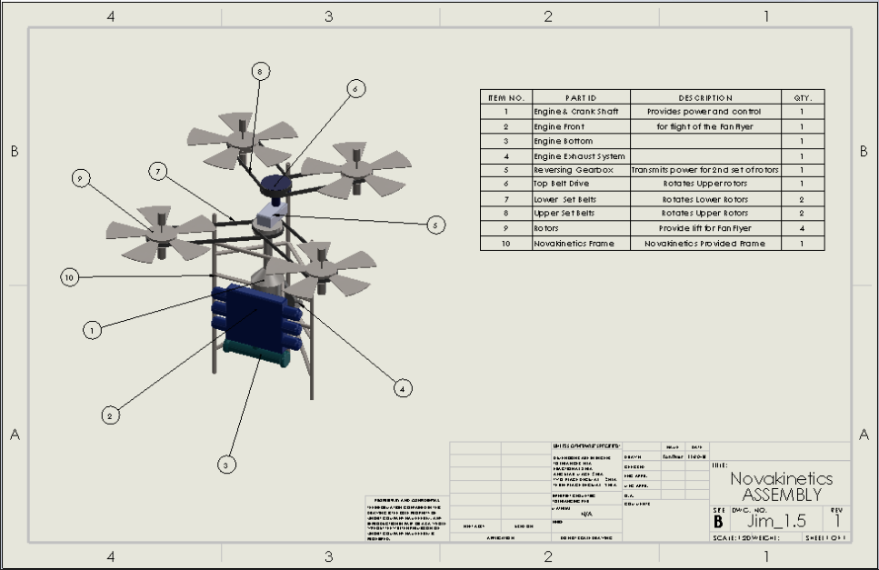

Figure 13: Nova-kinetics BOM with Nova’s frame

Table 1: BOM zoom in for Figure 13

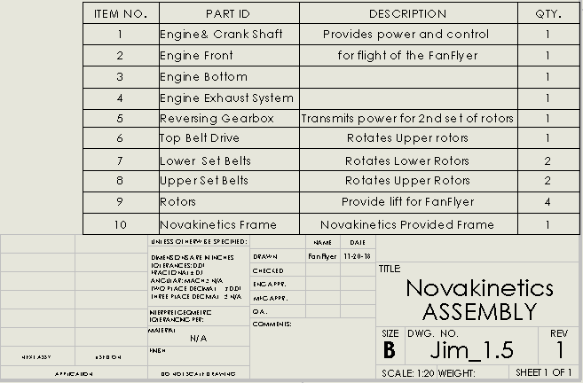

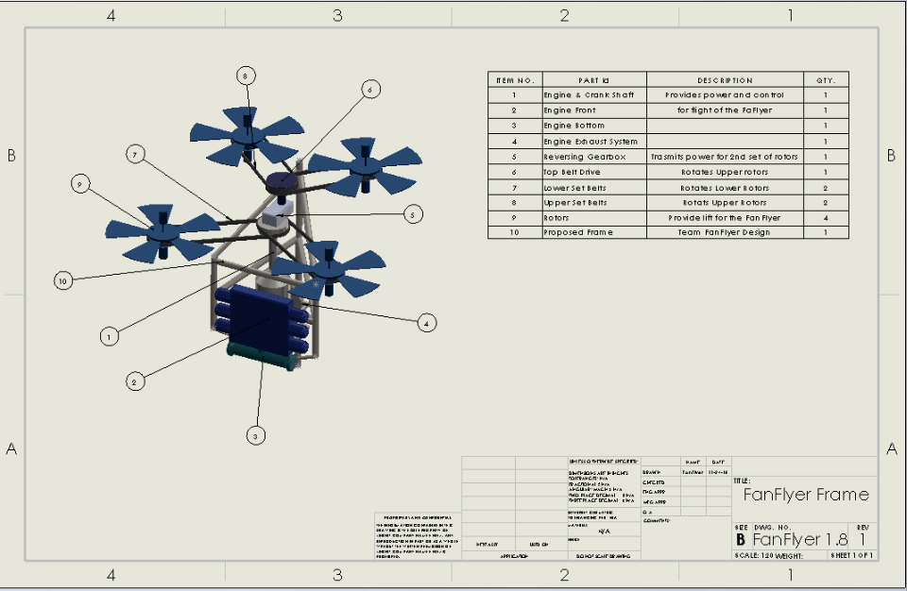

Figure 14: Team FanFlyer’s BOM with Fan Flyer’s frame

Table 2: BOM zoom in for Figure 14

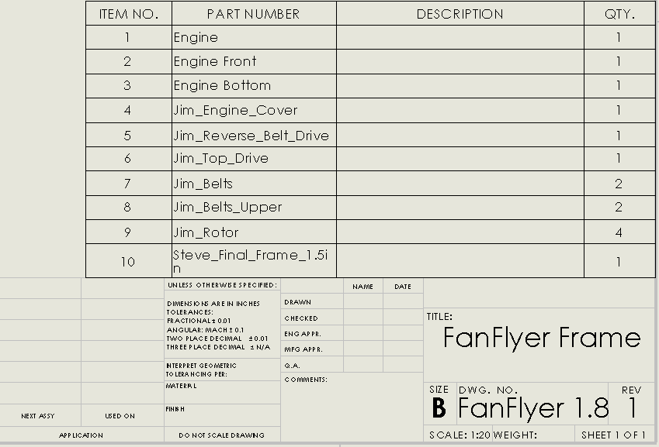

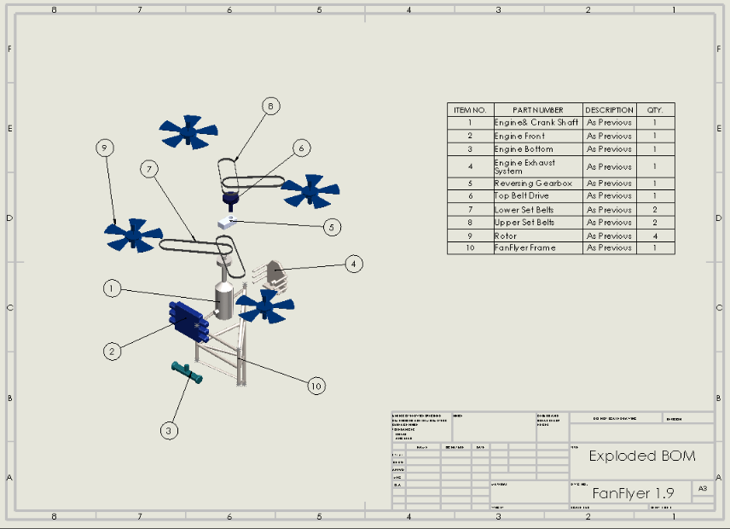

Figure 15: Exploded view of Team FanFlyer Sub System BOM

Table 3: BOM zoom in for Figure 15

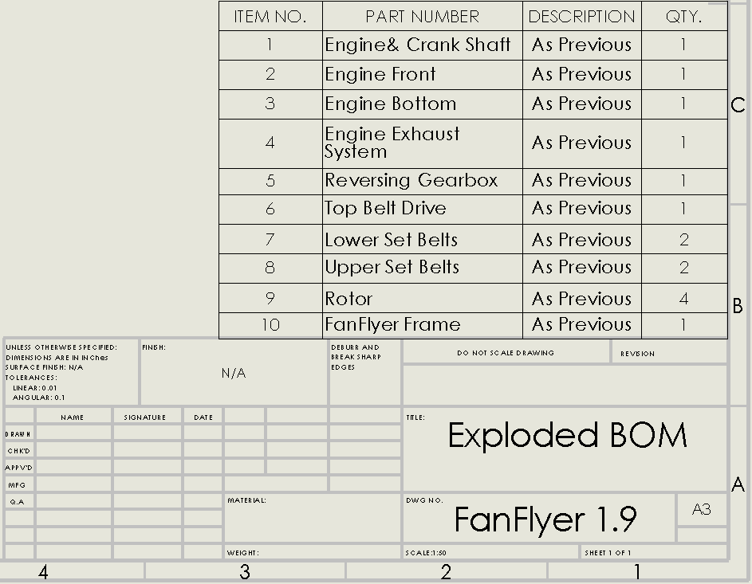

Table 4 – Realistic BOM for 4130 Steel



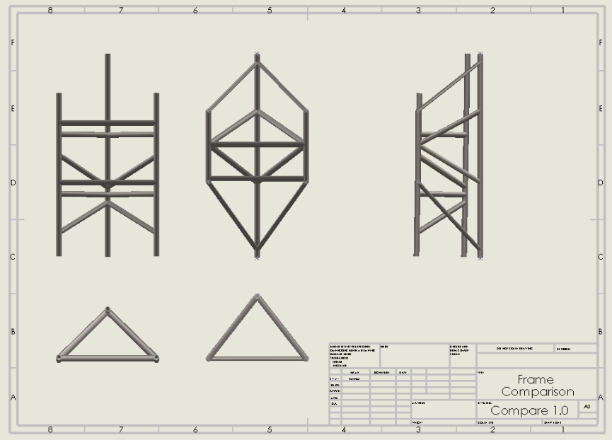

Figure 16: Novakinetics & Team FanFlyer frame comparison

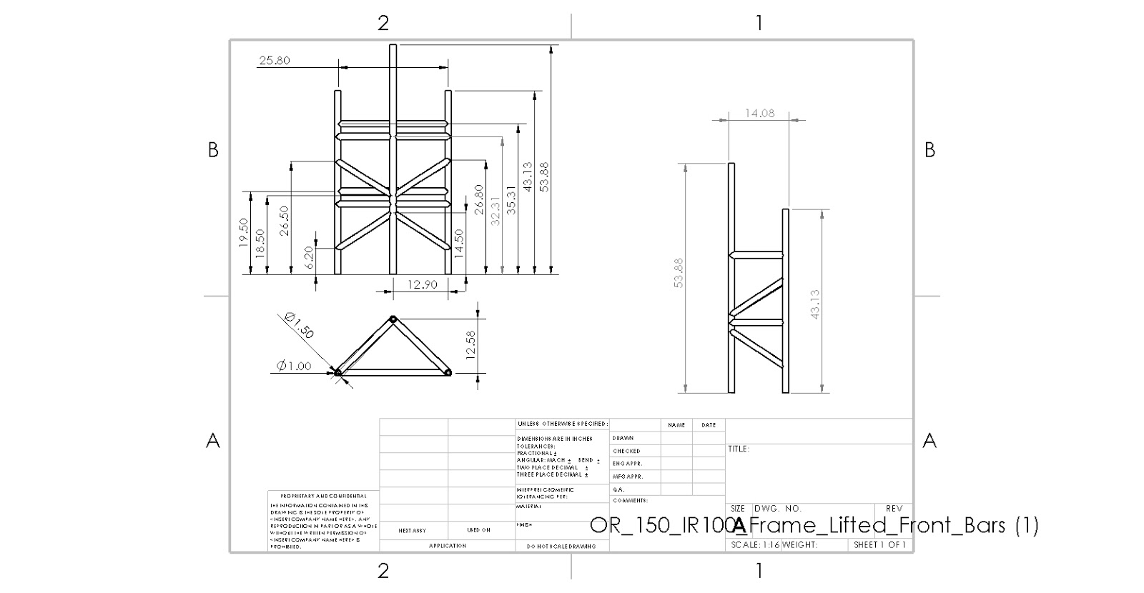

Figure 17: Novakinetics Frame dimensions

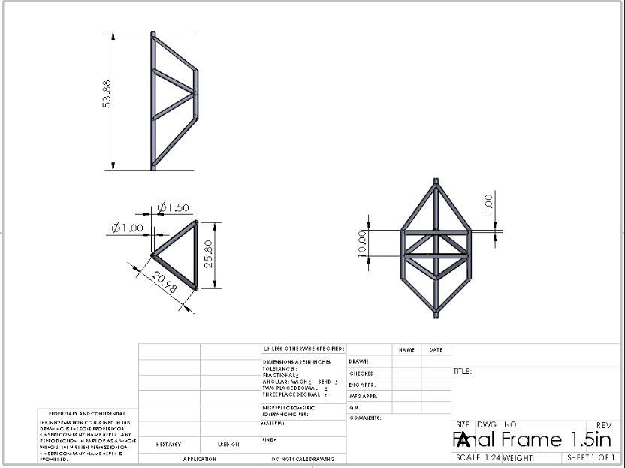

Figure 18: Team FanFlyer’s frame dimensions

**Nova-Kinetics Provided**

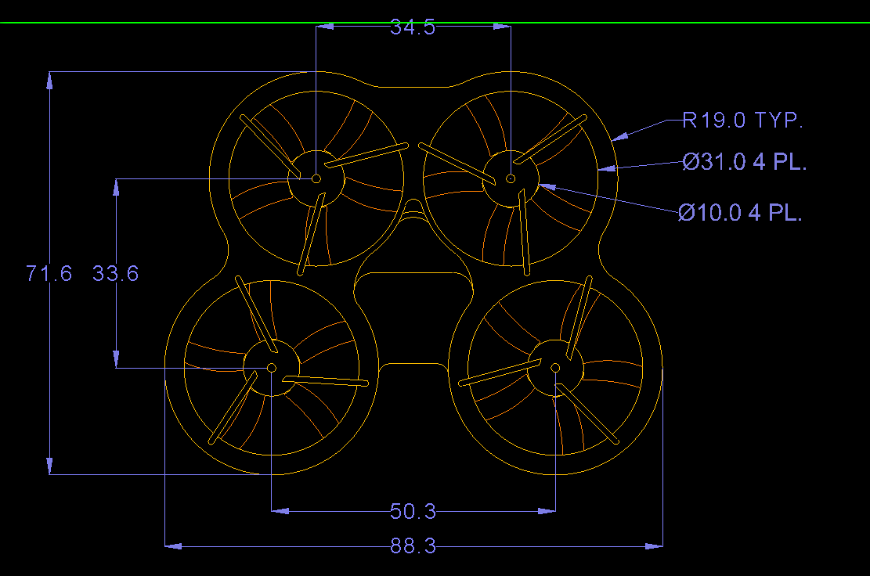

Figure 19: Top view of Nova-Kinetics CAD dimensions

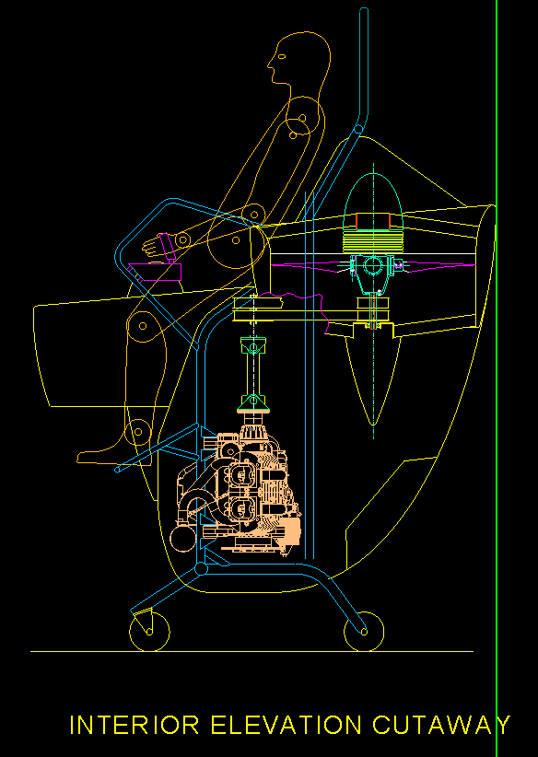

Figure 20: Side view interior of Nova-Kinects FanFlyer with pilot

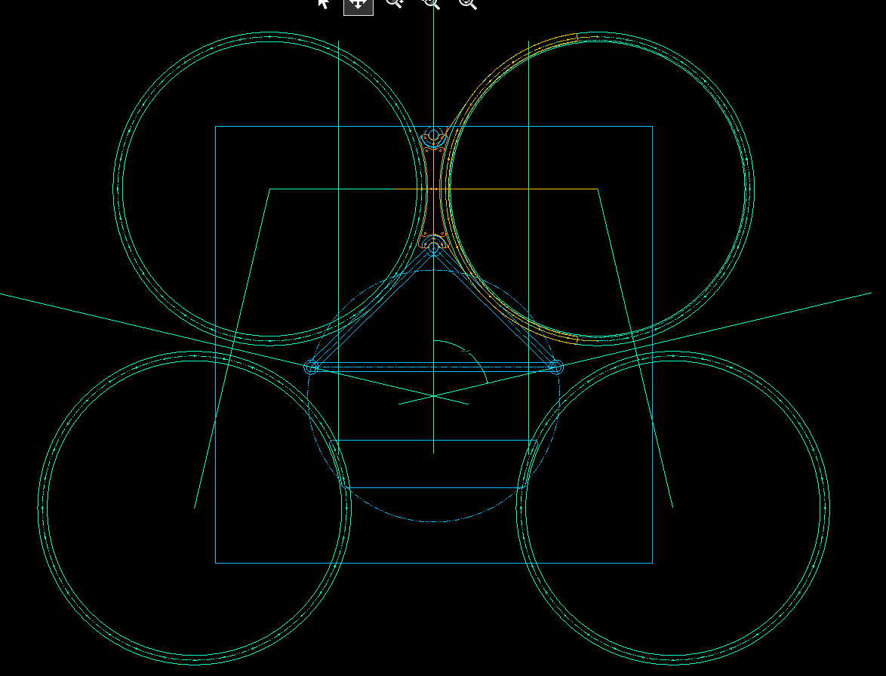

Figure 21: Top view radial position of Nova-Kinects FanFlyer

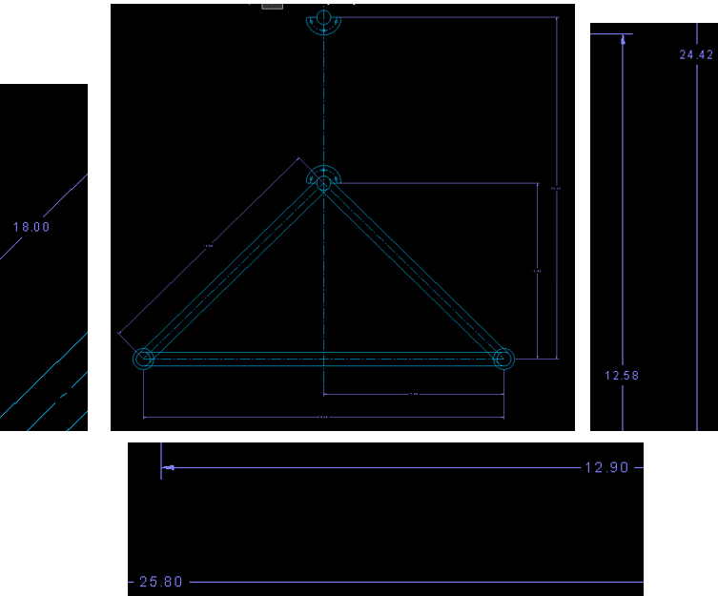

Figure 22: Top view of Nova-Kinetics Frame dimensions

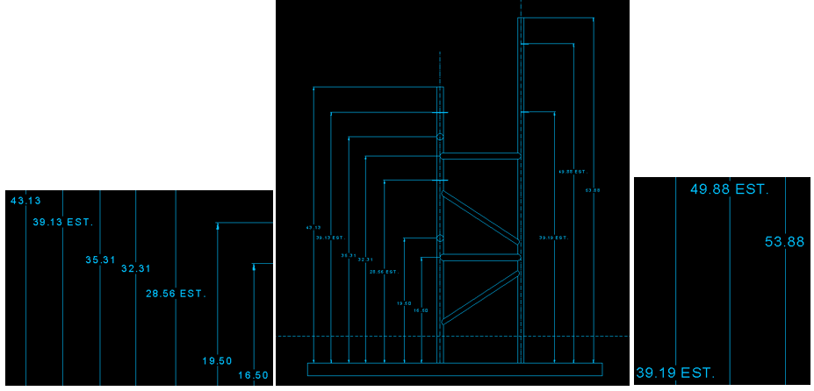

Figure 23: Side view of Nova-Kinects Frame dimensions