Fanflyer – Internal Frame

Final Report

Steve Sorden
Corey Marcum
Nathaniel Schaul
Travis Byakeddy

2018-2019

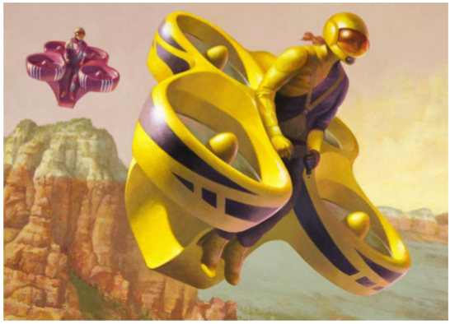

Project Sponsor: Jim Corning of Novakinetics Aerosystems
Faculty Advisor: Brandon Begay
Instructor: Dr. Trevas

DISCLAIMER
This report was prepared by students as part of a university course requirement. While considerable effort has been put into the project, it is not the work of licensed engineers and has not undergone the extensive verification that is common in the profession. The information, data, conclusions, and content of this report should not be relied on or utilized without thorough, independent testing and verification. University faculty members may have been associated with this project as advisors, sponsors, or course instructors, but as such they are not responsible for the accuracy of results or conclusions.

EXECUTIVE SUMMARY
NovaKinetics Aerosystems has invited the NAU FanFlyer team to assist them in their design for their personal Manned-Air-Vehicle (MAV). Jim Corning, the CEO of NovaKinetics Aerosystems is taking part in the Boeing sponsored GoFly competition. By designing their MAV, Jim and his company are hoping to bring home the $1 million-dollar grand prize as well as create a market for their design after it is completed. Jim gave the team a pamphlet at the start of the year containing vital information about the project. In it, the base design for the MAV was already laid out for the team to analyze. The rotors, engines, belts, and outer shell for the design had already been designed and Jim sought out the NAU FanFlyer team for assistance with designing the MAV’s inner frame.
From Jim’s requirements, the team learned about the parameters their design for the frame would need to withstand. The frame will need to be able to sustain all the forces and weights from the rotors, engine, and the rest of the parts from the design. The estimated weight of the MAV is about 900 lbs, the weight of the motor is about 50 lbs, and the weight of the pilot must be at or below 200 lbs. this required the frame to hold together all the parts of the MAV. The target weight for the frame that team decided to achieve was 50 lbs. which is half of the weight of the client’s pre-existing design at 107 lbs. The team decided to cap their maximum weight requirement to be 99 lbs. in order to achieve a lighter weight than Jim’s pre-existing design. For the team this was the most important requirement as shown in the Customer Requirements section.
In order to design and test a proper frame to propose to the client, the team had to take many steps. Gaining information about the design was first on the list. After the team had acquired this information, forces were able to be estimated that were going to be acting on the frame. Calculating these forces were critical for the team’s design in order to design a durable and sturdy frame while still being lightweight. Calculations were divided into two tiers, ‘ANSYS Simulations’ and ‘Hand Calculations’. ANSYS is a Finite Element Analysis program that shows the user the critical points of stress and deflection on a design given imputed imposed forces. For the team, this program was used to analyze their frame’s stresses to locate the weak points and minimum factor of safety. This way, the team knew where the critical points were so they could add supports to their frame’s design where the stresses surpassed the yield stress of the material. The calculations from ANSYS were then to be back checked using closed-form-solutions and validated by demonstrating a convergence with the FEA mesh size. These solutions included a lot of statics such as free body diagrams, method of joints, and truss analysis. These closed-form-solutions were used to check the hand calculation work on the ANSYS evaluations.
After extensive designing and calculations, the team designed a frame to propose it to the client. Using ANSYS and closed-form-solutions, the team checked the stresses and deflections in both the existing datum design, and in the new frame. The team managed to decrease the weight of the frame from 107 lbs. down under 84 lbs. while still maintaining the frame’s structural integrity. The main concern for the team was making sure the yield stresses had a high enough factor of safety, about 1.5 to 1.75, so the frame wouldn’t fail when subjected to the loads from the MAV.

TABLE OF CONTENTS
Contents
Executive Summary………………………………………………………………………………………...………….3
TABLE OF CONTENTS………………….……………………….……………………………………...……….......4
1.0 BACKGROUND……………………………….……..……………………………………………………....7
1.1 Introduction.………………..……………………………………………………………....…….....................7
1.2 Project Description………………………………………………………………………....………………….7
1.3 Original System…………………..….………….……………………………………...…..………………….7
2 REQUIREMENTS………………….………………………………………………...………..……………...8
2.1 Customer Requirements (CRs) …………..…………………………………...……………..………….…….8
2.2 Engineering Requirements (ERs)…………………………………………………....…….………………….9
2.3 Testing Procedures (TPs) ………………………………………………………….....……….….…………...9
2.3.1 Lower cost of material………………………………………………………………...……………………...9
2.3.2 Total empty weight…………………………………………………………………….....………………….10
2.3.3 Total volume….………………...………………..…………………………………….....….…………........10
2.3.4 Precision of structural analysis……………….…..…………………………………......…………….……..10
2.3.5 Factor of Safety within Aircraft Tolerance……….……………………………………..…………………..10
2.3.6 Deflection and stress within tolerance……….….……………………………………....……………..........10
2.3.7 Pilot drag coefficient……………….………………………………….…………………….……………...10
2.4.0 House of Quality (HoQ)…….……………….……………………………………….….……………..........10
3 .0 EXISTING DESIGNS………………………………................................................……………………….11
3.1.0 Design Research………………..…….……….……………………………………….…..…………...........11
3.2.0 System Level ……………………..…………….…………………………………....….…………………..11
3.2.1 Existing Design #1: Hoverbike…..……………..……………………………………..……….…………....11
3.2.2 Existing Design #2: EHang 184…..……….…………………………………………...……………............12
3.2.3 Existing Design #3: Quadcopter Frames.………………………………………….……….……..………....13
3.3.0 Functional Decomposition……………….….……..…………………………………..….………………...13
3.3.1 Black Box Model …………………….….…………..…………………………………..…..……………...13
3.3.2 Work Progress …………………………………………………………………………….…….……..........14
3.4.0 Subsystem Level …………………………………………………………………………….…..………….15
3.4.1.0 Subsystem #1: Finite Element Analysis (FEA)……………………………………………...……………...15
3.4.1.1 Existing Design #1: ANSYS ……………………………………………………………….…..……...........15
3.4.1.2 Existing Design #2: MATLAB………………………………………………………………....…………...15
3.4.1.3 Existing Design #3: SolidWorks……………………………………………………………...……………..16
3.4.2.0 Subsystem #2: Rotor Types……………..……………..…….……………………………………....……....16
3.4.2.1 Existing Design #1: Single Rotor…………………………….…………………………………..………....16
3.4.2.2 Existing Design #2: Multi-Rotor……………………………..…………………………………..………....16
3.4.2.3 Existing Design #3: Fixed Wing Hybrid Drone………..….…………………………………...…………...16
3.4.3.0 Subsystem #3: Materials………………………………..….……………………………………..………....16
3.4.3.1 Existing Design #1: 4130 Steel………………………………………………………………..…….............17
3.4.3.2 Existing Design #2: Aluminum………………………………………………………………….……..........17
3.4.3.3 Existing Design #3: Cold rolled steel…………………………………………………………..……............17
4 DESIGNS CONSIDERED……………….……..……………………………………....…..………………17
4.1 Design #1: Smaller Main Design……….………..…….….…………………………………...…………....17
4.2 Design #2: Three Pole Frame……….………..………………………………………………...…………....18
4.3 Design #3: Hover Pad Frame…………………..…………………………………………...……………….18
4.4 Design #4: Triangular Box Frame ……………..…………………………………………..…..……............19
4.5 Design #5: Race Car Hover Pad……………………….….…………………………………...……............19
4.6 Design #6: Five Point Pole……………………….….….……………………………………....…………...20
4.7 Design #7: Box Frame………………………….…………..…………………………………..…………...20
4.8 Design #8: Simple 3-Point Design…………….………………………………………......……..………….21
4.9 Design #9: Multi-Support Design…………………….…………………………………...………………...21
4.10 Design #10: Supported Tail Frame……………………………………………………...….…..………….22
4.11 Design #11: Open Tailed Frame…………………….…………………………………....………..……….22
4.12 Design #12: Shelf Crate Design…………………………………………………...….….………………...23
4.13 Design #13: Multi-Support Design………………………………………………...…….….……..……....23
5 DESIGN SELECTED – First Semester………..……….……………………………………...……............24
5.1 Rationale for Design Selection……………………..…….……………….…………………...….………....24
5.2 Design Description..…………………………………………………………………………….…………...25
6 PROPOSED DESIGN – First Semester………….…………………………………………..……...............27
7 IMPLEMENTATION - Second semester…...……………………………………………………..………...28
7.1.0 Manufacturing………………………………………………………………………………..……28
7.1.1 Materials…………………………………………………………………………………..……….29
7.1.2 ANSYS……………………………………………………………………………………..……...30
7.1.3 FEA Hand Calculations…………………………………………………………………...……….36
7.1.4 Buckling Stress……..……………………………………………………………………..……….38
7.2 Design Change..…………………….….…………………………………………………..………………..40
8 TESTING……..………………………………………….……..……………………………………............42
9.0 CONCLUSIONS……………………………………………………………………………………………..44
9.1 Contributing To Project Success……………………………………………………………………………..44
9.2 Opportunities for Improvement……………………………………………………………………………….45
10 REFERENCES……………………………………………………………………………………………….46
11 APPENDICES…………………….….……………………………………………………………......…....48
11.1 Appendix A: Black Box model ….………….....….…………………………………...…………...48
11.2 Appendix B: Functional Decomposition …...…………………………………………..…………..49
11.3 Appendix C: Decision Matrix……………….…………………………………………..….……....50
11.4 Appendix D: System level…………………….……………………………………..……..............50
11.5 Appendix E: Black Box Model………………….…………………………………...……………...51
11.6 Appendix F: Functional Decomposition…………………………………………..………...............52
11.7 Appendix G: Decision Matrix & Pugh Chart……………………………………..….……...............52
11.8 Appendix H: Design Models……………………………………………………...............................54
11.9 Appendix I: Hand Calculations & Software Analysis…………………………………..…………..62

1 BACKGROUND

1.1 Introduction

The NAU Fan Flyer team was given the opportunity to assist NovaKinetics AeroSystems with their design to compete in the Boeing sponsored, GoFly competition. Jim Corning, the CEO of Novakinetics tasked the team with designing and analyzing an interior steel frame for their manned air vehicle. The steel frame had to support loads that add to about 900lbs. Novakinetics was looking for a strong and durable frame to act as the backbone for their manned air vehicle. Jim Corning is striving to win the GoFly competition as well as create a market to sell their design with the help of the FanFlyer team’s frame. The GoFly competition is a two year long feat requiring teams from all over the world to generate a personal flying vehicle. After passing the first-year trials, Novakinetics is looking to bring home the million-dollar prize in the second year with the help of the NAU Fan Flyer team.

1.2 Project Description

The following is the original project description provided by Novakinetics AeroSystems; “The FanFlyer will have a ladder structure of welded 4130 steel tubing that connects the engine, landing gear, reversing gearbox, pilot restraint harness mounting points, and ballistic parachute harness anchor point. This steel tube structure will also interface with the carbon fiber shell structure that forms the ducted fan housings. Each ducted fan will have a structural outer shell that connects with the steel tube frame, and an inner duct that is removable, along with the fan hub and supports, for maintenance and for easy updating of ducted fan components.” [1].

To take on this task, the team has learned to use Finite Element Analysis (FEA) and the program ANSYS. Using ANSYS, the team was able to analyze their proposed designs by locating the weak points and areas of high stress on the steel frames. These calculations were then checked by demonstrating a convergence within ANSYS.

1.3 Original System

The original system structure for the Flyer design shown in Figure 1 below, was already designed by Novakinetics. The original system housed four rotors, a combustion engine, generic pilot seat with controls, and a generic landing wheel set. Figure 2 shows an isometric view of the rotor, crank shaft, and the combustion engine. This layout is not yet physically in existence and is still merely a concept in development, because the Flyer is a from-the-ground-up proposal for a working prototype. As a result there is no datum or data to currently compare against. Since there is no original design to improve upon, the designed frame will be the first of its kind for both Novakinetics and for team FanFlyer. Along with being the first of its kind, there is no data depicting how any original system operated, performed, or failed.

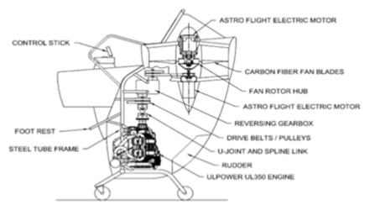
Figure 1 -Original System Layout [1].

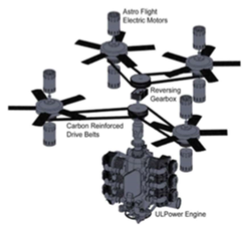
Figure 2 - Powertrain layout [1]

2 REQUIREMENTS
In section 2, the team evaluated the requirements put forth by the client and engineering industry. The FanFlyer team used the requirements discussed to prioritize the aspects of the project into an order of operations in which to complete the project in the best manner possible. This was done to satisfy the expectations of the client by meeting and or exceeding industry standards associated with the project.

2.1 Customer Requirements (CRs)
From the first meeting with the client, the team learned that the customer requirements were vague. It was stated that the predominant feature desired was a lightweight frame that was stable enough to carry the loads given by the MAV. For this reason, the design being lightweight was ranked number one for the team to focus on. This criterion was also important because in the GoFly competition there is a weight limit. A higher factor of safety was the next most important requirement because it would guarantee the frame not yield under the forces imposed on it. Next, stability was classified as the third most important requirement. This was important for the frame because the design had to be aerodynamic and accountable for the center of gravity to keep balance. Next, the joint failure and impact parameters were ranked fourth most important. Minimizing joint failure was important because the stresses and strains were usually localized at the joints, so the team had to make sure the joints were strong. In the instance of a collision, the team also took precautions for impacts. Making sure the design was strong and durable were also requirements because of their importance to keep the MAV from failing and failing over long distances of time. A list of the Customer Requirements can be seen in Appendix A

2.2 Engineering Requirements (ERs)
Nine engineering requirements were derived from the customer requirements by the team for this project. Lower cost of materials was the first and was important because the client needed a realistic price to market their design after it was tested. Next, the total empty weight had to fall under 625 lbs. in order to meet the competition requirements. The total volume could not exceed 275 ft^3 because of the requirements for the GoFly competition. Another engineering requirement the team added was to be precise in their structural analysis. They completed this by using the ANSYS program to demonstrate data convergence. Having the analysis of the proposed frame handed to the client by March 19th was also a requirement in order to give Jim and the team a month to prepare for their first testing. Also, meeting the factor of safety within aircraft tolerances was required in order to meet the industry standards for private aircrafts. Meeting the FAA part 23 and 27 standards were also requirements because it is crucial for the specifications of the structural loads. Another requirement was to meet the deflection and stress tolerances to make sure the design would not wear down over time. A list of the Engineering Requirements can be seen in Appendix B

2.3 Testing Procedures (TPs)
The project was analytical so testing procedures were developed and based on computational and analytical means. Once Flyer dimensions from the client were received, calculations regarding imposed forces and buckling were performed. These were all based on gravity, weight of the overall Flyer, and force output of the rotors. This resulted in approximate forces, stresses, and moments that the Novakinetics’ frame was expected to endure. These results were utilized as a base and placed into FEA hand calculations, and simulations to further guide the analytical and computational analysis. As a result each frame design and calculation required constant improvements and iteration for the calculations and simulations. As such the test procedures were all based on repeated Analytical and Computational calculations
2.3.1 Lower cost of materials:
The cost of materials is somewhat beyond the scope of team FanFlyer. The client has specified a baseline material of 4130 steel for the frame’s construction, but is open to utilizing other types of lighter metals. The client’s openness to other metals, such as aluminum, is not based on cost effectiveness but rather strength to weight ratio. The flyer design for the GoFly competition is a prototype that only needs to be constructed one time for competition. However, despite the client valuing the strength to weight ratio of the material over its cost effectiveness, there is certain dollar value of the steel needed to construct the Flyer. Based on interactions with the client, an approximate cost of 4130 steel 1” diameter pipe can be purchases for approximately $4 a foot.The length in required steel is approximately 80 feet, which brings the total price around $320.
2.3.2 Total empty weight:
In order to validate the total empty weight, two models of the frame were needed to be generated in Solidworks. One was made of full volume matter, and the second was hollowed out. The difference between the two model’s mass weight was generated using Solidworks, by analyzing the design properties. The numerical lbs. values were mathematically differenced to find the total empty weight of the hollowed-out model once the design is finalized.
2.3.3 Total volume:
The total volume of the raw material was verified by hand calculations based on the CAD package given by the client. Adding the individual frame components together gave an approximated overall length of the material, if it were a long pipe. Utilizing the diameter of the desired pipe in the client given CAD package, the volume of the material was hand calculated in relation to the approximate overall length.
2.3.4 Precision of structural analysis:
To test the precision of the structural analysis of the frame, a series of increased mesh size analysis were performed using ANSYS Finite Element Analysis. By doing this the teams goal was to demonstrate that the data would converge to a definite answer by decreasing the mesh size until there was no significant data change. This would allow the team to identify the precision of the data.
2.3.5 Factor of Safety within Aircraft Tolerance:
In order to test for a reasonable Factor of Safety (FOS), closed form hand calculations that were previously mentioned assumed a total weight of 1200 lbs. to 1800 lbs. to account for dead weight that the frame needed to support in the event of a sudden change in elevation. Note, 1800 lbs. is twice the weight of the Flyer itself. This aided in assuming that the four rotors needed to provide an output force of 1800 lbs. to provide lift. Designing for this power output also aided in finding a reasonable FOS for the frame’s design. A baseline factor of safety is considered to be 1.5, which is outlined in the FAR Part 23.2265[2]
2.3.6 Deflection and stress within tolerance:
Treating the overall frame as individual elements, or piece by piece, utilizing the method of joints provided a baseline of expected stress and deflections per element. These values of stress and forces were compared to the metallic properties of the material’s modulus of elasticity, yield stress, and ultimate stress to establish a tolerance limit.
2.3.7 Pilot drag coefficient:
The human drag coefficient is 0.5, knowing this the drag coefficient of the design determined if it met the criteria.

2.4 House of Quality (HoQ)
The House of Quality was generated in accordance to the list of customer and engineering requirements. The customer requirements were weighted appropriately and connected to corresponding engineering requirements. The customer and engineering requirements correlation is indicated by an value of how strong it correlates to the requirement in cross section of both categories. Team Fanflyer’s HoQ can be seen in Appendix C. The House of Quality allowed the FanFlyer Capstone team to keep design requirements organized and to find correlation between interrelated requirements. For an example, strength-weight to price-weight correlations. Because some Aluminums provide a slightly higher yield strength and weight much, much less than 4130 steel, however, they cost 2 to 3 times more than 4130 steel dose.

3 EXISTING DESIGNS
The FanFlyer Capstone team included all the research designs and techniques that had been considered through the project thus far. Within this research the team has used these designs to narrow the scope of the project to find a result that most appropriately fit the expectation of the client. The designs were analyzed and juxtaposed in order to completely understand every aspect of the project.

3.1 Design Research
Although the below references for the Hoverbikes & various drone style cars [3-9] could be cited as potential benchmarks, there are differences in their lift force generation. Novakiniects has selected the ‘2017 Can Am Maverick X3’ engine to provide power to their circuitry and rotor systems. Whereas the references [3-8] do not seem to utilize a combustion engine of any type. However, each of the references do make better use of their rotor placements, and if they do not utilize a combustion engine, they are far superior in design to what Novakinetics is attempting to produce. In relation to said superiority, it should be noted that the design of the Flyer itself is beyond the scope of team FanFlyer. Novakinetics already began production of their flyer’s exterior and had already laid out where they would like the rotors and engine to be placed. Team FanFlyer was tasked with designing an optimal internal support frame that would hold the pilot, pilot seat, four rotors, combustion engine, and battery pack system. As a result, there was not a lot of freedom to research basic internal frame designs for this project. The team was limited by the already decided external flyer frame. Stated differently, team FanFlyer has no say in where the engine, pilot seat, and four rotors will be placed, they were simply tasked with designing a frame that would effectively support all these systems, that was justified by FEA simulations. Quadcopter frames were sought and considered to generate basic geometrical conceptions for sketch designs, beyond that there was little creative freedom on how the frame was to be researched because given the exterior of the flyer being produced, the internal frame had to fit that model from the inside out.

3.2 System Level
What follows are three current, but different benchmark designs that team Fan Flyer reverted to for both inspiration and guidance in satisfying some of the requirements of Nova-Kinetics in Flyer size, weight, and pilot operations. They are Hoverbikes, Quadcopter-cars, and Quadcopter drone frames. Each of the three satisfied a need of the client in some way, or they paved the way for the mental framework of how to approach the Fan Flyer design.
3.2.1 Existing Design #1: Hoverbikes
Hoverbikes in development from Malloy Aeronautics and Hoversurf [2-4], are currently in the testing and funding stages, or in are ready for public sales of their personal hovercraft bikes. They are designed to combine the flight dynamics of a helicopter with the simplicity & compactness of a personalized bicycle. See Appendix D for Hoversurf.
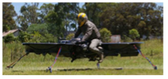
Figure 3 - Mallory Aeronautics [3]
These designs and application meet the client’s CR, of size and weight. Mallory Aeronautics is essentially a large overlapped quadrotor that houses one person and given the size of the tester, it would fit within a parking space of 9’x 9’. It also appears to be lightweight and compact however, no technical specifications were found, but given the size of the rotors it is not an unreasonable weight. The same can be said for Hoversurf, however their rotor blades are oriented in the fashion as current drone-copters.
3.2.2 Existing Design #2: Quadcopter Car
The Chinese based company EHang [6,7], and Italian centered company Italdesign [8,9], have essentially made what Novakinetics is hoping to achieve, only lighter, comfortable, user friendly, and more effective. These drones can be programed to transport one passenger to their desired location with the touch of programed button. Eliminating the need for a pilot to control and fly the air-vehicle. In the case of EHang an entire system mapping out the location of a city can be uploaded via GPS and the passenger contacts a touch screen, selecting a preloaded landing pad to fly to and the drone flies there itself. There is no need for additional flight input from the passenger. They only point and click where they wish to go and the drone does the rest. This is a large scaled coaxial-double-quad-rotor drone with an enclosed seat on top for a person to sit in.
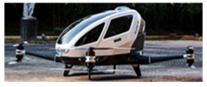
Figure 4 - Full scale working prototype [10]

A tag line of the article claims that it is ‘car sized’, and given the picture and accompanying video this design is about the size of a small car which certainly fits within a parking space to satisfy the CR of a 9’x9’ area. The video also shows one person entering the MAV and seemingly flying off, which accounts for the overall weight of the aircraft and passenger. Judging by the image of the MAV the largest areas of mass is the cockpit which houses the passenger. It would be a safe assumption that the MAV does not require an automotive engine to power the rotors, thereby reducing the weight in both engine and fuel loads. The rotor attachments seem to only be connected to the body via the arms housing electronics and serving as a bridge to the MAV. This seems to imply negligible heat transfer and vibrations experienced by the arms. This satisfies FanFlyers customer’s needs by adhering to approximately fitting into parking space, while also being incredibly lightweight for its personal applications. It is also based on the Client’s quadrotor design.
‘Italdesign’ has a similar concept called ‘Airbus’. The difference is that the cockpit can also be attached to a set of wheels to become a type of smart car. This is beyond the scope of team FanFlyer, however, see Appendix D and ref [9] for more details.
3.2.3 Existing Design #3: Quadcopter Drone Frames
These are frames for current remote-control quadcopters that can be purchased & assembled for hobbyists. Although, the sizes are incredibly small relative to what team FanFlyer is expected to design, they can serve as a benchmark of what to bare-in-mind when designing the internal frame.
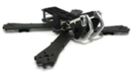
Figure 5 - Quadcopter Frame [9]

These frames give an approximate idea of what team FanFlyer should aim to consider in the project design. The geometries vary and some layouts are impractical for what is being asked, however, Novakinetics is essentially designing a glorified quadcopter. So, it would be in the best interest of team FanFlyer to keep an open mind about quadcopter frames, at the very least for inspirational ideas, if not small scaled geometric analysis. This applies to FanFlyer’s project by understanding the layout of sub-system placements, and how various geometries can be manipulated to accommodate all subsystems. This can be done by locating and understanding the design considerations of the analogous systems to FanFlyer that were accounted for on these Quadcopter frames.

3.3 Functional Decomposition
In order to grasp the design concept and product generation breakdown, the Functional Decomposition for the FanFlyer project was broken up into two aspects, ‘The Black Box model’ and a ‘Detailed Decomposition model’.

3.3.1 Black Box Model
The ‘Black Box model’ for the FanFlyer design encompassed the compositional breakdown of Matter & Energy for the internal frame team FanFlyer was designing, see Appendix E. ‘Signal’ was omitted because a visual cue of the frame integrity was beyond the scope of team FanFlyer. Novakinetics will install their own method of validating the performance quality of in-flight frame integrity to their pilot operations system if they choose. This is in large part because team FanFlyer was not being asked to build the frame itself, but rather to provide supporting data for Novakinetics to use in making the frame themselves. However, they do not need anything from team FanFlyer aside from the frame construction data to achieve that system on their own. So, this Black Box model only houses ‘materials & energy’. See Appendix E. Materials for the Matter component of the Black Box model, the following ingredients are in the physical construction of the support frame:
● 4130 Steel
● Welding materials
● Fasteners (bolts, nuts, rivets, etc.)
● Finite Element Analysis (FEA) data

Energy
For the Energy portion of the Black Box model the following sources of influence will be experienced by the internal metal frame, or will be entering the system (input) upon its use in the manned aerial vehicle (MAV):
● Forces (stress, strain, gravity)
● Heat
● Vibrations

The functional response, or ‘output’, will be the following:
● countered acted forces to balance the input forces experienced by the frame
● Heat dissipation &/or resistance
● Vibrational damping & redirection

3.3.2 Work Progress
The Decomposition Functional Model was based on four tiers of consideration to generate team FanFlyer’s project design, they were: FEA, Customer Requirements, Imposed Caveats, & Materials. See Appendix A. The project breakdown of what will generate the team’s FanFlyer design was based on these four tiers of influence. They served as the parts to help guide and direct the teams justified design.
FEA
The cornerstone of this project, from the initial project description, is Finite Element Analysis. Novakinetics asked NAU engineering for an analysis for an interior metal frame for their FanFlyer MAV, which encouraged their construction designs of the frame. Novakinetics already determined the exterior design & geometry of said flyer, and have selected a ‘2017 Can Am Maverick X3’ engine for their initial trials. However, they are still in search of the proper rotors to use. The FEA simulations have accounted for the forces imposed on the frame by the main engine and the four rotors, in conjunction with the weights of the pilot, the pilot seat, pilot controls, battery system, and circuitry systems.
The FEA component of the project is broken into two areas, of ‘ANSYS’ & ‘Theory’. The ANSYS branch was comprised of learning how to use the FEA program ANSYS, where the team had to double check the results of ANSYS by using a closed form hand calculation of the Frame. The theory aspect was learning the basics of FEA theory to better understand the boundary conditions and element constraints of the FEA simulations. Dr. Penado was an unofficial resource for basic questions of FEA because he teaches the FEA class in the spring of each year. Further initiative was performed to find free online courses, lectures, and textbooks to learn FEA on the teams’ own time.
Customer Requirements
Mr. Corning’s requirements, that applied to team FanFlyer, were based on the GoFly competition’s constraints of total empty weight of 625 lbs. and total volume of 275 ft^3. As such Novakinetics has already designed & constructed the exterior framework of the MAV. The geometries they have decided upon, based on the competition requirements, are team FanFlyer’s baseline requirements to adhere to. The internal Frame itself has a target weight requirement of 50 lbs. with a max of 99 lbs., and the proposed geometry must accommodate the total volume limit, which will include the application of all the mechanical systems.
Imposed Caveats
These are forces & phenomena that must be considered due to the presence of the required matter in the MAV, like engine & rotor weights, heat transfer, and vibrations. These forces & phenomena will be experienced by the designed frame and will be accounted for.
Materials
The material (matter) makeup of the frame has a baseline material recommendation of 4130 steel, however Novakinetics is open to suggestions regarding alternative materials. Welding various beams & bars in combination based on the design composition will greatly aid in the overall frame strength, but will provide additional matter to the system. Welding joints and fasteners to each other will also be installed in some fashion to the frame for its integration into the MAV.
The layout of these four tiers help to map out all the external and internal influences to team FanFlyer’s design. They each encompass a different branch of required influences that the team must adhere to.

3.4 Subsystem Level
What follows are three subsystems that Nova-Kinetics and Fan Flyer are based on, Finite Element Analysis (FEA), Rotor Platforms, & Materials. These subsystems have proven useful in other applications and products around the world for various situations. Here they not only served as a type of bench march, but also to served as considerable options for analysis references, like comparing different types of FEA software as a check or for comparing different types of metallic properties to one another. These subsystems have variable applications, constituents, variations, Pros and Cons. Within each subsystem three variations of each will be addressed.
3.4.1 Subsystem #1: Finite Element Analysis
As mentioned earlier, FEA is what the entire FanFlyer project is based upon. A proper analysis using FEA techniques will help support the desired geometrical designs of the proposed internal metal frame. This analysis has shown various stress/strain concentrations of the frame based upon applied loads and forces in relation to the geometrical layout of the designed frame. For subsystem #1, three programs that can perform Finite Element Analysis of solid mechanics are presented: ANSYS, MATLAB, & Solidworks. They each have their strengths and weaknesses when applied to various systems and conditions. For the purposes of FanFlyer, because of simplicity and availability, ANSYS will be utilized.
3.4.1.1 Existing Design #1: ANSYS
ANSYS is a powerful tool for numerical analysis relating forces and physical phenomena to physical geometrically defined systems. The software has branches in fluid mechanics, solid mechanics, & electricity, among other subjects [10]. For purposes of FanFlyer the structural analysis component of ANSYS was utilized for the interior support frame of the MAV. It related to team FanFlyer’s project because ANSYS is readily available for the team’s use, and can perform reliable FEA simulations, which is what is required per request of Novakinetics.
3.4.1.2 Existing Design #2: MATLAB
Matrix Laboratory (MATLAB), has numerous built in mathematical functions that can perform numerical calculations and can produce simple vectorized simulations based upon boundary conditions and mathematical descriptions. These conditions and descriptions require the user to properly input syntax code to generate the proper simulations. This FEA approach is beyond the capability of the members of team FanFlyer. However, its relevance to the project could, when coded correctly, be able to see how the forces & phenomena relate to the frame mathematically. This would help design the frame from a different physical perspective.
3.4.1.3 Existing Design #3: SolidWorks
Solidworks, which is used mainly as a drafting tool for team FanFlyer, also has FEA capabilities for simple geometries. Solidworks applied to team FanFlyer because the sponsoring professor, Dr. Trevas, recommended that the team attempt basic FEA simulations using Solidworks to gain any results and understanding. Aside from the simple FEA simulations, Solidworks was utilized for drafting the proposed frame concepts because ANSYS requires a CAD packaged model to perform analysis on.
3.4.2 Subsystem #2: Rotor types
There were four types of aerial drone platforms, Single-Rotor, Multi-Rotor, Fixed-wing, & Fixed Wing-Hybrid. ‘Single’ is basically a helicopter design, ‘Multi’ is anything more than one, ‘Fixed-wing’ is essentially an airplane usually with horizontal rotors, & The ‘Hybrid’ is a fixed wing drone with one or more helicopter style rotors attached to it [11]. Nova-Kinetics is designing their Flyer with 4 rotors which classifies as a Multi-Rotor aerial vehicle. Only three of the four will be discussed here, Single, Multiple, and Hybrid. ‘Fixed-wing’ was be omitted because Nova-Kinetics’ Flyer does not fit within this category.
3.4.2.1 Existing Design #1: Single Rotor
Single Rotors are the most commercialized currently with the applications of helicopters [12]. The tail rotor does not contribute to the rotor count so most helicopters are still considered Single-Rotor vehicles. This design has been in use for decades and as such has proven its reliability. Nova-Kinetics’ Flyer will operate like a helicopter considering it’s hovering and pitch capabilities. However, rather than one large rotor it will be comprised of four smaller rotors.
3.4.2.2 Existing Design #2: Multi-Rotor
Multi-Rotors, or multi-engine aircrafts rotors fall into this classification [12,13]. Drones of this nature are aerodynamically unstable and require onboard electronics to assist in its flight controls. It was brought to the attention of Nova-Kinetics that such an on-board capability may be required for their type of multi-rotor application as well. Nova-Kinetics’ FanFlyer is an upscaled Quadcopter (Multi- Rotor) and this directly applies to team Fan Flyer’s design and consideration.
3.4.2.3 Existing Design #3: Fixed Wing Hybrid Drone
Fixed-Wing-Hybrids are an amalgamation of a fixed wing design with any number of helicopter style rotors [14]. This offers the best of both worlds in providing the vertical takeoff and landing capabilities of a quadrotor with the speed, and range of a fixed wing aircraft. This is adding one extra powerful dimension to the design of current quadcopters, and is beyond the scope of team Fan Flyer’s design and requirements, however it does provide a baseline of control in the various potentials that Nova-Kinetics could branch into.
3.4.3 Subsystem #3: Materials
What the frame is composed from is highly important. It will react differently if it were made from metal or plastic, which will determine the life and function of the frame under its intended use. ‘Materials’ is a design tier from the decomposition model, and houses welding and fastener materials. However, for the bulk of expected materials, team FanFlyer does not have much experience working with metals or plastics under extreme conditions that the MAV will endure. However, at the recommendation of Novakinetics, welded 4130 steel is offered as a base material for the frame’s material construction.
3.4.3.1 Existing Design #1: 4130 Steel
The Client of Novakinets has recommended 4130 steel as the base material, but was open to alternative justified suggestions. The advantages of this option are that not only was it recommended by a mechanical engineer who is also the president of the Novakinetics, it is incredibly strong, and will yield before it breaks. This applies to the project in satisfying the integrity of the internal frame of the MAV by yielding before breaking. As such it is incredibly strong and under the correct ratio of cross diameter geometries to thickness (wider diameter & thicker walls, or visa-versa) it can withstand the imposing forces that it is expected to experience.
3.4.3.2 Existing Design #2: Aluminum
Aluminum, although light and strong, can be brittle in comparison to 4130 steel. Under certain conditions and geometries, more Aluminum may be required to equate to the strength of the 4130 steel. Alloy 3003 is an aluminum alloy that can compete with steel. It is 20% stronger than most aluminum because it is injected with magnesium to increase its strength. Alloy 3003 is also extremely easy to weld which is an important factor for this project because the client desires to weld the parts of the MAV to the frame. Not only this, but Alloy 3003 has properties for preventing corrosion which will expand the life of the frame. This relates to the project because it was mentioned in meetings with the client that certain alloys of aluminums may work.
3.4.3.3 Existing Design #3: Cold rolled steel
Cold roll steel was used before the use of 4130 steel. It is incredibly durable; however, it is heavier and not as hard as 4130 steel is. 4130 steel is a standard for current aircraft materials because of its simplicity in its workability, of forming, welding, cutting and fastening. Whereas cold rolled steel is not as ‘flexible’ because it is lacking a similar hardness. This relates to the project because although 4130 steel is far superior, cold roll steel does offer a potential alternative if used accordingly.

4 DESIGNS CONSIDERED
Included within this section are the designs that have been proposed and evaluated thus far. Each concept has a description and picture associated with it in order to fully explain what the team was aiming for in the design concept. Included in this section are only a portion of the designs considered but were the best, most creative, or most inspiring to the group.

4.1 Design #1: Smaller Main Design
This design came from the advice of the client of this this project, but on a smaller scale and with some additional features. This design was lighter than the clients but did not protect the pilot and was unstable in comparison to the original.

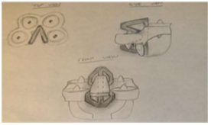
Figure 6 - Design #1 - Smaller Main Design

4.2 Design #2: Three Poll Frame
This design was brainstormed off the client’s idea of using a 3-point system for the device. Three long poles connect the seat to the outer shell of the design. This design was lightweight, and easy to test and manufacture. However, it was not aesthetically pleasing, not stable, and had a good chance of joint failure
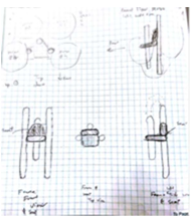
Figure 7 - Design #2 - Three Poll Frame

4.3 Design #3: Hover Pad Frame
This design was another design based off the advice received from the client. This design was light, had near to no possibility of joint failure, was safe and was easy to manufacture. Some disadvantages include that it was not easy to test and it was not stable.
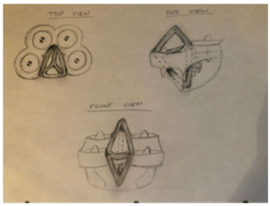
Figure 8 - Design #3 - Hover Pad Frame
4.4 Design #4: Triangular Box Frame
This design was once again conceived from the client’s three-point system. It was much like the three-poll frame but with smaller poles and with supports on the right, left, and bottom of the sides of the seat. This design was heavy, provided no ease of load testing and was not safe. However, it had great stability and a low chance of joint failure.
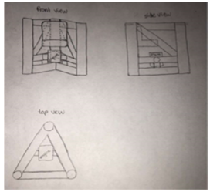
Figure 9 - Design #4 - Triangular Box Frame
4.5 Design #5: Race Car Hover Pad
This design was once again based off the advice the client relayed to us requiring a 3 point-of contact system. This design was light and did not have joint failure. However, it was not safe or stable.
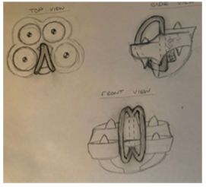
Figure 10 - design #5 - Race Car Hover Pad

4.6 Design #6: Five Point Pole
This design was based off a five point-of-contact frame instead of three points. It was light, easy to analyze, and pleasing to the eye. However, it was not balanced and could have joint failure because of the five cantilever beams extruding from the base pole in the back, this frame would have been subjected to high bending moments which would in turn cause high stresses at the joints of each of the five poles.

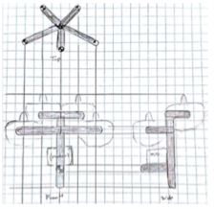
Figure 11 - Design #6- Five Point Pole

4.7 Design #7: Box Frame
This design does not meet Jim’s requirement of having a 3-point of contact system. However, the design was lightweight and safe for the pilot. It also could have been unstable and weak at the joints.

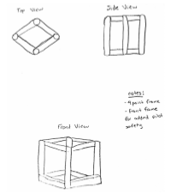
Figure 12 - Design #7 Box Frame
4.8 Design #8: Simple 3-Point Design
This frame was designed to be simple and lightweight. However, as such the design was weak at the joints and was prone to failure from loads because of its triangular-box simplicity. A missing cross beam, to allow for the pilot to sit allows for torsional deflection to take place.

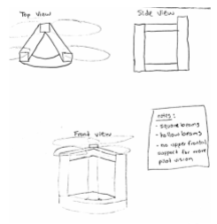
Figure 13 - Design#8 Simple 3-Point Design

4.9 Design #9: Multi-Support Frame
This frame was designed to be structurally sound and stable. It utilizes several support beams to make sure the forces acting on the frame would not let it yield. However, this design was heavy which objects with the customer requirement; lightweight.
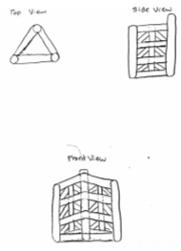
Figure 14- Design #9 Multi-Support Frame

4.10 Design #10: Supported Tailed Frame
This frame was based off of the new six point design the client gave to the FanFlyer team. This design is to provide stability and support in the back for the pilot seat. there are horizontal supports around the entire design and some cross supports to provide extra strength to the overall design. the tail is for supporting the pilot seat and is supported by cross supports..
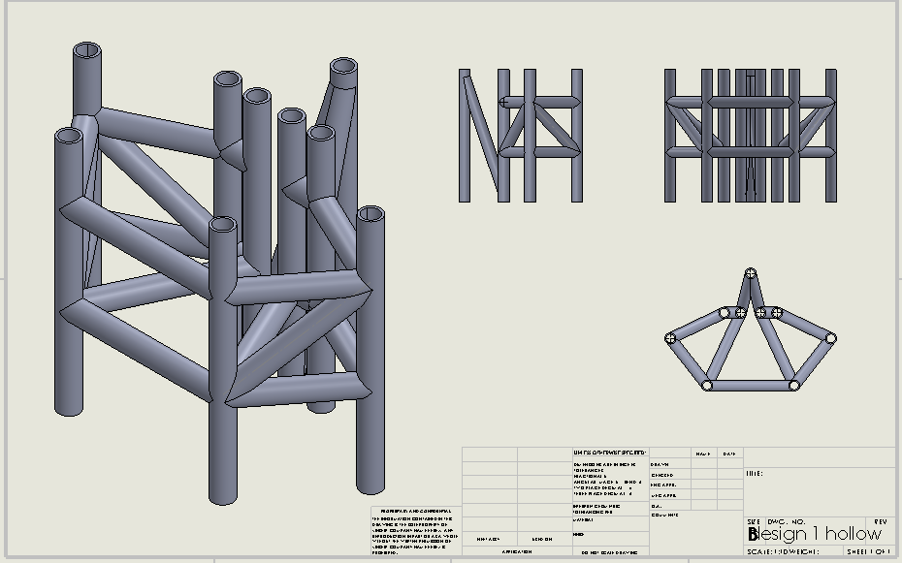
Figure 15 - seven point redesign with support

4.11 Design #11: Open Tailed Frame
This frame was designed to be similar to design #10, but lighter and with more space to place the engine and rooters. the entire design is cross supports around the design. The tail is once again for the pilot seat and is also supported by cross beams.
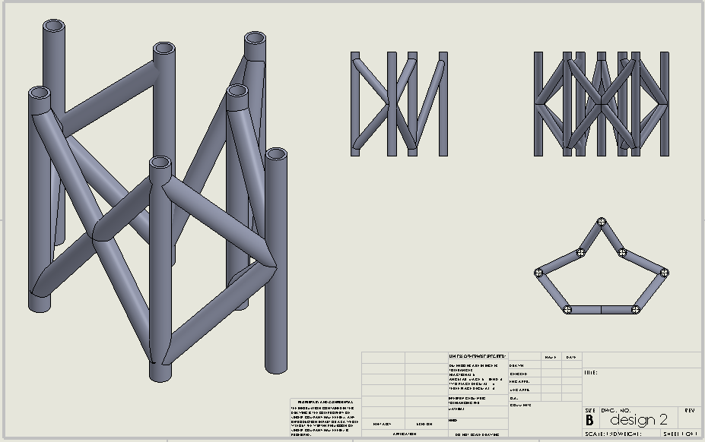
Figure 16- seven point redesign open

4.12 Design #12: Shelf Crate Design
The shelf crate idea was inspired by a three level shelf. The additional cross beams connecting the vertical six point bars were inspired by a 2 x 1.5 foot milk crate. The additional cross bars provide additional support for the engine block and help distribute the weight of the pilot and Flyer itself to be evenly dispersed among the cross bars. This is a six point design.
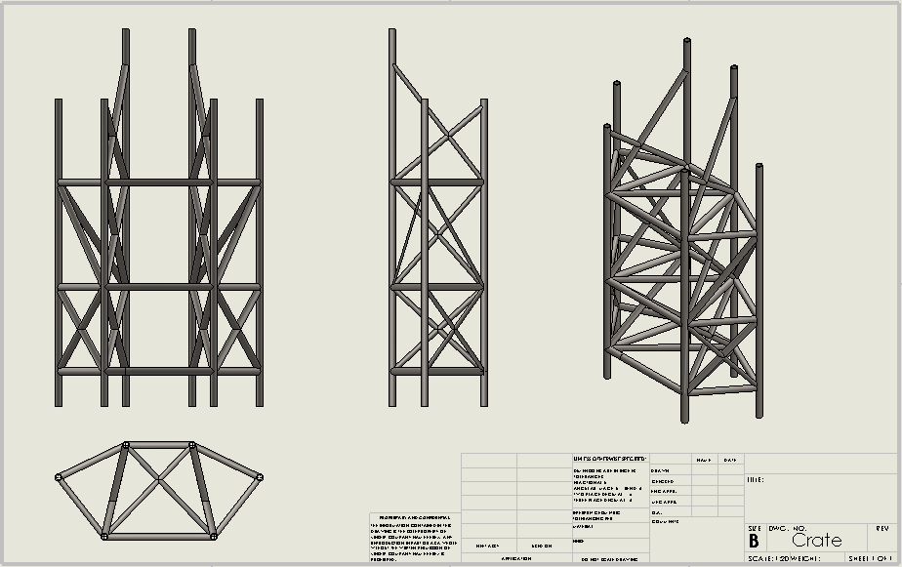
Figure 17 - Redesign involving six points

4.13 Design #13: Shelf with Big tail
Feeding off design #12 above, the Shelf crate idea was implemented with a large tail to help support the rear dual rotor ducts. The tail, in theory, helps to transmit the force imposed by the rear rotors to be disbursed among the cross beams of the frames. To reduce the weight of the frame, portions of the crossbars in design #12 were removed to allow for the extra weight of the bars from the larger tail.This is a seven point design.
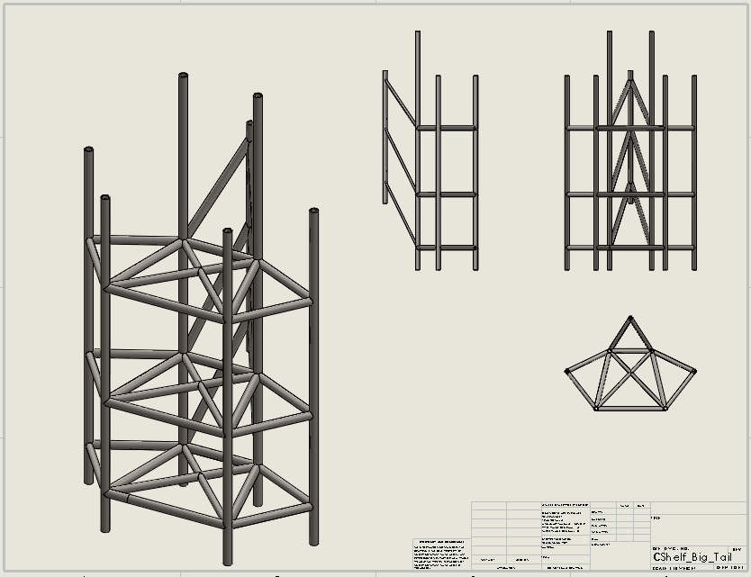
Figure 18 - Redesign involving seven points
5 DESIGN SELECTED
The client wanted the FanFly team to aid in his company’s participation in the GoFly competition. The team was to design an internal frame for the aircraft he had proposed. The Criteria was that it needed to be lightweight, stable, and safe. The design had to be within 900 lb. operating weight, could remain stable on the ground or in the air for 20 minutes, and had safety measures in case of emergency. The client also wanted the team to keep the device within 9x9 ft ground area to be able to fit within a parking space. After examining the considered designs the team reached a final decision, through the Pugh chart and the decision matrix in Appendix G and chose to use design #3.

5.1 Rationale for Design Selection

First Semester Design:
Through the team’s help of the decision matrix and Pugh chart the team was able to narrow down its choices into a singular selection that met the necessary requirements and proved to be a more sound choice than the datum design offered by the client. As can be seen in the Pugh chart and decision matrix located in Appendix G. Design #3 came out as the best choice for the team to pursue. In the decision matrix where the designs were evaluated on the given criteria alone where decision #3 outperformed the next best design which was #4. The Pugh chart allowed the team to analyze the designs against the datum offered by the client. In the Pugh chart and decision matrix narrowly beat the 5th design on how it compared to the datum. The team evaluated the design and decided it best meets the required standards by being more lightweight, stable, aesthetically pleasing and safer than the client design proposal.

The design was chosen to be more lightweight based off the fact that overall it involved less of the material needed to be constructed. Based off the simple notion that whichever material the analysis determines to be the best for the project a less quantity meant less weight. The design was determined to be more stable because it offered a suggested lower center of gravity which created an increase in balance and stability. The design was encouraged to lower center of gravity based on a basic visual evaluation and until the team could use FEA simulations and closed form hand calculations to determine if the design is more stable, they moved forward with the evaluation and at the time of evaluation would be able to adjust the design to fit the required stability. The aesthetics was a subjective category and was decided based off the team’s preferences. Lastly the design was determined to have a higher operator and safety score simply because the design implemented a directly integrated roll cage into the design.

Second Semester Design:
During the Second semester the client presented the team with a new layout of the frames connection points. Initially, in the first semester the team had only three connections points between the frame and the outer shell of the frame. When the team returned, however, the client had determined that the frame would now be required to have 6 points of connection with an additional seventh point for a future addition of a ballistics parachute. Although this seems like a minor change in the design, it had major implications on the process of the frame design. The team had to scrap the designs they had from the first semester and generate new concepts for the second semester so that the new frames could be analyzed. All other components and attributes of the frame established in the client and engineering requirements, however, remained the same from the first semester to the second. The 6 point connection can be seen further in the report at figure 23. This topic is discussed further in section 7.

5.2 Design Description

First Semester
The datum design constructed by the client was offered in a CAD package that provided the detailed specifications of the frame. The CAD package that was used can be viewed in Appendix H Figures 26-28.

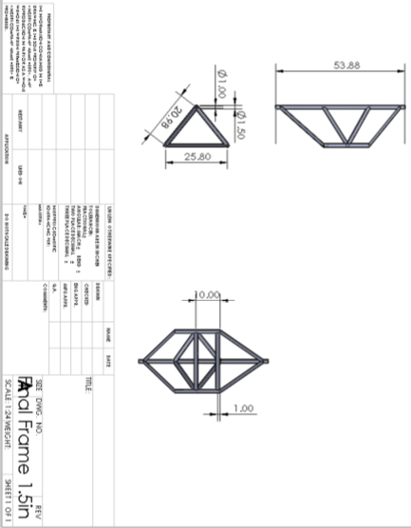
Figure 19 – FanFlyer frame design
The team then used Solidworks to develop a CAD package. This 3D model allowed for a full visualization of the design in its full measurements and determine areas to be improved on. The team then moved onto turning the selected design sketch into a 3D Solidworks model that was created using the specifications required by the client, Figure 19. The 3D models of both the datum client design and final proposal design can be seen in Appendix H Figures 24 & 25. The CAD models were compared using the Solidworks software to determine the differences between the two frames. The finalized frame was determined to be approximately 17 lbs. lighter when they were analyzed using 4130 steel suggested by the client. This analysis confirmed the team’s initial assumption that they could cut weight from the datum design. The frame weight also came in under the maximum weight requirement of the client. The team continued to evaluate other materials to determine which would be best based off the other analysis that performed in the future using the ANSYS software. The team had been working through the last semester teaching themselves the ANSYS program to analyze the frame through FEA. The team was far from proficient using the software but had made headway in ANSYS as well as analyzing the frame using closed form hand calculations. The hand calculations can be seen in Appendix I Figure 29 & 30. The hand calculations were used to determine the static stresses and deflection of the frame using the forces acting on the frame. These hand calculations are performed in order to create a baseline of what the finite element analysis should return using the ANSYS software and helped determine how accurate the analysis was. The team had received basic results from ANSYS, though they were far from finalizing results on the frame. The preliminary ANSYS results can be seen in Appendix H and shows a brief glimpse into what the stress results should have ultimately look like and what the team was working towards.

Second Semester
During the second semester the team went through many different design iterations in-order to establish a final proposed frame design for the client. The final proposed 6-point frame with an additional 7th point for ballistics parachute design can be seen in figure 25. The design was established after many design iterations that ultimate didn’t hold up within the analysis of ANSYS therefore additional cross members were added to strengthen the frame internally. The team’s design also required mounting points for the motor and internal components required to power the MAV. These mounting points became pivotal to use as fixed points in the final analysis of FEA. Additionally, the team was able to introduce increased levels of safety by adding a roll cage and points of contact for a 5-point safety harness, all required to keep the pilot unharmed and in control during flight.

6 PROPOSED DESIGN

The team planned to implement the design by providing a full analysis of all stresses, strains, deflections, and possible failure propagations, of the team’s proposed frame compared to the datum frame provided by the client through the ANSYS data and by hand calculations.
This data was presented to the client and showed how both the frames will perform in relation to one another under the same conditions. To do this, a printout and write up of the calculations found in ANSYS, along with hand drawn static analysis on the design, was used in order to demonstrate the capability of the team’s final design. It was also shown that calculations on the volume and weight of the design would be much lighter and smaller than the datum frame from Nova-Kinetics.
Additionally, because the team’s project was based solely on data analysis, and was not constructed by the team, there was no costs, budget, purchasing, or assembling of the frame on team FanFlyer’s part. The only budget that was considered so far was the purchasing of an ANSYS software book.
The frame was to be welded and as such there were no components that made up a bill of materials aside from the frame material, and its projected quantity. Nova-Kinetics had established a baseline of 4130 Stainless Steel as the material. However, research and analysis were ongoing to find more robust material to outperform this. Regardless of the material selection the material in conjunction with the frame had to be below 99 lb. and if team FanFlyer choose to remain with 4130 steel, the client would remain happy so long as the requirements were met.
The table below was the team’s most realistic Build of Materials (BOM.) As stated only the material of the frame made up the frame itself because it was to be welded together. Along with the material was both the baseline and projected quantities of the material, along with the geometry type with the inner and outer diameters. The projected quantity was based on Fan Flyer’s frame and the baseline quantity was based on Nova Kinetics frame. These were based on Solidworks dimensioning of 28.34 feet for FanFlyer’s design, and 26.78 feet for Nova-Kinects frame design, where an additional 5 feet were added to accommodate for waste, because these numbers represented the combined length of each pipe that makes up the finished frame model.
Table - 1 Frame Materials BOM
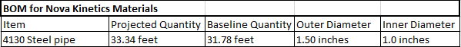
The team ultimately created a CAD view model of the components that were provided by the client, that the frame supported, but that are also outside the scope of the team’s project. This model was created in order to get a better understanding of how the outside components fit within the frame and where they were in relation to the frame. These components were the motor, the rotors, belts, the fan ducts, the emergency parachute, the pilot controls, and the landing gear.
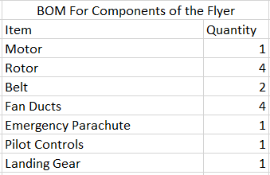
Table-2: FanFlyer Components BOM
In conclusion, team FanFlyer had hit a few roadblocks and setbacks in relation to ANSYS and FEA software, due to the lack of experience of both aspects for all members, however despite the slow progress, progress was still being made, and the team knew how to perform the required hand calculations in order to supplement and validate the ANSYS simulations.

7 Implementation - second semester

7.1.0 Manufacturing
Manufacturing the FanFlyer frame is currently a one time production. However, the long term plan is to produce and market the FanFlyer design to commercial and military aircraft providers in the event of a successful flight and implementation. The later is currently beyond the scope of team and as stated previously all cost analysis and production is centered around producing one frame, because the task at hand is to manufacture a working prototype. In order to facilitate the manufacturing of the FanFlyer frame four branches of analytical analysis must take place in the areas of: Materials, ANSYS, FEA hand calculations, and Buckling stress. Each providing an aspect of analytical performance that contribute to the depth of production in manufacturing. ‘Materials’ is a key physical component making up the total contribution to what is going to be purchased and why. The ‘ANSYS ’ component is the key visual feedback of the imposed forces acting on the proposed frame based on the client induced maximum forces. ‘Hand calculations’ supporting or challenging the ANSYS analysis are paramount because using a program such as ANSYS is merely a tool of simplicity while ‘hand calculations’ provide the necessary validation of engineering decisions. ‘Buckling stress’ accounts for the main type of failure associated with beams and frames. Since the FanFler frame is essentially a complex beam, accounting for buckling stress per bar element of the frame is necessary. These four components help to facilitate the ease of manufacturing by accounting for the cost effectiveness of the selected material in relation to price vs. strength, providing computational and analytical validation for the geometric design that optimizes the most cost effective use of the geometry and materials to strength requirements, and for accounting for the most likely cause of failure in a frame.

7.1.1 Materials
The team took the liberty to test different materials for which could be considered as frame material substitutes of the client recommended 4130 steel. A list was compiled from typical frame materials that were used in bike frame assembly. This specific category of material was selected because bike frames provide a good amount of rigidity and strength while remaining very light in weight. This was a crucial emphasis from the client at the beginning of the first semester when discussing frame design. The materials were compiled and compared based off their modulus of elasticity, yield stress, weight, and price per weight. All materials were first considered for their price and weight based on three specific test specimen volumes. These materials can be seen in Table 2 below.

Table 3: Materials Properties to Determine Price Per Weight [15] [16] [17] [18]
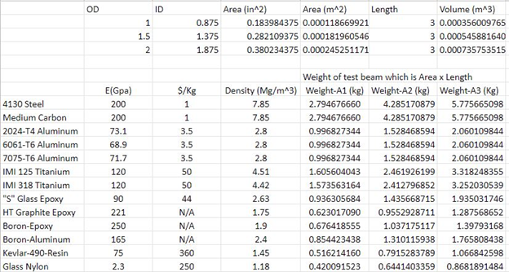

Based on the results from the Table 3 the team could ultimately eliminate multiple materials compared to the datum of 4130 steel. The materials that were eliminated were done so because they were well outside the price region that could be justified compared to the 4130 steel. Other considerations were made on the ease of manufacturing and obtaining the materials to eliminate some of the composite materials suggested. Eventually, the team was able to limit the comparison between the steels and the aluminums. The 4130 Steel and Medium Carbon steel were combined in one category because of their similar properties.

The remaining materials were placed in Table 4 to compare their strength and subsequent deformation under a given force. The force chosen was 2500N which would be experienced on the frame by the force from the rotors. Table 4 shows the material’s modulus of elasticity, yield stress, and the stresses for each of the three areas and their related stresses.

Table 4: Materials stress and deformation [14] [19] [20] [21]

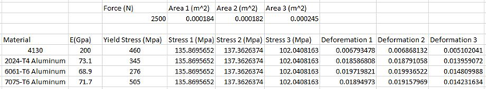

At first glance it appears that indeed 4130 steel is the best material to use because of its ease of manufacturing, cheap price per weight, and great resistance to stress and deformation. Although, with a closer evaluation the team would make a legitimate case for the use of 7075-T6 Aluminum. The 7075-T6 Aluminum offers a higher yield stress than 4130 steel and despite deforming almost three times as much as steel in comparison the deformation is only .01m more for aluminum which is arguably negligible and therefore insignificant for the case for steel. The biggest argument for the use of 7075-T6 Aluminum is that it is roughly one third the weight of steel. This would be a significant savings in weight for the frame structure. Currently, the teams model frames with 4130 steel are estimated to be around 90lbs. If the material was simply changed to aluminum than the team’s frame designs would save roughly 60lbs. This is an estimated 6% savings for the overall weight of the FanFlyer. That may seem like a small amount but it is significant when designing aircrafts. The only foreseen downside to building the frame out of Aluminum versus steel would be that it is around 3.5 times more expensive. So ultimately it comes down to the client's discretion on whether saving weight or money is more of a priority, however, from working closely with the client, the team projects that their priorities will be focused on saving weight.

7.1.2 ANSYS

To facilitate confidence in the Flyer’s performance ANSYS simulations were performed on team designed frames for immediate feedback. After countless trials and errors these simulations provided a general area of frame improvement within minutes. This helped to quickly identify areas of immediate improvement. Though the results did not provide exact solutions, they provided immediate problems to further iterate upon. Such as weak, or at -risk members as can be indicated in Figure 20.

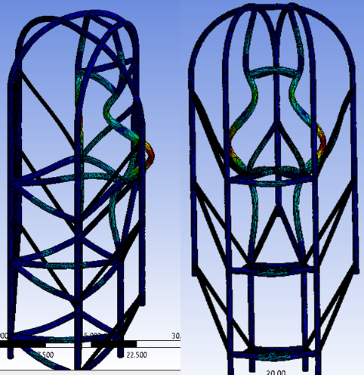
Figure 20 - Weakest member. Isometric and Front (One image)

As an example, Figure 20 shows a pair of at-risk members when the loads were applied. It also showed what would be the other likely members of the frame that would be affected as a result. This type of instant simulation feedback provided a reasonable guide on what to consider when improving the design.

Simulations were based on moment forces derived from a previous individual analysis performed by one of the fan Flyer members. Figure 21 showcases the Flyer as a whole compared to the acting moments locations imposed on each of side of the frame. Since the frame is symmetrical, only one side of the moment values need be present. Moment arms, denoted in red arrows, represent the imposed moment forces that connect to the frame at different heights. This is represented by the floating arms in the Flyer of Figure 21. Figure 21 shows the relationship between the moment forces and the frame, and gives an approximate visual of the moment relationship to the flyer based on the rotor’s axis of rotation, denoted by the four floating cylinders.

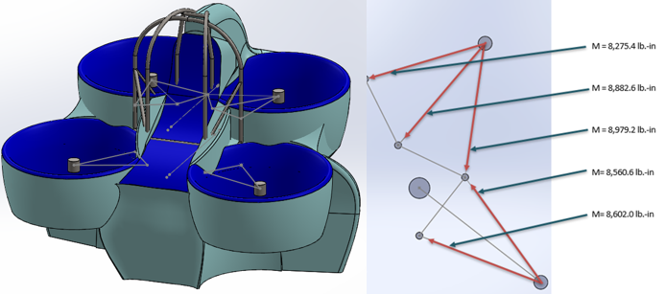
Figure 21 - Moment forces and directions (One image)

It should be noted that the red arrows, and floating lines in Figure 21 only represent an approximate visual representation of the geometry for the moment force analysis. Figure 22 shows the actual rotor connections to the rotor duct, and Figure 23 show how said connections and ducts relate to the FanFlyer as a whole. In reality parts of the moment forces will also be transmitted to the rotor ducts. An analysis of this is beyond the scope of team FanFlyer because the ducts are not considered part of the frame, as was stipulated by the client.

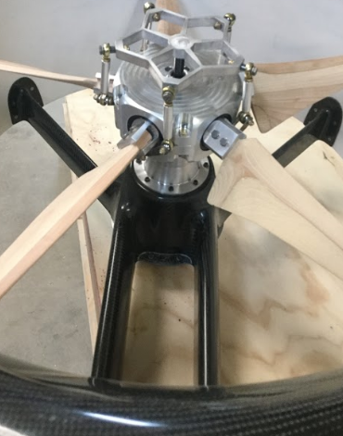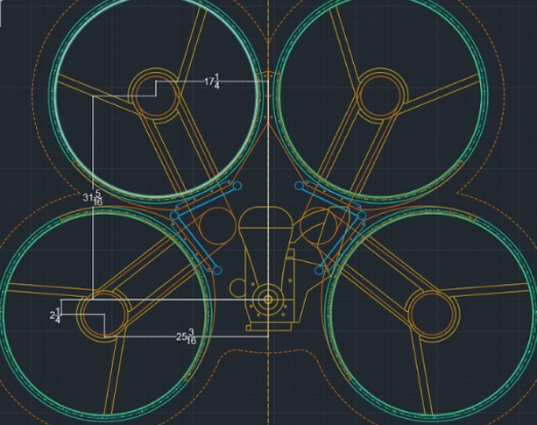
Figure 22 - Actual rotor connections Figure 23 - Actual Rotor Geometry

The moment forces calculated were based on the maximum thrust output capabilities of each rotor at approximately 70 HP and 460 lbs as seen in Figure 24. Figure 24, depicts the power to lbs relationship provided by the pre-analysis performed by Novakinetics [1]. Designing the frame for the maximum force output generated by each rotor was a logical group decision. Because this considers that the potential maximum amount of imposed stress that the frame can be potentially expected to endure is accounted for.

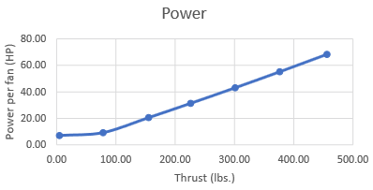
Figure 24 - Thrust projection per rotor [1]

The proposed Frame to date can be viewed in Figure 25 below. This recent design is based on the client’s requirements of a seven point frame, roll cage, and additional motor reinforcement beneath the pilot seat. Figure 26 shows the approximate visual representation of how the frame from Figure 25 will fit into the Flyer shell. Figure 26 shows a clear indication of how the Flyer will look.

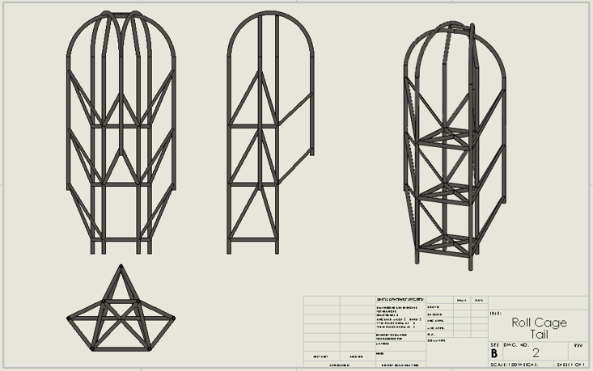
Figure 25- Seven point Roll cage

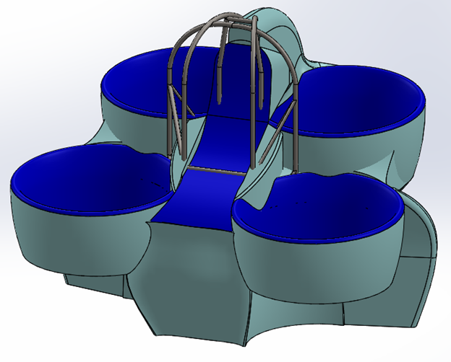
Figure 26 - Frame and Shell integration

Figure 27 and 28 are the ANSYS post-processing results for deflection, stress, and strain respectively. In a previous analysis assignment the option to relocate the fixed point to either extreme ends of the top or bottom was brought to light. It has since then been deduced to best have the fixed point located close to the center of gravity of the frame, indicated by the yellow arrow at the center frame of Figure 27. Using the frame’s center of mass region to place the fixed point allows for the assumption that all forces revolving around the center of mass will inherently revolve around the frame’s natural balance point. However, this does not account for the actual weight distribution and vibrations of the motor and rotor drive belts. For purposes of the frame analysis it is assumed that a center of mass point with which all forces will act around is a reasonable assumption as far as treating the frame as a static system, where the system is what is moving rather than the frame moving through a system.

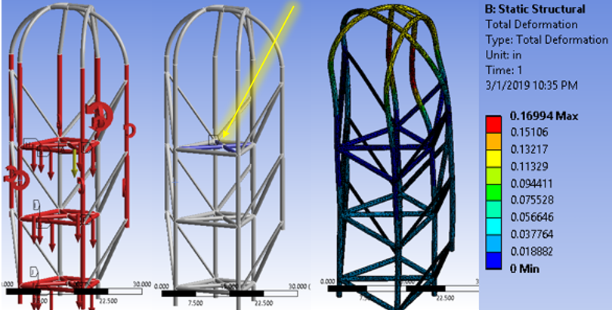
Figure 27 - Frame deformation with the fixed point at the center (One image)

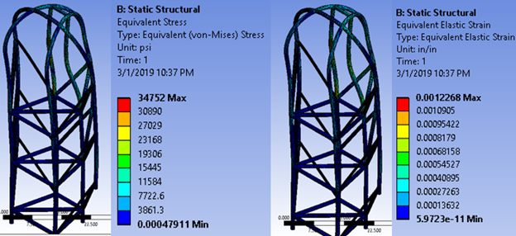
Figure 28 - Stress and Strain with the Fixed point at the center (One image)
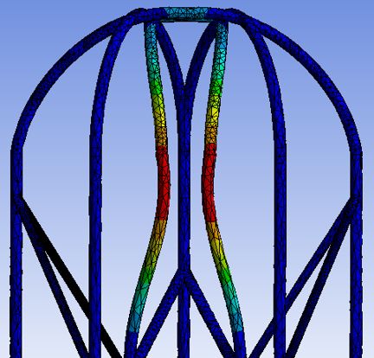
Figure 29 - At risk frame members. Front view.

Upon viewing the ANSYS results of the recently proposed frame, it can clearly be seen that the target areas for improvement lie within the roll cage area of the top portion of the frame. Figure 29 shows the at-risk members of the roll cage to be addressed. The at-risk members are the most prone to all three areas of concern in deflection, stress, and strain. This brings the analysis for manufacturing to light by using ANSYS to validate and search for at-risk components. In order to prepare this frame for manufacturing, the roll cage portion of the frame requires design attention and analysis. In contrast, however, as can be see in Figures 27 and 28, the lower portions of the frame supporting the engine block and rotor shafts are all within the dark blue range, indicating an approximate stability in design. Using this information from the post-processing portion of ANSYS the team is also identifying what cross members can be removed while maintaining the same, if not similar, structural integrity.

Figure 30 shows the imposed forces acting on the frame. Vertical lines indicate gravity influenced forces, while circular arrows represent moment forces from the rotors. Frame members highlighted in red indicate the frame members that are directly exposed to said forces. The final weight of the Flyer as a whole can be no more than 900 lbs, however the current simulations are set at 500 lbs of weight per horizontal level of the frame. This brings the total simulated weight to 1500 lbs. accounting for a dead weight factor of 1.67. Despite this 67% increase in projected Flyer weight the lower portion of the frame appears to withstand considerably more weight than the Flyer itself.

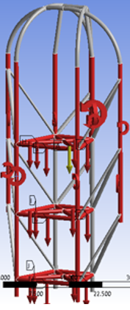
Figure 30 - Frame forces

The computational analysis utilizing ANSYS gives an immediate response of where at-risk components are, and how to address them. Whether it be by altering one parameter at a time in the simulation set up to see what is effected, or by localizing and sifting out the weakest portion of the frame, ANSYS is a powerful tool for immediate feedback. This has help guide the design process heavily as far geometry, and hand calculations go. Because performing certain hand calculations require a new set up each time requiring a start over every time, computational methods give an approximate output that can be refined using calculations.

7.1.3 FEA HAND CALCULATIONS

Because the completed frame design has not been approved, the team has neglected performing FEA hand calculations for the entire frame. In this section, the team will be showing FEA hand calculations for simple truss elements using two different kinds of materials; 4130 Steel and 7075-T6 Aluminum. The purpose of these hand calculations were to show the deformation in a simply supported truss for these two different materials. Constants for these calculations can bee seen in Figure 31. The area was chosen to stay constant at 0.283 in^2 for a pipe with an outside diameter of 1.5 in and an inside diameter of 1.375 in. The length was chosen to remain constant at 5 in and the force acting at node 2 was constant at 10000 lb. Because of the way the truss is supported, node 1 was fixed to keep the deflection at node 1 constant at 0 in. The team used the direct procedure to first calculate the stiffness matrices before solving for the displacement vector. The results for deflections at node 2 for each material can be seen below in Figure 31 and Figure 32.
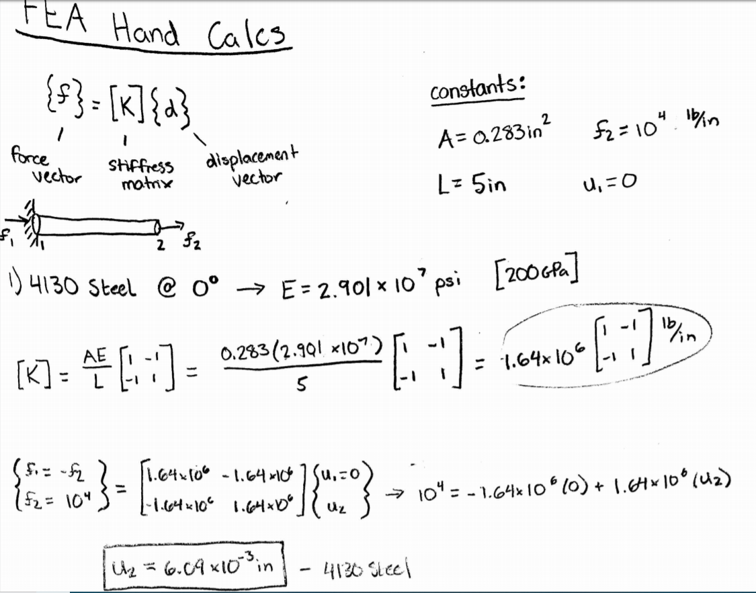
Figure 31: FEA Hand Calculations for 4130 Steel

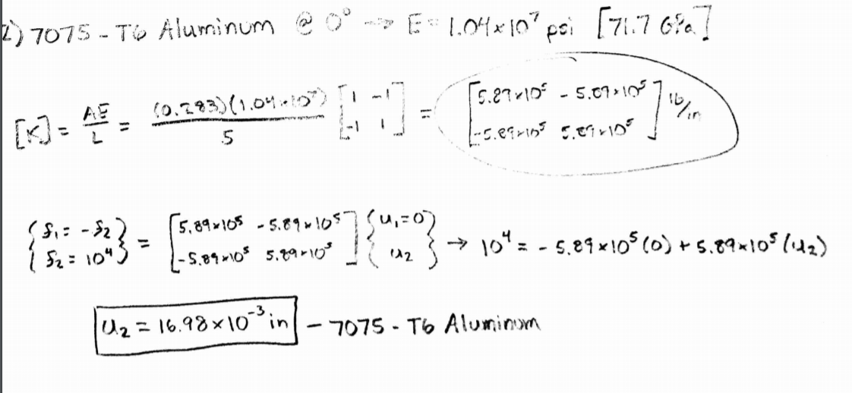
Figure 32: FEA Hand Calculations for 7075-T6 Aluminum

From these results, the team found that the material 4130 Steel had a smaller deflection than the 7075-T6 Aluminum by about 10^-3 in. Although this difference is small, it could have fatal repercussions if not carefully checked. Going forward, the team will need to calculate the maximum deflections for the frame design to be compared to these results. This will ensure that the frame does not fail due to deflection.

7.1.4 BUCKLING STRESS

The following section contains hand calculations for critical buckling stress in a simply supported beam for three different materials. In the critical buckling stress section, the buckling stress and buckling load were both calculated to show when a material would fail. Buckling is the main source of failure in frames so learning the maximum levels of loads and stresses on a material is very important for this project. The results for these calculations can be seen in the Critical Buckling Stress Analysis section. The three different materials and their modulus of elasticity can be seen in Figure 33 shown below.
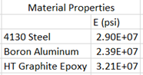
Figure 33: Material Properties

For this analysis, many variables were chosen to be constant to ease the analysis. The outside and inside diameter of the pipe were kept constant at 1.5 in and 1.375 in respectively. This left the cross-sectional area of the beam to be 0.2823 in^2. The length of the test beam was held constant at 10 in. The moment of inertia was held constant at 0.073 in^4. K was assumed to be 0.5 for 2 fixed ends leaving the equivalent length to be 5 in.
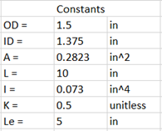
Figure 34: Buckling Constants

The following calculations use Euler’s equation for critical buckling stress and critical buckling loads [22]. The equation for critical buckling stress is as follows:
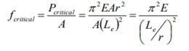
Figure 35: Critical Buckling Stress Equation

The critical buckling load equation can be seen below in Figure 36.
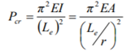
Figure 36: Critical Buckling Load Equation

Using the assumptions shown above, the critical buckling load was calculated first for each of the three materials. The results for these calculations can be seen in Figure 37 below.
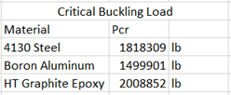
Figure 37: Critical Buckling Loads

Using these results, the critical buckling stress was calculated for each material. The results for these calculations can be seen below in Figure 38.
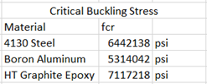
Figure 38: Critical Buckling Stress

From these results, it is clear what affected the critical buckling stresses and loads. The modulus of elasticity is the material property that affects these calculations. This means selecting a material with a high modulus of elasticity is of utmost importance for the material selection for the team’s frame. From this data, HT Graphite Epoxy had the highest modulus of elasticity which led to the material to have the highest critical buckling load and critical buckling stress. HT Graphite Epoxy had 1.1 times higher values than 4130 Steel which was the client’s material of choice. Also, HT Graphite Epoxy has a much lower density leaving the mass of the frame to be lighter as well. This was one of the client’s main customer needs to design a lightweight frame. Going forward with this analysis, a working code will be programmed to automatically calculate buckling stresses as well as deflections. Also, the team will need to calculate the maximum load and maximum stress for the frame design to be compared to these values. This will prevent buckling failure in the frame.

7.2 Design Change
The Team encountered a large design change at the beginning of the spring semester from Novakinetics. The client had reconfigured the mounting system from a three point triangular system, figure 39, to a design that would include six points of support for the frame, as seen in light blue of Figure 40. A seventh point was requested later in the semester to support the rearward rotors as indicated with a red arrow in Figure 40. These changes in modification can be viewed in the overall Flyer configuration as seen in figures 42 and 43.

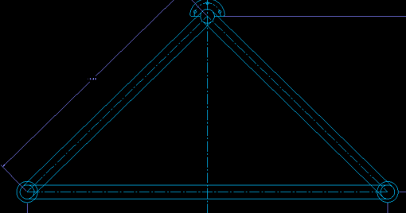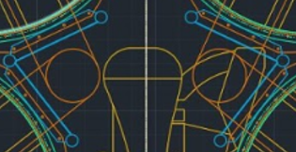
Figure 39 - Three point Frame Figure 40 - Six point Frame

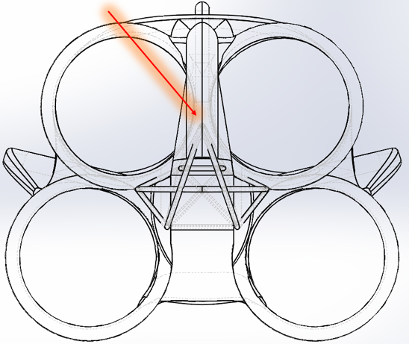
Figure 41 - Seven point Frame

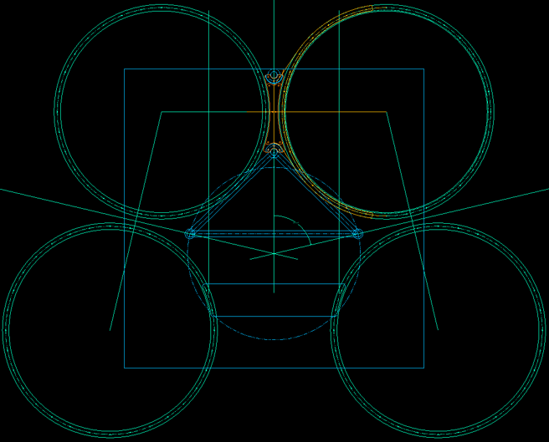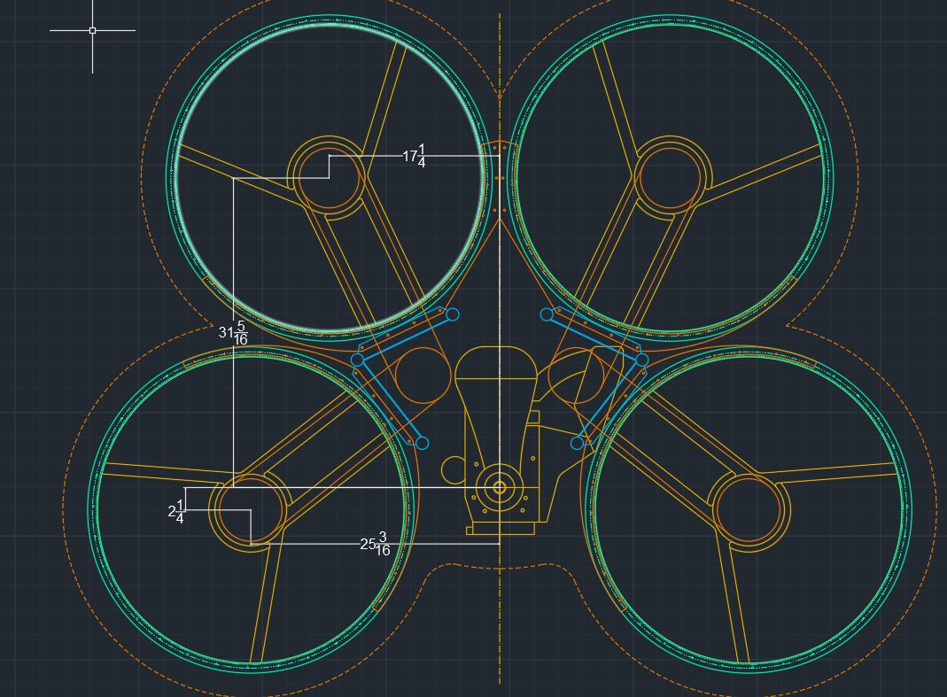
Figure 42 - First Semester Client Design Figure 43 - Second Semester Client Design

With these change a great deal of the team's designs from the fall semester were rendered moot. Especially, the team’s proposed final frame design. The teams goal is to now modify any designs to fit the new system requirements, or to perform a complete set of redesigns that would better fit the clients new configuration and needs. The team worked individually and collectively to put together a new portfolio of design sketches to present to the client.
Figure 41 depicts a basic proof of concept of the Flyer, while Figure 43 shows the model in greater detail by comparison. Relative to the Flyer’s rotors, the frame original design and redesign can be seen in the light blue within both the cad models. The model in Figure 42 was presented to the team at the beginning of the spring semester, and serves as the current datum with which all designs, improvements, and analysis are currently based.
In closing, the dimensions given to the team based on Figure 43 gave a greater understanding of exactly how the client intends to fit the frame within the FanFlyer shell, and where the subsystems will all be supported at. As such the team has a general understanding of where the subsystem components as the motors, rotors, belts and pulleys intend to be placed. The significance of this gives a better understand of the weight distribution for the team’s analysis on the frame. In addition the client’s proposed six point frame provides more opportunity for connection points for protection, while allowing for additional space support for the motor and rotor drivetrain. Figure 44 below shows a proof of concept of potential cross beam support for the motor and rotor shaft, located on the bottom half of the frame.

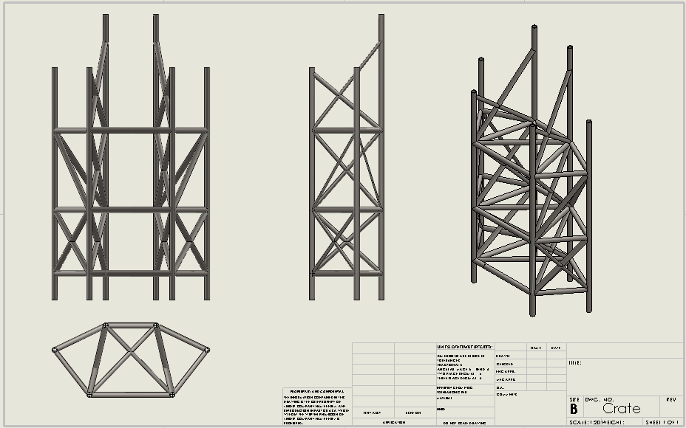
Figure 44 - Motor and Rotor shaft support

8 TESTING

The last part of the design process was for the team to definitively prove that the data they were showing was acceptable and reasonable results. This was important because the team had been running simulations on different frames for almost a full year and the simulations continually returned results and values but those numbers could have been astronomically inaccurate. Therefore, it was vital for the team to prove that their frame could actually perform under the conditions and have accurate results with a confidence level that could be demonstrated to the client.
The way the team set out to do this was to prove that the simulation data accurately converged to a specific data point. This means that the precision of measuring the data would increasing until each measurement returned numerically the same results. The process of accomplishing this task in ANSYS was to increase the meshing size of the FEA calculations to where they were smaller and smaller which equates in a more accurate calculation. The steps of decreasing the mesh size can be seen below in figure 45 & 46. Because the data sets were becoming increasingly smaller by an increase mesh size that indicates that the data results would also be getting more and more precise and hopefully converging to a numerically singular value. The specific dimensions of the increased mesh size can be seen below in figure 47.
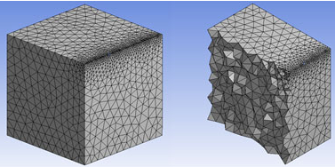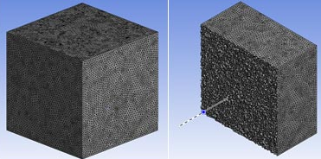
Figure 45: Steps 1 & 2 of Increasing Mesh Size Figure 46: Steps 3 & 4 of Increasing Mesh Size

Figure 47: Specific Mesh Size of Steps 1- 4 Respectively
Essentially, the amount of elements that were being measured or the individual tetrahedral shapes began at around 200,000 and maxed out around 331,000. The total deformation showed a convergences in the data which can be seen in figure 48. Basically, the discrepancy between each deformation became smaller and smaller eventually leading to what the team deemed a convergence at .32 inches of total deformation. Because the team’s original deformation calculations were .3197 inches this gave the team confidence that there data calculations were correct because the data converged to the same deformation.

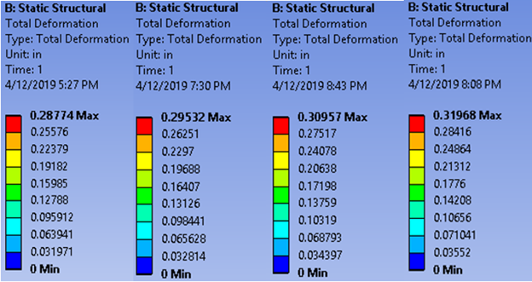
Figure 48: ANSYS Deformation Calculations for Simulations 1 - 4 Respectively

9 CONCLUSIONS

Overall, the team learned a lot about themselves as well as their project through the entirety of the capstone year. The team learned how to communicate effectively with one another under a tight schedule and meet the project deadlines on-time. Going into this project, none of the team members were familiar with finite element analysis (FEA) or the computer program going along with it (Ansys). The team was tasked to learn these skills by themselves in order to correctly design and analyze a steel frame. Understanding Ansys allowed the team to simulate the forces experienced on their frame by applying proper boundary conditions. Then, the team could find the stresses and reaction forces plotted inside of the program to check with the FAR benchmark data. Learning the theory behind FEA allowed the team to double check the ANSYS results using closed-form hand calculations. Examples of these hand calculations can be seen in section 7.1.3. This allowed the team to have a secondary check on the computer simulations ran by Ansys.

9.1 Contributing To Project Success

Over the span of the project lifeline, there were many contributing factors that led to a successful design for the team. The first contributing factor was the team’s client at NovaKinetics Aerosystems. The client provided a clear path for the team to follow, making sure the customer requirements were met. The team was able to keep up with what the client asked of and in turn, this allowed the team to keep up with the class. Another factor that led to a successful project, was the team’s teamwork. Being able to communicate with each other effectively, over group texts or emails, allowed the team to complete the tasks on time. Also, because of good teamwork it made it easier to have team meetings and make presentations go smoothly. The team’s work ethic was also a factor that contributed to success. Learning ANSYS and Finite Element Analysis from scratch really proved the team’s work ethic at the start of the semester. This in turn, led to a successful project where the team worked together to meet all of the deadlines presented by the client and by the class.
The purposal and goals stated in the project charter were met by the team during the span of this project. The team’s final design was a high-quality, cost effective, and properly functioning frame for the quad copter. These requirements were proven through Ansys simulations and hand calculations for the cost of the frame. The coping strategy the team used for team members with different ideas of participation was to make sure the team was clear with each other. The team made sure they all worked together to meet the deadlines and did not tolerate accepting less than what was asked. To make sure homework or exam barriers didn’t affect the team’s meeting times, the team made sure to preemptively notify the other team members for more time. In the case where a team member was feeling unmotivated to work, the team was able to reach out and help that team member to find a resolution.
A positive aspect of this project was learning a computer program with very little help and advising. The team was able to learn Ansys with the help of online tutorials and the textbook provided with the program. Another positive aspect for project performance was the team’s time management. The team was all able to complete the tasks on time and with high quality.
The team’s goal for this project was to exceed the client’s expectation through a respectfully, timely, and cohesive team effort. All in all, the team was able to create a working frame that was tested through many simulations to meet the client’s ask. The frame was more lightweight, durable, balanced, and cost-effective than the client’s previous design.

9.2 Opportunities for Improvement

One opportunity for improvement the team could have done was meet together more often. Even though the team met about once a week over the course year, there was still a lot of time the team met over Google Docs instead of in person. This could have reduced the confusion on what was required from each team member for specific assignments. Also, another opportunity for improvement would have been meeting with the client more often. The team’s client had a very busy schedule and it was extremely hard to meet with him on a regular basis because of that. Meeting with client more often would have put the team on the right path to meet the requirements for the frame in a more timely manner. This would have also made sure that the team was meeting the customers requirements instead of being in the dark for a couple of weeks.
The biggest problem the team encountered during this project occured right at the very beginning of the first semester. The team was told by the client and advisor that they would need to learn the computer program Ansys as well as Finite Element Analysis in order to properly analyze the frame designs. Because the team had no background in this field, they were forced to learn these skills quickly and by themselves. Within a few months, the team was able to properly import a frame into the program and analyze it for stress and reaction force values. Another problem the team encountered for this project was a change in customer requirements halfway through the year. The client changed his idea of a 3-point connection system to the shell by the frame to a 7-point connection system. This required the team to scrap their proposed design and recreate a new one to meet this new requirement. The 7-point of contact system required 3 connection points on each side of the frame to connect to the shell as well as a 7th, singular point of connection to the shell to be in the back. This 7th point of connection was also required to support a ballistics parachute system which would undergo a lot of stress and force if activated. Another problem the team encountered was a tight deadline schedule for deliverables for not only the class but for the client. Working together efficiently and effectively allowed the team to design and propose a viable frame to the client by his deadline of March 19th as well as finish all of the capstone deliverables for the class.
One technical lesson the team learned during this project, was the importance of teamwork. Teamwork has to be efficient and compatible. Without good chemistry in a team, work will not be done as efficiently as possible. Having good relationships with each other motivates a team to work harder together while still creating an exceeding design. Another technical lesson the team learned was to not procrastinate. Procrastinating causes a team to rush their deliverables instead of taking enough time to make sure everything is correct and exceeding the requirements.

10 REFERENCES
[1] FanFlyer Potential Technical & Design Discussion. Novakinetics. 2018. Journal copyright 2018.
[2] V. Turk., "This Hoverbike Is Basically A Giant Quadcopter Drone". [online] Motherboard. Kickstarter. Available at: https://motherboard.vice.com/en_us/article/pgakab/this-hoverbike-is-basically-a-giant-quadcopterdrone, [23 Jul. 2014.]
[3] A. J. Hawkins. The Verge. World’s first rideable hoverbike looks cool as hell but will probably kill you. [online] Available at: https://www.theverge.com/2017/2/20/14671758/hoverbike-hoversurf-russia-dronequadcopter-hellno [20 Feb. 2017].
[4] Home | HOVERSURF. (2018). Home | HOVERSURF. [online] Available at: https://www.hoversurf.com/ [Accessed 1 Dec. 2018].
[5] A. Fitzpatrick., "This Insane Car-Sized Drone Carries People Like A Helicopter". [online] Time.com. Innovations. Available at: http://time.com/4171329/drone-helicopter-ehang-184-ces/ [7 Jan. 2016].
[6] M. Fitzsimmons., “Flying cars? Watch as this drone flies around with passengers inside”. [online] TechRadar. Available at: https://www.techradar.com/news/flying-car-watch-as-this-drone-flies-around-withpassengers-inside, [5 Feb. 2018]
[7] Italdesign. Italdesign-Airbus-PopUp. [online] Available at: https://www.italdesign.it/project/popup/. 2016.
[8] Website. The Verge. (2018). Airbus’ new concept is a car, a drone, and a train all in one. [online] Available at: https://www.theverge.com/2017/3/7/14841324/airbus-concept-car-drone-train-geneva-motorshow [7 Mar. 2017].
[9] THE BEST QUADCOPTER FRAMES FPV Know-It-All - Joshua Bardscell. (2018). THE BEST QUADCOPTER FRAMES. [online] Available at: https://www.fpvknowitall.com/ultimate-fpv-shopping-list-frame/ [Accessed 26 Oct. 2018].
[10] ANSYS .com. (2018). Engineering Simulation & 3D Design Software | ANSYS. [online] Available at: https://www.ANSYS .com/ [Accessed 27 Oct. 2018].
[11] Chapman, A. (2018). Types of Drones: Multi-Rotor vs Fixed-Wing vs Single Rotor vs Hybrid VTOL - AUAV. [online] AUAV. Available at: https://www.auav.com.au/articles/drone-types/ [Accessed 1 Dec. 2018].
[12] Global UAV Technologies Ltd. (2018). Single Rotor and Multi Rotor Drones Face Off. [online] Available at: https://www.globaluavtech.com/news-media/blog/single-rotor-or-multi-rotor-uavs-yourchoice/ [Accessed 1 Dec. 2018].
[13] Ardupilot.org. (2018). What is a MultiCopter and How Does it Work? — Copter documentation.
[online] Available at:http://ardupilot.org/copter/docs/what-is-a-multicopter-and-how-does-it-work.html [Copyright 2016].
[14] L3 Latitude. (2018). Hybrid Quadrotor - Hybrid Quadcopter - VTOL UAV - Autonomous Takeoff -
Autonomous Landing. [online] Available at: https://www.latitudeengineering.com/products/hq/
[Accessed 1 Dec. 2018].
[15] | A. Cantrell, T. Stoebe, K. Firdaus, R. Oakes and J. Sines, "Bicycle Materials Case Study," 12 June 2003. [Online]. Available: https://depts.washington.edu/matseed/mse_resources/Webpage/Bicycle/Bicycle%20Materials%20Case%20Study.htm. [Accessed 1 March 2019].
[16] | B. VanDragt, S. Defever, K. Brandenberg, R. Herman, J. Doezema, S. Oram, W. Faust and M. Saltzgaber, "Michigan State University College of Engineering," Michigan State University, [Online]. Available: http://www.egr.msu.edu/msm/dept/KWON/. [Accessed 1 March 2019].
[17] | TTI, "TTIinc," TTI, [Online]. Available: https://www.ttiinc.com/content/ttiinc/en/resources/tools/material-costs.html. [Accessed 1 March 2019].
[18] | "Fiber Reinforced Composites," Altair, 7 March 2016. [Online]. Available: https://altairenlighten.com/in-depth/fiber-reinforced-composites/. [Accessed 1 March 2019].

[19] | AZO Materials, "Aisi 4130 Alloy Steel," AZO Materials, 12 November 2012. [Online]. Available: https://www.azom.com/article.aspx?ArticleID=6742. [Accessed 1 March 2019].
[20] | AmesWeb, "Aluminum Alloys- UYield Strength and Tensile Strength," [Online]. Available: https://www.amesweb.info/Materials/Aluminum-Yield-Tensile-Strength.aspx. [Accessed 1 March 2019].
[21]  [22] | J. Callister.W.D, in Materials Science and Engineering:An Introduction 7th edition, John Wiley &Sons, Inc., 2007.  Texas A&M University, “Rigid Frames - Compression and Buckling.” Note Set 11.1. 2013. Available:http://faculty-legacy.arch.tamu.edu/anichols/index_files/courses/arch614/arch614old/NS11-1frames.pdf

11 APPENDICES
11.1 Appendix A: Customer Requirements
Table - 3 Customer Requirements
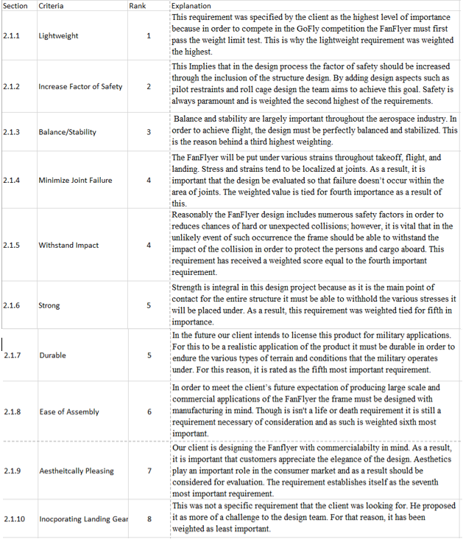

11.2 Appendix B. Engineering Requirements

Table - 4 Engineering Requirements
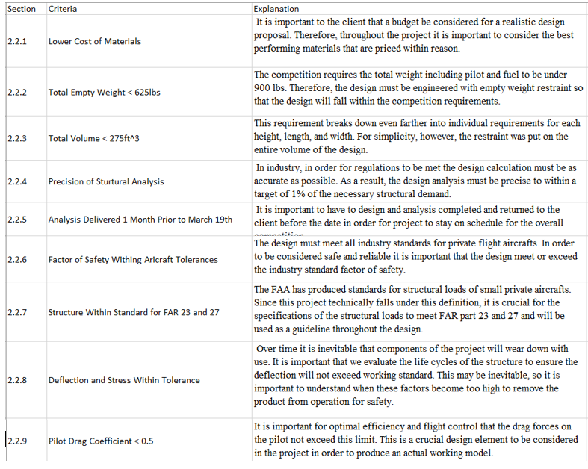

11.3 Appendix C: House of Quality

Table 5 - House of Quality
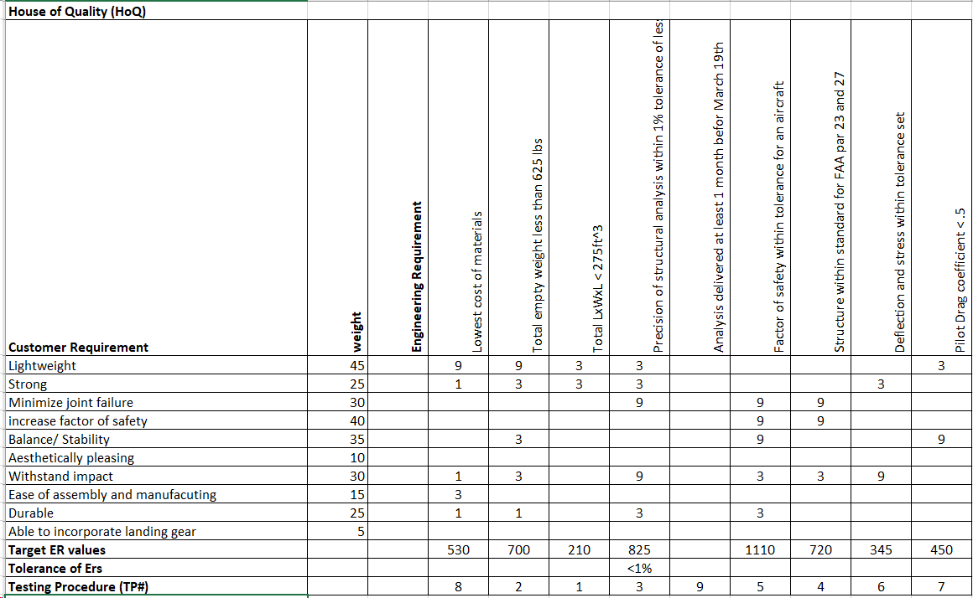
+
11.4 Appendix D: System Level

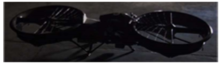
Figure 15 - Full scale working prototype. Mallory Aeronautics [2]

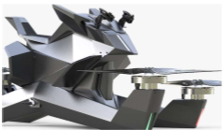
Figure 16 - Production Model, Hoverbike eVTOL [2]

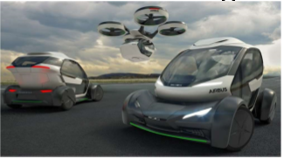
Figure 17- Italdesign Airbus flyer and driver [8]

11.5 Appendix E: Black Box model
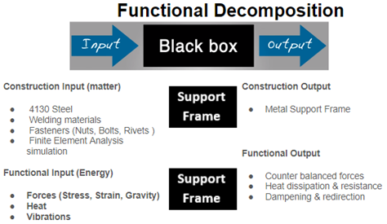
Figure 18 - Black Box Model
11.6 Appendix F: Functional Decomposition
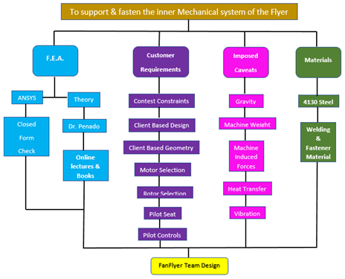
Figure 19 - Functional Decomposition

11.7 Appendix G: Decision Matrix & Pugh Chart
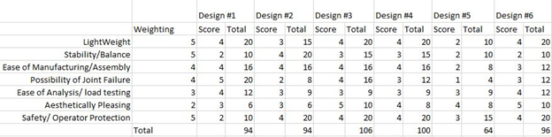
Figure 6 - Decision Matrix

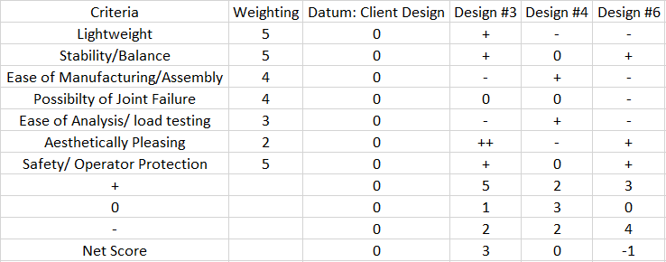
Figure 20 - Pugh Chart

11.8 Appendix H: Design Models
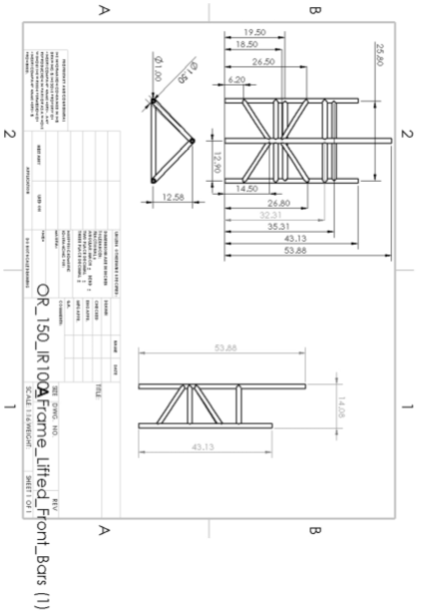
Figure 21 - Client Design CAD Model
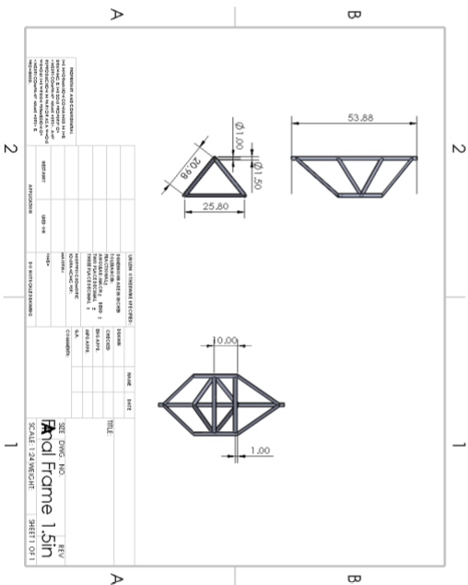
Figure 22- Team Frame Design CAD Model

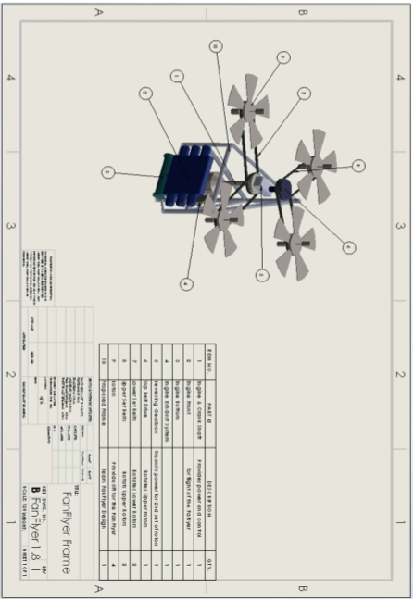
Figure 23 - Integrated Final Design CAD Model

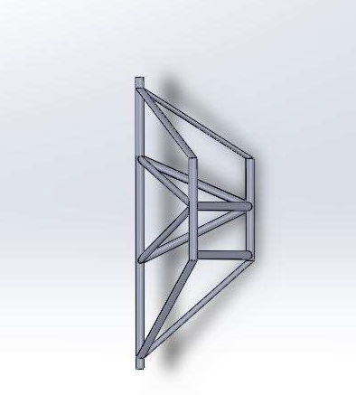
Figure 24 - 3D CAD Model of Final Frame

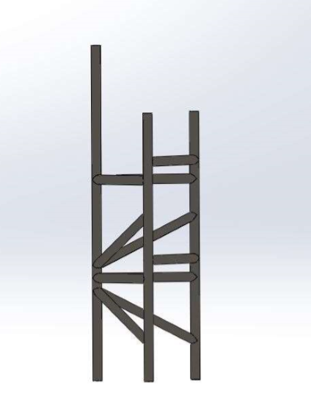
Figure 25 - 3D CAD Model Datum Frame

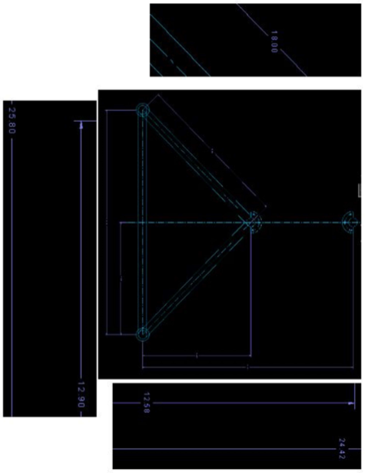
Figure 26 - Client Design Specifications 1

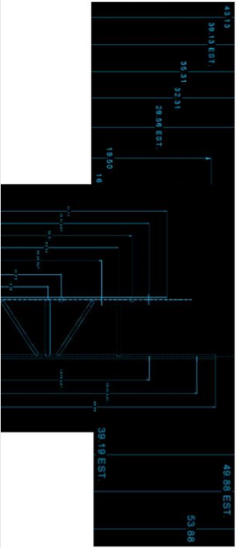
Figure 27 - Client Design Specifications 2

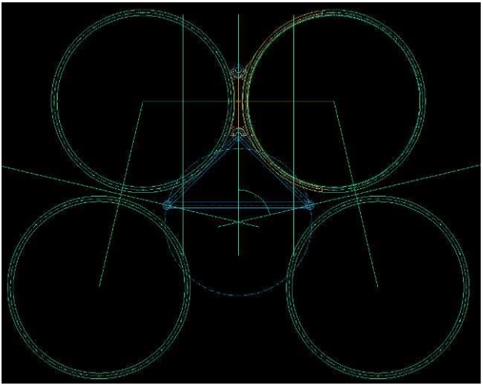
Figure 28- Client Design Specifications 3

11.9 Appendix I: Hand Calculations and Software Analysis
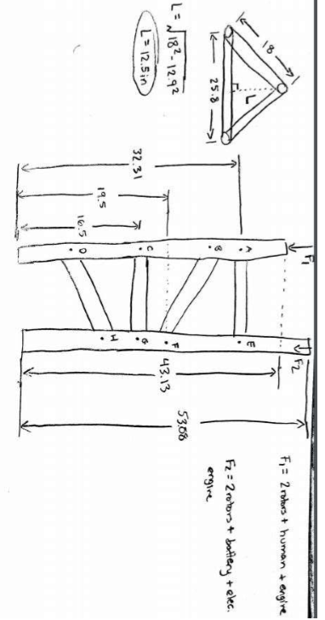
Figure 29 - Hand Calculations 1

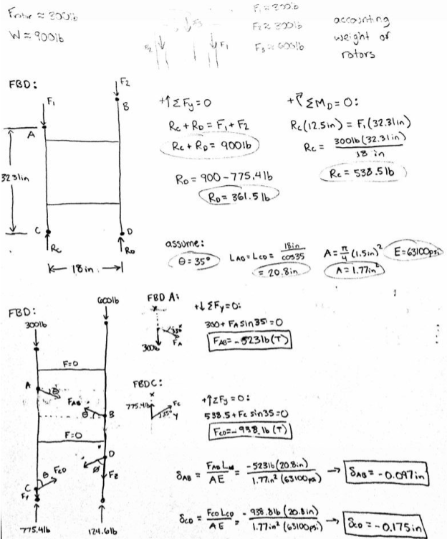
Figure 30 - Hand Calculations 2

