

**Team Aeolus – 313**

Yaqoub Almounes

John Cowan

Josh Gomez

Michael Medulla

Mohammad Qasem



Certificate of Compliance

**Event:** SAE Aero Design West

**Project:** Technical Design Report – Micro class

**Team Name:** Team Aeolus

**Team #:**  313

**Issue Date:** January 26, 2017

*This certificate of compliance is based on an evaluation of the SAE Aero Design competition Technical Design Report for the team mentioned above. The signee below verifies that the team has followed all guidelines and rules given by the Society of Automotive Engineers for this competition. 2017 competition rules are located at* [*https://www.saeaerodesign.com/content/2017_AERO_RULES_FINAL.pdf*](https://www.saeaerodesign.com/content/2017_AERO_RULES_FINAL.pdf)

______________________________________

John Tester, Faculty Advisor

Team Aeolus, #313

Northern Arizona University

**Table of Contents**

**Table of Figures** 2

**Table of Tables** 3

**Executive Summary** 4

**1. Introduction** 5

**2. Project Description** 5

**2.1 Technical Review** 5

**3. Existing Designs** 6

**3.1 Design Research** 6

**3.2 Designs Considered** 7

**4. Design Analysis** 9

**4.1 Material Analysis** 10

**4.1.1 Assumptions** 10

**4.1.2 Material Calculations** 11

**4.1.3 Material Analysis Conclusion** 14

**4.2 Wing Analysis** 14

**4.2.1 Airfoil Selection** 15

**4.2.2 Aspect Ratio** 17

**4.2.3 Wing Analysis Conclusion** 18

**4.3 Motor Analysis** 18

**4.4 Propeller Analysis** 19

**4.4.1 Propeller of a Micro Aircraft** 19

**4.4.2 Propeller Sizing** 20

**4.4.3 Propeller Blades** 20

**4.5 Payload Bay** 21

**5. Bill of Materials** 21

# **Table of Figures**

Figure 1: Three Surface Aircraft [2] 6

Figure 2: Flying Wing [3] 6

Figure 3: Square Wing Aircraft [4] 6

Figure 4: Top View Assumptions 10

Figure 5: Side View Assumptions 10

Figure 6: Bending Moment Diagram of Max Lift Acting on Half of the Wing 12

Figure 7: Bending Moment Diagram for Circular Fuselage 13

Figure 8: Cl vs Alpha [15] 17

Figure 9: Propeller Sizing Chart [17] 20

Figure 10: Payload Bay 21

# **Table of Tables**

Table 1: Potential Designs Considered 7

Table 2: Advantages/Disadvantages of Each Design 8

Table 3: Decision Matrix 14

Table 4: Potential Airfoils 16

Table 5: Final Wing Properties 18

Table 6: Comparison of AC to DC Motors 18

Table 7: Ratings of the BLDC Motor 19

Table 8: Bill of Materials 21

**Table 9: Table of References** 22

# **Executive Summary**

The following contents in this report detail thorough analysis, calculations, and the selection process for the SAE Aero Design West: Micro RC aircraft competition. It will represent a replication of real-world design challenges that engineers currently face. The 2017 SAE Aero Design® Rules verify all contents included in this report [1]. These rules compress a typical aircraft development program into one calendar year, taking participants through the system engineering process of breaking down requirements. After the team thoroughly talked about the project description and the requirements from SAE, the team researched potential designs. Preexisting designs helped the team create ideas for the design of this project, but all designs considered and calculations are genuine and original. The team chose the final design using various methods, including concept generation, a decision matrix, and more. The team evaluated the advantages and disadvantages of all concepts generated to give a practical understanding of which concepts will perform most effectively. These advantages/disadvantages eliminate the least effective concepts. Once the team selected the final design, the process continues with a detailed analysis of each component of the aircraft. The team made minor adjustments to the design after each analysis. Throughout this report, the team used tables and figures to best explain the analysis performed on the plane. The team is confident that the following information will lead to an aircraft which can be constructed and complete the course with relative ease, resulting in a successfully competitive aircraft in Fort Worth, Texas.

# **1. Introduction**

Every year, the Society of Automotive Engineers (SAE) hosts an international competition for schools to compete in an aircraft design and flight competition. There are three separate competitions: micro, regular, and advanced. Team Aeolus from Northern Arizona University (NAU) joined the micro aero design competition. Beginning the first week of September, Team Aeolus worked hard to bring a competitive aircraft to the competition in Fort Worth, Texas in March.

# **2. Project Description**

The rules for the micro aero design competition are simple. Each team is responsible for designing an aircraft that can carry the highest payload fraction. Teams score highly based upon the ranking of payload fraction that their design can withstand. Equation 2.1 below describes payload fraction.

|  |  |  |
| --- | --- | --- |
|  | $$Payload Fraction= \frac{W_{payload}}{W_{payload}+W_{empty}}$$ | (2.1) |

Along with the highest payload fraction, teams are required to make an oral presentation as well as a design report.

# **2.1 Technical Review**

The team recognized lift as the main contributor in the design of a micro remote control airplane. Including lift, the team also recognized weight and stability as the next biggest factors when designing in compliance with the rules and regulations of the micro aero design competition. As mentioned in the section before, the highest payload fraction is one of the most important scores to receive in the competition. The weight of the plane and the amount of lift generated by the wings directly compliment this score.

# **3. Existing Designs**

# **3.1 Design Research**

The team researched the shape, aerodynamic efficiency, and the area of the wing to optimize lift in the design. Scientific journals and websites detailed possible designs for our team to explore. The flying wing, three-surfaced aircraft, and the square wing presented the most promise for a successful design. Figure 1, Figure 2, and Figure 3display the three different types of aircraft.

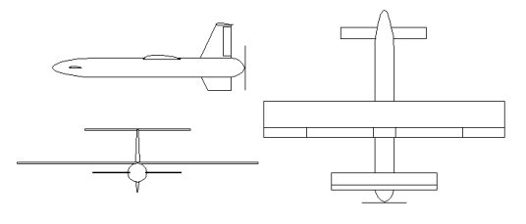

Figure : Three Surface Aircraft [2]

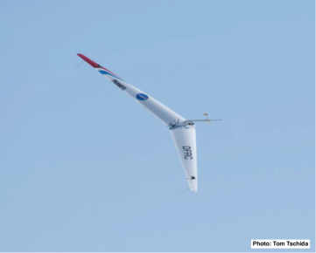

Figure : Flying Wing [3]

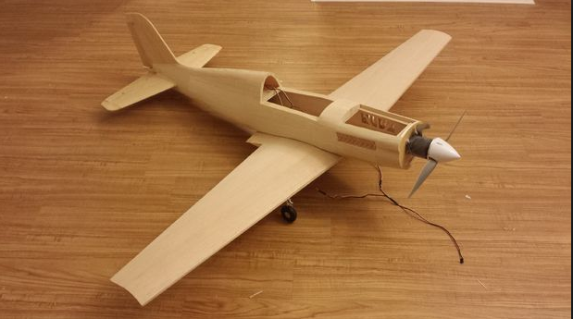

Figure : Square Wing Aircraft [4]

# **3.2 Designs Considered**

The team realized that cutting down the potential designs to three designs limits the team’s creativity. Instead of only deciding between the square wing, flying wing, and the three surface aircraft designs, the team decided to think of parts separately and make a table combining all the parts together. The parts that the team decided to look at separately were the wing design, airfoil, material, motor, motor position, number of blades on the propeller, and the body type. Table 1 lists the potential designs that the team thought of using for separate aspects of the aircraft.

Table : Potential Designs Considered

|  |  |  |  |  |  |  |  |
| --- | --- | --- | --- | --- | --- | --- | --- |
| **Concept** | **Wing** | **Airfoil [5]** | **Material** | **Motor** | **Motor Position** | **Propeller** | **Body** |
| 1 | Square -Mounted High | PT-40 | Foam | Single Brushless | Front | 2 – Blade | Carbon Fiber Rod |
| 2 | Flaps | Falcon 56 Mark II | Foam | Twin Brushless | Middle | 2 –Blade | Square Foam |
| 3 | Expandable | Clark Y-14 | Monokote | Single Brushless | Front | 2 –Blade | Carbon Fiber Rod |
| 4 | Delta Wing | Trainer 60 | Balsa/ Monokote | Twin Brushless | Rear | 3 – Blade | Square Foam |
| 5 | Biplane | Clark Y-14 | Foam | Single Brushless | Front | 3 – Blade | Carbon Fiber Rod |
| 6 | Three Surface | PT -40 | Balsa / Monokote | Single Brushless | Rear | 3 – Blade | Streamline Foam |
| 7 | Flying Wing | DH4009 | Foam | Single Brushless | Rear | 2 – Blade | N/A |
| 8 | Square -Mounted low | Clark Y-14 | Foam | Single Brushless | Front | 2 – Blade | 3D – Flat |
| 9 | Flying Disk | N/A | Plastic | Single Brushless | Middle | 3 – Blade | Circular |
| 10 | Square -Mounted middle | Clark Y-14 | Balsa/ Monokote | Twin Brushless | Middle | 3 – Blade | Square Carbon Fiber |

After creating a list of potential designs for the competition, the team created a table to list the advantages and disadvantages of each concept. Table 2 below shows the table created by the team. The table convinced the team that certain concepts were not viable for the competition. For example, the biplane wings are too heavy to have a high payload fraction, even though they provide a high amount of lift.

Table : Advantages/Disadvantages of Each Design

|  |  |  |
| --- | --- | --- |
| **Concept** | **Advantages** | **Disadvantages** |
| 1 | -Greater lift/ Stability  -Lightweight | -Flexible  -Low Power |
| 2 | -Greater lift when deployed | -Must be deployed for extra lift  -Square body not aerodynamic |
| 3 | -Fits size constraint | -Can collapse  -Possibly too light |
| 4 | -High speed  -Twin motors provide more thrust | -May not fit size constraint  -Heavy |
| 5 | -Stable  -High lift | -Greater drag  -Heavy |
| 6 | -More surface area for maximum lift  -Stable | -Heavy  -Greater drag and weight |
| 7 | -Light weight  -Streamline | -May not fit size constraint unless designed in sections |
| 8 | -High speed  -Stable | -Without power will not glide (instant crash)  - Less lift |
| 9 | -Aesthetically pleasing | -Unpractical  -Minimal control |
| 10 | -Acrobatic  -Moderate lift | -Less thrust from propeller  - Without power will not glide (instant crash)  - Drag induced from square body |

# **4. Design Analysis**

Creating the tables for the mixed parts and the advantages and disadvantages of the various combinations that our team believed can compete in Texas was a giant step towards the correct direction. Our team decided that concept number 1 was the best design for the competition. However, once the team decided on the type of plane that the team would use, the team realized that we need more analysis if we want to believe that concept 1 is the best decision. The team performed analysis on the material of the wings, type of airfoil to use for low speed, motor, and the propeller best suited for our design.

# **4.1 Material Analysis**

The goal of the material analysis is to maximize lift while determining which material has the least weight. In addition to these constraints, the material selected will also influence the empty weight, payload, in-flight stability, durability, as well as cost. Based on the rules and regulations of the SAE Micro Aero competition, the team discussed foam, carbon fiber, and balsa wood as the best materials for a winning chance in the competition.

# **4.1.1 Assumptions**

Multiple assumptions help solve the assumption driven equations. The first assumption made is a thin square airfoil with a length of 36” and a width of 5.95”. Our team assumed the thickness of the airfoil was thin, meaning the team ignored the thickness. To save weight, the team agreed that a single circular rod of 26” would make a great fuselage for the aircraft. The diameter of the rod will be determined from the stress equations. 3.5” from the nose of the plane sits the center of gravity. For the assumptions made by our team, the speed of the plane must be less than or equal to 30 feet per second and the angle of attack must be at a minimum of 4 degrees and a maximum of 6 degrees. Figure 4 and Figure 5 below displays the assumptions that the team made.

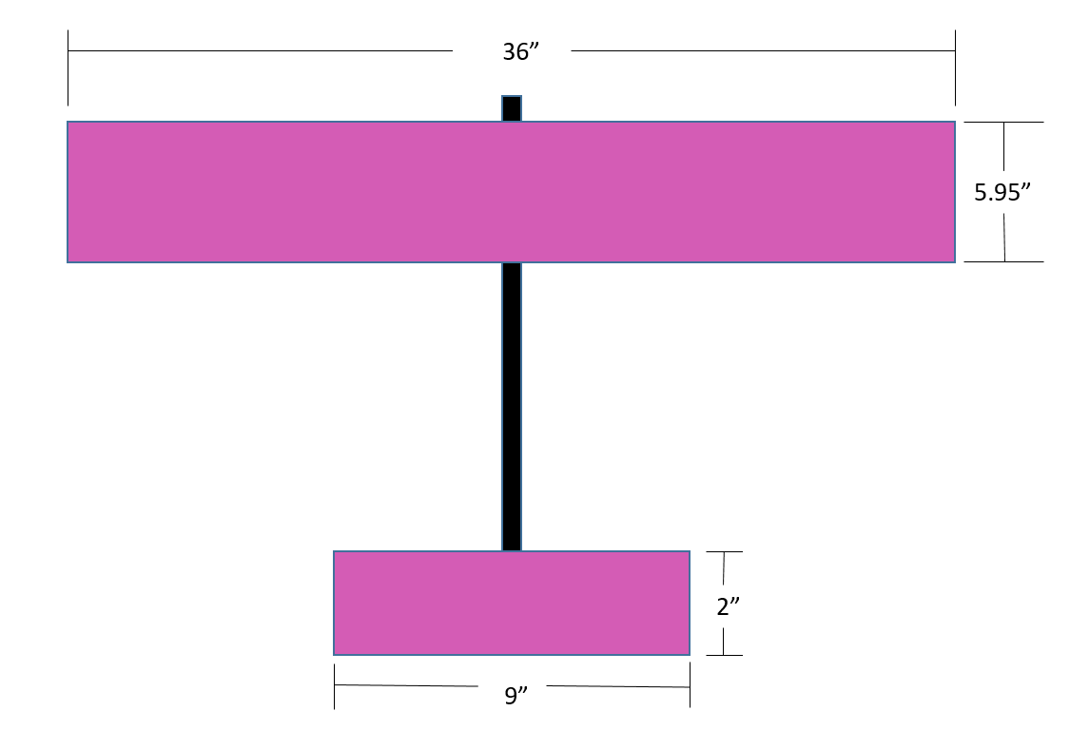

Figure : Top View Assumptions

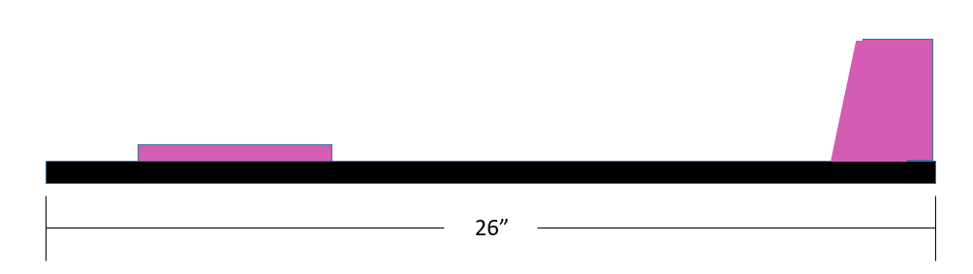

Figure : Side View Assumptions

# **4.1.2 Material Calculations**

From these assumptions, maximum lift is calculated which helped construct a bending moment diagram. The bending moment diagram will help yield the maximum stresses along the fuselage and wing. For the wing, stresses can be dangerous depending on the materials yield strength; therefore, the team selected the material for the best results. For the fuselage, the bending stress equation determined the diameter of the rod. The selected material’s density and dimensions will conclude which material is the lightest. Equation 4.1 below displays how the find the max lift force acting on the half of the wing [6]. L is the lift generated, ρ is the density, V is the velocity of the plane, A is the cross sectional area, and CL is the coefficient of lift for the geometric design.

|  |  |  |
| --- | --- | --- |
|  | $$L=\frac{1}{2}ρV^{2}AC_{L}$$ | (4.1) |

Using the assumptions previously listed, velocity equals 30 ft/s = 9.144 m/s, area is equal to 0.15113 m2, density is equal to 1.225 kg/m3, and CL is equal to 2πϴ (where theta is in radians and equal to 0.10472 rad). Plugging all values into the equation, equation 1, yields Lmax= 2.328 N acting on the middle of half the wing. Figure 6displays the bending moment diagram at half of the wing using Lmax.

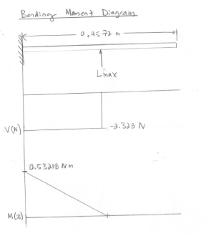

Figure : Bending Moment Diagram of Max Lift Acting on Half of the Wing

The team calculated the max bending and shear stress from the moment diagram. Equations 4.2 and 4.3 display the bending and shear equations for a rectangular cross-section, respectively. [7].

|  |  |  |
| --- | --- | --- |
|  | $$σ_{max}=\frac{My}{I}$$ | (4.2) |
|  | $$τ_{max}=\frac{3V}{2A}$$ | (4.3) |

Using the calculated values from **Error! Reference source not found.**, σmax = 14554.9 Pa and τmax= 606.5 Pa. Comparing these values to the yield strength of balsa wood, 15 MPa [8], and foam, 13.8 [9] MPa, both materials provide enough strength to handle the wings bending moment. However, the team did not ignore density when deciding which material to select. Since balsa wood has a density of 130.0 kg/m3 [8] and foam has a density of 32.4 kg/m3 [10]; the calculated mass of the balsa wing equals 0.3423 kg and foam wing equals 0.0854 kg, therefore foam produces a wing that is 4 times lighter than balsa wood. To find the diameter of the circular fuselage, a bending moment diagram is created where the max lift equals 4.76N (sum of the lift at both sides of the wing; 2.328 N * 2 = 4.76N) at the center of gravity; 0.0889 m from the nose of the plane. Figure 7 below displays the calculated bending moment diagram.

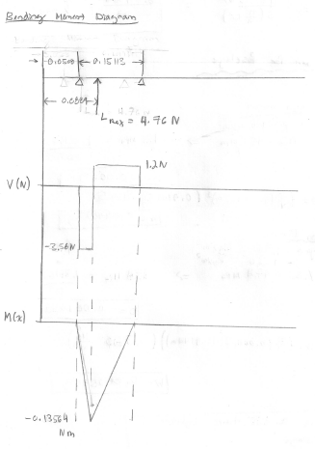

Figure : Bending Moment Diagram for Circular Fuselage

The team then calculated the max bending and shear stress from this bending moment diagram. Equation 4.4 shows the max shear stress for a circular cross-section [7].

|  |  |  |
| --- | --- | --- |
|  | $$τ_{max}=\frac{4V}{3A}$$ | (4.4) |

Using the calculated values from **Error! Reference source not found.**, σmax = 1.38162/ D3 and τmax= 6.0436/ D2. Plugging in yield strength values for balsa and carbon fiber, where carbon fiber is equal to 474 MPa [11], the equation produces a diameter of 0.00452m for balsa and 0.001433m for foam. Using these diameters in conjunction with the material’s density values, 130 kg/ m3 [12] for balsa and 1760 kg/m3 for carbon fiber [15]; the mass of circular fuselage for balsa is equal to 0.001907 kg and carbon fiber is equal to 0.002579 kg. The mass of balsa is 1.35 times lighter than carbon fiber.

# **4.1.3 Material Analysis Conclusion**

The team picked the material from the calculations made in the previous section. The team chose foam as the material for the wing since it provides the lightest weight possible while holding a relatively high yield strength in comparison to balsa wood. In addition, if the aircraft were to crash during the competition, foam is easily repairable with CA foam safe glue. For the fuselage, the team selected carbon fiber because of its high yield strength as well as it lightness. In comparison with balsa wood, carbon fiber’s yield strength is 31.6 times stronger. Carbon fiber’s significant strength made it an easy pick for the team even though balsa is lighter than carbon fiber by 1.35. From the analysis, the team concluded that the materials used for the plane would be foam and carbon fiber.

# **4.2 Wing Analysis**

Although the team decided that concept 1 would generate enough lift to be efficient in the air, the team had disagreements on what type of the wing to use for the design. Table 6 depicts a decision matrix to decide the best of the five wing types that would be potentially be great for the competition.

Table : Decision Matrix

|  |  |  |  |  |  |  |  |  |  |  |  |
| --- | --- | --- | --- | --- | --- | --- | --- | --- | --- | --- | --- |
|  |  |  |  |  |  | **Concepts** |  |  |  |  |  |
| **Criterion** | **Weight** | **High Mount** | **Score** | **Flaps** | **Score** | **Expandable** | **Score** | **Delta** | **Score** | **Biplane** | **Score** |
| **Safety** | 0.23 | 10 | 2.3 | 7 | 1.61 | 5 | 1.15 | 8 | 1.84 | 8 | 1.84 |
| **Weight** | 0.18 | 9 | 1.62 | 8 | 1.44 | 10 | 1.8 | 8 | 1.44 | 4 | 0.72 |
| **Durability** | 0.13 | 8 | 1.04 | 7 | 0.91 | 4 | 0.52 | 9 | 1.17 | 7 | 0.91 |
| **Payload** | 0.23 | 9 | 2.07 | 8 | 1.84 | 7 | 1.61 | 9 | 2.07 | 9 | 2.07 |
| **Lift** | 0.23 | 9 | 2.07 | 10 | 2.3 | 7 | 1.61 | 8 | 1.84 | 8 | 1.84 |
|  | 1 |  | 9.1 |  | 8.1 |  | 6.69 |  | 8.36 |  | 7.38 |

Of the top five concepts chosen for evaluation via the decision matrix, the “High Mount” wing design generated the highest weighted score. As previously mentioned, one of the primary objectives of this competition is to provide the lowest empty weight of the aircraft possible while also providing the highest payload carry. Disregarding the scores, the High Mount concept satisfies these objectives based on the components selected to complete the design. The relative simplicity of this concept design will allow it to satisfy the “micro” size constraint of being able to fit inside a 6-inch diameter round container. The components selected will keep the design lightweight while providing the potential payload fraction (payload carry divided by empty weight) necessary to compete and thrive in the competition.

# **4.2.1 Airfoil Selection**

To begin the selection process, the team calculated the theoretical Reynold’s number that the plane will be operating. Using a theoretical speed of about 5 meters per second, the Reynolds number can be found using equation 4.5 below [12].

|  |  |  |
| --- | --- | --- |
|  | $$Re= \frac{ρVc}{μ}$$ | (4.5) |

Where ρ is the density of the air, V is the vehicle velocity, c is the chord length, and μ is the viscosity. The team used the theoretical values of Fort Worth, TX in all calculations. Since Fort Worth is only about 600 feet above sea level, the team agreed to take values at sea level. ρ is about 1.2 kg/m^3, c is 5 inches (.127 meters) and μ = 1.8 x 10^-5 kg/ (m*s) [13]. We selected a chord length of 5 inches because of one of the design requirements that SAE provided. The parts of our plane must fit into a 6-inch cross section. The team agreed on a chord length of 5 inches so the wings can fit in the cross section

$$Re=\frac{\left(1.2\frac{kg}{m^{3}}\right)\left(5\frac{m}{s} \right)\left(0.127 m\right)}{1.8\frac{kg}{m*s}}≈42,000$$

At such a low Reynold’s number, an under cambered airfoil is excellent for generating high amounts of lift [14]. Another important aspect of the airfoil is the max percent thickness. The percent is the ratio of the thickness to the chord length of airfoil. For a low Reynold’s number, the team agreed that a thickness around 12 – 17 percent is ideal. Numerous airfoils demonstrated value to the design criteria. Table 7 below displays the potential airfoils that the team could use.

Table : Potential Airfoils

|  |  |  |
| --- | --- | --- |
| Airfoil | Max Cl/Cd at Re = 50000 | Max Thickness |
| EPPLER 560 | 31.1 | 16.1% |
| EPPLER 561 | 26.9 | 16.9% |
| FX-63-120 | 40.0 | 12.0% |
| GOE 190 | 37.2 | 12.7% |
| GOE 430 | 36.5 | 13.4% |

A reasonable decision for our aircraft is the GOE 430 airfoil. It has a great Cl/Cd ratio and the thickness is reliable in flight. The GOE 430 boasts a great balance of sturdiness and aerodynamic capability. Airfoiltools.com provides excellent graphs on every airfoil. Figure 8 below demonstrates the capabilities of the aircraft versus a range of angles of attack.

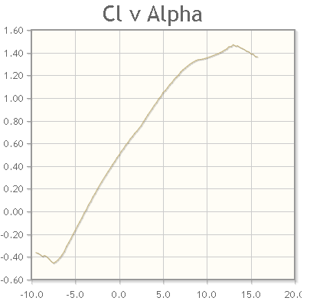

Figure : Cl vs Alpha [15]

# **4.2.2 Aspect Ratio**

The aspect ratio, or slenderness, greatly helps in determining how the aircraft will behave mid-flight. A higher aspect ratio refers to long, slender wings. A small aspect ratio refers to small and wide wings. Both high and low aspect ratios have their own benefits, but for different planes. For a sailplane or an RC plane, a high aspect ratio works more effectively. Since the aircraft travels at low speeds, it needs a large area to push down the air and generate more lift. At low speeds, the tip vortices are also very week so they do not interfere with drag enough to be a problem. For rectangular wings, the aspect ratio can be calculated using equation 4.2 [16].

|  |  |  |
| --- | --- | --- |
|  | $$AR=\frac{b}{c}$$ | (4.6) |

Where b is the wingspan and c is the chord length (same as above). The team agreed to have an aspect ratio ranging between the values of 8 and 9. The team agreed to use a wingspan of 3 and half feet because that gives an acceptable value for the aspect ratio like we want.

$$AR=\frac{42 in}{5 in}$$

# **4.2.3 Wing Analysis Conclusion**

Overall, the analysis of the wing has led to the result in **Error! Reference source not found.Error! Reference source not found.** below. The team believes that the wing properties chosen will be suitable for the SAE Micro Aero design competition.

Table : Final Wing Properties

|  |  |  |  |  |
| --- | --- | --- | --- | --- |
| **Airfoil** | **Chord Length** | **Wing Span** | **Aspect Ratio** | **Material** |
| GEO 430 | 5 in | 42 in | 8.4 | Housing Insulation Pink Foam |

# **4.3 Motor Analysis**

The team began by comparing AC and DC motors. Table 9 displays the differences in AC and DC motors.

Table : Comparison of AC to DC Motors

|  |  |
| --- | --- |
| **AC Motor** | **DC Motor** |
| High Torque | Less Rotor Heat |
| No Permanent Magnet | Maximum Power Setting |
| Adjustable magnetic field strength | No losses in A.C to D.C conversion |
| Difficult to control | Simple |
| Optimal Power factor of 0.85 | High Power factor |
| Inexpensive | Expensive |

A brushless DC motor (BLDC Motor) provides good power to weight ratio and is available in variable sizes, which can produce output powers in kilowatts. It makes the aircraft design simple and lowers its weight. It enables the aircraft to ascend vertically rather than climbing vertically. Equations 4.7 and 4.8 display the load power and load torque equations, respectively.

|  |  |  |  |  |
| --- | --- | --- | --- | --- |
|  | | $$P_{load}=22.4{\left(\frac{w_{m}}{120π}\right)}^{3}KW$$ | (4.7) | |
|  | $$T_{load}=\frac{P_{load}}{w_{m}}$$ | | | (4.8) |
|  | $$T_{load}=4.18*{10}^{-4}w_{m}^{2} N.m$$ | | |  |

The selected BLDC motor has a speed of 3600 rpm for which wm=120 π. Plugging in this value, the team got Tload=59.4 N-m. **Error! Reference source not found.** displays the torque speed characteristics of the motor. At the start, the motor provides constant torque. A battery of 11.1 volts provides the armature voltage of motor. As the speed of the motor increases, the aircraft starts to lift, and then the torque provided by the motor decreases exponentially. During that process, the power of the motor remains constant.

The model of our BLDC motor is NEMA GM33Y-3612200 and it has the following characteristics located in Table 7.

Table : Ratings of the BLDC Motor

|  |  |
| --- | --- |
| No. Of poles | 4 |
| No. Of phases | 3 |
| Rated voltage | 12 V |
| Rated Speed | 20000 RPM |
| Continuous Stall Torque | 2/44.6 Nm |
| Rated Torque | 60 Nm |
| Peak Torque | 70 Nm |
| Rated Power | 25 Watt |
| Weight | 100 grams |

# **4.4 Propeller Analysis**

# **4.4.1 Propeller of a Micro Aircraft**

Selecting an appropriate propeller is critical for optimization of the performance of a micro aircraft. A propeller is composed of vertically mounted wings. Propeller extracts engine power and converts it into thrust to push the plane in air. There is a twist in the propeller to create the angle of attack for each blade similar to a wing. The size of twist increases towards the hub of the propeller because the airspeed varies along the lengths of air blades to vary the thrust generation.

# **4.4.2 Propeller Sizing**

The team used figure 9 for the appropriate propeller size for the aircraft. The figure displays the engine displacement on the x-axis and the propeller size on the y-axis for the specific engine. The figure provides propeller dimensions for various ranges of engine sizes. For example, a 0.9 engine would need a propeller range of 13x6 to 15x8.

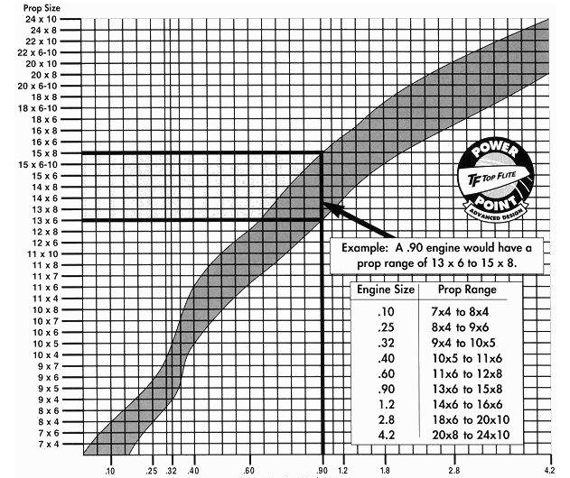

Figure : Propeller Sizing Chart [17]

# **4.4.3 Propeller Blades**

The team agreed to use a three-blade propeller for the micro aircraft. Increasing the number of blades may reduce the efficiency of aircraft because each added blade will cut the amount of turbulent air from the preceding blade. The team selected a 4.41 x 3.54 in, three-blade propeller for the design from Horizon Hobby.

# **4.5 Payload Bay**

The requirements in the SAE aero micro rules and regulations state that the team needs a payload pay that has the dimensions of 1.5” x 1.5” x 5”. The team agreed to make the payload bay out of balsa wood due to the lightweight characteristics of balsa. Figure 10 displays the payload bay for our aircraft. The slot in the front is for a panel to slide through, that way the weights do not fall out of the payload bay.

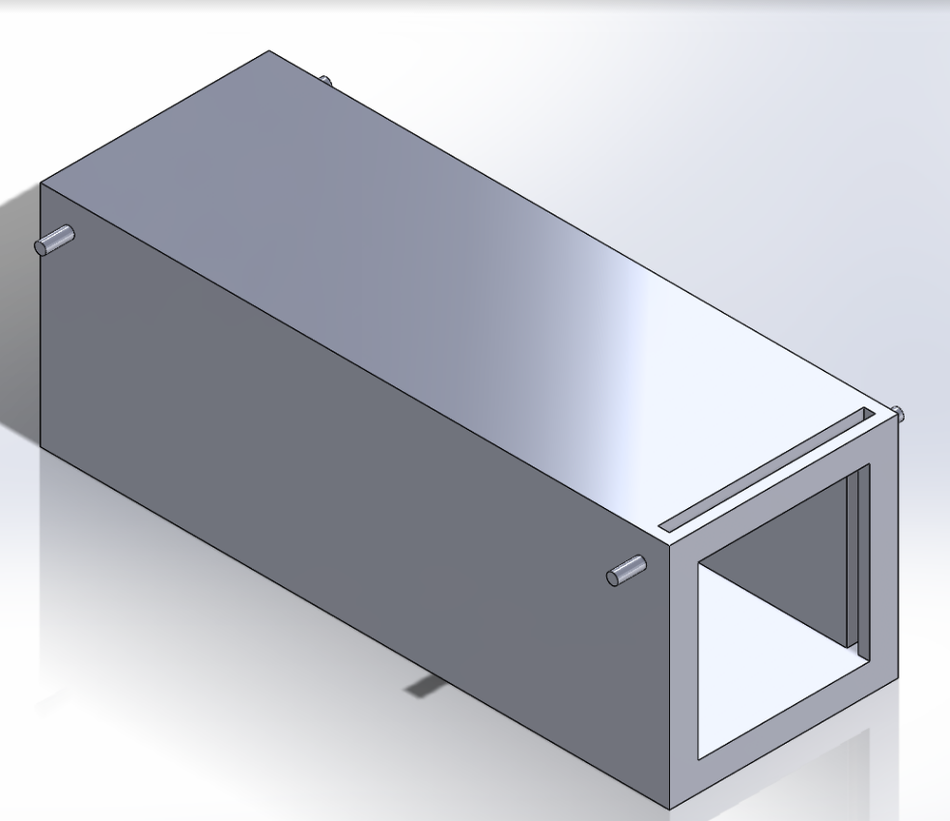

Figure : Payload Bay

# **5. Bill of Materials**

Table 8 below shows the bill of material to design our SAE airplane project. The team made a list of the parts we purchased. It includes the description, quantity and the cost of the parts. The reinforced tape connects the joints for the aileron and the elevator. The square carbon fiber rod has dimensions of 8mm*8mm*1000mm as calculated. The Velcro strap connects the speed controller (ECS) and the Battery and prevent them from moving during the flight.

Table : Bill of Materials

|  |  |  |  |  |
| --- | --- | --- | --- | --- |
| Part# | Part name | Description | Qty | Cost $ |
| 1 | Motor | 11.1v, 860Kv, 9,546rpm | 1 | 23.66 |
| 2 | Reinforced Tape | It will be used as joint for Aileron and Elevator | 1 | 6 |
| 3 | Propeller | 3 Blades propeller 112mm*90mm | 1 | 3 |
| 4 | Carbon Fiber square rod | 8mm*8mm*1000mm | 1 | 11.6 |
| 5 | Velcro strap | To prevent some components from moving during the flight | 2 | 2.74 |

**Table 9: Table of References**

[1] “2017 Collegiate Design Series: SAE Aero Design Rules” 2016. Available: <https://www.saeaerodesign.com/content/2017_AERO_RULES_FINAL.pdf>

[2] D. Coiro and F. Nicolosi, "Design of a Three Surfaces R/C Aircraft Model," 2002. [Online]. Available: https://ojs.cvut.cz/ojs/index.php/ap/article/viewFile/314/146. Accessed: Oct. 1, 2016.

[3] A. Bowers and O. Murillo. “On Wings of the Minimum Induced Drag: Spanload Implications for Aircraft and Birds.” *NASA*, March 2016. [Online].

[4] O. Bholse. “Radio Controlled Airplane” *International Journal for Scientific Research & Development.* pp 90-94. 2015.[Online].

[5] "Camberline." *: Newsletter of the UIUC Low-Speed Airfoil Tests*. N.p., n.d. Web. 27 Oct. 2016.

Available: <http://m-selig.ae.illinois.edu/uiuc_lsat/lsat_5bulletin.html>

[6] J. Anderson, *Fundamentals of Aerodynamics*, 5th ed. New York: McGraw-Hill Companies Inc., 2011, p. 24.

[7] R. Budynas, J. Nisbett and J. Shigley, *Shigley's mechanical engineering design*, 1st ed. New York: McGraw-Hill, 2011, pp. 92-97.

[8] “Balsa Wood Properties” *Matbase*, 2016. [Online]. Available: <https://www.matbase.com/material-categories/composites/polymer-matrix-composites-pmc/wood/class-4-wood-slightly-durable/material-properties-of-balsa-wood.html#properties>

[9] 2016. [Online]. Available: <http://depronfoam.com/depron-foam/resource/Depron-White-Technical-Data-Sheet.pdf>

[10] "Engineering Values for model materials. - RC Groups", *Rcgroups.com*, 2016. [Online]. Available: <https://www.rcgroups.com/forums/showthread.php?t=179292>

[11] J. Corum and R. Battiste, "Basic Properties of Reference Crossply Carbon-Fiber Composite", *Oak Ridge National Laboratory*, 2016. [Online]. Available: [7] O. Feather and T. Feather, "wing design," in aeronautics.nasa. [Online]. Available: http://www.aeronautics.nasa.gov/pdf/wing_design_k-12.pdf. Accessed: Oct. 1, 2016.

[12] Engineering Toolbox. *Reynold’s Number.* [Online] Available: <http://www.engineeringtoolbox.com/reynolds-number-d_237.html>

[13] Engineering Toolbox. *Dry Air Properties.* [Online] Available: <http://www.engineeringtoolbox.com/dry-air-properties-d_973.html>

[14] P. K. Johnson, “About Airfoils for Flying Model Aircraft” *Airfield Models,* 2015. [Online] Available: <http://www.airfieldmodels.com/information_source/math_and_science_of_model_aircraft/rc_aircraft_design/plotting_airfoils/about_airfoils.htm>

[15] (2016) *Airfoil Database search.* [Online] Available: <http://www.airfoiltools.com/search/>

[16] D. P. Raymer, “Airfoil Geometry and Selection”, in *Aircraft Design: A Conceptual Approach: third edition.* Reston, VA: AIAA Education Series, 1999, ch 4 pp 39 – 86

[17] “Understanding RC Propeller Size.” R/C *Airplane World* [Online]. Available: <http://www.rc-airplane-world.com/propeller-size.html>

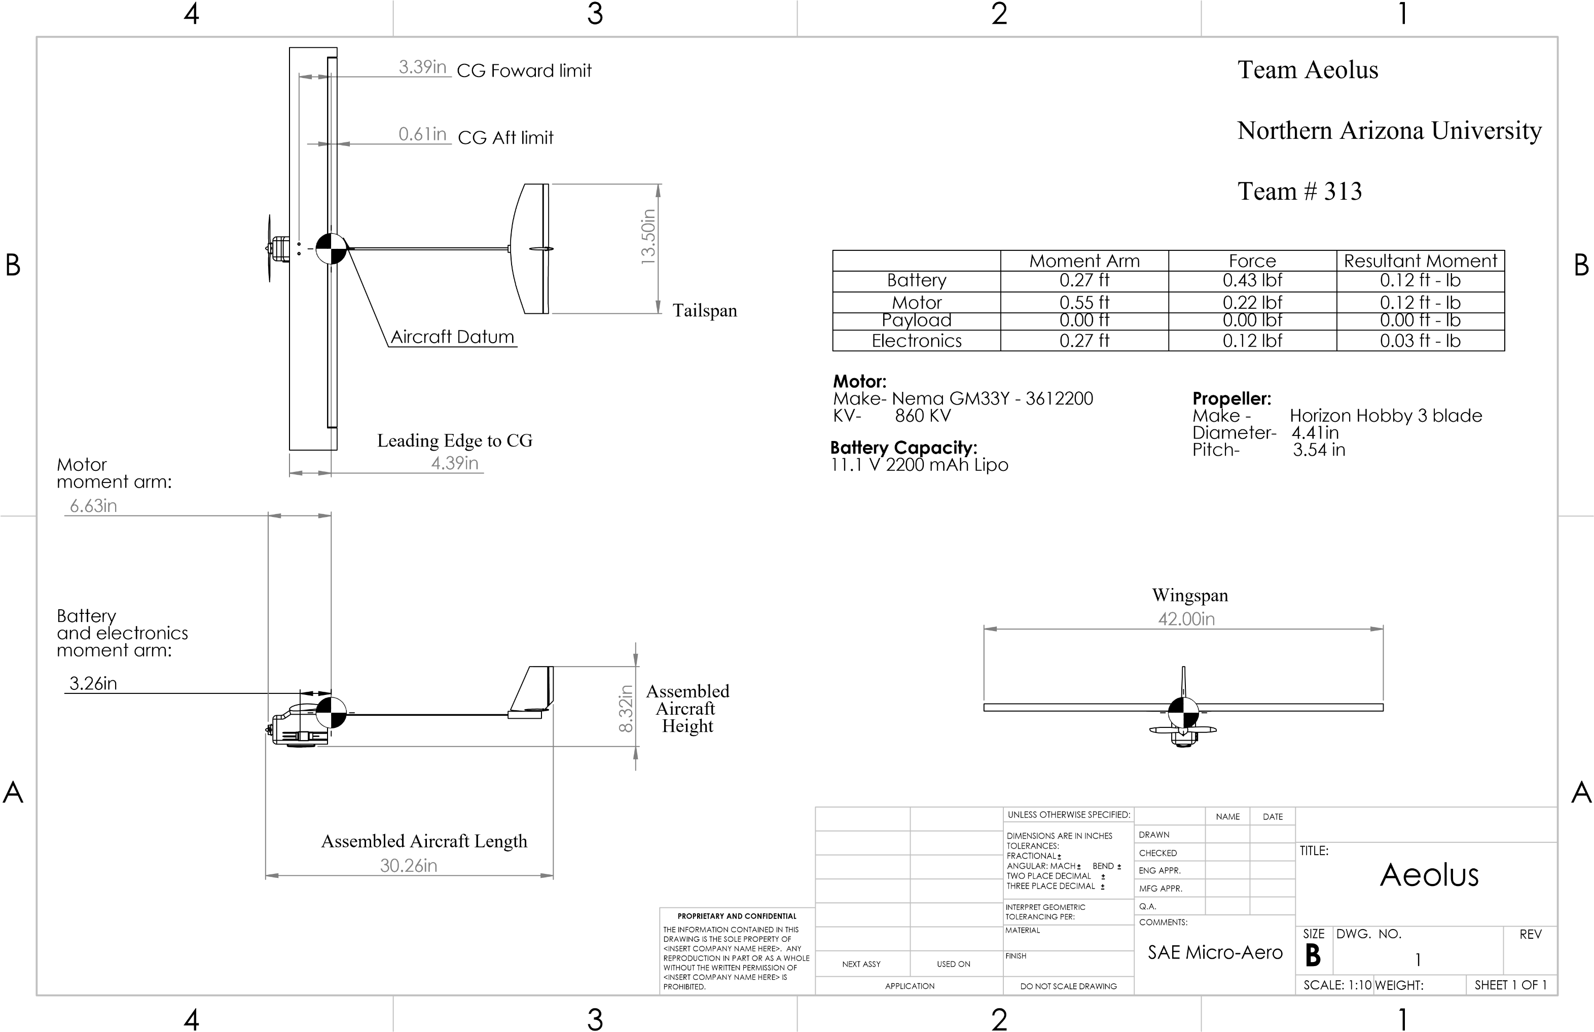**2D Drawing**

**TDS: Aircraft Weight Build-Up Schedule**

|  |  |  |
| --- | --- | --- |
|  | **Component** | **Weight (lb)** |
| 1 | Battery | 0.4390 |
| 2 | Motor | 0.2200 |
| 3 | Speed Controller | 0.0121 |
| 4 | Servos (x3) | 0.0110 x 3 = .0330 |
| 5 | Wing | 0.1430 |
| 6 | Carbon Fiber Rod | 0.0478 |
| 7 | Carbon Fiber Beam | 0.0243 |
| 8 | Propeller | 0.0823 |
| 9 | Payload Bay | 0.2425 |
| 10 | Tail | 0.0463 |
| 11 | Elevator | 0.0463 |
|  | **Total** | **1.3367** |