Preliminary Design:

Renewable Energies Based Hydrogen Production

Presented To:
Dr. Thomas L. Acker
Associate Professor of Mechanical Engineering

Northern Arizona University


H2 Generation:
Josh Spear; Team Leader
Andrew Boone; Secretary
Ryan Hirschi; Financial Officer
Robert Burke; Team Mediator

Northern Arizona University
College of Engineering and Technology
ME 486 Capstone Design SP03

Last Revised: 2/5/03

Table of Contents

Summary of the Renewable Energy Based Hydrogen Production Project……..Page 1

Deliverables for the Renewable Energy Based Hydrogen Production Project...Page 1

Design Philosophy and Schedule of Upcoming Important Dates……………….Page 1

Feasibility of the Renewable Energy Based Hydrogen Production Project…....Page 1

Preliminary Design Layout of Hydrogen Production Plant…………………….Page 1

Summary of PV Cell Calculations………………………………………………..Page 2

Summary of Wind Power Calculations…………………………………………..Page 3
Summary of the Total Power Produced by the Wind Turbine and PV Cells….Page 3

Summary of the Rooftop Water Collection Analysis……………………………Page 3

Design of Water Storage and Purification System……………………………Page 3-4

Hydrogen Generation Analysis………………………………………………...Page 4-6

Hydrogen Storage……………………………………………………………….Page 6-7

Safety Research For Hydrogen Production Plant……………………………….Page 7

Appendix 1: Updated Team Schedule

Appendix 2: Renewable Energy Analysis

Appendix 3: Rainwater Collection Analysis
Appendix 4: Electrolyzer and Hydrogen Analysis

Appendix 5: Hydrogen Usage Analysis

Appendix 6: Overall Reference List

H2 Generation Contact Information:

Josh Spear; Team Leader (928) 853-1617, jds33@dana.ucc.nau.edu
Andrew Boone; Secretary (928) 523-3963, NAUBoone@yahoo.com

Ryan Hirschi; Financial Officer (928) 213-0007, rsh6@dana.ucc.nau.edu
Robert Burke; Team Mediator (928) 523-2876, rcb27@dana.ucc.nau.edu

Preliminary Design: Renewable Energy Based Hydrogen Production

Summary of the Renewable Energy Based Hydrogen Production Project

The purpose of this project is to design a hydrogen-gas production facility that uses the available water and renewable energy resources located behind the Northern Arizona University (NAU) College of Engineering & Technology (CET) building. The following are the requirements stated in proposal to Dr. Acker.

- Use of existing renewable energy as the energy supply to produce hydrogen gas
- Hydrogen must be stored in a manner available to fuel a hydrogen racecar
- Use available rainwater (utilizing available rooftops) supplemented, if necessary, with CET tap water

Deliverables for the Renewable Energy Based Hydrogen Production Project

H2 Generation proposes to provide two deliverables in the solution to the renewable energy based hydrogen production problem. The first deliverable will be the specification of the design layout for the production facility. The second deliverable will be to construct a proof of concept demonstration model.

Design Philosophy and Schedule of Upcoming Important Dates

The design philosophy incorporated by H2 Generation is to break down the large-scale design of a hydrogen generation station into manageable components for individual analysis. H2 Generation team has created and updated a schedule entailing deliverable dates and milestones aiming for the completion of the project (See Appendix 1). Listed here is a summary of upcoming dates.

- Receive edited Preliminary Full Scale Design Deliverable 2/13/03
- Design Review 3/11/03-3/13/03.
- Capstone Design Conference 4/25/03.

Feasibility of the Renewable Energy Based Hydrogen Production Project

H2 Generation has found the design of a renewable energy based hydrogen production facility at the NAU CET “Solar Shack” to be feasible. The table below summarizes the renewable energy and water collection calculations (See Table 1 below). For comprehensive calculations, see Appendix 2 and Appendix 3. The next step in determining feasibility for the project is to determine the mileage a hydrogen-powered vehicle could travel with the given amount of hydrogen producible. The table below summarizes the predicted mileage a vehicle could travel based on energy colleted and water collected.
Table 1: Energy and Rainwater Limitations. *For calculations see Appendix 5.
Source | Amount Collected | H2 Produced Estimate | Mileage Traveled
Rainwater | 8177.55 gallons/year | 40,242,012 liters H₂* | 35851 miles*
Electricity | 14761 kWh/year | 1,968,133 liters H₂* | 1753 miles*
The table above shows that electricity is the limiting factor. The rough mileage that a vehicle may travel on the possible hydrogen produced is 1753 miles. In order to produce more hydrogen electricity must be supplemented to equal the amount producible by water collected or a more efficient energy usage must be accomplished.

Preliminary Design Layout of Hydrogen Production Plant

The preliminary design for the hydrogen production plant includes the specification of the individual components illustrated in the Layout of Major System Components (See Appendix X). The specified components are listed in the table below (See Table 2 below).

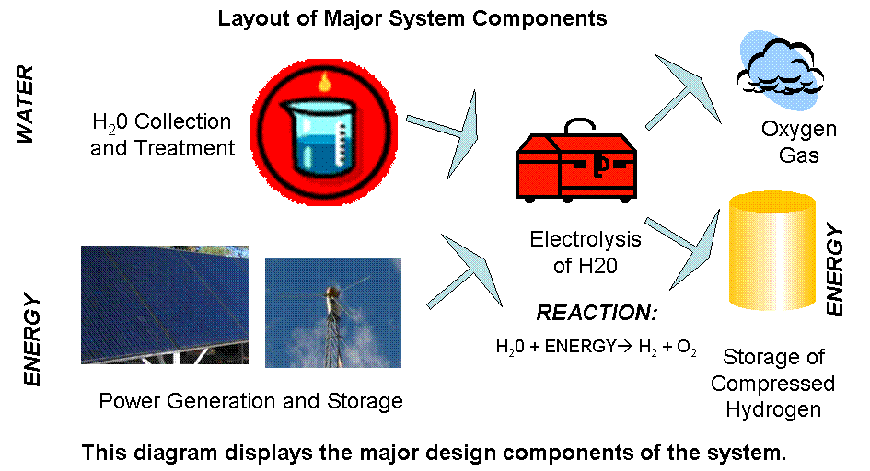
Figure 1: System Component Layout

Summary of PV Cell Calculations

The preliminary photovoltaic cell calculations consist of analyzing NAU’s existing PV cell systems located at NAU’s Solar Shack in Flagstaff, AZ. NAU’s existing PV cell systems are made up of solar shingles lining the roof of the Solar Shack and a 45 degree angle (south facing) array. Data was collect including: area of the solar shingles lining the roof, angle of the roof’s pitch, the area of the 45 degree array, and verification of the 45 degree angle.

The resource of NREL’s website, http://rredc.nrel.gov/solar/old_data/nsrdb/redbook/atlas/, provided 30 years of daily average insolation data (insolation in terms of kwh/m²/day) for each month according to a specific location and desired angle of the PV cell array (the Solar Shack’s roof was assumed to be flat plate). Combining the collected data with NREL’s information, average kwh/day (a day in each month) and kwh/month was found. A “shading factor” was applied to the annual kwh production value. See Appendix 2 for exact values.

Summary of Wind Power Calculations

The preliminary wind power calculations consist of analyzing the 1.5kw Bergey wind turbine located at NAU’s Solar Shack in Flagstaff, AZ. Western Regional Climate Center’s website, http://www.wrcc.dri.edu/htmlfiles/westwind.final.html, provided monthly average wind speeds. Using Betz’s equation (Power = C_{p}*.5*rho*u³*A; refer to calculations for variable meaning and value) average joules produced/hour for each month was found. From that, kwh/month could be found, totaling to an annual kwh production value. See Appendix 2 for exact values.

Summary of the Total Power Produced by Wind Turbine and PV Cells

The total power produced by the wind turbine and the PV cells combines the power outcomes from the wind turbine and PV cells. The combination includes monthly PV cell power with shading factor, monthly wind production power, and an annual grand total power. See Appendix 2 for exact values.

Summary of the Preliminary Rooftop Water Collection Analysis
The preliminary rooftop water collection calculations consist of analyzing NAU’s existing Solar Shack and rainfall in Flagstaff, AZ. University of Utah’s website, http://www.met.utah.edu/jhorel/html/wx/climate/normrain.html, was used to find average monthly rainfall in Flagstaff, AZ. Collected data included the area of the Solar Shack roof. This area was then geometrically manipulated into a flat roof. A flat roof is desired because can represent a cubic rainfall depiction for volume calculation. The volume calculations were found for each month and annually. See Appendix 3 for exact values.

Design of Water Storage and Purification System

At this point using distilled water for the electrolyzer is necessary. Still to be determined is whether the water should be stored in the distilled state, or the initially filtered state. The initial filter will consist of a gravity filter that removes large impurities from the water. Storage of the water will take place in off the shelf drums, illustrated in Figure 4 below (Emergency Preparedness Center 2003), designed to store drinking water. There are two options for distilling the water. The first is to solar-distil the water using a “solar still” such as the “Rainmaker” illustrated in Figure 2 below (Sol Aqua 2003), and the second is to use an electrical distiller in Figure 3 below (Renewed Health Supply 2003). Table 2, below, summarizes the major aspects of each component.

Table 2: Summary of Water Storage Components

The advantage of using the “Rainmaker is the lack of power draw that will help conserve battery power, but if it is found that we have excess power, the electric distiller will be a good investment due to its higher and predictable production rate. With inexpensive water drums, the water can be stored pre-distilled or distilled.

Hydrogen Generation Analysis:

In the first phase of the project it was decided by the client to use electrolysis as the means for hydrogen production. In further research of hydrogen electrolysis, we found a simple system which includes a solid polymer electrolyte (SPE). The function of the SPE is to eliminate the use of caustic solutions that are typically mixed with water in electrolyzer usage. The function of a caustic solution or the SPE are to add a resistance to water so electrons can move more freely when separating the hydrogen and oxygen of the water molecule. The benefit of not needing to mix external solutions to act as an electrolyte (using the SPE) reduces the cost of producing hydrogen. Another benefit of SPE is the electrolyzer life cycle is increased due to the absence of corrosion on the cathode and anode caused by caustic solutions.

Additional benefits of the SPE include the following:

- Certified Safety: National Fire Protection Agency, and (OSHA-1910.103)
- Hydrogen produced to six sigma purification: 99.9999%
- Allowable output pressure ranging from 0 to 90 psi
- Hydrogen purity detection shutoff system

The SPE electrolyzer is available to produce at many different production rates. To analyze the energy efficiency we compared the energy per unit volume of hydrogen produced to the energy usage of the electrolyzer. The table below shows the production rate of each SPE electrolyzer system compared to electrolyzer power usage (watts).

Table 3: Electrolyzer power usage vs. hydrogen volume output

We used a molecular volume ratio for water in order to quantify the amount of hydrogen produced per unit of water. The molecular weight of water (a combination of two hydrogen atoms and one oxygen atom) was used to find a mass ratio of hydrogen to oxygen. It was found that 11.11% of the weight of water is hydrogen. The monthly energy of hydrogen stored was compared to the monthly energy used to produce it. The table below shows the monthly calculations and the amount of water in liters for each month.

Table 4: Electrolyzer Production
Figure 5: Power used by Electrolyzer vs. Time

Hydrogen Storage

The hydrogen storage system will consist of three main components:

- Low pressure propane tank
- Hydrogen gas compressor
- High pressure compressed gas cylinder

Because the electrolyzer and compressor will run at different volumetric rates, it is necessary to place a buffer tank between them. A 100 gallon propane tank will serve this purpose. The electrolyzer will pressurize hydrogen to about 90 psi in the propane tank. When this propane tank is full, the compressor will compress the hydrogen gas into a high pressure compressed gas cylinder.
Safety Research for Hydrogen Production Plant

Safety research is ongoing in the design of the hydrogen production plant. Listed below are some valuable statistics on safe levels of hydrogen in various situations (Pyle 1997 page 16, Pyle 1998 page 47):

- Flammable when volume of hydrogen in air is between 4 and 75 %
- Explosive when volume of hydrogen in air is between 18.2 and 58.9 %
- Flammable when volume of hydrogen in oxygen is between 14.7 and 93.9 %
- Explosive when volume of hydrogen in oxygen is between 15 and 90 %
- Industrial safety standards for purity: 99.5% pure hydrogen
- Research Grade hydrogen: 99.9% pure hydrogen
- Ultra high purity hydrogen: 99.9999% pure hydrogen
Appendix 1: Updated Team Schedule

Appendix 2: Renewable Energy Analysis

Appendix 3: Rainwater Collection Analysis

Appendix 4: Electrolyzer and Hydrogen Analysis

Appendix 5: Hydrogen Usage Analysis

