Combustion Air Preheater

STATUS REPORT #3

April 3, 2003
By

Purina Boiler Efficiency Team

Kofi Cobbinah Matthew Bishop
Team Leader/ Website Designer Financial officer/Mediator
3200 S. Litzler Dr. (Apt19-122) 3200 S. Litzler Dr. (Apt1-204)
Flagstaff AZ 86001 Flagstaff AZ 86001

Ryan Cook Carl Vance
Documenter/Secretary Communicator/Historian
1000 W. Forest Meadows St.#235 4015 E. Soliere Ave. #249
Flagstaff AZ, 86001 Flagstaff AZ, 86004

In partial fulfillment of the requirements of ME 486 Engineering Design
Northern Arizona University
College of Engineering and Technology

Purina Boiler Efficiency Team
College of Engineering & Technology
Northern Arizona University
Flagstaff, AZ 86011

April 2, 2003

John Cain
4700 E. Nestle Purina Dr.
Flagstaff, AZ 86004

Dear Mr. Cain,

SUBJECT: STATUS REPORT # 3

This letter is to inform you about our team’s design progress to date on the combustion air preheater design.

The design team has been able to complete the mathematical model of design and a copy of the model was submitted to you on February 5, 2003. The mathematical model included energy savings that were also correlated to monetary savings.

The team is currently finalizing the calculations of drag, materials, and labor costs for installation. The team is also currently working our CAD models for the design.

Through this project we are learning how to work as a team, remain on schedule, overcome challenges and improve our knowledge in the engineering field.

Thank you for your company’s support on our education. We will present a complete and accurate design by the end of the semester.

Sincerely,

Matthew Bishop Kofi Cobbinah Ryan Cook Carl Vance

Table of Contents

1. Introduction 3
2. Design Concept 3
3. Justification for Design 3
4. Analysis 4
4.1. Forced Convection 5
4.2. Radiation 6
4.3. Counter-Flow Heat Exchanger 7
5. Energy and Financial Savings Calculations 7
6. Conclusions 8
7. References 9
8. Appendix A: Excel Spreadsheet, Convection 10
9. Appendix B: Excel Spreadsheet, Radiation 11
10. Appendix C. Excel spreadsheet: Counter Flow Heat Exchanger 12
11. Appendix D: Figures 13
12. Appendix E: Team Time Log for the Semester 15

1. Introduction

The purpose of this report is to provide the client with a design update and detailed justifications for the design choices made to this point concerning the design of a combustion air preheater. The report will include detailed mathematical modeling proving that the design will provide savings to Nestlé Purina.

2. Design Concept

Major design concepts for the combustion air preheater are based on client requirements and include; economic feasibility, impact on existing systems, measurable efficiency improvements, and safety. The basic design of a concentric duct was determined using the client requirements and the justification for this choice is explained in detail in section 3. of this report. The main components of a concentric duct preheater are a duct with an air inlet and outlet and the transition from the preheater to the intake fan. The duct surrounds the existing stack and intake air is drawn down and around the stack gaining heat as it passes through the duct. The existing fan draws the air into the boiler at a higher temperature and decreases the amount of fuel needed to produce steam. Please refer to Appendix D for diagrams of the design concept.

3. Justification for Design

The choice of a concentric duct design is justified through all three major design points mentioned in section 2. of this report; economic feasibility, efficiency improvements, impact on existing systems, and safety.

The design will have a low impact on existing systems with no modifications needed to the stack, and minimal alterations to the intake of the boiler.

The concentric duct design will minimize installation costs, with the major prices coming from the duct material, installation, and labor.

The potential efficiency increases will be slightly lower than with other designs, however the air can only be heated so much before the system will become oxygen starved due to lowered air density. This point will be analyzed in the final design.

During the research phase different combustion air preheater designs were considered and included an air-to-air heat exchanger, a runaround design, and a concentric duct design.

The air-to-air heat exchanger operates on the same concept as the concentric duct design but with heat transfer occurring through a series of coils situated in the stack. The air-to-air heat exchanger would provide higher heat transfer in a smaller area, but would require stack alterations and an expensive custom made series of heat exchanger coils.

The runaround design uses a fluid to transfer heat from the exhaust air to the intake air. This design would also require custom made coils, stack alterations and an addition fluid for heat transfer.

With the client requirements taken into account the design that best fit the scope of the senior design course and the clients needs was determined to be a concentric duct design.

4. Analysis

The analysis part of the report has been completed with mathematical modeling of the heat transfer methods that are present in the system. The heat transfer methods included radiation and forced convection. A counter flow heat exchanger analysis was applied to the system to verify the results in the forced convection model. Two analyses were performed for the convection model since it will provide the majority of the heat transfer in the system with radiation only accounting for approximately 10% of the energy transfer.

The mathematical model of the combustion air preheater is an analysis of forced convection and radiation through a concentric duct. The concentric duct design draws air from the top of the boiler room down around the stack, heating the intake air. Two parts make up the main concentric duct design: the existing boiler stack, and the outer duct that surrounds the stack. It is important to note that the system will experience radiation as well as forced convection. The majority of the radiation will be absorbed by the inner surface of the outer duct, therefore increasing its surface temperature depending on insulation. The increase in surface temperature will contribute to the energy input of the preheater through forced convection from the outer surface. Ultimately, the air will gain energy from both surfaces. (See Figure C.1 in Appendix C)

The mathematical model is intended to prove that adequate heat transfer exists from the stack in order to meet final design goals. The mathematical model is based on Dittus-Boelter heat transfer equations to model forced convection. The model acknowledges forced convection and radiation and also includes an energy balance to determine energy savings. Free convection is not applied in the analysis since forced convection overwhelms free convection. Also, the surface temperature of the stack is known from measurement, rendering conduction calculations uneccessary.

The following sections show the calculations of the forced convection from the stack surface, the radiation from the inner duct surface, and the estimated energy and financial savings.

4.1. Forced Convection

The following measurements and preliminary assumptions were used when modeling forced convection in the design.

- Air temperature at ceiling height averages 100 degrees Fahrenheit from infrared measurements.
- Boiler intake air is currently 80 degrees Fahrenheit. Infrared temperature measurements averaged this amount.
- Stack length is 14 feet from ceiling to the top of the boiler.
- The following Dittus-Boelter equation provides an accurate method for finding the Nusselt number.¹¹
Nu_{d} =.023Re ^{4/5}_{D} Pr^{.4}

Where Re_{D} = Reynolds number
Pr = Prandtl number
- The Prandtl number .707 is appropriate for air at 300 K. ¹¹
- The Reynolds number in the duct would always provide turbulent flow since it is greater than 10,000 for the duct sizes analyzed.
- For calculation purposes all units are in SI units. The final energy savings is converted into Btu to adhere to Nestle Purina Standards.

The listed assumptions and measurements were incorporated into an Excel spreadsheet that provided a way to alter duct sizes in order to determine optimum design characteristics. (See Appendix A) Altering the duct size varies the temperature and air speed in the duct. The optimum air speed and temperature are estimated to minimize the fan loading and maximize the force convection heat transfer.

Forced convection equations:

1. Nu_{d} =.023Re ^{4/5}_{D} Pr^{.4} provides the Nusselt number

2. h = (Nu (k))/D_{h} provides the convection coefficient (h) for a given hydraulic
diameter(D_{h}). The hydraulic diameter is the outer duct diameter
minus the stack diameter.

3. q” = h(T_{stack}-T_{air}) provides the heat flux from the stack.

These three equations are the basis for the convection spreadsheet. All three equations are dependent on the hydraulic diameter. The hydraulic diameter was also linked to the airspeed. The duct cross- sectional area was sized to provide a duct airspeed equal to or less than the airspeed of the fan intake (to prevent additional fan load).

Results of Forced Convection Analysis

Heat Flux (q”) | Energy Saved (w) | Energy saved (kBtu/year) | Financial Savings ($/year)
1794 w/m² | 22,000 | 459,325 | $1,409

See section 4. for financial and energy savings calculations.

4.2. Radiation

The outer duct surface will increase in temperature as a result of the stack radiating heat from its surface to the duct. The heat transfer to the duct due to radiation is determined through analyzing an infinitely long concentric duct and then applying the concept to the stack. The radiation absorbed by the duct will heat its surface and provide a heat transfer to the air depending on the chosen insulation. An insulation value for the outer duct was assumed and will be finalized as materials are chosen for the final design. The radiation spreadsheet is presented in Appendix B, and is derived from the equation shown below.

Concentric duct radiation analysis: heat transfer =$\frac{{σA}_{1}(T_{1}^{4}−T_{2}^{4})}{\frac{1}{ε_{1}}+\frac{1−ε_{2}}{ε_{2}}(\frac{D_{1}}{D_{2}})}$

Where:
σ = Stefan-Boltzmann constant, 5.67 x 10⁻⁸ W/m²K⁴
A₁ = Surface area in m²
T₁ = Surface temperature of stack in K
T₂ = Surface temperature of duct in K
ε₁ = emissivity of stack surface
ε₂ = emissivity of duct surface
D₁ = Stack radius
D₂ = Duct radius

Results of Radiation Analysis

Energy (q) | Energy saved (kBtu/year) | Financial Savings ($/year)
1752 w | 36597 | $112

See section 4. for energy and financial savings calculations.

4.3. Counter-Flow Heat Exchanger

The heat exchanger model is based on forced convection. The model was started with known values for the initial temperature of the hot side (stack), the initial temperature of the cold side (duct), the mass flow rates of each side, and the length of the duct.
The stack information was used to determine h_{i} and h_{o}, the convection coefficients for the inside and outside walls of the stack, respectively. These values were used to calculate the overall convection coefficient, U.

With the above values known, an iterative process was started using a series of equations to find the correct values for the final temperatures for the stack and duct, and also for the amount of energy transferred, in Watts. The iteration began with a guessed value for the final temperature of the stack gases. This, along with the mass flow rate, was used to find the total energy transfer. This was then used to calculate the final duct temperature, and the ΔT_{lm}, which is a natural- log- mean difference between the hot and cold initial and final temperatures. This ΔT_{lm} and the U value were used to solve for the area needed for convection.

This first area value did not match the area of the actual stack because the final stack gas temperature was a guessed value. Thus, the iteration involved varying the guessed final stack gas temperature, and comparing the output stack area to the known stack area. When the 2 values matched, the solved values were correct. This model provided accurate values for the final temperature of the stack gases, the final temperature of the preheated combustion air, and the total energy transferred in watts. This model was then used to more accurately calculate monetary savings.

5. Energy and Financial Savings Calculations

The final energy savings is a combination of the forced convection and radiation values to give a final heat transfer to the intake air. The energy is then converted from watts to Btu to determine a fuel savings number. The fuel savings number provides a yearly cost savings through fuel use reduction.

The financial savings calculations are outlined below:

Combined Heat Transfer from Convection and Radiation = 38,269 W

1 Watt = 3.4123 Btu/h

3.4123 * 38,269 W = 130,586 Btu/h

Btu/h = 799,187 kBtu/year, note: 255 operating days per year, 24 hours a day.

1 gallon of No. 6 fuel oil = 150 kBtu = $.46

799,187 kBtu per year / 150 kBtu = 5,327 Gallons of Fuel oil saved.

$.46 * 5,327 gallons = $ 2,450 saved per year 5 year savings = $12,254

The 5-year savings are based on a conservative estimate of insulation values and duct sizing for reduced fan loading. The mathematical model provides a basis for design to increase heat transfer and therefore increase yearly savings and fuel conservation.

6. Conclusions

The design has been proven through mathematical models and the design process is on schedule for a May 2 completion date.

The mathematical model proves that adequate heat transfer is available from the stack and can be reintroduced into the boiler to provide energy savings to the client. The financial savings will be a starting point for optimizing material selection and labor costs for the final design.

For the duct size shown and materials chosen as a preliminary design, the concentric duct design will provide an energy savings from radiation and forced convection. The mathematical model will be a basis for material and size specifications in the future.

As the design is finalized, a more accurate account of energy savings and financial savings will be determined that will include drag calculations for the intake fan, and materials selection.

As a reminder the final design will include a complete materials list, drag calculations on the intake fan, and a complete set of AutoCAD drawings detailing the design.

7. References
- Boiler Control Training Handbook. Emerson, Edward R. 2000. Boiler Consulting
and Training Inc. Surprise AZ.

2. Fundamentals of Boiler Efficiency. Exxon. Lubetext. D250 1976

3. Guidelines for Industrial Boiler Performance Improvement. EPA-600/8-77-003a.
January 1977. Federal Energy Administration. EPA. page 79.

4. Reducing energy costs. KEH energy engineering. Reisterstown, MD. Lewellyn
Technology. 1990

5. http://www.agr.gc.ca/cal/epub/5181e/5181-0007_e.html
information and a diagram for three types of combustion air pre- heaters

6. Energy Technologies.
http://tristate.apogee.net/et/ezithbs.htm
brief information on boiler stack heat recovery

- Fundamentals of Heat and Mass Transfer, 5th Edition. Frank P. Incropera and David P. Dewitt. August 2001.

- Fluid Mechanics, Fifth Edition. Frank M. White. McGraw Hill.1999

8. Appendix A: Excel Spreadsheet, Convection

9. Appendix B: Excel Spreadsheet, Radiation

10. Appendix C. Excel spreadsheet: Counter Flow Heat Exchanger

11. Appendix D: Figures

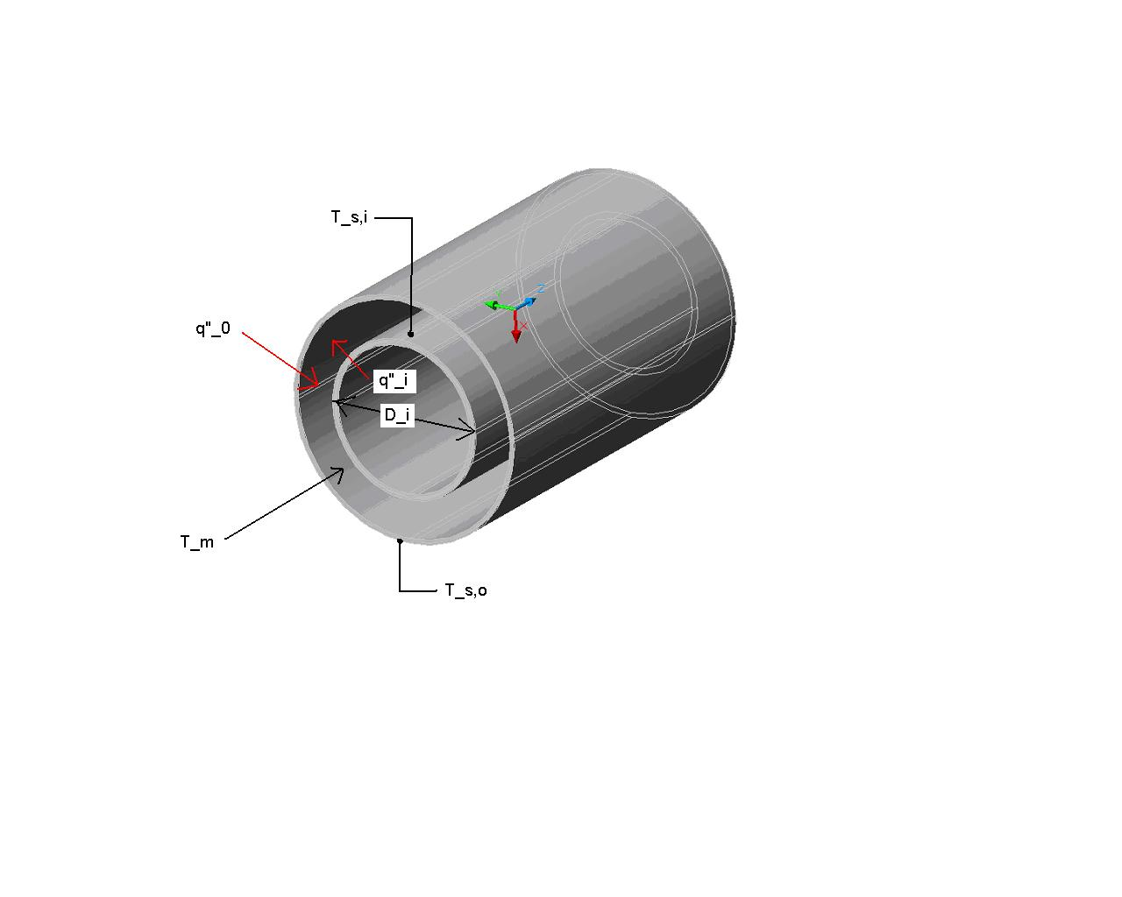

Figure C.1.

The concentric duct design is shown above with the inner cylinder representing the stack and the outer cylinder representing the duct. The air flows between the two and increases in temperature from the heat transfer from the stack.

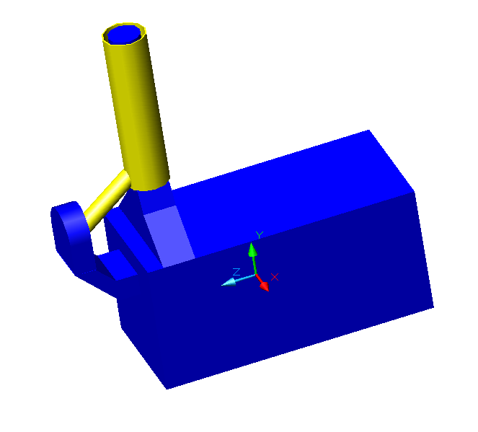

Figure C.2

The boiler system can be seen above with the stack and intake fan being the system components that the combustion air preheater interacts with. The fan to duct portion of the preheater is still being designed.

12. Appendix E: Team Time Log for the Semester

Team Member | Carl Vance | Kofi Cobbinah | Ryan Cook | Matthew Bishop
Week of | 13-Jan |  |  |  |  | Week Total
Time (hours) | 4 | 4 | 4 | 4 |  | 16
Week of | 20-Jan |  |  |  |  | Week Total
Time (hours) | 6 | 5.8 | 5.7 | 7 |  | 24.5
Week of | 27-Jan |  |  |  |  | Week Total
Time (hours) | 12 | 4.9 | 5.2 | 12 |  | 34.1
Week of | 3-Feb |  |  |  |  | Week Total
Time (hours) | 5.7 | 4 | 5.5 | 6.3 |  | 21.5
Week of | 10-Feb |  |  |  |  | Week Total
Time (hours) | 6.4 | 4.5 | 6.7 | 6.2 |  | 23.8
Week of | 17-Feb |  |  |  |  | Week Total
Time (hours) | 7 | 7 | 7 | 7 |  | 28
Week of | 24-Feb |  |  |  |  | Week Total
Time (hours) | 12 | 11.5 | 10 | 11 |  | 44.5
Week of | 3-Mar |  |  |  |  | Week Total
Time (hours) | 10.4 | 9.3 | 0 | 11.5 |  | 31.2
 |  |  |  |  |  | Total
 |  |  |  |  |  | 223.6

The team time log shown above shows individual and total team time devoted to the project throughout the semester. (Times are in hours)

