

DESIGN REVIEW

March, 8th, 2002

by
Mobility Solutions Team
Scott Turnbull  Team Leader  615 Campus Heights  Flagstaff, AZ 86001  (928)-523-7708  sft2@dana.ucc.nau.edu | Brett Bonner  Asst. Team Leader  NAU Box 20644  Flagstaff, AZ 86011  (928)-523-2830  bcb7@dana.ucc.nau.edu
Roy La Barbera  Treasurer  NAU Box 6497  Flagstaff, AZ 86011  (928)-523-4671  rjl23@dana.ucc.nau.edu | Joseph Speigl  Communications  NAU Box 7825  Flagstaff, AZ 86011  (928)-523-3713  jrs44@dana.ucc.nau.edu

Satisfying requirements for ME 476, Senior Capstone Design at Northern Arizona University

Table of Contents

Introduction 4
Design Process 4
Modeling 4
Design #1 5
Design #2 6
Design #3 7
The Selected Wheelchair Design 7
Status of the Design and Analysis Phase 9
Frame Material Selection 9
Structural Strength Analysis 9
Stability Analysis 10
Current and Near Future Tasks 11
APPENDIX A: Off-road wheelchair functional requirements 12
APPENDIX B: Project Schedule 14
APPENDIX C: Cost estimate and bill of materials 15
APPENDIX D: State of the art research 16
APPENDIX E: Static stability analysis 17

Introduction

MST has been asked to design and build a safe and reliable off-road wheelchair that is capable of traversing unpaved trails. The wheelchair must provide a comfortable ride, easy passenger transfers, and an enjoyable view.

MST’s client and her daughter, Carol and Toni Seumptewa, enjoy outdoor excursions in Flagstaff, Arizona. Unfortunately, Toni is spastic quadriplegic and confined to a wheelchair that is not adept at rough or off-road travel.

The client tested a special needs baby jogger in an attempt to solve this problem. The testing revealed that the jogger did not suit her needs. The jogger was sized for a child rather than an adult and deprived the passenger of an enjoyable view. Passenger transfers were difficult due to the obstruction that the front wheel caused. These problems created the need for a new wheelchair designed specifically for the client’s daughter.

Design Process

MST began the design process by attempting to completely understand the problem and project requirements. There was extensive correspondence with the client and her daughter to ascertain their specific needs and requirements. MST met with the client on several occasions and traveled to her residence to speak with her daughter and a physical therapist. The results of this investigation are summarized in Appendix A.

A schedule was established near the beginning of the project to organize the tasks that would have to be completed by the project’s end in May of 2002 (See Appendix B for the Spring semester schedule). The schedule highlights milestones such as periods of research, project presentations, status report deadlines, and phases of design and manufacturing. An original cost estimate and bill of materials was established and has evolved throughout the project. The latest revision is shown in Appendix C.

Once the project requirements were known, MST conducted state of the art research. MST researched the web and spoke with local vendors to understand what special needs wheelchairs and wheelchair accessories were currently available on the market. A summary of this research is documented in Appendix D. After the research was complete, MST began brainstorming ideas that would solve the client’s problem in an efficient and economical manner.

Modeling

MST incorporated the use of models in order to visualize the problem. Full-scale two-dimensional cardboard models were especially useful. They allowed MST to approximate the dimensioning and positioning of key design components such as the castor wheels. These models are shown in Figures 1 and 2.

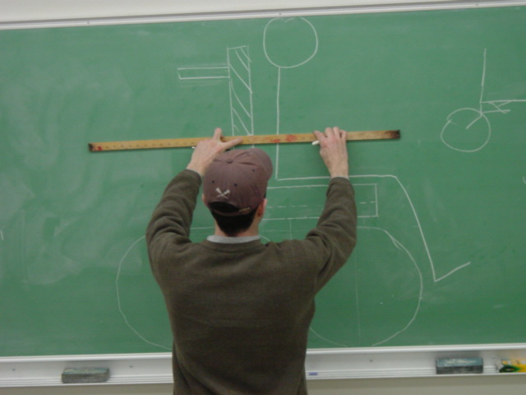
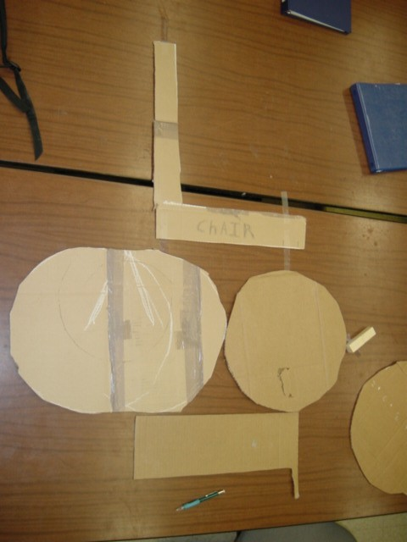

Figure 1 – Team leader Scott Turnbull uses a full-scale wheelchair model on the chalkboard to approximate dimensions

Figure 2 – These full-scale cardboard cutouts allowed MST to approximate the area taken up by the castors

Having gained insight from modeling, MST focused its energy upon three design concepts. They are summarized on the following pages.

Design #1

The first design implemented two extended front castor arms attached to the wheelchair by hinges (see Figures 3 and 4). These arms would rotate to the sides providing an unobstructed space in front of the wheelchair for passenger transfers. The extension of these arms would provide off-road stability and allow for the use of a larger 12-inch castor wheel. The rear wheels consisted of lightweight 16-inch mountain bike tires. The hinged castor arms could also be removed allowing the wheelchair to be lightweight and easy to transport.

Three problems impeded this design from being selected. First, the rigidity of the hinged arms was a concern. The shock from bumps on the trail would be transferred from the front castors to the arm hinges. It would be difficult to manufacture these hinges without some vertical play. The combination of the trail induced shock and vertical play may have resulted in a wobbly ride. Second, the wheelchair would need a stabilizing mechanism. The wheelchair would be less stable while the castor arms were rotated to the sides. This would require another point of contact with the ground. Also, the front castors would need to be raised from the ground in order to rotate the castor arms for passenger removal. Although implementation of a kickstand may have fixed this problem, it proved to be more complex than necessary. Third, the forward extension of the castor arms would be an inconvenience when used in an indoor environment.

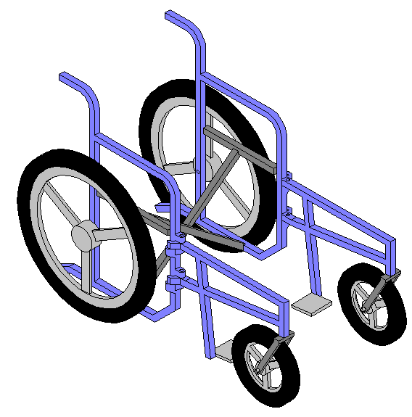
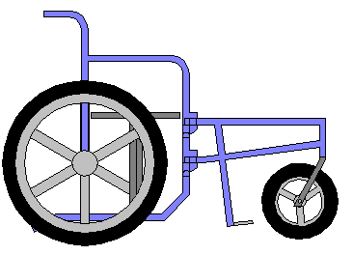

Figure 3 – Isometric view of design #1
Figure 4 – Side view of design #1

Design #2

The second design implemented rear castors (see Figures 5 and 6). This design would allow the use of larger 16-inch castor wheels. These larger wheels along with the 16-inch front wheels would help dampen trail vibrations. The front wheels would only protrude slightly providing a mostly unobstructed front area for transfers.

There were several problems associated with this design. First, the rear castors presented stability problems. The wheelchair would be likely to tip when the castor wheels were both turned to the same side. Second, the wheelchair would have difficulty going over curbs or large obstructions in the trail. Currently, the client rocks the wheelchair backward on the rear wheels and places the front wheels onto the curb. In this design, the rear castor wheels would rotate to the sides as the wheelchair was rocked backward causing instability. Third, the rear castors would cause the wheelchair to maneuver differently than the current wheelchair.
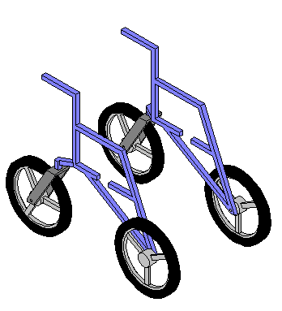
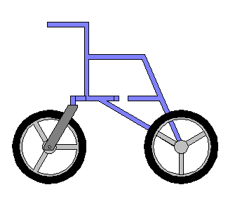

Figure 5 – Isometric view of design #2
Figure 6 – Side view of design #2. Notice the rear castor design.

Design #3

The Selected Wheelchair Design

The final design implements 12-inch BMX bike tires as front castor wheels located in relatively the same position as the client’s current wheelchair (Figure 7). Castors will be modified from the 12-inch forks from a kid’s bicycle. The slotted tabs will be cut off and replaced with larger tabs to produce a 3-inch rotation offset (Figure 8). The rear wheels will be 20-inch mountain bike tires with quick-release hubs. The elevating footrest will rotate to a 45-degree angle with respect to the vertical to allow clearance for full rotation of the castors. The seatback will fold forward to decrease the wheelchair size for transportation. When rear wheels are removed and the wheelchair is completely collapsed, it will have an approximate size of an 18-inch cube (See Figure 9). Armrests and side supports will be attached to the seatback and will fold back during collapsing. For passenger transfers the footrest will be rotated down and the front castors will be positioned to the sides (See Figure 10). This design will allow simple passenger transfers and sufficient maneuverability.
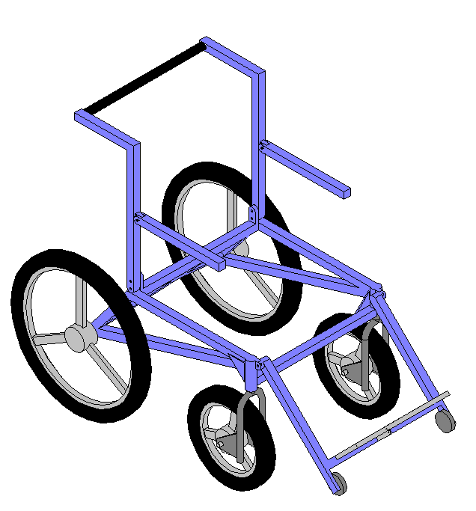


Figure 7 – Isometric view of the chosen design, design #3.
Figure 8 – Close-up view of the castor design. Notice the large tabs that will be welded onto a standard bicycle fork.
Welded
Tab
Design #3 (Continued)
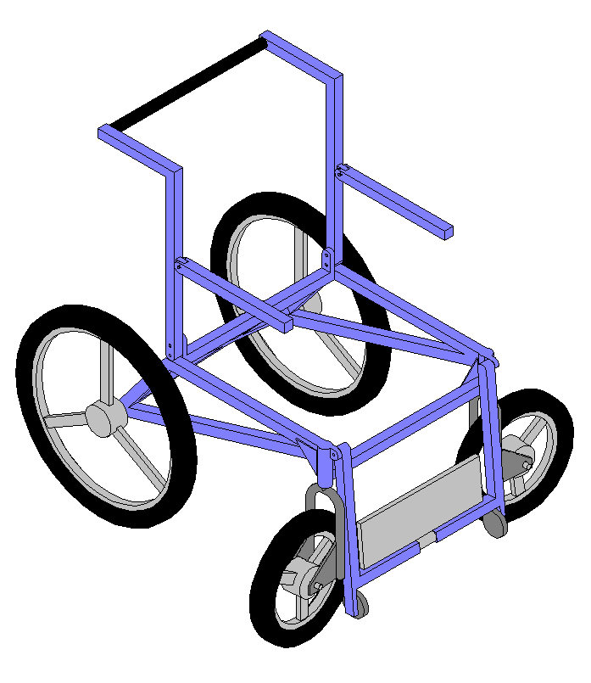

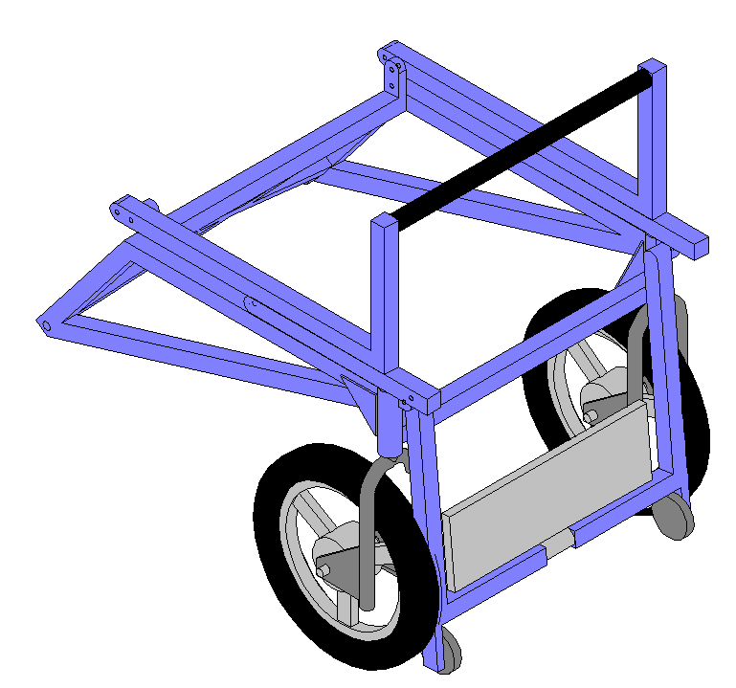

Figure 9 – View of design #3 when it is folded up and ready for storage.
Figure 10 – Position of the wheelchair during passenger transfers.

Status of the Design and Analysis Phase

The wheelchair design and analysis phase is approximately one week behind schedule. This is due to difficulties associated with selecting a wheel setup to best suit the client’s needs. The final frame design was recently selected from three possible designs.

Frame Material Selection

Aluminum was selected as the frame material because of its strength to weight ratio, anti-corrosiveness, and availability. MST is using aluminum 5052, which has better than average weldability and anti-corrosive properties. This material has been purchased and tested. The material was tested to failure in a Tinius Olsen strength-testing machine. The material yielded at 16,000 psi and failed at approximately 24,000 psi.

Structural Strength Analysis

A conservative estimate of the passenger load is 150 pounds. From this, a vibration shock analysis revealed that the worst-case scenario that the wheelchair could encounter would be a square wave impulse shock. The Lord Corporation shock analysis charts were used for this analysis (See Figure 11 below). This translates to forces that are twice that of the static load. A finite element analysis was then completed with the design load of 300 pounds. The load was distributed over one inch of the structural member in the seat. The load was placed according to worst case loading conditions in approximately the center of the beam (See Figure 12). The analysis revealed that the highest stress in the frame would be approximately 5700 psi. The factor of safety was then calculated to be 2.8. The deformed frame and its stress concentrations are shown in Figure 13.


Figure 11 – Shock response spectrum for various exciting pulse shapes.
Figure 12 – This picture shows the loading of the FE model.

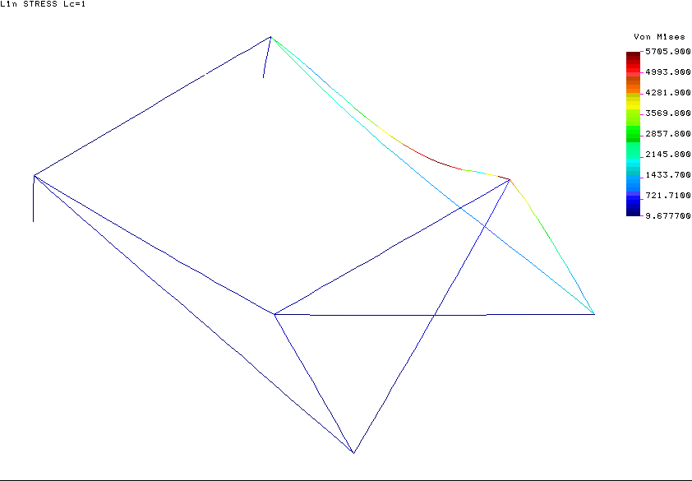

Points of
Max Stress

Figure 13 – The FE model shows the wheelchair in its deformed shape (amplified 100X). The points of maximum stress, 5700 psi, are shown.

Stability Analysis

The center of gravity of the wheelchair/passenger combination has been approximated. All of the components of the wheelchair were catalogued and referenced to a common point in order to determine each individual component’s center of gravity. The center of gravity of the complete system was determined by summing the individual centers of gravity for each part. The center of gravity analysis is documented in Appendix E, Figure 1. The center of gravity was then applied to a simple trigonometric analysis that determined the angle of the slope that would induce tipping. The trigonometric methods are documented in Appendix E, Figures 2 and 3. This is only a two-dimensional analysis from the front to the rear of the chair. A more in depth analysis that accounts for the lateral stability will soon be complete. The off-road wheelchair should be at least as stable as the client’s current wheelchair.

The next steps in the project’s evolution are the finalizing of analysis followed by the manufacturing phase. MST will complete more FE models to prove the strength of joints and gusset plates. MST will also order the remaining materials to build the frame and wheel assembly within the next week. MST has consulted with material suppliers and an expert welder in preparation for the manufacturing process.

MST believes that the off-road wheelchair project will be a success. Fundraising efforts have been successful and should completely cover the project’s expenses. Also, MST feels that the selected design is robust and reliable. MST will deliver a safe and fully functioning off-road wheelchair with its documented design no later than May 2, 2002.

Current and Near Future Tasks

- Research available locking hinges and joints
- Order parts (i.e. Wheels, Hubs, Forks, Armrests, Seat Belt, etc.)
- Begin Manufacturing
  - Cut and dimension structural frame members
  - Confer with Howard Bailey, welder

APPENDIX A: Off-road wheelchair functional requirements

Functional Requirements

- Wheelchair must offer a comfortable and upright seating position.

  - The seating position will provide a full view of the path ahead.
  - The seat will be wide enough to accommodate passenger in winter clothing.
  - The wheelchair will absorb vibrations and bumps during off-road use.
  - Footrests, armrests, and a headrest are required.
  - Support is required for the passenger’s left side.

- Wheelchair must facilitate passenger loading and unloading.

  - Client must be able to help the passenger into and out of the wheelchair with minimal effort.
  - Wheelchair will be free from obstructions in the loading area such as wheels or footrests that may hinder loading.

- Wheelchair must be capable of safely traversing dirt trails with minimal effort.

  - Wheelchair must negotiate slight to moderate gradients.
  - Wheels will be capable of handling outdoor terrain.

- Wheelchair must fit into a 1996 Nissan XE pickup truck.

  - Must fit side-by-side in truck bed with standard wheel chair.
  - Wheelchair must have handles for loading into truck.

- Wheelchair must be lightweight.

  - The client must be able to lift chair from ground up to pickup truck tailgate.
  - Wheelchair will weigh a maximum of 50 lbs (ideally 30lbs).

- Wheelchair must have a braking system.

  - Operator brakes must bring wheelchair to a halt on slopes.
  - Parking brakes will lock wheels on slopes with passenger loaded and be accessible to both operator and passenger.

- Wheelchair must have a passenger restraint system.

  - A lap belt with optional diagonal harness will secure passenger.
  - Restraints must stay out of the seating area such that once the passenger is loaded the passenger will not be sitting on the restraint system.

- Tires.

  - Tires will resist punctures from bullheads, goatheads, and other sharp objects.
  - Tires can be replaced at a local bike shop.

Nonfunctional Requirements

- Wheelchair must be low maintenance.

  - The wheelchair will be weather resistant.
  - The wheelchair will be reliable and won’t break under normal use.
  - The wheelchair will be designed for easy maintenance and adjustments.
  - The wheelchair will be easily serviceable by a bike shop.

- Wheelchair frame must be painted dark purple to the client’s standards.

APPENDIX B: Project Schedule

APPENDIX C: Cost estimate and bill of materials

APPENDIX D: State of the art research

www.froglegs.com Shock absorbers for castor wheels
www.greentyre.com Air-free tires
www.diesteo.com Wheelchair canopies and storage bags
www.strotos1.com Mountain bike shock absorbers
www.rockshox.com Mountain bike shock absorbers
www.home.HiWAAY.net/~arnolcj/ind/chair.html Previous Senior design project
www.disabilityoptions.com Kili Kart off-road wheel chair
www.disabilityexpo.com/unique/bcomber.htm A beach wheelchair design
www.beachwheelchair.com A beach wheelchair design
www.jmseeker.com.index.html A beach wheelchair design
www.achievableconcepts.com.au/beach.htm A beach/off-road wheelchair design
www.hotshotproducts.org.product.htm A beach wheelchair design
www.natural-access.com A beach/off-road wheelchair design

Consultants:

John Hovey – employee at Agassiz Healthcare in Flagstaff, AZ.

John works on wheelchair accessories and knows the client personally. John has given MST expert advice concerning wheelchair dimensions and available wheelchair accessories.

Single Track Bike Shop, Flagstaff, AZ – local bike shop.

The employees at Single Track advised MST that they could match a wheel rim with spokes to almost any wheel hub that MST decides to use.

Ackerman Welding, Flagstaff, AZ – local welding supplier.

Ackerman welding provided MST with quotes for aluminum and sold MST 40 feet of one inch 5052 aluminum tube with 1/8-inch thick walls for two dollars per foot.

APPENDIX E: Static stability analysis

