Table of Contents

1

2

3

4

5

6

8

10

13

16

19

33

39

43

46

Introduction…………………………………………………………………………….. 1
Design Challenges……………………………………………………………………… 2
Design Philosophy……………………………………………………………………… 3
Deliverables…………………………………………………………………………….. 4
Project Status…………………………………………………………………………… 5
Compressor Selection………………………………………………………………….. 6
Compressor Mounting……………………………………………………………………...
Compressed Air Transport………………………………………………………………….
Bench Test………………………………………………………………………………….

References………………………………………………………………………………
Appendix I………………………………………………………………………………….
Appendix II…………………………………………………………………………………
Appendix III………………………………………………………………………………..
Appendix IV………………………………………………………………………………...
Appendix V…………………………………………………………………………………

Introduction

AEROMAG Corporation of Prescott Valley, AZ requires a working model of a Lakota Compressed Air Energy Turbine (CAET). The Lakota is an existing wind turbine, which will be retrofitted to power an air compressor. Lakota CAET is the integration of an air compressor and the existing Lakota wind turbine. Lakota CAET will facilitate compressed air energy storage for a variety of applications. Possible applications include soil aeration, air-lift water pumps, and pond aeration.

The design and implementation of Lakota CAET will address several issues. A mechanical link will be required to join the shaft output of the turbine with the mechanical input shaft of the compressor. The compressor selected must be capable of producing compressed air over a wide range of turbine speeds. Lakota CAET will maximize the use of existing components to facilitate rapid and cost effective production. When the Lakota CAET project is completed, AEROMAG Corporation will have a prototype suitable for bench testing. At this point AEROMAG can optimize the Lakota blades for the selected compressor and go on to wind testing or further refine the bench testing. Other deliverables that will be submitted to AEROMAG Corporation upon project completion will consist of detailed drawings in AutoCAD R14, performance data of the bench-tested compressor, and recommendations for further development.

Design Challenges

The retrofitting of the Lakota Turbine for the purpose of driving an air compressor presents several design challenges. The design challenges include compressor selection, compressed air transport, and component redesign.

The selected compressor must be compatible with the dynamic working range of the Lakota blade array. A compressor that is compatible with the Lakota array must have a working range of zero to approximately 2000 revolutions per minute (rpm). In addition, the compressor torque requirements must be less than or equal to the torque that the Lakota blades can supply. If the input torque requirement of the compressor is too great the compressor will simply not turn and compressed air will not be generated at reasonable wind speeds. In order to minimize maintenance interactions an oil-less compressor is preferred. The compressor selected must also be capable of operating in adverse conditions such as high temperature and humidity. The geometry of the selected compressor must be compatible with the size constraints imposed by the Lakota castings. If the compressor is too long it will interfere with the furling feature of the Lakota CAET. Ultimately the performance capabilities of the selected compressor will need to be verified with a bench test.

Lakota CAET will be mounted on a tower approximately 50 feet tall. With the compressor located at the top of the tower and the pressure vessel located on the ground the necessity for designing a fluid transport system for the compressed air becomes obvious. The most difficult part of this system is getting the air through the yaw assembly. A solution must be obtained that allows for the normal 360 degrees of rotation of the Lakota CAET about its vertical axis.

These design challenges will involve modification of the original Lakota castings and components. Throughout the design process, consideration must be given to deriving solutions that incorporate a minimum of redesign and maximize the use of original castings and component hardware.

Design Philosophy

There were several guidelines followed by Team CAET during the design process. Many of these guidelines came about as a result of consulting AEROMAG prior to the design process. Probably the most important aspect of our design philosophy was to implement design solutions that are as economically viable as possible. Keeping Lakota CAET economical is key to AEROMAG Corporation’s marketability. One way to keep Lakota CAET economical was to minimize the redesign of existing parts. In addition, keeping design concepts simple is important as well. A robust design concept is important because of the significant service life needed of Lakota CAET, components of the design need to be able to withstand loads from adverse mechanical, vibrational, thermal, and weather conditions. It is also important that the design is has aesthetic appeal, this will enhance Lakota CAET’s marketability.

Deliverables

The deliverables for the Lakota CAET project were outlined in the Proposal document submitted on January 30, 2002. A detailed description of the design deliverables are as follows: Selection of a suitable compressor, a solution to the compressed air transport systems, detailed AutoCAD R14 drawings of the Lakota CAET prototype, load analysis of compressor housing and yaw assembly, redesign of existing Lakota components to allow for the implementation of the compressor and compressed air transport systems, and performance analysis of the prototype.

In the proposal phase of the project the compressor selection strategy was to acquire several compressors and perform bench testing to determine the optimum compressor. After researching different compressor configurations and associated costs we determined that obtaining multiple compressors would be too burdening on our budget and require too much bench test time. As a result of budget and schedule considerations, compressor selection was accomplished by comparing Lakota performance data to compressor performance data. The specific performance data used for the compressor selection were torque, power, and angular velocity data. The selected compressor can then be bench tested to validate manufacturer data and to allow for the further optimization of Lakota CAET.

A solution to the design challenge of the compressed air transport system will be delivered to AEROMAG Corporation. Possible solutions to the compressed air transport system are a rotating union or a rotational shaft seal. The design solution selected must allow Lakota CAET to yaw freely with changes in wind direction.

In order to be consistent with AEROMAG Corporation’s current software, Team Lakota CAET will submit new casting, component, and machining drawings in AutoCAD R14. Justification of component changes and new component selection will be provided and delivered in accordance with the schedule in Appendix III.

Analysis of the compressor housing and yaw assembly will consist of a mechanical design analysis of various components that are impacted by design changes. Finite element analysis will be performed with COSMOSM software as deemed necessary.

A bench test apparatus and procedure will be designed and implemented to establish performance parameters of the selected compressor. The bench test apparatus will be designed such that the compressor and face-plate can be tested as one unit. This will give a realistic indication of the power necessary to turn the compressor because of energy losses associated with friction in the bearings mounted in the face-plate. A DC or AC motor will be selected with appropriate power capabilities for driving the selected compressor. The collected data will be used to generate plots of torque versus angular velocity at various system pressures. This performance data can be used to for enhanced design optimization.

Project Status

As of February 8, 2002 we have completed several of the project deliverables. The design solutions, methodology, and analysis used for the completion of each deliverable are given in pages 6 through 15.

A GAST 1534 rotary vane compressor has been selected and ordered. The selected compressor will be most suited to low pressure and high volumetric flow rate applications. A new component “compressor housing” has been designed to support the compressor. The existing shaft that links the blade array to the generator has been modified. The shaft has been redesigned to drive the input shaft of the air compressor.

A compressed air transport system has been designed which involves the pressurization of the yaw housing. The compressed air transport system involves machining and casting changes to the yaw housing as well as machining changes to the yaw shaft. In addition to the casting modifications, several new components have been specified. The new components include a rotational shaft seal, a nylon bushing, a stainless steel sleeve, and a flange. The seal has been ordered and has been received by AEROMAG Corporation. The pressurization of the yaw housing has been validated with machine design and a finite element model using COSMOSM software. A flange and o-ring have been implemented to temporarily seal the access panel of the yaw housing for prototype testing. Casting changes can be used to eliminate the flange and o-ring in future prototypes at AEROMAG’s discretion.

The bench test phase of the project is currently being designed. Several alternate bench- testing methods have been considered. The bench test is currently the area of focus. Timely completion of the bench test will allow for the rapid collection of data once the compressor has been delivered.

The budget for the remainder of the project is given in Appendix III. This budget reflects the purchase of final components necessary for the bench testing and data collection phase. The schedule for the remainder of the project is given in Appendix III. The schedule has been amended to reflect component delivery times and unanticipated design challenges. The project completion date has not changed and is May 3, 2002.

Compressor Selection

There were several key features we were looking for throughout our search for a compressor. To minimize the redesign of the existing Lakota parts we decided to use the existing rotor shaft as the drive for the compressor, leading to the need for a mechanically driven compressor. As stated in the functional requirements of the proposal document the compressor should not require any more than one maintenance action within a five-year interval. With this in mind we restricted our search to oil-less compressors. Since the Lakota CAET will be susceptible to a variety of environments, the need for a durable, corrosion resistant compressor was obvious. Another compressor feature that we were looking for was an overall length of no more than six inches. This magnitude of length was determined by the space that the existing Lakota requires to furl out of the wind. The compressor must be capable of operating from zero to approximately 2000 rpm. This is the current operational range of the Lakota wind turbine. The most important feature that we were looking for, in a compressor, was availability. The availability of the compressor is important in the event that AEROMAG decides to go into production with the selected compressor.

The Lakota CAET Team spent considerable time researching different compressors utilizing local vendors, Internet, and catalogs. Through our initial search we noticed that to obtain a compressor within our size constraints we would be looking for a compressor with a power rating of no more than 3 Hp. We were having much trouble finding compressor models that have the features we were looking for. In light of this Ryan Adams visited several companies in Phoenix, AZ in November of 2001 to speak with them about any suggestions they may have in regards to choosing a compressor for our application: Airnetics, Nachi Wistech, Ingersoll Rand, AV Compressor, Kendel, Phoenix Air Center, Southwest Products, AZ Air Compressor, and AZ Pneumatic Systems. Several brochures and catalogs were obtained from the companies. We searched through the catalogs and chose several compressors that had appropriate specifications. Table 1 displays a list of these compressors.

In the initial stages of the project we were attempting to obtain several compressors for our bench-testing phase. Through bench testing each compressor we would analyze the data and chose the compressor that best fits the application. Specifically, we wanted to match torque versus rpm curves of the compressor to the existing Lakota blades to create the most efficient system. Several compressor companies were contacted through our search: Gast, Brenner Fiedler & Associates, Inc., Thomas, Hypro, Airnetics, and Nachi Wistech. An explanation of the project was given to the representatives such as to who we are, what the purpose of the project is, and the potential of many compressors to be purchased in the future if the compressor is chosen and works well for the application. A request was then made to the company that a sample of the specified compressor be sent to us for testing. An incentive for sample donations was that the data gathered from bench testing the compressors would be sent to the donator. Unfortunately no compressor samples were obtained from the companies.

Table 1. Below are the potential compressors that Lakota CAET application.

Manufacturer | Model Number | Type of Compressor
Gast | 0533-103A | Rotary Vane
Gast | 0240 | Rotary Vane
Gast | 0440 | Rotary Vane
Gast | 0740 | Rotary Vane
Gast | 0870-P110 | Rotary Vane
Gast | 1534 | Rotary Vane
Gast | 1067 | Rotary Vane
Gast | 2067 | Rotary Vane
Gast | 2567 | Rotary Vane
Gast | PAB-10 | Diaphragm
Thomas | SGH-605 | Piston Cylinder
Thomas | SGH-505 | Piston Cylinder
Thomas | SGH-405 | Piston Cylinder
Thomas | SGH-3051 | Piston Cylinder
Buckeye | 31NR-910 | Rotary Vane
Buckeye | 31NR-910 | Rotary Vane
Gardner-Denver | H10 Series | Rotary Vane

The difficulty in obtaining multiple compressors for testing and the approaching compressor selection deadline prompted us to select a compressor based on approximate Lakota performance data. We used the working range of the Lakota and decided to go with a very conservatively sized compressor. This would insure that the Lakota blade array would supply sufficient torque to drive the compressor. A consensus was made between AEROMAG and the Lakota CAET Team that the Gast 1534 compressor would work well for our application. A schematic of the Gast 1534 compressor can be viewed in Appendix IV.

The features of the Gast 1534 compressor are as follows:

- Oil-less, pulse free operation
- Rotary vane
- Mechanically driven
- 2.2 cfm when open (0 psi), 2 cfm when at maximum pressure (10 psi)
- Operating range up to 5000 rpm
- Rugged construction/low maintenance (design life approximately 10,000 hrs)
- Dimensions: 4.05inL x 3.52inH x 3.62inW
- Counter-Clockwise rotation
- 3 lbs

The rotary vane compressor feature of low start up torque is excellent when a low cut-in speed is desired. With the compressor operation range of up to 5000 rpm, a large operating range is feasible for the Lakota CAET. The compact size minimizes the redesign of the existing Lakota parts. The counter-clockwise rotation is opposing to the existing Lakota rotation. Since the blades for the Lakota will need to be matched to the Gast 1534 compressor using torque versus rpm data, inverting the twist of the Lakota CAET blades to correspond to the compressor rotation will be necessary. The Gast 1534 compressor was purchased by AEROMAG in February of 2002 through Mark Steffens of Brenner Fiedler, see Appendix V for contact information.

Compressor Mounting

A redesign of the rotor shaft was needed in order to couple to the Gast 1534 compressor. In order to minimize any load applied to the compressor shaft an additional bearing was implemented into the compressor housing to support the rotor shaft. A setscrew will be used to couple the rotor shaft to the compressor. Detailed drawings of the rotor shaft can be viewed in Appendix II, drawing number 007-0010x.

Since the Gast 1534 compressor will not fit in the existing Lakota generator housing, a compressor housing was designed to replace the generator housing. The compressor housing will mount to the existing faceplate just as the existing Lakota generator housing. The torque of the compressor will transfer a load to the compressor housing mounting bolts. This load will produce a shear stress in the bolts. The factor of safety with respect to bolt shear is 11.5. The detailed analysis of the bolt shear can be viewed in Appendix I. The compressor will be fastened to the compressor housing using bolts. Detailed drawings of the compressor housing can be viewed in Appendix II, drawing number 007-0004x.

The original Lakota stops furling when the rubber bumper on the generator housing impacts the back of the yaw housing. The elimination of the generator housing requires a modification to the existing furling mechanism to prevent the compressor from impacting the yaw housing. Figures 1,2 illustrate the Lakota CAET assembly in standard operating position and furled position respectively. This will be accomplished with the installation of small diameter steel cables inside the furling springs. These cables will have specific length such that furling will stop at the appropriate angle.

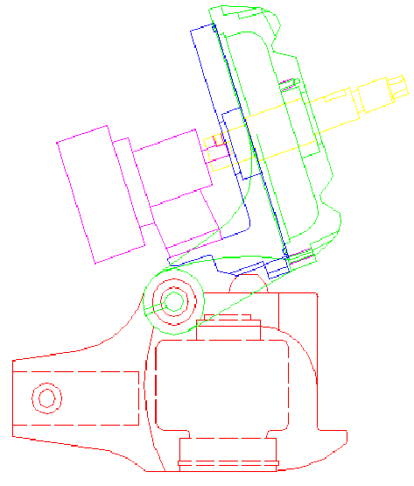
Figure 1. The Lakota CAET assembly in standard operating position.

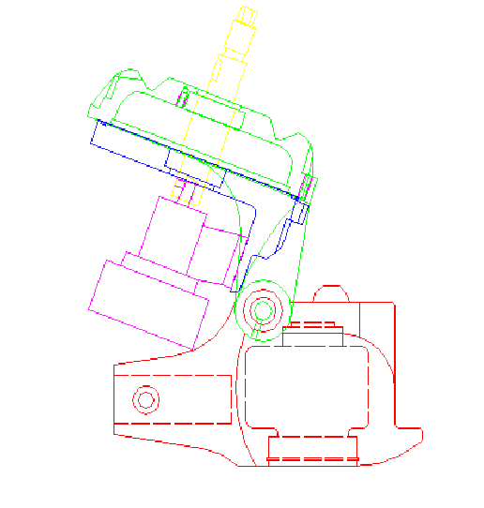
Possible impact point
Figure 2. The Lakota CAET assembly in furled position.

Compressed Air Transport

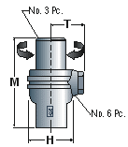
With the compressor located behind the hub of the wind turbine, a design was needed to pass compressed air through the yaw housing and yaw shaft, down the tower, and into a storage tank located at ground level. The design needed to allow the turbine to rotate 360 degrees while being able to pass compressed air through the system. One of our first ideas for passing the compressed air was through a rotating union, as shown in Figure 3. A swivel union allows compressed air to pass through while rotating freely. Many companies were contacted to discuss the practicality of using a swivel union for our application: GNY Equipment LLC, Anson, Cabris, and Barco Seals. In regards to the responses from the companies a style 20 aluminum swivel with buna seals should work for our application. We contacted Jay Shaw of GNY Equipment LLC to discuss the matter in further detail. Jay had stated that the swivel union would not function correctly under a bending stress, as it would see in our application. The budget and modifications necessary to implement a swivel union into the yaw assembly were not feasible.

Figure 3. Basic schematic of a swivel union.

Through many hours of intense brain storming the Lakota CAET Team had come up with a new design for the passing of compressed air through the yaw housing. By using the yaw housing as a pressure vessel the compressed air could pass through the existing yaw shaft into the tower. In order for this design to work the sealed bearings would be required to hold compressed air. Even though the Gast 1534 compressor outputs a maximum of 10 psi we decided to design the Lakota CAET for a pressure system of 100 psi for potential future applications. Local hardware stores in Flagstaff, AZ were consulted about the application of using sealed bearings to hold compressed air. Unfortunately no one had experience in this area. We then decided to assemble the yaw housing and pressurize the unit ourselves to see what pressure, if any, the bearings would hold. Figure 4 shows Brandon Gerber, the team leader of Lakota CAET Team, applying internal pressure to the yaw housing. The test concluded that the unit would not hold any compressed air. By applying a solution of soap and water to the bearing it was obvious that the bearing would not work for the application.

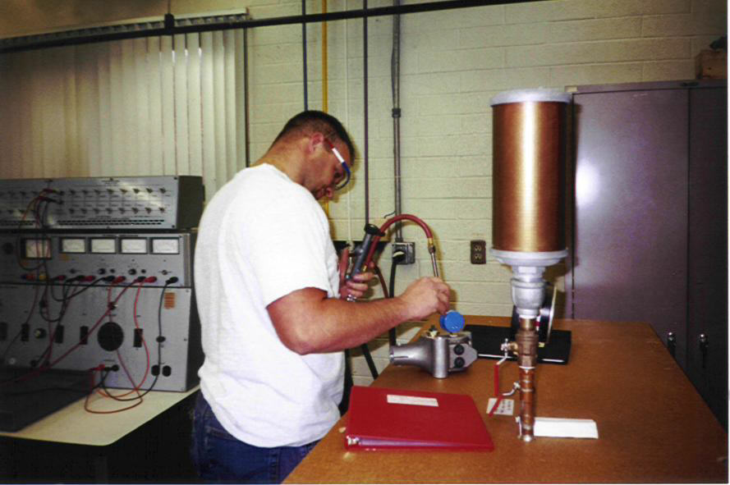
Figure 4. Brandon Gerber pressure testing the yaw housing in December of 2001.

We then needed to find a way to seal the yaw shaft so that the yaw housing could be used as a pressure vessel while still being capable of rotating 360 degrees. Our method of sealing the yaw assembly requires the addition of a rotational shaft seal. By using the yaw housing, as a pressure vessel there is no need for the electrical access panel located on the existing Lakota yaw housing. To eliminate the panel the casting of the yaw housing needs to be changed. Due to time constraints, this part of the project will not be implemented in the prototype of the Lakota CAET. For the proof of the concept, a flange along with an o-ring will be bolted over the access panel to seal the yaw housing.

Initially, much of the research was done by contacting seal companies found on the Internet. Garlock, American High Performance Seals, and JM Clipper. All of the companies responded with potential seals for the project. The standard seal dimensions available were not compatible with the existing casting. American High Performance Seals offered to fabricate a custom seal for our application. Seal specifications can be viewed in Appendix IV.

The features of the American High Performance Rotary Seal are as follows:

- Nylon casing
- NBR (Nitrile Rubber) seal
- Dimensions: 35mmID x 62mmOD x 10mmH
- Pressure rating of 100 psi

This seal will work well for the Lakota CAET application. With the seal pressure rating of 100 psi this is equivalent to the design of the Lakota CAET yaw housing. The seal was purchased by AEROMAG in February of 2002 through David Townley, of American High Performance Seal; see Appendix V for contact information.

In order to incorporate the rotary seal and the bearing into yaw housing a redesign of the casting would need to be made by extending the bottom of the yaw housing. A casting modification is not feasible therefore the bearing will be replaced by a nylon bushing in order to allow room for the seal. The bushing will become an in house part fabricated by AEROMAG. With the Lakota CAET furled out of the wind, the factor of safety for the bushing is 296. The detailed analysis of the bushing can be viewed in Appendix I. Detailed drawings of the bushing can be viewed in Appendix II, drawing number 007-0017ax.

In order for the seal to operate effectively with our existing yaw shaft a steel sleeve needs to be implemented. The steel sleeve needs to be incorporated into the sealing interface between the yaw shaft and the seal. The steel sleeve will become an in house part fabricated by AEROMAG. The implementation of this sleeve requires a machining modification to the yaw shaft. The lower bearing interface will be machined to a slightly smaller diameter, see Appendix 2, drawing 007-0018x.

The flange used to seal the access panel will be used for proof of concept only. The o-ring (1/8in x 2 1/4in) used with the flange is available from local hardware supply stores. A casting modification to the yaw housing can be made to eliminate the flange in future prototypes. With the yaw housing having an internal pressure of 100 psi, the factor of safety due to bolt failure is 9.5, while the factor of safety due to joint separation is 17. The detailed analysis of the flange can be viewed in Appendix I. Drawings of the flange can be viewed in Appendix II, drawing number 007-0017ax.

The design for the compressed air to pass from the yaw shaft to a storage vessel on ground level is quite simple. There will be a one-way valve located at the bottom of the yaw shaft so that the compressed air does not leak back through the yaw housing while the compressor is not operating during periods of no wind. An air line will be attached to the one-way valve that will run down the tower and couple to a storage tank on the ground.

With the design of using the yaw housing as a pressure vessel, an analysis of the yaw housing was performed. Finite element analysis was used to analyze the yaw housing. Modeled with an internal pressure of 100 psi to include the possible future application of a high-pressure system, the maximum Von Mises stress obtained was 9.8 MPa. This gives a factor of safety with respect to yielding of 18. The details of the finite element analysis can be seen in Appendix I.

Bench Test

The purpose of bench-testing the prototype is to gather performance data. More specifically, we need to measure the torque (lbf-ft) required to drive the compressor shaft at various angular velocities in revolutions per minute (rpm) at various system pressures (psi). This data will be used to generate performance curves similar to Figure 5. These performance curves will be delivered to AEROMAG at the end of the project. The performance curves will be analyzed and a recommendation for further prototype development will be submitted to AEROMAG. These performance curves could then be used to optimize wind turbine blades for future Lakota CAET models to increase the efficiency of the design. A schematic of the bench test is given in Figure 6.
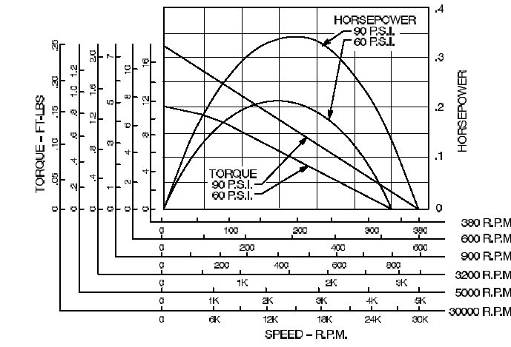

Figure 5. An example of torque (ft-lbf) versus angular velocity (rpm) curves for a compressor.

The bench test method and design is not frozen at this time. The bench test procedure and components will be amended as necessary. The following is the bench test concept thus far. There were several bench testing solutions considered for data collection. There were several requirements that a design needed to meet before considered viable:

- The fixture needed to be relatively inexpensive
- Data collection process needed to be moderately easy
- Compressors of various dimensions should incorporate easily
- Moderately mobile
- Good resolution

Collecting RPM and system pressure data is a relatively simple. A hand held digital tachometer could be used to directly measure shaft angular velocity (rpm). A simple photo-resistor circuit could also be implemented to measure rpm. Measuring the system pressure of the compressor is simple as well. An airline will be used that attaches the compressor output to a pressure vessel. A pressure transducer and/or an analog Bourdon type pressure gauge could be used to measure static pressure in the tank and dynamic pressure output of the compressor. If the pressure transducer is used, voltage data across the transducer will be sampled with a PC via a Data Acquisition Card. Table 2 illustrates the desired measured variables and the method of data acquisition. Because we are trying to construct performance curves at constant system pressures, an adjustable pressure relief valve will be installed on the storage tank to ensure constant system pressure.

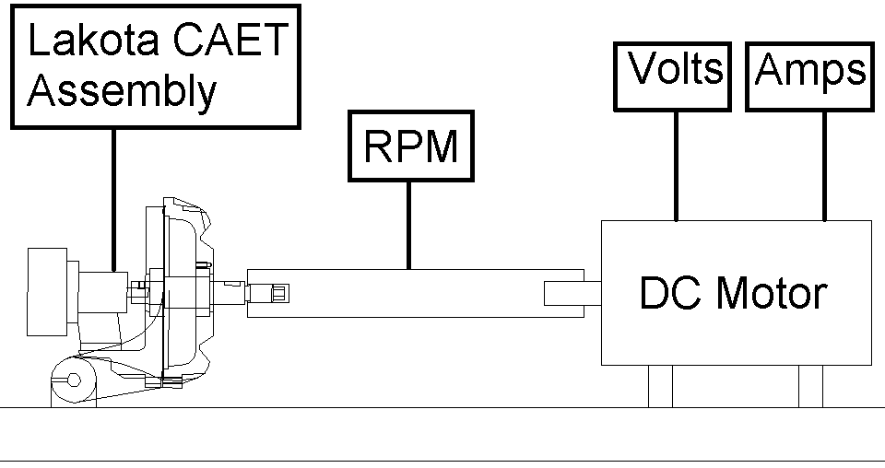
Figure 6. A schematic of the bench test is shown.

Measure Variable | Variable (nomenclature) | Units | Method
Pressure (Tank) | pt | psi | Transducer/Bourdon Gauge
Pressure (Compressor) | pc | psi | Transducer/Bourdon Gauge
Angular Velocity | ω | rpm | Handheld Sensor/Photo resistor Circuit
Power | P | hp | Not measured directly
Torque | T | lbf-ft | Not measured directly
Voltage | V | volts | Digital Multi-meter
Current | I | amps | Digital Multi-meter
Stall Torque | Ts | lbf-ft | Prony Brake

.

Table 2. Possible variables to measure during bench testing

The main challenge faced by the team was to design a system to measure torque accurately and economically. The challenge with torque measurement is that the torque required to drive the compressor is dynamic (time varying). Direct measurement of the torque would require the purchase of an expensive transducer. The most viable method thus far, is to determine the torque/power/rpm characteristics of a DC motor. These torque/power/rpm characteristics can then be related to the power consumption of the compressor at steady state conditions, that is constant angular velocity of the compressor shaft and constant compressor load (system back pressure). With these relationships established, at any given motor angular velocity and associated supply voltage and current, we can determine the torque.

