Dynamometer shaft redesign
ME 486
NAU College of Engineering and Technology
May 2001

Team Members:
Scott Jennings
Steven McLaughlin
Michael Kinzel
Nathan Scott

Enclosed is a detailed report of our analysis and recommended redesigns. Much effort has been put into this report and we expect you will be pleased. If you have any questions on this document, please contact us, as we will be happy to answer your questions.

It has been a pleasure working with you, Mr. Mark Davis.

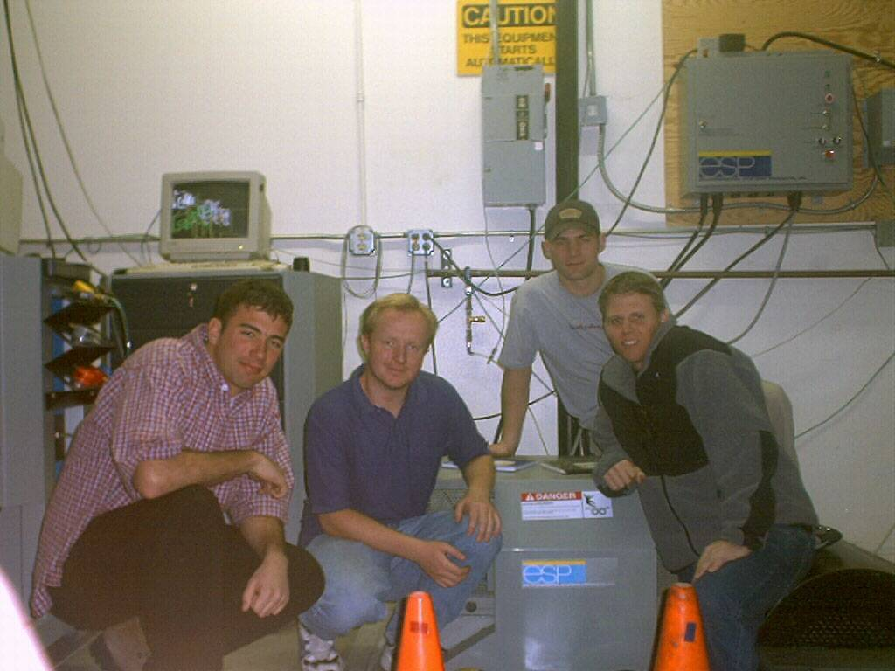

Dynamometer Shaft Redesign Team: (Left to right; Steve McLaughlin, Scott Jennings, Michael Kinzel, Nathan Scott)

Scott Jennings Steve McLaughlin

Michael Kinzel Nathan Scott

Table of Contents

1.Introduction To Project 4
1.1.Problem Statement 4
1.2.Client’s Requirements 5
1.3. Scope of Work 5
2. Analysis of the Original Design 5
2.1. Shaft Inspection 5
2.1.1. Shaft Assembly 6
2.1.2. Material Determination 7
2.2. Analysis of The Original Design 7
2.2.1. Results Using the Initially Determined Loading and Boundary Conditions 7
2.2.2. Revised Loading Conditions and Analysis 8
3. Redesign 9
3.1. Redesign Guidelines 9
3.2. Redesigns 10
3.2.1. Extend Shaft Through Roll 10
3.2.2. Round Plate Design With Stubbed Shafts 10
3.2.3. Round Plate Design With Shaft Extending Through the Roll 12
3.3. Other Considerations 13
3.4. Cost Analysis 13
3.5. Recommendation of Redesign 13
4. Budget 14
5. Schedule 14
6. Conclusion 15
Appendix A 16
Appendix B 19
Appendix C 20
Appendix D 21
References 24

- Introduction To Project

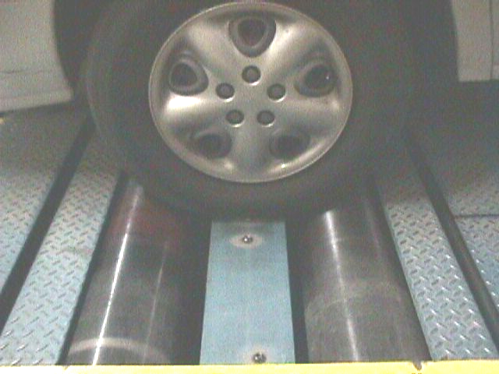
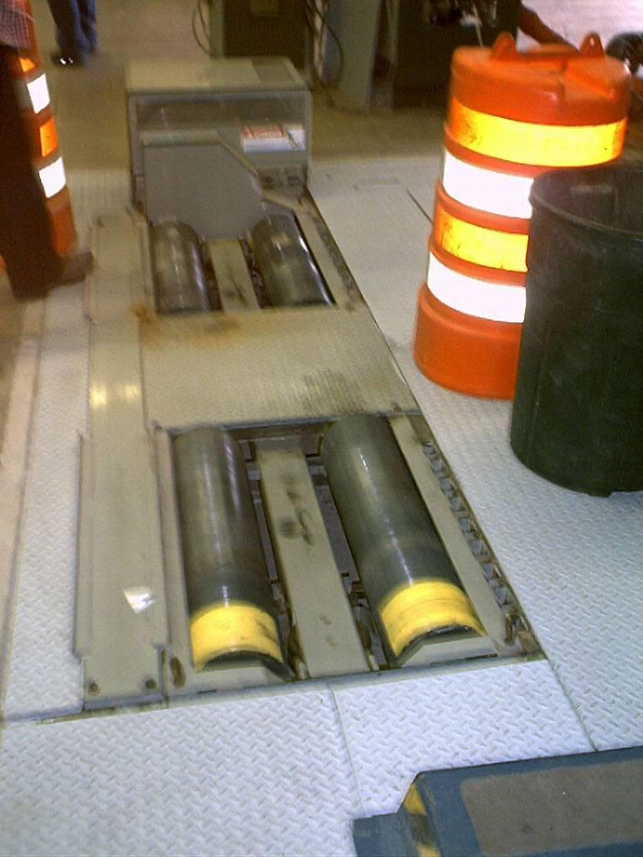
Emission tests are conducted by measuring exhaust gasses from a vehicle while the vehicle’s drive wheels spin on two rolls, allowing the vehicle to simulate driving (Figure 1.1a and 1.1b). These rolls apply a load to the wheels to simulate real world driving conditions, where vehicles exhausts become toxic (expelling Nitrous Oxides). These rolls or, dynamometer shafts, endure several types of loads from the weight of the car and torque from the wheels. All of these forces are under cyclic loading conditions. Because the tests are done on mid-size vehicles, failure of a shaft could lead to a serious injury that our client could be liable for. This and the cost of replacing the roles gives an excellent reason for the client to be interested in finding a solution to the problem.
Figure 1.1a: Emissions Figure 1.1b: Vehicle resting on rolls of emissions testing machine testing machine

  - Problem Statement

The dynamometer shaft catastrophically fails after six months of use. The location of failure is shown in figure 1.2. There are approximately 30 shafts failing a month, at a cost of approximately $1000 to replace each. This reoccurring failure has been costly to the client; therefore a redesigned shaft that will no longer fail is needed.

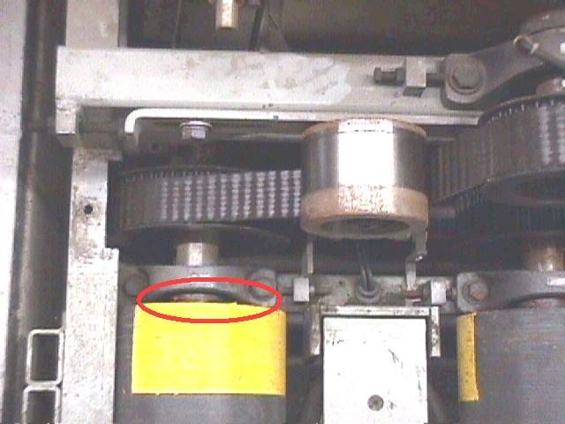
Figure 1.2: The red circle shows location of failure

  - Client’s Requirements

- An analysis of the current axle design, using Finite Element Methods and fatigue analysis that will explain the cause of failure.
- Ideas for revising the design that can be verified with calculations that failure will no longer occur. This also includes any new specifications that the new design will require.

  - Scope of Work

The scope of work that Shaft Consulting used to solve the problem is as follows:
- Examine the roll and shaft assembly
- Determine the material that the failing shaft is made of
- Analysis of the current design using:
  - Finite Element Methods (FEM)
  - The Goodman Failure Criteria for an infinite life failure analysis
- From analysis, determine the reason for shaft failure
- Redesign the shaft so that it will last for an infinite number of cycles
- Prove that the redesign will not fail using:
  - FEM analysis
  - The Goodman Failure Criteria for infinite life

- Analysis of the Original Design

  - Shaft Inspection

After obtaining an entire broken dynamometer shaft from the client, the shaft was disassembled so that Shaft Consulting could determine the assembly of the shaft, and what material the breaking shaft is made of.

    - Shaft Assembly

It was important for us to determine the assembly of the shaft to conduct an analysis. This was done by cutting off an outer plate that covered the interior of the shaft, and cutting open the center of the roll. Figure 2.1a shows the hole cut in the center of the roll, showing that the shaft does not extend through the roll. Figure 2.1b shows how the shaft is connected to the outer roll, using three square-plates welded along the length of the shaft, and one round plate welded at the end of the shaft.

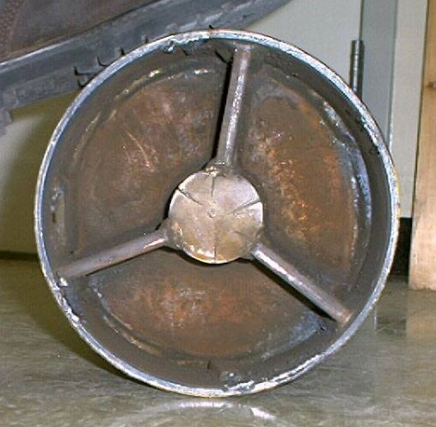
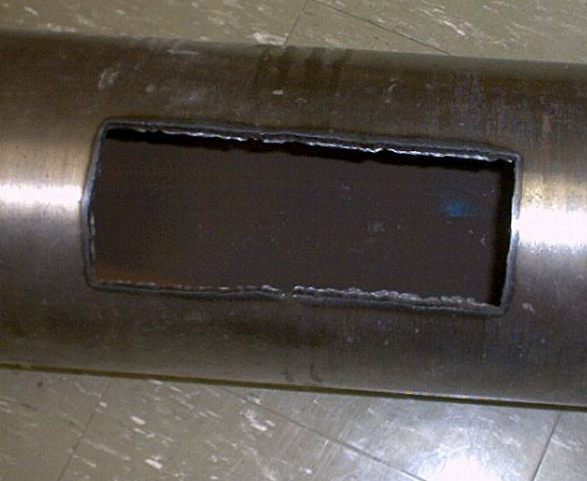

Figure 2.1a: Picture of the shaft with a hole Figure 2.1b: Picture of the shaft with the
cut out of side. Notice the roll is hollow. outer plate cut off. Notice the assembly of
the shaft to the roll.

After determining the assembly of the shaft, CAD drawings were developed of the original design assembly seen in figure 2.2. To focus on where the shaft breaks, a view of the CAD drawings of the shaft that is breaking is seen in figure 2.3.

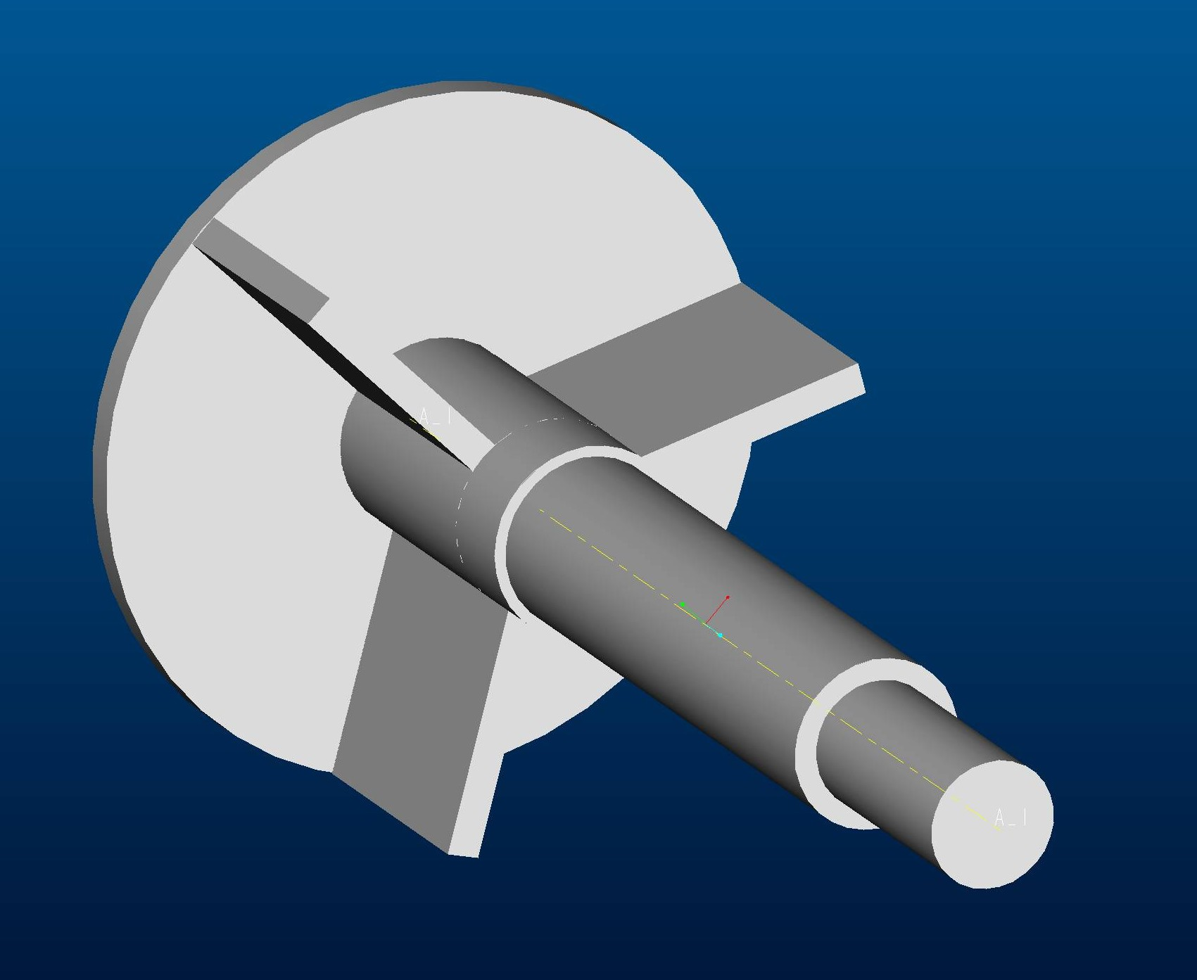
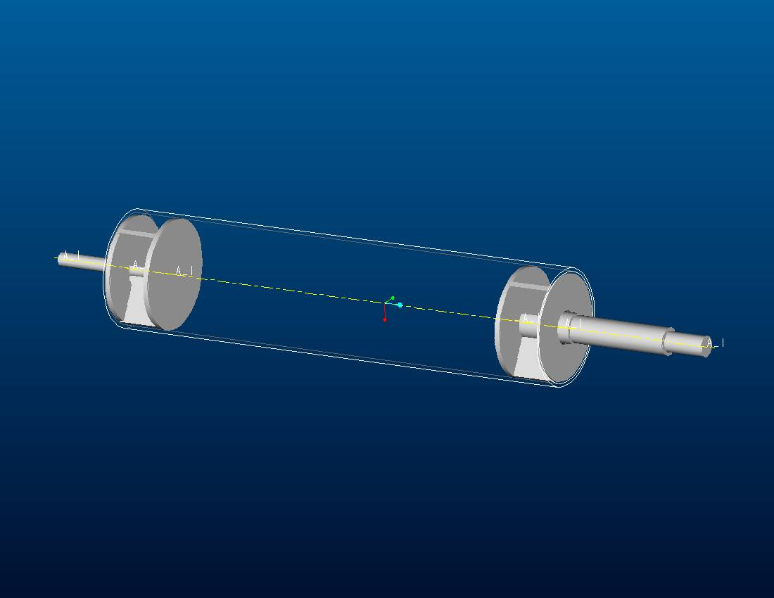

Figure 2.2: CAD drawing of the original design of the dynamometer shaft.
Figure 2.3: CAD drawing of shaft assembly in the area of failure.

    - Material Determination

The material of the breaking shaft was determined so that the material properties of the shaft could be used in our analysis. The first test performed on the shaft was a hardness test, where the hardness was measure across the diameter of the shaft. The shaft was measured to have a Rockwell C hardness of 19, with little variation across the diameter (see Appendix A.1 for results). The next step taken was to determine the carbon content in the steel. This was determined using photos of the microstructure of the steel (seen in Appendix A.2). Using the Lever rule (Shackleford, 331-333) it was determined that the shaft is made of steel with a carbon content of 0.495% (calculations in Appendix A.3); therefore the shaft can be determined to be made of a 1050 steel. Then, by comparison of hardness numbers, the heat treatment of the steel was determined to be normalized (Shigley, 759).

  - Analysis of The Original Design

    - Results Using the Initially Determined Loading and Boundary Conditions

A FEM analysis was done on the original design of the shaft. From the original design, the shaft was modeled using 20-noded solid elements, and the roll and plates were modeled with 9-noded shell elements with a thickness of 0.25 in. For the analysis, the car is assumed to rest at the center of the shaft, where it applied a 1000 lb. vertical load, and a 1313 ft*lbs of torque. The results of the FEM analysis are displayed in figure 2.4, which shows the Von Mises stresses on the shaft. Notice that the high stresses are occurring at the outer diameter of the shaft. These high stresses are expected because the instant change of geometry between the roll and the shaft, which results in high stress concentrations (Shigley,748). The high stress regions the FEM results display on the shaft are on the order of 10,000 psi, and occurs in the region that the shafts have been failing.

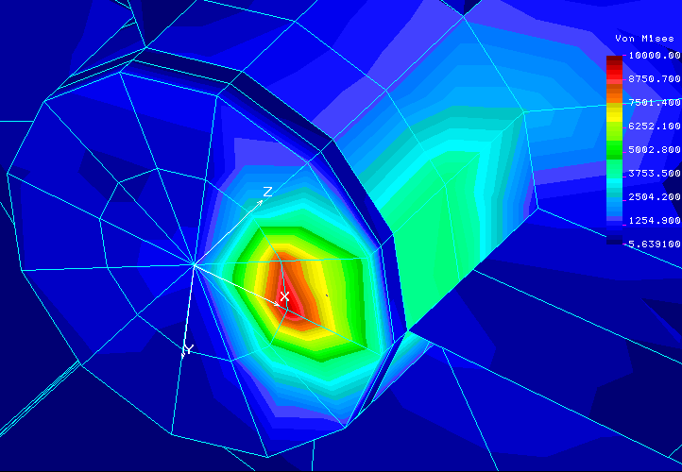
Figure 2.4: Contour plot of the Von Mises stresses from the FEM analysis of the original design. Note that the highest stresses occur at the location of failure in the shaft.

The next step was to develop a model for a fatigue analysis on TK Solver using the Goodman Failure Criteria (Shigley, 295-299) to determine if the shaft should fail with an infinite number of loading cycles (see Appendix B for math model). Combining this math model with the results given from the FEM analysis, it was determined that the original design has a factor of safety (FS) of 3.7. For the failure to occur the FS would have to be less than one, our results show that the shaft should not be failing when loaded an infinite number of times. This led us to a different reason for failure in the shaft discussed in the following section.

    - Revised Loading Conditions and Analysis

This discrepancy led us to believe that the cause of failure is not due to the loading that the vehicles apply to the dynamometer shaft during the test. In researching shaft designs and failures, one common cause of failure that this shaft may have, is misalignment (Metals Handbook Vol. 11, pg. 459). This design flaw appears it could be present because of the shaft and roll assembly. In observing figures 2.1b and 2.3 the assemblies of the original design, it seems that in the manufacturing process misalignment is probable to occur. The misalignment could be between the two shafts at the ends, or by the shaft having an angle with roll. Another common torque transmitting shaft failure occurs when shafts are welded, where the metal near the shaft is hardened and does not perform well in fatigue situations (Metals Handbook Vol. 11, pg. 459, 468-469). This design flaw can be seen in the original design in figure 2.1b, where there are welds on the shaft. It is evident by the hardness of the shaft near the weld, where it was recorded to have a Brinell hardness of 420, while the Brinell hardness was as low as 220 (or Rockwell C – 19) everywhere else. Because the shaft is over designed (from calculations using FEM), it was determined that having welds would not cause failure in the shaft. This led us to an analysis of the shaft where the shaft is assumed to be misaligned.

The shaft was then analyzed with a misalignment using FEM. The same Loads and boundary conditions were used; however, this time the shaft was displaced 0.002 in between the round plate and where the bearing supports the shaft. At only a 0.002 in displacement, the stresses increased by over 50% to a stress of over 15,000 psi, as seen in figure 2.5. Using the same math model to determine the factor of safety, this resulted in FS = .7, which means that the shaft is highly likely to fail when there is a displacement in the shaft just below 0.002 in (see Appendix C for calculations).

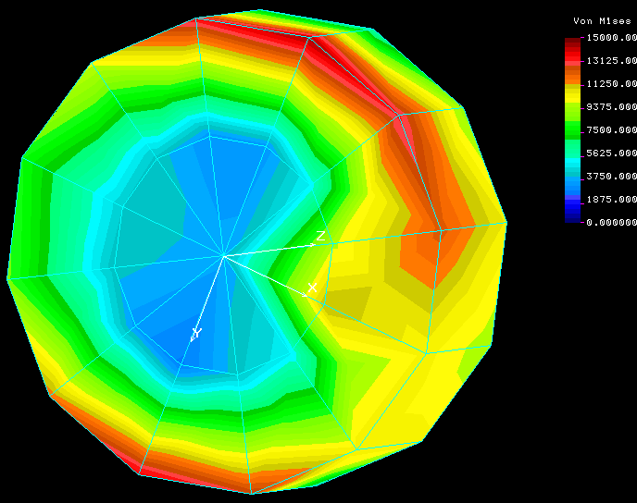
Figure 2.5: Contour plot of the predicted Von Mises
stresses on the shaft stub, using a FEM analysis when the
shaft has a displacement.

- Redesign

  - Redesign Guidelines

The guidelines that Shaft Consulting used to redesign the shaft were:
- Reduce the probability of shaft misalignment during manufacturing.
- Reduce of the hardness of the shaft to increase the shaft fatigue life.
- Reduce the stress concentrations of the shaft.
- Redesign must be compatible with the currently running machines, with no modifications to the apparatus that the dynamometer shaft attaches to

.

  - Redesigns

    - Extend Shaft Through Roll

This redesign would have an assemble between the roll and the shaft nearly identical to the current design, except the shaft would run all the way through the roll as seen in figure 3.1.

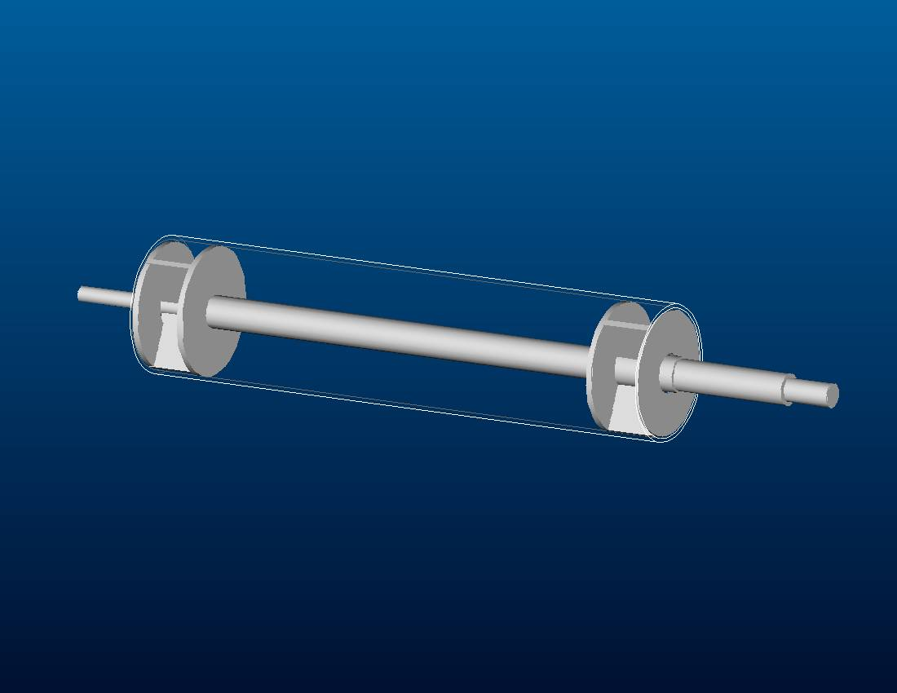
Figure 3.1: CAD drawing of the original design with the shaft that extends through the roll.

This redesign has several benefits:
- The misalignment of the shaft will be eliminated.
- The design is easy to assemble.
- The manufacturing is already implemented.
- Assuming no heat treatment from the welds, this design has a FS = 3.7

Poor aspects of this design are as follows:
- Uses more materials, will cost more money to manufacture.
- High stress concentrations are still present, which is a weakness.
- The shaft still has a brittle region at the outer diameter near the welds, which is another weakness when in a fatiguing loading situation.
- Shaft may not be concentric in the roll.

    - Round Plate Design With Stubbed Shafts

This redesign would use shaft stubs that are identical to the shaft stubs used in the original design, however the assembly of these shaft stubs to the roll would be modified. This assembly modification uses three rounded plates that attach the shaft to the roll (see figure 3.2). The attachment between the plates and the shaft could be done using various methods (keys, splines, welds, etc.), but we designed the attachment where welds were used to attach.

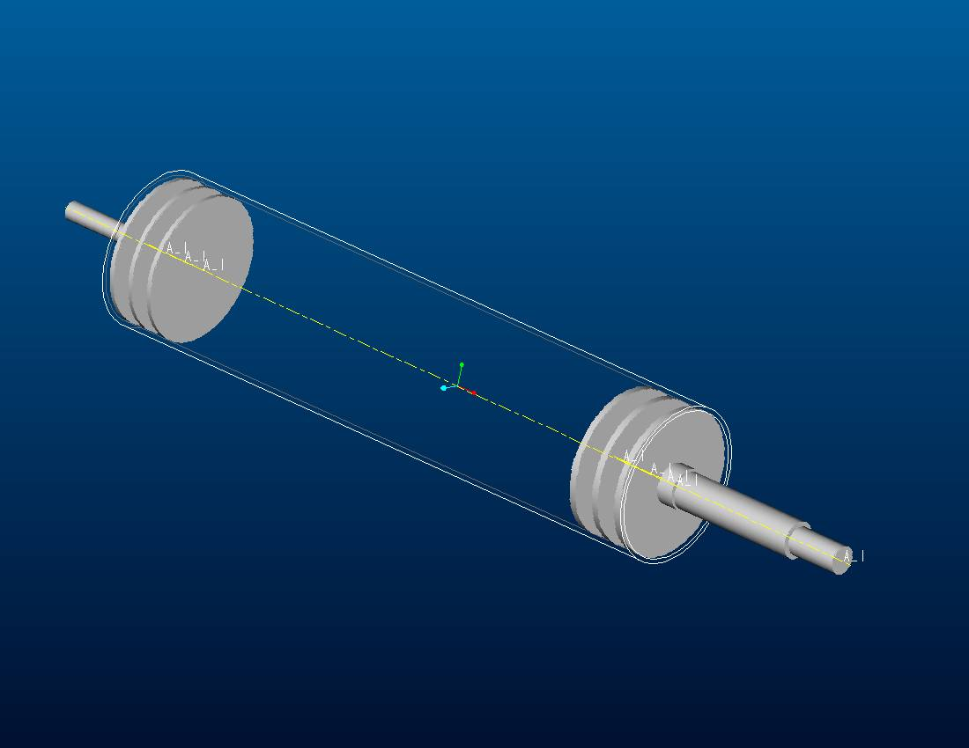
Figure 3.2: CAD drawing of redesign using three round plates and stubbed shafts.

This redesign has the following benefits:
- Reduces the probability of a misalignment in the shaft during manufacturing. This is because the shafts are aligned using plates that have a concentric hole for the shaft to fit in rather than using a square plate that would only align the shaft at one particular placement, when perpendicular to the roll.
- Reduces the stress concentrations by using a filleted method of connection.
- Provides a redesign that will solve the problem using a minimal amount of materials.
- FEA shows lower stresses, approximately 3500psi on the shaft (Outer plate Figure 3.3, Inner plates Appendix A.3)
- Fatigue F.S. = 4.7 using Goodman Failure Criteria (Appendix D)
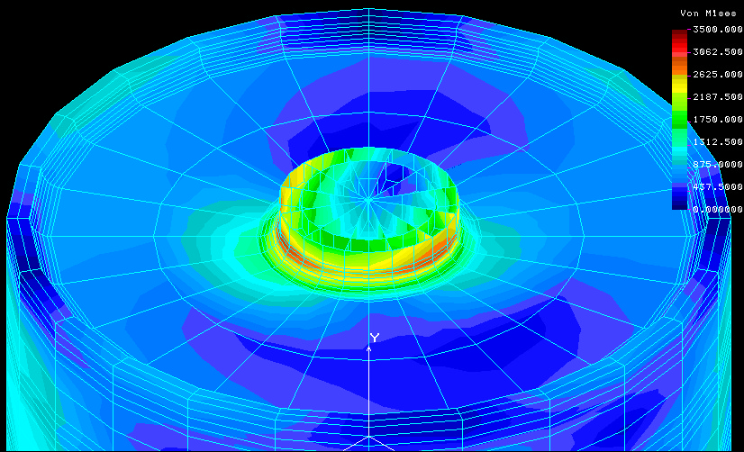
Figure3.3: FEA of outer plate for three-plate design

Flaws in the design:
- Manufacturing could be difficult because it is not currently implemented.
- Still allows a chance for misalignment because of the tolerances in the manufacturing.
- Welds harden the outer regions of the shaft.

    - Round Plate Design With Shaft Extending Through the Roll

The redesign uses a combination of the two previous designs, where the shaft is welded to three round plates that are welded to the roll. This design also uses just one shaft, which extends through the roll as seen in figure 3.3.

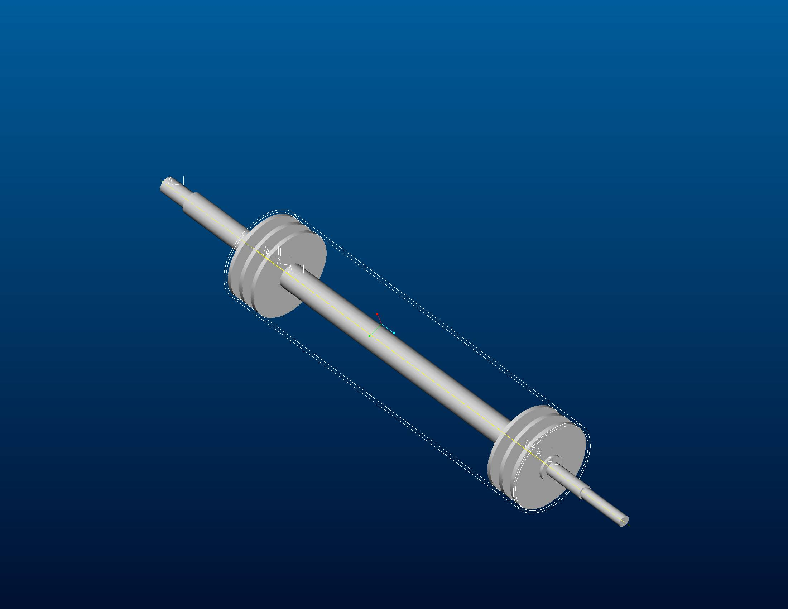
Figure 3.4: CAD drawing of the three-plate design using a shaft that extends through the roll of the dynamometer shaft.

The benefits of this redesign are:
- Eliminates shaft misalignment.
- Shaft has to be concentric to the roll.
- Uses fillet welds, reducing the stress concentrations.
- FEA shows lower stresses, approximately 3500psi, same as stubbed shaft design. (Outer plate Figure 3.3, Inner plates Appendix A.3)

The cons of this redesign are:
- Could be difficult to manufacture because the process has never been implemented.
- The design has the highest material costs.
- Welds harden the outer regions of the shaft.

  - Other Considerations

Redesigning for fatigue is another option that could reduce the chance of failure. Because the shaft is failing in fatigue, the use of a more ductile steel would be beneficial. Tempering the shaft after assembly would be ideal to reduce the hardness of the shaft near the welds, and greatly reduce the chance of the shaft to crack. A much easier solution would be to change the steel to a more ductile steel, such as a 1020 hot rolled that will increase the toughness of the steel throughout the rest of the shaft.

  - Cost Analysis

Table 3.1: Cost Analysis of the dynamometer shaft redesigns, as a percentage of the cost of the original design.
 |  | Original Assembly With Shaft Through the Roll | Three-Plate Design With Stubbed Shafts | Three-Plate Design With Shaft Through the Roll
Materials
 | Roll | 100% | 100% | 100%
 | Plate | 100% | 144% | 144%
 | Shaft | 180% | 100% | 180%
 | Welds | 100% | 140% | 140%
Machining
 | Roll | 100% | 100% | 100%
 | Plate | 100% | 80% | 80%
 | Shaft | 125% | 100% | 125%
 | Welds | 100% | 100% | 100%
 | Assembly | 85% | 120% | 115%
Overall Average |  | 110% | 109% | 120%

  - Recommendation of Redesign

Shaft Consulting strongly recommends that the client should change the design to one that uses round plates with concentric holes that the shaft can fit in to for the assembly. This design is recommended because it is easier to align the shaft during the manufacturing and uses fillets to reduce stress concentrations where there is an instant change in geometry. With the use of the three round plates, if material costs are not too great, the best solution is using a shaft that extends through the roll. This eliminates the possibility of misalignment, and will have a FS of 4.71. The final recommendation is to use a lower carbon steel, preferably 1020 hot rolled, that will resist fatigue more than the 1050 steel currently in use, which is an easy, inexpensive improvement to the design.

- Budget

Because this was a paper project, most of the expenses were software, communications and a small amount of testing supplies that were covered by Northern Arizona University. The remaining costs mainly including the site visitation were negotiated with the client during the project. All expenses are shown in table 4.1

Table 4.1: Expenses of project
Expenses
Expense | Sub-Expense | Cost | Covered by
Field | Food | 32.16 | Mark Davis
 | Gas | 30.77 | Mark Davis
Software | COSMOS | N / A | NAU
 | MS Office | N / A | NAU
 | Autocanon | N / A | NAU
Communication | Phone | N / A | NAU
 | e-mail | N / A | NAU
Testing | Microscope Pictures | N / A | NAU
 | Chemicals | N / A | NAU
 | Hardness | N / A | NAU
Machining | Machine Shop Usage | N / A | NAU
 | Materials | N / A - Use broken shafts. | Mark Davis
Total |  | 62.93

- Schedule

To complete the project within the time requirements, Shaft Consulting created a schedule to follow seen in figure 5.1. The schedule was followed throughout the semester so that each portion of the project could be allocated a sufficient amount of time.
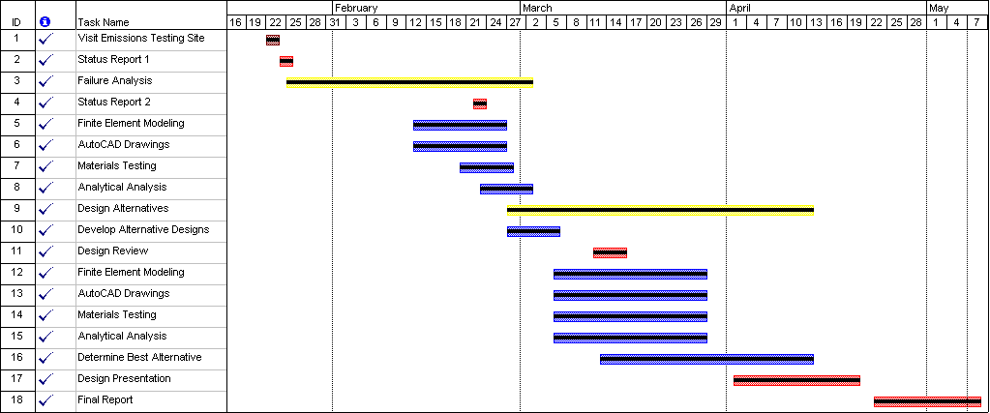
Figure 5.1: Gantt chart displaying the schedule followed throughout the project.

- Conclusion

The purpose of this project was to determine the failure mode and create a solution for the failing shafts. The shafts were determined to be failing from the material and misalignment of the shaft. Solutions to the problems are listed below.

Shaft Consulting recommends:
- 3-plate design
- Shaft running through the entire roll
- Shaft consisting of 1020 HR steel

Appendix A.1 – Material Determination Testing

The material determination of the shaft material was needed to give us material properties of the shaft for analysis. To determine the metal used, a hardness test was first conducted where the shaft was determined to have a hardness of 19 on the Rockwell C scale all of the way across the diameter ( check for case hardening ) as shown in figure A.1. The next step taken was taking a photograph of the shaft’s microstructure as seen in figure A.2.

Figure A.1: Rockwell C hardness test results across the diameter of the shaft.

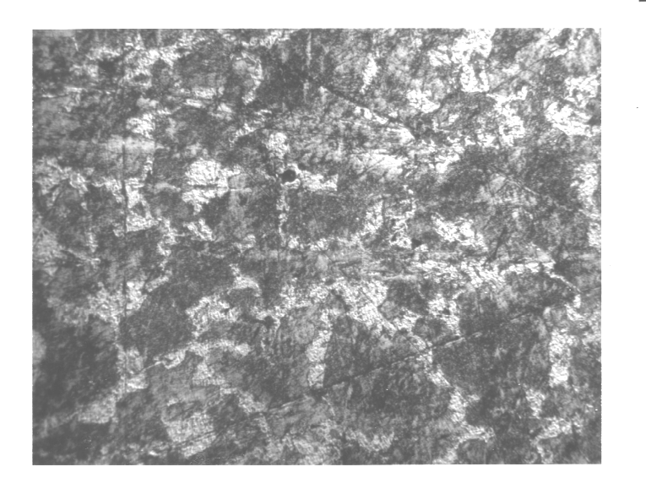
Figure A.2: Microstructural photograph of the shaft material.

Appendix A.2 – Material Determination Calculations

Using the metallography pictures of the shaft, the composition of the metal was determined. Initially a section of the microstructure photograph was divided into forty-nine squares of equal area (see figure A.3), from which the percentage of the eutectoid composition was determined as shown in table A.1, where then an average of these 49 square’s eutectoid compositions were taken (see table A.1).

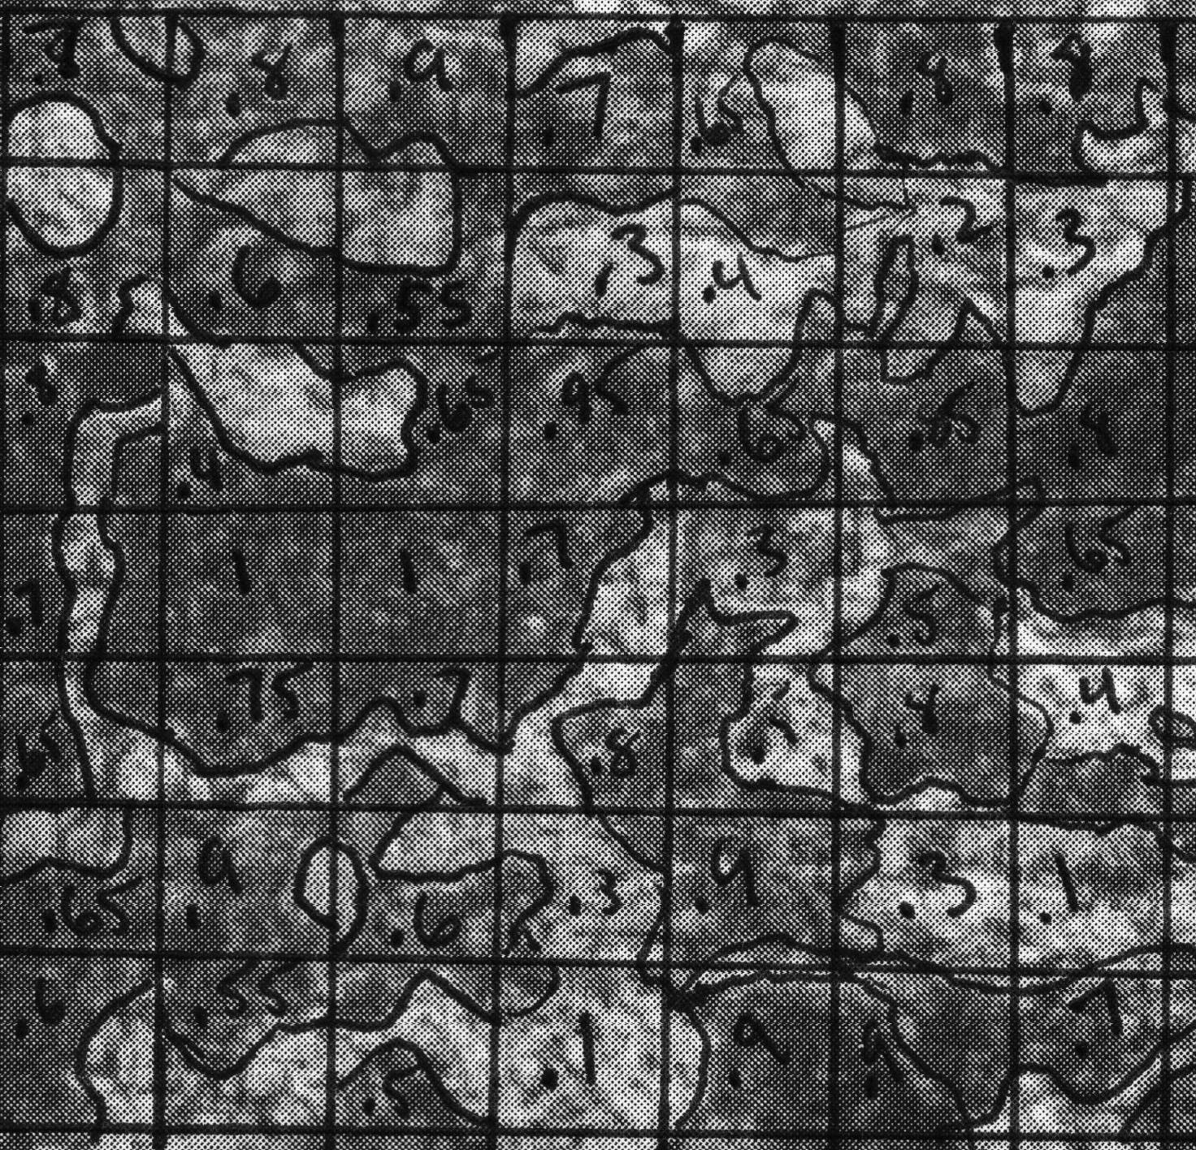
Figure A.3: Picture of the microstructure of the breaking shaft that is divided into 49 squares to determine the average percentage of the eutectoid composition of the shaft.

Table A.1: The percentages of eutectoid composition in each square division made from the photo of the microstructure of shaft, and the average of these squares.
 | 1 | 2 | 3 | 4 | 5 | 6 | 7
1 | 70% | 80% | 90% | 70% | 65% | 80% | 80%
2 | 80% | 60% | 55% | 30% | 40% | 20% | 30%
3 | 80% | 40% | 65% | 95% | 65% | 85% | 80%
4 | 70% | 100% | 100% | 70% | 30% | 50% | 65%
5 | 65% | 75% | 70% | 80% | 50% | 80% | 40%
6 | 65% | 90% | 60% | 30% | 90% | 30% | 10%
7 | 60% | 55% | 50% | 10% | 90% | 90% | 70%
 |  |  |  |  | Average = |  | 63.4%

Using equation A.1, the Lever Rule on steel (Shackelford, 331 - Equation 9.6), and the phase composition diagram (figure A.4), the percentage of eutectoid composition corresponds to a carbon weight percentage of .495%. This corresponds to a shaft made of 1050 steel.

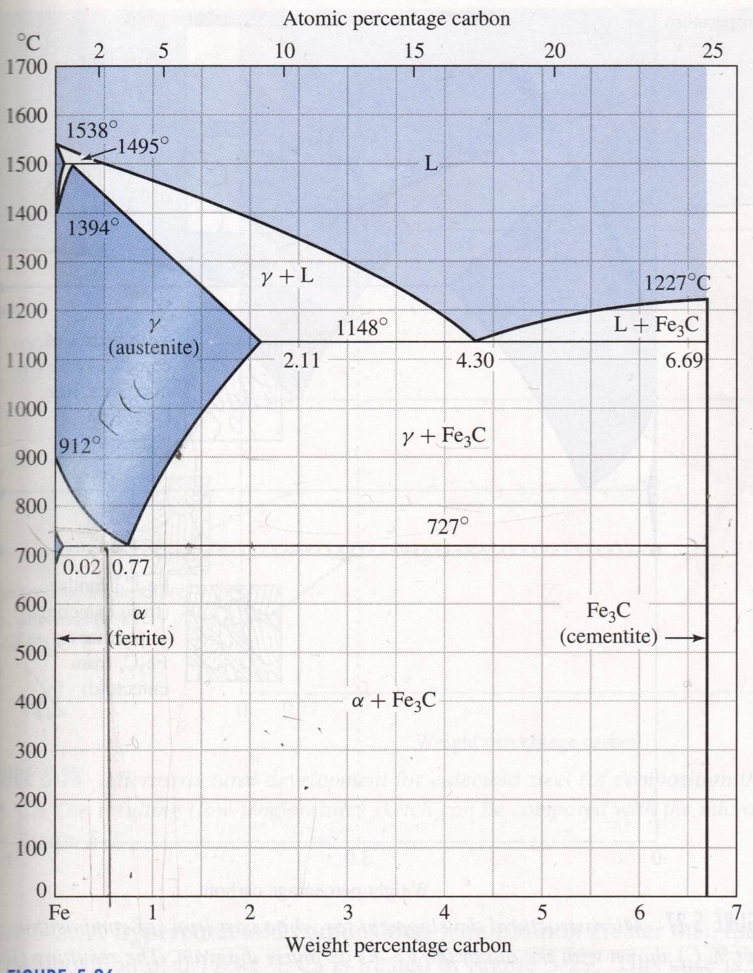
Figure A.4: Phase composition chart of Fe₃C system.

C_{W/0} = E_{/0} * ( 0.77 - 0.2 ) + .02 ( EQN A.1 )

Results in:
C_{W/0} = | 0.495%

The hardness was then used to determine the heat treatment of the steel. In a comparison to a material property reference ( Shigley, 759 ) of 1050 steels, the hardness corresponded to a normalized heat treatment.

Appendix B – Fatigue Analysis of the Original Design

The fatigue analysis of the dynamometer shaft was done for combined loading, with the modified Goodman Failure Theory (Shigley, 306-8). The equation was modified to use Von Mises Stresses (Penado), found from the axial and shear stresses in the part. The axial and shear stresses used in the calculations were determined from the FEM analysis and in put into table B.2.

Table B.1: Fatigue analysis equations used to determine the FS of the original design that are simultaneously applied in a TK Solver model.
Table B.2: Table of the inputs and outputs from the TK Solver model. The initial model was used. Note the Factor of safety equals 3.76.

Appendix C – Fatigue Analysis of Original Design (Misaligned)

Using the FEM model of the shaft after being displaced ( see figure 2.5 ), the shaft was analyzed in fatigue using the Goodman Failure Equations in table B.2. This resulted in a FS of 0.714, just below the condition needed for failure. Therefore if our prediction is correct, when the shaft is misaligned only a slight amount, the shaft will encounter increased stresses and have a high probability to fail.

Table C.1: Table of the inputs and outputs from the TK Solver model. The model with a displacement of 0.002” was used. Note the Factor of safety equals 0.71. Table B.1 in Appendix B shows the equations used.

Appendix D - Computer Modeling of Three Plate Redesign

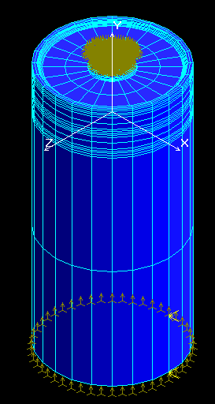
The three-plate redesign of the dynamometer shaft was analyzed with the use of an FEM analysis. Using the results from the FEM analysis combined with the Goodman Fatigue Failure Theory gave a fatigue factor of safety of 4.71. In the FEM analysis, it was assumed that there are no displacements in the x and z directions at the bearing (see figure D.2 for x & z direction definition). There was also no displacement in the y-direction (as defined in figure D.2) at the symmetric axis. Two point loads were applied simulating the weight of the car ( 1000 lbs. ), and a torque (1313 in*lb ). All of our FEM modeling was done with the use of Cosmos/M, a commercially licensed FEM software. The analysis shows that the shaft at the outer plate has the highest stresses of the three plates (compare equally scaled contour plots of figures D.2, D.3 & D.4 ). Therefore, the fatigue analysis was conducted on the shaft at this point.

Figure D.1: Picture of the loading conditions used for the FEM analysis of the redesign.

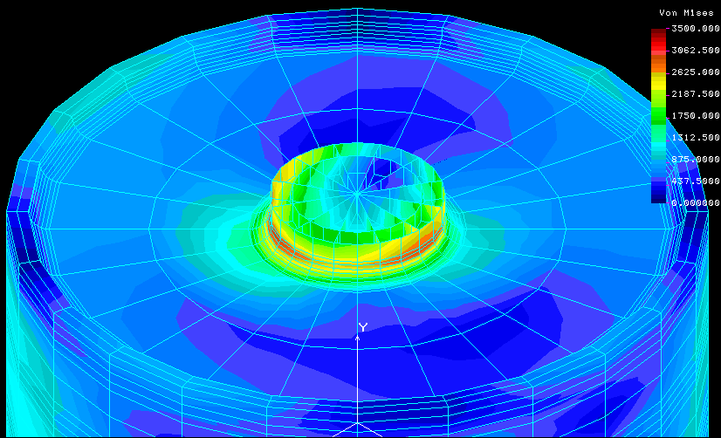
Figure D.2: Contour plot of the Von Mises stresses that are expected where the outer plate of the redesign attaches to the solid shaft using FEM
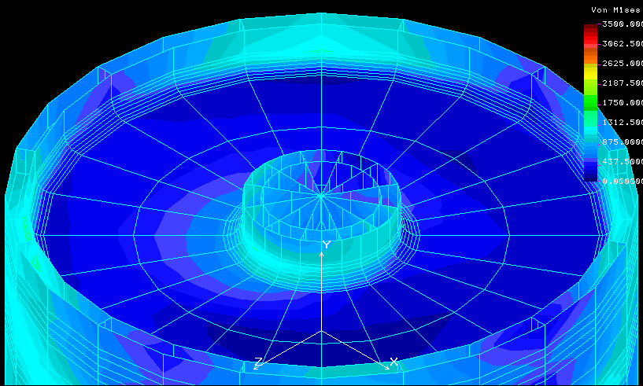
Figure D.3: Contour plot of the expected Von Mises stresses on the middle plate of the redesign using FEM.

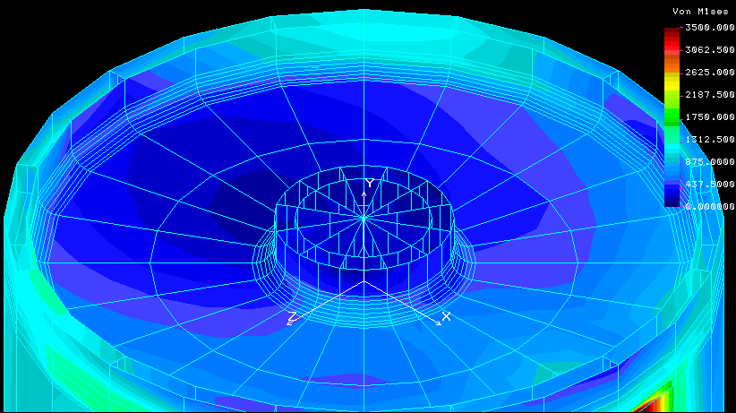
Figure D.3: Contour plot of the Von Mises stresses expected on the most inner plate of the redesign using FEM.

The fatigue analysis of the redesign using the FEM results used the same equations in table B.2. The results from the calculations ( see table D.1 ) show that the fatigue factor of safety will be 4.71. These results are valid for both of three-plate designs when aligned. Therefore the design with a shaft extending through the roll will have a FS of 4.71 because it will not be misaligned while the stubbed design, having slight misalignments, will be slightly lower.

Table D.1: Inputs and results from the fatigue calculations of the three-plate redesign.
References

- ASM Handbook Committee. 1986. Metals Handbook(9th ed.): Failure Analysis and Prevention(vol. 11). Metals Park, OH: American Society for Metals

- Cook R. D. 1995. Finite Element Modeling for Stress Analysis. New York: John Wiley & Sons Inc.

- Hamrock, B. J., Jacobson, B. O., Schmid, S. R. 1999. Fundamentals of Machine Elements. Boston, MA: McGraw-Hill, Inc.

- Sachs, N. 1999. Root Cause Failure Analysis-Understanding Mechanical Failures. [Internet] Reliability Magazine, Reliability Center Inc. Available from: www.reliability.com/article28.htm

- Samuels, L. E. 1980. Optical Microscopy of Carbon Steels. Metals Park, OH: American Society for Metals

- Shackelford, J. F. 2000. Introduction to Material Science For Engineers(5th ed.). Upper Saddle River: NJ: Prentice-Hall, Inc.

- Shigley, J. E., Mischke C. R. 1989. Mechanical Engineering Design(5th ed.). New York: McGraw-Hill, Inc.

- Vander Voort, G. F. 1986. Applied Metallography. New York: Van Nostrand Reinhold Company.

- Penado, Dr. F. E. Fall 2000. ME 365 - Mechanical Design Handout. Fatigue Under Combined Stresses, Modified Goodman Criterion.

