Design Review
Wired Bliss Climbing Cam Project
Presented to: Gene Hacker

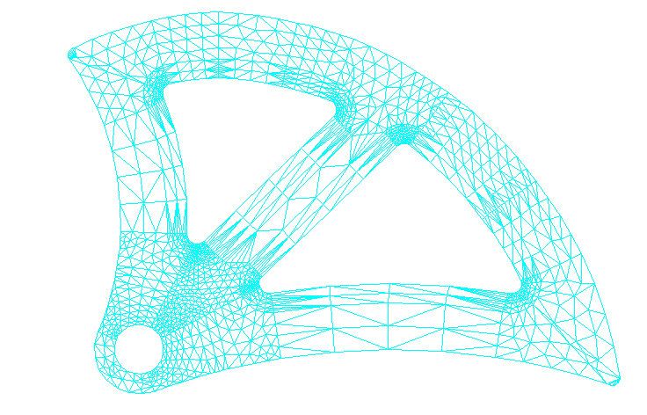

GM³ Engineering
Mike Greene
Karl Martinson
Zane Miller
Sky Moule

ME486
College of Engineering and Technology
May 8, 2001
Abstract

Table of Contents

1. Introduction

2. Specifications and Requirements

3. Scope of Work

- Design Decisions

- Budget

- Schedule

- Recommendations

- References

Appendix A: Final Design

Appendix B: Umbrella Design

Appendix C: Drawings of Unused Design Ideas

Appendix D: Wired Bliss Shop Testing Procedures

- 1. Introduction

The sport of rock climbing can be dangerous. To reduce the risks climbers use safety equipment to limit falling distances. The most important safety equipment includes nylon ropes and anchors. Pitons are permanently mounted anchors, which are hammered or screwed in to the rock surface. Friction anchors are temporary and they are removed after climbing. Friction anchors cause no damage to the rock face. There are two main types of friction anchors, active and passive. Passive friction anchors have no moving parts. Nuts and hexes are examples of passive friction anchors. Active friction anchors have moving parts so that they are more adaptable and can be used in a large range of crack sizes. Few active friction anchors have been designed to operate in cracks 13 cm (5 in) or larger. The few current active friction anchors that will span the larger cracks fall into two main categories: the expandable tube chock and the cam. Camming units are the most popular active friction anchors used by rock climbers today. The cam design uses two opposing logarithmic curve cams to develop a force normal to the walls of a crack. The expandable tube chock design incorporates two telescoping tubes, which can be locked into position, thereby providing a force normal to the walls of the crack.

Wired Bliss, LLC, a manufacturer and retailer of rock climbing equipment, is GM³’s Senior Capstone Design Project client. Wired Bliss currently manufactures climbing cams that range from 1.036 cm (0.408 in) to 9.360 cm (3.685 in). GM³ has been asked to design and build an active friction anchor prototype that will span a 13 cm (5.12 in) crack. This document describes the project achievements of GM³. Included is an overview of the design and its analysis.

The following table lists the team members and faculty advisor contact information:

Table 1: GM³ Team Members
Member Name | Phone Number | Email
Sky Moule | 523-2137 | Sam38@dana.ucc.nau.edu
Karl Martinson | 779-6092 | Kfm3@dana.ucc.nau.edu
Zane Miller | 773-9119 | Zbm@cet.ucc.nau.edu
Mike Greene | 773-9119 | Mg35@dana.ucc.nau.edu
Dr. David Hartman |  | David.Hartman@nau.edu

2. Specifications and Requirements

The objective of the Wired Bliss Climbing Cam design project is to design and build a working prototype of a large span active frictional anchor for rock climbing. The device must span cracks of approximately 13 cm (5 in).

A frictional anchor is classified as active when it uses mechanical action, most often in the form of springs, to hold itself in position before a load is applied. An example of an active protection device is the various camming devices available on the market.

The delivered product must be adaptable to fit cracks greater than 13 cm (5 in) wide. It must be designed to support a dynamic load of 13 kN. Design considerations include weight, production cost, portability, manufacturability, and ease of use. The design should not be substantially heavier than comparable items on the market (300 grams). Nor should it have a production cost higher than current production costs for an equivalent sized cam ($34 each). The range of cracks in which the frictional anchor is operable needs to be comparable with that of cams on the market of similar size. The device should be easy to carry on a standard climbing harness, and allow for one-handed operation. In addition the device should be compatible with all standard climbing equipment (i.e. standard sized carabineers, webbing, ropes, and harnesses) and be easy to manufacture.

The following list summarizes the design requirements. The design should:

- Function properly in a crack of 13 cm (5 in) width
- Support loads of 13 kN
- Be lightweight (300 grams)
- Be cost effective to produce (about $34 each)
- Have operable crack range of 3.9 cm (1.5 in)
- Be easy to carry
- Allow for one-handed operation
- Be compatible with standard climbing equipment
- Be easy to manufacture
3. Scope Of Work

GM³’s solution to the design problem includes designing, building, and testing a prototype of an active frictional anchor for rock climbers. At the completion of the project GM³ will submit three principle deliverables to the client. The deliverables include this completed design report, a working prototype, and a web page documenting the progress of the design over the course of the semester. To date the working prototype is still in production and will be finished by May 30, 2001. The project web page is located at http://www.cse.nau.edu/Design/D4P/EGR486/ME/00-Projects/cams/.
4. Design Decisions

The first step taken to solve the design problem was researching current climbing equipment and examining the positive and negative aspects of their designs. Based upon the results of that research, GM³ brainstormed several unique preliminary solutions. After discussing the advantages and disadvantages of those preliminary ideas, the design choices were narrowed down to three, the umbrella style anchor, a wide track bi-cam, and an anti-walking device (See Appendix C, Figures 1 and 2 for drawings of wide track bi-cam and simple anti-walking device and Appendix B, Figure 1 for drawings of umbrella design).

These remaining design ideas were then taken to our client, Gene Hacker, and thoroughly explained. Rough drawings were included when deemed necessary. Gene Hacker then gave advice on which of the ideas he believed were the most feasible when considering manufacturing, marketing and consumer use. He was most intrigued and excited by the umbrella design. With the approval from Gene Hacker, we then began working on a series of models of the umbrella design.

The umbrella design went through several stages of development and as a result, multiple models were constructed. All models were tested in the wood crack. The wood crack consisted of two 2x6 boards attached to each other by bolts. The boards could be moved through a wide range of positions with respect to each other and to nonparallel relations to simulate a large variety of cracks. The umbrella anchor started out with two independent arms, which pivoted when actuated with a wire trigger. This was unstable. The second stage in the evolutionary process was to replace the wire actuator with a rigid actuator arm. This caused the arms to be dependent. Although this added some stability to the model, the anchor could still be easily removed from a crack. Pivoting feet were then added to increase the surface in contact with the crack. (See Appendix B, Figure 2 for pictures of rough models) When the feet did not significantly increase the force needed to resist anchor pull out, hand calculations were then done on the umbrella anchor design. Hand calculations should have been completed before physical modeling began. It was found that the necessary friction force could only be developed over a very small range of motion. This resulted in an effective range for the anchor of less than a centimeter, which was unacceptable. (See Appendix B, Figure 3 for calculations)

After abandoning the umbrella design, standard pieces of rock climbing gear were examined. The logarithmic spiral cam is the market favorite in active friction anchors. The design consists of four independently moving lobes, two on each side of an axle, with a torsion spring actuator. The lobes utilize a logarithmic spiral to maintain a constant camming angle. The camming angle is the angle between the line of force and the horizontal plane. The camming angle determines the range and holding power of the cam. A larger camming angle increases the range, but decreases the holding power. Current cam designs use an optimized camming angle of approximately 14.5 degrees. Because the angle at which the force is transmitted is constant, the forces are constant at any point along the range of the cam. See Figure 1 for the compliment of the camming angle.

Wired Bliss recommended that we construct all parts of our design that make contact with the rock surface out of 6061 T-6 aluminum because it is lightweight and bites in to the rock without being damaged. It is the current market standard material. Given the strength of 6061 T-6 Aluminum (240Mpa) the minimum cross sectional area for the cam lobe can be calculated as 2.2 cm² assuming the cam was supporting a load of 13 kN on all four lobes. (See Appendix A, Table 3 for calculations)
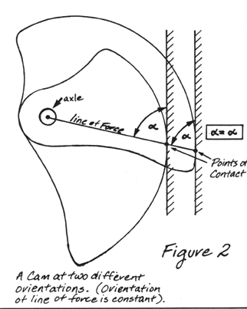
GM³ decided to focus on reducing the weight of the cam by only using a section of the logarithmic curve used for a standard cam. This allowed us to shave off a significant amount of material while maintaining a large range. (See Appendix C, Figure 1 for design drawing) When we next met with our client and showed him our ideas he thought that we were excessive in removing material and reduced the range of the cam too much.
Figure 1: Compliment of the camming angle. The camming angle remains constant through out the entire range of cam.

GM³ added back some of the material to the cam lobes that we had previously removed and when we next contacted our client he was satisfied with the design. See Figure 2 on the next page drawing of final design and prototype (See Appendix A, Figure1 for 3-dimentional rendering of drawing). FEA was then performed on the cam lobes. Because the cam lobes are such an unusual shape it was difficult to accurately model the exact loading conditions that would be seen while used in a real life setting. However after discussing the matter with Dr. Ernesto Penado, a professor who teaches FEA at NAU, a reasonable approximation was made. The cam lobes were determined to be able to withstand a sufficient amount of force. (See Appendix A, Figure 4 for the FEA results) GM³ then asked Dr. John Tester, a professor at NAU who runs the CAD/CAM Lab, if we could use the CNC machines in the CET building and how to write the code. High quality prototypes were then made (See Appendix A Figure 2 for a picture of the prototype). All parts used in creating the prototypes, excepting the lobes and in some cases the axle were Wired Bliss parts used as part of the Wired Bliss #4 cam (spans cracks from about 6.1 cm to 9.4 cm). By using standard Wired Bliss parts we know it will be easy for our client to manufacture our new design.
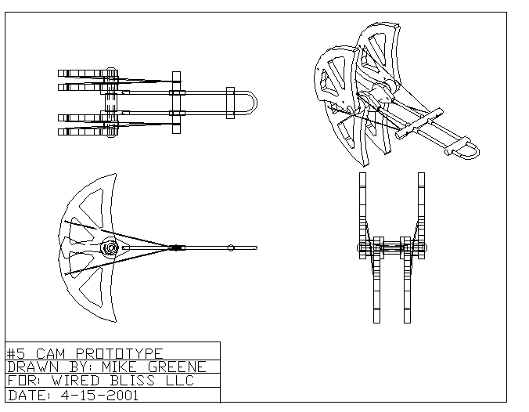
Figure 2: Isometric drawing of final design and prototype.

After creating two prototypes, GM³ constructed the test fixture in accordance with the Wired Bliss shop test procedure. See Appendix D for details on the test procedure and fixture. The first prototype tested failed at 10.14 kN (2280 lbs), which is below our design parameters. The prototype failed in ductile shear of the axle. The cam lobes also bent slightly. We were not certain if the axle failed because the lobes bent or if the lobes bent after the axle failed. A second test was then performed. The prototype failed in the same mode and in the same place at 10.36 kN (2330 lbs).

A third prototype was then constructed with more material around the bottom of the cam, near the axle hole. The axle once again failed in the same location at 10.76 kN (2420 lbs) due to shear. However, the cam lobes deformed less than on the previous tests.

A fourth test was conducted using the lobes with extra material around the axle hole. Metal spacers were made and placed on both sides of each cam lobe. The spacers are shaped like washers and were made out of steel. GM³ thought that the spacers might prevent the cam lobes from bending. The cam failed at 12.63 kN (2840 lbs). The cam lobes did not deform and axle failed in the same location.

For the fifth test an axle was constructed out of sound metal stock found in the NAU machine shop. The axle was of solid construction with external threads. It was tested with the cam lobes with the extra material around the axle hole and the spacers. The cam failed at 13.34 kN (3000 lbs) due to plastic deformation of the axle. The cam lobes deformed after the axle deformed. This design met all of our design parameters. The axle was tester using the Rockwell Hardness test to determine the type of steel. The results of the Rockwell C test classify the axle as either very low carbon steel or iron. The axel was a very soft metal.

Based on the results of these test GM³ recommends our client use a solid axle with external threads for all cams produced with the large cam lobes. The axles will be constructed from the same steel round stock used by with other Wired Bliss cams. This recommendation should be confirmed with further testing.
5. Schedule

GM³ created a schedule at the beginning of the project. We attempted for follow it with varying degrees of success. See Table 2 below for our final schedule. We remained on schedule until it was discovered that the umbrella design would not work. Creating a completely new design after the failure of the umbrella design put GM³ behind schedule. After many long hours we have managed to get mostly back on schedule. We are finishing up about a week later than planned. With the completion on this report, all of GM³’s tasks will be complete.

Table 2: Schedule of Major Tasks
Schedule
Task Name | Start Date | End Date
Client Contact | 9/18/00 | -
Requirements Gathering | 9/18/00 | 10/16/00
SOTA Research | 9/18/00 | 12/8/00
Project Presentation | 10/30/00 | -
Website Development | 10/16/00 | 5/4/01
Build Testing Device | 10/16/00 | 10/30/00
Initial Proposal | 10/30/00 | 11/13/00
Refine Proposal | 11/14/00 | 11/29/00
Proposal Presentation | 12/4/00 | -
Acceptance Document | 12/8/00 | -
Prototype Design | 1/18/01 | 3/15/01
Prototype Preparation | 1/22/10 | 3/12/01
FEA Analysis | 3/12/01 | 3/30/01
Prototype Testing | 1/29/01 | -
Redesign Prototype | 3/15/01 | 3/16/01
Finalize Design | 3/13/01 | 4/15/01
Design Review Presentation | 3/7/01 | 3/13/01
Design Review Report | 2/22/01 | 3/16/01
Design Presentations | 4/10/01 | 4/17/01
Capstone Conference | 4/20/01 | -
Finalize Web Page | 12/18/01 | 5/4/01
Final Report | 4/20/01 | 5/4/01

6. Budget

GM³ had several expenses over the course of the project in order to create a working prototype.

Table 3: Expenses to date
Material | Cost
Wood crack (wood, nuts and bolts etc.) | $72.97
Rough umbrella prototype (steel) | $0.00 (provided by NAU machine shop)
Aluminum (test prototype) | $0.00 (provided by NAU machine shop)
Aluminum (useable prototype) | $0.00 (provided by NAU machine shop)
Milling bits | $35.00
Wired Bliss pieces | $0.00 (provided by Wired Bliss)
Poster board materials | $36.00
Report printing and binding | $14.00
Total | 157.97

GM³ has spent many hours working on the project both inside and outside of class time. We have logged a total of 431.2 hours this semester outside of class time. The majority of the time has been spent making and testing prototypes. The finite element analysis was also demanding task. Another big time consumer was the administrative work, which included writing papers and making presentations.
7. Recommendations

GM³ recommends that our client, Wired Bliss manufacture our cam lobe design with modifications to the existing Wired Bliss axle. These modifications include using a 5/16 in solid steel axle of length 7.62 cm (3 in). The axel should be constructed from the same material as current Wired Bliss cams. External threads should replace the current internal threads for all cams produced with GM³’s large cam lobes. The axles will be constructed from the same steel round stock used by with other Wired Bliss cams. This recommendation should be confirmed with further testing.

8. References

Black Diamond (mfr.)
http://www.blackdiamondequipment.com/
Company home page with links to their products.
http://www.blackdiamondequipment.com/bd/inn_design_philos.html
Design Philosophy

Global Engineering Documents
http://global.ihs.com/search_res.cfm?COUNTRY_CODE=US&LANG_CODE=ENGL
(It may be necessary to enter EN 12276 for the document number) A copy of the standards and test procedures for mountaineering safety equipment, specifically frictional anchors, can be purchased here.

HB Climbing Equipment (mfr.)
http://www.hb.wales.com/
Company home page with links to their products.
http://www.hb.wales.com/cam.htm
This page provides specifications and other information about HB camming devices.

NSSN (A National Resource for Global Standards)
http://www.nssn.org/search.html
(Search here for EN 12276)
The search results will list places where a copy of the standards and test procedures for mountaineering safety equipment, specifically frictional anchors, can be purchased.

Trango (mfr.)
http://www.trango.com/
Company home page with links to their products.
http://www.trango.com/showitem.cfm?catnum=23&itemnum=27&parentcatnum=0
This page provides a description of the Big Bro expandable tube chock.
http://www.trango.com/showitem.cfm?catnum=23&itemnum=19&parentcatnum=0
This page provides a description of the 4 Cam camming device.
http://www.trango.com/showitem.cfm?catnum=23&itemnum=21&parentcatnum=0
This page provides a description of the 3 Cam camming device.

Wild Country (mfr.)
http://www.wildcountry.co.uk/
Company home page with links to their products.
http://www.wildcountry.co.uk/pages/tfriends.htm
This page provides specifications, design considerations, parts list, and names a test procedure used by the company to test their camming devices.

Wired Bliss (mfr.)
http://www.wiredbliss.com/
Company home page with links to their products.
http://www.wiredbliss.com/tcu.htm
This page provides specifications, parts list, and materials list for the tri-cam units.
http://www.wiredbliss.com/quad.htm
This page provides specifications, parts list, and materials list for the quad-cam units.

Appendix A: Final Design
Figure 1: 3-D Rendering
Figure 2: Pictures of Prototype
Figure 3: Calculations
Figure 4: Finite Element Analysis
Appendix A, Figure 1: 3-D Rendering of Final Design

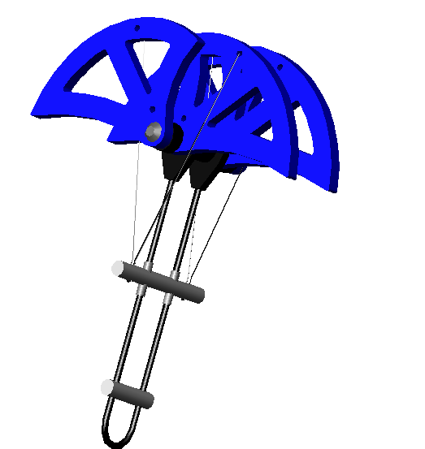
Appendix A, Figure 2: Picture of Prototype of Final Design

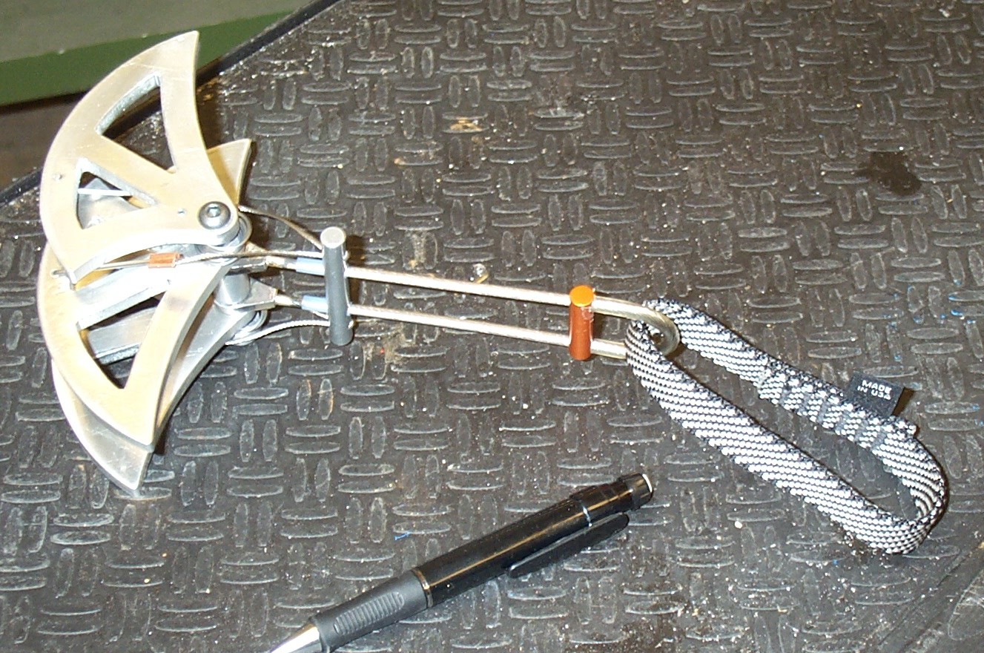
Appendix A, Figure 3: Calculations on Final Design
Appendix A, Figure 4: Finite Element Analysis of Final Design
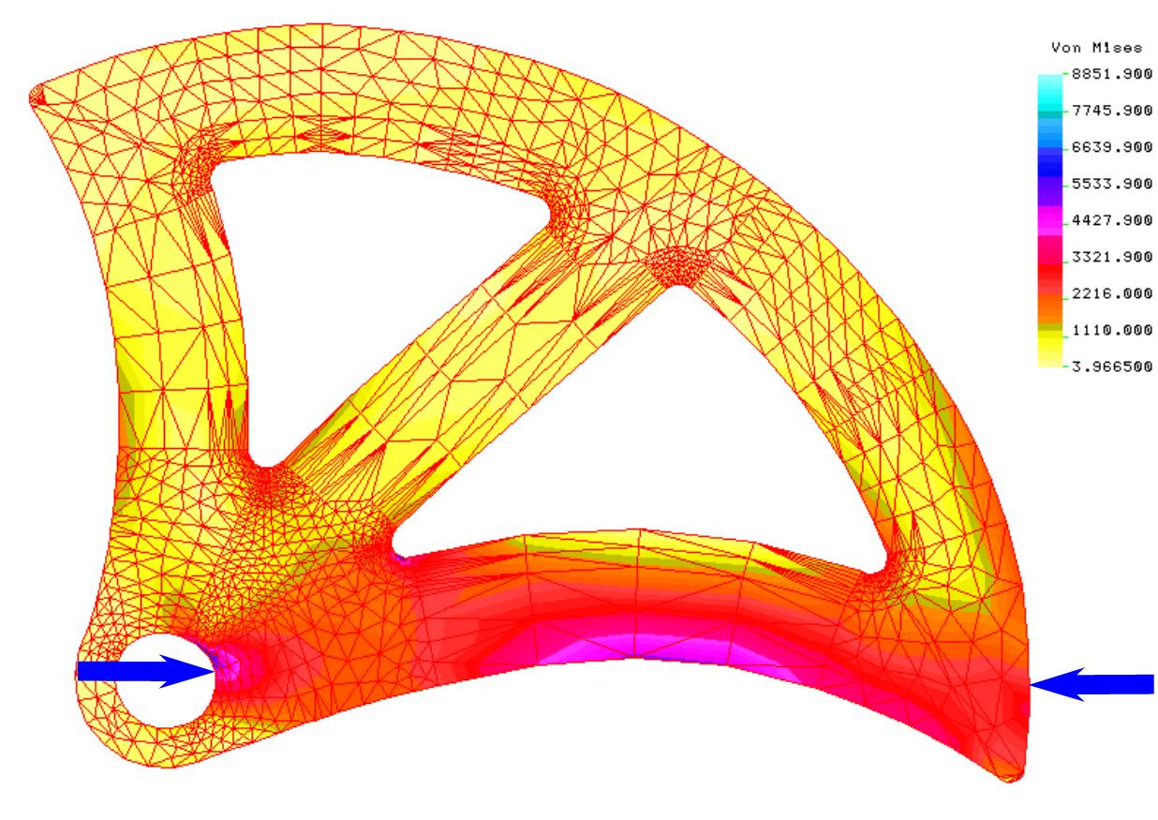
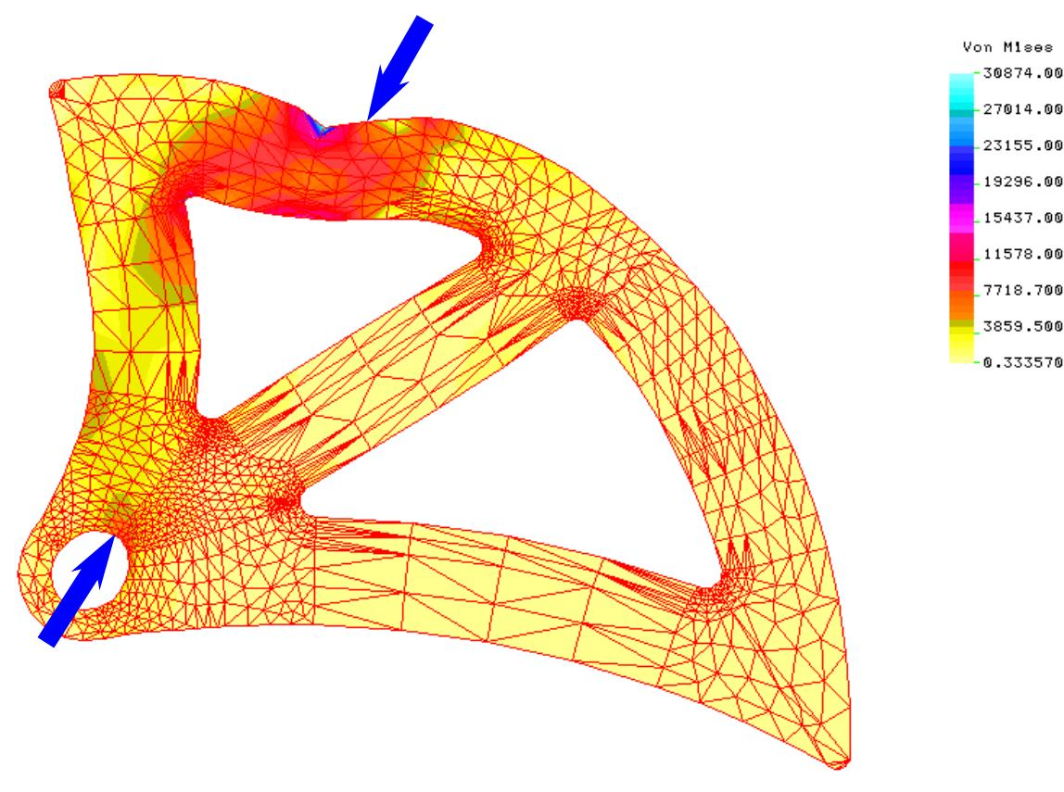
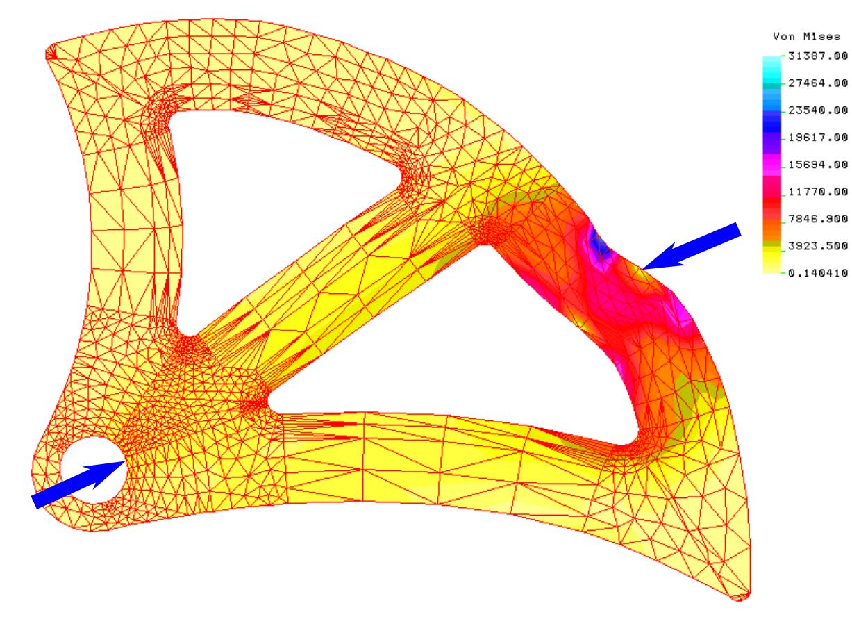
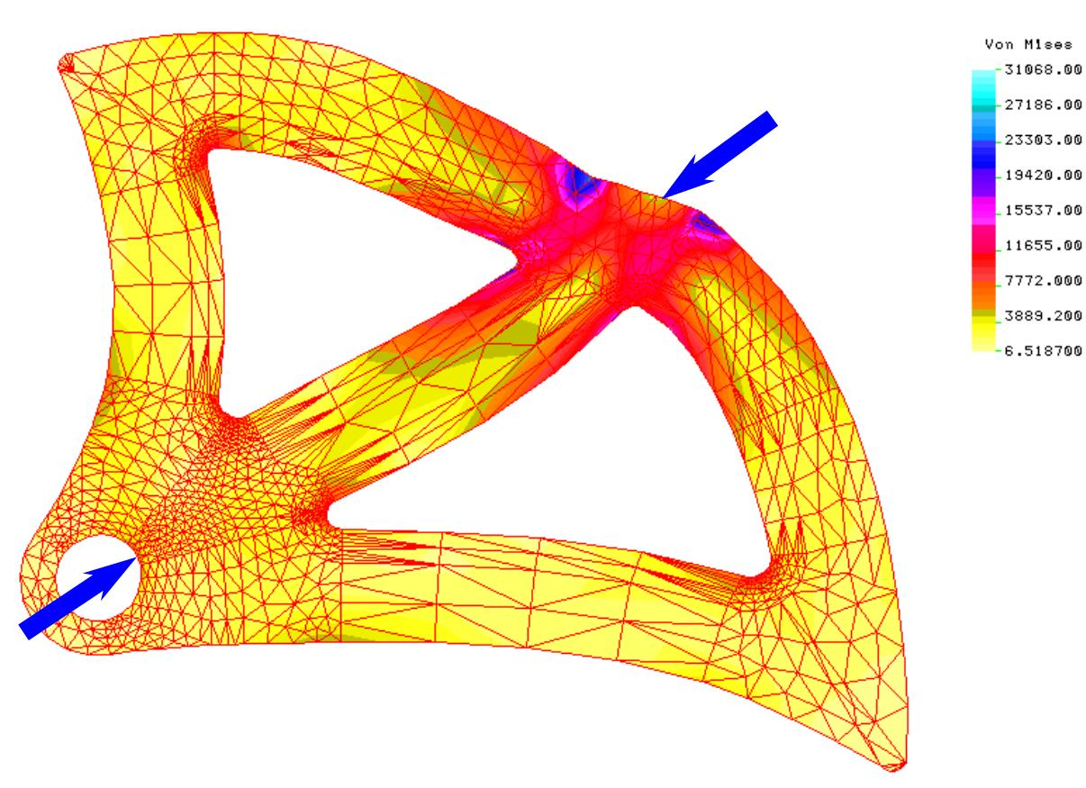
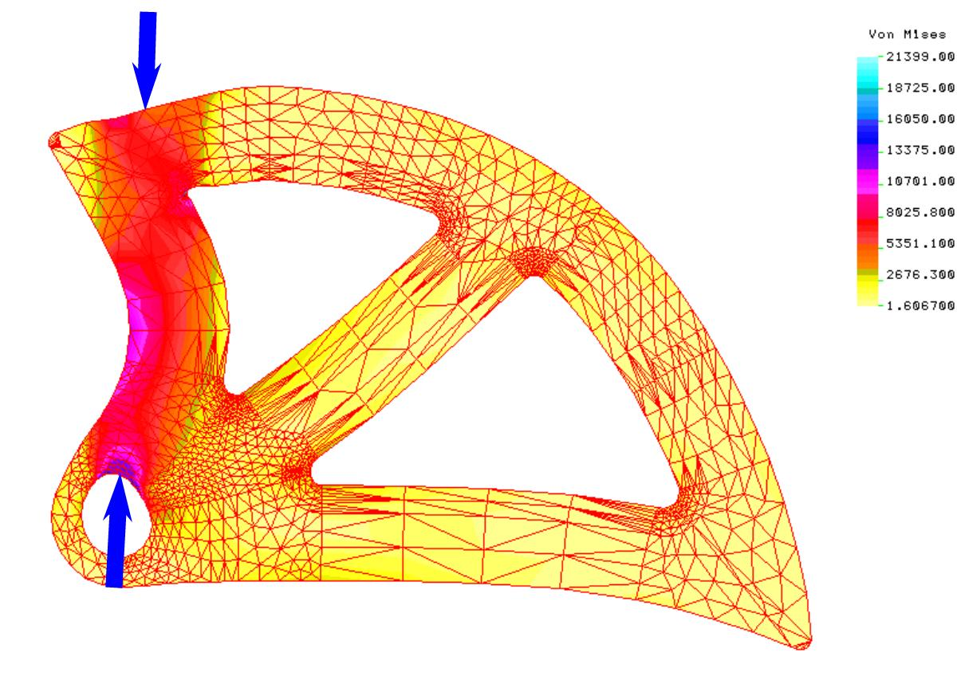

Finite element analysis was performed on the cam lobes for several different loading conditions in order to and simulate the various stresses it would see while in use. It was difficult to model the exact loads and geometry of the cams.
Appendix B: Umbrella Design
Figure 1: Drawing of Design
Figure 2: Pictures of Rough Models
Figure 3: Calculations

Appendix B, Figure 1: Drawing of Umbrella Design
Appendix B, Figure 2: Pictures of Rough Prototypes of Umbrella Design

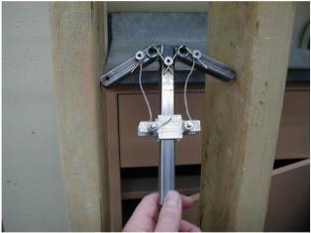
First Rough Model of Umbrella Design: Model has wire trigger actuator mechanism and both arms are independent. Design is very unstable.

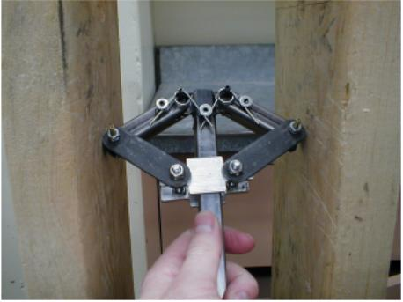
Second Rough Model of Umbrella Design: Model has solid steel bars connecting arms to actuator. The arms are no longer independent. Design is unstable.

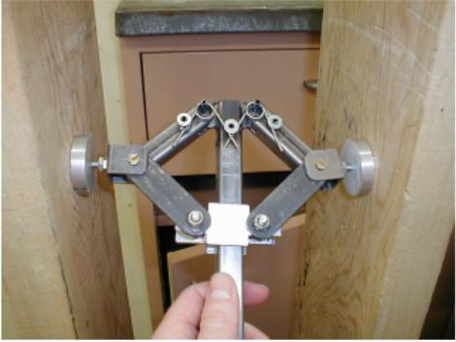
Third Rough Model of Umbrella Design: Feet with ball joints were added to ends of arms. Design was still unstable.
Appendix B, Figure 3: Calculations on Umbrella Design
Appendix C: Drawings of Unused Design Ideas
Figure 1: B-cam
Figure 2: Wide Track Bi-Cam
Figure 3: Simple Anti-Walking Device

Appendix C, Figure 1: B-Cam

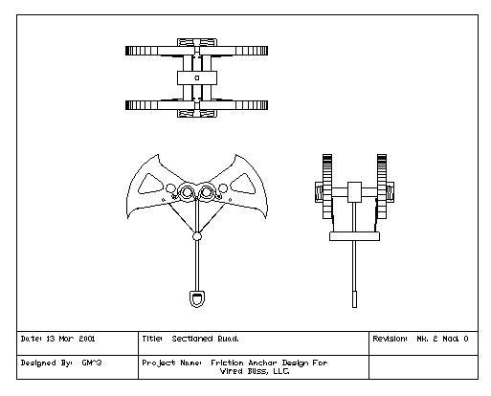
Appendix C, Figure 2: Wide Track Bi-Cam

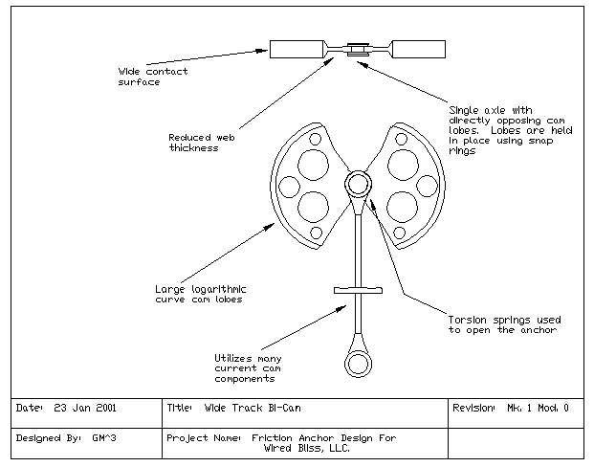
Appendix C, Figure 3: Simple Anti-Walking Device

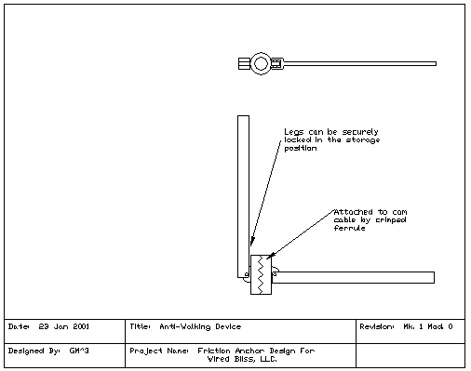
Appendix D: Wired Bliss Shop Testing Procedures

