**SMART MOSQUITO TRAP-POWER USER MANUAL**

**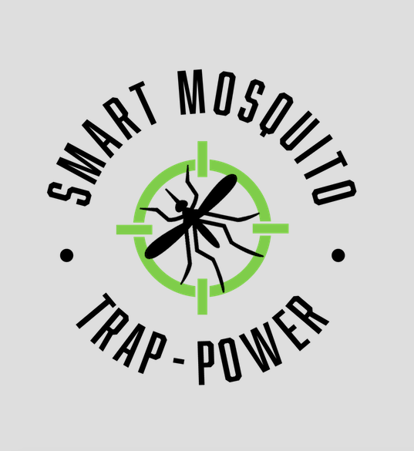**

**TABLE OF CONTENTS**

**3……………………………….INTRODUCTION**

**4……………………………….INSTALLATION OF POWER SYSTEM OF TRAP**

**5……………………………….CONFIGURATION/USE**

**7……………………………….MAINTENANCE**

**8……………………………….TROUBLESHOOTING**

**9……………………………….CONCLUSION**

**10……………………………….APPENDIX**

**INTRODUCTION**

First off, the Smart Mosquito Trap-Power team would like to thank Dr. Crystal Hepp and her research assistant Chase Ridenour for allowing us to design and complete such a fun project to work on throughout the first semester. We were very pleased with our project throughout the semester, and we hope you get great long-lasting use out of the power system we designed for your trap. There is a great need for research on mosquitoes and the diseases they carry, as they are becoming more and more common throughout America. Our design has a few key features almost all the things that you asked for. Some of these features include; durability, weatherproof, charges the battery via sunlight, long-lasting mosquito trap power, and a system that is simple to use. The purpose of this user manual we are providing you is to educate you on the configuration, installation, maintenance, and troubleshooting of the power system we have provided you.

Dr. Hepp is an evolutionary biologist at Northern Arizona University in Flagstaff, Arizona. She works within the school of Informatics, Computing, and Cyber Systems (SICCS). Dr. Hepp recently received a grant to begin studying mosquitoes and the diseases that they carry throughout the southwestern United States. More specifically, she studies the West Nile Virus and a virus called the Saint Louis encephalitis virus (SLEV). With her groundbreaking research into these viruses, we will be able to discover where the mosquitoes that have the diseases are. This will hopefully allow us to contain them better and stop it from spreading to multiple humans.

At the beginning of the year, Dr. Hepp needed a long-lasting, durable, and travelable power system to power her bg-sentinel 2 Trap and the microcontroller that will be connected to it. This trap will often be used in remote areas of the Southwestern United States, so it is important that it can handle the tough situation It needed to include solar power, so it could take advantage of the often very sunny and hot days that come with being in remote areas of the Southwest. Ideally, she wanted the power system to power the trap for 1 week.

To accomplish this difficult task, we were able to come up with three subsystems that would be deemed mission-critical to the project at hand. Our first subsystem would be the battery bank for the project. This part of the project was mission-critical because, without it, we would not be able to power the system at all when there is no sunlight. Furthermore, without the correct voltage or amperage coming from the battery, it would have been impossible to make the system power the trap for long periods. It is also important that the battery is weatherproof and durable because the trap should still be able to be powered when a little wind or rain comes along. On top of that, the battery will be going on a plane, so the battery must meet Transportation Security Administration (TSA) requirements.

Secondly, it was decided that the solar panel would also be one of the three subsystems. The solar panel was deemed mission-critical to the project because of the solar panel requirement in our project. However, it is the only reasonable way to charge a battery in the middle of the desert. The panel also needs to be waterproof and small enough to carry on a plane, yet produce enough power throughout the day to keep the battery operating without sunlight.

Lastly, the third subsystem we included was the dc/ac converter. This was a very simple yet mission-critical subsystem that would not allow our trap to operate if it were not implemented. This is because of the outlet plug that came with the trap. It will not power without an ac plugin, so the dc/ac converter must be implemented. Furthermore, this converter needs to be able to withstand weather and be easily carried.

We were able to create and finalize this system by researching, prototyping, testing, and simulating our ideas throughout the semester. Our final design met almost all of the requirements detailed to us at the beginning of the year. We made our design innovative by implementing multiple aspects of the problem and requirements into our design. We understood that the problem researched and what needed to be done to ensure we met the requirements, prototyped our research into three subsystems, created simulations to ensure function ability, then implemented and tested the trap to ensure it met specifications required by Dr. Crystal Hepp.

**INSTALLATION OF POWER SYSTEM OF MOSQUITO TRAP**

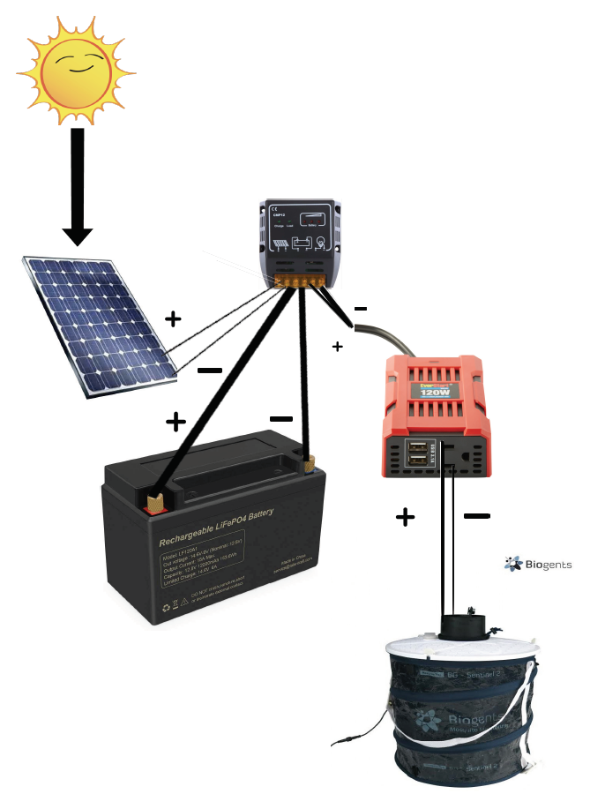

**1: 12v solar panel**

**2: cmp-12 solar charge controller**

**3: dc/ac converter**

**4; 12v, 12ah lithium-ion battery**

**5: BG-sentinel 2 Mosquito trap**

2

1

3

4

5

**REQUIRED BEFORE INSTALLATION:**

* Hammer/screwdriver
* Sunlight
* Flat surface for equipment placement

**INSTALLATION**

1. To install the Power system properly, make sure the trap [5] is unplugged from the converter [3] and that the battery [4] is unplugged from wiring provided.
2. Go to the desired location where you would like to trap mosquitoes (preferable near water and by vegetation) and place the trap [5] there.
3. Take solar panel [1] and place in the closest area with full exposure to the sun. Wires should be long enough to fit most situations.
4. Take stake or screws and lightly hammer or screw into ground to ensure solar panel does not fall over.
5. Once completed, return to trap [5] and connect battery [4] to proper terminals, then plug in the trap [5] to dc/ac converter [4]. Make sure the trap is operating.
6. Look at the solar charger and ensure a green light is indicated on “charging” at least 2 of the three “battery” lights are lit up, and the “load” light is lit up.
7. After all indicator lights are showing, the trap should be fully operational and last at least 5 days.

**Other things to Note During installation**

* Consider installing at the beginning of the day to ensure maximum charging from solar panel to battery
* Consider placing trap, battery, converter, and charge controller in shaded areas. Not only is this where mosquitoes tend to hang out most, but it will also help to prevent overheating of the device.

**Finishing touches**

Once the second solar panel ordered comes in, simply also connect the positive and negative terminals of the panel to the charge controller.

**CONFIGURATION/USE**

* Using the Power system of the trap is fairly easy, but there are many things to consider. Below is how you use every item included in the power system of the trap.

1. **Solar Panel**
   1. The 12-volt solar panel included is a fairly simple device to use and implement. Simply connect the two wires into their respected + and – terminals of the Charge controller.
   2. After that, place the solar panel in an angle that promotes maximum sunlight (usually about a 70% tilt to the west).
   3. Finally, screw or bolt the panel into the ground to ensure it does not tip over due to wind or wildlife. Once that is completed, a green light on the charge controller
2. **Solar charge controller** 
   1. The CMP-12 solar charge controller is a great way to ensure over currents and under voltages does not compromise the circuitry of your system. It is also an easy device to use, but many things can go wrong.
   2. Connect your solar panel, battery bank, and load to the respective terminals specified on the controller.
   3. After that, when the solar panel is charging, it has an indicator light on it that is green when it's charging the battery, and off when it is not.
   4. The three indicators for the battery indicate the amount of life the battery has.
   5. The load indicator lights up green when the load should be working, and off when there is no load.
3. **DC/AC converter**
   1. Our DC/AC converter simply converts the DC power that the solar panel and battery use to AC power that the mosquito trap can operate on.
   2. To use this device, simply connect the positive and negative leads of the converter to the charge controller.
   3. After that, you can plug in any device rated below 12 amps into the socket located on the converter.
   4. You are also able to connect USB devices in the sockets provided on the converter as well
4. **Lithium-Ion battery**
   1. Our 12 volt, 12 aH lithium-ion battery is the battery bank of our power system. To use it, simply plug the proper terminals into the charge controller.
   2. Once it is plugged in, you should see 3 lights on the charge controller indicating how charged the battery is.
5. **BG-sentinel 2 trap**
   1. The bg-sentinel 2 trap is a mosquito-trapping device that uses a fan and C02 to trap mosquitoes in a bag located under the fan of the trap.
   2. To use it, take the lid off the trap and pull out the plug that will be plugged into the outlet.
   3. Ensure that the fan of the trap is running once the trap is plugged in. Close the lid of the trap and fasten to trap using provided locks on the lid.
   4. When not being used, unfasten the lid of the trap and collapse the trap downwards.
   5. There is a strap located on the trap that is used to secure the collapsed trap. Finally, place the trap into the provided bag and zip up for easy carrying.
6. **Using the whole device**
   1. As a whole, the device is incredibly simple to implement and use.
   2. Simply put the solar panel in a space where there is ample sunlight, move the trap and other devices to a preferably shaded location where it won't get damaged long term, and connect the wires of the battery to the appropriate terminals of the battery and the trap will operate perfectly.

**MAINTENANCE**

There are a few things that should be considered in terms of the maintenance of the products. Most products need to be replaced at least semi-annually.

**Solar panel:**

The 12-volt solar panel should be wiped off after each time in the field to remove any dirt or pollen it may have collected over the course of collecting energy. This will ensure the solar panel works to its maximum potential. The solar panel should be replaced every year, as they are fairly easy to break while being carried and traveled with.

<https://www.amazon.com/Waterproof-Sealed-Battery-Charger-UV87511/dp/B003LZ4IK4/ref=sr_1_5?keywords=12v+waterproof+solar&qid=1581014243&sr=8-5>

**Solar Charge controller:**

The CMP-12 controller should have a close eye kept on it. This is the most common thing to break in our final design, for several reasons. First off, ANY load that takes more than 10A of current will fry the circuitry of the controller. Therefore, it must be made sure that the mosquito trap and microcontroller are the only 2 things plugged into the load. This will have to be replaced every 2-3 months, but it is the cheapest part of our design, costing roughly $8. We recommend buying multiples of 3-5 at a time.

<https://www.aliexpress.com/item/32883439664.html?src=google&src=google&albch=shopping&acnt=494-037-6276&isdl=y&slnk=&plac=&mtctp=&albbt=Google_7_shopping&aff_platform=google&aff_short_key=UneMJZVf&&albagn=888888&albcp=9824643245&albag=103112554314&trgt=896505316494&crea=en32883439664&netw=u&device=c&albpg=896505316494&albpd=en32883439664&gclid=EAIaIQobChMI2rXU3d6g6QIVicDACh3qwQtwEAQYAiABEgK1hPD_BwE&gclsrc=aw.ds>

**DC/AC converter:**

The dc/ac converter should remain dry at all times and be checked on to ensure that it keeps working. These were breaking fairly often through testing, as they are rather unequipped to deal with sunlight. Keeping the converter out of the sun will make it last longer.

<https://www.amazon.com/BESTEK-Inverter-Converter-Charger-Listed/dp/B07JJSW48V/ref=sr_1_3?dchild=1&keywords=dc%2Fac+converter&qid=1588819638&sr=8-3>

**Lithium-Ion battery**

The 12-volt, 12-aH lithium-ion battery used in the design will need to be replaced roughly every 1-2 years to ensure it maintains its capacity. Make sure to remove any dust from the object and try your best to keep it dry when not being used. Also, make sure to charge at home when not being used to ensure the maximum duration of the trap being operational in the field.

<https://www.amazon.com/TalentCell-LF120A1-Rechargeable-153-6Wh-Phosphate/dp/B07JF56C7L/ref=sr_1_4?keywords=power+bank+watt+hours+battery+post&qid=1582823985&sr=8-4>

**BG-Sentinel 2 Trap**

The mosquito trap requires little to no maintenance. Just be sure to clean out the bag of any dead mosquitoes and rinse it off with water. The fan in the trap should last a very long time since it has a protective covering.

[**https://www.nhbs.com/title?slug=biogents-bg-sentinel-2-mosquito-trap**](https://www.nhbs.com/title?slug=biogents-bg-sentinel-2-mosquito-trap)

**TROUBLESHOOTING**

Here are some troubleshooting tips to help you fix a few known problems that we ran into throughout the design of the trap

**There are three blinking lights for my battery indicator on the solar charger and the mosquito trap isn’t running, what is wrong?**

There are two things you should check first when this occurs:

1: make sure your battery is completely connected; sometimes the wire does not sit on the battery well, so really make sure the wire is secured on the battery

2: make sure there is nothing else connected to the load part of the controller. If this occurs, you are more than likely drawing more than the 10 Amps the controller is rated for, and will likely short out the controller. To see if you did, test the output of it with a voltmeter. If the meter reads 0, you’ve most likely broken the controller and need a new one.

**I’ve plugged in my mosquito trap the converter and it is running very slowly, how can I make it run faster?**

This most likely means the battery is almost depleted and cannot support the full load of the trap. Make sure your solar panel is in the correct position to achieve maximum sunlight, and make sure to charge the battery fully before bringing it out to the field.

**It's been days since the sun has been out and the battery is not being charged enough by the solar panel to last through the night, what should I do?**

Unfortunately, due to the battery and solar panel size constraints of the project, the only thing you can do is go out to the field more often and bring it home to recharge. The battery can only support the load by itself for a little more than 24 hours, so sunlight is a key part of making the trap run for long periods at a time. If it is raining frequently, I suggest waiting until the rain has stopped to put the trap back into the field. There will be more mosquitoes, and it will be fully charged.

**My Battery seems to be getting very hot when out for too long, and I’m worried it will explode and cause a fire. What are my options?**

Do try your best to keep the battery in shaded areas and out of the sun. Sunlight and heat not only damages batteries over time, but it also increases the chance of an explosion.

**CONCLUSION**

In conclusion, we hope that you enjoy our product and find it easy to use in your future endeavors of capturing mosquitoes and studying the diseases they carry. We were truly delighted to work with you for this project, and if you have any questions for us in the future, do not hesitate to contact us.

Best wishes,

Smart Mosquito Trap-Power

Members:

Abdulaziz Alharbi

[aaa682@nau.edu](mailto:aaa682@nau.edu" \t "_blank)

Christopher Schafer

cms688@nau.edu

**Abdulrahman Alnajar**

aa3792@nau.edu

APPENDIX



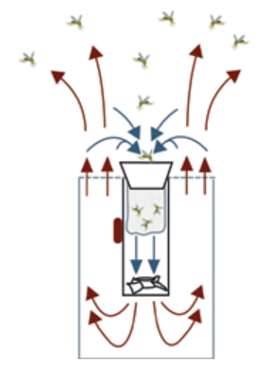

**The functionality of the BG-sentinel 2 trap**

**Schematic of our Power System**