**To:** Dr. Kyle Winfree

**From:** Abdulaziz Alharbi, Christopher Schafer and Abdulrahman Alnajar

**Date :**

**Subject:** Design Review 4

Dear Dr. Winfree,

This memo highlights the status of this project. It covers who our client is, what we were tasked to do, the design process of the project, project constraints as we handled the work, and a work breakthrough structure of the project.

Thank you in advance,

Smart Mosquito Trap-Power team

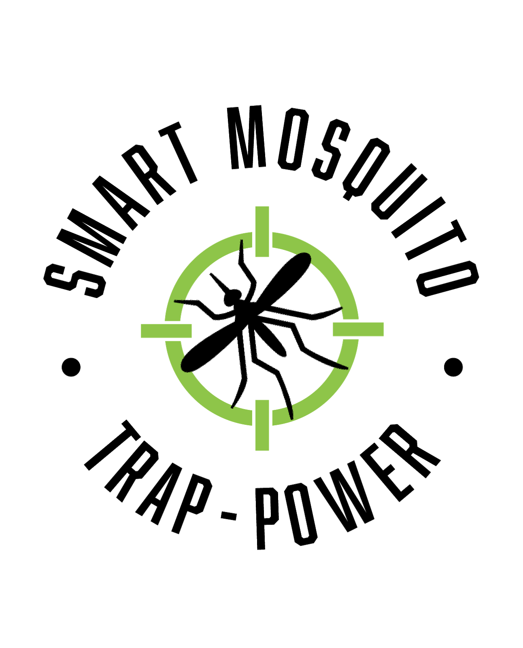

**SMART MOSQUITO TRAP-POWER**

**Client:** Dr. Crystal Hepp

**GTA**: Mahsa Keshavaraz

**CONTRIBUTORS**

Abdulaziz Alharbi

Christopher Schafer

Abdulrahman Alnajar

Table of Contents

INTRODUCTION 4

PROJECT TASK 5

DESIGN PROCESS 6

PROTOTYPING 7

Battery Bank 7

Battery Bank Voltage output 7

Size of the Design 8

Durability/Organization 8

Power testing 8

DC/AC converter 9

PROJECT CONSTRAINTS 9

Client Based Constraints 9

Other Constraints 9

DC/AC Converter 9

Solar panel 10

Battery bank 10

WORK BREAKDOWN STRUCTURE 10

CONCLUSION 12

REFERENCES 13

# INTRODUCTION

Various types of mosquitos are responsible for the spread of various disease-causing organisms. The intensity of the spread of disease by mosquitoes can be based on the abundance of mosquitoes in a certain location [2]. Trapping these mosquitos is something that can help to reduce the number of mosquitos so that the chances of these mosquitoes spreading disease-causing microorganisms are minimized. Concerning that, many pieces of research and developments in the design and implementation of mosquito trappers have been in place for quite some time now [1][2][3]. These trappers, which are in place, have some drawbacks in that they do not categorize the specific type of mosquito trapped. Thus, our design will incorporate the capability of mosquito traps to detect the type of mosquito being trapped. Furthermore, our project will allow the BG-sentinel 2 trap used by Dr. Hepp to run for extended periods.

Therefore, we are pleased that you have chosen the Smart Mosquito Trap-Power team for your business needs. There is a strong need for Smart Mosquito Trap, as evidenced by the increasing need to catch and study the mosquitos pending the diseases they spread. We provide for you here a powerful system for your research needs that have been custom-designed to meet your needs. Some of the key highlights include:

* Durability
* Portability
* Accuracy
* Environment friendly
* Cost-effective

# PROJECT TASK

**Handled by Abdulaziz Alharbi**

Mosquitos have been termed to be among the most dangerous disease-carrying animals as their diseases that they transmit are quite deadly when in the human body [2]. Therefore, a need to work on a project that can regulate the disease spread by tapping the mosquitos. Dr. Hepp, an Evolutionary Biologist at Northern Arizona University, has been studying mosquitoes and the diseases they transmit. The main disease being researched is the West Nile virus, whose research is being conducted in Africa and Mexico. Dr. Hepp and her research team want to catch mosquitoes, grind them up, and look for viruses as a means of surveillance. For doing this her team distributes traps over a large geographic area such as the southern US and Mexico border.

These traps must be able to attract mosquito bait towards them. The current ongoing method to do this is to load a trap with dry ice as an emitter which is powered by Dry cell batteries that run a fan and catches and retains the mosquitoes [4]. This method is feasible but has certain limitations too. Therefore, we were tasked with coming up with a power system for the project device, mosquito trap, that can trap mosquitos for as long as seven days. The Mosquito trap should not go off at any point meaning that the power must be consistent. The trap may operate in a low power mode when there are no mosquitoes around the trap, but for the majority of the time, the trap must be operating at full power. Furthermore, the power system designed should be small enough and light enough to carry and travel with. Also, we were required to implement a solar panel in our project as a means of conserving the environment as well as ensuring no depletion of energy in the trap.

This means that with this project, Dr. Hepp and the team will be able to catch very many mosquitoes and be able to carry out their research hence develop strategies for the diseases being spread by these dangerous insects.

# DESIGN PROCESS

**Handled by Abdulaziz Alharbi, Christopher Schafer and Abdulrahman Alnajar**

Developing this trap took several steps including testing, and selecting different subsystems for maximum efficiency. The selection mostly based on accuracy and functionality. The durability and power consumption were also a major concern while selecting the subsystems to make the whole system [5]. The figure below shows a graphical view of the sub-systems we selected for our trap project.

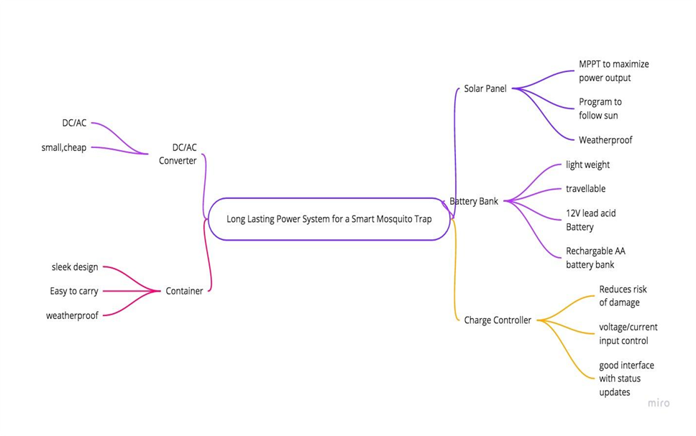

*Figure 1 Subsystem Classification*

The figure above illustrates the mind map and idea processing of our project. It goes over our initial thoughts on how we thought our project would be divided. The first subsystem to be realized is the solar panel [9]. We started with a cheap one just to get an idea of how they work/function. For this one, it presented poor results and a lack of durability as it could not harness enough power to be used over the night. This made a selection of another one solar. A solar panel is important in this project because it does harness power from the sun and then power stored to be used during the night. Therefore, the stronger the solar panel, the more power can be harnessed and the surety that the trap will run the entire night without running out of power [9]. Apart from just the quality, the solar panel we chose was one that could not be easily be affected by weather; weatherproof.

The solar panel has to store power somewhere, hence leading to another selection of the system; battery bank [12]. The battery bank is connected to the solar panel, so they are related because, throughout the day, the solar panel will charge the battery to allow the battery to last overnight, which should include the traps busiest operation times. The DC/AC converter was also included in the design because the trap runs on AC power and the solar panel generates DC power [12]. Therefore, with the DC/AC converter, the power can be converted from Dc to AC to enable the trap to function.

Related to these first three subsystems is a charge controller. The charge controller was important in this design process because it greatly reduces damage to the Mosquito Trap's internal hardware [8]. It does this by controlling voltage and current going into the system as at times there are over currents and under voltages in the system. Furthermore, the charge controller has an LED interface that can let the user know how much relative charge the battery is holding, if the solar panel is charging the battery, and if the load is operating at full power.

Hence, with these sub-systems, the final design came out to be a weatherproof, sleek-looking container for all the parts of the design. Being weatherproof, and sleek-design was important putting in mind about the harsh weather conditions and portability.

# PROTOTYPING

The project included a solar panel with the whole design small travelable and waterproof. For the prototypes of our project, A small, 12V solar panel, a 12V lead-acid battery, and a DC/AC converter are used [12]. These prototypes were chosen because all three are mission-critical to our project and are functional and complete with each other. These fitted into the bigger picture because the solar panel charges the battery throughout the day so the trap can be powered throughout the night. The converter is necessary because, without it, the trap will not operate at all. Therefore, we were able to learn about how much energy the panel will retrieve throughout the day, how long the battery would charge, and if we would need a converter or not to operate the trap.

## Battery Bank

We chose to prototype the battery bank of the Smart Mosquito Trap because it is mission-critical to our project. Without a power source, the mosquito trap will not be able to trap mosquitoes. It should also be able to power the trap for an extended period without human intervention.

## Battery Bank Voltage output

The battery bank should store enough energy so it can power the mosquito trap for at least a week at a time. This included rigorous testing of the mosquito trap during all different types of weather to see what will be required of the battery. In prototyping, we decided to go with a 12-volt 7 Ah/ 20 hr. lead-acid battery [12]. This was because it is inexpensive, easy to implement, and is long-lasting. Without the mosquito trap, it was difficult to spend a lot of money on a prototype without knowing how long it will last. So, we got something with a similar amperage use and tested it, we only got a rough estimate of how long the battery would truly last. When tested, we allowed the battery to be charged throughout the day without any human intervention. At night, it was able to charge a load from full charge for 13 hours.

## Size of the Design

The size was also critical in the completion of the project in general, but it was very critical to the battery. This power source will be traveling in all different corners of the Earth, and it was critical that the power source not be bulky. Furthermore, it required that it be light for portability. A convenient container was necessary as well so that wires are not disorganized. This small, 12-volt battery filled our expectations in regards to size and ease of transportation. The battery was small enough to carry around in a small container and only weighed roughly 5 pounds [12]. This should, therefore, be perfect for transportation needs.

## Durability/Organization

The mosquito trap will often be in unforgiving parts of the globe, so a durable and weatherproof power source was critical to the end goals of the project [8]. This relates to size, but again the battery bank must be in a concealed environment so water does not get into the source and ruin critical components.

## Power testing

In the beginning, we did not know what type of solar panel we would need, so we just bought a basic one to test out and gage what we would need in the future. We went with a 12V solar panel, after researching what panel we would need. When tested, the panel was able to accumulate enough power to keep the battery at a decent level of charge. We let the panel charge the 12V lead-acid battery throughout the day, and it was able to keep the battery on and not completely discharge overnight. There were a couple of issues we ran into while testing the solar panel. First, we were unable to maximize power output because we weren't orientating the solar panel correctly throughout the day. As the sun changes position throughout the day, it was important to change the solar panel angle so it faces directly at the sun. Luckily, we learned these angles can be optimized based on your location on earth.

Furthermore, solar panels often do not maximize power output on their own because they cannot control their voltage or current. We learned this can be achieved by implementing a Maximum Power Point Tracking method. The budget for our project was around $500, and some of these devices could go from $40-$200 dollars.

## DC/AC converter

For the DC/AC converter [12], we did not first realize we needed this. After attempting to charge a phone without the Converter, we did not first realize that we would need a converter to implement. Then, after some research, we bought a relatively cheap, universal inverter that allowed us to test our device. While testing, the device was able to easily convert the energy and allow the power to be converted to AC for device use.

# PROJECT CONSTRAINTS

**Handled by Christopher Schafer**

## Client Based Constraints

Based on the project requirements, a consideration of the availability of the power source when needed, reliability and efficiency were the core issues that were ought to be addressed in the provision of the power to the mosquito trap. Although much effort was put to ensure that the power supplied to the system meets the minimum expected threshold, many challenges were experienced. Some of these challenges included but not limited to the cost of the power source, and limited knowledge to determine the best approximation of the sizing of the power source. Although that was not a challenge at the beginning, the challenges emerged during the time of implementation of the prototype. This made the team to change some parameters for each of the three prototypes considered checking the suitability of the prototypes. Previously, conversion of DC to AC was considered as the main source that could be selected for the design but after changing the parameters, solar emerged the winner of this project.

The client needed a trap that was small, portable, and very efficient. This means that the trap had to be light enough and friendly to be carried everywhere. This was the main challenge from the client as we had to base on the specifications presented. However, from handling this challenge, we were to come up with a sleek design model that could fit anywhere, easy to carry, and easy to handle.

## Other Constraints

### DC/AC Converter

The DC/AC converter was much important for this project; however, the three constraints here were; high cost, unavailability of the most desired one, inability to calculate power output.

The converters that we were getting on the market were quite expensive compared to the fixed budget that we were dealing with. This made us choose something that was quite within the budget. Also, while working within the budget, getting the most desired converter that is small, light, and efficient was a problem, though at the end we were able to get one at a favorable price. Then with the power output, the smart trap can only run efficiently when the required amount of power is pumped in. This was another constraint that took a lot of time to figure out though we eventually calculated and were able to regulate the power flow.

### Solar panel

While choosing a solar panel, we were required to incorporate a solar panel that is light, small, powerful, and cost-effective. We were operating within a fixed budget therefore the solar price was to be favorable. We wanted something portable, so the solar panel was required to small and light. We also needed power that could last throughout the night, this meant that the solar panel we choose should be powerful enough to harness more power. Therefore, with these constraints, we found a solar panel that was light, small, and cost-effective hence enabling us to work perfectly for the design. However, increase the power, we added one more solar panel and soldered everything together.

### Battery bank

With the battery bank, we were constrained on cost, size, and durability. The battery bank needed to be small, less expensive, and be able to hold a charge for at least 14 hours. After a search, we were able to find one that was favorably small, it could last for the entire night till the following day and it was also less expensive.

# WORK BREAKDOWN STRUCTURE

**Handled by Abdulrahman Alnajar**

The following figure (below) shows the wok breakthrough of our project. From the main system, there are three subsystems. Each system shows the factors that were to be considered in its selection and implementation. For example, for the Battery bank, we were to consider the voltage output requirement, the size, and then the durability of the battery. For the solar panel, we were to consider power testing, size issues, and how it may be affected by the weather. For converter, current and voltage ratings and durability were the key factors. Using the factors for each subsystem, we were able to select the best subsystems hence coming up with a final product that is sleek, light, and working even in adverse weather conditions.

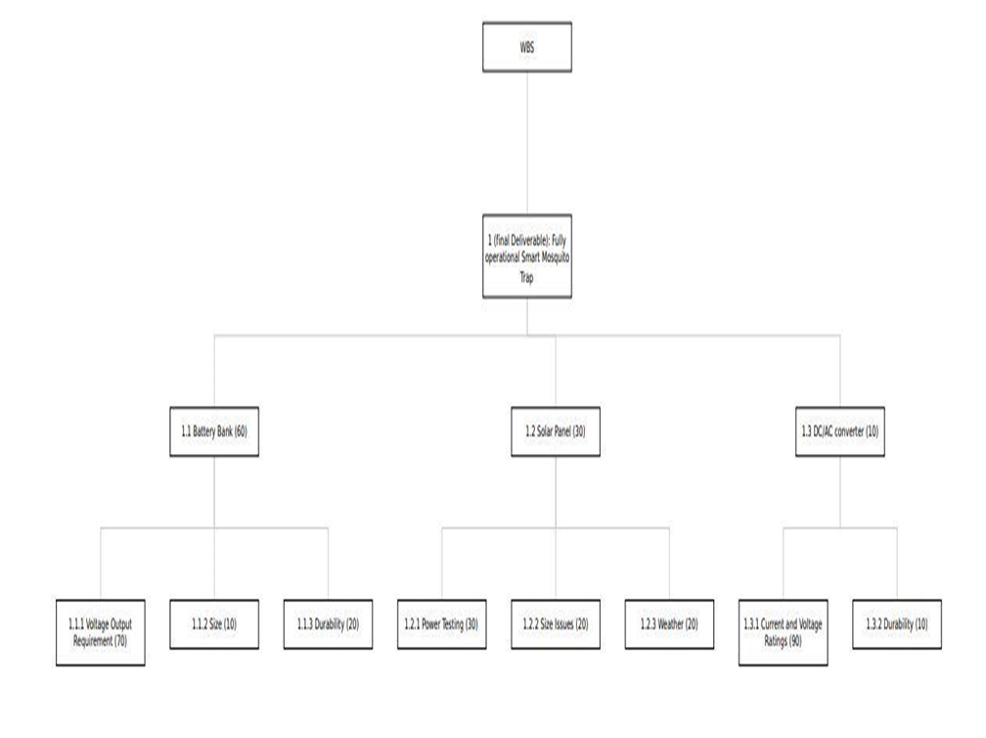

*Figure 2 Work Breakthrough Structure*

From the WBS above, the source of electricity for the mosquito trap is solar energy. However, for optimal performance, our device has to take ac voltage. This is the reason why we have the DC/AC converter because it is essentially the main driver of the project. Normally mosquitoes are dormant during the day, and the battery will be charged during the day. The integration of the component first involved circuit design where we defined schematics and then simulated to ensure that they were working as per the team’s goal, which was outlined at the start of the project.

This project was supposed to be handled within a stipulated period. With that in mind, we developed a Gantt chart to help us work on the project effectively and ensure that we complete the milestones as required and within the scheduled time. This ensured that the entire project is done within the required time. The Gantt chart is shown below.

### 

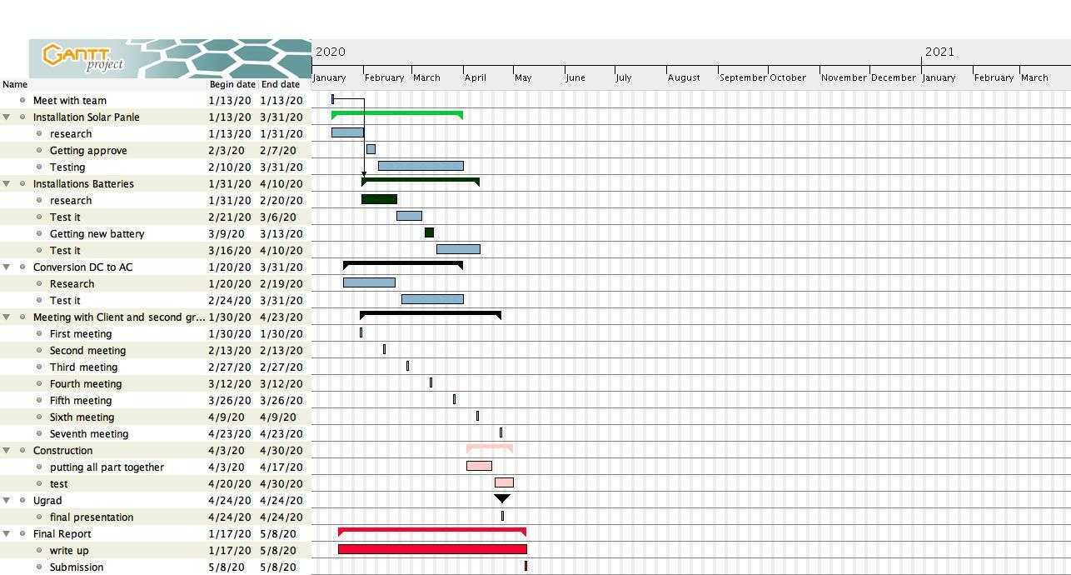

*Figure 3 Gantt Chart*

We were able to work within the stated time as seen from the Gantt Chart as we kept time to be a very serious factor. With everything working, we can say that our project was a success.

# CONCLUSION

Mosquito traps are designed and developed based on mosquito characteristics. By using these characteristics, the development of mosquito traps takes place depending on the specific technology available and the intended purpose of the trap. For example, it has been observed that insect wing beats can determine the species of an insect. Such behavior can be inherently adopted in the design and implementation of the mosquito trap. Through understanding the characteristics of mosquitoes, it is possible that mosquito detection and trapping can be done. This can be achieved through interfacing and integrating many features such as power systems, mosquito detection sensors, and software integration. This will enable the categorizing of the species of mosquito captured. Basing on such factors, we based on these mechanisms to develop the design from the beginning to the end.

# REFERENCES

[1] C. Boonsri, S. Sumriddetchkajorn and P. Buranasiri, &quot;Laser-based mosquito-repelling module,&quot; 2012 Photonics Global Conference (PGC), Singapore, 2012, pp. 1-4.doi: 10.1109/PGC.2012.6458039

[2] N. Zulkiply, L. Audah and M. H. Abdul Wahab, &quot;Smart Mosquitoes Trap Using Favoriot Monitoring System,&quot; 2018 IEEE Conference on Wireless Sensors (ICWiSe), Langkawi, Malaysia, 2018, pp. 83-88.

[3] D. A. A. Santos, R. F. Brandao, G. A. C. Duarte, D. R. Totti, V. Furtado and J. J. P. C. Rodrigues, &quot;A Fan-Based Smart Selective Trap for Flying Insects,&quot; 2018 IEEE 10th LatinAmerican Conference on Communications (LATINCOM), Guadalajara, 2018, pp. 1-5.

[4] A. K. Biswas, N. A. Siddique, B. B. Tian, E. Wong, K. A. Caillouët and Y. Motai, &quot;Design of a Fiber-Optic Sensing Mosquito Trap,&quot; in IEEE Sensors Journal, vol. 13, no.11, pp. 4423-4431, Nov. 2013. doi: 10.1109/JSEN.2013.2274271

[5] M. Bazin &amp; C. R. Williams, &quot; Mosquito traps for urban surveillance: collection efficacy and potential for use by citizen scientists,&quot; 2018 Journal of Vector Ecology. https://doi.org/10.1111/jvec.12288

[6] W. Tseng et al., &quot;Applying physical optics to design solar-powered outdoor UV LED mosquito trapping system,&quot; 2018 IEEE International Conference on Applied System Invention (ICASI), Chiba, 2018, pp. 1052-1055. doi: 10.1109/ICASI.2018.8394456

[7] M. Minakshi, P. Bharti and S. Chellappan, &quot;Identifying mosquito species using smart- phone cameras,&quot; 2017 European Conference on Networks and Communications (EuCNC), Oulu, 2017, pp 1-6

[8] A. K. Biswas, N. A. Siddique, B. B. Tian, E. Wong, K. A. Caillouët and Y. Motai, &quot;Design of a Fiber-Optic Sensing Mosquito Trap,&quot; in IEEE Sensors Journal, vol. 13, no. 11, pp. 4423-4431, Nov. 2013. [6] E. Fanioudakis, M. Geismar and I. Potamitis, &quot;Mosquito wingbeat analysis and classification using deep learning,&quot; 2018 26th European Signal Processing Conference (EUSIPCO), Rome, 2018, pp. 2410-2414.

[9] W. Tseng et al., &quot;Applying physical optics to design solar-powered outdoor UV LED mosquito trapping system,&quot; 2018 IEEE International Conference on Applied System Invention (ICASI), Chiba, 2018, pp. 1052-1055.

[10] X. Porcasi et al., &quot;Spatial analysis of Aedes aegypti activity for public health surveillance,&quot; 2019 XVIII Workshop on Information Processing and Control (RPIC), Bahía Blanca, Argentina, 2019, pp. 214-217. doi: 10.1109/RPIC.2019.8882135

[11] G. E. A. P. A. Batista, Y. Hao, E. Keogh and A. Mafra-Neto, &quot;Towards Automatic Classification on Flying Insects Using Inexpensive Sensors,&quot; 2011 10th International Conference on Machine Learning and Applications and Workshops, Honolulu, HI, 2011, pp. 364-369. doi: 10.1109/ICMLA.2011.145

[12] B. J. Johnson, B. B. Rohde, N. Zeak, K. M. Staunton, T. Prachar, S. A. Ritchie&quot; A low- cost, battery-powered acoustic trap for surveilling male Aedes aegypti during rear-and-release operations, &quot; 2018 PLOS one Research Article, Doi: https://doi.org/10.1371/journal.pone.0201709

[13] Y.N. Liu, Y. L. Y.-C. C., Hsin-Yi Ma &amp; Hsiao-Yi Lee&quot; Enhancement of mosquito trapping efficiency by using pulse width modulated light emitting diodes, &quot; Scientific Reports volume 7, Article number: 40074 (2017). doi: 10.1109/OCEANSKOBE.2008.4531029

[14] B. Poulin, G..Lefebvre, C.M-Kovacs, and S. Hilaire, &quot; Mosquito Traps: An Innovative, Environmentally Friendly Technique to Control Mosquitoes,&quot; Journals IJERPH Volume 14 Issue 3 10.3390/ijerph14030313