Team ECO Runnings
Urban Concept Status Update

Table of Contents
I

I - TABLE OF CONTENTS 2

II - ABSTRACT 3

EXECUTIVE SUMMARY 3
INTRODUCTION 4
PROBLEM OVERVIEW 5
SYSTEM DIAGRAM 6

III - RESEARCH 7

RESEARCH SURVEY 7
Shell Eco-Marathon Rules 7
Electric Vehicles 7
Battery Management System 8
Encoder Feedback Signal 8
Accessory Controller 8
Other Items Researched 8
Controllers 9
Torque Curves 9
Data Conversion 9
Rotational Measurement 10

IV - RERENCES 10

SPECIFICATIONS & REQUIREMENTS 12
Overall Requirements 12
Mechanical 12
Electrical 13
Environmental 15
Documentation 15
Testing 15
Safety 15
General 16

V - DESIGN 16

MATRICES 16
Accessory Controller 16
Throttle Signal Controller 17
Rotation Measurement 18
SCHEMATICS 19
Electrical Accessory System 19
Drive Train System 19
PARTS CHOSEN OR RECOMMENDED 21
CONSTRAINTS 21

VI - BUDGET 22

UPDATED BUDGET 24

VII – SCHEDULE & DELIVERABLES, TASK LIST 26

VIII – COMPREHENSIVE TEST PLAN 29

VIII – UPDATED SCHEMATICS 31

Abstract
II

Vehicle emissions account for a vast majority of airborne pollutants, including 72% of nitrogen oxides and 52% of reactive hydrocarbons. Development of electric vehicles is essential to reducing these pollutants and additionally beneficial to reducing transportation costs. Part of the Shell Eco-Marathon was to design the electric systems of such a vehicle, and to optimize the efficiency of the vehicle’s battery usage. To achieve this, a motor control system is programmed to improve acceleration efficiency. All components were chosen to work together in order to optimize efficiency and reliability based on statistical data gathered about the motor, potentially increasing battery life up to several hours in an urban driving environment. Making electric vehicles more efficient is a step toward the future and a key improvement to the world’s economy and environment.
Executive Summary _
There have been several changes in the design. The control of the accessory lighting is no longer being handled by a micro-controller, as the EE Team was able to get several electromechanical devices donated by NAPA Auto-Parts that will handle these functions. This frees up processor time and memory space for the motor control routine.
The goal of the motor control program has also been changed. The EE Team has found that programming efficient acceleration limits based on current draw will be difficult given that the response time of the current transducer feedback signal is not quick enough. The controller will now possibly be used to command the motors into several pre-programed drive cycles that will accelerate the vehicle efficiently during competition.
Several major updates have been done on the schematic. A regenerative braking switch has been added to improve efficiency when coming to a stop, an automatic accelerator button has been added for an efficient acceleration from standstill, and the brake switch has been modified so that when applied the vehicle can exit regenerative braking or automatic acceleration. Two bypass switches were also added to the schematic. One that disconnects the throttle from the Arduino Mega and connects the throttle input to both Motor Excellence controllers. The other bypass switch disconnects the reverse capabilities (regenerative braking) from the Arduino Mega and connects the reverse input directly to the Motor Excellence controllers. These bypass switches have been added just in case the Arduino Mega is not functioning properly before competition.
The EE Team has the motor system assembled with a stand for testing and has gotten Motor Excellence to install a reverse switch on their controllers. The team has also spent time writing code for the micro-controller to test the reception of the signals from the encoders and the throttle, and testing the reverse switch signal on the Motor Excellence controllers. The team has also drawn flowcharts and written pseudocode for the full program that the vehicle will potentially run during competition. As far as parts are concerned, the team has ordered and obtained virtually most of the major parts but some extra switches and buttons might be needed for the drive cycle routines. The team is currently in the process of figuring out the most efficient way to set up the system with the Arduino Mega.
There are also a number of critical issues that have been encountered. The mounting systems for the encoders on the test stand are unstable, so the motors spontaneously switch direction due to inaccurate encoder readings. Also a signal needs to be sent from the Arduino Mega to the Motor Excellence controllers in order to have an efficient vehicle. Once that is completed, determining an efficient drive cycle for the competition in Houston, Texas will need to completed and implemented.

Problem Overview________________________________
The Shell Eco-Marathon is a challenge held each year that requires student teams to design, construct, and test vehicles that are highly energy efficient. Vehicles are designed to a set of rules and the student groups compete against each other to determine which vehicle is most efficient. The NAU vehicle for this year will be competing in the Urban Concept category under the designation of a battery electric vehicle.
The concept of electrical vehicles has existed for decades. In recent years they have become a viable reality, with many prominent auto manufacturers now selling fully functional, totally electrical vehicles and hybrid fuel/electric vehicles. Its origins can be derived from many reasons, among them, that they cause less pollution, they will lessen considerably the public dependence on oil, and they are less expensive to operate. Although these advantages do exist and have been well documented, there are also some disadvantages to owning an electrical vehicle. Among these, their batteries do not currently have a very long distance discharge rate and require an electrical source for recharge that must be done quite frequently.
A crucial part in designing our Shell Eco-Marathon competition vehicle is electrical power control and distribution, specifically, the behaviors of various electrical circuits and their components. The EE Team is responsible for all electrical components for the vehicle. However, the two major electrical aspects of this project are the critical drive train system and ancillary accessories required to make the vehicle viable and efficient.
Motor Excellence, an innovative clean technology company located in Flagstaff, AZ, has designed a new class of high-efficiency electric motors, generously, that have been donated (two electric motors), plus lithium ion batteries with associated management systems, and two motor controllers. There can be only one source to drive both motors, which can be a lithium ion battery or a super capacitor. In this case the vehicle will be powered with a lithium ion battery.
There will also be a 12V accessory battery that will power: two headlights, two front turn signals, two rear brake lights, windshield wipers, two cooling fans, two rear running lights that will have integral blinkers, and a horn. All lights will be LED’s with ancillary reflectors. All accessories will be controlled by switches through a micro-controller, and will be purchased to make efficient use of the available voltage of the accessory battery. Figure 1 shows the various components of the two electrical systems of the vehicle.
System Diagram__________________________________
Figure 1: Components of Electrical Systems
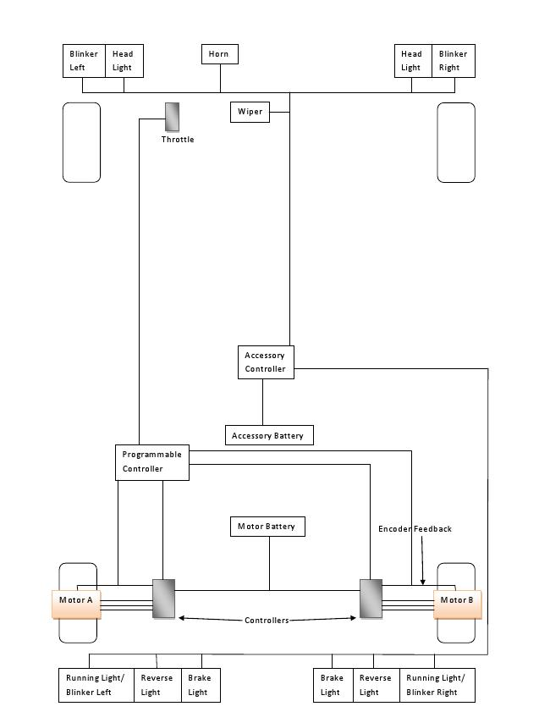
The accessory lights, horn, and wiper are powered by an accessory battery, and interfaced with switches on a programmable micro-controller.
Figure 1 shows the electrical systems for the ECO car. The drive train motors are powered by the motor battery, which is managed by the battery management system and controllers provided by Motor Excellence. Encoder feedback from these controllers and motors may be used in a programmable controller of our own to establish communication with the throttle, and provide data for a dashboard display.
Front of Vehicle
Rear of Vehicle
Research
III

Research Survey_________________________________
Since the last project proposal documents, there has been more research conducted related to the advancement in the project definition and design specifications. Specifically, research was conducted on the usage of controllers, the relationship of torque, current, power, motor characteristics and RPM. These have been the most recent developments in the project and are summarized in the end of the section.
Shell Eco-Marathon Rules
To determine possible restrictions for the design the EE Team first reviewed the Shell Eco-Marathon competition rules [1]. This is where the team learned the limitations on the lithium ion batteries, the vehicle’s electrical system, operational speed, motor power, and the general role in the construction portion of the project.
Electric Vehicles
In the past decade there has been a huge impetus by lawmakers, environmentalists and the general public to find alternative power source other than fossil fuel and to reduce pollution created not only by large factories, but also by the large number of diesel and unleaded fuel powered vehicles that are on the road today. An electric vehicle offers such an alternative solution. Electric vehicles are powered by large batteries that are rechargeable. The vehicle is simply plugged into a home electrical outlet or an alternate electrical power source to recharge spent batteries. The batteries tend to last for a reasonable amount of time. These vehicles do not emit any harmful byproducts or pollution from an exhaust. This will definitely reduce atmospheric pollution as well as the consumption of fossil fuel, whether diesel or unleaded gasoline. These petroleum products are made from crude oil and therefor deplete our world’s supply, which is not a sustainable resource. Once all the crude oil on our planet has been depleted, there will be no more! The final advantage of an electric car is its cost to operate. The rising cost of fossil fuels, makes gas powered vehicles very expensive to operate. An electric vehicle can easily be charged at home at the cost of a normal electrical bill, which is considerably less expensive that those incurred from frequent trips to the gas station [2].
As with anything, along with the pros, there are always cons. One of the drawbacks of electric vehicles, are their lack of power and speed, which unfortunately are huge deciding factors when purchasing a vehicle. Our culture likes sports vehicles and fast cars with gasoline powered engines. Unfortunately the technology for a “fast” electrical vehicle, that is easily affordable, is just not available at this time. Another drawback is the useful lifetime of the batteries. They tend to drain rapidly after only a few hours of continuous use. This inconvenient truth makes long road trips somewhat difficult. There is also the issue of expenses when they batteries completely fail. Current batteries are very expensive to replace completely. Last, but not least, is their performance at extreme temperatures. In either extreme cold or extreme heat, the batteries lifetime varies, so they are not consistently reliable in certain extreme climate areas [3][13].
Battery Management System
The battery management system will monitor and detect for over-charging in the battery, so that it functions within safe healthy operating conditions. Once fully charged the management system will then have a discharge rate of at least 2.0V, making sure it does not overcharge or over-discharge the battery [7].
Encoder Feedback Signal
Rotary encoders are necessary for effective communication between the motors and their controller. Encoders are also required to provide information for wheel speed, direction, and rotation. The feedback signal from the vehicles wheels will send information that will help regulate and control the current dispersed to the drive wheels while they are operating; thus trying to improve the power efficiency consumed [8][11].
Accessory Controller
To regulate the behavior of the accessory components, the EE Team determined through research that use of a programmable logic controller would be most prudent due to the controllers ability to have multiple inputs and outputs, function in extremer temperature ranges, such as Houston, TX, the place of the competition, and an immunity to electrical noise/cross-talk, and resistance to vibration and possible impact during competition [14]. Several controllers have been investigated (shown on budget sheet), and the most useful one is the Arduino brand, because of availability, cost effectiveness, and research concluded that it would be suitable for our accessories as well.
Other Items Researched
Lighting
The EE Team began searching for the “ideal lights” for the vehicle. Light emitting diodes (LED’s) seem to be the brightest and most efficient. Several websites were found offering 12V LED’s with conveniently attached sockets. So, this vehicle will employ LED lights for all lighting components [4].
Reflectors
Another consideration for the EE Team is to use reflectors in conjunction with the LED lights. The team did find several options on the Edmund Scientific website as well as Mouser Electronics. There is a wide variety of options, all offered at inexpensive prices. The wide selection will make it easy to find the reflector that will fit into the final design produced by the Fairing Team of the project [5][12].
Radio Communication System
Walkie-talkie communication radio set, that has a headset jack for a “hands-free” operation with optional headsets [6].
Controllers
The two options for controllers are using an FPGA or micro-controller. There are many options in each category, varying in speed, I/O ports, and programming sophistication. In the end the controller the team uses will come down to what meets these criteria for the specific design purpose. Several controllers researched are listed in the references [16][17][18].
Torque Curves
The relationship between torque and RPM is complex, but it will ultimately play a role in the efficiency of the vehicle. The torque and RPM are related to the current, and thus power, expended in the motors. Having a torque on the wheels is not indicative of using the power capabilities, it is the work done. The torque applied to move the wheel along the ground, RPM, that is indicative of power spent, and thus it is the RPM and throttle signal that the EE Team will use to regulate the power to the motors efficiently [19].
In addition the entire team has learned about different motor types, and the relationship of motor parameters in the first unit of the electric drives class [26].
Data Conversion
In order to perform operations on the throttle signal within the motor controller and compare it to values on the torque curve, the EE Team would need to convert the signal from Analog-to-Digital format, depending on the controller type chosen. In order to determine what type of controller is to be used, the team looked at what the commitment would be building an Analog-to-Digital converter [20][21].
Rotational Measurement Equipment
The measurement of the rotation of the wheel was going to be handled by a Hall Effect sensor or encoder, so the team researched alternative parts from different manufacturers. The Hall Effect sensors, from Spark Fun Electronic did not have the precision wanted, even though they were of a better price. The encoders were recommended by Motor Excellence, and the team researched their recommended model and a few others from Quantum Devices Incorporated, and as well as Mouser Electronics, Netzer Precision, and Encoder Products Company. The decision made from the EE Team design and specific part details are discussed in the design section [22][23][24][25].
References
IV

[1] Shell Eco-marathon Official Rules 2012. Online PDF. Available FTP:
http://ecomarathon.shell.com/registration/documents/2012_SEM_Rules.pdf
[2] Cowan, Robin.(1996).Escaping Lock-in: the Case of the Electric Vehicle. Available FTP:
http://www.cgl.uwaterloo.ca/~racowan/escape.html
[3] Brain, Marshall.(2005).How Electric Cars Work. Available FTP:
http://srinivasarao.webs.com/electric-cars.pdf
[4] Superbrightleds. (2002-2011). Available FTP:
http://www.superbrightleds.com/cgi-bin/store/index.cgi?action=DispPage&Page2Disp=%2F1157.htm
[5] Edmund Scientific. (2011). Available FTP:
http://www.scientificsonline.com/large-parabolic-reflectors.html?gclid=CKWC05Ghw6sCFYTs7Qod_Sq-sQ/
[6] Radio Shack. (2011). Available FTP:
http://www.radioshack.com/product/index.jsp?productId=12101918
[7] Mark Hardy. (2009). Battery Mangement system for electric vehicle [Online]. Available FTP:
lithiumstorage.com/Lithium_BMS_Tutorial.ppt
[8] Ganssle, Jack. (2005). Encoders provide a sense of place [Online]. Available FTP:
http://www.eetimes.com/discussion/break-points/4025565/Encoders-provide-a-sense-of-place
[9] Trahey, Steve. (2008). Choosing a code wheel: A detailed look at how encoders work [Online]. Available FTP: http://www.smallformfactors.com/articles/id/?3039

[10] Leyva, Phill. (2003). Feedback Encoder Types [Online]. Available FTP:
http://electronicdesign.com/article/components/feedback-encoder-types3361.aspx
[11] Embedded Ltd. Motor Control and PWM [Online]. Available FTP:
http://web.archive.org/web/20110717090211/http://www.embedded.com.au/pages/Motor_Interface.html
[12] Mouser Electronics. (2011). Available FTP:
http://www.mouser.com/Search/Refine.aspx?Keyword=reflectors&No=25&FS=True
[13] How Electric Cars Work, How Do Electric Cars and other Electric Vehicles Work?
http://www.all-electric-vehicles.com/how-electric-vehicles-work.html
Requirements & Specifications
[14] M. A. Laughton, D. J. Warne (ed), Electrical Engineer's Reference book, 16th edition,Newnes, 2003 Chapter 16 Programmable Controller
[15] http://arduino.cc/en/Main/ArduinoBoardMega
[16] Parnell, Karen. (2004). “Comparing and Contrasting FPGA and Microprocessor.” Online PDF. Available FTP: http://www.xilinx.com/support/documentation/white_papers/wp213.pdf
[17] Difference Between FPGA and Microcontroller. (2011). Available FTP:
http://www.differencebetween.net/technology/difference-between-fpga-and-microcontroller/
[18] Press Exposure. (2010). “FPGA vs CPLD vs Microcontroller.” Available FTP:
http://pressexposure.com/FPGA_vs_CPLD_vs_Microcontroller-142920.html
[19] Largiader. “Torque Vs Horsepower.” Available FPT:
http://www.largiader.com/articles/torque.html/
[20] Smith, Sedra, “Microelectronic Circuits,” sixth ed, ch 9.
[21] Richard C Jaeger; Travis N Blalock, “Microelectronic circuit design” Travis N Blalock New York: McGraw- Hill, ©2011, 4th ed ch 12.
[22] Sparkfun. Available FTP:
http://www.sparkfun.com/products/9312
[23] Newark (1970). Available FTP:
http://www.newark.com/jsp/search/productdetail.jsp?SKU=22T1218&CMP=AFC-GB100000001
[24] Netzerprecision (1998). Available FTP:
http://www.netzerprecision.com/about.asp
[25] Encoder Products Company (2010). Available:
http://www.encoder.com/
[26] Krishnan, R. (2001) Electric Motor Drives Modeling, Analysis, and Control. Prentice Hall. Upper Saddle, NJ.

Specifications & Requirements___________________
Six requirement categories addressed by this project are identified below. The needs, wants, and constraints are specified for each category along with an explanation for each category and how it relates to this project.
Overall Requirements
- The vehicle should have realistically similar electrical components of a car that is currently on the market.
- The vehicle should follow electrical safety standards such as a fail-safe mechanism, as well as the Shell Eco-Marathon rules and specifications set forth by Dr. Tester.
- The vehicle should be competition worthy.
- The vehicle should stay within constraints of the donated Motor Excellence parts.
Mechanical
The ECO car, as any vehicle, is very heavy in mechanical requirements. These requirements are stipulated in the Shell Eco-Marathon rules, which translate to needs for any vehicle participating in the completion. The rules specify mechanical constraints such as the size, weight, top speed, turning radius, and safety mechanical requirements. The EE Team also has requirements that come from the client, Dr. Tester, that go beyond the competition rules. These requirements specified by Dr. Tester include the frame and faring design, stopping distance, longevity, budget, overall weight, and to a further extent than the rules. Finally the team is constrained by the parts that have been donated by Motor Excellence for the use in constructing the vehicle. The sum total of the mechanical requirements for the vehicle:
Marketing Requirements | Engineering Requirements | Justification
The motors must keep the vehicle within a certain speed range. | Max Weight is 140kg, ours should be lighter.  Max speed in competition 25mph. | This rule is specified by Shell and sets a standard for the competition to keep all participants within certain boundaries. Dr. Tester specified that the vehicle should be lighter as an electric car to make it more marketable and efficient.
Must use a wheel for steering. |  | This is specified by the Shell Eco-Marathon rules to keep all participants within a certain bound.
Batteries and motors stored behind driver, protected by a watertight firewall. | This limits the available total volume on these components to an area smaller than that of a normal car trunk | These safety precautions are specified by Shell. Motor Excellence parts constrain the size of the firewall and rear compartment.
The vehicle must be constructed within the SAE budget. | This number is determined by donations received from sponsors.
Electrical
Since undergraduate senior students are building an electric vehicle, the electrical specifications for this project are more numerous than that of a typical automobile. The EE Team requirements, once again, come from three places, the needs of the competition, the desires of Dr. Tester, and the constraints of the equipment donated to the project. The electric requirements govern the interface systems of the vehicle; the dashboard components, lights, horn, and windshield wiper, the programming of all these interface systems and the power components of the vehicle; the motor controller, power generation, and management, etc. The team wants the feel of the vehicle to be as close as possible to that of one available for purchase today. The vehicle must be safe and follow the design rules of the Shell Eco-Marathon competition, and remain within the ability of the donated parts. In summary:
Marketing Requirements | Engineering Requirements | Justification
Vehicle must have running lights, turn signals, reverse lights, brake lights, headlights, internal lighting, and displays. | All of these lights will be LED’s, and not exceed the amount of the 12V accessory battery. | The instructive lighting is required by the competition, and the displays are for making the vehicle realistic as specified by Dr. Tester.
In an emergency there must be a way to kill the battery connection to the motor, for the safety of the driver or someone outside the vehicle. | Vehicle must have one internal and two external kill switches. | The kill switch is to shut off the motor in the event of an emergency and must be accessible to the driver and/or emergency track personnel.
Must be a battery electric vehicle. | 50V battery power supply for the motors.  12V battery power supply for the accessories. | The battery is limited by the Shell Eco-Marathon rules. Dr. Tester specified the maximum voltage for the motors as well as the max for the accessories.
Must have a mechanism for visibility in rain, a horn, and air conditioning. | A fan will be installed for air conditioning.  A wind shield wiper will be installed for visibility in rain. | Specified by Dr. Tester, these requirements make the vehicle realistic.
Interface with accessories, (lights, wipers, etc.) will be done via switches. | 6 switches will be necessary. | Makes the vehicle realistic and easy to use.
Interface with vehicle will be done via accelerator pedal. |  | Makes the vehicle similar to marketed cars.
The vehicle must survive the competition, and be in working order through the end of the spring semester. | Parts will be durable. | Specified with Dr. Tester, the vehicle will be a trophy to promote SAE and NAU.
The power usage must be handled as efficiently as possible. | All accessories will be within the accessory range.  The motor controller will be provided so the team hopes it is efficiently using the motor battery. | This is the goal when designing any green technology, and if set forth by the client, but also the motivation to promote cleaner technology.

Environmental
Marketing Requirement | Engineering Specification | Justification
The vehicle must be able to operate in extreme temperatures. | Houston, Texas is where the competition is. Temperature can be up to 110 degree F in the summer. A fan will provide driver comfort. | Electric vehicles are known for questionable performance in low temperatures.
Vehicle must be operable in the rain. | We will have 1 windshield wiper for visibility and the electronics will be shielded from the outside. | The track is outdoors and thus the vehicle is susceptible to precipitation.
Documentation
Maintenance Manual
The EE Team will contribute to the vehicle’s maintenance manual that will cover all the electrical circuits. Each switch will be given a designation number to make it easy to find and will feature a figure that details how the switch has been connected, and how frequently the parts used are expected to need replacement.
User’s Guide
The team will write a user’s guide for the driver to explain the switches and controller. Again, each switch will be given a number and the guide will include a picture with details.
Testing
The team plans to have the vehicle “ready” by the end of January so that there will be enough time to test it. However, the team has already started to build their own equipment to test the motors and controllers, and the accessory controller. That will provide the EE Team time to attend to any problems before installing the final system components in the vehicle.
Safety
Safety of the driver is of primary concern and will require many steps to correctly implement. First, the battery will be separated from the driver by a wall of steel behind the drive seat. Second, while all wires and cables will be hidden from the driver, they will be easy to access for maintenance. Lastly, there will be a safety switch within easy of reach for the driver to kill the circuitry in the vehicle if anything goes wrong.
General
The general requirement of the project is not related to the competition but rather the concept of an electric vehicle as a whole. The general idea is that the vehicle will be captivating and impressive enough to represent NAU Engineers, SAE chapter at NAU, and our sponsors. To this end, the engineering specifications are:
Marketing Requirements | Justification
The vehicle must be reliable to the point of functioning past the competition. | The whole point is to have a marketable vehicle, so it makes sense that it will continue to function longer than required by the weekend of the competition.
The code for the motor control must be unaltered and will not be provided. | The motor control code is an intellectual property of Motor Excellence, and will be a representation of their products, so the team will have to make the existing code fit the functions rather than alter the Motor Excellence products.

Design Matrices_________________________________
Design
V
Due to the large amount parts that were donated or specified by the client, there was little decision making left to the team as far as parts to use in implementing the systems. In the section following the team discusses the decisions the team had authority over and how the final decisions were reached.
Accessory Controller
The first system the EE Team was responsible for was the handling of the accessory control system. The options here were to use a FPGA or micro-controller to control the logic driving the accessories, or simply have a series of switches wired directly to each accessory and no controller. These options were judged on the basis of price, ease of programmability or availability of open source code, sophistication of design which is important to the representation of the team, and the marketability or realism of the vehicle. The decision matrix is shown in Figure 2, in the end, already having an available micro-controller, and the prospect of a more sophisticated design led to this being the design of choice for the EE Team.
Figure 2: Accessory Controller
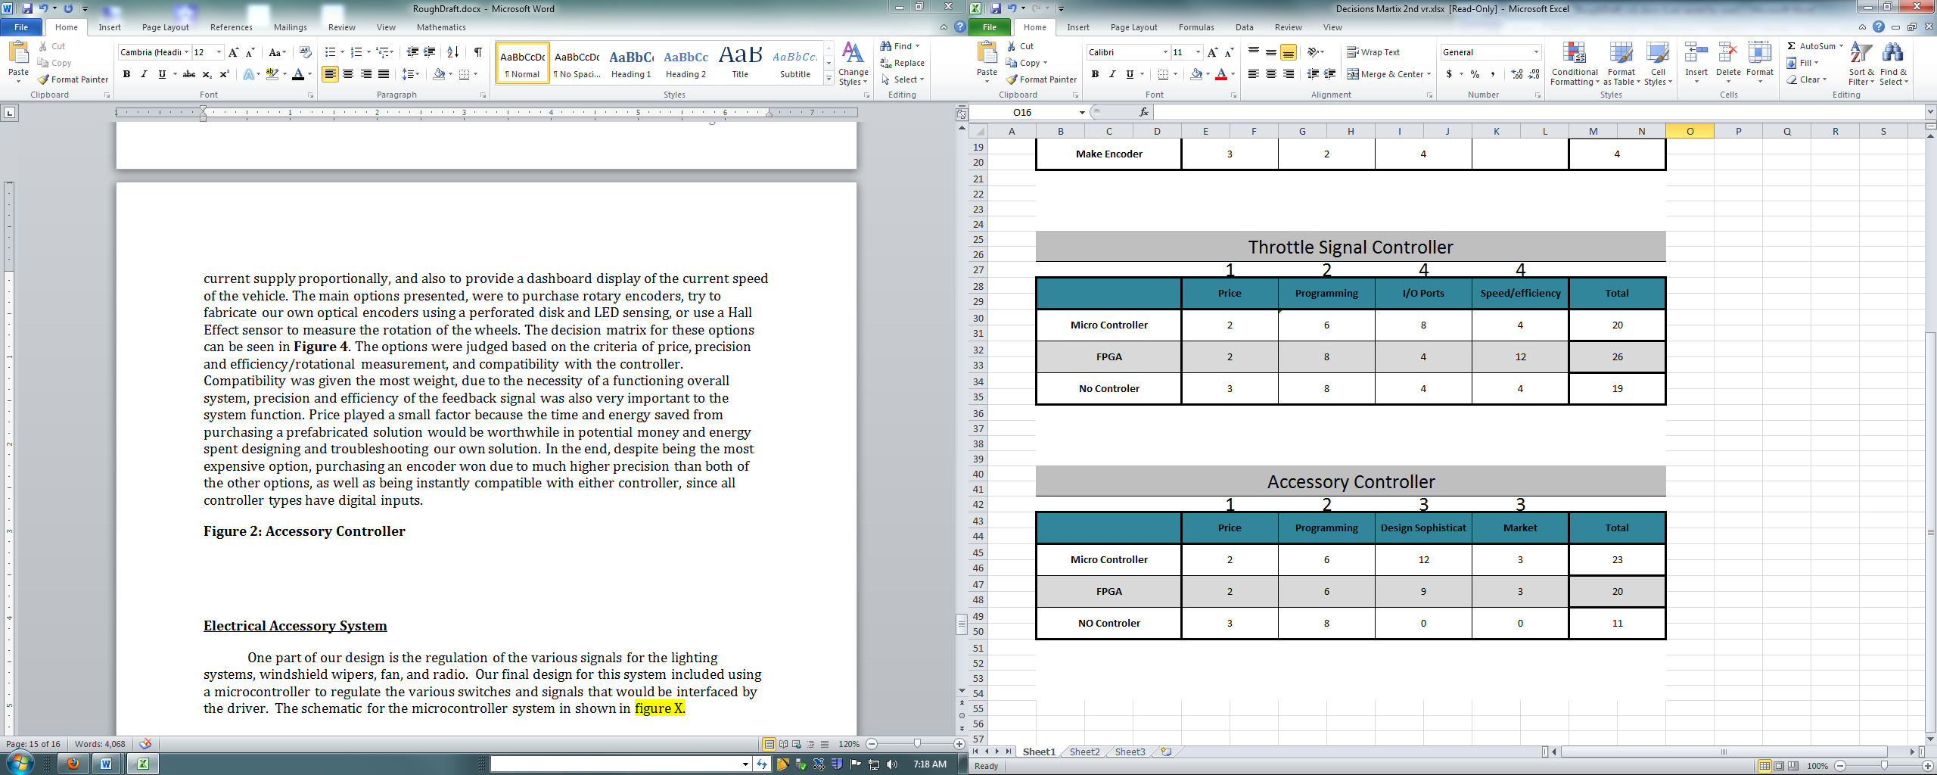
Throttle Signal Controller
Another system in which the EE Team took responsibility in decision-making was increasing the efficiency of the motors. Three options for regulating the signal between the throttle and each motor controller were using a FPGA, micro-controller, or using neither, and just splitting the throttle signal between each motor controller. This decision was made on the basis of price, simplicity of programming, available I/O ports, and speed/efficiency of the solution. The most important characteristics of each solution were the efficiency, which would suffer without the use of both controllers and the number of I/O ports. The FPGA would not have enough analog inputs, requiring the EE Team to purchase or design an Analog-to-Digital converter for the throttle signal, whereas any micro-controller can be purchased with an Analog-to-Digital converter input. Ease of programming the code was weighted less since it was somewhat of a non-issue, as there would be open source available for a micro-controller, and the team already has experience with FPGA programming. Price was again of little consequence, since the controllers would be about the same price for the purpose, and the efficiency lost for the money saved by foregoing a controller would not be worth it. The decision matrix is shown in Figure 3. This decision came down to speed/efficiency and the available I/O ports, with the micro-controller barely besting the FPGA in this area, while the option of not regulating the signal, using no controller, caused such a loss of efficiency that it lost by far.

Figure 3: Throttle Signal Controller
Rotation Measurement
One decision that was required of the team was how to measure the rotation of the wheels. This was necessary in order to provide feedback on the turn position and adjust the current supply proportionally, and also to provide a dashboard display of the current speed of the vehicle. The main options presented, were to purchase rotary encoders, try to fabricate optical encoders using a perforated disk and LED sensing, or use a Hall Effect sensor to measure the rotation of the wheels. The decision matrix for these options can be seen in Figure 4. The options were judged based on the criteria of price, precision and efficiency/rotational measurement, and compatibility with the controller. Compatibility was given the most weight, due to the necessity of a functioning overall system, precision and efficiency of the feedback signal was also very important to the system function. Price played a small factor because the time and energy saved from purchasing a prefabricated solution would be worthwhile in potential money and energy spent designing and troubleshooting the solution. In the end, despite being the most expensive option, purchasing an encoder won due to much higher precision than both of the other options, as well as being instantly compatible with either controller, since all controller types have digital inputs.
Figure 4: Rotational Measurement
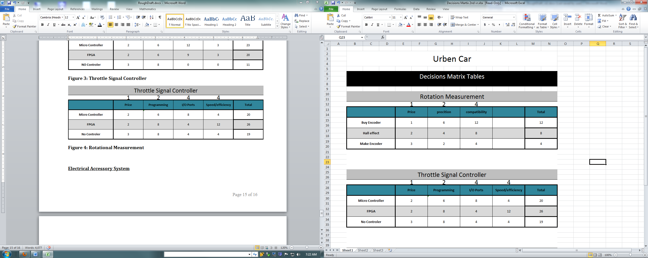
Schematics______________________________________
Electrical Accessory System
One part of the EE Team design is the regulation of the various signals for the lighting systems, windshield wipers, fan, and radio. The team’s final design for this system included using a micro-controller to regulate the various switches and signals that would be interfaced by the driver. The schematic for the micro-controller system is shown in Figure 5.
Case: The competition requirement consists in making the electrical unit visible. The EE Team has decided to make the case of plastic glass, because of its characteristics that is making it easy to be formed. Also, Plexiglas can resist to the high temperature. The case will contain two motor controllers, one micro-controller, and two batteries.
Door Switches: Each door in the car is designed to press on a switch. That is when a door is left open or not closed properly the switch will be uncompressed, therefore, a signal will be sent to the controller and thus the interior light will be on.
Switches: There are three main switches which are the interior light, fan, and kill switch. All switches will be connected to the accessory battery.
Drive Train System
For the final chosen design concept, the EE Team selected the design that included an additional programmable controller. The main reason for this decision is to regulate the output current to the motors in order to optimize the efficiency and run time of the batteries. Encoders attached to motors provided by Motor Excellence will determine the distance travelled and RPM of the wheels and this information will be used to calculate a power efficient torque to apply for each motor based on the predetermined efficiency curves for the motors. These calculations will be used to increase the efficiency of the battery by distributing the throttle signal to each wheel in proportion while the vehicle is turning. As the wheels turn, the outside wheels will require more power to cover the extra distance travelled. With this design concept, the additional controller will interpret the feedback signal from the encoder and send a signal to the Motor Excellence controller that will regulate the current distributed to each motor, so that a proportionally smaller current is sent to the motor on the inside wheel and a larger current sent to the motor on the outside wheel. The amount of current sent to the motors will also be dictated by the throttle output controlled by the driver. In summary, the additional controller will be responsible for interpreting the input from the throttle and then regulating the amount of current sent to each motor. Figure 5 illustrates the design layout of the controllers, encoders, and battery as well.
Figure 5: Electrical Accessory & Drive Train SystemThis is a simplified version of the electrical system. It breaks down the connections and components between the frame and the fairing.
Parts Chosen or Recommended_____________________
Based on these decisions and the final system design, the EE Team has several parts already acquired via donation, and several recommendations made for the parts the team still needs to finish the design. From Motor Excellence the team has obtained the majority of the drive train system, including two motors, a completed controller for each, batteries to power the vehicle, and a throttle with a 0-5V output signal. Based on these parts, in order to implement the design with the throttle signal controller the team will need to purchase a controller to regulate throttle signal, and encoders for each wheel that will be used to also regulate throttle signal via encoder feedback signal. Several encoder options were researched, but ultimately a recommendation from Motor Excellence of an encoder that has already been implemented using their equipment was the deciding factor: the model 775 from Encoder Products Company. As far as the throttle signal micro-controller, the EE Team will be researching more about the programmability of a PIC processor, and a MSP 430. After a good amount of part price and performance research, the EE Team has decided to use the Arduino Mega. For the accessory system the final design will no longer be implemented with an Arduino, but a series of electromechanical devices connected to switches. Each accessory has been determined already, the LED’s chosen are discussed in the research survey section, the horn is already in the possession of SAE, and for the windshield wiper the team will either acquire an actual windshield wiper from an auto scrapyard, or purchase one and attach a wiper blade that may be obtained from Napa. Thus the parts list and budget are currently a good estimate, since the EE Team has researched the exact parts needed.
Constraints_____________________________________
There are a number of constraints on the design including the environmental conditions during operation, health and safety hazards, sustainability of the design, and the budget of the vehicle. Since the vehicle should be expected to run in most climates, no parts could be used that would function considerably less effectively in heat, cold, or other weather conditions likely to be experienced in the continental United States, particularly the southwest. The vehicle will need to be able to run through sustainable practices to ensure that if it were marketed, it could continue to be without causing detriment to the environment. This constraint comes down more to whether or not sustainable energy practices are used to charge the vehicle, that is, renewable energy sources. In practice it would be very possible to charge the vehicle’s battery systems using a solar array, or other sustainable source as long as a sustainable infrastructure was in place. This constraint also directly ties into manufacturability of the vehicle, as sustainable manufacturing practices are a necessity in ethical manufacturing, so the team needs to choose parts that could be available on a large manufacturing scale. Finally, the safety constraints specified by the competition limit the speed of the vehicle, maximum voltage of the battery, and mandate kill-switches.

Budget
VI

Figure 6 shows the companies that have donated money so far, as the well as the respective amount that each company has donated. Figure 7 also displays and categorizes the parts needed, with the estimated cost listed in the adjacent column. The Shell Eco-Marathon competition provides funding for a maximum of eight individuals to travel to the competition in Houston, Texas. There are 25 students currently involved in the project, so additional time will be spent to search for funding to pay for the travel expenses for everyone who wishes to be at competition. One-hundred dollars per person is required by the competition, which will fund 8 team members, so approximately $1700 dollars will be needed if all team members plan to travel to the competition. Acquiring the necessary funds will be a combined effort of all the subgroups involved in the project.
Figure 6: Companies That Have Donated Funds or materials
Donations
 | Company Name | Total
1 | Architectural & Environmental Assoc | $101.00
2 | Advanced Digital Solutions International, INC | $1,000.00
3 | Motor Excellence | $3,000.00
4 | Napa Autoparts | $741.52
Total |  | $4,842.52
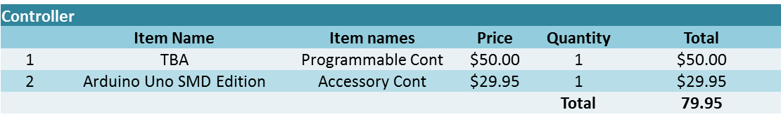
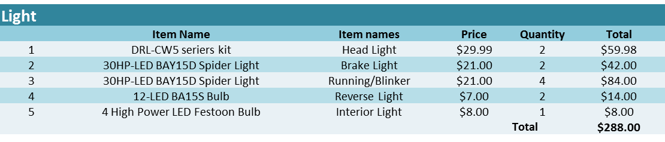
Figure 7: Parts Needed

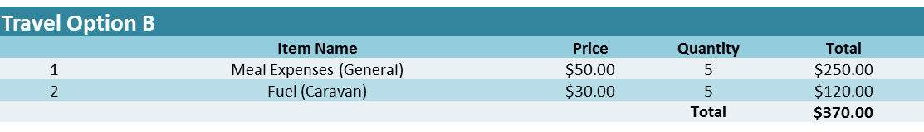
Motor Excellence has been a large supporter of this project. They currently have donated two 50-volt Lithium ion batteries, two motors, and two controllers. Each battery is valued at $300, while one controller is $200, and one motor is $2,000. These items total a combined value of $5,000 worth of parts donated.
Based on the Excel table listed, the EE Team subgroup has a budget of $1,101.00. Of that budget, $601.73 has been allocated to be spent on parts needed. Those calculated values leave the EE Team with 45.35% of the current budget to assign to other parts that will be needed, specified in the parts recommended subsection, thus the team is attempting to get the encoders donated from Encoder Products Company.
Northern Arizona University is providing computers and all other necessary work environments to complete the project tasks. A workbench to test the controllers with the motors, and install wiring and lighting will be available in the Engineering Building. A cabinet to store equipment and other parts is also provided by the Electrical Engineering Department at NAU. The EE Team will have space and parts made available by the machine shop as well as access to electrical laboratories and equipment including power suppliers, oscilloscopes, multi-meters, and soldering irons. All of these things will be excluded from the budget, as the collective tuition of engineering students goes to providing these resources.
Updated Budget__________________________________
The updated budget is show below and reflects the changes with the donated parts from Napa Auto Parts. The Motor Excellence donations have been modified. The table also includes the status of each item. Blue is for the totals of each source, green denotes received items, and yellow are shipping, while red separates sections.

ITEM | DESCRIPTION | COMPANY | PART NUMBER | QUANTITY | AMOUNT | NOTES | STATUS
Rotatory Encoder | Encoder for motors | Encoder Products Company | 775-B-S-4096-R-HV-V-9D-A-Y-N | 2 | $ 635.00 | need to get shipping cost; price is w/50% student discount | Received
Arduino Mega Micro-controller | Controller for motors | Amazon | B004A7H3DG | 1 | $ 56.50 |  | Received
Current Transformer | Transducer for Motor input current | Mouser Electronics | 553-CST206-3T | 2 | $ 13.34 |  | Received
Motorcycle Battery | 12V Battery, 8Ah | NAPA | PSB 9BS | 1 | $ 74.99 |  | Received
Horn | 500hz, 132db, 10A | NAPA | BK 7301057 | 1 | $ 17.69 |  | Received
Wire Terminal | Female, 10-12 gauge | NAPA | NW 723106 | 50 | $ 24.50 |  | Received
Wire Terminal | Male, 10-12 gauge | NAPA | NW 721122 | 50 | $ 24.50 |  | Received
Ignition Switch | 4 Terminals & Positions | NAPA | ECH KS6180 | 1 | $ 23.49 |  | Received
Flasher | Electro-Mechanical, 12V, 2 Terminals, 20A | NAPA | LIT 502623 | 1 | $ 11.99 | 60-120 FPM w/ 1.5 Sec after start up | Received
Turn Signal Relay | Left & Right Blinkers | NAPA | MPE AR153SB | 2 | $ 39.98 |  | Received
Headlight Switch | Front Headlights | NAPA | ATM 1C0941531B | 1 | $ 28.77 | Have schematics for wiring | Received
Toggle Switch | 2 Positions, 3 Terms | NAPA | ECH TG6261 | 5 | $ 69.95 | Have 1, Need 4 more | Ordered
Push Button | Momentary switch | NAPA | ECH PP5007 | 2 | $ 16.58 |  | Ordered
Brake Switch | 2 Terminals | NAPA | ECH SL169 | 1 | $ 7.99 |  | Received
Brake Switch | 2 Terminals | NAPA | ECH SL322 | 1 | $ 17.88 |  | Received
Door Switch | 2 Terminals | NAPA | ATM 1433011 | 2 | $ 19.38 | Driver & Passenger Light Switch | Received
Fans Switch
Fairing/ Frame Connector | 10 pins, Male | NAPA | ECH EC533 | 1 | $ 127.88 |  | Received
Fairing/ Frame Connector | 10 pins, Female | NAPA | ECH EC1157 | 1 | $ 83.96 |  | Received
Turn Signal Switch | Left & Right Indicators, Hazard, Horn, & High Beam | NAPA | ATM 1H0953513C | 1 | $ 21.99 | High Beam will be used for the walkie talkie | Received
Black Wire | 50' for motor and controller connections | NAPA | BEL 732710 | 50 | $ 35.00 | 10 Gauge, GND | Received
Red Wire | 50' for motor and controller connections | NAPA | BEL 732702 | 50 | $ 35.00 | 10 Gauge, +12V | Received
Orange Wire | 100' for accessory connections | NAPA | BEL 732503 | 100 | $ 30.00 | 14 Gauge, +5V | Received
Purple Wire | 100' for accessory connections | NAPA | BEL 732507 | 100 | $ 30.00 | 14 Gauge, GND | Received
Plastic Conduit
TOTAL |  |  |  |  | $ 741.52
Head Lights | LED White Lights, Eyebrow Style | SuperBrightLeds | DRL-CW6-L | 1 | $ 29.95 | Comes in a set of 2 | Received
Brake/Blinker Lights | LED Red Lights, Circular | SuperBrightLeds | 1156-R19 | 6 | $ 41.94 |  | Received
Reverse Lights | LED White Lights, Circular | SuperBrightLeds | 1156-W19 | 2 | $ 19.98 |  | Received
Base Sockets | Circular LED Lights | SuperBrightLeds | BA15S-1156 | 8 | $ 7.92 |  | Received
SHIPPING |  |  |  |  | $ 6.63
TOTAL |  |  |  |  | $ 106.42
Walkie Talkie | Radio Communication w/ Driver | Radio Shack | 2100123 | 1 | $ 19.99 | Comes in a set, get 2 radios | Received
0.25A Fuse | Fast-Acting Glass Fuse | Radio Shack | 2701002 | 2 | $ 4.38 |  | Received
0.5A Fuse | Fast-Acting Glass Fuse | Radio Shack | 2701003 | 1 | $ 2.19 |  | Received
Fuse Block | 4 Position | Radio Shack | 2700742 | 2 | $ 6.98 |  | Received
Solder Paste | Preserve Solder Tips | Radio Shack | 6400022 | 1 | $ 6.99 |  | Received
Solder Core | 8oz of Solder | Radio Shack | 6400009 | 2 | $ 23.98 |  | Received
0.1A Fuse | Fast-Acting Glass Fuse | Radio Shack | 55048551 | 4 | $ 11.76 |  | Received
SHIPPING |  |  |  |  | $ 6.05
TAX |  |  |  |  | $ 5.03
TOTAL |  |  |  |  | $ 87.35
Lithium Ion Battery | 37V | Motor Excellence |  | 2 | $ 600.00 | Each battery w/BMS valued at $300 | Received
Motor Controller |  | Motor Excellence |  | 2 | $ 1,000.00 | Each controller valued at $500 | Received
Electric Motor |  | Motor Excellence |  | 2 | $ 1,400.00 | Each motor valued at $700 | Received
TOTAL |  |  |  |  | $ 3,000.00
COMPLETE | TOTAL | PARTS LIST | Money EE team has spent |  | $ 898.61
The EE Team has spent a total of $898.61 on the project so far. The total amount of this project with donations included is $5,275.13.
Schedule & Deliverables
VIII

Our detailed task list can be found in Figure 8, with the master task list for the Urban Concept project. A main task is programming the throttle controller. This task is owned by Devin Fredrickson, and divided into sub-projects that will be addressed in order, in terms of getting the absolute requirements for the competition done first, and fine tuning the efficiency once the minimum requirements have been met. All the EE Team members are involved in this task, in addition to John Dyer of the Drive Train Team. The sub-tasks for this leg of the project go in order of most prominent to least: read signals from encoder, read signals from encoder from motor, program speedometer, give output to controllers, pipe throttle and reverse signals through Arduino Mega, program regeneration switch, program throttle shunting, efficiency mapping, and program drive cycles. Currently the encoder signals pose a problem due to a lack of signal strength, however likely it will be resolved soon. Realistically, the EE Team will program the regeneration switch by the time of the competition, and possibly implement the drive cycles by the time of UGRADS. This is due impart to unclear design objectives and system understanding until recently.
The next major task is to organize parts. As mentioned earlier this task is very near completion, all that remains is obtaining the Plexiglas for the electronic component protection box at the rear of the vehicle, and potentially purchasing a speedometer, if programming one is too difficult. This will be done within the first week of March.
After all parts are obtained the EE Team will begin the pre-integration testing of all electrical components, to get the system working independently of the vehicle while the team waits for the completion of the fairing. This involves testing the accessory battery after pre-charging it. Then, the team will test each accessory component with its respective battery and switch. This involves testing the relays for the turn signals, the switch for the brake light on the brake pedal, the ignition switch with the running/headlights, the reverse lights with the reverse switch, the speedometer, wiper motor, Arduino bypass switch, automatic drive cycle switch, and integrating the walkie-talkie with the helmet. All of this can be done by the second week of March, so the EE Team will be prepared for integration with the vehicle systems when the vehicle fabrication is complete.
The next major task is the integration of the electrical systems into the vehicle frame and fairing. This involves running wire for the electrical systems in the vehicle, as well as installing the protection box. This will most likely be completed over spring break when the vehicle is ready for the EE Team.
Figure 8: Task List
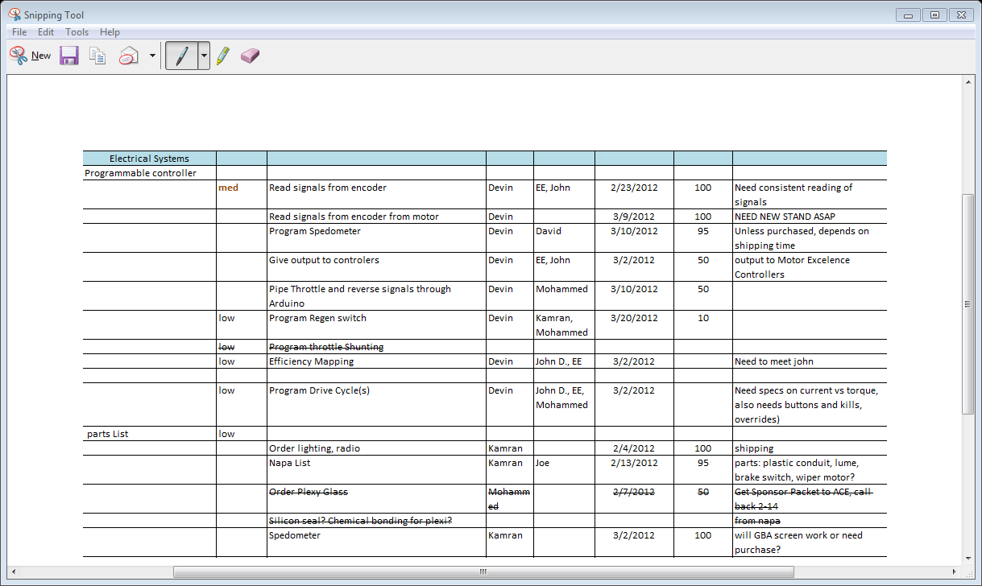
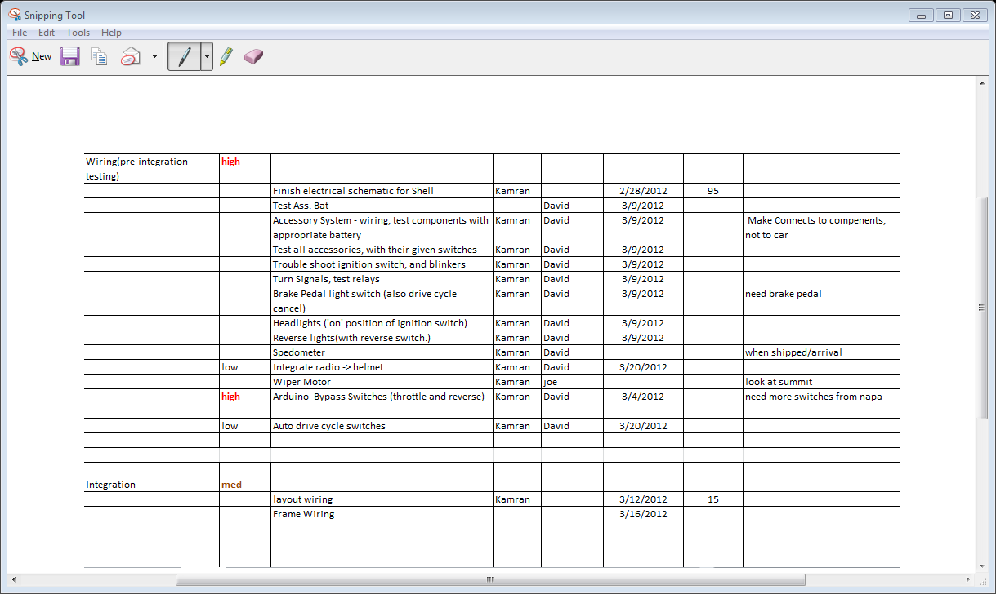
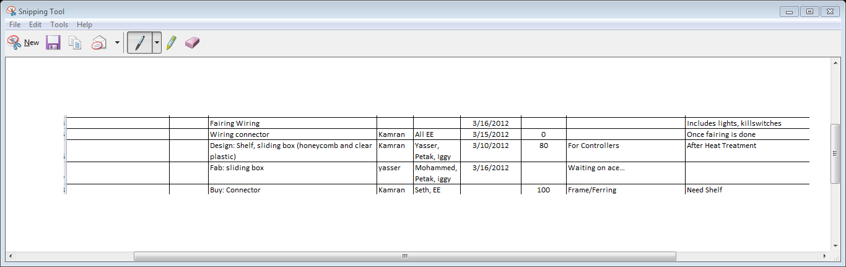

Critical Issues
The first and most immediate problem that exists is the test stand used for debugging computer code that will be used by the Arduino Mega. The motor frequently switches direction of rotation without any prompting from anything or anyone. The cause of the issue has been determined to be that the test stand is not completely level and stable, therefore causing the rotary encoder to interpret inaccurate signals. Members of the Drive Train Team are currently working to fix this issue so that accurate testing and debugging can resume. They explained to the group that an extra bolt to secure the rotary encoder would improve the rotary encoder readings. The Drive Train Team is also going to use different bolts and more washers to level the wheels on the test stand.
Communication with the throttle input and to the Motor Excellence controllers is an essential part to the project. A method to confirm a successful transmission to the Motor Excellence controllers has not yet been determined. A preliminary idea for testing this issue is mentioned in the EE Team’s Comprehensive Test Plan section on the following page.
After effective communication between the Arduino Mega and its respective inputs and outputs has been attained, work on an efficient drive cycle for the competition will begin. Kamran Sheikh and David Glennon have worked with John Dyer, who is on the Drive Train Team, to come up with some ideas on how to control variables of the system that affect the efficiency of the power consumption on the battery used by the motors. Once a desirable drive cycle is chosen, the Arduino Mega will be programmed to implement the drive cycle. Unfortunately, testing for this project task cannot commence until the construction of the vehicle is complete. This is due to the nature of the design implementation that involves the EE Team attempting to improve a real-world scenario. There is no possible or feasible testing method that can be done at this time. As a result, testing for this implementation will most likely occur shortly before the departure of the competition. A more in-depth explanation of this testing process is explained in the Comprehensive Test Plan portion found in the following section.
Comprehensive Test Plan
VIII

Past Testing
Most testing for this project has involved the motors, Motor Excellence controllers, and rotary encoders. Initial testing began with checking to see if the motor and wheel rotated properly when power was supplied from the Lithium-ion batteries. The motor was initially spoked on a bicycle wheel and mounted on a steel test stand. The next test consisted of connecting one rotary encoder alongside the motor on the test stand. The rotary encoder signal wires were then connected to an oscilloscope to confirm an appropriate reading of the signals sent from the encoders. Once the EE Team quantitatively knew what to expect from the rotary encoders, programming, testing, and debugging proceeded. Devin Fredrickson wrote code to simply read and display the values sent from the encoders. Once the Arduino Mega read the encoder signals, reading the signals consistently and accurately became a significant task in debugging and testing. The objective was to read a signal from the encoder that pulsed ‘high’ once every rotation. The program written to detect this pulse was only read occasionally, rather than every rotation. Further research into effective programming and understanding of the rotary encoders had to be done to make progress. Interrupt functions proved to be the final solution to proficiently reading the rotary encoders.
Present Testing
The EE Team is currently working on making the Arduino Mega calculate the revolutions per minute of the rear wheels based on the rotary encoder readings. Devin Fredrickson has included calculations in the most recent program used for testing. Sending the values to a computer monitor will show if the team’s calculations are precise and current. No results have yet been recorded or witnessed. Writing a program to test the reading input from the vehicle’s acceleration pedal has begun. Testing will consist of reading an analog signal from the throttle pedal and displaying a digital value on a computer screen to verify proper and efficient responses.
Future Testing
Plans for tests that will be conducted over the remainder of the project are in place. One of the first tests will be to send an analog signal to the Motor Excellence controllers and verify that a signal was received. To enact this verification, the EE Team members will analyze the data from the encoders when the wheels spin. The varying rates of speed will be compared to the throttle input signal sent by the Arduino to show whether or not the Motor Excellence controllers are reacting properly to the output signals from the Arduino. Another test that is scheduled to occur is the wiring configuration. Due to the short amount of time between the completion of the vehicle and the competition, the EE Team is going to setup the wiring and the connections separately from the vehicle to ensure that the current wiring schematic will work accordingly. Testing to verify that an efficient drive cycle can be implemented for the competition is a significant task. Once the entire vehicle is complete, a computer program that will already be written will be used to implement the drive cycle. A designated group member will drive the car during a test run similar to the conditions expected at the competition. Based upon the results of power used, distance travelled, and mean velocities of the vehicle, the EE Team should be able to gauge the effectiveness of the implemented programming embedded in the Arduino. However, before motor efficiency testing can begin, thorough testing and training must be done for the driver to understand the different modes of motion. In order for the motors to go from motor mode to generator mode, a momentary push button must be pressed. The generator mode will act as a braking technique when slowing down, but does not behave entirely the same as brakes. Once the vehicle comes to a complete stop, it will try to go backwards, so programming the behavior of the motors and educating the driver of these conditions will be a necessary process for a successful experience at the competition. All of these scheduled tests vary in priority, but all are definite objectives for the goals of this project.
The team first started testing the encoders to make sure they read the signal correctly. Devin Fredrickson was mainly in charge for that test, and has thus far been able to measure position of each encoder. Each rotation has also been detected and counted accurately. There have been several changes on the schematic and Kamran Sheikh is in the process of finalizing the schematic and ensuring its accuracy. Yasser Alherz and Mohammed Alsulaiman are in the process of designing a slide rack for the controllers and ensuring the proper dimensions with the Chassis and Suspension Team. They are also responsible for the light connections and placement on the fairing. The lights will be tested as the fairing is completed.
Currently, the team is involved in programming and testing the Arduino processor; this includes finding the most efficient drive cycle and figuring out the optimum and most capable mode of the Arduino. The team is planning to put the system all together and test it in a small scale before it actually goes on the car. Once everything works as expected, then the system will go on the car where there will be another testing phase.

Updated Schematics

IX

Wiring Diagram Explanation
Figure 9 is a detailed schematic of the connections from the fairing will attach the frame the vehicle. Figure 10 is a detailed schematic of the connections that all parts/systems that are located on the fairing.
Below is an explanation of the system.
Fairing of Vehicle
- Left (Run/Blink Left) and right (Run/Blink Right) blinkers are integrated with running lights; locations of these lights are on the front and rear of the fairing with 19 LEDs each and are the color red. Rated for 12 volts.
- The front headlights are Headlight Left and Headlight Right. Rated for 12 volts.
- The brake lights (Brake) are circular in shape with 19 LEDs each and are the color red. Rated for 12 volts.
- The reverse lights (Reverse) are circular in shape with 19 LEDs each and are the color white. Rated for 12 volts.
- All the lights on the fairing have their grounds tied together except the reverse light.
- The lights and the kill switch system are attached to a connector (Frame to Fairing Connect) between the fairing and frame. This is a 10 pin connector.
Kill Switch System
- The accessory battery (Acc Bat) and the motor battery (Motor Bat) have their grounds tied together (Kill L).
- Kill L goes through Frame to Fairing Connect, which leads to a two position on/off switch on the left side (Kill Left).
- Kill Left is connected in series with a kill switch on the right side (Kill Right). Kill Right is then connected back to Frame to Fairing Connect witch then goes to an ignition switch (ignition sw).
- When ignition sw is turned one switch over the motor and accessory system is turned on (Motor/Acc On). This then completes the grounding of the vehicle.
- The second switch over on the ignition switch puts the vehicle in reverse (Rev GND).
Accessory System Operation
- A horn is located on the front of the vehicle operating at 12 volts, has a pitch of 500Hz, and emits a sound at 132dB.
- One/two computer fans rated at 12 volts will be used for an air conditioning system.
- Attached to the steering column will be a turn signal switch. The turn signal switch will not interfere with the steering wheel. A flasher (Flasher) with 60-120 flashes-per-minute will be attached to the turn signal switch (L-Turn and R-Turn). This will also allow for hazard lights (Hazards). The signal from the turn signals and hazard signal are connected to relays (Relay L and Relay R) which allow the integration between running lights and blinkers. The high beams on the turn signal will be used as a switch for the walkie talkie (Walkie Talkie Sw). This will allow the driver to communicate with the team. The turn signal switch will also have the horn incorporated with the steering wheel.
- When the brake is applied a switch (Brake SW) will then be released, making a connection, which allows the brake lights (Brake) to turn on.
- The headlight switch (Head SW) turns on Headlight Left and Headlight Right.
- There are two interior lights (Driver Light and Passenger Light) that are independent of each other and are turned on when the driver door (Door Left) and/or the passenger door (Door Right) is opened. These interior lights are not connected to the kill switch system.
- The Walkie Talkie has is connected into the drivers helmet. There will be a quick disconnect on the helmet to allow the driver to exit the vehicle immediately if an emergency occurs.
Motor Operation
- The Throttle has a 0-5V signal that it sends to a programmable controller (Arduino MEGA). The Arduino MEGA then sends a corresponding throttle signal (Throt L and Throt R) to two motor controllers that were donated by Motor Excellence (ME L Controller and ME R Controller). These motor controllers then send a signal to their respective motor (Motor Left and Motor Right).
- Motor Left and Motor Right have their respective rotary encoders (Encoder L and Encoder R). These rotary encoders then send a feedback signal to their respective motor controllers and to the Arduino MEGA.
- The Arduino MEGA is supposed to read the rotary encoders signals to optimize the efficiency of the motors.
- On the dash board there will be a momentary push button (Regen SW) that when pressed notifies the Arduino MEGA that the vehicle will be in regenerative mode. This regenerative mode will then slow the vehicle down just before it comes to a complete stop (5 mph), allowing the vehicle to cruise for just a moment before the driver applies the brakes.
- Another momentary push button (Auto Acc), next to Regen SW, allows the vehicle an efficient drive cycle. This drive cycle can be interrupted by pressing the brakes.
- There are three Arduino MEGA bypass switches. MEGA Kill turns the Arduino MEGA off; MEGA Bypass makes a connection from the throttle to ME L Controller and ME R Controller; Rev Bypass makes a connection to ME L Controller and ME R Controller, which puts the vehicle in reverse.

Figure 9: Fairing Layout

Figure 10: Frame Layout

