December 9th, 2005

Dr. Lutz,

We would like to thank you for your commitment to the project and Team CAPHAB. Your time and knowledge have provided breadth and insight to the challenges that we have and will face in the upcoming months. We would also like to thank you for your time and knowledge contributed throughout the weekend of November 18th and 19th.

In order to demonstrate our understanding of this project, we would like to provide you with a concise problem definition. In order to foster interest in space research and the education of undergraduate engineers, the NAU/NASA Space Grant Administration has requested the design, launch, and retrieval of a small payload on a high-altitude weather balloon. The undergraduate engineering design team will complete a full design-build-fly-operate-analyze cycle of a space mission.

Team CAPHAB is dedicated to the application of our suite of electrical engineering abilities to successfully design and build a payload that will provide scientific insight into the numerous levels of the Earth’s atmosphere. This payload will function and survive severe environmental stresses.

Our first mission in this project is to provide you with several benefits from our work. The first benefit you will receive is a thoroughly documented design. Our work will be fully reproducible by following the design instructions we will provide. We will also engineer an improved heating solution. This solution may be integrated into the present workshop handbook. Finally we will present our payload on April 28th for the final ASCEND launch.

We recognize there are two different ways that purchases can be handled for this project. The first is to notify Kathleen Stigmon of what to purchase and where. Kathleen will then purchase the item with the funds allotted for the project. The other solution is to purchase the item and then provide Kathleen with a receipt for the item. Kathleen will then reimburse the purchaser by mailing them a check.

The next step in furthering the design of this project is for you to read the acceptance document and either accepting the terms listed in our acceptance document or to respond, noting what you would like to have changed. In order to meet the requirements of our instructor, we would like to complete negotiations by December 22, 2005. If additional time is required, we only ask that we be contacted for this prior to December 22nd.

Sincerely,
Rob Hough Jad Lutfi

Rob Conant Andrew Prosory

Team CAPHAB  Rob Hough – Andrew Prosory  Jad Lutfi – Rob Conant | NAU Box 6148  Flagstaff, AZ 86011  (928) 814-3577  rom1047@yahoo.com
Project Proposal
Capstone High Altitude Balloon
Satellite Payload



Contents:
Executive Summary 4
Design Details 5
Budget 15
Problem Overview 17
Requirements and Specifications 18
Design Philosophy and Approach 20
Deliverables and Schedule 22
Acceptance Agreement 24

Section
1
Executive Summary

In order to comply with the desires and requirements established by the NAU NASA Space Grant and Dr. Barry Lutz, and to accomplish the objectives in the recognized design philosophy, the Capstone High-Altitude Balloon Team (CAPHAB) proposes to implement and launch a satellite payload as described in this document for a high altitude weather balloon.
The main function of the balloon will be the characterization of the earth’s atmosphere through stored digital images and logged sensor data correlated with logged longitude, latitude, altitude, and time. Beyond this functionality, this project includes the possibility of transmission of position data wirelessly back to earth during flight.
The digital images will be obtained from a digital camera and stored onboard the satellite. Sensor data, logged internally, will include internal satellite temperature, relative humidity, vertical acceleration, and horizontal acceleration. Location information will be provided by a GPS receiver and logged independently of the other sensor data. The payload structure will be constructed of foam and polymer layers to form an environmentally stable cube. The payload will be powered by internal batteries.
Scheduled project deliverables consist of two satellites. The first satellite was already constructed, launched, and recovered. The second satellite is deliverable on April 28th, 2006. Document deliverables consist of biweekly activity reports, a completed status report, this proposal, an upcoming status report in mid March, and a final project report in mid May.
Work will be completed by the CAPHAB team during the spring semester, January to May, 2006. The first third of Spring 2006 will be devoted to reviewing and finalizing the payload design, the second third for implementation and testing, and the final third for launch, analysis, and reporting.
All project expenses, including a budget of $2000 for the payload itself, will be covered by the NASA Space Grant through the NAU NASA Space Grant office.

Section
2
Design Description

Design Concept Summary
The CAPHAB satellite is restricted to 1-foot cube and the entire system has a weight limit of 3 pounds in order to meet launch criteria provided by Dr. Lutz and Arizona Near-Space Research (ANSR). The design system will be broken down into 5 subsystems: structure, sensor, digital imagery, tracking and power. The structure subsystem will include the container for all the system components and the thermal insulation of our cube. The sensor subsystem will include a thermometer to measure internal and external temperature variations, a pressure sensor, a relative humidity sensor, and accelerometers to measure the G forces. All the sensor output data will be stored on 2 HOBO data loggers. The imagery subsystem will consist of a digital camera with high image quality and an image capture controller. The tracking subsystem will be based on a GPS to provide the system with it is positioning and a GPS data logger to store and analyze the data. Finally, the power subsystem will be based on rechargeable lithium ion battery cells. This system is outlined in figure 1.

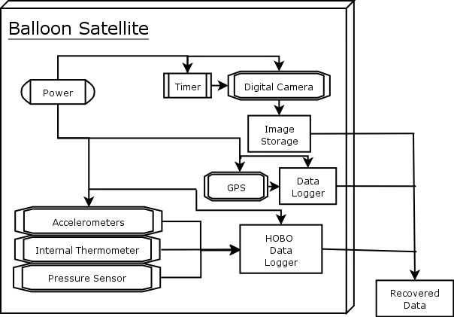
Figure 1: System Block Diagram

Structure Subsystem
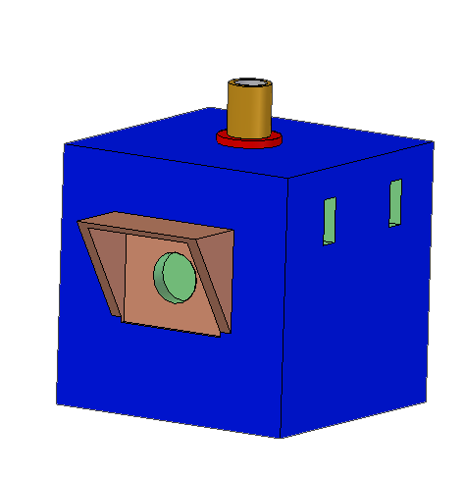
Tether Rod
Camera Lens
Camera Shade
Switches
CAPHAB Satellite
Figure 2: Satellite 3-D design sketch

One of the most critical components of any payload that is to be carried to the near reaches of space is some form of heating and/or insulation. Temperatures reach a low of around –70°C about halfway through the ascent. All of the subsystems present on the payload, including the battery, must be capable of handling these extreme temperatures, or some form of heating and/or insulation must be implemented. One novel idea to reduce the complexity and weight of the payload is to use the packaging of the payload to assist in insulating the load. This, however, will not be enough to fully insulate the payload. Another form of insulation must be used to assist the packaging in insulating the devices.
There are two forms of analysis that are useful for this portion of the design. The first is using published information that indicates how great of an insulator each type of material is. This will assist the team in determining what types of insulation to consider. This, however, is not the best way to select the insulating materials for our final payload. It is also useful to purchase and test several types of insulation to see which meets the needs of our project most.

We have two types of insulation that we would like to test to see which is most effective for our project. The first type is known as polyethylene foam. This is the type of insulation that we used in the design of our first payload. This insulation is in sheet form and must be cut for installation. This type of insulation is known for being difficult to cut accurately. The other type of insulation is polyurethane foam. This can be obtained in sheet form, but it is most often found in spray form. The benefit of this material is that it has a slightly higher thermal resistance value, R-value, and it can be sprayed into the package, which reduces heat loss from seams that do not mate quite perfectly. Thus we would like to purchase each type of material and test to see which is most efficient.

In order to test our two forms of insulation, we will create an environment that simulates the extremely low temperatures of the upper atmosphere. One method of replicating this environment is to surround a thermally stable container that is slightly larger than our payload with dry ice. Dry ice is 109.3°F. We will place dry ice inside the larger container and use small fans to promote an even temperature throughout the container. Our payload with devices will be placed inside this larger container and operated for several hours to determine which insulation is most effective.

 | R-value | Weight | Cost | Size | Manufacture | Total
Polyethylene Foam | 5 | 7 | 6 | 6 | 7 | 31
Polyurethane Foam | 8 | 6 | 7 | 7 | 6 | 34
Mattboard | 3 | 3 | 8 | 9 | 7 | 30
Styrofoam | 6 | 3 | 7 | 5 | 2 | 23
Table 1: Insulation Decision Matrix

Styrofoam has decent insulation abilities, however it is fairly easy to break and it is incredibly difficult to cut accurately through Styrofoam. Additionally, Styrofoam is actually heavier in larger quantities than either of the poly foams. Mattboard (ie foamcore or posterboard) is derived from Styrofoam. Mattboard is produced by placing a piece of Styrofoam between two pieces of cardboard. Mattboard is a fairly good insulator, however it too suffers from high weight in large quantities. It is, however, fairly rigid due to it’s cardboard construction. As a result of its strength and decent insulation abilities, we have selected mattboard to produce our container.
As we can see from above, the polyurethane foam scores higher on the decision matrix. Our biggest interest in this is that the R-value of polyurethane foam is higher than that of polyethylene foam. We have, however, already tested a payload using polyethylene foam and the payload operated flawlessly throughout the entire flight. Thus we are not sure that we will require using this other type of foam. We are going to purchase the polyurethane foam from Home Depot for a relatively low price and test how it performs in comparison to the polyethylene foam. We were provided with a supply of polyethylene foam when we began this project and therefore will not need to purchase further supplies of it.

Digital Imaging Subsystem
A digital imager of 2 to 5 Mega Pixels is needed to meet customer requirements. Various digital imagers from digital video camcorders to digital cameras were investigated. The search was narrowed down to digital cameras since they posses improved still frame image quality, less weight, and lower power consumption requirements. After randomly searching the internet, a website was found that reviewed and provided the user with a camera feature search to narrow down camera choices. The link of the web address that provides the camera feature search is the following URL: http://www.dpreview.com/. Using the camera feature search, options for cameras were narrowed down. Based off of price the field of choices was then narrowed down to the four cameras shown in Table 1. A final camera choice was determined by the use of a decision matrix that uses a point system of 1-10, this is illustrated in Table 2. The Casio EX-Z50 was found to have the highest total score and best meet our specifications and requirements. The Casio EX-Z50 is shown below in Figure 1.

Camera Type | Weight  (lbs) | Dimension  (inches) | Picture Quality | Price | Batteries | Operation Life
Olympus C-55 | 0.75 | 4.3 x 2.6 x 1.9 | 5 Mega Pixels | $270 -$300 | AA (4) batteries | 340 min
Sony Cyber-shot T5 | 0.3 | 3.7 x 2.4 x 0.8 | 5 Mega Pixels | $250 -$350 | Proprietary Lithium | 128 min
Canon SD400 | 0.29 | 3.4 x 2.1 x 0.8 | 5 Mega Pixels | $250 -$350 | Proprietary Lithium | 108 min
Casio EX-Z50 | 0.33 | 3.4 x 2.3 x 0.9 | 5 Mega Pixels | $200 -$250 | Proprietary Lithium | 240 min
Table 2: Digital cameras specifications

Camera Type | Weight | Dimension | Battery Life | Memory | Feature/Quality | Totals
Olympus C-55 | 3 | 3 | 10 | 6 | 7 | 29
Sony Cyber-shot T5 | 9.5 | 9 | 4 | 6 | 5 | 33.5
Canon SD400 | 10 | 10 | 3 | 8 | 8 | 39
Casio EX-Z50 | 9 | 9.5 | 8 | 8 | 8 | 42.5
Table 3: Digital camera decision matrix (Using a scale from 0 to 10)

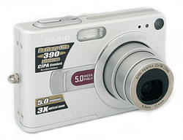
Figure 4: Casio EX-Z50

Camera Controller
A picture must be taken at least every 30 seconds during the satellite’s flight. A timer is essential to control the camera’s capture button during a specified time interval. Two timers used in previous flights were investigated, the 555 Circuit – V-MK111 and the Parallax BASIC Stamp 2. The specifications of the two timers are shown in Table 4.
Both timers meet the camera’s control switch requirements. CAPHAB has decided to use the V-KM111 due to prior experience during the first flight demo as well as the unit has already been provided. The controllers specification are illustrated in Table 4 as well as shown in Figure 5-a and Figure 5-b.

Camera Controller Types | Weight  (lbs) | Dimension  (inches) | Timing Control | Temperature Reliability  (Fahrenheit) | Voltage Requirements
555 Circuit – V-MK111 | .063 | .85 x 2.2 x 1.5 | Circuit Reliant | 32° to 158° | 12 Volts
Parallax BASIC Stamp 2 | .02 | 1.2 x .6 x .4 | Computer Controlled | -40° to 185° | 5-15 Volts
Table 4: Camera controller specifications
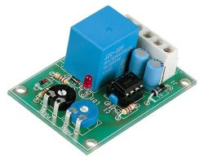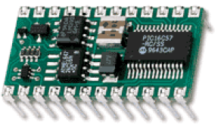
Fig. 5(a) Fig. 5(b)

Figure 5: Camera Actuator, (a) 555 Circuit – V-MK111, (b) Parallax BASIC Stamp 2

Tracking Subsystem
After researching many possible tracking devices it became fairly obvious that a Global Positioning System, GPS, device was the only realistic possibility for this project. A GPS device allowed the highest level of accuracy in an extremely small and light package. The only concern with a GPS device is ensuring that it operates above 60,000 ft. Most GPS devices do not operate over this height due to Federal Aviation Administration, FAA, regulations. These regulations require GPS devices to limit data to devices over 60,000 ft that are traveling several hundred miles per hour. These regulations are put in place to ensure that foreign countries are not able to use GPS devices to navigate there ballistic missiles with any precision. After considerable research, CAPHAB was able to find a list of GPS devices that are able to operate above this regulated height limit. Table 5 shows these possible GPS devices. Researching of this table narrowed CAPHAB’s choice down to a few possible GPS devices. The Garmin GPS 35HVS, shown in figure 6, was eventually chosen due to its availability and price. It also had a good review from another NASA Space Grant team. Details regarding the Garmin GPS 35HVS are found in table 6.

GPS RECEIVERS THAT PASS THE 60KFT TEST

MANUFACTURER | MODEL | SOFTWARE | TESTED BY | TEST DATE
FASTRAX | iTrax02 | V 1.11 | AMSAT-France (F6FAO) | 15-May-04
GARMIN | ETrex | 2.11 | KMC (Pioneer Astro) | 17-Apr-02
GARMIN | GEKO 201 | V 2.0 | TVNSP (KD7OST) | TV03G 12Jul03
GARMIN | GPS-16-HVS | 2.3.0 | TVNSP (N7MTZ & W7MJR) | 4-Jul-04
GARMIN | GPS-18-LVC | 2.30 & 2.40 | TVNSP (KC7DBA) | 6-Nov-04
GARMIN | GPS-25 LP-LVS | GPS 25-LVS V2.5 | F1SRX | 12-Jun-03
GARMIN | RINO | TBD | HABITAT SKYLAB (KAØJLF) | 1-Aug-04
GARMIN | GPS-35HVS | GPS 25-HVS V2.5 | WØZC | 22-Apr-01
GARMIN | GPS-15H | 2.7 | KB8PVR | 9-Apr-05
MOTOROLA | M12  P183T12N12 | 61-G10002A  Ver.1 Rev. 3 | ANSR (KD7LMO)
MOTOROLA | M12+  P283T12N15 | 61-G10002A  Ver.1 Rev. 8 | ANSR (KD7LMO) | 7-Dec-02
RAND McNALLY | Streetfinder GPS for the Palm III  (ROCKWELL ZODIAC) | ZODIAC V1.83 | ORB (KC5TRB) | ORB-5 14Sep03
ROCKWELL  (CONEXANT) | JUPITER  TU30-D140-221/231 | JUP V180  CRC:CFB5 | EOSS (W5VSI) | EOSS-39 12Mar00 thru -49 21Apr01
TRIMBLE | LASSEN LP GPS P/N 39263-00 | 7.82 | BEAR (VE6SBS) | BEAR-1 27May00  BEAR-2 05Aug00
Table 5:GPS Receivers that pass the 60,000 feet altitude test.

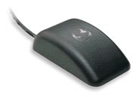
Figure 6: Garmin GPS 35-HVS TracPak

Size | 2.2"x3.8"x1.1"
Weight | 0.275 lbs
Accuracy | 5m
Input Voltage | 6 to 40 VDC unregulated
Input Voltage | 3V to 6V VDC regulated
Receiver | 12 Channel
Baud rate | 1200, 2400, 4800, 9600
Data format | NMEA 0183
Interfaces | 2 serial ports
Operation Temperature | -22F to -185F
Acquisition Times | 45 sec in cold
Acquisition Times | 15 sec in warm
Case | Water-resistance
Antenna | Built-in
Price | $160
Table 6: Garmin International GPS 35-HVS specifications

GPS data storage
A solution is needed in order to store the GPS’s tracking data for later analysis. One possible answer is a data logger. After various research of GPS data loggers the XL-25 was found as the best choice. The XL-25, shown in Figure 7, can record real-time GPS data sentences from an external GPS receiver. The stored data can be downloaded to a PC as an ASCII GPS raw format of data that is compatible with map software for route replay. CAPHAD chose this device as a promising solution over the other GPS data loggers because of it is small size, light weight, Large storage Capacity, ability to read data in any format and most important its low cost.
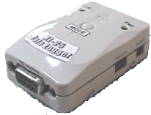
Figure 7: XL-25 GPS data logger

Serial protocol | Full Duplex, Asynchronous
Serial Format | RS232 compatible
Power supply | +5~18 VDC
Power consumption | <0.2 watt max.
Current Consumption | 20mA, 0.1 watt @ 5V
Baud Rate | 4800 bps (default)
Signal | TX1 & RX1
Data Storage | 77 byte with 50,000 capacity for $GPRMC
Dimensions | 2.4"(L) x 1.5" (W) x 0.5" (H)
Weight | 0.08375 lbs
Price | $115

Sensor Subsystem
A combination of sensors will be included in the design to meet and exceed the customer requirements. Sensor possibilities were investigated thoroughly including angular rate, acceleration, muons and other effects of cosmic radiation, internal temperature, external temperature, humidity, and pressure. Due to the size and weight limits of the project, the muon detector has been recognized as too bulky and heavy. It would have required some digital counting device and a logger to record where the muon densities were encountered in the atmosphere. The angular rate sensors available are somewhat expensive and require complicated data processing and logging. ST Microelectronics markets a tri-axis accelerometer that is fitting to our purposes and current HOBO data logger. A single sensitivity-adjustable chip monitors three axes and outputs a voltage scalable to the HOBO input range.

Table 1 summarizes why team CAPHAB proposes to include the HOBO logger and sensors (logger examples shown in figure 8) and the ST accelerometer (package shown in figure 9).

Sensor Type | Benefit (1-5) | Complexity | Price | Size
Analog Devices Angular Rotation Gyro | 2 | High | $75+ | Small
NAU Physics Muon Detector | 5 | Med-High | $50+ | Large
Onset HOBO Internal Temperature | 3 | Low | $0 | Small
Onset HOBO External Temperature | 2 | Low | $0 | Small
Onset HOBO Pressure | 2 | Low | $0 | Small
Onset HOBO Internal Relative Humidity | 3 | Low | $0 | Small
ST Microelectronics Accelerometer | 4 | Med | $20 | Small
Table 8: Sensor Comparison
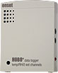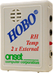
Figure 8: HOBO Data Loggers

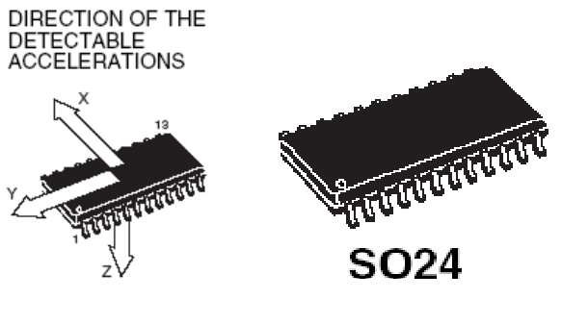
Figure 9: E-LIS3L02AS4 Accelerometer Package

Power System

CAPHAB’s satellite electrical components will each have their own power sources while the GPS, GPS data logger and the custom accelerometer sensor will be powered from one individual power source. The criteria used to judge the selection of a battery cell brand, to successfully power the GPS, GPS data logger and the custom sensor, were as follows:
- Weight
- Voltage output
- Power life for sever temperature changes
- Dimensions
- Testing for space applications
Based on these constraints, the lithium ion battery, Panasonic CGP345010, ranks highest. The battery specification is shown in Table 9. The power design will use two battery cells in series, which increases the total voltage up to 7.4V with a current of 1400 mAh. Several space programs have performed extensive testing of the Lithium Ion battery and demonstrated its abilities for space use. Lithium-ion has successfully proven it is ability to sustain constant power during these tests.
Both HOBO’s sensors have there individual internal self-power. As for the camera controller, it is powered using 12 volts batteries tested in the previous CAPHAB Sat flight. The camera controller power design was based on three 12 volts N-type batteries connected in parallel.

Nominal Voltage |  | 3.7v
Standard Capacity |  | 1400mAh
Dimensions | Width | 1.2"
Dimensions | Height | 1.95"
Dimensions | Thickness | 0.45"
Dimensions | Weight | 1.5 oz
Temperature Operation |  | -20 to 40 C
Table 9: Panasonic CGP345010

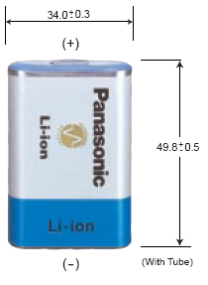
Figure 10: Li-ion battery, Panasonic CGP34510

Constraints

Budget
There are several constraints that we must keep in mind throughout the design and implementation phase of the project. The first constraint is cost. Our project has a budget of $2,000. We administratively decided that we would like to preserve 20% of our budget. Therefore we will have approximately $1,600 to spend on the design and construction of our final payload. The remaining budget will be set aside for any difficulties encountered, such as emergency purchases due to accidental damages. We have opted not to set aside proportions of the budget for each subsystem. Rather any subsystem designer can put in a proposal to the team that requests additional funding for a purchase. Team CAPHAB feels that this will prevent limiting creativity and technical capacity of each subsystem.

Environmental
The environmental extremes that the payload must encounter create an interesting predicament from a design perspective. The launch site is in central Arizona. Therefore the payload must be able to operate at temperatures up to 85°F. The payload will encounter extremes of –60°F at around 40,000 ft. It is questionable whether all of our devices will be capable of operating reliably at temperatures below 0°F. As a result it is imperative that the payload structure be designed to keep the interior as thermally stable as possible. Accordingly we will use extensive thermal insulation.

Sustainability
Typical balloon payloads must sustain a flight time of around three to four hours. This places a constraint on the sustainability of the payload. The extreme cold temperatures encountered will reduce the ability of batteries to provide consistent power. Consequently the sustainability of the payload is dependent on the battery selection.

There are not any real constraints on the sustainability of the packaging. The payload is only required to last one flight. The payload will only be launched on clear days and therefore will not need to survive adverse environmental conditions.

Manufacturability
The entire design will be required to be documented. The end result is that the entire design should be reproducible by an external team with a similar budget. For this reason the design must be well documented and should not use any devices or items that are impossible to locate.

Section
3
Budget

The NAU Physics Department has supplied office space in Physics room 203, phones, computers, printers, paper and tools. The rest of the project expenses, including the materials for the satellite, stipends for each student and travel expenses such as food, lodging, and rental vehicles are all provided by the NAU NASA Space Grant. All costs are on an as needed basis except for the satellite, which is limited to $2000. Fitting with NASA procedure, Team CAPHAB has set apart a portion of the budget for emergencies. The team may purchase satellite materials and be reimbursed by Kathleen Stigmon, or have Kathleen order them herself. Specific components for the planned satellite, and their costs are found in table 10.

Components | Cost
Casio EX-Z50Camera | $250.00
Memory Card | $125.00
555 Circuit – V-MK111 Camera Actuator | Provided *
2 On / Off Switches | $6.00
Onset HOBO Data Logger | Provided *
Garmin GPS 35 TracPak | $180.00
Flexible Format GPS Logger XL-25 | $115.00
Temperature Sensor | Provided *
ST Microelectronics LIS3L02AQ 3-Axis Accelerometer | $20.00
Resistors | Provided **
Circuit Mounting | Provided **
Batteries | $40.00
Wires | Provided *
Box Materials | $50.00
Interior Insulation | Provided *
Aluminum Tape | Provided *
Tether Rod | Provided *
Contact Adhesive (glue) | Provided *
Test Equipment (dry ice, ice chest, etc) | $50.00
Total | $836.00
*Provided by NASA Space Grant ** Provided by the College of Engineering
Table 10: Satellite Planned Expenses

Section
4
Problem Overview

Similar to projects completed over the last several years around the country, and for the purposes of promoting space research, interest, and the education of undergraduate engineers, the NAU/NASA Space Grant Administration has requested the design, launch and retrieval of a small payload on a high-altitude weather balloon. Fitting with the main purpose of educating undergraduates, the project will involve students in the full design-build-fly-operate-analyze cycle of a space mission.

The payload satellite will be designed to measure various atmospheric parameters as a function of altitude up to 100,000 feet, and correlate the data to a series of images. These images will help characterize the earth’s surface features, cloud structure and curvature.

The payload satellite will be battery powered, equipped with a position and altitude sensor, timing circuits, data loggers, temperature sensors, digital camera, pressure sensor, and other yet to be determined measuring devices with which to conduct other atmospheric experiments. The electronics designed must function within the environment maintained by the container, specifically the rapidly changing and extremely low temperatures and pressures.

Along with being thermally consistent, the payload container will be mechanically stable to facilitate the operation of the electronics during high levels of shock and vibration. It also must connect securely to the balloon-tether provided by Arizona Near-Space Research (ANSR).

The photo and atmospheric data will be stored in the satellite and easily downloadable once the balloon payload is recovered. Recovered data will be analyzed with the assistance of the Space Grant and ANSR teams.
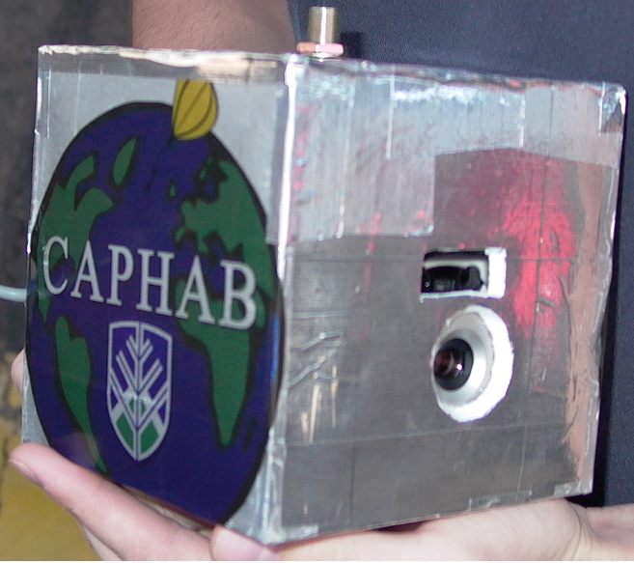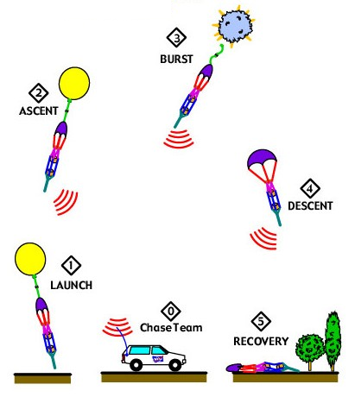
Figure 11: Satellite Payload Figure 12: Balloon Flight Profile

Section
5
Requirements and Specifications

Update Since Previous Release
These requirements and specifications are identical to what was presented earlier. The only changes to date are more specifics on how these requirements will be met. The details on the design were presented above. This section represents the original requirements and specifications for the payload.
- Mechanical
The satellite will contain all relevant components in a container that satisfies the size and weight requirements. The container should be able to facilitate a non-abrasive tether through the center mass of the container. The payload should be able to withstand the shocks, vibrations and temperatures incurred during the flight and landing.

Requirement | Specification
Size of the container | 1 cubic foot (1ftx1ftx1ft)
Weight of the container | 2-3 pounds
The temperature range that the container should withstand | From -80° to 90° F
Withstand Shocks | Internal satellite devices remain intact when dropped in a parachute onto a hard ground
Table 11: Mechanical Specifications

- Electrical
The electrical system will consists of a digital imager, temperature sensors, pressure sensor, and tracking device. Each data device must be able to record data for the entire flight. The images and atmospheric data must be correlated with altitude and geographic location as well as time. All electrical devices should be easily interfaced with a personal computer to retrieve logged data after the satellite’s recovery.
Table 12: Electrical Specifications
Requirement | Specification
Power | Minimum Battery life of 3 hours
Devices operation specs | Temperature range between -80° and 90° F
Devices operation specs | Pressure range between 0 and 1 bar
Digital imager | Resolution of 3-5 Mega-pixels
Digital imager | Capture an image each one minute
Digital imager | A storage capacity of at least 1 GB (>180 images)
Temperature Sensor range | -80° to 90° F
Pressure Sensor range | 0 to 1 bar
Tracking device altitude range | 0 to 100,000 ft
Accuracy | Data correlation error between devices of < 10 minutes

- Documentation
The documentation requirements consist of biweekly reports and a final document. The specifications of each report are illustrated in Table 13.

Requirement | Specification
Biweekly reports | What happened since last report
Biweekly reports | Major Milestones for the next two week
Biweekly reports | Critical problems
Final documentation | Design & detail descriptions of each sub-system
Final documentation | Well recorded to facilitate repairs
Table 13: Documentation Specifications

4. Testing
The satellite test will occur during the second third of the spring semester. The satellite will undergo a payload operation test, a battery life test, a durability test, a camera functionality test, and a data-logging test for each of the sensors. The specification of each test is described in Table 14.
Requirement | Specification
Testing period | Completed during the second one-third of the spring semester
Payload operation test | Simulate operation under high and low temperature
Battery test | Battery operation for at least 3 hours
Durability test | Simulate payload under vibration and shock
Camera functionality test | Appropriate correlation between timing and image capturing ( i.e. 1 image per 1 minute)
Camera functionality test | Enough memory space to capture > 180 images
Data loggers | Test storage of sensors data outputs
Table 14: Test specifications

5. General
General requirements and specifications such as project budget, payload launch location as well as payload launch and recovery date are illustrated in Table 15.

Requirement | Specification
Project budget | Payload should cost < $2000
Payload launch location | Maricopa City, AZ
Payload launch and recovery Date | Late April (28-29 April)
Table 15: General specifications

Section
6
Design Philosophy

Design Philosophy

Customer Satisfaction
We strive to deliver a product to our customer that exceeds their expectations. In order to achieve this, we plan on keeping reliable customer contact and requesting consistent design and implementation feedback.

Quality & Reliability
Our satellite will only have one opportunity to collect data. Thus, it is paramount that the quality and reliability of our satellite is of the highest caliber.

Schedule
A strict schedule has been provided for the completion of each stage of the project. The team has selected Rob Hough to monitor the progress of the deadlines.

Cost Constraints
The project will have a budget of approximately $2,000. If deemed necessary for the success of the project, emergency funds are available.

Design Approach

Subsystems
In order to meet the requirements set by our client, our goal is to include the following subsystems in the design:

  - Electrical
    - Digital Imaging
    - Data-Logging
      - Temperature Sensors
      - Pressure Sensor
      - Latitude/Longitude
      - Altitude
    - Power
      - Batteries
      - Power Supply Lines
  - Mechanical
    - Physical Container Design/Construction
      - Tether
      - Insulation
      - Device Installation
      - Heating

Attack Method
The team will assign a manager over each subsystem area. The manager will be responsible for the overall progress of his project area, and ensuring the area’s completion by the posted deadline. The team will come together to brainstorm, discuss and implement each area’s solution.

Design Challenges
The team will be challenged by balancing the tradeoffs between functionality, weight, cost, and size. For example, a camera with a certain level of functionality and storage may be available in either inexpensive and heavy or expensive and light models.
It will be technically challenging to meet the battery life requirements for each device and still be under the weight limit. It will also be challenging to design a container to meet the requirements of an environment we can not accurately simulate. Correlating the data from the sensors and camera will be challenging as well.
It will be difficult to decide how to maintain an operating environment in the extremes of space. We will also need to decide between location devices, cameras, sensors, and batteries using the tradeoffs mentioned above.

Section
7
Deliverables and Schedule

Deliverables for client

Biweekly Reports – The team is responsible for submitting biweekly reports to the client, Dr. Barry Lutz and our faculty advisor Dr. Niranjan Venkatraman. These reports must include any updates since the previous set of reports, any major technical milestones for the following two weeks, and any critical problems.

Vision and Mission Statement – A vision and mission statement with goals will also be submitted to Dr. Barry Lutz.

Full Design Report – The final design concept and budget must be presented in a design proposal that includes background information and any research documents.

Four Formal Reports

Status Report (early November) – This status report includes the problem definition with a problem statement overview and background. This document should also include the requirements and specifications and a design plan.

Proposal (mid-December) – This proposal includes all research and design concept.

Status Report (March) – This document should provide your client with up-to-date knowledge of where the project stands. It should provide the details of the design review conducted on the product.

Final Report (mid-May) – The final report is a two-fold report. The first part entails providing the customer with the completed product. The second part includes some form of documentation for the completed product.

Individual Detailed Tasks for Next Phase

- Rob H – Research battery and sensor options, create list of design concepts with benefits to choose from
- Rob C – Research environmental options for container, create list of design concepts with benefits to choose from
- Jad L – Research cameras, create list of design concepts with benefits to choose from
- Andrew P – investigate location tracking devices, create list of design concepts with benefits to choose from

Fall 2005: Phase II
The team will proceed to central Arizona to fly and retrieve a small payload. This workshop will help the team learn the intricacies of designing a satellite that is capable of operating under the required operating conditions. We will look deeply into effective methods of maintaining a stable environment inside the satellite. Further, we will analyze how well the instruments collected their desired data throughout the flight. IE: Some instruments may become erroneous at higher altitudes or lower temperatures.

Fall 2005: Phase III
Develop preliminary design. This phase includes taking the preliminary design to the final design concept. This concept should be articulated in a design proposal as documented above (Final Design Concept).

Spring 2006 – Skeleton plan
- Spring 2006: Phase I (first 1/3 of semester)
Finalize design of payload with appropriate documentation.
Conduct design reviews.

- Spring 2006: Phase II (second 1/3 of semester)
Implement the design and build the payload.
Payload undergoes extensive pre-flight testing.

- Spring 2006: Phase III (Final 1/3 of semester)
Launch and recover payload at weekend workshop in central Arizona.
Review images and data acquired.

- Debrief on experience, complete program evaluation, and present results at AZ/NASA
Space Grant Statewide Undergraduate Research Internship Program Symposium, April 28-29 at UA.

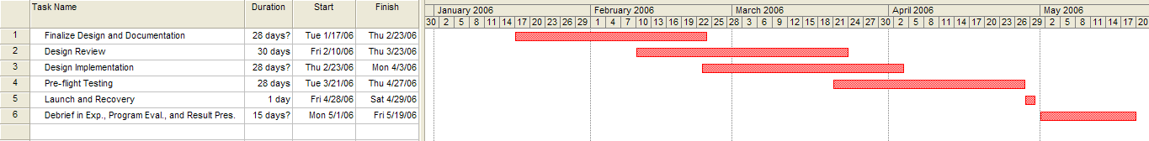

Figure 13: Project Schedule Chart

Section
8
Acceptance Agreement

Liability
Team CAPHAB does not accept any responsibility for any harm caused as a result of operation of the designed payload. Further, Team CAPHAB does not accept responsibility from any harm caused during the construction of and operation of duplications of the designed payload.

You (the client) accept full responsibility for the care and upkeep of the payload after Team CAPHAB has presented it in final form.

The final payload will be designed by Team CAPHAB to operate in the desired environment and to perform desired measurements. Team CAPHAB does not promise that the presented payload will operate faultlessly; it is to be expected that unknown circumstances could prevent the final payload from operating in the desired manner.

Ownership
Any and all items purchased with funds provided to Team CAPHAB by the NAU/NASA Space Grant are property of the NAU Physics Department. The final payload that is to be designed and implemented during the Spring 2006 will be presented to Dr. Barry Lutz following the final flight during the weekend of April 28-29th.

Team CAPHAB Signatures

Signature_________________________ Date _______________

Signature_________________________ Date _______________

Signature_________________________ Date _______________

Signature_________________________ Date _______________

Client Signature

Signature_________________________ Date _______________

