

David J. Kanies
Senior Electrical Engineer II
Raytheon Systems Company
Tucson, Arizona

Dear David Kanies,

First of all, we would like to thank you for the opportunity to develop the Hand Held Boundary Scan Tester. We look forward to the challenge of creating an affordable alternative to the status quo for Raytheon.

Currently, Raytheon uses expensive hardware and software packages to diagnose interconnect faults. We plan to deliver an inexpensive solution to this problem by interconnect problems with the HHBST. We at Altitude Innovations are committed to the successful completion of this project.

We have run into several different possible solutions to the problem. However, we have yet to receive a budget; therefore we based our decisions on what we considered to be the most cost effective solution to the problem.

Enclosed with this letter are our Proposal Package which includes an executive summary, design section, budget section, and updated versions of the problem overview, requirements, design philosophy and approach. This will also include an acceptance page where you, when satisfied, will sign and return to us. If there are any aspects of the proposal in which you are not satisfied please feel free to recommend changes to the design.

We would like to have the design finalized, by signing the acceptance agreement, by December 16, 2005. However, we understand that it is the Holiday Season and understand that it might be later. If there are any problems please contact us as soon as possible.

Sincerely,

Julius Tso Gabriel Brewer
Sudan Basnet Jason Kidd
Clinton Pitterle

Client Project Proposal for

The Hand Held Boundary Scan Tester

Contact Information

Team Members Phone

Julius Tso…………………………………..(928) 526-0108 jkt24@ieee.org 2627 Fox Run Flagstaff AZ,86004

Gabriel Brewer……………………………..(602) 377-0542 rgabrielbrewer@ieee.org 5303 E Cortland Blvd #D9 Flagstaff AZ, 86004

Sudan Basnet ………………………………(928) 380-2072 sb243@dana.ucc.nau.edu 435 Campus Height Flagstaff AZ 86011

Clinton Pitterle……………………………..(928) 970-0633 cwp2@dana.ucc.nau.edu 51 S Maricopa St #802 Flagstaff AZ 86001

Jason Kidd………………………………….(928) 600-1403 jak39@cet.nau.edu 213 S Humphrey Flagstaff AZ 86001
Table of Contents

Executive Summary ....................................................................pg 1
- Project Overview
- Design Concept
- Deliverables and Budget

Design Section .............................................................................pg 3
- Narrative Summary of Design Concepts
- Block Diagrams
- Analysis
- Decisions
- Research
- Constraints

Budget Section ............................................................................pg 8
- Costs
- Payment Arrangements
Problem Overview........................................................................pg 9
Requirements Section ................................................................pg10
Design Plan ................................................................................pg 12
Deliverables and Schedule .......................................................pg 13
Acceptance Documents ............................................................pg 14

Executive Summary

1. Project Overview
The goal of this project is to design a Hand Held Boundary Scan Tester using what is readily available to us in industry. The HHBST will be comprised of a prefabricated boundary scan test board and an encasement that protects the board from the outside elements. The hand held device will be programmed to load a test program, run a boundary scan test and output a pass fail result on the LCD screen attached to the prefabricated board. Operation will be implemented by using the 4 pushbuttons located on the board,

2. Design Concept

- Microcontroller board
This part of the system will be bought as a prefabricated board with all of the peripheral devices needed to realize the HHBST. The board comes fully connected and the pin locations are shown on the schematic in the design section.
- Software
This part of the system will comprise most of the work for the next semester. The microcontroller will be programmed to load a test file into memory and then the user can detach the HHBST from the computer and using the 4 pushbuttons run tests, or reset the device for testing a new device. There may be an option for loading several test files into the memory and using a combination of buttons readying different test files for testing of different boards. Given the amount of memory and the assumed size of the test and output files to be small this should not be very difficult.
- Encasement
We have yet to find an encasement that we know will work. The SL series 07-S made by Serpac is the best device enclosure we have found as of now, it has the right dimensions but we want to get a look at the board before making a final decision. Our other option is to make a custom designed enclosure for the board to fit our exact needs.

3. Deliverables and Budget

- Deliverables
- A working and tested HHBST prototype will be presented to the client on April 29, 2004. The prototype will be delivered with the appropriate manuals and documentation to replicate, and trouble shoot the device. Will also include software purchased for the development of the device.
- The second client status report which will be an updated version of the first one combined with final specs for the proposed prototype is scheduled for early March.

- Budget
We have yet to receive a full budget description, but from what we gathered we would be supported in buying a prefabricated chip, the development tools for designing the program needed to run the test, and other small miscellaneous costs.

- Schedule
The schedule is mapped out in the Schedule and Deliverables section that is near the end of this proposal. It also covers the project progress up to the date of this proposal.

Design Section

- The design concept to meet the requirements of the client, Raytheon, involved the research into JTAG boundary scan test. IEEE 1149.1 establishes the industry standard on the implementation of boundary scan test.

The concept for the design is to implement a Hand Held Boundary Scan Tester, HHBST. The device will be hand held and battery powered in order to be mobile. The HHBST will interface with a PC for loading of a test file to implement a boundary scan test. The HHBST will store the test file with Flash Memory. The HHBST will implement the test to a board and determine Pass/Fail by an indicator.

- Schematics, Diagrams and Pictures
  - Circuit diagram of the TI MPS430F449 depicts the interconnects to the components and inputs/outputs.
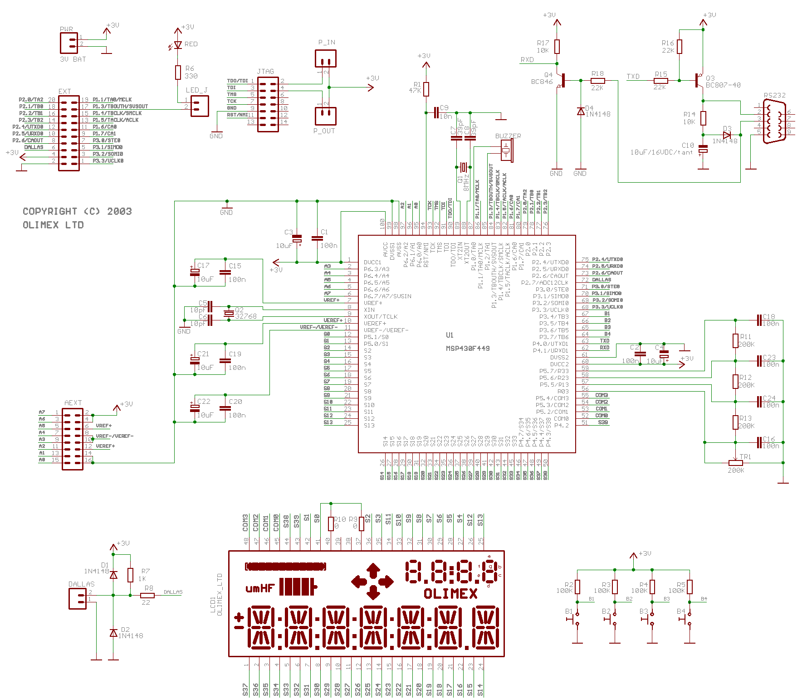
Figure-1
Circuit Diagram of TI MPS430F449
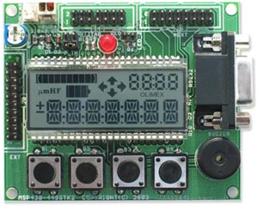
Figure-2
Image of TI MPS430F449

- Analysis/Simulation
A request to the vendor for more information will be needed as the vendor’s online resources were general. A board will have to be purchased to evaluate the board’s design compatibility with the requirements.

Software evaluation will also need to be carried out to evaluate the complexity.

- Design Decisions
Benchmark
Full test station-PC, Software, Controller, Interface Cables

Mobile Options

Laptop/Notebook, Software, Controller, Interface Cables

PDA, DAQ interface, Software for PDA

Preexisting Hand Held Boundary Scan Tester, Interface to PC, Software

Design and Build Hand Held Boundary Scan Tester, Develop Circuitry,
Device | Cost | Tester  /Interface | Cost | Software | Cost | Size | Development Time | Total
PC | 4 | JTAG Controller | 3 | PC Base | 2 | 1 | 10 | 20
Laptop/ Notebook | 3 | JTAG Controller | 3 | PC Base | 2 | 2 | 10 | 20
PDA | 5 | CF or PCMCIA Slot Module | 4 | LabView for PDA | 3 | 7 | 5 | 21
Prefab-ricated Hand Held Boundary Scan Tester | 7 | PC Interface and JTAG Connection Header | 6 | PC Base | 4 | 7 | 8 | 32
Design and Build Hand Held Boundary Scan Tester | 5 | Custom | 6 | Custom | 5 | 7 | 4 | 27
Scale 1(cost high, challenging)…. 5(cost moderate, )…...10(low cost, )

- Parts Chosen and Research

  - Parts Chosen
During our extensive research to meet the requirement of the project a device we found a prefabricated device that accomplished the client’s requirements. MicroController Pros Corporation part, TI MPS430F449, stratifies all the requirements Raytheon set forth.
    - Hand Held- The board comes equipped with two AA batteries holder that provide the voltages. The microcontroller is designed to operate 1.8V dc to 3.6V dc.

    - Microcontroller/Memory- The board uses Texas Instrument MSP430F449 mixed signal microcontroller. The microcontroller is designed to operate on battery power. The microcontroller is equipped with 60k Bytes Program Flash, 256 Bytes Data Flash and 2kb of RAM.

    - Programmable/PC Interface-The TI MPS430F449 is equipped with a RS232, sub-D 9 pin connector, connector to interface with PC for programming. The board is equipped to use Tx and Rx signals.

    - Software- The chip is programmable in C, and the MicroController Pros Corporation offers an IDE designed to interface the board which of course includes a C compiler designed for the TI MPS430F449, a debugger, and other functions common with IDE’s for ease of programming.

    - Indicators-The board is equipped with two visual and one audio indicator.

      - LED status indicator
      - LCD display
      - Buzzer

    - JTAG Interface- TI MPS430F449 is equipped with 2X7 JTAG connector. The connector contains all necessary signals to implement a Boundary Scan Test.

  - Research
    - The first resource for research was IEEE online library. 16 documents were downloaded to be reviewed by the team to gain an understanding of the JTAG and Boundary Scan Test.
    - A copy IEEE standard IEEE 1149.1 was never obtained for review. A copy of IEEE 1149.1 would have required a purchase through IEEE website.
    - Various companies had helpful online tutorials explaining JTAG and Boundary Scan Test. Using an online search engine to search for Boundary-Scan Tutorial we found over 20,000 results. The majority of companies demonstrated there were readily available products in the tutorials, where we got the idea to look more into prefabricated boards.
    - A search for preexisting technology to accomplish the goals of the project led us to http://microcontrollershop.com, the website for MicroController Pros Corporation, where we found a multitude of companies and configurations of boundary scan test boards.

- Constraints
  - Cost- A full test bench for Boundary Scan Tester cost thousands of dollars. Verification of interconnections is all the test station is used for in development phase. The costs of a full test station are not warranted. A simple programmable device that just indicates Pass/Fail is more cost effective. The benefits of a Hand Held Boundary Scan Tester would be reduction of cost in outfitting development teams that need the capability of ruling out interconnection problems, but don’t need a fully functional test station, it also allows mobility of the test station which is currently stationary which makes in field testing difficult.

  - Environmental-The Hand Held Boundary Scan Tester is a reusable device that is battery powered. The working environment would be mainly inside a manufacturing facility, but could possibly be used outside. The environmental impact would be limited to the disposal of used AA batteries.

  - Sustainability-The service life of the Hand Held Boundary Scan Tester would only be limited by a change in the IEEE 1149.1 standard. The product contains no major moving parts, and only the main connection points, the RS-232, and JTAG header will receive minimal stress from repeated connection/disconnection.

  - Manufacturability-The boundary scan tester is already in production. The only modification needed is to create a protective enclosure to protect from the environment, and program the device for our specifications.

http://microcontrollershop.com/Images/msp430-449stk2-sch.gif
http://microcontrollershop.com/product_info.php?products_id=571&osCsid=0a9f462ed1fb7f8c60b8e181f1f0cd21 Budget Section 1. Cost Most of our cost will be in the compiling software that will be used in programming the chip to interact/process as we find appropriate. DescriptionSupplierCostMaterials BatteriesWal-Mart$25 CaseTBD$15 CableTBD$20 TI MPS430F449Micro Controllers Pro Shop$75 CompilerMicro Controllers Pro Shop$225 Test CardRaytheonsuppliedShipping $30 Literature (IEEE standard, printing manuals)TBD $120 Other Lab/Room/Building UsageNAUsuppliedComputersNAUsuppliedOther SoftwareNAUSuppliedMiscellaneous costsTBD $200Estimated Total Cost: $710 2. Payment Arrangements Altitude Innovations estimates the project cost at ~$585, in order to purchase needed materials and miscellaneous costs including but not limited to, travel reimbursements, presentation material costs, and extra unforeseen costs. We feel the easiest way to run the budget would be a check for the estimated amount that could be cashed so we have the money on hand to purchase things as we need them. Our financial/purchasing coordinator, Jason Kidd, will track all the money spent by keeping receipts that will be provided to our client upon finalization of the project unless otherwise requested. An excel file with our latest purchases and account balance will be updated continually and posted on the team website which can be accessed at http://www.cet.nau.edu/Academic/Design/D4P/EGR486/EE/04-Projects/BoundaryScanner/index.htm and can be accessed early January . We will do our best to remain within the estimated budget of $710.00 and return the balance with the excel worksheet and all receipts to our client David Kanies, with Raytheon. Project/Problem Definition The target of our project is to develop and design a hand held boundary scan tester (HHBST). The HHBST is a portable device powered by a battery that performs a boundary scan test to determine if there are any faults or broken connections between the point at which a chip is inserted into a printed circuit board, and the outlying devices it communicates with. The HHBST only determines if there is an interconnect problem not where the problem is located. As technology progress the circuitry on a printed circuit boards become more complex and dense and the ability to use physical probes to test are no longer feasible. Boundary scan testers enable the possibility of testing printed circuit boards for faults or problems. A boundary test station allows different teams working during the development phase to rule out interconnect problems. Various teams working on different pieces of a project need the capability of having a test station, but cost becomes an issue because hardware and software, for a full test station, costs thousands of dollars. A hand held boundary scan tester that just tests for interconnect problems would meet the needs of development teams that only need to rule out interconnect problems in a pass fail manner. Industry standard for a boundary scan test is IEEE 1149.1 developed by the Joint Test Action Group (JTAG). The work began in 1985 with the foresight that as circuitry becomes smaller and denser there will be a need to perform tests for faults or interconnect problems. IEEE standards create a common framework and are a fundamental building block for the industry. Requirements Section 1. Mechanical The mechanical requirements are determined by the constraints of the physical environment, in this case portability is the major factor. The mechanical requirements are as follows: 1. Mechanical requirements - Max Size: ~ 5" x 3" x 2" - Max Weight: ~ 2 pound - Prototype will include microcontroller board & I/O ports attached to custom fabricated board. - Packaging will be durable plastic casing that contains the microcontroller board with external on/off switch, LED indicator, and port openings. - Will contain 2xAA 1.5 V Battery holder. 2. Mechanical constraints - Prototype must be hand held (portable) 2. Electrical The electrical requirements for our project must meet FCC, IEEE, and our client’s specifications. The electrical system will connect the HHBST to the DUT through a 2x7 pin JTAG connector. The device will also have a RS-232 serial port for transmitting the test data file to the HHBST. 1. Electrical Requirements - Powered by 2x AA 1.5V Battery - Must have memory to store test data file. - Must be capable of testing devices of varying operating voltages - Operating temperature must be between ~20º C to ~50º C - Must determine with 100% accuracy a pass/fail result. - Result must be displayed on LCD custom display. - Must have I/O interface using standardized IEEE 1149.1 2. Electrical Constraints - Battery powered 3. Environment The system must be safe for hand-held use and within the vicinity of other electronic devices as per FCC regulations. 1. Environment Requirements - Operation at standard room temperature - Must comply with FCC and IEEE standards - Prototype should operate in standard office environment - Prototype should withstand drops of ~ 6 inches and normal portable device transport 2. Environment constraints - Must comply with FCC and IEEE standards 4. Documentation Documentation will include all documents required for operating, testing, and maintenance. These will be updated as the solution develops. The documentation will consist of the following manuals. 1. Documentation Requirements - Operation's Manual: Instruction for implementation of Boundary Testing - User's Manual: Included in Operation's Manual - Coding documentation - Testing documentation 5. Testing The system will be tested in accordance with the client’s expectations and other industry standards. The tests will determine the continuity of the circuit boards under tested. 1. Testing Requirements - Test Board to be supplied by Raytheon - Proper documentation of procedures - Proper equipment used for testing 2. Testing constraints - Supplied test board 6. General 1. General Requirements - Reliability - Easy to use - Vendor preferences: TBD - Client preferences: TBD Design Plan 1) Design Philosophy Our design goals consist of satisfying the clients need for a portable boundary scan tester, while keeping the simplest design possible. For the safety of the design, we will take all possible precautions for user safety as well as safety of the device. The design will be with in FCC regulations for accepting or emitting electromagnetic interference. Because of the portable nature of the device, performance reliability needs to withstand normal wear and tear due to transportation. There will need to be some explanation for operation, but once the initial training is done, the operation will be straight forward. As the majority of the project can be purchased or will be programmed already, replication of the HHBST and modifications to it should be relatively easy to implement. There should be almost no maintenance, except of course to replace the battery. There should not be very many cost constraints, considering the client is providing the test board and file, and the rest of the components should be fairly inexpensive. The schedule will be followed as specified below as closely as possible. 2) Design Approach The approach to the design will include researching different "boundary scan testers" and applying those concepts. After thorough research we found a prefabricated board that included a microcontroller, memory, I/O devices, and the proper device connections for talking to a computer and a DUT. The microcontroller we found with the proper configuration will be programmed in the C programming language. The only two sub-systems we envision are the hardware and software subsystems, with the appropriate team members assigned respectively. The hardware sub-system will be in charge of building the encasement with the proper connections for the portable Boundary Scan Tester to the test card. The software sub-system will deal with the actual testing code and outputting the results to a test file and/or screen. Through research and communication with the client the problem will be addressed and solved. Some challenges that could be foreshadowed are both communication problems between components and implementation of software. Design decisions will be addressed by the team, with the appropriate sub-system teams input weighted. Deliverables and Schedule Deliverables and progress to date To date the majority of work on the project has been in the researching of the project and what exactly a boundary scan tester is. We have to date produced two deliverables, the first being the client status report, a quick overview of our understanding of the scope of the project, and this document a formal proposal to start work on the project and an official declaration of what we think we will do over the course of the next semester. Project developments foreseen over the next few months are research on the C programming language, purchasing of required elements to begin programming and development of the HHBST, a revision of the proposal document if needed, and work on the client status report that will be due in the early days of March. Deliverables to come are as follows: Project Schedule and Deliverables: - Client Proposal (Mid. Dec.) (this document) High level design proposal of the prototype will be delivered before the semester break in December. This is the first step in the development phase submitted for review. - Deliverable: Project Proposal - Client Status Report (early March) Revision of the 1st client status report and a detailed design of the solution. - Deliverable: Client Status Report 2 - Final Report (early May) & Presentation (April 29th) The final results and demo of the solution to the purposed problem. - Deliverables: - Prototype HHBST - Manuals, code documentation - Final report (turned into instructor) Acceptance Document David Kanies, please read the following conditions, sign and date, and return by January 7, 2005 to: Gabriel Brewer 5303 E Cortland Blvd Apt D9 Flagstaff AZ 86004 This agreement is between David Kanies of Raytheon Systems Company and the Northern Arizona University, College of Engineering and Natural Science EE476/486 team Altitude Engineering of the 2004-2005 academic year. The Altitude Engineering team consists of Julius Tso, Gabriel Brewer, Sudan Basnet, Clinton Pitterle, and Jason Kidd and from hereon will be referred to as Altitude Engineering. Altitude Engineering will supply David Kanies with one working prototype of the Hand Held Boundary Scan Tester (HHBST) with user’s guide and complete design data package by May 1, 2005. Once delivered, David Kanies and Raytheon Systems Company will have full ownership of the prototype and all intellectual property of the design. David Kanies of Raytheon Systems Company has the right to, at anytime, waive the right of ownership of this above mentioned prototype. Altitude Engineering will not be liable or held accountable for any damage resulting in the use or handling of the Hand Held Boundary Scan Tester, it components, byproducts, or devices in which interface with the HHBST. This includes, but is not limited to damage to equipment, printed circuit boards and users. Altitude Engineering agrees to the above terms. __________________________________ __________________________________ Julius Tso Date Gabriel Brewer Date __________________________________ __________________________________ Sudan Basnet Date Jason Kidd Date __________________________________ Clinton Pitterle Date I, David Kanies, agree to the above terms. __________________________________ David Kanies Date

