Project Overview

Problem Statement
Imagine standing in front of an interesting piece of artwork in an art gallery. Usually, a description of the artwork is placed below or nearby, to help the artist convey the meaning of the piece. What if there was no description? Instead when you walk up a projector and speakers are triggered to convey the feel of the artwork, complimenting the visual representation by a video and audio presentation. And, what if this whole system was adjustable with the touch of a button? In other words, the artist can set the parameters – room dimensions, volume, sensor type, video image – through a user interface. This interface can be loaded onto a removable personal computer device. With the use of sensors, video projectors, speakers, and a control unit, an interactive display can be created, giving the artist another angle to apply to the art.

Below is an illustration of a possible floor layout for the Interactive Art Display design concept.

Figure 1: Possible Floor Layout Design Concept

EXIT
Art
Projector
Motion Sensor
Speaker
Room
Control Unit
ENTER
This will be removed once parameters are entered.
Laptop
Speaker
Projector
Art
Motion Sensor

The following block diagram shows the design and interconnectivity of the overall system.

Figure 2: Interactive Art Display System Design Block Diagram

Laptop System (GUI)
Audio Card
Video Card
Memory Unit
Processor
Projector
Speakers
Sensor Input Subsystem
GUI Subsystem
Controller Subsystem
Audio Output Subsystem
Video Output Subsystem

And this next illustration shows the physical subsystem interconnections, as inputs or outputs.

Figure 3: Interactive Art Display Single System Design
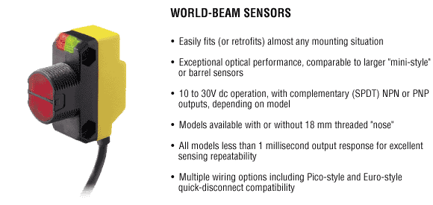

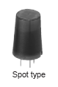
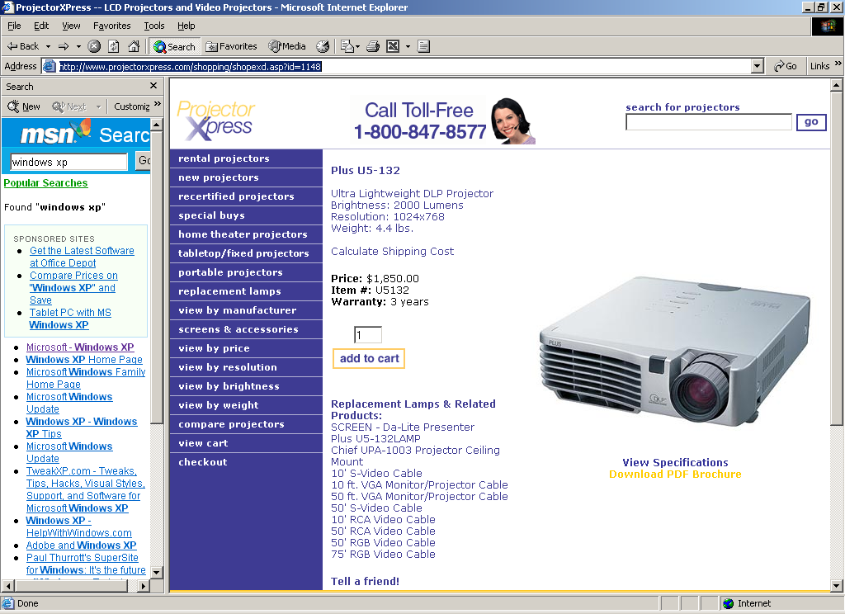
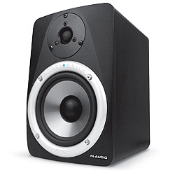
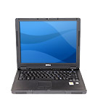

Control
Unit
Inputs
Outputs

Requirements and Specifications

In order to solidify design requirements and specifications, we have placed size constraints on all subsystems. We have also taken into account the aesthetic value of the system.

Mechanical Requirements
Mechanical requirements are determined by the physical needs of the system.

- The use of a personal laptop
- The ability to connect/disconnect the laptop as needed
- The system will be aesthetics pleasing
- All units will be enclosed and portable
- The speakers will be no larger than 12 inches³
- The Projector size will be no larger than 10x10x5 inches
- The projector will be 5 lbs
- The controller will be no larger than 3x3x2 feet
- The system will be safe for people and the environment
- All electrical wire interfacing between the components will be camouflaged to make it aesthetic pleasing

Electrical Requirements
The electrical requirements include both hardware and software aspects for the system, and the components of the system must perform according to the requirements listed below.

- GUI must be user friendly
- User will enter parameters of the room and adjust the sound of the speakers
- Initial GUI must be usable in a Windows XP environment
- All circuitry must comply with IEEE and FCC standards

Environmental Requirements
Environmental requirements contain any constraints of the space being used. The following is a list of environmental requirements taken into consideration for this project.

- Must be adaptable to various art display spaces, sizes and configurations
- The display room various in size and is enclosed
- Art display room is carpeted
- Art display room has a ceiling (no lows and highs requirements)
- The display will operate under “normal” room temperature (minimum temperatures determined by sensitivity of computer needs)

Documentation Requirements
The documentation of the project’s designs, testing, and expenses will be kept up to date. The documentation is to update the client on the team’s progress. The following is a list of required documentation.

- Client Status Report #1
- Research and Development of Design Ideas
- Final Design Proposal
- Client Status Report #2
- Final Report

Testing Requirements
A prototype in a simulation environment is desired.

