Interactive Art Display Final Product

The Interactive Art Design overall integrated system is pictured below.

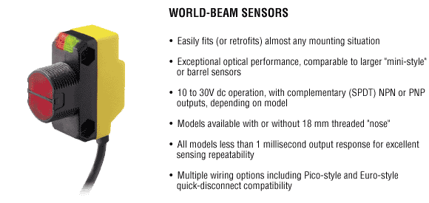
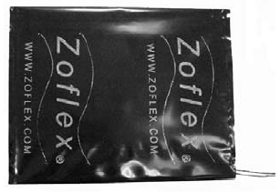
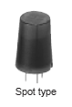
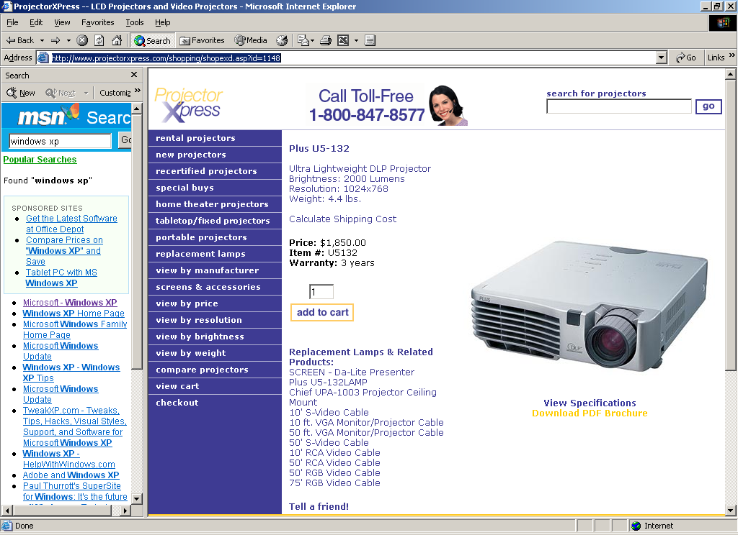
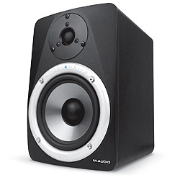
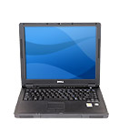

Control
Unit
Inputs
Outputs

The lines in the diagram represent wired connections. The arrows represent the direction of information, i.e. input to the control unit or output to the control unit.

The actual final design only uses one type of input sensor at a time. The three sensors chosen for the final design were the NaPiOn Panasonic Infrared Motion spot sensor, the ZOFLEX Pressure mat sensor and the Banner World-Beam QS18 Laser sensor. The sensor, when triggered, sends a signal to the control unit, which in turn sends a signal to a projector and speakers to play a specified video/audio file. This file is specified through the Local Area Network software on the client’s removable laptop.

Features

The following are features of this design:
- Interchangeable sensors: motion, pressure and laser
- Removable laptop is used to send new video/audio files to control unit
Applications

- Art Gallery Interactive Art Display
- Museum Art Display Information Guide
- College of Engineering and Natural Sciences Information Display
- Directory Assistance
- Automated Receptionist
- the possibilities are endless…..

