July 31, 2026
GCT Machine EE. Team
1830 S .Milton Rd#132, Flagstaff, AZ86001
Tom Wishon Golf Technology
695 Country Road 233
Durango, CO 81301
Dear Mr. Wishon:
This attached document is the status report as of today for the Golf Club Testing Machine Project. The project presentation will be held on April 23rd, a formal invitation with specific directions and information regarding a parking permit will be sent to you as a separate document. We will be submitting the final and complete design document. We are also planning to simulate a demonstration for the EE subsystem. Here is a summary of the contents of this report.
- Changes in Design Philosophy
- Project Progress
- Scheduled Tasks
- Problem Statement
- Accomplishments since the proposal document
- Updated Schematics
- Updated Project Schedule
- Updated Budget
- Copy of PowerPoint Presentation given in class March 2nd
If you have any questions or concerns please contact us via email, phone, or at the address above.
Thank You
Sincerely,
Nasser Almarri John Bring Charles Siko

GCT Machine EE. Team
cc: Dr. David Scott cc: Art Mittendorf cc: Dr. John Haney
cc: Prof. Jerry Hatfield cc: Dr. Walter Hopkins

_________________________________________________
Tel# 928-225-9990, Email: golfswingrobot@hotmail.com, Fax 928-214-8106
Changes in Design Philosophy

The Golf Club Testing Machine Project is extremely dependant on the Mechanical Engineers. The ME subdivision has switched to a paper design to compensate for more time to complete the dynamic and stress analysis. Given this current issue, we arranged a separate meeting with project advisor (Art Mittendorf) and submit a different proposal to you, through him, to work on the EE subsystem only. Our goal is to model the communication between all the involved hardware and the software for this subsystem.

Based on this, the specifications of this project were broken down to the EE subsystem only including the controller, encoders, launch monitor, and the software. These parts will be tested and simulated. The deliverables will be as follows

- Final Report including the detailed design of the EE subsystem
- Final Presentation
- Partial EE subsystem for demonstration at the capstone conference.

The subsystem will be partially complete because we will not have all the needed parts by the end of semester. As Mr. Art Mittendorf suggested, the main motor will be purchased later this summer. The subsystem will not include the main motor and the additional encoders for the shoulder joint and the wrist joint. It will include one encoder for the elbow joint to test the modeled subsystem. In addition, there will be two external encoder inputs available in the controller board or separate DAQ (Data Acquisition Card) multi-channel for future assembly of this design. The output of the controller will be amplified using a digital torque amplifier drive. When the whole robot is assembled later this summer, the output of the digital drive will be connected to the main motor. Inside the motor, there will be another encoder to report the position back to the controller. This step will perform the closed loop operation for the whole system. During the demonstration, a pulse will be modeled to perform this operation if needed.

Progress Description

We have received the Launch Monitor from the Mechanical Engineering Division. Right now, we are testing the golf achiever software and trying to implement an interface with Visual Basic (VB). We have met with the local distributor for YASKAWA Inc. and were able to determine a system quote included in this document. Also, we presented our design in class last week. A meeting with faculty advisors was held to make sure that the selected parts will perform their tasks. A complete EE subsystem design has been finished. Our goal is to complete the software graphical user interface. One is Yterm2000 and the other is the one for Launch Monitor software (Golf Achiever). As soon as we receive Yterm2000, we will begin the Visual Basic GUI. We have already built the VB GUI to interface with the Golf Achiever software. The system schematics and cost are included in the updated schematics and budget section of this report respectively.

Tasks behind Schedule

One task that has not been accomplished is the software interface between Visual Basic and Yterm2000; this is due to the supplier delivery. Once we receive the Yterm2000 software, we will further develop the GUI between VB and Yterm2000. Also, in our subsystem design, we are still doing last minute checks on the encoder connections and making sure it is fast and sufficient enough.

New Tasks to be added

As discussed previously, a note book computer (lab top) will be needed. In addition, a USB/ Serial adaptor will be needed in order to interface between the controller and the launch monitor with the lab top. This new computer will be designed to have multi port for future requirement. If needed, a data acquisition card will be built in the computer to collect the data from the encoder. This will be necessary if the system is not fast enough to collect data through the controller. A decision will be made Monday Mar.8th after meeting with the project advisors.

Problem Statement
We are required to design, Implement, and Assemble an EE subsystem of the Golf Club testing Machine. This subsystem is capable of reading and collecting data from the Launch Monitor, Reading/ Writing data from the controller. The encoder is monitored by the controller. A visual Basic GUI is to be implemented to interface with both of the controller and the launch monitor software. Speed and efficiency of collecting data is a primary goal of this design. The connection between the hardware and the computer must be designed in a strategy that goes with specifications of the purchased hardware.

Accomplishments since the proposal document

Since the proposal document the Golf Club Testing Machine Team has researched and finalized choices for hardware. Much time was spent talking to experts and investigating devices that will fit our function and cost restraints. We chose our Encoder, Controller, and Drive. We have submitted this information to our local advisor Art Mittendorf for approval and purchase. We have spent time learning how to build Graphical User Interfaces (GUI’s) on Visual Basic (VB). We were fortunate to receive added help from Mr. Mittendorf on the GUI subject as well. We have begun building the GUI and are improving on it as we learn. We have in our possession the Launch Monitor; this has been helpful for researching how we plan to transport the data taken from it, onto the GUI.

There have been many changes to the overall design philosophy. The majority of these changes stem from the mechanical sub-division decision and approval not to implement a working model. The electrical sub-division is on course for completion of the same concept design that will best fit the new entire design. Our requirements and specifications will be more difficult to determine due to the lack of direct application with an incomplete machine. We have narrowed those tasks down to integrating the hardware with the VB GUI and monitoring the encoder since there were no specifications.
Electrical schematics

We have a modified flow chart of the electrical sub-division responsibility for the Golf Club Testing Machine Project as shown below.

Using Ethernet or USB

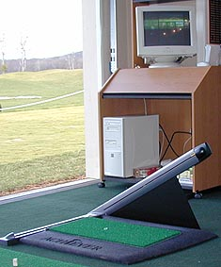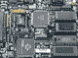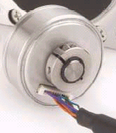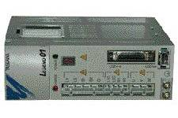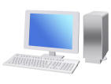

Encoder

Controller
PC
Pc
Serial Port

Drive
Digital Torque
Amplifier
To Servo Motor
PC
Controller
Drive(Amp.)
Encoder
Launch Monitor
Serial port/RS32
We also have a new cost outline for the modified project electrical sub-division portion. So far, the only part we have is the Launch monitor and it was provided by you. In the budget section a detailed cost summary was added. Based on the following quotes in the next page, we chose the proper parts that fulfill our deign needs.
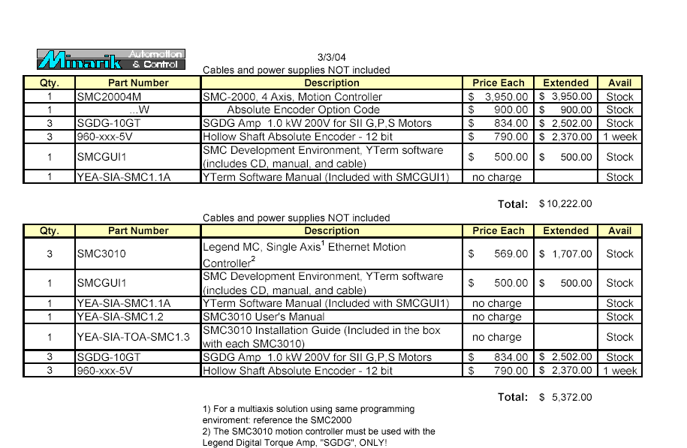

Project Schedule

Day | FEBRUARY | MARCH | APRIL | MAY
1
2 |  | Update Presentation
3 |  |  |  | Working on Report
4
5 |  | Draft Status Report
6 |  |  | Final Programming/ | Final Report Due
7 |  |  | Assembly
8
9 |  | Purchasing/
10 |  | Web Site Design
11 | Initial Web site due
12
13 |  |  | Working on Report
14 |  | Receiving Parts
15
16
17 |  | Working on Presentation
18
19 |  |  | Working on Poster
20 |  | Conference Presentation Dry Run/
21 |  | Final Website Due
22
23 |  |  | Capstone Presentation/
24 |  |  | Poster Session
25 | P. Eval. Exercise Due
26 |  | Assembly
27 |  | Troubleshooting | Working on Report
28
29 | XXXXXXXXXXXXXX
30 | XXXXXXXXXXXXXX |  | Draft for Final Report Due
Schedule Narrative

- Documentation/Customer Reporting

We submitted a design proposal last semester and this report is our Final Status report.

- Presentations

We recently gave our update presentation on March 2nd, introducing major design changes for our project. The next presentation date is on April 23rd.

- Communication

We have had weekly meetings with our outside advisor Art Mittendorf both at NAU and in Williams. This Tuesday he approved all our purchasing decisions and parts will be ordered.

- Research

We had an important meeting at Art’s house to learn Visual Basic coding for GUI’s.

- Hardware

We are ordering parts as soon as we meet with Art Mittendorf. We have selected everything we need and have a list of the costs and associated specs.

- Software

We are currently working on developing the Visual Basic Software necessary to create the GUI.

- Demonstration/Poster Session

We plan to have a demonstration on April 23rd after our final conference demonstration.

- Testing/Prototyping

We have plans to have a complete setup ready for testing by April 10th.

- Purchasing/Vendors

All large purchases should be completed by the week ending March 12th.

- Web Site
We plan to be working on our website from March 5th through the12th. It will be completed by March 20th.

- Financial Tasks

An account has been setup through the school so that we can ask for the funds from the front office before we need to buy anything.

*****All mechanical Assembly was removed from the schedule because they are now doing a “Paper” Design. This eliminated integration testing so we will use this time for troubleshooting

Budget

The following is a quote for the system. Some parts were added as you requested. Possible chance is to eliminate one of the parts (i.e. serial/USB adaptor). If we observe another connection using DAQ, we will remove it. It all will be determined when we meet with Art Mittendorf Mar.9th.

Item | Qty. | Part Number | Description | Price | Supplier | Purchase | Delivery
Launch Monitor | 1 | N/A | Focaltron Golf Achiever | Provided | Focaltron  Corp. | N/A | Delivered
GolfAchiver Software | 1 | N/A | Software | Free | Focaltron  Corp. | N/A | Delivered
Motion Controller | 1 | SMC20004M | Multi-Axes Controller | $3,950 | Yaskawa | 03/09/04 | 03/15/04
Digital Torque Amplifier | 1 | SGDDG-10GT | Amp. 1Kw 200 for G, P,S motor | $834 | Yaskawa | 03/09/04 | 03/15/04
Encoder | 1 | HS135 | Position Encoder | $790 | Netzerprec. Corp. | 03/09/04 | 03/15/04
USB/ Serial Port Adaptor | 1 | N/A | Serial to USB conversion unit | $200 | Radio Shack | 03/09/04 | 03/09/04
Dell Laptop | 1 | N/A | Computer/ multi-port interface/DAQ | $1044.50 | Dell | 03/09/04 | 03/15/04
Accessories | 4 | N/A | Cables/ Connectors | $200 | Minarik Corp. | 03/09/04 | 03/15/04
Yterm2000 | 1 | N/A | Yaskawa Controller software | $500 | Minarik Corp. | 03/09/04 | 03/15/04
Total |  |  |  | $7518.50
Note: Launch Monitor price wasn’t included and Laptop price is added as you requested.

