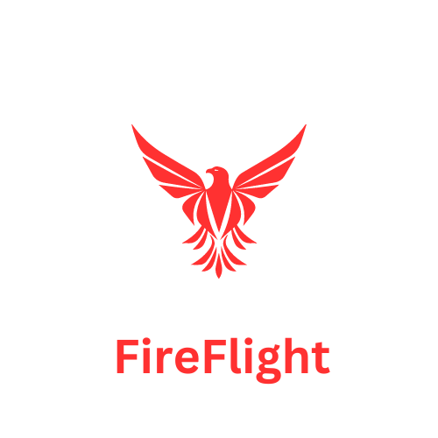

**Sponsors:** Northern Arizona University

USDA

US Forest Service

**Clients:** Dr. Jamie S. Sanderlin, Dr. Ana Miller-ter Kuile, and Dr. Kiona Ogle

**Mentor:** Scott LaRocca

**Team Members:** Alyssa Ortiz, Andrew Ortega, Payton Watts, and Tyler Chapp

**October 3, 2024**

### This document focuses on the roles and responsibilities of the team and each team member through the course of our capstone project. It designated the roles of each team member, our meeting expectations and conflict resolution guidelines, the standards for our tools and documents, as well as how we will conduct our team self reviews. Each team member has agreed to abide by these guidelines and standards.

### **Team members and roles:**

* **Team Leader**: Alyssa Ortiz
  + Coordinates task assignments and ensures work is progressing.
  + Runs meetings, and makes initial efforts to resolve conflicts.
  + Coordinates and conducts client communications via email.
* **Tester**: Tyler Chapp
  + Responsible for setting up and running automated tests after each push to GitHub
  + Ensures 100% code coverage for test cases
* **Recorder**: Andy
  + Maintains detailed meeting minutes.
  + Ensures that the team is on track during meetings.
* **Architect**: Payton
  + Primarily responsible for ensuring that core architectural decisions are followed during implementation.
* **Release Manager/Reviewer**: Payton
  + Coordinates project versioning and branching.
  + Reviews and cleans up commit logs for accuracy, readability, and understandability.
  + Ensures that any build tools can quickly generate a working release.
* **Integrator**: Tyler Chapp
  + Integrates front-end with the back-end of the system.
  + Facilitates communication between front-end and back-end developers.
* **Front End Developers: Andy, Alyssa**
* **Back End Developers: Payton, Tyler**

### 

### 

### 

### **Team Meeting Expectations**

* **Meeting Times**: Regular in person meetings with mentor at 3pm on Mondays, and Discord group call meetings at 1pm on Thursdays. Impromptu meetings can be scheduled through Discord.
* **Agenda Structure**: Start each meeting with reviewing last week’s task report, and each member doing a short 2 minute check in (what we have accomplished, and what we have struggled with/any questions).
* **Minutes**: Google document with Member Review section at the top, and the rest of the meeting notes as bullet points.
* **Decision-Making Process**: In case of disagreement, we will move forward with a 3 out of 4 majority. In case of a 2 and 2 split, we will consult our mentor Scott for guidance.
* **Attendance**: At least 1 day notice for total absence is acceptable for Monday meetings.
* Notice of lateness before the meeting starts on Monday or Thursday is acceptable. Notice for absence Thursday Discord meeting starts is also acceptable. If someone has more than 2 unexcused absences or late arrivals, the team will meet to discuss a plan for moving forward.
* **Conduct**: For non-performing or disruptive members, we will first give a polite warning/heads up. If the problems persist, we will have a team meeting including our mentor, Scott, to discuss this with said member. If this does not resolve the issue(s), a meeting with the CS Capstone Organizer will be scheduled.

### **Tools and Document Standards**

* **Version Control**: We are using Github. We will have main branch protections, so that a review is required before pushing to main. We have a separate branch for each team member. We will also have a branch for back-end and a branch for front-end, which will be the only branches pushed to main.
* **Issue tracking**: For all tasks, we will use the task sheet in our Google Drive. For specific coding tasks or issues, we will use the GitHub issue tracker and assign team members.
* **Word Processing and Presentation**: We will use Google Docs, Google Slides, and Google Sheets for our word processing and presentations. We will use Canva for logo design and graphics, and we will use Figma for UI mockups.
* **Composition and Review**: We will determine for each assignment when we should have a rough draft by, and then from there determine who will integrate and edit the document to make it uniform and cohesive.
* **Communication**: All official email correspondence between the team with the clients and mentor will be facilitated by team lead, with team input, and posted in Discord. All communication between team members is conducted through Discord in the appropriate channels.

### **Team Self Review**

Before each meeting, each team member gives an update on their progress and anything they struggle with. This is recorded in the meeting minutes document for the week. These recordings ensure that everyone is meeting expectations for the project. If there are issues, they can be asked in the meeting so that the troubles are resolved and more progress can be made on the project. These actions also determine whether or not any disciplinary actions are needed for a lack of work.