 | Weekly Team Task Report | 17

Team: Team Lora |  |  |  |  |  | Date: 3/2/20
Project Title: Mobil Crowdsensing Framework Over Low-Power Wide Area Networks

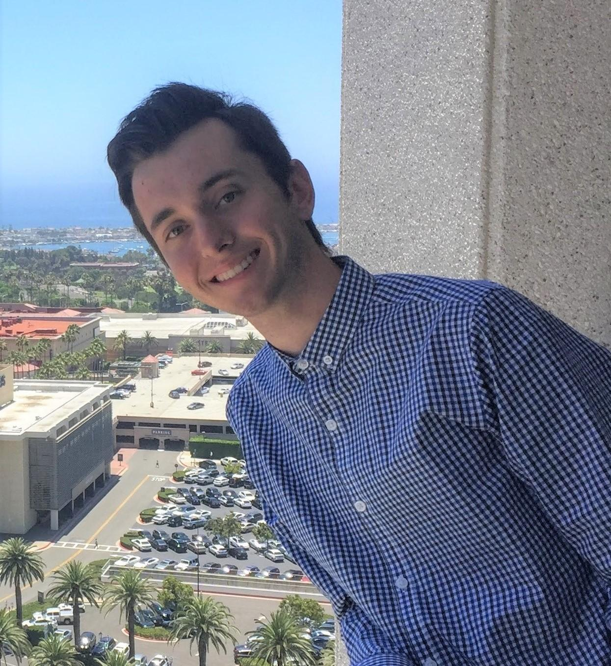 | Ryan  Present  On-time | 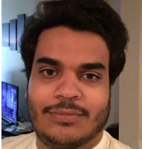 | Mohammed  Present  On-time | 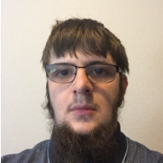 | Benjamin  Present  On-time |  | 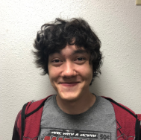 | Brandon  Present  On-time

Recent Meetings:

- Team Meeting (2/2420) Team meeting via Discord. Discussed tasks for the upcoming week, worked on revising the software design document.
- Team Meeting (2/27/20) Met to troubleshoot bugs in configuration service and LoRaMessenger

TASKS COMPLETED since the last meeting:

Task Title: Design Review 2 Presentations | Task Initiation:  2/17/20 | Orig. Due Date:  2/25/20 | Status: Completed
Who (%): Ryan (40%) Ben (20%) Brandon (20%) Moe (20%)
Description: Create the Google Slide with all the information for the presentation.
Expected Outcome: A ready to go presentation for our Design Review.

This week’s Tasks: Work plan for the coming week

Task Title: Create Wiki For Documentation | Task Initiation:  2/10/20 | Orig. Due Date:  2/17/20 | Status: In-Progress  0% Completed
Who (%): Ryan (25%) Mohammed (25%) Benjamin (25%) Brandon (25%)
Description: Create the start of the Wiki for our project.
Expected Outcome: A github wiki for our github project that explains how to use our code.

Task Title: Set up a Router to be our "CANIS LAB" connection | Task Initiation:  2/24/20 | Orig. Due Date:  2/26/20 | Status: In-Progress  20% Completed
Who (%): Ryan (100%)
Description: Buy and Set up a router as a "test" router to act as the CANIS LAB Lora connection
Expected Outcome: A router connected to our phone and able to mimic a Lora Connection via IP.

Task Title: Implement Android Device to LoRa Node Connection | Task Initiation:  1/30/20 | Orig. Due Date:  2/17/20 | Status: In-Progress  90% Completed
Who (%): Ryan (50%) Mohammed (50%)
Description: Getting connection between the library and the lora node via kotlin connection.
Expected Outcome: A connection is created.

Task Title: readEncodingTable() | Task Initiation:  2/16/20 | Orig. Due Date:  2/29/20 | Status: In-Progress  75% Completed
Who (%): Ben (33%) Ryan (33%) Brandon (33%)
Description: A function that reads the lookup table and translates strings into byte strings.
Expected Outcome: usable lookup table that works before spring break and works with encodeFromTable function.

Task Title: encodeFromTable() | Task Initiation:  2/16/20 | Orig. Due Date:  2/29/20 | Status: In-Progress  0% Completed
Who (%): Ben (33%) Ryan (33%) Brandon (33%)
Description: A function that encodes the message based on the lookup table parameters.
Expected Outcome: Encoded message ready to be sent to the loRa Node.

Task Title: Secure Proxy Server’s Connections | Task Initiation:  2/8/20 | Orig. Due Date:  2/29/20 | Status: In-Progress  0% Completed
Who (%): Ben (100%)
Description: Ensure that the packets being transmitted to and from the proxy server are properly encrypted, and that the server validates all connections made to it.
Expected Outcome: Demonstrate that the packets transmitted to and from the proxy server are encoded, show a connection without proper certification be refused

Task Title: handleMessage() | Task Initiation:  2/24/20 | Orig. Due Date:  3/7/20 | Status: In-Progress  50% Completed
Who (%): Ben (100%)
Description: A function for the Proxy Server designed to handle the messages being received.
Expected Outcome: A basic function that can handle the messages received.

Task Title: sendLoRaMessage() | Task Initiation:  2/16/20 | Orig. Due Date:  3/14/20 | Status: In-Progress  50% Completed
Who (%): Ryan (50%) Mohammed (50%)
Description: A function that sends the "message" to the lora node.
Expected Outcome: A basic function that can send a message to the lora node.

Upcoming Tasks: Planning

Task Title: testing and finalizing LoRaMessenger Library | Task Initiation:  3/8/20 | Orig. Due Date:  5/1/20 | Status: In-Progress  0% Completed
Who (%): Ryan (25%) Mohammed (25%) Benjamin (25%) Brandon (25%)
Description: This is the part where we perfect our code and make our project run smoothly and remove any issues we find. This might also include adding more functionality to our project.
Expected Outcome: Polished and finalized android library.

Other Problems / Other Issues:

