
CS 476
Requirements Engineering
Fall 2012
Instructor: Dr. Georgas

REQUIREMENTS
Version Date: 11.08.12
Greg Andolshek
Alex Koch
Michael McCormick
Shane Russell

Table of Contents

Introduction 3
Problem Statement 5
Solution Statement 7
Functional Requirements 11
Environmental Requirements 19
Non-Functional Requirements 21
Risks 23
Plan 25

Introduction

This document discusses Group Wrangler’s functional and non-functional requirements. It outlines the expectations that the team will accomplish and documents the common plan that we have with our sponsor. We set the context for the requirements by outlining why our sponsor needs Group Wrangler and what problems Group Wrangler solves. There is also a discussion about the potential risks for the project. Finally, we explain the details for our project plan.
The problem and solution statement explains the issues that our sponsor has and how our project will address each of those issues. Our sponsor, Melissa Armstrong is the Assistant Director for the Global Science and Engineering Program (GSEP). The GSEP project provides students with a method to earn a language degree in a language and addition to their science or engineering in only 5 years. GSEP students get the experience of a year abroad to study and participate in internships. The problem is that Melissa needs a way to keep track of the students with various common characteristics, such as major or language and perform analyses of the groups or subgroups. She also wants to be able to communicate with groups and encourage communication within groups. Essentially, Melissa needs an effective group management system that still focuses on communication.
Group Wrangler is a system that combines the easy group management and tracking features with communication among group members. Our system allows administrators to create data models for groups that define the requirements that are necessary for a general user to be considered part of a group. Each user has a profile that contains information about the user in the form of attributes. The attributes in this profile are based on the requirements in the data models for each group. The system periodically checks each user profile against the data models in order to handle group membership automatically. In addition, administrators can manually add a user to a group even if the user doesn’t have common attributes with the rest of the group. The administrator can apply filters to groups to find only certain members based on their common characteristics. Once the groups have been set up, an administrator can configure the group to perform an analysis of the group, email a subset of the group, set up a communication space for the group, add photo album for the group, and so on. Note that the group functionality tools apply to all sizes of groups and subgroups.
We have broken up the main functional requirements for Group Wrangler in terms of the roles in the system. The main roles in the system are general user and administrator. The overall functionality for a general user includes the ability to manage the user’s own account, view groups he or she is in, and communicate. An administrator is generally able to manage applications for membership, manage groups, and manage users. The owner can manage all users, including administrators. The group content manager can manage group pages such as forums.
Our environmental requirements are based on the fact that Group Wrangler will be used in a wide variety of organizations. The system needs to support for many platforms and modern browsers. It also needs to enforce privacy protection so that user information is protected. The system should also be open source so that other users can expand upon our design.
The non-functional requirements for the system are based on the idea that Group Wrangler should be simple, usable, and maintainable. Any technical user should be able to quickly install, set up, and start working with Group Wrangler. With this in mind, our non-functional requirements section includes details on user-friendliness, extensibility, and maintainability.
The main risks for our project are related to data management, security, and extensibility. Since the administrator has a high degree of control over the system, we must make sure to inform him or her of the consequences of actions and ask for confirmation. We also need to provide strong authentication and database encryption to secure user information. Since the system will be available for future expansion, we need to use a modular design and bundle our software.
Our project plan establishes a timeline for when we will work on the major milestones of the project. We have identified three main phases for the project. Phase 0 includes core functionality, phase 1 includes supplemental functionality, and phase 2 includes user integration functionality. This section includes a Gantt chart that details the work month by month.

Problem and solution Statement

This section describes the problem that our sponsor is having and the system that we plan to develop to address the problem. We begin with an overall description of our sponsor and the challenges that she is facing. We then move on to discuss how Group Wrangler addresses these challenges.

Sponsor and Organization
Our sponsor is Melissa Armstrong. She works for the Center for International Education at Northern Arizona University (NAU). She is also the Assistant Director of the Global Science and Engineering Program (GSEP) project at NAU. This program is a dual-degree curricular track that expands upon a student’s engineering studies to include an intensive language study and an immersive experience with other international students. The program also includes a variety of other international curricula and activities. Students study language and culture while they are taking their normal courses in their engineering and science majors.

GSEP is based on a 5 year course of study. In their third year, GSEP students spend a year abroad. This year starts with one semester of study in language and professional skills at one of NAU’s international partner institutions. During the next part of the year abroad, students have the opportunity to do a professional internship with one of NAU’s corporate or research partners.

The program is designed to prepare engineering and science students to be successful in the global economy. GSEP students will have a competitive edge in the global market because of their integrated language study and study-abroad experience. Upon completing the program, students will have the following:

- B.S. in a science or engineering discipline
- B.A. in a foreign language
- NAU International Engineering and Natural Science Certificate
- extensive real-world international professional experience

Problem
Melissa is facing several challenges in starting up the GSEP project. She would like to be able to effectively keep track GSEP students based on their major, language, year abroad, etc. Additionally, she needs the ability to analyze certain statistics for the various student groups. She wants to keep track of GSEP students even after they graduate. Melissa also wants to encourage communication among students. She envisions students being able to keep in contact with each other through a messaging system, blogs, wall posts, and various other forms of social media. Essentially, Melissa is looking for an effective group management and tracking system that still places an emphasis on communication among members.

There are a number of software systems available that are oriented toward groups. However, none of these systems accomplishes exactly what Melissa is looking for. Some of these systems are based on casual social groups where members can update their own information and communicate amongst each other. These grouping systems do not have the functionality to structure groups and analyze their information in a more formal group setting. Systems in this category include Facebook, Google groups, Yahoo groups, etc. Melissa is looking for a group management system where there is an emphasis on maintaining an online membership database for structured groups of students.

Of course, there are already a number of systems available that are focused on managing small groups in more formal settings. Each of these systems also fall short of what Melissa is looking for. These systems have varying degrees of complexity and can be hosted in a number of different environments. ChurchTeams provides simple software that is meant to organize groups within a church environment. Lotus Notes and Microsoft Exchange offer more sophisticated collaborative software that attempts to organize people to achieve a common goal with the use of calendar-sharing, e-mail handling, and file replication. Other software systems even offer electronic meeting environments. One problem is that any system that comes close to what Melissa is looking for in terms of group management is also quite expensive. Most of these systems only focus on communication among users to set up meetings or collaborate on work tasks. Additionally, they lack the administrative analysis tools that Melissa is looking for. Figure 1 shows comparisons of grouping systems.

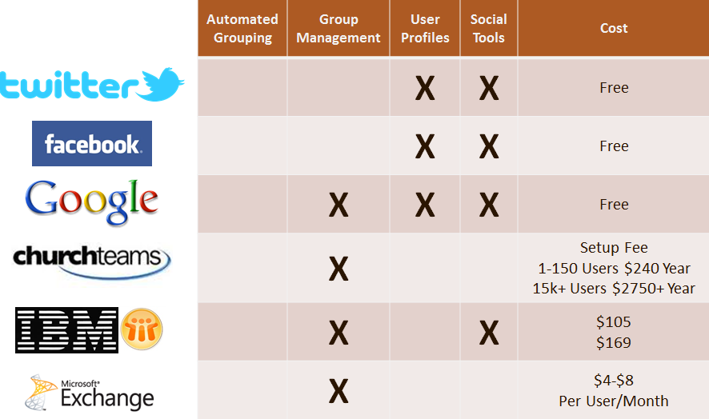
Figure 1: Comparison of systems with support for groups
Solution
The system we plan to build to address the challenges that Melissa is facing is called Group Wrangler. This system combines simple membership managing and tracking with an emphasis on communication among users. The focus of this system will be on simplicity, usability, and maintainability.

We also recognize that this system could be used to manage groups in various other organizations besides GSEP. For example, we could see this system being used to manage little league sports teams or work teams in a small business. We are designing this system to support tracking a wide variety of groups. The idea is that any organization can install Group Wrangler and configure it to manage the groups that the organization is interested in. The goal is to develop a product that is free, open-source, and extensible. We want non-technical users to be able to quickly install and configure the system based on their needs.

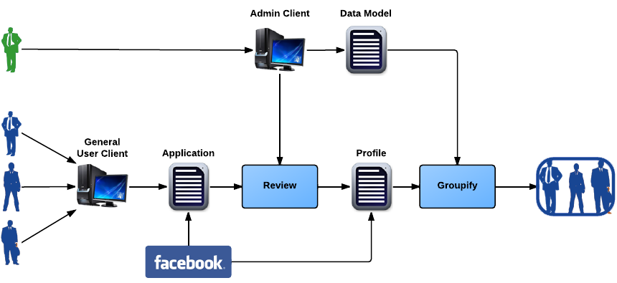
Figure 2: Data Input and Maintenance

Some of the key features of our system are shown in Figure 2. Users will be able to log into the system and fill out an application that contains a list of attributes associated with them. An administrator will review the application, and the system will make a user profile if the user’s application is approved. Each user will have a set of required attributes and set of optional attributes. Required attributes will include name, e-mail, phone number, and birthday. An administrator may choose to expand the required attributes that users must fill out. For example, an administrator for GSEP might want to make the major and language attributes required. Note that a user can get profile information from outside social networking sites, such as Facebook, if he or she wants to for convenience.

Administrators will make a data model to decide what users will be included in a group. A group definition specifies how attributes must be filled out in order for a user to be considered part of a group. For example, a GSEP administrator may make a group of Japanese language students that are currently studying abroad. The group definition would then check the language attribute value to see that it is equal to Japanese, and it would check the current work address attribute to see that its value is not in the United States.

The attributes for each user and the group definitions are passed into the groupify function. This is where each user’s attribute list is compared against the group definition. If a user meets the requirements of a group definition, then the user is automatically made a member of the group. The system checks the attribute list of each user against the group definition periodically so that users are put into the proper groups when attribute lists or group definitions change.

Note that the system can do all of the grouping automatically based on common attributes. The user simply fills out attributes and is put into the appropriate groups. There is no need to manually join particular groups. While there is an upfront cost for users in terms filling out attributes and for administrators in terms of making group definitions, membership management becomes much easier with this automatic grouping feature. Also note that an administrator can manually add a user to or remove a user from a group no matter what the user’s attributes are.

An administrator can choose to put a filter an already existing group definition in order to analyze a subgroup. For example, a GSEP administrator may be interested choose to filter the group mentioned above by choosing to look at all of the junior students in the group of Japanese language students that are currently studying abroad.

Using filters means that an administrator does not have to create a new group for every subgroup that he or she is interested in. We considered the alternative where an administrator simply creates a new group definition for every subgroup that he or she is interested in, but we realized that too many groups could be hard to manage. The idea is that it is much easier to use filters on current groups than to create a large number of new groups to analyze every subgroup that the administrator is interested in. It can also be quite confusing to users if they are part of groups with many overlapping attributes. Users will only be able to see the groups that they are a part of. Administrators will only use the filters to analyze subgroups.

Administrators can do an analysis on any group (filtered or unfiltered). This analysis may include a timeline, bar graph, pie chart, or some other data summary based on user attributes in a certain group. The administrator will be able to customize the type of analysis he or she wants to perform. This feature addresses the need for effective group tracking tools that is lacking in many other grouping systems.

The system also encourages communication among users. Any user can message another user in the system. Each user has a blog page that he or she can post to. Additionally, once a group has been set up, an administrator has several ways to communicate with a group. An administrator can post to the group wall so that all members can stay aware of events happening in the group. The administrator for the group may also choose to send a message to everyone in a group (filtered or unfiltered). The fact that there are multiple communication channels in the system should make it easy for users to stay in contact and keep aware of current group events. This addresses the need for communication in the system.

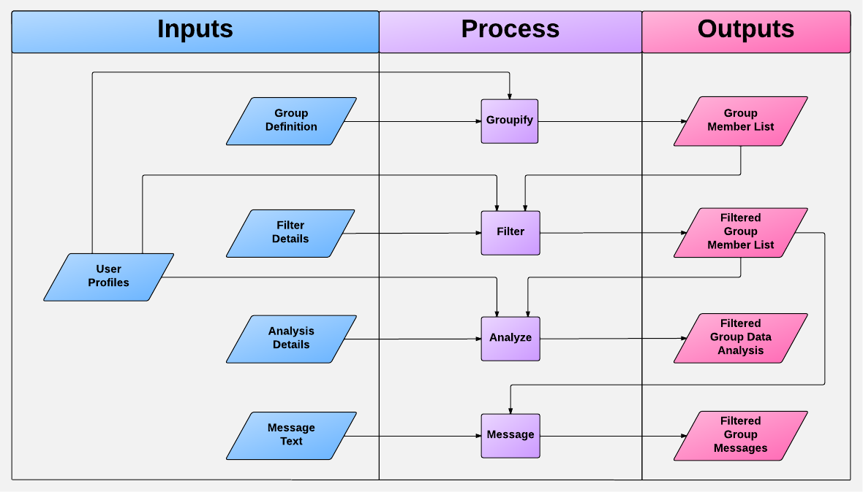
Figure 3: Group Wrangler information flow diagram

We can also think about Group Wrangler in terms of inputs and outputs. Figure 3 shows an information flow diagram for the system. This shows much of the information in Figure 2 more formally. Each user profile includes the attributes for a particular user. The group definition and user profiles are used to produce the group member list. The group member list can then be filtered with filter information. Any filtered or unfiltered group member list can be used to generate a data analysis. The administrator can also use a filtered or group member list to send messages to users.

Group Wrangler clearly addresses all of the challenges that Melissa has with the GSEP project. The system will allow her to easily create groups based on user attributes. There is some upfront work on the part of the administrator to set up group definitions and on the part of users to set up their attributes, but group membership becomes much easier since our system automates this process. Group Wrangler includes the necessary analysis tools needed to track groups or subgroups. In addition to the group management and tracking features, Group Wrangler also includes the communication features that Melissa is looking for in the form of messages, blogs, wall posts, and forums.
The effect of our system also extends beyond GSEP. We can see Group Wrangler being used in a variety of other organizations. There is no other system out there that accomplishes the group management and tracking features we plan to include at a reasonable cost while still encouraging communication among users. This will save other organizations time, effort, and money in terms of managing groups.

FUNCTIONAL REQUIREMENTS

For the Group Wrangler system, we have defined four different roles that users can fall into. The first role is that of the generic user. Generic users have only the most basic privileges such as maintaining a profile and being placed in groups. Admins are the next category of users. They have all of the privileges that generic users do, but have more control in the system. The third category, owner, is really only a special type of admin. They are the one responsible for initially setting up the Group Wrangler system and are also the only ones who can demote other admins. The final role is that of group content manager. A group content manager is a special type of generic user, promoted by an admin, who can help in managing the group wall and help maintain the forums. Described below in detail is a complete listing of each user’s requirements.
1. Generic Users
1.1. Login
1.1.1. Pre existing generic users will be able to log in to the system with their username and password.
1.1.2. New generic users will have an option to fill out and submit an application to sign up for the website.
1.1.2.1. New generic users can sign in with their Facebook account (provided they have one) to have Group Wrangler pull data from their Facebook account to fill in some details in the application.
1.1.3. New generic users will be asked for an email address and password, as well as to fill out each of the core attributes before submitting an application.
1.1.4. Generic users can request to reset their password if it has been forgotten, in which case a confirmation email will be sent to the user’s registered email address.
1.2. Profile Management
1.2.1. Generic users will be able to change their core attributes, but their email address cannot be changed.
1.2.2. Generic users can request to change their password, in which case a confirmation email will be sent to the user’s registered email address.
1.2.3. Generic users will be able to fill out and update any and all optional attributes as often as they would like.
1.2.3.1. If updating an attribute makes a user no longer match the required attributes for a group the system will notify the user and the user will have to confirm the change.
1.2.3.2. If filling out or updating an attribute makes a user match required attributes for a group the user will be added to that group and the system will notify the user that they have been added.
1.2.4. Generic users will be able to view their current notifications.
1.2.5. Generic users will be able to view their current list of groups and travel to that group’s page.
1.2.6. Generic users who have sent in an application, but have yet to be accepted may view their profile and modify attributes, but will not be placed in groups.
1.2.6.1. These users may not view group pages, other generic user’s profiles, or view the forums.
1.2.6.2. These users may not send any messages and may not receive any messages except to/from admins.
1.2.7. Generic users who have had their application denied will be informed of such and can resubmit their application.
1.2.7.1. These types of account will be removed automatically from the database after 60 days of inactivity on the account.
1.2.8. Generic users will be able to logout.
1.3. Blog Management
1.3.1. Generic users will be able to add a new blog post to their profile at any time.
1.3.1.1. Generic users will be able to edit and delete any blog posts from their own blog.
1.3.1.2. The generic user will be informed and confirmation will be requested before being able to delete a post.
1.3.2. A user will be able to comment on another user’s blog posts.
1.3.2.1. Generic users will be able to delete other’s comments on their own blog.
1.3.2.2. Generic users will be able to edit/delete any of their own comments.
1.3.2.3. The generic user will be informed and confirmation will be requested before being able to delete a comment.
1.4. User Communication
1.4.1. Message Communication
1.4.1.1. Generic users will be able to send/receive messages to/from other generic users.
1.4.1.1.1. Generic users will be able to delete any messages they have sent/received.
1.4.1.1.2. The generic user will be informed and confirmation will be requested before being able to delete a message.
1.4.2. Forum Communication
1.4.2.1. Generic users will be able to post topics in any sub forum provided they are part of that sub forum’s associated group.
1.4.2.2. Generic users will be able to post replies to other user’s topics in any sub forum provided they are part of that sub forum’s associated group.
1.4.2.3. Generic users will be able to edit any post that they create.
1.5. Group Management
1.5.1. Generic users will be able to view basic group information, including required attributes for the group.
1.5.2. Generic users will be able to post comments in any group’s news and announcements section provided that they are part of the group.
1.5.3. Generic users will be able to edit/delete any comments they have posted.
1.5.4. The generic user will be informed and confirmation will be requested before being able to delete a comment.
1.5.5. Generic users will be able to view a group’s list of members, travel to any group member’s limited profile page and send any group member a message.
1.5.6. Generic users will be able to travel to the group’s sub forum from the group’s page.
2. Administrators
2.1. Admins will be able to do anything a generic user can do.
2.2. Applications
2.2.1. Admins will be able to edit the application form.
2.2.2. Admins will be able to view current pending applications.
2.2.2.1. Admins will be able to approve pending applications. The generic user will then be given normal generic user privileges.
2.2.2.2. Admins will also be able to deny pending applications. The generic user in question will receive an email notifying them of such.
2.3. Managing Users
2.3.1. Admins will be able to view member’s full profiles.
2.3.2. Admins will be able to edit any non-admin user’s profile information.
2.3.3. Admins will be able to delete any other non-admin users. A notification email will be sent to the deleted member’s email address.
2.3.3.1. The admin will be informed and confirmation will be requested before being able to delete a user.
2.3.4. Admins will be able to ‘lock’ any generic user’s account. A ‘locked’ account cannot post anything or message other generic users. The ‘locked’ user can still message admins.
2.3.4.1. The admin will be informed and confirmation will be requested before being able to lock a user.
2.3.5. Admins will be able to delete any posts/comments on any generic user’s blog.
2.3.5.1. The admin will be informed and confirmation will be requested before being able to delete a post/comment.
2.3.6. Admins will be able to track individual generic users with a log of notes.
2.3.6.1. Admins will be able to add new notes to the log.
2.3.6.2. Admins will be able to edit the log’s notes.
2.3.6.3. Admins will be able to delete notes in the log.
2.3.6.3.1. The admin will be informed and confirmation will be requested before being able to delete notes.
2.3.6.4. All admins will be able to view a generic user’s log.
2.4. Managing Groups
2.4.1. Admins will be able to create new groups and set up the required attributes for the group.
2.4.1.1. Created groups will be set to public by default. Admins will have the option to change this to private. A private group will not have the automatic grouping and members must be added manually.
2.4.1.2. Admins will be able to invite generic users to private groups.
2.4.2. Admins will have special privileges for public groups.
2.4.2.1. Admins will be able to invite generic users to groups they do not meet the requirements for.
2.4.2.2. Admins will be able to block specific generic users from joining groups even if they meet the requirements.
2.4.3. Admins will be able to update any group’s required attributes and basic information.
2.4.4. Admins will be able to delete groups.
2.4.4.1. Admins will be presented with a notification requesting confirmation before the system deletes a group.
2.4.4.2. Any generic users that are part of the group will be notified of the group’s deletion.
2.4.5. Admins will be able to post to any group’s news and announcements section.
2.4.5.1. Admins will be able to edit/delete any posts in a group’s news and announcements section.
2.4.5.1.1. The admin will be informed and confirmation will be requested before being able to delete a posts.
2.4.5.2. Admins will be able to delete any post’s comments in a group’s news and announcements section.
2.4.6. Admins will be able to apply filters to a group’s members.
2.4.6.1. Admins will be able to view statistical data about filtered group members.
2.4.6.2. Admins will be able to mass message filtered group members.
2.5. Managing Group Forums
2.5.1. An admin will be able to lock any topic in their group’s sub forum.
2.5.2. An admin will be able to delete any topic in their group’s sub forum.
2.5.3. An admin will be able to delete any post in a topic in their group’s sub forum.
2.5.4. An admin will receive a notification requesting confirmation before locking/deleting a topic or deleting a post in a topic.
2.6. Admin/Group Manager Management
2.6.1. An admin will be able promote any generic user to an admin or group manager.
2.6.1.1. The generic user in question must then accept the promotion.
2.6.1.2. An admin can revoke the promotion offer before it is accepted.
2.6.2. An admin will be able to demote a group manager back to a generic user.
2.6.2.1. The system will request confirmation from the admin before demoting a group manager.
3. Owner
3.1. The owner will be able to do anything that an admin is allowed to do.
3.2. First Time Set Up
3.2.1. The owner will set up core attributes.
3.2.2. The owner will set up optional attributes.
3.2.3. The owner will create their account.
3.3. Admin Management
3.3.1. The owner will be able to demote an admin back to a generic user.
3.3.1.1. The system will request confirmation from the owner before demoting an admin.
4. Group Content Manager
4.1. A group content manager will be able to do everything that a generic user can do.
4.2. Managing Group News and Announcements
4.2.1. A group content manager will be able to post to any group’s news and announcements section.
4.2.1.1. A group content manager will be able to edit/delete any posts in a group’s news and announcements section.
4.2.1.1.1. The system will request confirmation from the group content manager before deleting any posts.
4.2.1.2. A group content manager will be able to delete any post’s comments in a group’s news and announcements section.
4.2.1.2.1. The system will request confirmation from the group content manager before deleting any comments.
4.3. Managing Group Forums
4.3.1. A group content manager will be able to lock any topic in their group’s sub forum.
4.3.2. A group content manager will be able to delete any topic in their group’s sub forum.
4.3.3. A group content manager will be able to delete any post in a topic in their group’s sub forum.
4.3.4. The system will request confirmation from the group content manager before locking/deleting a topic or deleting a topic.

Environmental REQUIREMENTS

Group Wrangler will need to be supported on a variety of hardware systems and browsers. We also want to ensure that privacy is maintained and that the system will be open source. We detail the environmental requirements below.

Run on Many Hardware Systems
Group Wrangler will need to be able to support small to large amounts of users. This means that for scalability and for anyone to host their own server Group Wrangler will need to support various hardware setups. To support these needs Group Wrangler will be able to run on a:
- Cloud computing system
- Standard desktop
- High-end server

Multiple Operating Systems
Group Wrangler will need to be capable of running on different operating systems. This allows for anyone that wishes to use Group Wrangler to run a server on their machine. The operating systems supported by Group Wrangler will be:
- Windows
- Mac OS
- Linux

Modern Browser Support
Group Wrangler will need to be current in the design and implementation of its coding to support current and future internet browsers. This means that code will need to support popular internet browsers used by its users. The browsers supported by Group Wrangler will be:
- Internet Explorer 9
- Mozilla Firefox
- Google Chrome

Privacy Protection
Group Wrangler will have the potential to contain private and personal information of its users. For the widest range of uses for Group Wrangler, it will need to be secure. This will protect the information of users on the Group Wrangler system. Group Wrangle will need to protect these systems:
- User authentication
- Network communication
- Database

Open Source
Group Wrangler will be open source and free to use for anyone that wants to use Group Wrangler. This will allow Group Wrangler to be easily accessible and widely used. This will also allow for the future expansion of Group Wrangler by its users.

Non-functional Requirements

Group Wrangler’s non-functional requirements are related to making sure that any non-technical user can easily install, set up, and run the system. The system should also be able to run well in a variety of environments and be expanded upon.

- User-friendliness – The level of computer literacy needed in order to operate the Group Wrangler system must be minimal. The system must offer installation mechanics that merely require a one-button press input from the user, a thoroughly user-tested UI design, and automated features for grouping functions. A new instance of Group Wrangler will be fully installed and ready to use within 30 minutes, and new users must be deployable into the system in 5 minutes.
- Correctness – The Group Wrangler system must determine the lists of users that pertain to groups and filters set by the administrator with 100 percent accuracy. In addition, the safety feature that will enable the system to inform administrators of the consequences of removing or adding additional user attributes must:
- Inform the administrator which groups will be affected upon removal of a user attribute with 100 percent accuracy.
- Inform the administrator of the spatial cost of adding additional attributes at every instance of creation.
- Reliability – The Group Wrangler system must have a high level of reliability upon the software level of operation, as the system is meant to be capable of deploying on any operating system or Internet browsing platform. In addition, as it is necessary for the software to be able to scale up to a user base of 10,000 as specified by the client, it becomes crucial that the grouping and filtering mechanics be able to operate with any scale data set. However, hardware reliability is not a concern that is feasible to address, as Group Wrangler is meant to be deployable on any custom hardware environment of the users choice.
- Performance – Performance expectations are moderate for the Group Wrangler system. The types of transactions the software will perform revolve around dynamic database interaction and data filtering for users. Considering the large-scale user base that it is intended to serve, the speed of transactions occurring cannot exceed a time cost of 3 seconds. In addition, initial group or new user creation must not exceed a time cost of 5 minutes.
- Extensibility – A key feature of the Group Wrangler system is a software-level design that caters to future expansion by the addition of software modules. As the system will operate on a custom environment assembled by the user, Group Wrangler must be allow for users to expand its features within the tolerance of the environment provided.
- Robustness – Forms of input that can be taken by the Group Wrangler system will be vast in array, leaving a considerable margin for collision of data types. Handling faulty data should be an automated process performed by the system in the event that it arises, while thoroughly informing the user of the issue and how it had effected the state of the system.
- Verifiability – Testing the functionality of the Group Wrangler system is not complicated, but a generous amount of time must be spent testing the system throughout each phase of implementation. As features exhibit high levels of interactivity, each must be tested continuously as workable implementations reach completion and continuously tested as new modules of functionality are deployed.
- Maintainability – The lifespan of Group Wrangler is anticipated to extend beyond the foreseeable future, as long as a social need for highly advanced, expandable grouping software remains stable. The extensive compatibility features of Group Wrangler will ensure its longevity upon all platforms and future hardware configurations. In regard to the hardware demands of Group Wrangler, expansion and maintenance of a physical environment are wholly dependent upon the user, as Group Wrangler will not include a deployable hardware component.
- Reparability – All deployable features of Group Wrangler will be highly modular, which will allow for either repair or modification of key features in the software if the need arises. In addition, the modularity of Group Wrangler will leave the system open for necessary expansions to functionality if or when the need for necessary or optional additions to the code arise.
- Portability – With a collection of modern web technologies being used in the employment of Group Wrangler, the capability for Group Wrangler to interface with other systems is strong. Considering the intended general use of Group Wrangler, the capacity of the system’s portability is a critical consideration. That being the case, it is necessary that Group Wrangler is developed in highly portable environments.
- Understandability – While the underlying functionality of Group Wrangler may have several points of complexity, the use of the system and its advanced tools must be an easy process.
- Timeliness – The time budget for the completion of the requirements acquisition, design, and implementation of Group Wrangler cannot exceed 5/5/2013.

Risks

The key risks associated with the Group Wrangler project are related to data management, security, and system expansion. We detail these risks and ways to deal with each of them below.
Flexibility and data integrity
Standing as a question of data management, this issue is in regard to the key requirement that allows administrative users to create or remove attributes that define users at any point during the use of Group Wrangler, which creates a twofold risk to the system. First, as the administrative user is granted the power to create as many user-defining attributes as they would like to, there lies the potential risk that erroneous data is instantiated, which may flood the system’s database. Secondly, there lies the potential risk that an administrative user may choose to remove an existing attribute that is among the defining characteristics that forms one or multiple groups, potentially corrupting one or more groups within the given instance of the system. As the potential for either of these issues is unpredictable and their direct prevention is not possible without violating a required feature of the system, Group Wrangler will provide the user a small level of guidance prior to the creation or removal of attributes by informing them of the consequences of each instance of either action.
Security of User Information
Related to the issue of administrative users and their freedom of data control, the Group Wrangler system will allow for nearly any type of attribute to be created in order to define users. In order to address the need to safeguard user’s information, as attributes may carry private information, Group Wrangler will require (at least) two levels of security. First, the system will require strong user authentication in order to prevent unauthorized access to user accounts and information. Second, as user attribute data is stored in a database, a level of encryption will be required to prevent unauthorized agents from accessing it.
Future Expansion of the System and Compatibility
As Group Wrangler’s design will be intended to allow for future developers to expand upon the system by developing additional tools and mechanics that are desired, compatibility of future modules becomes an important consideration to Group Wrangler after its deployment. As there is a vast array of web development tools that offer cross-compatibility when developing web-based systems, a risk arises that the implementation of Group Wrangler may become convoluted with a vast array of technologies that third party developers may employ to expand it. In order to ensure any third party developments offer optimal compatibility with the deployed system, a bundle of the development tools used by Team Lasso will be offered for outside developers to employ in order to further expand upon Group Wrangler.

Project Plan

The development of Group Wrangler will occur in four major sequences, beginning upon September 20, 2012 and reaching deployment upon May 9, 2013. These four sequences are as shown and highlighted below.
Design and Requirements
In the first sequence of the project, Team Lasso will attend regular meetings with their sponsor, Melissa Armstrong, in order to assemble and refine a list of requirements for the Group Wrangler system. Once an appropriate compilation of requirements has been created, the team will move to the process of developing Group Wrangler’s design.
- Requirements Acquisition: 9/20/12 – 10/9/12
- Assemble Requirements: 10/9/12 – 10/17/12
- Design: 10/17/12 – 11/5/12

Phase 0: Core Functionality and Prototype
In Phase 0 of Group Wranglers implementation, Team Lasso will be developing feature sets core to Group Wrangler’s functionality. Once core pieces are properly implemented, user testing will begin upon the system at the end of the phase. The segments of functionality, phase operations, and their allotted time are as follows:
- User Profiles: 11/5/12 - 11/22/12
- Group Mechanics: 11/5/12 - 11/22/12
- Attribute Mechanics: 11/5/12 - 11/22/12
- Administrator Powers: 11/12/12 – 11/29/12
- Data Searching: 11/19/12 – 12/8/12
- User Testing: 11/19/12 – 12/8/12

Phase 1: Supplemental Feature Sets
Phase 1 of Group Wrangler’s implementation will focus upon the implementation of features that supplement the system’s core functionality, but will not be critical to its essential function. The feature sets that will be implemented in this phase are as follows:
- Facebook Integration: 1/14/13 - 1/31/13
- NAU Login: 1/14/13 - 1/31/13
- User Locking: 1/21/13 – 2/7/13
- Forum Activity Tracker: 1/31/13 – 2/19/13
- Notification System: 1/31/13 – 2/19/13
- Attribute Investigation Mechanics: 1/31/13 – 2/19/13

Phase 2: User-Aid Features and Testing
In this final phase of implementation and development, Team Lasso will integrate feature sets that are intended to aid the user in the use of the Group Wrangler system. In addition, the system will undergo intense user testing through this phase to ensure the deployable system is as stable as possible. The Phase 2 feature sets and allotted testing time are as follows:
- Application Builder: 2/19/13 – 3/8/13
- Group Wrangler User Tutorial: 3/1/13 – 3/20/13
- Group Suggestion Tool: 3/8/13 – 3/27/13
- Webinar Tools: 3/8/13 – 3/27/13
- User Testing: 3/18/13 – 5/9/13

Gantt Chart
The following Gantt chart is a visual representation of all milestones mentioned in the Project Plan section:
