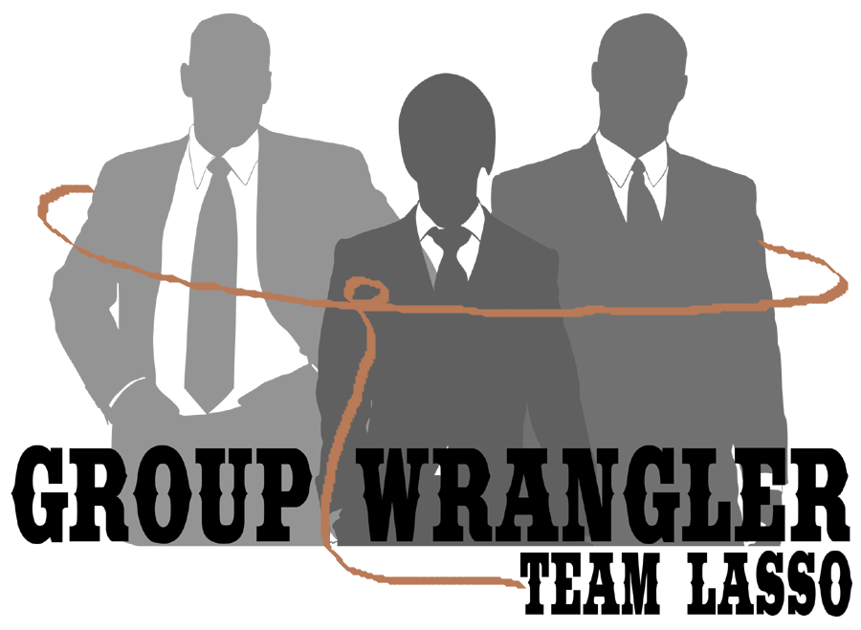
CS 476
Requirements Engineering
Fall 2012
Instructor: Dr. Georgas

Team Standards
Version Date: 10.25.12
Greg Andolshek
Alex Koch
Michael McCormick
Shane Russell

Table of Contents

Introduction 3
Team Roles 4
Meeting Procedures 6
Document Procedures 8
Team Self-Review 12

Introduction

This report discusses the shared agreement of the standards we expect among team members in our group. We have clearly laid out the details of the standards here to ensure that we have a shared idea of the expectations so that we work together effectively on the project. The sections of this report include team roles, meeting procedures, document procedures, and team self-review.
The team roles section deals with a description of the duties associated with each role in this project and an assignment of roles to each team member. The roles are meant to give each person in the group an area to focus on to make sure that each aspect of the project is being addressed. However, each team member is expected to do whatever is necessary to help the project even if it does not fit his role. We have included some general roles such as team leader, but there are also more specific roles based on the requirements of the project.
Our meeting procedures section discusses our plan for team meetings. The topics include meeting time, agenda structure, minutes, decision-making process, attendance, and conduct. The details in this section will ensure that meeting rules are upheld and meetings are run efficiently.
Document procedures are meant to outline the steps to manage the many documents that we will produce for this project. The topics include tools, version control, formatting, and composition and review. We need these procedures in place so that we can maximize our time working on code and minimize the time spent on merging and formatting issues.
The team-self review section is in place to help us monitor our progress. We want to be able to assess our work as we continue through the semester. We have considered the schedule, process, and documentation for these evaluations. These evaluations should help us improve and keep us on track to complete the project on time.

Team roles

The following roles were devised based on the necessity for more specialized member participation in ensuring quality work is produced and appropriate attention to detail is paid for more critical team tasks. No single team member will be solely responsible for all the tasks their selected role implies, but will be the authority in how the developments under their position will be handled. The major roles and their assigned members are as follows:
Documenter (Shane Russell)
The role of the documenter is responsible for ensuring the accuracy and quality of any documentation produced for the project. Examples of documentation include but are not limited to:
- Making sure all inter-code documentation, namely commenting, is present and well written.
- Documentation relating to the development of the system (i.e. requirements and design documents).
- Detailed meeting minutes.
The minimum effort expected from the team documenter will involve the assembling and editing of document drafts from their initial stages through their final form. Team members will or may contribute portions of documentation as they are developed; i.e. comments in assigned coding implementations, or segments for necessary documentation.
Visual Designer (Alex Koch)
As a visual designer, this role will be responsible for all aesthetics attached to the project and the system. The visual designer will be responsible for maintaining visual aspects of the developing system, and will be expected to enforce effective GUI design and maintain any system formatting rules. In addition, they will be primarily responsible for producing needed graphics that follow the aesthetic themes of the system. The team visual designer will be responsible for enforcing the proper employment of required aesthetics as determined by the team, mentor, or customer.

Team Leader (Michael McCormick)
The team leader will serve as the team’s primary monitor and communication medium to ensure all assigned tasks are being carried out in a timely, coordinated, and appropriate fashion. As such, the team leader is expected to have a firm grasp of task details, task progress, customer expectations, and mentor expectations. The team leader must be prepared to offer any team member, mentor, or customer adequate information over general topics regarding the project in the event the team leader is prompted, or the opposite party is confused. In addition, it is expected that the team leader will be the primary party concerned with resolving any team conflicts, in that conflicts will be brought to the team leader’s attention first. The team leader will be responsible for deciding if any further escalation is necessary.
Architect (Greg Andolshek)
As the team architect, this member should be able to determine the feasibility of any expected features, must ensure that system requirements are being fulfilled as completely as possible, and must have a masterful understanding of the system design. The main point of this role is to ensure that the implementation follows the core architectural decisions. As such, the architect will be the authority on the approval of system features as well as oversee the implementations produced by team members. In doing so, the architect will ideally ensure that the code will be produced with a minimum amount of development related conflicts.
Programming Pairs (All Team Members)
As teamwork and communication are essential parts of the project, team members assigned to implement substantial features in coding will be expected to utilize the team and pair with a partner while programming. In doing so, team members can share their expertise and insight to ensure a smoother development process upon the implementation level. Pair programming sets must also fluctuate the team members for any given feature implementation; in other words, teams of two must not exclusively use the same programmers in a pair for every new feature implementation. The cycling of partners will help facilitate a general understanding of all working pieces of the system, preventing any given programmer or pair of programmers from developing a specialty for any one piece of the system and excluding themselves from exposure to others.
The roles listed above are based off of necessity determined from the team’s initial impressions of the tasks to be handled for the system development. All team members are still expected to share workloads in any given field and offer support and aid in the event their peers require it. These roles are also subject to change based off of the future needs of the project; any changes in role expectations or the additions of new roles will be determined, documented, and approved by the team as needed.

Meeting procedures

The purpose of this section of this document is to outline and detail the various rules and guidelines our team will be expected to abide by that are related to our planned-in-advance meetings.
Meeting Time
Weekly meetings will be held on Wednesday at 3PM. Additional days and times will be added as needed the further we get into the project.
Agenda Structure
At the start of each meeting for our team, we will begin with each member giving a roughly 2 minute long (longer if needed) update on anything project related that they have been working on since the last meeting, complete with written reports if deemed necessary. The remainder of the meeting’s content will depend largely on the stage of the project, but will consist of discussing where we are at on the project, and where we would like to be for the next meeting.
Minutes
The minutes taken at each meeting will detail what has been accomplished since the last meeting, where the project is at now, and where we would like to see the project at by the next meeting by deciding on specific task items that will be completed by the next meeting.
Decision Making System
For our team’s decision making system, we elected to go with a majority rules approach. For our team, this would mean 3 out of the 4 members of our team being in agreement. In the case of a tie, further discussion will be had until a majority can be reached.
Attendance
For showing up to meetings, we have decided to allow a 10 minute grace period for attendance, in case of weather, traffic or other delays. Arriving less than ten minutes late is acceptable any number of times, if for valid reasons. If any team member arrives more than ten minutes late, our team will talk to them about it. However, if it happens more than 3 times, we will be forced to escalate the issue to the mentor to determine a resolution to the issue and/or consequences. Absences will be handled in a similar fashion. A team member will be allowed 2 unexcused absences before the mentor is brought into the discussion. Acceptable reasons for absences include poor weather, emergencies, and illness. Any team member who is going to miss a meeting should make the effort to contact the rest of the team as soon as possible to inform them of their absence and to coordinate plans moving forward. Any cases of absence or tardiness will be documented in the meeting minutes so that we have a record to consult.
Conduct
Basic rules of common decency and respect will be expected of all teammates during all meetings. Teammates are also expected to remain on task throughout all meetings (i.e. no working on other class’ homework, etc.). Teammates are expected to finish their assigned tasks before any meeting starts. Any teammate who is not going to be able to finish his tasks should inform, through email and/or texts, the rest of the team as soon as they realize that is won’t be complete and provide adequate reasoning as to why the task will not be complete. Acceptable reasons our team agreed upon are illness and emergencies.

document procedures

We have several procedures in mind for handling the many documents involved in our project. These procedures concern the tools, version control system, issue tracking system, formatting, and composition and review we will use.
Tools
We will need tools for managing code and documents. This includes word processing tools, an IDE, and web development tools.
Word Processing tools
We will use word processing tools to produce the documents for the deliverables. The main application we will use is Microsoft Word. Word has some nice formatting tools that we can use to set up a template for our documents. We will also use Google Docs if we need multiple people to edit the same document before we apply formatting.
IDE
We will need an IDE that will allow us to manage the code we write for this project. We have chosen the NetBeans IDE because it is free and provides good support for programming with PHP.
Web Development Tools
There are several web tools that will be helpful in the development process. We will use Firebug for Mozilla Firefox and Google Chrome’s Developer Tools to debug and edit CSS, HTML, Javascript, etc. for the project website.
Version Control
The large number of team members and document changes involved in this project mean that we will need a central location to manage the versions that we produce. We have chosen to use the Git distributed version control system in combination with the bitbucket hosting site in order to manage our documents and code. These tools are free, effective, and simple to use. We will use separate repositories for code and our documents in order to keep the two logically separated.
We would like to use a development strategy where we attempt to only commit working code to the main trunk. This means that our configuration management style will be based on releasing from the trunk rather than releasing from a branch. Each person working on a feature will work on his own branch of the repository. When a new feature has been completed, the team will do extensive testing to make sure that the new code works with the existing code in the trunk. All merge conflicts will need to be carefully addressed by all team members. Only at this point should code be committed to the main trunk.
By carefully following the procedure described here, we should be able to easily recover older versions of code at the right level of granularity. Each version in the trunk should be a stable release that we can revert to if necessary. We will also commit often to the branches that we are working in to make sure that we have can carefully track how features are evolving.
Issue Tracking
In order to keep track of the features and bugs that we are working on, we will need an effective issue tracking tool. We have chosen to use the JetBrains YouTrack program for this purpose. This program allows developers to set the priority, type, state, assignee, etc. for various issues. There is also a handy search tool for finding specific issues.
Formatting
We would like to establish template for the documents that we produce so that they are consistent and professional. We have considered such things as structure, fonts, page numbering, etc.
Structure
The structure of this document shows the structure that we will be using for each document that we produce. The document will have a cover page that includes our team logo, our names, and the name of the deliverable. An index page lists the beginning page for each section of the paper. Each section of the document is clearly separated with a new header and a page break after the previous section.
FoNTS
The two main fonts we will use are Calibri and Cambria. We will use Calibri for the cover page title and for section titles. We will use Cambria for almost all other text. We may use a different text if we need a particular block of text to stand out.
SIZES
We want to use different text sizes for different parts of the document.
- 68pt: main title
- 24pt: section titles
- 18pt: headings
- 14pt: sub-headings
- 12pt: paragraph text
- 11pt: bullet formatted text

Page numbers
Each page number will be at located in the bottom left of each page after the table of contents page. The appendix pages will be labeled in Roman numeral format.
Spacing
There will be clear spacing between various parts of the document to ensure document readability. We will use styles to help us with the spacing in Microsoft Word. For the most part we will use the “Normal” style because it puts clear separation after each carriage return. We will use special styles for the cover page title and section titles. These styles are used in this document and will be stored in a template file so that we can easily reuse them.
Color Scheme
We will use different colors to help bring out certain parts of the text and separate sections. Grey, blue, black, and white are the main colors that we will use. The background of the main document title and the section titles will be a blue-grey color, as seen in this document. The text in these titles will be white to stand out. Headings will be blue-grey, and sub-headings will be another shade of blue-grey. The main text of the document will be black. The bulleted text will be a light grey.
IMAGES
All images will be clearly set off from the text with clear spacing and be large enough to be easily readable. Each image should be labeled as “Figure X” in numbered order throughout the document and have a short description of the image.
COVER PAGE
The cover page will have the title of each major section of the document, followed by an underscore leading up to the starting page of the section.
REFERENCES
Any citations and references will be in MLA format. The references page will include an alphabetical list of the sources.
Composition and Review
There are several stages for submissions that we will enforce internally. We would like to have all rough drafts of document sections completed at least four days before the official due date. At this point, each team member will have 24 hours to look through the rough drafts and make comments or revisions. Each team member then has 24 hours to make the necessary changes to his or her section. Two days before the due date, all of the parts of the document will be compiled and formatted. Team members will use the remaining time to carefully look over the final document to make sure everything is correct. The final document should be printed out 24 hours before the official time that the document is due.
We expect all team members to carefully follow the composition rules discussed in the formatting section so that the compilation process is as simple as possible. The formatting will help to ensure that we have a uniform and professional look throughout the document.

team self-review

The team self-review will occur on a regular schedule during meetings. The review will be based on a simple checklist of what is being completed and will provide a status update of current progress on the tasks being completed by the team. This will be recorded in the meeting minutes and will also be logged in the self-reviews.
Scheduling
Reviews will be held bi-weekly during the weekly team meetings; also to be noted in the meeting minutes. Two weeks seems to be a good interval so that we can assess our work periodically while continuing to move forward with tasks.
Process
Evaluation will be based off a checklist of expected tasks to be completed by any given team member. We will keep a log of project tasks that will be continuously updated. We will use the evaluation time to go through to make changes to the status of each tasks based on our discussions. Team members will have a chance to offer comments on the quality of particular tasks and whether or not the task can be considered complete. We will use this formal process to evaluate the performance of each team member and the judge the progress of each part of the project.
Status will be noted as "ahead of schedule", "on schedule", or "behind schedule."
Documentation
The documentation of the task list and status updates will be in the meeting minutes and it will be logged in the self-reviews. These documents will be in an online repository so that all team members can access them.

